Course Five

The Nuts and Bolts of Machine Learning


Instructions
Use this PACE strategy document to record decisions and reflections as you work through the end-of-course project. As a reminder, this document is a resource that you can reference in the future and a guide to help consider responses and reflections posed at various points throughout projects.

Course Project Recap
Regardless of which track you have chosen to complete, your goals for this project are:
- Complete the questions in the Course 5 PACE strategy document
- Answer the questions in the Jupyter notebook project file
- Build a machine learning model
- Create an executive summary for team members and other stakeholders

Relevant Interview Questions
Completing the end-of-course project will empower you to respond to the following interview topics:
- What kinds of business problems would be best addressed by supervised learning models?
- What requirements are needed to create effective supervised learning models?
- What does machine learning mean to you?
- How would you explain what machine learning algorithms do to a teammate who is new to the concept?
- How does gradient boosting work?

Reference Guide:
This project has seven tasks; the visual below identifies how the stages of PACE are incorporated across those tasks.
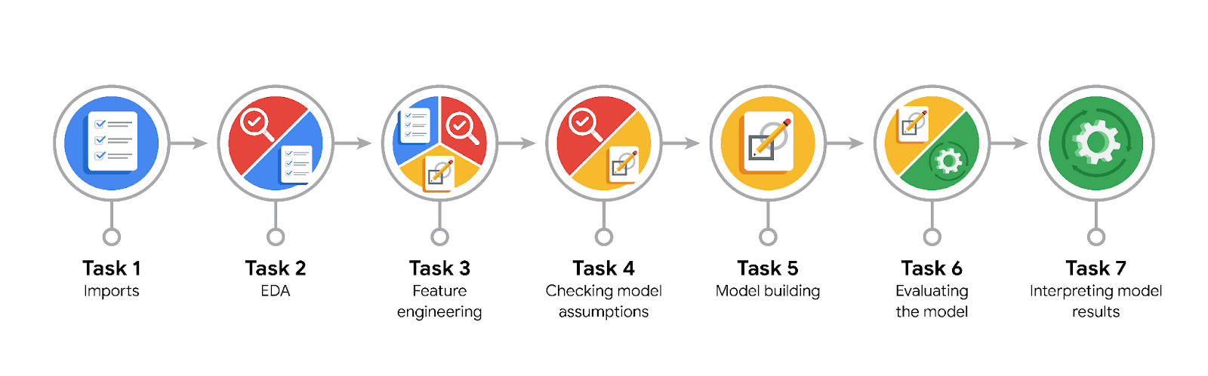

Data Project Questions & Considerations
PACE: Plan Stage
- What are you trying to solve or accomplish?
Trying to perdict customer churn using supervised learning models

- Who are your external stakeholders that I will be presenting for this project?
Data team leader and the business clients

- What resources do you find yourself using as you complete this stage?
Documentation and help of coursera’s reference guides

- Do you have any ethical considerations at this stage?
Ensure minimum bias during model training and tuning.

- Is my data reliable?
Yes, after performing feature engineering, we have improved our reliability of the data, any futher data requirements will be understood as we build the supervised learning models

PACE: Analyze Stage
- Revisit “What am I trying to solve?”Does it still work? Does the plan need revising?

- Does the data break the assumptions of the model? Is that ok, or unacceptable?

- Why did you select the X variables you did?

- What are some purposes of EDA before constructing a model?

- What has the EDA told you?

- What resources do you find yourself using as you complete this stage?

PACE: Construct Stage
- Do I notice anything odd? Is it a problem? Can it be fixed? If so, how?

- Which independent variables did you choose for the model, and why?

- How well does your model fit the data? What is my model’s validation score?

- Can you improve it? Is there anything you would change about the model?

- What resources do you find yourself using as you complete this stage?

PACE: Execute Stage
- What key insights emerged from your model(s)? Can you explain my model?

- What are the criteria for model selection?

- Does my model make sense? Are my final results acceptable?

- Do you think your model could be improved? Why or why not? How?

- Were there any features that were not important at all? What if you take them out?

- What business/organizational recommendations do you propose based on the models built?

- Given what you know about the data and the models you were using, what other questions could you address for the team?

- What resources do you find yourself using as you complete this stage?

- Is my model ethical?

- When my model makes a mistake, what is happening? How does that translate to my use case?

