

Project Interim Report

On

File Compression Simulator (Using Core Java & OOP Concepts)
RU-100-01-00012
Object Oriented Programming with Java

SESSION: 2025-26

Submitted By ABHAY RAJ RU-25-11674

Bachelor of Technology in Computer Science & Engineering with (AI) in association with Google

Under the Guidance of Mr. ASHISH SHIVHARE

SCHOOL OF COMPUTER SCIENCE AND ENGINEERING RUNGTA INTERNATIONAL SKILLS UNIVERSITY BHILAI, CG
(April 2026)

Abstract
The Expense Tracker Application is a Java-based system designed to help users manage their daily expenses efficiently.
In today’s fast-paced world, people often fail to keep track of their spending, which leads to poor financial planning.
This project allows users to add, edit, and delete their expenses easily. Each expense contains details such as name, category, and amount. The system automatically calculates the total expenditure and provides a category-wise summary of expenses.
The main objective of this project is to implement Object-Oriented Programming (OOP) concepts such as classes, objects, and data handling. The application is simple, user-friendly, and can be extended in the future with advanced features like database integration and graphical user interface.

Introduction
The Expense Tracker Application is a simple and effective software system used to record and manage daily expenses. It helps users organize their spending and maintain financial discipline.
With this system, users can add multiple expenses, modify existing ones, and delete unnecessary records. The system also calculates the total amount spent and displays category-wise summaries such as Food, Travel, and Entertainment.
This project is especially useful for students and beginners who want to understand Java programming and OOP concepts through a real-world application.

Scope
This project is suitable for small-scale usage such as personal expense tracking. It can be further enhanced in the future by adding:
- Database integration
- Mobile application support
- Graphical User Interface (GUI)

System Requirements

Hardware
- Computer/Laptop with minimum 4GB RAM

Software
- Java JDK
- IDE (VS Code / Eclipse)

Methodology
The working process of the project is as follows:
- The program starts and displays a menu
- The user selects an option
- Operations are performed:
  - Add Expense
  - Edit Expense
  - Delete Expense
  - View Expenses
- The system calculates total spending
- Category-wise summary is generated
- Results are displayed to the user

Flowchart

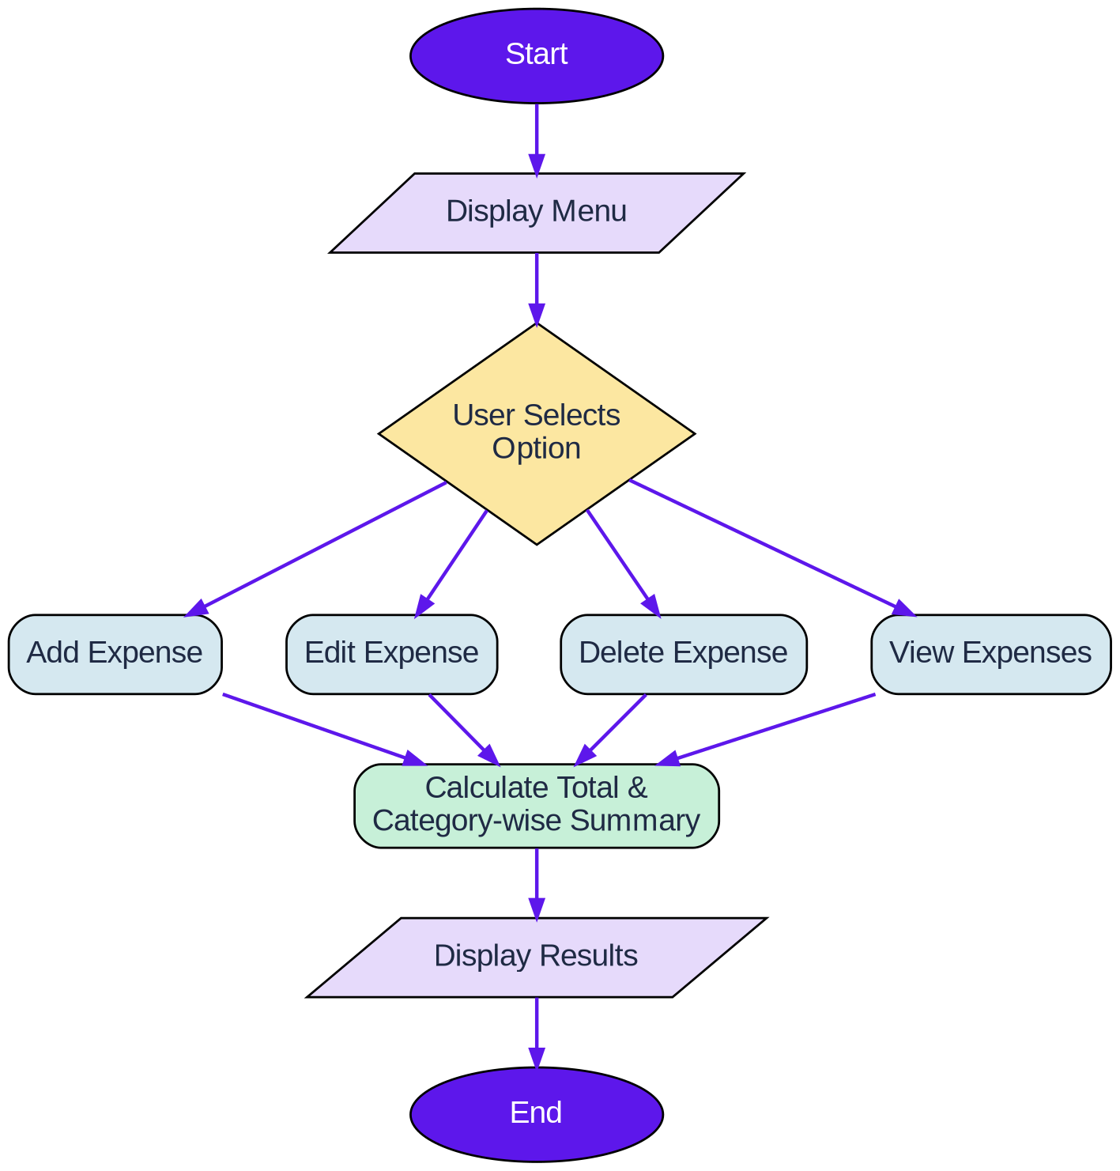

Class Diagram Class: Expense Variables:
- expenseId
- expenseName
- category
- amount

Methods:
- Constructor
- Getters and Setters
- displayExpense()

Class: ExpenseManager Variables:
- ArrayList<Expense> expenses

Methods:
- addExpense()
- editExpense()
- deleteExpense()
- viewExpenses()
- calculateTotal()
- categorySummary()

Implementation

Expense Class
This class represents a single expense. It stores details such as expense name, category, and amount. It also contains methods to display and manage expense data.

ExpenseManager Class
This class handles all operations of the system such as:
- Adding new expenses
- Editing existing expenses
- Deleting expenses
- Calculating total spending
- Generating category-wise summaries
The program uses the ArrayList data structure to store multiple expense objects and the Scanner class for user input.

Gantt Chart

Gantt Chart Table
Task No. | Task Name | Start Day | End Day | Duration
1 | Planning | Day 1 | Day 1 | 1 Day
2 | Requirement Analysis | Day 2 | Day 2 | 1 Day
3 | System Design | Day 3 | Day 4 | 2 Days
4 | Coding / Development | Day 5 | Day 7 | 3 Days
5 | Testing | Day 8 | Day 9 | 2 Days
6 | Documentation | Day 10 | Day 10 | 1 Day

- Simple Explanation
The Gantt Chart represents the timeline and planning of the project. It divides the project into different phases such as planning, design, development, testing, and documentation.
  - Planning phase includes deciding the project idea and structure.
  - Requirement Analysis involves understanding features like adding, deleting, and managing expenses.
  - System Design includes creating class diagrams and flow of the system.
  - Coding/Development is the main phase where the Java program is written.
  - Testing ensures the program works correctly without errors.
  - Documentation involves preparing the project report.
This structured timeline helps in completing the project efficiently and avoids last-minute issues.

Conclusion
The Expense Tracker Application successfully demonstrates the use of Java and Object-Oriented Programming concepts. It provides a simple and effective way to manage daily expenses and helps users improve their financial awareness.

References

Book Format:
Format:
[1] Author(s), Book Title, Edition. City: Publisher, Year.
Example:
[1] H. Schildt, Java: The Complete Reference, 11th ed. New York: McGraw-Hill, 2018.

Website
Format:
[3] Author (if any), "Title of page," Website Name. [Online]. Available: URL
Example:
[3] Oracle, "Java Documentation," Oracle. [Online]. Available: https://docs.oracle.com

Conference Paper Format:
[3] Author(s), "Paper title," in Proc. Conference Name, year, pp.

Example:
[3] S. Kumar, "AI in Education," in Proc. IEEE Conf. on AI, 2021, pp. 120-125.

Journal Article Format:
[4] Author(s), "Title of paper," Journal Name, vol., no., pp., year.

Example:
[4] A. Sharma and R. Gupta, "Machine Learning Techniques," International Journal of AI, vol. 5, no. 2, pp. 45-50, 2020.

