a. Experiment 1: Plot of Percentage Accuracy vs K should be shown for [KNN_Normal].

Also mention the best choice for the K and the corresponding confusion matrix.

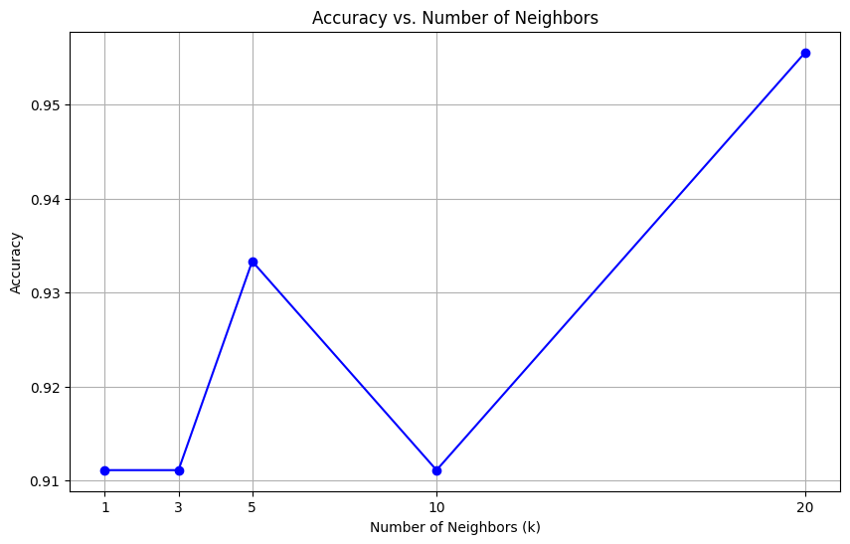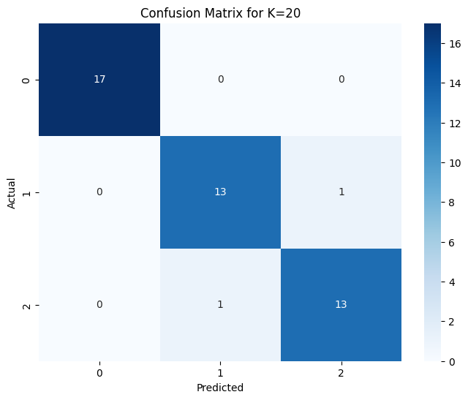

Best k=20

b. Experiment 2: Plot of Percentage Accuracy vs K should be shown for [KNN_Weighted].

Also mention the best choice for the K and the corresponding confusion matrix.

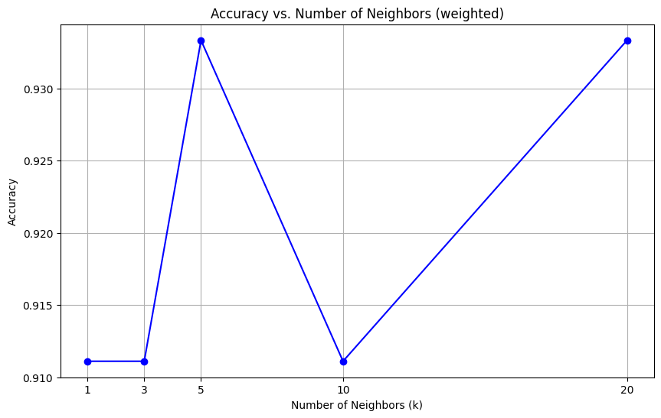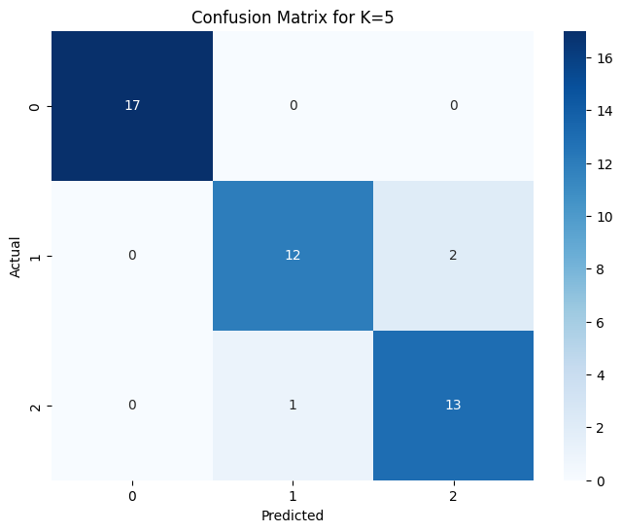

Best k = 5

c. Experiment 3: Report the performance with and without noise levels. Comment on the

robustness of [K-NN_Normal] and [KNN_Weighted] to noise in the training dataset.

Accuracy_normal: 0.956

Accuracy_weighted: 0.933

Accuracy_normal_noisy: 0.911

Accuracy_weighted_noisy: 0.889

accuracy difference normal: 4.49%

accuracy difference weighted: 4.40%

d. Experiment 4: Report the effect of curse of dimensionality in KNN_Normal based on points (a-e) as mentioned for the problem of Experiment 4.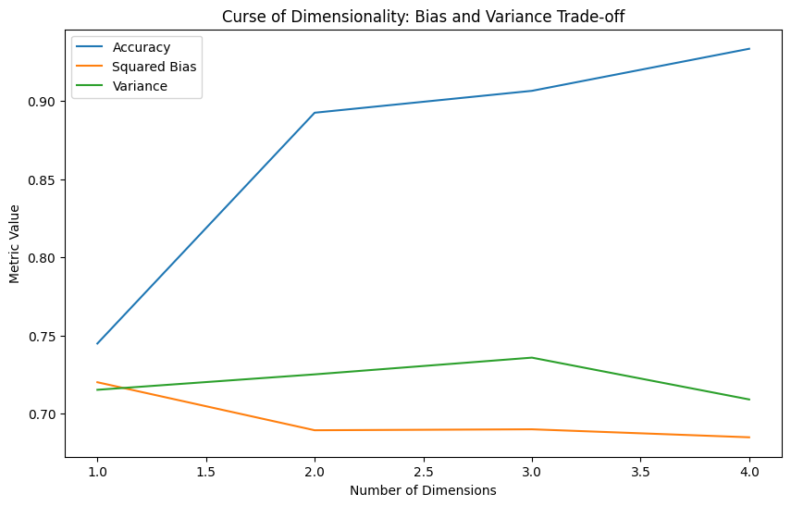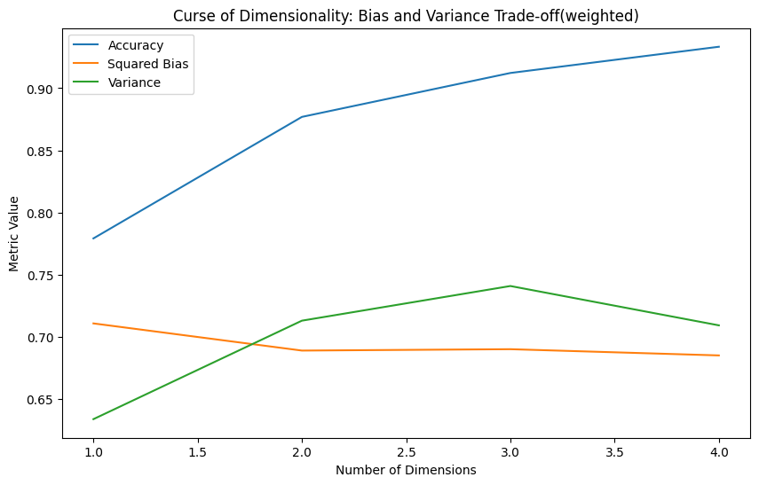-Abhay Sharma

-22CH10001