**Report**

1. Experiment 1: A table containing the first 8 rows to get an overview of the data.

|  |  |  |  |  |
| --- | --- | --- | --- | --- |
| OrderID | Product | Quantity | Price | Date |
| 1 | Product_A | 10 | 20.0 | 01-01-2023 |
| 2 | Product_B | 5 | 15.0 | 02-01-2023 |
| 3 | Product_A | 8 | 20.0 | 03-01-2023 |
| 4 | Product_C | 12 | 25.0 | 05-01-2023 |
| 5 | Product_B | 6 | 15.0 | 01-02-2023 |
| 6 | Product_A | 15 | 20.0 | 02-02-2023 |
| 7 | Product_C | 10 | 25.0 | 03-02-2023 |
| 8 | Product_A | 7 |  | 01-03-2023 |

b. Experiment 2: A table containing each group name and corresponding number of

missing values.

|  |  |
| --- | --- |
| OrderID | 0 |
| Product | 0 |
| Quantity | 0 |
| Price | 2 |
| Date | 0 |

c. Experiment 3: A line plot of the revenue trend over date. Proper labeling on the

plot should be there (X-label, Y-label, Title, and legend).

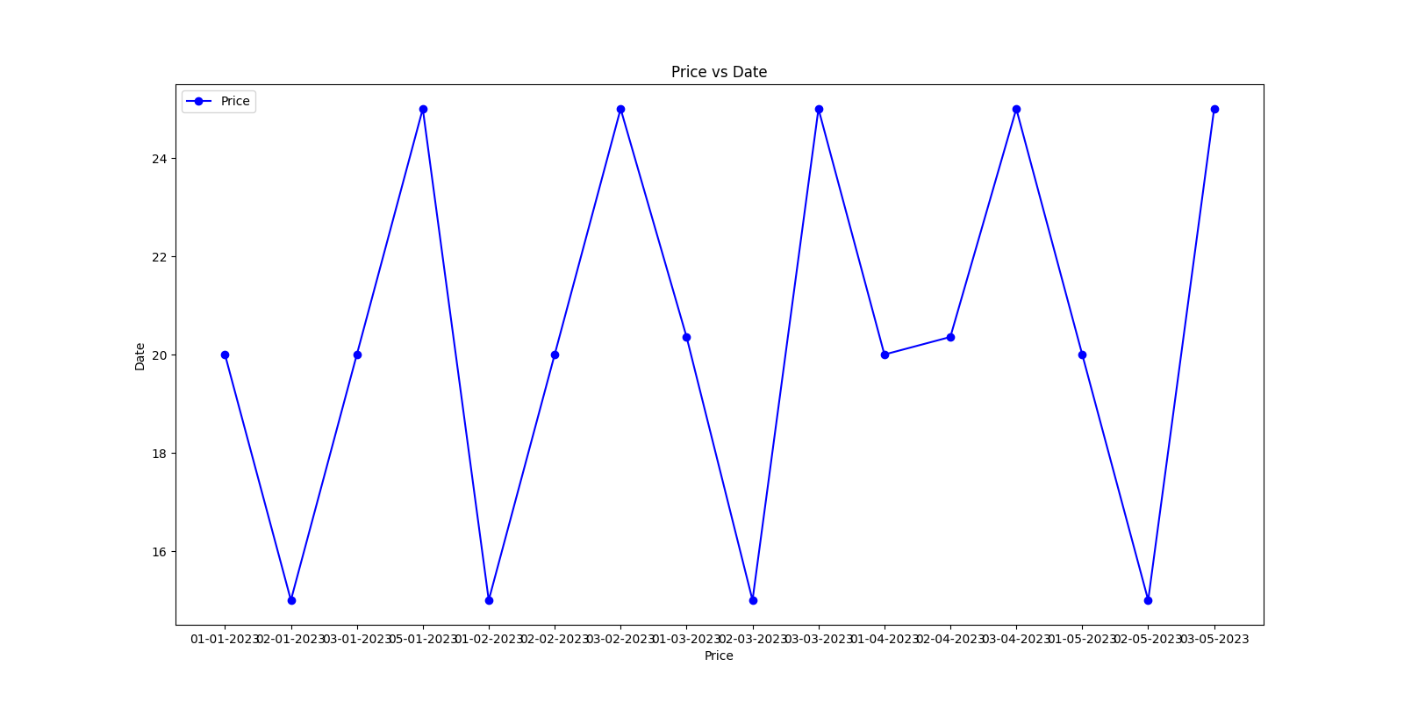

d. Experiment 4: Mention total number of orders and total revenue.

Total number of orders: 16

Total revenue generated from the sales: 3505.357142857143

e. Experiment 5: A table containing three individual products and corresponding

average price. A bar plot which plots the average price for each product. Mention

the most sold product.

|  |  |
| --- | --- |
| Product_A | 20.059524 |
| Product_B | 16.071429 |
| Product_C | 25.000000 |

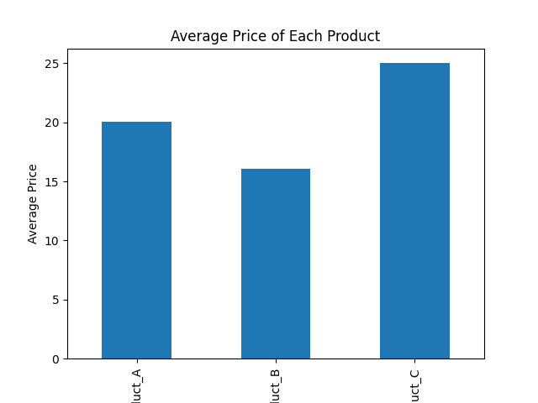

top sold product: Product_C: 74

Abhay Sharma

22CH10001