1. Experiment 1: A table containing the first 10 rows of dataset_altered.

|  |  |  |  |  |  |  |  |  |  |  |  |
| --- | --- | --- | --- | --- | --- | --- | --- | --- | --- | --- | --- |
| CRIM | ZN | INDUS | CHAS | NOX | RM | AGE | DIS | RAD | TAX | PTRATIO | MEDV |
| 0.00632 | 18.0 | 2.31 | 0.0 | 0.538 | 6.575 | 65.2 | 4.09 | 1.0 | 296.0 | 15.3 | 24.0 |
| 0.02731 | 0.0 | 7.07 | 0.0 | 0.469 | 6.421 | 78.9 | 4.9671 | 2.0 | 242.0 | 17.8 | 21.6 |
| 0.02729 | 0.0 | 7.07 | 0.0 | 0.469 | 7.185 | 61.1 | 4.9671 | 2.0 | 242.0 | 17.8 | 34.7 |
| 0.03237 | 0.0 | 2.18 | 0.0 | 0.458 | 6.998 | 45.8 | 6.0622 | 3.0 | 222.0 | 18.7 | 33.4 |
| 0.06905 | 0.0 | 2.18 | 0.0 | 0.458 | 7.147 | 54.2 | 6.0622 | 3.0 | 222.0 | 18.7 | 36.2 |
| 0.02985 | 0.0 | 2.18 | 0.0 | 0.458 | 6.43 | 58.7 | 6.0622 | 3.0 | 222.0 | 18.7 | 28.7 |
| 0.14455 | 12.5 | 7.87 | 0.0 | 0.524 | 6.172 | 96.1 | 5.9505 | 5.0 | 311.0 | 15.2 | 27.1 |
| 0.21124 | 12.5 | 7.87 | 0.0 | 0.524 | 5.631 | 100.0 | 6.0821 | 5.0 | 311.0 | 15.2 | 16.5 |
| 0.22489 | 12.5 | 7.87 | 0.0 | 0.524 | 6.377 | 94.3 | 6.3467 | 5.0 | 311.0 | 15.2 | 15.0 |
| 0.11747 | 12.5 | 7.87 | 0.0 | 0.524 | 6.009 | 82.9 | 6.2267 | 5.0 | 311.0 | 15.2 | 18.9 |

b. Experiment 2: Histograms of “NOX”, “RM” and “AGE” for dataset_altered; table

containing correlation coefficients; correlation matrix heatmap. State what all you

can infer from the correlation matrix.

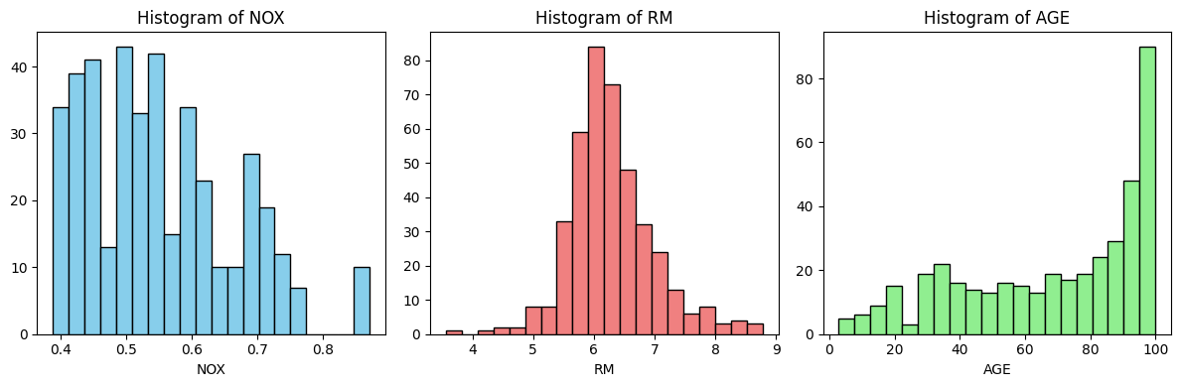

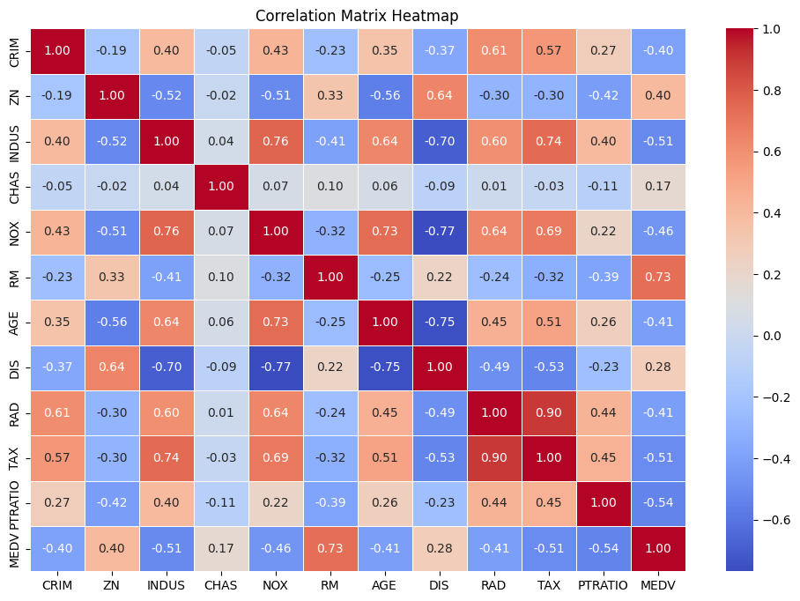

The correlation matrix shows the relation between features.

1. Experiment 3: Print the shape of individual data matrices.

Features Training Set: (370, 11)

Features Testing Set: (42, 11)

Target Training Set: (370,)

Target Testing Set: (42,)

d. Experiment 4: Values for coefficients and intercept; RMSE value of predicted

data with the testing data.

Coefficients: [-1.64988173e-01 3.73093490e-02 -9.87442617e-03 3.21391436e+00

-2.27553707e+01 6.16182106e+00 -4.96702692e-02 -1.48516544e+00

2.39856484e-01 -1.20609362e-02 -1.00154675e+00]

Intercept: 26.713825236556403

RMSE: 3.7846529574647403

e. Experiment 5: A bar plot of RMSEs vs learning rate. State the optimal learning

rate, and corresponding values for coefficients and intercept.

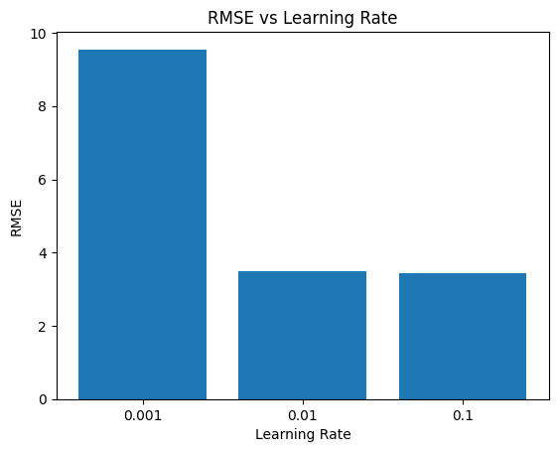

Optimal learning rate: 0.1

Optimal coefficients: [-1.55908907 0.8865506 -0.06988328 0.82174483 -2.53634841 4.35916899

-1.37712025 -3.05785509 2.09436154 -2.04512379 -2.13048576]

Optimal intercept: 22.47405405405404

RMSE: 3.443138526682574

-Abhay Sharma

-22CH10001