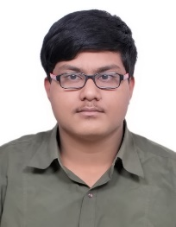

monu@abhaysv.co.in abhay_sanjay@srmuniv.edu.in 8447750105

SRM Innovation And Incubation Centre, 5th Floor, BEL Block, SRM Inst. Of Sci. & Tech. , KTR, TN - 603203

Abhay SV

Electronics & Communication Engnr. | Robotics & Automation Research | Product Dev.

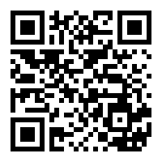 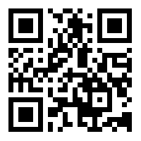  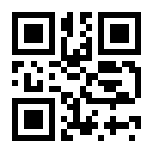 

|  |  |
| --- | --- |
| Academic Summary | * Pursuing B.Tech in E.C.E from SRM Inst. of Sci. and Tech. KTR, Chennai * CBSE, Class 12th pass out from K.V. RK Puram, Delhi with 70.4 % * CBSE, Class 10th pass out from K.V. RK Puram, Delhi with CGPA 9 |
| Areas of Work | * **SRM Robocon Team:** *Team Leader (2018-19):*   As the team leader handled core technical team, created a planner, set goals and priorities for Robocon 2018. The task also entailed recruiting of new talents from the college, identifying their skill sets and training requirements. Project execution involved identification of team responsibilities, delegation of tasks, and completion within the set deadlines, documentation and progress reviews for reporting to college administration, budgeting, taking tough questions from the administration, keeping the team motivated and going. |
| Skills | * Electronic circuit designing, prototyping, testing, debugging, wiring. * Proficient in EAGLE and Ki CAD EDA Tools. * Proficieint in C++ , PHP, JavaScript , Python , MATLAB and other programming Tools. * Technical sketching and concept developing. * Fabrication of circuit boards and mechanical parts for primary and sub systems. * Overall system integration and servicing. * Technical and End user training for designed systems. * Documentation and Technical manual developer. * Aesthetic & compact designing. |
| Experience | * Head of Systems and IT Operations at MHRD Innovation Cell - SRM Innovation and Incubation Center * Team Lead and Designer at Electronics division,Team Robocon. * System layout and integration sequence designer. * Fabricator and Supervision at Mechanical Division , Team Robocon. * Design and Development of Two stage Electro- Pneumatic Delta Style Robot. * Design and Development of avionics of Unirotor Flying System major project. * Design and Development of Non Combustible Chemical Thruster major project. * Design and Development of Linear Servo type remote CNC machine minor project. * Design and Development of Sensory Devices Multiutility project. * Design and Development of 2016 Carbon Fiber Hybrid Bot. * Design and Development of 2017 Al-Y-Drive Bot. * Design and Development of Robocon 2017 RBC Bot. * Design and Development of Robocon 2018 Autonomous Bot. * Design and Development of Robocon 2018 WiFi controlled Manual Bot. |
| Publications | * Research paper on “An Efficient Design Approach for Implementation of 2 Bit Ternary Flash ADC Using Optimized Complementary TFET Devices” IEEE Conference 2019 on VLSID. * Research paper on “Semiconductor Embedded PCB Manufacturing Technique” under review by IEEE. |
| Ongoing Works | * Universal heavy duty motion controller for all Rotary and Linear Motors. * Plug n Play devices for home appliance and peripheral automation. |