VISVESVARAYA TECHNOLOGICAL UNIVERSITY
“Jnana Sangama”, Belgaum -590014, Karnataka.



Full Stack Web Development Report
On

“DAILY JOBS”

Submitted by

ABHAY V PAWAR (1BM25CS401)

ABHILASH Y N (1BM25CS402)

ABHISHEK S V (1BM25CS406)

Under the Guidance of
Prof.Anita Harish Kenchannavar
Assistant Professor
Department of CSE

in partial fulfillment for the award of the degree of
BACHELOR OF ENGINEERING
in
COMPUTER SCIENCE AND ENGINEERING



B.M.S. COLLEGE OF ENGINEERING
(Autonomous Institution under VTU)
BENGALURU-560019
Sep 2025 – Jan 2026
B. M. S. College of Engineering,
Bull Temple Road, Bangalore 560019
(Affiliated to Visvesvaraya Technological University, Belgaum) Department of Computer Science and Engineering

CERTIFICATE
This is to certify that the project work entitled “Daily Jobs” carried out by ABHAY V PAWAR (1BM25CS401),ABHILASH Y N (1BM25CS402),ABHISHEK S V
(1BM25CS406) who are bonafide students of B. M. S. College of Engineering. It is in partial fulfillment for the award of Bachelor of Engineering in Computer Science and Engineering of the Visveswaraya Technological University, Belgaum during the year 2025-2026. The project report has been approved as it satisfies the academic requirements in respect of Full Stack Web Development (23CS3AEFWD) work prescribed for the said degree.

Signature of the Guide Signature of the HOD

Prof. Anita Harish Kenchannavar Dr. Kavitha Sooda
Assistant Professor
Department of CSE Prof & Head of Dept of CSE
BMSCE, Bengaluru BMSCE, Bengaluru

External Viva
Name of the Examiner Signature with date
1)
2)

B.M.S. COLLEGE OF ENGINEERING DEPARTMENT OF COMPUTER SCIENCE AND ENGINEERING



DECALARATION

We, ABHAY V PAWAR (1BM25CS401), ABHILASH Y N (1BM25CS402), ABHISHEK S V (1BM25CS406) students of 3rd Semester, B.E, Department of Computer Science and Engineering, BMS College of Engineering, Bangalore, hereby declare that, this Full Stack Web Development entitled "Daily Jobs" has been carried out by us under the guidance of Anita Harish Kenchannavar, Assistant Professor, Department of CSE, BMS College of Engineering, Bangalore during the academic semester Sep 2025 - Dec 2026. We also declare that to the best of our knowledge and belief, the development reported here is not from part of any other report by any other students.

Signature

ABHAY V PAWAR (1BM25CS401)
ABHILASH Y N (1BM25CS402)
ABHISHEK S V (1BM25CS406)

TABLE OF CONTENTS

Serial No. | TITLE | PAGE NO.
1 | Introduction | 1
1.1 | Overview | 1
1.2 | Motivation | 1
2 | Software Requirement Specification | 2
2.1 | Hardware Requirements | 2
2.2 | Software Requirements | 2
3 | ER diagram of the project | 3
4 | Schema of project | 4
5 | User Interface Design | 5-9
6 | Back End Design | 10-11
7 | Conclusion and Future work | 12
8 | References | 13

INTRODUCTION
1.1 Overview
- The rapid digitalization of service-based platforms has increased the demand for efficient systems to manage skilled daily wage employment.
- Traditional methods of hiring daily wage workers are largely unorganized and rely on manual searches, which leads to inefficiencies such as limited worker availability, lack of verified profiles, and absence of transparent pricing.
- The Daily Jobs project is a full-stack web application designed to provide a centralized platform for connecting customers with skilled daily wage workers including electricians, plumbers, cleaners, carpenters, drivers, and domestic helpers.
- The system follows a client–server architecture, where the frontend handles user interaction and the backend manages business logic, authentication, data processing, and database operations.
- DailyJobs enables customers to search and filter workers based on category, location, availability, and ratings, while workers can register, manage profiles, receive booking requests, and track job history and earnings.
1.2 Motivation

- The lack of a structured digital system for daily wage employment creates difficulties for customers in finding reliable workers and limits job opportunities for workers.
- Existing hiring methods do not provide real-time availability, service quality assurance, or performance tracking.
- There is a strong need for a scalable and secure platform that supports worker discovery, booking management, communication, and review systems.
- The motivation behind the Daily Jobs project is to apply modern web technologies to solve real-world employment challenges in an efficient and user-centric manner.

SOFTWARE REQUIREMENTS
2.1 Hardware Requirements:
A PC with the following or greater specifications:
- Intel Core i3 or higher
- 8 GB RAM
- 500 GB Hard Drive
- Stable Internet connection (2 Mbps or higher)
- Standard input/output devices (Keyboard, Mouse, Monitor)

2.2 Software Requirements
    - Operating System : Windows / Linux / macOS
    - Front End Technologies : HTML, CSS, JavaScript, React.js
    - Back End Technologies : Node.js, Express.js
    - Database : MongoDB
    - IDE : Visual Studio Code
    - Server Environment : Node.js Runtime
    - Web Browser : Google Chrome / Mozilla Firefox

3.ER diagram of the project

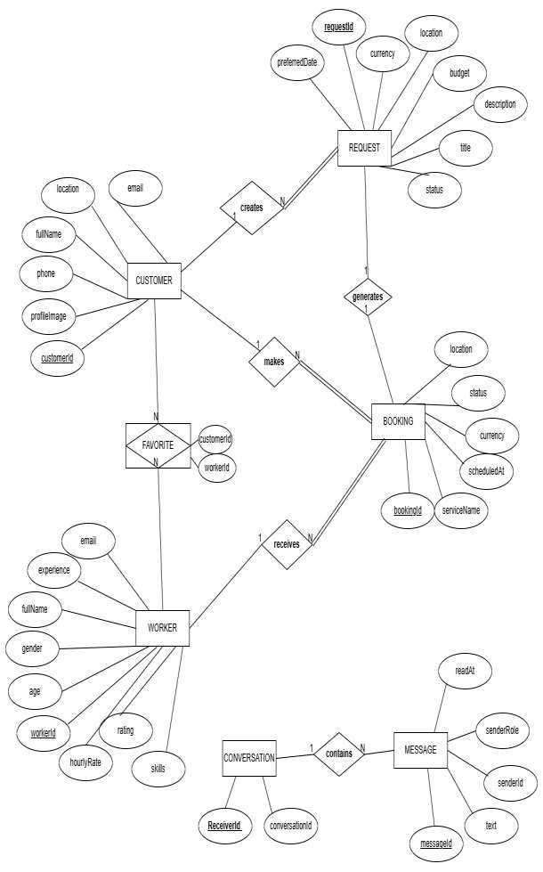

SCHEMA OF THE PROJECT
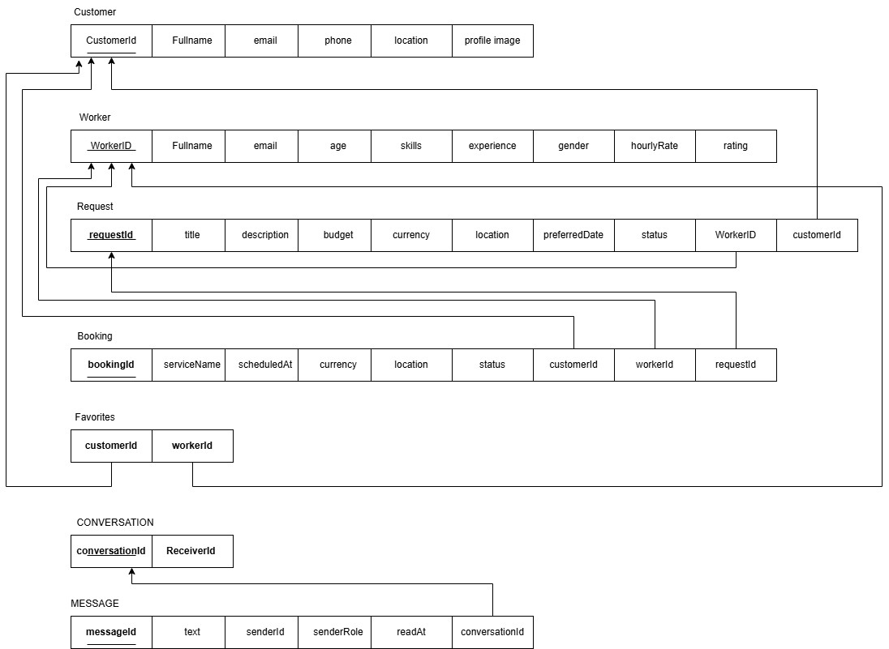

USER INTERFACE DESIGN

Figure 5.1: Home Page of Daily Jobs
This page acts as the entry point of the application. It allows users to navigate to search, registration, and login functionalities.
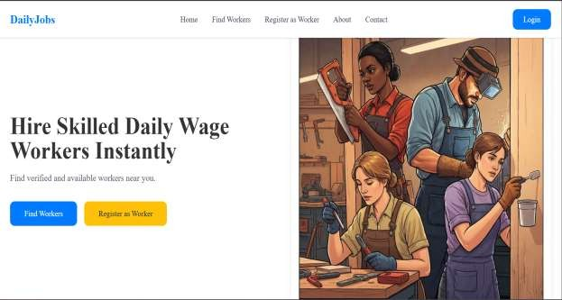

Figure 5.2: Customer Login Page
This page allows registered customers to log in securely using their credentials.
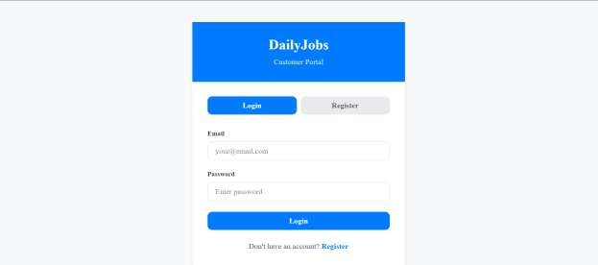

Figure 5.3: Customer Dashboard
The customer dashboard provides an overview of bookings, messages, and favourite workers.
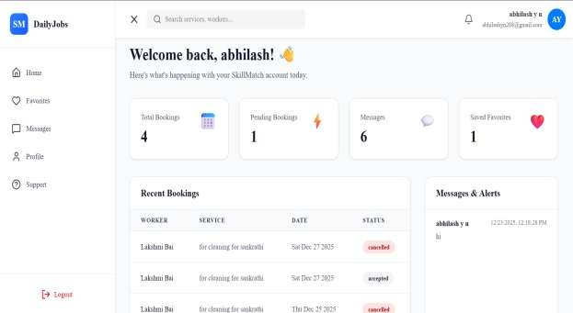

Figure 5.4: Worker Search Page

This page allows customers to search and filter workers based on service category and availability.
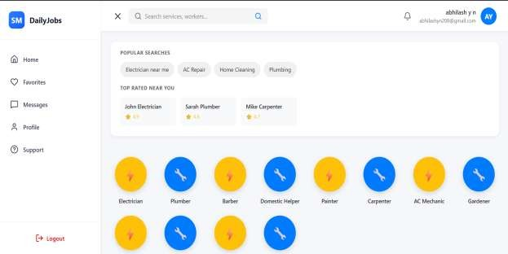
Figure 5.5: Worker Profile Page
This page displays detailed information about a worker, helping customers make informed hiring decisions.
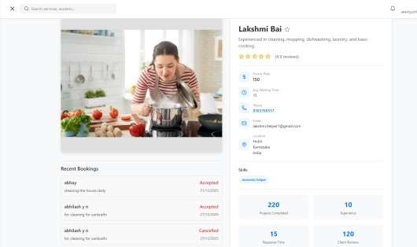

Figure 5.6: Booking Page

This page enables customers to book a worker by selecting date and location.
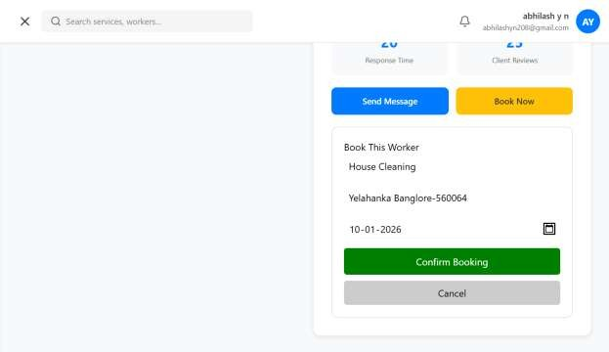

Figure 5.7: Messaging Interface
The messaging page allows real-time communication between customers and workers.

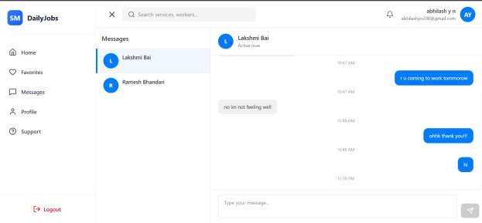

Figure 5.8: Worker Login Page
This page enables registered workers to log in securely using their credentials.



Figure 5.9: Worker Dashboard
This dashboard allows workers to manage bookings, track earnings, and view job status.

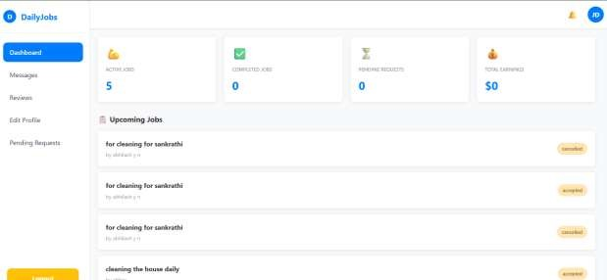

Figure 5.10: Worker Reviews Page
This page displays customer feedback and ratings, improving trust and transparency.

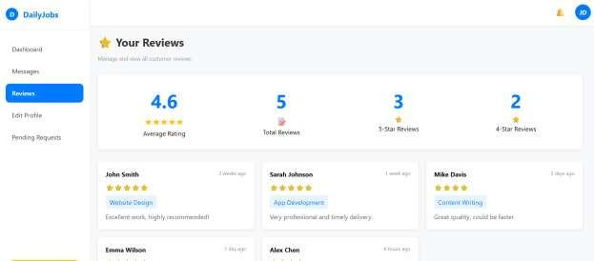

BACK END DESIGN

Figure 6.1: Backend Project Structure

This figure shows the organized backend project structure used to manage routes, controllers, models, and middleware in the Daily Jobs application.
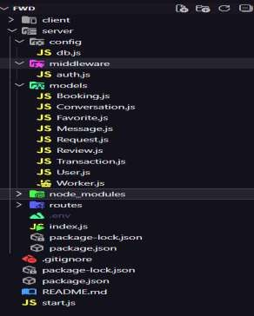

Figure 6.2: Server Configuration File

This file initializes the Express server, configures middleware, and defines the application entry point.
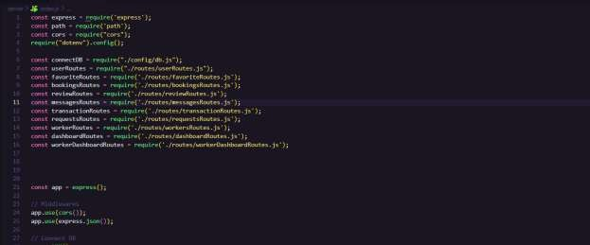

Figure 6.3: User Registration and Login API
This figure shows the backend APIs for user registration and login in the Daily Jobs application using secure authentication mechanisms.
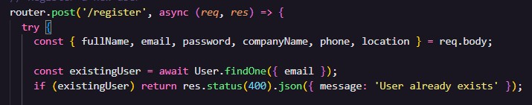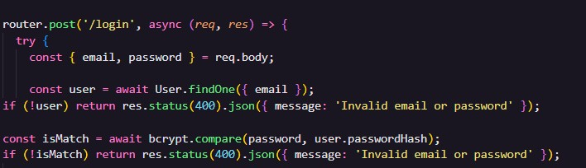

Figure 6.4: Worker Registration and Profile Management API

This figure shows the backend API used for worker registration and profile management in the Daily Jobs application.

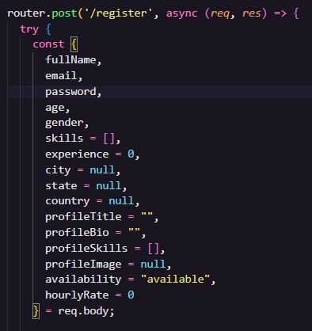

CONCLUSION AND FUTURE WORK

Conclusion
The Daily Jobs project has successfully developed a digital platform that connects skilled daily wage workers with customers efficiently and reliably. By digitizing the hiring process, the platform reduces the traditional challenges of manual hiring, such as time consuming searches, unclear pricing, and lack of accountability. Workers can create profiles highlighting their skills, experience, and availability, while customers can make informed decisions using ratings and reviews.
The platform promotes transparency and trust, ensuring fair treatment for workers and a reliable service experience for customers. Additionally, it provides workers with better access to job opportunities and a chance for consistent income, contributing to their financial stability. Overall, Daily Jobs demonstrates the potential of technology in improving the daily labour market and enhancing the employment ecosystem.
Future Work
- Future enhancements can make the platform even more useful: Mobile Application Development: Creating Android and iOS apps will make the platform more accessible, allowing users to hire or get hired anytime, anywhere.
- GPS-Based Worker Tracking: Real-time location tracking will improve task management, punctuality, and accountability.
- Online Payment Integration: Secure digital payment systems will simplify transactions, reduce cash dependency, and ensure timely wage payments.
- AI-Based Worker Recommendations: Intelligent suggestions based on skills, ratings, and job history can help match the best worker to each task.
- Multi-Language Support: Supporting multiple languages will make the platform accessible to a wider audience and encourage adoption across different regions.
- Enhanced Feedback System: Detailed ratings on skills, professionalism, and punctuality can help maintain high service quality.

REFERENCES

HTML and CSS Documentation.
https://developer.mozilla.org/en-US/
JavaScript Documentation. https://developer.mozilla.org/en-US/docs/Web/JavaScript
Node.js Documentation.
https://nodejs.org/docs/latest/api/ Express.js Official Documentation.
https://expressjs.com/
MongoDB Documentation.
https://www.mongodb.com/docs/ MongoDB Atlas Documentation.
https://www.mongodb.com/products/platform/atlas-database
React Documentation.
https://react.dev/learn
Database Design and ER Modelling Concepts.
https://docs.oracle.com/en/ Online Diagramming Tool. https://www.drawio.com/
Infosys Springboard.
https://infyspringboard.onwingspan.com/web/en/app/toc/lex_auth_013951019900878848219_shared/overview

