1.Agent wise ticket count:-

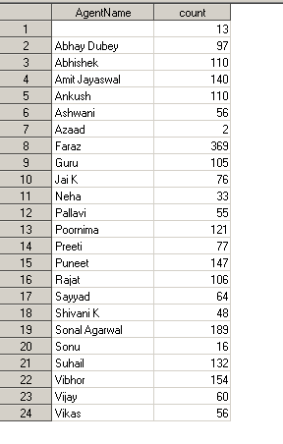

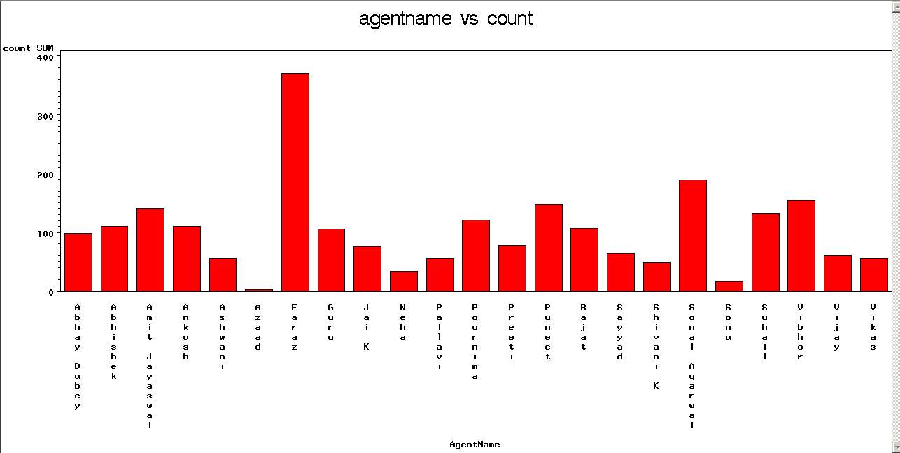

OR

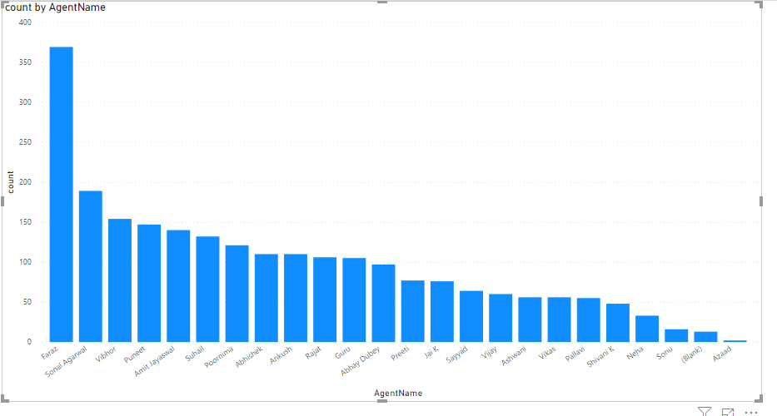

OR

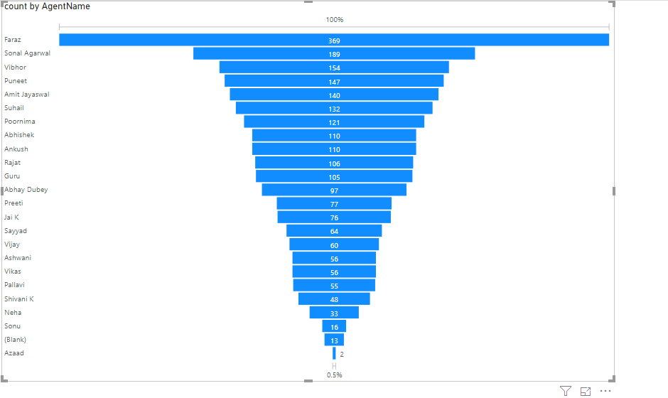

2.Agent / status wise (closed/pending/client end pending) report with count:-

Through this we can track if any older issue is pending agentwise.

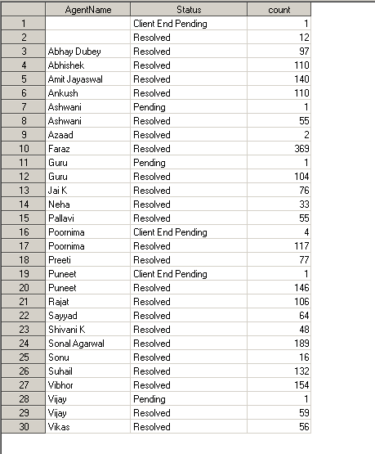

3.Agentwise /categorywise/ count report:-

|  |  |  |
| --- | --- | --- |
| AgentName | Category | count |
|  |  | 13 |
| Abhay Dubey | Customer Query External | 96 |
| Abhay Dubey | Marketplace External | 1 |
| Abhishek | Customer Query External | 85 |
| Abhishek | Marketplace External | 10 |
| Abhishek | Product Defects Internal | 13 |
| Abhishek | Transporter External | 2 |
| Amit Jayaswal | Customer Query External | 33 |
| Amit Jayaswal | Marketplace External | 75 |
| Amit Jayaswal | Non actionable/Auto-Emails | 3 |
| Amit Jayaswal | Product Defects Internal | 29 |
| Ankush | Customer Query External | 44 |
| Ankush | Marketplace External | 13 |
| Ankush | Non actionable/Auto-Emails | 9 |
| Ankush | Product Defects Internal | 43 |
| Ankush | Transporter External | 1 |
| Ashwani | Customer Query External | 22 |
| Ashwani | Marketplace External | 9 |
| Ashwani | Product Defects Internal | 22 |
| Ashwani | Transporter External | 3 |
| Azaad | Customer Query External | 1 |
| Azaad | Product Defects Internal | 1 |
| Faraz | Customer Query External | 289 |
| Faraz | Non actionable/Auto-Emails | 79 |
| Faraz | Product Defects Internal | 1 |
| Guru | Customer Query External | 70 |
| Guru | Marketplace External | 1 |
| Guru | Product Defects Internal | 33 |
| Guru | Transporter External | 1 |
| Jai K | Customer Query External | 48 |
| Jai K | Marketplace External | 1 |
| Jai K | Product Defects Internal | 27 |
| Neha | Customer Query External | 6 |
| Neha | Marketplace External | 7 |
| Neha | Product Defects Internal | 20 |
| Pallavi | Customer Query External | 26 |
| Pallavi | Marketplace External | 6 |
| Pallavi | Product Defects Internal | 23 |
| Poornima | Customer Query External | 91 |
| Poornima | Marketplace External | 13 |
| Poornima | Non actionable/Auto-Emails | 5 |
| Poornima | Product Defects Internal | 10 |
| Poornima | Transporter External | 2 |
| Preeti | Customer Query External | 59 |
| Preeti | Marketplace External | 6 |
| Preeti | Product Defects Internal | 12 |
| Puneet | Customer Query External | 135 |
| Puneet | Product Defects Internal | 12 |
| Rajat | Customer Query External | 70 |
| Rajat | Marketplace External | 11 |
| Rajat | Non actionable/Auto-Emails | 2 |
| Rajat | Product Defects Internal | 23 |
| Sayyad | Customer Query External | 50 |
| Sayyad | Marketplace External | 5 |
| Sayyad | Product Defects Internal | 9 |
| Shivani K | Customer Query External | 47 |
| Shivani K | Marketplace External | 1 |
| Sonal Agarwal | Customer Query External | 115 |
| Sonal Agarwal | Marketplace External | 34 |
| Sonal Agarwal | Non actionable/Auto-Emails | 1 |
| Sonal Agarwal | Product Defects Internal | 37 |
| Sonal Agarwal | Transporter External | 2 |
| Sonu | Customer Query External | 5 |
| Sonu | Product Defects Internal | 11 |
| Suhail | Customer Query External | 115 |
| Suhail | Marketplace External | 9 |
| Suhail | Non actionable/Auto-Emails | 1 |
| Suhail | Product Defects Internal | 1 |
| Suhail | Transporter External | 6 |
| Vibhor | Customer Query External | 152 |
| Vibhor | Marketplace External | 2 |
| Vijay | Customer Query External | 28 |
| Vijay | Marketplace External | 26 |
| Vijay | Product Defects Internal | 4 |
| Vijay | Transporter External | 2 |
| Vikas | Customer Query External | 16 |
| Vikas | Product Defects Internal | 40 |

4.category wise/ count:-

This will help us to identify category wise count.

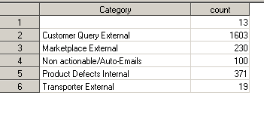

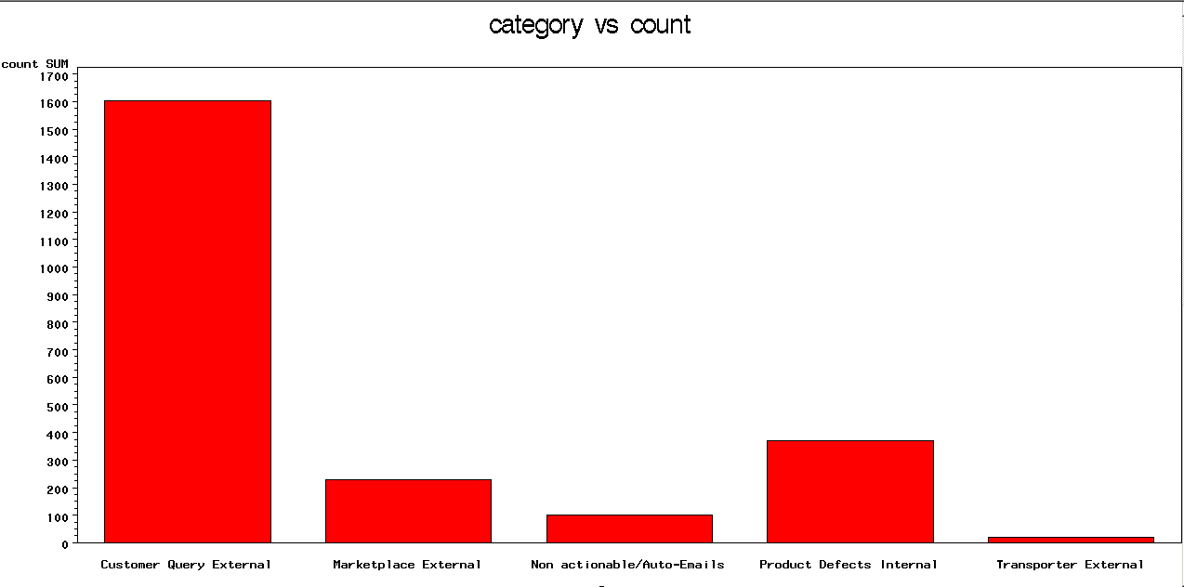

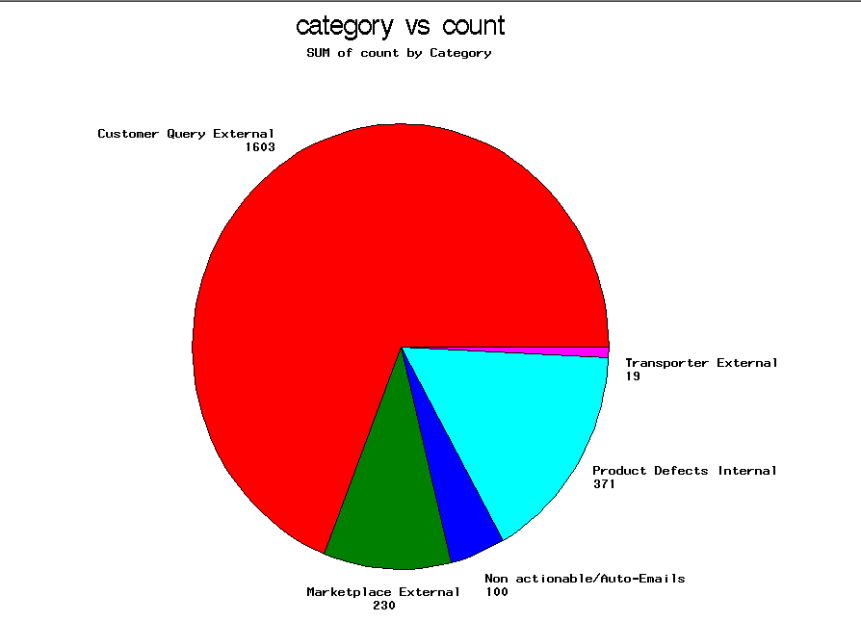

We can also represent it in power BI better than this.

Here we can see the pattern that maximum ticket is coming under “customer query external” ,so we can work on our training process to reduce such issues which will minimize out ticket count.

5.companywise/ count of tickets:-

|  |  |
| --- | --- |
| CompanyName | count |
|  | 10 |
| ART&TREND | 21 |
| AVG_Global | 4 |
| BMSWellness | 1 |
| Bantom(RB) | 14 |
| Bata | 5 |
| Bluedart | 46 |
| Clik2buy | 14 |
| Cogentscs | 5 |
| DTDC | 114 |
| DecorKart | 8 |
| DivyaTax | 1 |
| ECOM | 29 |
| Eagle | 6 |
| Extra Mails | 1 |
| Fashor | 10 |
| Fizzy Goblet | 24 |
| GHC | 9 |
| GiniandJony | 1 |
| HOB | 1 |
| Happily Unmarried | 19 |
| Hasmukh Agency | 26 |
| Heathly18 | 27 |
| Herbalhills | 1 |
| Holistique | 23 |
| IB | 34 |
| INTOW | 9 |
| Iksula | 29 |
| JPC | 10 |
| Jaypore | 31 |
| Kheelkood | 2 |
| LFLogistic | 2 |
| Lockthedeal | 23 |
| MASHOLDINGS | 40 |
| Norquest | 3 |
| NykaaFashion | 72 |
| OnlineBechoo | 46 |
| Paragon | 34 |
| Planetsuperhero | 14 |
| RSBROTHER | 1 |
| RagUnited | 2 |
| Red_Direct | 2 |
| Redtape | 13 |
| SMRETAIL | 8 |
| SPOYL | 8 |
| Sangam_Lifestyle | 1 |
| Scarters | 6 |
| Sreenidhi | 34 |
| Teabox | 11 |
| Texet | 17 |
| TheMenCompany | 8 |
| Urbonretail | 11 |
| VLCC | 20 |
| Valueretail | 16 |
| Vestige | 50 |
| Vinculum_Internal | 11 |
| Viraj | 76 |
| Yusen | 4 |
| Zee | 74 |
| Zipped | 11 |
| bagzone | 22 |
| bksmotors | 9 |
| bodyshop | 42 |
| bombino | 1 |
| dentalkart | 27 |
| desiredesire | 1 |
| eChindia-Hari | 6 |
| ellementry | 16 |
| fabindia | 49 |
| ficosa | 12 |
| firststepprojects | 3 |
| fmlogistics | 5 |
| gourmetdelight | 1 |
| henryandsmith | 5 |
| holisol | 11 |
| iconic | 2 |
| intraglobe | 7 |
| janio | 21 |
| jewelmaze | 9 |
| lenova | 54 |
| nykaa.com | 464 |
| onefriday | 1 |
| onpoint | 14 |
| ottomate | 82 |
| padmawati | 19 |
| pbglobal | 13 |
| peesafe | 23 |
| quickshift | 10 |
| radicura | 18 |
| rarerabbit | 14 |
| repro | 42 |
| ritukumar | 12 |
| seniority | 53 |
| smytten | 11 |
| soch | 12 |
| superbottoms | 26 |
| tirupati_Olyampia | 47 |
| vajor | 14 |
| xlretail | 5 |
|  |  |

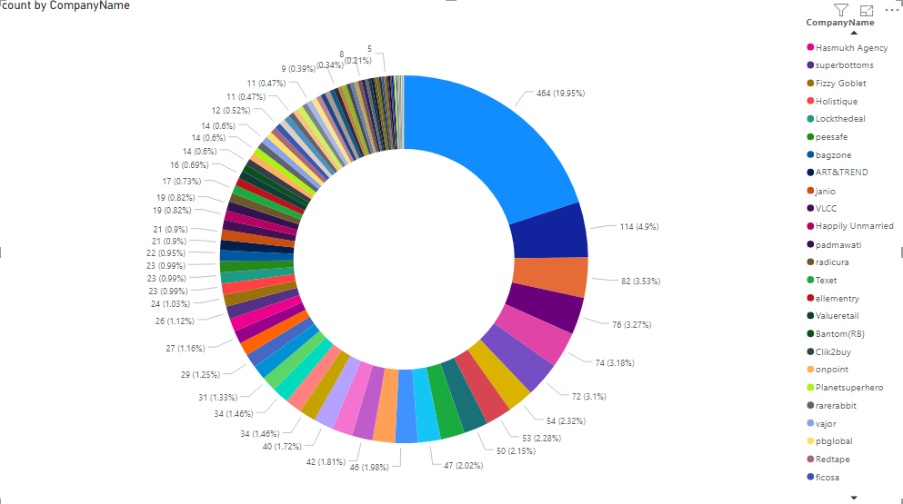

OR

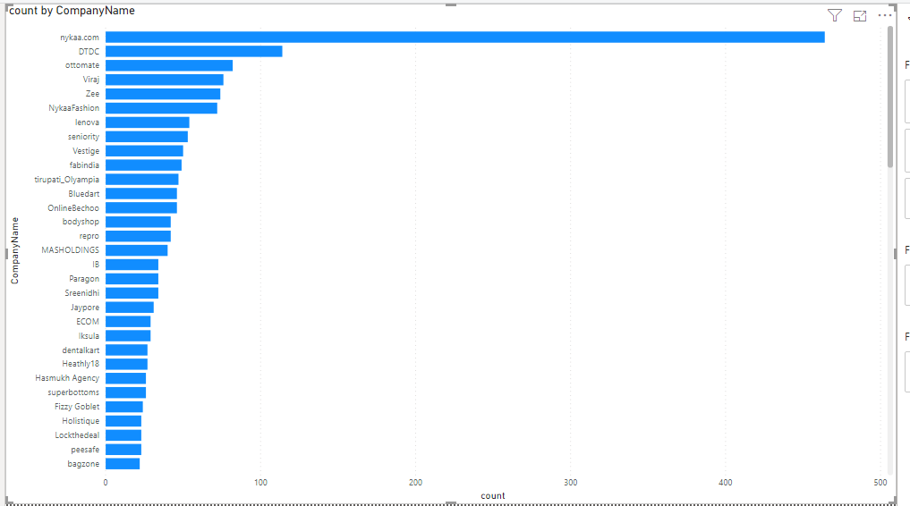

**Dashboard will help us to understand the pattern of tickets, because through report in Excel it will be difficult to visualize.**

we can do a lot more than this .

**I can also try to predict the future pattern of tickets (by using previous data) if you will provide me the dependent and independent variable parameters .(Through linear regression concept).**

Kindly share the feedback .

Thanks !!