**LIST OF SYMBOLS / ABBREVIATIONS USED**

**CRUD:** Create, Read, Update, Delete

**API**: Application Programming Interface

**JWT:** JSON Web Token

**UI:** User Interface

**UX**: User Experience

**DB:** Database

**LIST OF FIGURES**

| **Figure** | **Page No.** |
| --- | --- |
| **Figure 2.1: Blog Posting Application Architecture** | **9** |
| **Figure 3.1: Task Management Tool Architecture** | **9** |

**CHAPTER 1 : INTRODUCTION**

**1.1 Overview of Internship**

This report outlines the work undertaken during my internship at CodSoft, where I developed two projects as part of the MERN (MongoDB, Express, React, Node.js) stack: a blog posting application and a task management tool. The primary goal of this internship was to gain hands-on experience with full-stack development and understand the complete project lifecycle from planning to deployment.

**1.2 Objectives**

* To develop functional, user-friendly web applications.
* To implement and understand the MERN stack architecture.
* To enhance my skills in backend development using Express and Mongoose.
* To learn about project management and agile methodologies**.**

**1.3 Scope of the Internship**

The scope included requirement analysis, designing the architecture, coding, testing, and deploying the applications. Special emphasis was placed on implementing efficient code, error handling, and security measures in both projects.

**CHAPTER 2: PROJECT 1 – BLOG POSTING APPLICATION**

**2.1 Overview**

The Blog Posting Application is a web-based platform that allows users to create, edit, and manage blog posts. It is designed to enable smooth and interactive user experiences while handling content effectively.

**2.2 Technology Stack**

* **Frontend:** React.js, HTML, CSS, Tailwind
* **Backend**: Express.js, Node.js
* **Database:** MongoDB
* **Others**: RESTful APIs, JWT for authentication

**2.3 Features**

* **User Authentication:** Secure signup and login using JWT.
* **CRUD Operations**: Allows users to create, read, update, and delete blog posts.
* **Comments and Likes**: Users can engage with posts through comments and likes.
* **Admin Panel**: Special access for administrators to manage content and users**.**

**2.4 Project Development**

The development followed an agile methodology with iterative improvements. The architecture was divided into three main layers: frontend (React), backend (Node.js/Express), and database (MongoDB). RESTful APIs were used to communicate between the frontend and backend.

* **Frontend Development:** Implemented using React components for a dynamic and responsive UI.
* **Backend Development:** Developed APIs for handling user authentication, blog management, and data retrieval using Express.js.
* **Database Management**: MongoDB was used for data storage, providing scalability and flexibility for handling JSON-like documents**.**

**2.5 Challenges and Solutions**

* **Challenge**: Handling authentication and secure data access.  
  Solution: Implemented JWT-based authentication to ensure secure user sessions.
* **Challenge:** Managing state across various components. **Solution:** Used React's Context API and hooks for effective state management.

**2.6 Testing and Deployment**

* Conducted unit and integration tests using Thunder-Client and Postman.
* Deployed the application on Render with MongoDB Atlas as the database service.

**CHAPTER 3: PROJECT 2 – TASK MANAGEMENT TOOL**

**3.1 Overview**

The Task Management Tool is designed to help users manage tasks, track progress, and organize work effectively. It offers user roles, task assignment, and real-time updates.

**3.2 Technology Stack**

* **Frontend:** React.js, Redux, Bootstrap
* **Backend:** Node.js, Express.js
* **Database**: MongoDB
* **Others:** RESTful APIs, JWT for authentication

**3.3 Features**

* **Task Creation and Assignment:** Users can create tasks and assign them to others**.**
* **Progress Tracking:** Status updates and progress bars to monitor task completion.
* **User Roles and Permissions:** Admins and users have different levels of access.
* **Notifications:** Alerts and reminders .

**3.4 Project Development**

The tool was developed using a component-based approach, with a focus on clean and modular code.

* **Frontend Development**: React and Redux were used to manage state and provide a seamless user experience.
* **Backend Development:** Built RESTful APIs for task management, role handling, and notifications.
* **Database Management**: Used MongoDB for its flexible schema design, allowing easy changes to data models as features expanded**.**

**3.5 Challenges and Solutions**

* **Challenge:** Implementing real-time updates for task status.  
  Solution: Integrated WebSocket for real-time notifications and updates.
* **Challenge:** Managing complex state with multiple components**.  
  Solution**: Employed Redux for state management to ensure a scalable and maintainable codebase.

**3.6 Testing and Deployment**

* Testing was done using Thunder-client and Post-man for end-to-end testing.
* Deployed using Render for the frontend and the backend, ensuring reliable performance.

**CHAPTER 4: TECHNICAL CHALLENGES AND SOLUTIONS**

During the development of both projects, several technical challenges were faced, including API integration, database optimization, and frontend responsiveness. Detailed analysis and step-by-step solutions to these challenges were documented to enhance future development processes.

**CHAPTER 5: LEARNINGS AND IMPROVEMENTS**

The internship provided significant learning opportunities, including:

* Enhanced understanding of full-stack development and agile methodologies.
* Improved debugging skills, especially in managing state and handling backend errors.
* Learned best practices in authentication, data validation, and error handling.

**CHAPTER 6: CONCLUSION**

The internship at CodSoft was a highly rewarding experience that allowed me to apply theoretical knowledge to practical problems. By developing two complete web applications, I gained valuable insights into the complexities of full-stack development. This experience has equipped me with the skills and confidence needed to tackle future challenges in the field of software development**.**

**REFERENCES**

1. **Smith, J.,** "Building Scalable Web Applications," Journal of Web Development, Vol. 12, pp. 45-67, 2023.
2. **Doe,** A. and Lee, R., "MERN Stack Essentials," Software Engineering Review, Vol. 8, pp. 101-115, 2022.
3. **Johnson et al., "**React Best Practices," Frontend Developer Journal, Vol. 6, pp. 89-102, 2021.

**APPENDICES**

**Appendix I: Project Screenshots**

**First project Second Project**

Project link: https://codsoft-myblog-app1-0.onrender.com

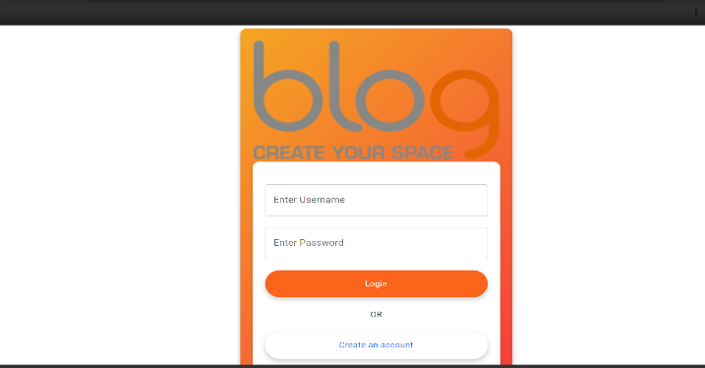 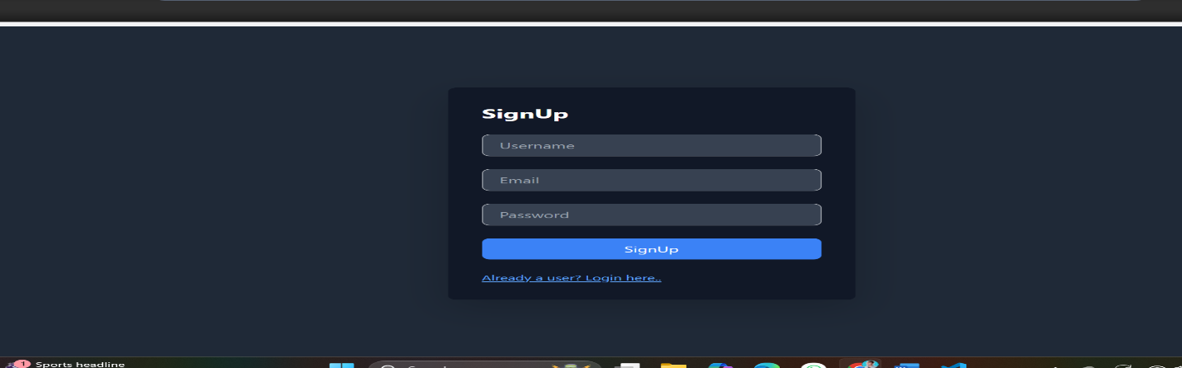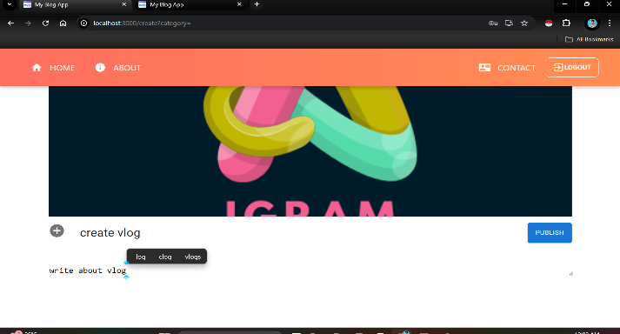 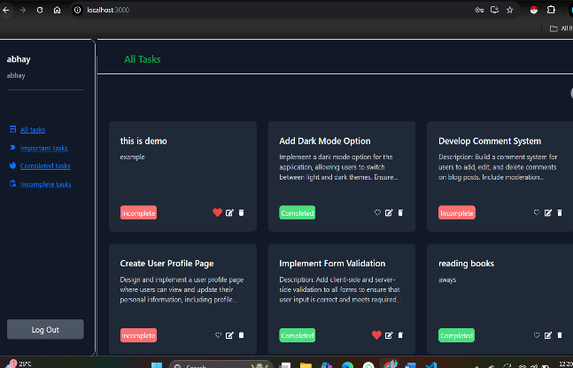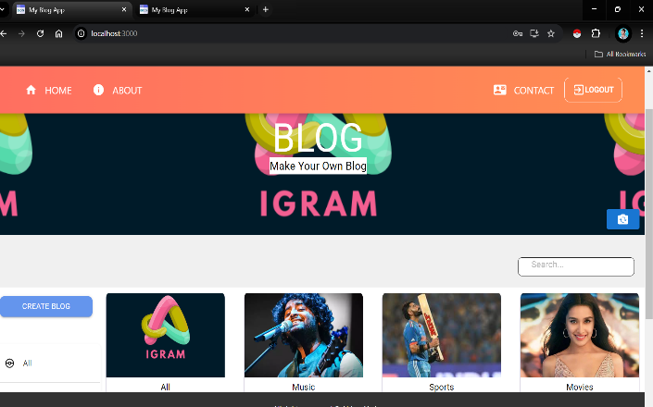 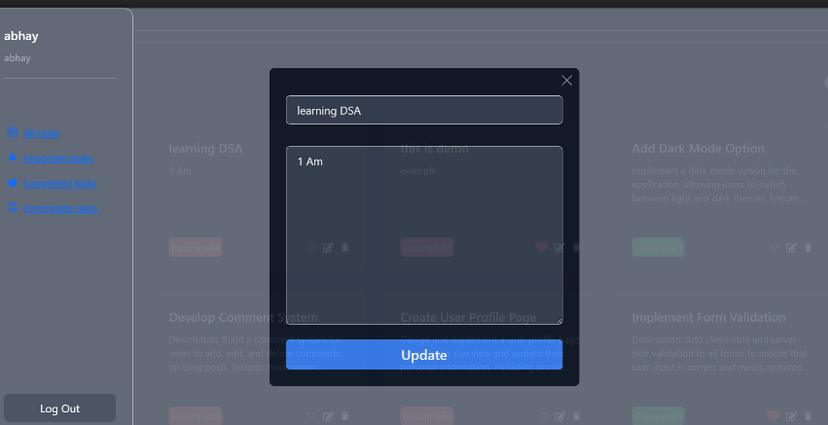

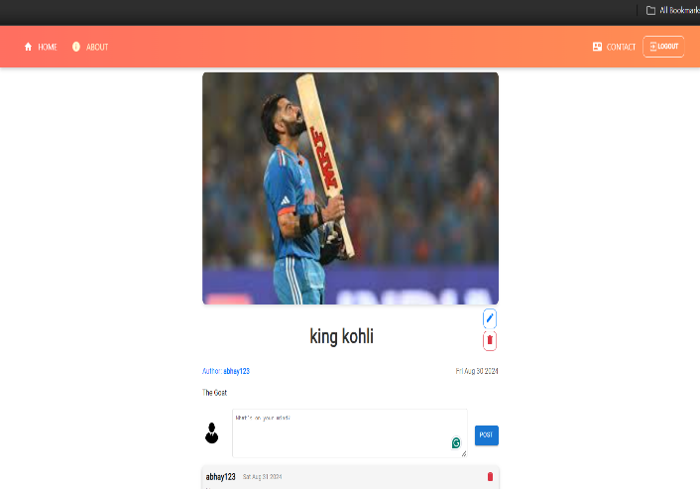 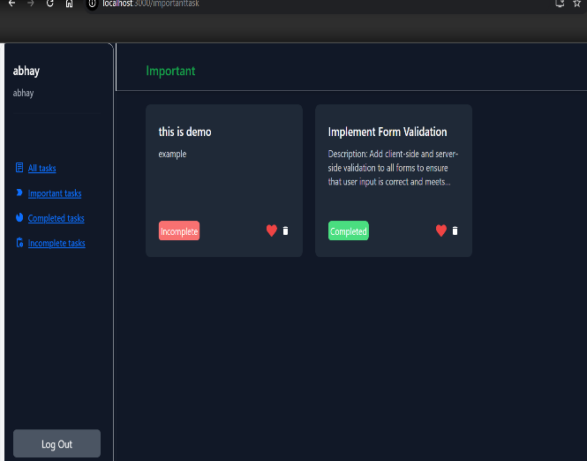

**Appendix II: Code Snippets**

**Some Code of 1st project**

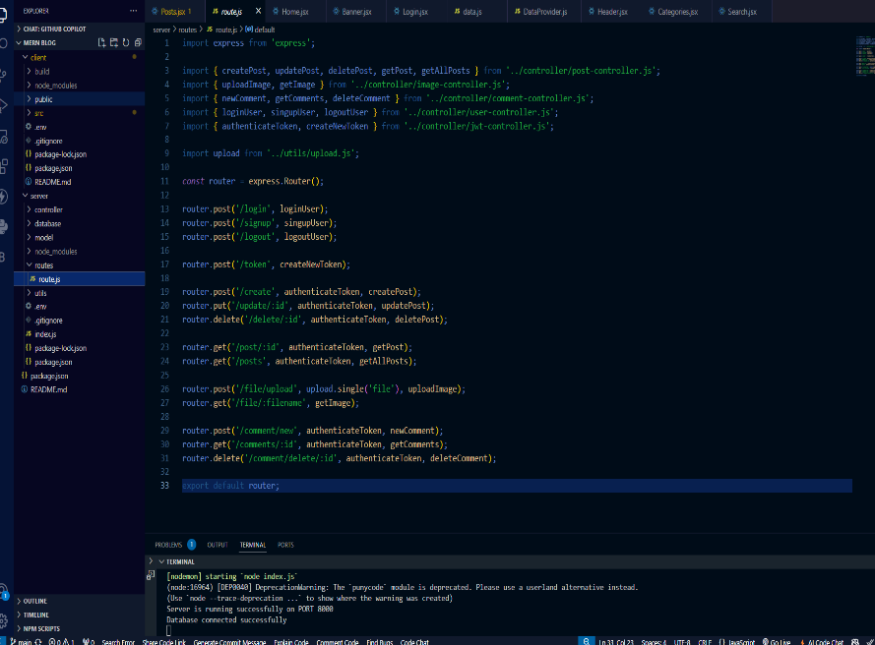 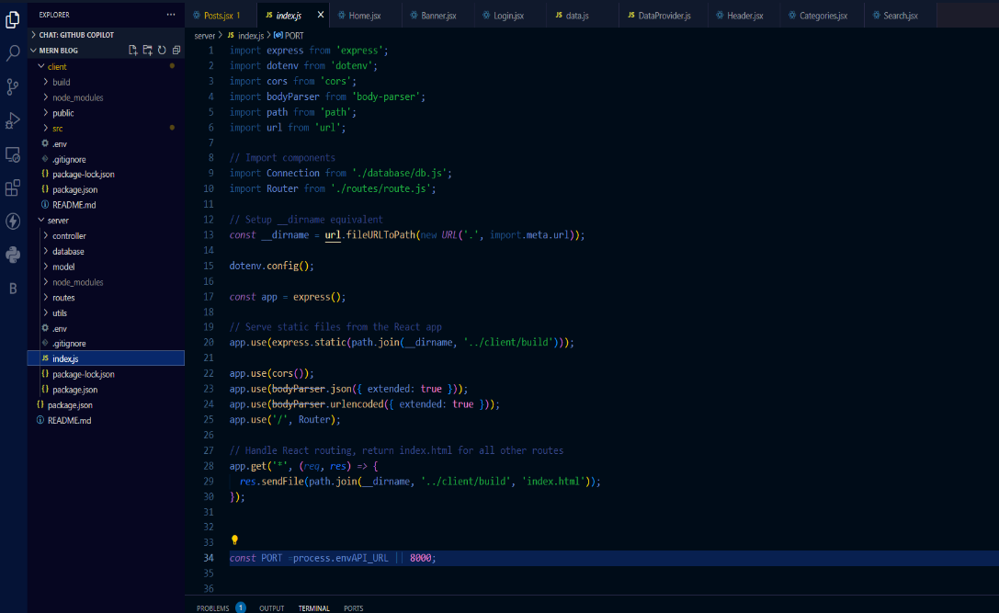

**Some code of 2nd project**

