INTERNSHIP REPORT SUBMITTED ON

## “JAVA PROGRAMING ”

PARTIAL FULFILMENT OF THE REQUIREMENT FOR THE DEGREE BACHELORS OF TECHNOLOGY

IN

COMPUTER SCIENCE AND ENGINEERING

BY

**RAHUL KUMAR SAH**

(ROLL NO: 220530101064)



J.B INSTITUTE OF TECHNOLOGY DEHRADUN, UTTRAKHAND

SESSION: 2023-2027

Duration :- 01/07/2024 -31/07/2024

# DECLARATION

I, **Rahul**, hereby declare that the internship report titled **"Java Programing"** is the result of my own efforts and work. This report is a detailed account of my one-month internship in Java programming, which I completed at **Code Soft**. Any errors or omissions in this report are entirely my responsibility.

**Rahul Kumar Sah**

B.Tech (cse)

Roll No: 220530101064

Dr. Manoj Chaudhary Mr. Faiyad aalam

( HOD CSE ) (ASST Professor)

# CERTIFICATE OF COMPLETION:

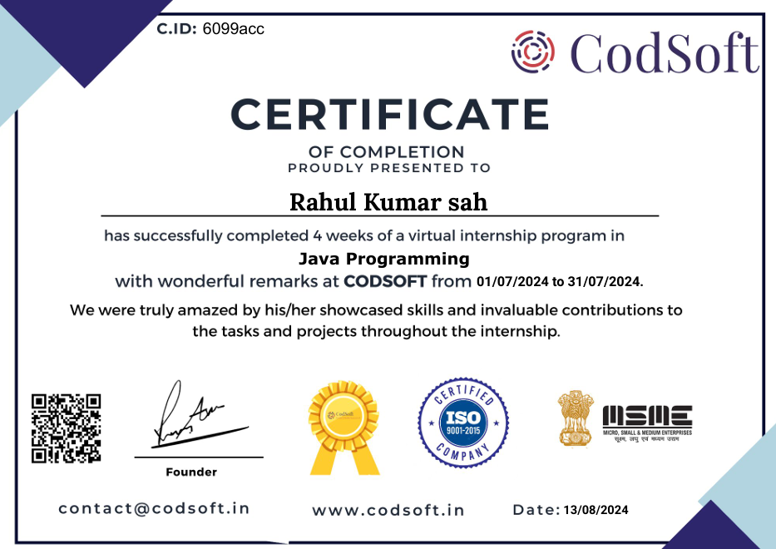

**ACKNOWLEDGEMENT**

I would like to extend my gratitude to the instructors at **Code Soft** for their invaluable guidance throughout this internship.

I would like to express my sincere thanks to **Dr.** **Manoj Chaudhary**, Head of the Department of **Computer Science and Engineering**, for her administrative assistance and encouragement during my academic journey.

I extend my profound gratitude to **Mr. Faiyad Aalam** for giving me the opportunity to undertake this internship, for his constant support, and for being a great mentor.

Their mentorship greatly enriched my understanding and skills in Java programming and project development.

Last but not least, I am deeply thankful to all my teachers, friends, and family for their wholehearted support towards the successful completion of this project.

**Sincerely**

Rahul Kumar Sah

Roll: no- 220530101064

# INTRODUCTION:

During my one-month internship in Java programming with Code Soft, I worked on enhancing my skills in object-oriented programming, data structures, and application development.

This report will cover the objectives of the internship, the projects I completed (ATM Interface and Quiz Application), challenges I encountered, and the technical knowledge gained.

I am deeply appreciative of the opportunity and support provided by the Code Soft team and look forward to discussing the details of my work in this report.

**Sincerely**

Rahul Kumar Sah

Roll: no- 220530101064

## Table of Contents:

|  |  |
| --- | --- |
| **S.No** | **Title** |
| 1. | Abstract |
| 2. | Problem Statement |
| 3. | Scope and Objective of the project |
| 4. | Solution Design |
| 5. | Implementation technology & platforms |
| 6. | User Interface |
| 7. | Future Enhancements |
| 8. | Conclusion |

1. **Abstract:**

The one-month internship at **Code Soft** provided an invaluable opportunity to gain hands-on experience in Java programming and practical software development. During this period, I worked on two significant projects: the **ATM Interface** and the **Quiz Application**, which allowed me to apply theoretical concepts in a real-world context and deepen my understanding of Java’s capabilities.

The **ATM Interface** project focused on simulating essential banking functionalities such as balance inquiry, deposits, withdrawals, and transaction history. The system was designed to be modular, ensuring maintainability and scalability. Key features included input validation for secure transactions and a menu-driven interface for an intuitive user experience.

The **Quiz Application** was developed as an interactive system for conducting quizzes. This project featured multiple-choice questions, dynamic scoring, and result displays. A user-friendly GUI was implemented using Java Swing, enhancing interactivity and providing an engaging experience. The application was designed with a robust structure to allow scalability and future enhancements, such as the inclusion of multimedia-based questions and online functionality.

This internship provided a platform to strengthen my technical skills in object-oriented programming, data structures, and Java-based GUI development. Additionally, I gained valuable insights into problem-solving, debugging, and designing practical solutions to meet project requirements. The experience has significantly contributed to my growth as a programmer and prepared me for tackling more complex software development challenges in the future.

## Problem Statement:

**ATM Interface:**

* Simulate the operations of an ATM to provide users with core banking functionalities.
* Address common user challenges like checking balances, making deposits/withdrawals, and maintaining transaction history.

**Quiz Application:**

* Design an engaging platform for users to participate in quizzes.
* Implement dynamic scoring and result generation.

## Scope and Objective of Project:

**Scope:**

1. **Simulate Real-World Banking Operations:** Develop a functional ATM Interface to replicate essential banking functionalities such as balance inquiries, deposits, withdrawals, and transaction history.
2. **Interactive Quiz System Development:** Create a user-friendly Quiz Application with features like multiple-choice questions, scoring mechanisms, and result displays.
3. **Implement Efficient and Modular Code Structure:** Ensure that both projects are built using clean, modular, and maintainable code for scalability and future enhancements.
4. **Enhance User Experience:** Focus on creating intuitive and interactive interfaces for seamless user interaction and task completion.

**Objectives:**

1. **Strengthen Java Programming Skills:** Gain hands-on experience with core Java concepts such as object-oriented programming, data structures, and exception handling.
2. **Design Scalable Applications:** Develop scalable and efficient applications with clear workflows and user-friendly interfaces.
3. **Integrate Real-World Problem Solving:** Address practical challenges during the development of the ATM Interface and Quiz Application to simulate real-world scenarios.
4. **Lay the Foundation for Future Enhancements:** Design both projects with extensibility in mind to enable additional features, such as online functionality for the Quiz Application or advanced security measures for the ATM Interface.

## Solution Design

## The project’s solution was structured around building robust, modular, and user-friendly Java applications with a strong emphasis on functionality, maintainability, and scalability. The solution design encompassed a multi-layered approach focused on creating efficient architectures that could adapt to future enhancements. The architecture consisted of the following elements:

## Application Structure:

## Designed using core Java principles to ensure modularity and reusability of code, with a clear separation of concerns between various components.

## Employed object-oriented programming (OOP) concepts such as encapsulation, inheritance, and polymorphism to create a scalable codebase.

## Structured the projects to support future enhancements, such as additional features or integrations.

## Interface Design:

## Developed console-based interfaces for the ATM Interface project to simulate real-world banking systems with intuitive navigation and functionality.

## Designed a graphical user interface (GUI) for the Quiz Application using Java Swing, ensuring an engaging and visually appealing user experience.

## Incorporated clear instructions and prompts to guide users intuitively through tasks, reducing potential errors.

## Interactive Features:

## Implemented dynamic features such as transaction processing for the ATM Interface, allowing users to perform operations like deposits, withdrawals, and transaction history viewing.

## Integrated scoring mechanisms, timer-based quizzes, and result displays in the Quiz Application, making it interactive and engaging.

## Optimization and Performance:

## Focused on writing efficient algorithms to optimize the performance of the applications, ensuring quick responses for user operations.

## Minimized memory usage and processing overhead by employing best practices in Java coding and resource management.

## Designed lightweight applications capable of running seamlessly on different environments with minimal configuration.

## This solution design approach provided a structured yet adaptable foundation, ensuring the successful implementation of the projects while laying the groundwork for potential future enhancements, such as adding online functionalities or integrating AI-based features to improve personalization and user engagement.

# IMPLEMENTATION TECHNOLOGY & PLATFORMS:

The project’s implementation utilized a range of technologies and tools to ensure efficient development and a reliable, user-friendly experience. Key technologies and platforms included:

* **Core Technologies:**
  + **Java:** The primary programming language used for building the logic and functionalities of both the ATM Interface and Quiz Application.
  + **Java Swing:** Utilized for designing the graphical user interface of the Quiz Application, providing an interactive and visually appealing experience.
  + **JDK (Java Development Kit):** Enabled compilation, debugging, and execution of the Java applications.
  + **File Handling and Collections:** Implemented for storing and retrieving data efficiently in both projects.
* **Development Tools:**
  + **Eclipse IDE:** Used as the primary development environment for writing, testing, and debugging Java code.
  + **Git & GitHub:** For version control and repository management, enabling change tracking and secure backup of project files.
* **Libraries and Frameworks:**
  + **Java Util Package:** Employed for implementing data structures such as ArrayLists and HashMaps, which were integral to the application logic.
  + **Swing Components:** Enabled the creation of forms, buttons, and other interactive GUI elements in the Quiz Application.
* **Testing and Debugging Tools:**
  + **JUnit:** Utilized for unit testing to ensure the reliability of core functionalities in both projects.
  + **Debugging Tools in Eclipse:** Assisted in identifying and resolving runtime errors during development.
* **Additional Supportive Tools:**
  + **Apache Maven:** Used for managing dependencies and project builds efficiently.
  + **JavaDoc:** Documented code for better readability and maintainability.

These technologies and tools formed the foundation of the project, ensuring an efficient development process while meeting the objectives of creating scalable, maintainable, and interactive Java applications. The use of Java's robust ecosystem allowed for the successful implementation of both the ATM Interface and Quiz Application, paving the way for future enhancements and integrations.

# USER INTERFACE:

The user interfaces for the projects were designed to prioritize simplicity, usability, and interactivity, ensuring an intuitive experience for users. Key highlights include:

* **ATM Interface:**
  + Designed as a **console-based interface**, offering a clear and structured menu for essential banking functionalities.
  + Provided an interactive navigation system with options for balance inquiry, deposit, withdrawal, and transaction history.
  + Displayed user-friendly prompts and error messages to guide users through the process and ensure accurate input.

Quiz Application:

* Developed using Java Swing to create a graphical user interface (GUI) that is visually appealing and engaging.
* Incorporated multiple-choice question panels with buttons for selecting answers and navigating between questions.
* Displayed real-time feedback, such as current scores and a summary at the end of the quiz, enhancing user engagement.
* Styled with Swing components like JLabels, JButtons, and JTextFields to maintain consistency and professionalism.

# FUTURE ENHANCEMENTS:

While the current implementations of the ATM Interface and Quiz Application have provided solid foundations, there are numerous possibilities for future enhancements that would improve functionality, user experience, and scalability. Potential future enhancements include:

1. **ATM Interface:**
   * **User Authentication:** Implement a secure login system, allowing users to access personal accounts, view transaction history, and perform transactions across multiple sessions.
   * **Mobile Integration:** Develop a mobile application version of the ATM Interface, offering similar features with an intuitive touch interface.
   * **Advanced Transaction Features:** Introduce additional banking features such as fund transfers, loan applications, or bill payments.
   * **Security Features:** Integrate two-factor authentication (2FA) for added security and protection of sensitive information.
2. **Quiz Application:**
   * **User Accounts and Progress Tracking:** Enable users to create accounts and track their quiz history and performance over time.
   * **Question Database:** Expand the database to include a wider variety of quiz topics and difficulty levels.
   * **Multiplayer Mode:** Add a multiplayer mode where users can compete in real-time quizzes against others.
   * **Admin Panel:** Develop an admin interface to manage quizzes, questions, and users more effectively.
3. **Overall Enhancements:**
   * **Artificial Intelligence (AI) Integration:** Implement AI-based question generation to offer more dynamic quiz experiences or AI-driven suggestions for banking operations in the ATM Interface.
   * **Cross-Platform Compatibility:** Adapt the applications to run on both desktop and mobile platforms seamlessly, enhancing accessibility.
   * **Cloud Integration:** Use cloud services for data storage and backup, ensuring data is securely saved and easily accessible.

These enhancements would take the applications to the next level, making them more functional, interactive, and scalable for a broader audience, while also providing a richer user experience.

# CONCLUSION:

This internship at Code Soft provided me with valuable hands-on experience in Java programming, enhancing my technical expertise and problem-solving skills. Through working on two key projects—the ATM Interface and the Quiz Application—I was able to apply core Java concepts, such as object-oriented programming, GUI development using Java Swing, and data management with collections and file handling.

These projects not only deepened my understanding of Java but also gave me practical experience in designing user-friendly interfaces, optimizing application performance, and addressing common development challenges. The experience further solidified my skills in application development and laid a solid foundation for integrating more advanced features such as user authentication, database integration, and security enhancements in future projects.

I am truly grateful for the learning opportunities provided by Code Soft, which have significantly contributed to my growth as a developer. This internship has equipped me with the knowledge and skills to take on more complex development tasks and prepare for more advanced roles in the software development field.