1. What We Are Testing
Our project asks a simple question. If you take a CNN that has already been trained on millions of ordinary photographs (ImageNet), and you fine tune it on medical images from different hospitals and imaging sources, does it automatically learn to handle all of them well, even though nobody told it to? Or does it just memorize whichever source's images it saw more of?
We compare four models. Three of them start from ImageNet pretrained weights (EfficientNetB0, MobileNetV2, ResNet50). One is built from scratch and has never seen any image before this project (Custom CNN). If the pretrained models handle the different sources more evenly than the from scratch model does, that is evidence the pretrained models picked up something like automatic domain adaptation just from their prior training, without us ever explicitly telling them to adapt.
We call this implicit domain adaptation, implicit because nobody added a special technique to force said domain adaptation.

What ImageNet pretrained actually means, in plain words
ImageNet is a very large public collection of over a million ordinary photographs, things like dogs, cars, furniture, and everyday objects, each labeled with what it shows. It has nothing to do with medicine. A model that is "ImageNet pretrained" has already spent a long time learning to recognize edges, textures, shapes, and general visual patterns from that huge photo collection, before it ever sees a single medical image. When we then show it chest X-rays, it is not starting from zero, it already has a working sense of how to look at images in general, and our job is only to teach it what a healthy versus abnormal chest X-ray looks like specifically. The Custom CNN in this project gets none of that head start, it starts completely blank and has to learn both "how to see" and "what to look for" from the same, relatively small, medical dataset alone.

What ResNet, MobileNet, and EfficientNet actually are
All three of these are different designs of convolutional neural network, which is a type of model built specifically to look at images by scanning small patches of pixels at a time and gradually building up an understanding of shapes, then parts, then whole objects. They differ mainly in how many internal parameters they have and how those parameters are arranged.
- ResNet50 is the largest of the three used here, with 25.6 million trainable parameters. It is built from repeating blocks that include a shortcut connection allowing information to skip ahead, which historically made it possible to build much deeper networks than before without them becoming impossible to train.
- MobileNetV2 is the smallest pretrained model used here, with roughly 2.6 million parameters, and it was specifically designed to be lightweight and fast, originally intended to run on phones.
- EfficientNetB0 sits in between at roughly 4.4 to 5.3 million parameters (the exact reported count has varied slightly depending on how the head layers are counted across this project's stages), and it was designed using a systematic method for balancing a network's depth, width, and input resolution against each other, aiming for a good accuracy to size tradeoff rather than simply being as large as possible.
In plain terms, a parameter is one of the many internal numbers a model adjusts during training to get better at its task, similar to a very large number of dials the model tunes based on the data it sees. More parameters generally means a model has more capacity to represent complicated patterns, but it also means it needs more data and more computing time to train well, and it can more easily memorize its training data instead of genuinely learning from it if there is not enough data to justify its size. Fewer parameters means a lighter, faster model, but potentially less capacity to capture subtle patterns. Part of what this project tests is whether pretraining on ImageNet lets even a small model like MobileNetV2 punch above its raw parameter count, by giving it a head start that a similarly sized model built from scratch does not get. The Custom CNN in this project has 322,338 parameters, meaningfully smaller than any of the three pretrained models, and it was never given any ImageNet head start at all.

What this task is actually screening for
This task looks at chest X-ray images and asks a single yes or no question: does this scan show any abnormal finding at all, anywhere in the chest? The two labels used throughout this project are no_finding and pathology. . This is different from the skin lesion task, which sorts images into six specific lesion types, and it is a deliberate choice explained below.
A no_finding label means the radiologist or the source dataset's labeling process determined the chest X-ray looks normal, with no visible sign of disease or injury in the lungs, heart, or surrounding structures. A pathology label means at least one abnormal finding was identified somewhere in the scan. Chest X-rays are used clinically to screen for and help diagnose a very wide range of conditions, including pneumonia (infection causing fluid or inflammation in the lungs, which shows up as cloudy or opaque regions), pneumothorax (a collapsed lung, where air has leaked into the space around the lung), cardiomegaly (an enlarged heart), pleural effusion (fluid buildup around the lungs), nodules or masses that can indicate tumors, and many other structural or infectious findings. Each of the three source datasets used in this project defines its own specific list of findings it looks for and labels, and those lists are not identical to each other, which is one of the real reasons this project treats the task as a single broad presence or absence question rather than trying to force all three sources into one shared list of specific diagnoses, explained further in the next section.

2. The Three Sources
Three sources were used, deliberately chosen because each comes from a different scanning setup, a different patient population, and a different labeling process, which is exactly the kind of real world variation this project is trying to measure.

CheXpert
- CheXpert is a large chest X-ray dataset originally released by a medical imaging research group at Stanford University, built from scans collected at Stanford Hospital.
- The version of the dataset used in this project is the smaller, downsampled JPEG release rather than the full resolution DICOM originals.
- It is the largest of the three sources by far, and it is heavily skewed toward abnormal findings, with about 90 percent of its images labeled pathology rather than no_finding.
- Its labels come from an automated natural language process applied to the original radiology reports, not from a human directly re-reading and re-labeling every image for this project.
- 223,414 images, 201,033 labeled pathology and 22,381 labeled no-finding, a prevalence of 90.0 percent pathology. 64,540 unique patients could be identified from the file structure, which allowed splitting the data so that no single patient's images appeared in more than one of the train, validation, or test sets.

NIH ChestX-ray14
- NIH ChestX-ray14 is a large public chest X-ray dataset released by the (US) National Institutes of Health Clinical Center. Like CheXpert, its labels were derived automatically from radiology reports using natural language processing rather than direct human re-review for this project, which is a real, disclosed source of label noise, not a hidden flaw. Of the three sources, this is the one whose prevalence sits closest to a natural balance between the two classes.
- 112,120 images, 51,759 labeled pathology and 60,361 labeled no-finding, a prevalence of 46.2 percent pathology. 30,805 unique patients were identified and used for patient level splitting, the same protection against data leakage applied to CheXpert.

VinBigData Chest X-ray Abnormalities
- VinBigData is a chest X-ray dataset collected from hospitals in Vietnam, originally released as part of a Kaggle competition focused on detecting and localizing specific abnormalities with bounding boxes, rather than as a simple classification dataset.
- Because of this, each image in the original data can carry multiple separate rows, one for each abnormality a radiologist marked, or a single row indicating no finding.
- For this project, that structure was collapsed down to a single label per image, an image was only kept as no_finding if every one of its annotation rows indicated no finding, and labeled pathology if any row indicated any abnormality at all.
- After this collapse, 15,000 unique images remained, 4,394 labeled pathology and 10,606 labeled no-finding, a prevalence of 29.3 percent pathology, the lowest of the three sources.
- No patient identifier exists in this dataset, the images are anonymized with no linkage available connecting multiple scans to the same patient, so this source was split at the level of individual images rather than patients, a disclosed limitation of the source itself.

Why binary, not a shared multi-class scheme
- CheXpert, NIH, and VinBigData each define their own specific list of findings they look for and label, and those lists genuinely differ from each other, both in which conditions are included and in how strictly each one is defined.
- Building one shared multi-class labeling scheme across all three would require making a series of clinical harmonization judgment calls that a reviewer could reasonably dispute.
- Any noise introduced by those judgment calls would contaminate the actual signal this project is trying to measure, which is the domain gap between sources, not disagreements about label taxonomy.
- Binary classification, is anything abnormal present, sidesteps this entirely, because each source already made that basic determination as part of its own labeling process, and this project simply reads that determination rather than re-deriving a new one.

All numbers verified live
Every count above was confirmed by actually running code against the real files in the working environment, sampling and confirming that image file paths genuinely resolved to real files on disk, rather than trusting documentation or an assumed folder structure
Source | Total images | Pathology | No-finding | Prevalence | Patients | Split level
CheXpert | 223,414 | 201,033 | 22,381 | 90.0% | 64,540 | patient
NIH ChestX-ray14 | 112,120 | 51,759 | 60,361 | 46.2% | 30,805 | patient
VinBigData | 15,000 | 4,394 | 10,606 | 29.3% | none | image

Subsampling to a common size
VinBigData's 15,000 unique images is the smallest of the three sources, so it sets a floor. CheXpert and NIH were each subsampled down to about 15,000 images at the patient level, selecting whole patients until the running image count reached roughly the target, never splitting one patient's images across the subsample boundary, and preserving each source's own natural prevalence rather than the pooled prevalence. This produces a pooled training set of approximately 45,000 images, 15,000 from each source, so that no single source can dominate the pooled experiment purely because it has more raw data available. Every subsample's realized prevalence was checked against its parent source's true prevalence and required to land within 3 percentage points, confirmed at CheXpert 0.02 percentage points of drift, NIH 0.30 percentage points of drift, and VinBigData exactly zero drift, since VinBigData is used in full and has no sampling step at all.

Train, validation, test split
CheXpert and NIH are split at the patient level, with an explicit check afterward confirming that no patient's images appear in more than one of the three splits. VinBigData is split at the level of individual images, since no patient identifier exists for that source.
Split | Train | Validation | Test
Pooled (all three sources) | 31,456 | 7,015 | 6,505
CheXpert only | 10,354 | 2,422 | 2,223
NIH only | 10,602 | 2,343 | 2,032
VinBigData only | 10,500 | 2,250 | 2,250

3. The Four Models
- Custom CNN: built from scratch, three convolution blocks, 322,338 parameters total. Trained in a single phase.
- MobileNetV2: ImageNet pretrained, roughly 2.6 million parameters. Trained in two phases.
- EfficientNetB0: ImageNet pretrained, roughly 4.4 to 5.3 million parameters. Trained in two phases.
- ResNet50: ImageNet pretrained, 25.6 million parameters, the largest model tested. Trained in two phases.
Two phase training means the following. First, the pretrained backbone is frozen and only a small new classifier head is trained on top of it, for 10 epochs. Then the whole model is unfrozen and fine tuned together at a much lower learning rate, for up to 60 epochs, stopping early if it stops improving for 7 epochs in a row. Every model was trained with class weighting, meaning mistakes on whichever class is rarer in that specific training set count for more than mistakes on the more common class, so the model is not simply rewarded for always guessing the majority answer.
Binary classification here is implemented as a two class softmax output rather than a single sigmoid number, which keeps the loss function, the way labels are encoded, and the overall output shape identical to how the skin lesion task is set up, so that architecture remains the only real difference between the tasks, not the classification mechanics underneath it.

4. Stage 4 to 7, Training All Four Models, Pooled Data
This is the main training run. All four models trained on the pooled dataset, all three sources combined, and tested on a held out pooled test set they never saw during training.

Locked results table
Model | AUC | Accuracy | Macro F1 | Sensitivity | Specificity
Custom CNN | 0.8921 | 0.7852 | 0.7783 | 0.8897 | 0.6621
EfficientNetB0 | 0.9190 | 0.8327 | 0.8324 | 0.8113 | 0.8580
MobileNetV2 | 0.9175 | 0.8350 | 0.8343 | 0.8357 | 0.8342
ResNet50 | 0.9280 | 0.8453 | 0.8446 | 0.8448 | 0.8459

What this means in plain words. ResNet50 has the highest score on every single metric here, AUC, accuracy, macro F1, sensitivity, and specificity, which is different from what happened on the skin lesion task, where EfficientNetB0 and ResNet50 split apart, one being best by ranking ability and the other best by raw accuracy. That divergence did not happen on chest, ResNet50 is simply the strongest model across the board on this task, and we are reporting that plainly rather than forcing it to match the other task's pattern. Custom CNN is meaningfully behind all three pretrained models on every metric, which is the first piece of evidence for our hypothesis, the pretrained models are genuinely doing more with the same pooled, heterogeneous data.

Training curves, all four models (Stage 4 to 7)
Each curve below shows training and validation accuracy across every epoch of training that we actually have a record of, so you can see how quickly and how smoothly each model learned.
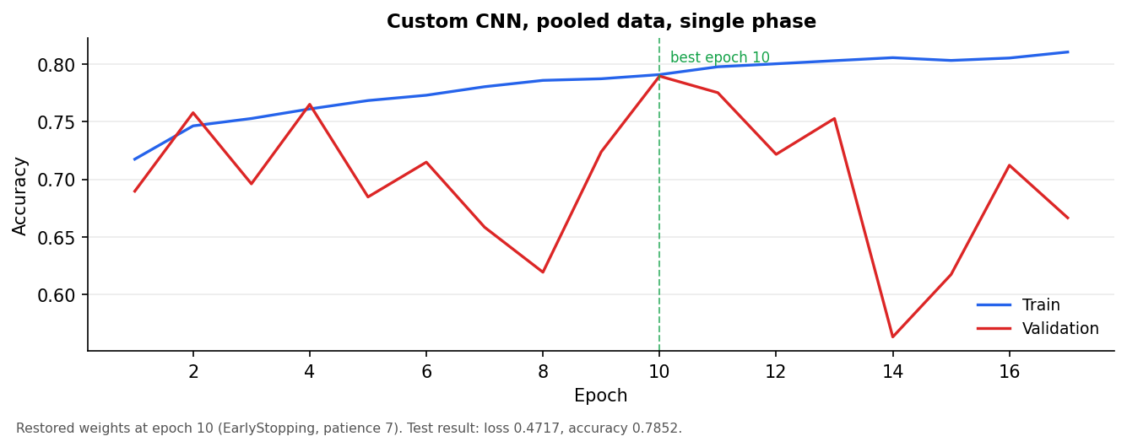
Figure 4.1: Custom CNN training curve, pooled data, single phase, 17 epochs
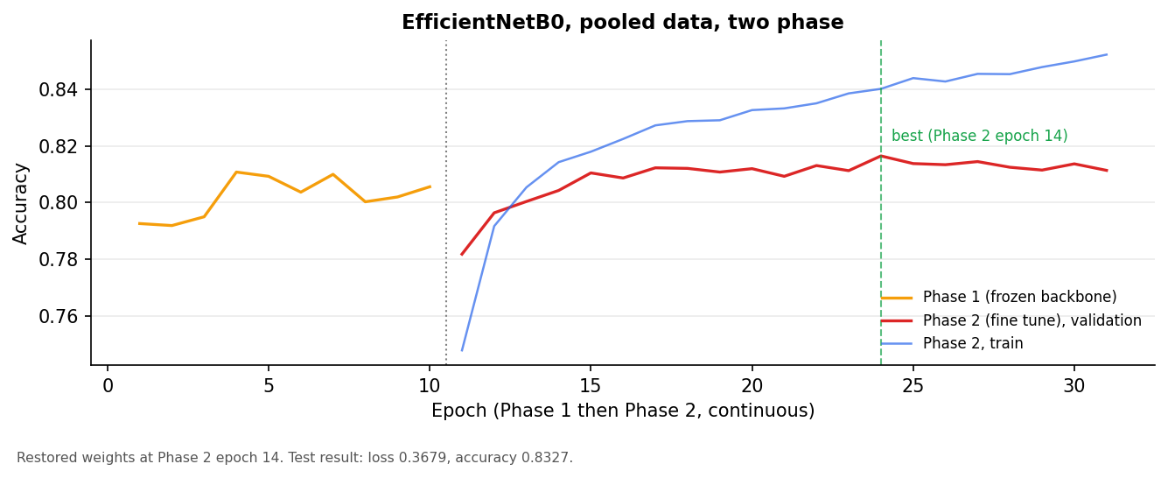
Figure 4.2: EfficientNetB0 training curve, pooled data, Phase 1 (10 epochs) then Phase 2 (21 epochs)
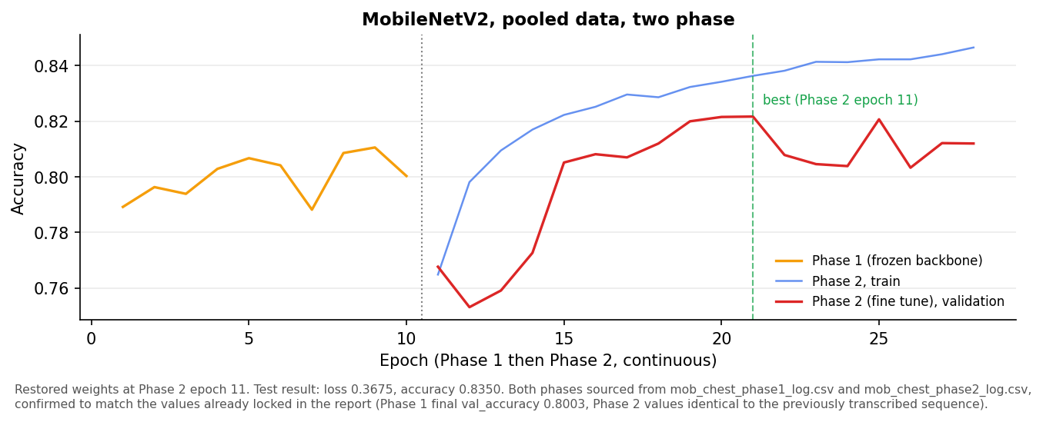
Figure 4.3: MobileNetV2 training curve, pooled data, Phase 2 only, 18 epochs. Phase 1's epoch by epoch numbers were never pasted into the project record for this specific run, only its final val_accuracy (0.8003) is known, which is why Phase 1 cannot be shown as a curve here.
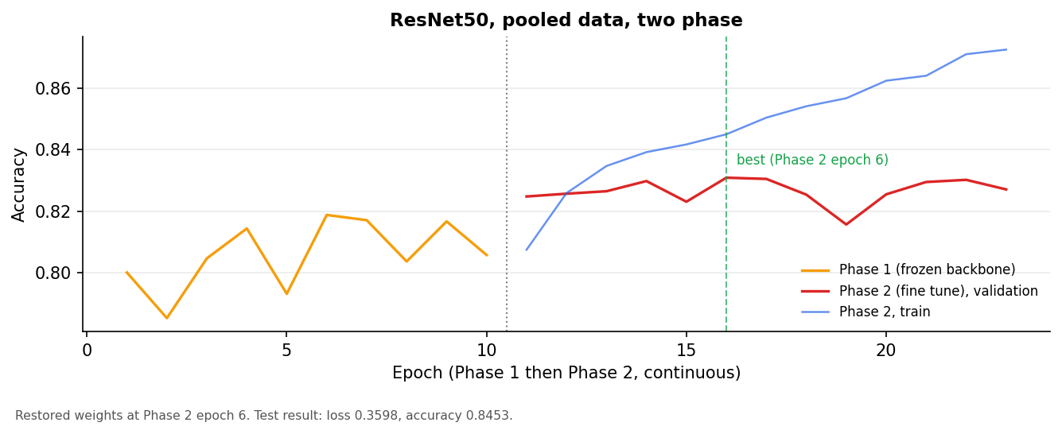
Figure 4.4: ResNet50 training curve, pooled data, Phase 1 (10 epochs) then Phase 2 (13 epochs)
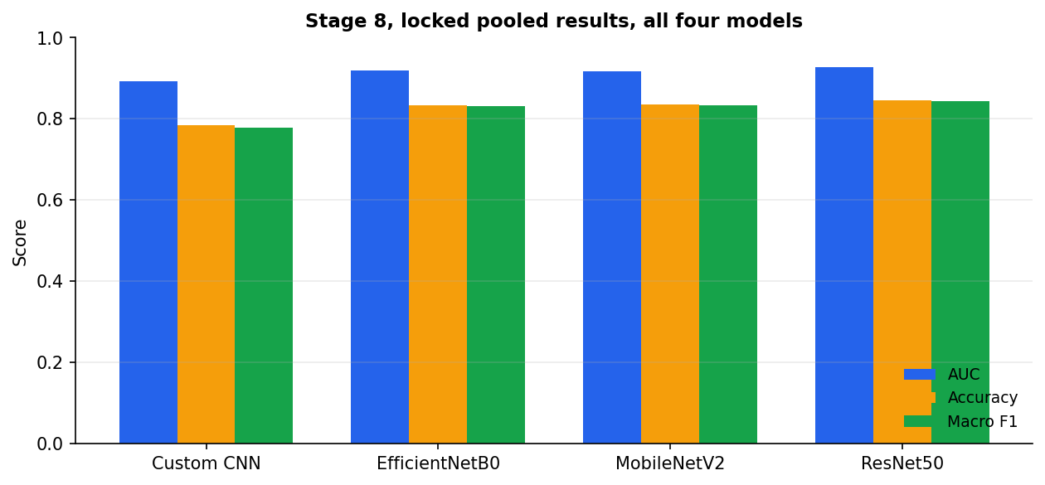
Figure 4.5: Stage 8 locked results, all four models, AUC, accuracy, and macro F1 side by side
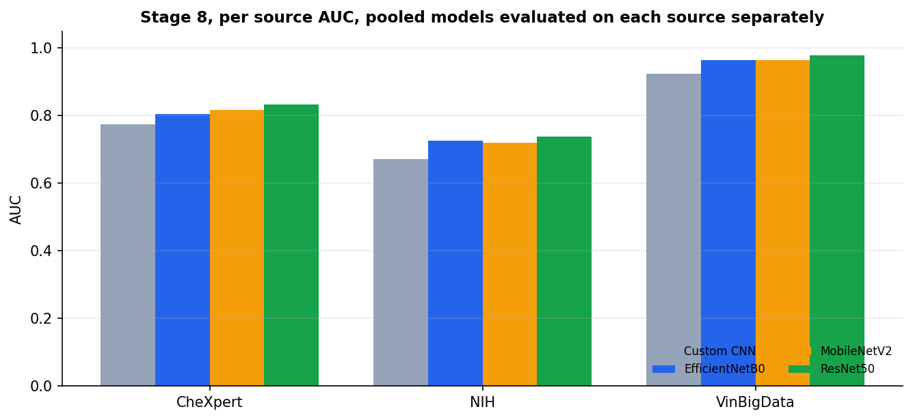
Figure 4.6: Stage 8 per source AUC. All four pooled models were also evaluated separately on just the CheXpert, just the NIH, and just the VinBigData portions of the pooled test set

An important, disclosed problem found in the per source results
When we broke the pooled test results down by source, we found that specificity on CheXpert collapsed to near zero for every single model, 0.0000 for Custom CNN and between 0.0750 and 0.1750 for the three pretrained models. In plain terms, every model, including the pretrained ones, almost never correctly identifies a genuinely normal CheXpert scan, it calls nearly everything pathology on that specific source. The most likely explanation is that CheXpert is 90 percent pathology, and even inside a roughly balanced pooled training set, the models still lean heavily toward guessing pathology whenever an image looks like it came from CheXpert specifically. This is disclosed plainly here rather than smoothed over, and it is exactly the kind of finding that should be described honestly in any paper or report built from this work.
We also found that NIH was the hardest of the three sources for every one of the four models, with AUC between 0.67 and 0.74, while VinBigData was the easiest by a wide margin, with AUC between 0.92 and 0.98 depending on the model. This same pattern, VinBigData easiest and NIH hardest, has since shown up again independently in the single source experiments described in Section 5, which is a genuinely reassuring sign that this is a real property of the data itself, not a coincidence specific to the pooled setup.

Confusion matrices, all four models
A confusion matrix shows, for every true label, what the model actually predicted. The diagonal is correct predictions, anything off the diagonal is a mistake, and the specific pattern of mistakes tells you what the model tends to confuse with what.
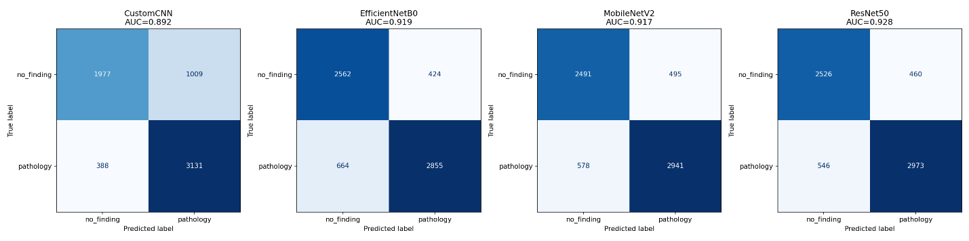Figure 4.7: Confusion matrices, all four models, pooled test set

Grad-CAM, where each model is actually looking
Grad-CAM produces a heatmap showing which part of an X-ray image the model paid the most attention to when making its decision, red and orange mean high attention, blue and purple mean low attention. Exemplar images for this were chosen systematically rather than picked by eye, specifically, images where the Custom CNN got the answer wrong while all three pretrained models got the same image right, so the comparison is not cherry picked to make one model look good.
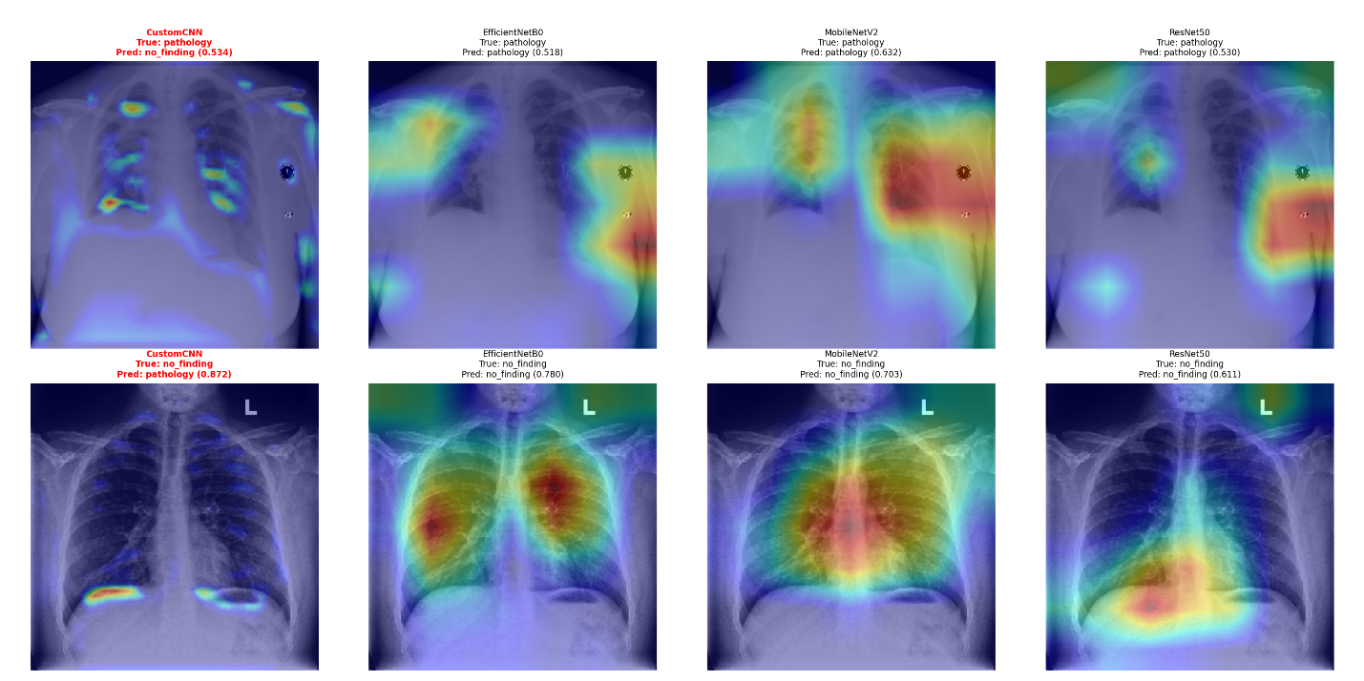Figure 4.8: Grad-CAM, pathology exemplar
In plain words, on the pathology exemplar, the three pretrained models converged on the same general lung region, while the Custom CNN's attention was scattered across both lungs in a much less focused pattern, and it also predicted the wrong answer on that same image. On the no-finding exemplar, the Custom CNN's attention sat mostly along the outer rib margins, a region with no real diagnostic meaning for a normal reading, while the pretrained models attended more toward the central chest, and all three landed closer to the correct answer. This is a second, independent piece of evidence, alongside the numbers above, that the pretrained models are picking up on something closer to real anatomical signal, not just an easy shortcut.

Statistical comparison between models
We used two statistical tests to check whether the differences between models are real or could just be random chance.
- McNemar's test checks whether two models disagree on which specific images they get right or wrong, more than you would expect by chance. Every pretrained model beat Custom CNN with overwhelming statistical significance. EfficientNetB0 versus MobileNetV2 was the one pair that was not significantly different from each other. ResNet50 significantly beat both EfficientNetB0 and MobileNetV2.
- DeLong's test checks whether two models' AUC scores are really different. We ran this two ways, once treating the two models as unrelated (the plain, naive version), and once correctly accounting for the fact that all four models were tested on the exact same shared images (the correlated version). The correlated version is the correct one for this setup and is what we report as primary. Two model pairs that looked like a coin flip under the naive version, EfficientNetB0 versus ResNet50, and MobileNetV2 versus ResNet50, turned out to be real, statistically significant differences once measured correctly. This exact pattern was independently confirmed by McNemar's test on the same two pairs, which is a strong internal consistency check between two completely separate statistical methods.
Model A | Model B | McNemar p (Holm corrected) | Significant
Custom CNN | EfficientNetB0 | 3.540e-19 | Yes
Custom CNN | MobileNetV2 | 1.173e-23 | Yes
Custom CNN | ResNet50 | 2.871e-34 | Yes
EfficientNetB0 | MobileNetV2 | 5.144e-1 | No
EfficientNetB0 | ResNet50 | 3.031e-4 | Yes
MobileNetV2 | ResNet50 | 1.182e-3 | Yes

Model A | Model B | AUC difference | Correlated DeLong p (Holm) | Plain DeLong p (Holm)
Custom CNN | EfficientNetB0 | -0.0269 | 0.0000 | 4.698e-7
Custom CNN | MobileNetV2 | -0.0253 | 0.0000 | 2.342e-6
Custom CNN | ResNet50 | -0.0358 | 0.0000 | 1.444e-12
EfficientNetB0 | MobileNetV2 | 0.0016 | 0.3734 | 0.7313
EfficientNetB0 | ResNet50 | -0.0089 | 1.374e-7 | 0.0905
MobileNetV2 | ResNet50 | -0.0105 | 1.976e-10 | 0.0571

The largest gap between the correlated and plain versions of this test, across all six pairs, was a p-value difference of 0.358, which is a substantial, concrete illustration of why the correlated version matters and was chosen as primary rather than the plain version.

5. Stage 11, What Happens With Only One Source's Data
Here we train each of the four architectures separately on just one source at a time, CheXpert only, NIH only, or VinBigData only, and test each resulting model only on its own held out source. This is the load bearing control for the whole project, it tells us whether the custom CNN genuinely struggles with domain heterogeneity specifically, or whether it is simply a weaker architecture in general, independent of any domain gap question. Class weights for these runs are computed against each source's own prevalence, not the pooled prevalence, so that each single source run is a genuinely clean, isolated experiment.
This stage trains twelve models in total, four architectures across three sources. As of this document, six of those twelve are complete: all three Custom CNN single source runs, and all three EfficientNetB0 single source runs. MobileNetV2's three single source runs were started as one combined, unattended run, but its output was never pasted back into the project record before this document was written, so there are zero epochs of real data available for MobileNetV2 at the single source level right now. ResNet50's three single source runs have not been started at all. Both of these gaps are described honestly in the open issues section at the end of this document rather than filled in with an estimate.
Architecture | Source | AUC | Accuracy | Macro F1 | Sensitivity | Specificity
Custom CNN | chex | 0.7980 | 0.8934 | 0.5803 | 0.9849 | 0.1375
Custom CNN | nih | 0.6860 | 0.6363 | 0.6319 | 0.6100 | 0.6563
Custom CNN | vinbig | 0.9239 | 0.8591 | 0.8164 | 0.6434 | 0.9485
EfficientNetB0 | chex | 0.7980 | 0.8052 | 0.6448 | 0.8280 | 0.6167
EfficientNetB0 | nih | 0.7228 | 0.6786 | 0.6648 | 0.5507 | 0.7758
EfficientNetB0 | vinbig | 0.9731 | 0.9293 | 0.9129 | 0.8452 | 0.9642

A real problem we caught and fixed in this stage
The first attempt at training Custom CNN on CheXpert only, using validation accuracy as the criterion for which epoch to save as the best model, produced a model with a specificity of exactly 0.0000, meaning it never once correctly identified a single normal scan out of 240 in that source's test set, despite reaching 89.20 percent overall accuracy. The explanation is straightforward once you see it, CheXpert is 90 percent pathology, so a model that simply always guesses pathology, without looking at the image at all, already scores close to 90 percent accuracy for free. Validation accuracy as a selection criterion was repeatedly locking onto exactly that shortcut whenever it appeared during training, rather than a genuinely discriminating epoch. The model's own AUC on that same run, 0.7072, showed that real, useful signal existed and was simply being thrown away by the selection rule.
The fix, applied for the rest of this stage going forward, was to switch the rule for choosing the best epoch from validation accuracy to validation AUC, since AUC cannot be gamed the same way by a model that just always predicts one answer. Rerunning CheXpert only with this corrected rule produced a real, if still imperfect, improvement, AUC 0.7980 and specificity 0.1375. This AUC based selection rule was then applied to every remaining Stage 11 run as a precaution, including ones where the accuracy based shortcut had not actually been observed to happen.

Training curves, Stage 11 single source models
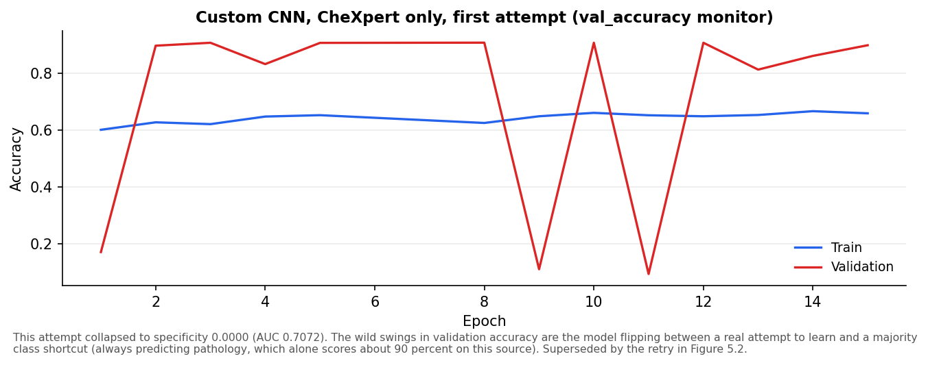
Figure 5.1: Custom CNN, CheXpert only, first attempt, validation accuracy monitor, later found to have collapsed to specificity 0.0000
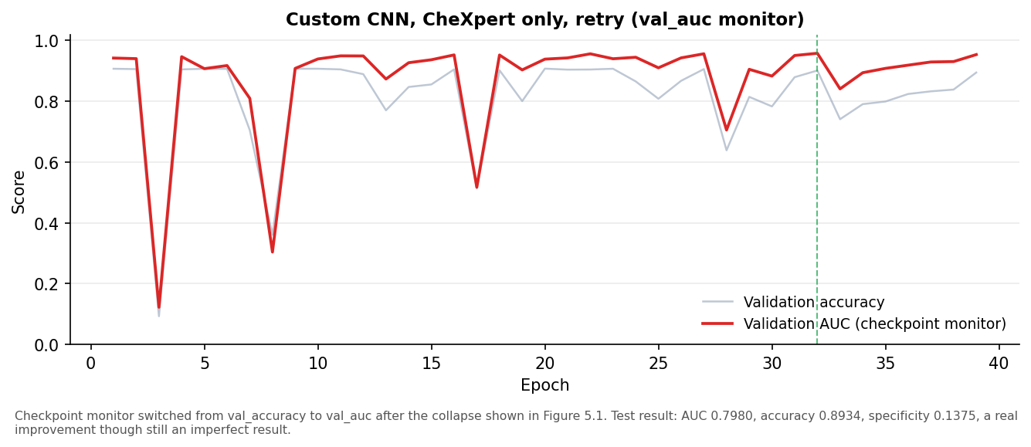
Figure 5.2: Custom CNN, CheXpert only, retry with validation AUC monitor, this is the result actually locked in the table above
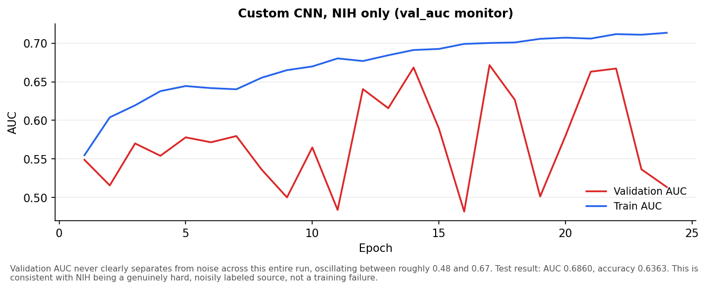
Figure 5.3: Custom CNN, NIH only
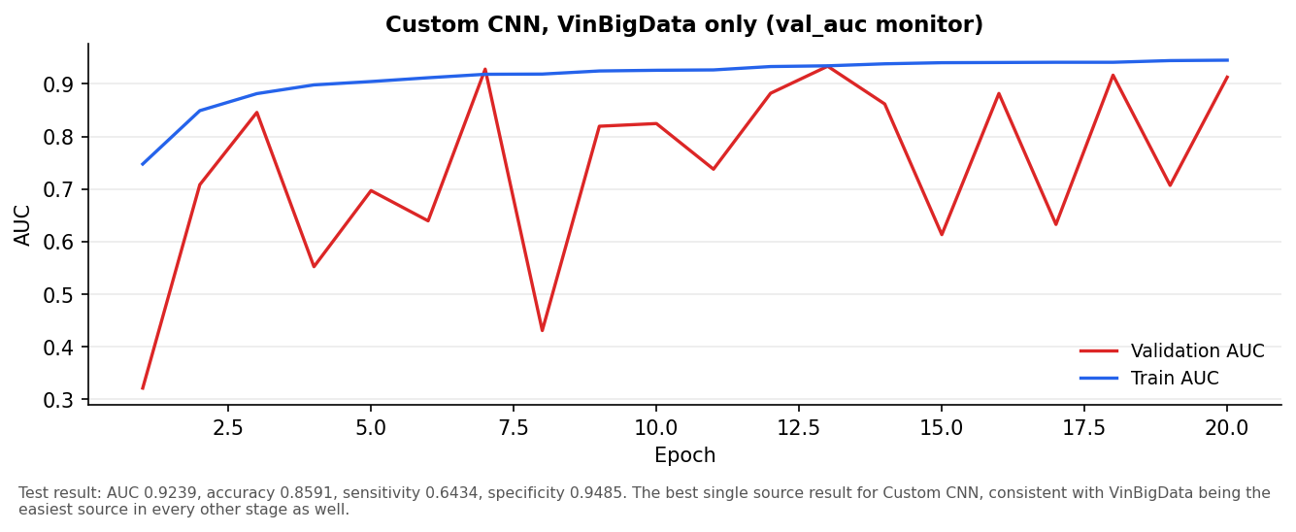
Figure 5.4: Custom CNN, VinBigData only
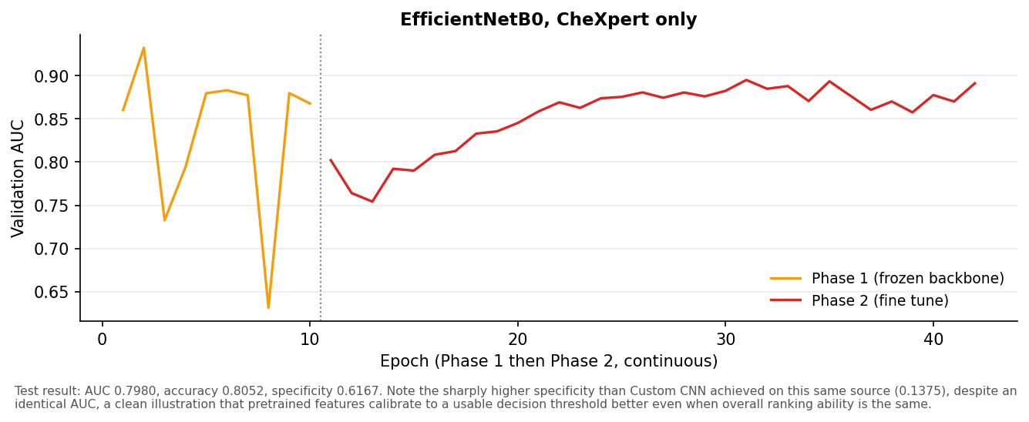
Figure 5.5: EfficientNetB0, CheXpert only, Phase 1 then Phase 2
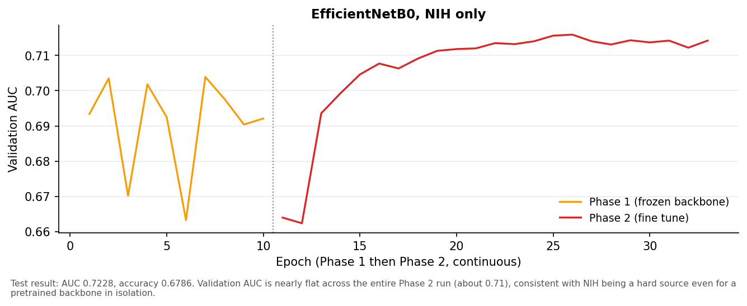
Figure 5.6: EfficientNetB0, NIH only, Phase 1 then Phase 2
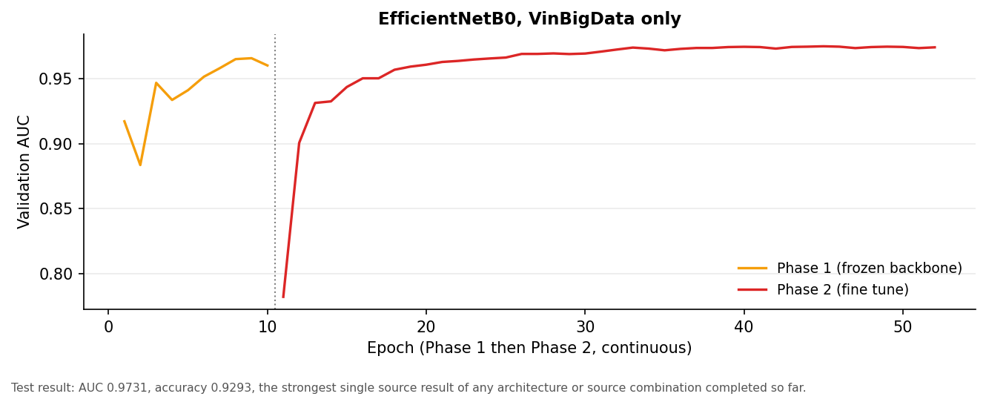
Figure 5.7: EfficientNetB0, VinBigData only, Phase 1 then Phase 2
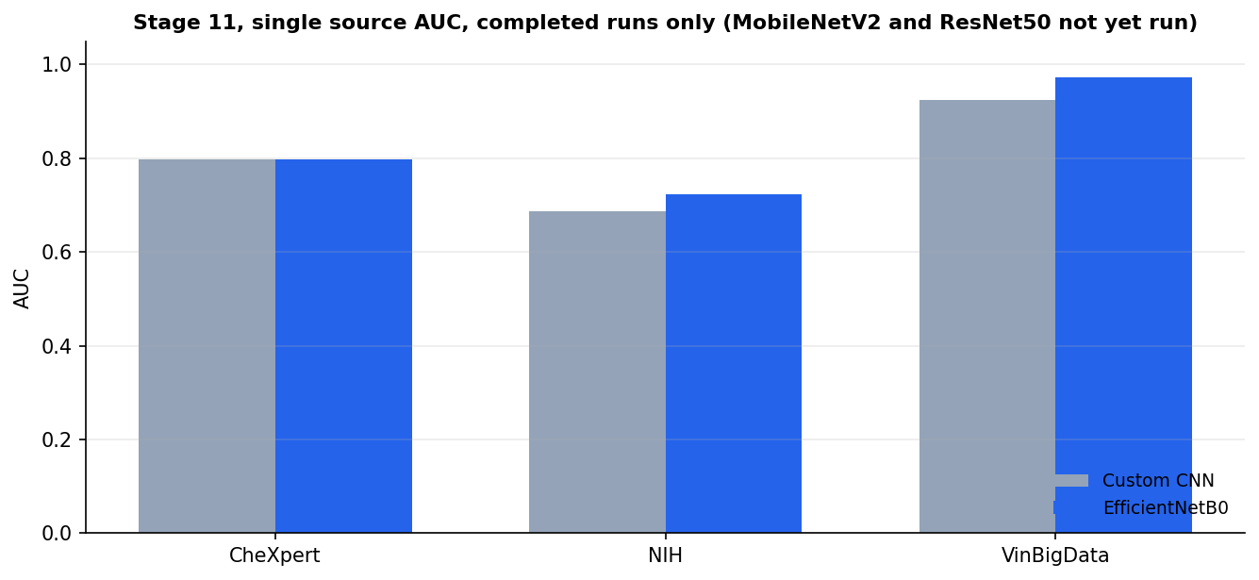
Figure 5.8: Stage 11 summary, AUC by source, Custom CNN and EfficientNetB0 only (the two architectures with completed runs)
An interesting pairing worth calling out directly. On CheXpert only, Custom CNN and EfficientNetB0 landed on the exact same AUC, 0.7980, but wildly different specificity, 0.1375 for Custom CNN versus 0.6167 for EfficientNetB0. Same underlying ranking ability, very different behavior at the actual decision threshold. That is a clean, concrete illustration of a point this whole project is trying to make, pretrained features do not just rank images better, they also tend to calibrate to a usable decision threshold better, even in a case where overall discriminative power came out identical.
The difficulty ordering seen here, VinBigData easiest, CheXpert Skewed but workable, NIH hardest, matches exactly what Section 4's pooled per source breakdown already showed. Seeing the same ordering appear independently in a completely separate, single source experiment is meaningful corroborating evidence that this is a genuine property of the three sources themselves, not an artifact of how they were combined in the pooled run.

6.. What Is Left?
- Stage 11 (single source baseline): six of twelve models done. MobileNetV2's three single source runs were started but the output was never captured in the project record, meaning that work likely needs to be rerun from scratch or its output needs to be located and pasted in before it can be counted as done. ResNet50's three single source runs have not been started at all.
- Stage 12 (cross source matrix): not started, blocked on all twelve Stage 11 models existing.
- Stage 13 (MMD, both directions, plus the pooled model reference comparison): not started, blocked on the same Stage 11 dependency as Stage 12.
- Stage 14 (fine tune depth ablation): not started.
- Stage 15 (CORAL baseline): not started.
- Stage 16 (five fold cross validation): not started. This is expected to be the single largest remaining piece of work, potentially over 90 hours of training on its own, since it means repeating the full pooled training experiment five times with five different random seeds for every model, to report an average and a spread instead of a single run. The exact scope, whether this covers all four architectures or a smaller subset, has not been finalized, and is an open, non blocking decision, meaning it does not stop any of the work currently in progress since Stages 11 through 15 all come before it regardless of how it is eventually scoped.
- Stage 17 (final results compilation): assembling everything above into the finished paper, once Stages 11 through 16 are locked.
- Confusion matrices and Grad-CAM visualizations for this document specifically: these require running inference against the actual saved model files and actual test images, which is why they are left as placeholders in Sections 4 and elsewhere rather than invented, even though the underlying models the pooled versions would come from already exist and are trained.

11. Appendix, Full CSV Files
The following result files are available in full alongside this document and contain every number referenced above.
- chest_stage8_summary.csv, chest_stage8_per_source.csv
- chest_stage9_mcnemar.csv, chest_stage9_delong_plain.csv, chest_stage9_delong_correlated.csv
- Stage 11 per run checkpoint and log files, named by architecture and source.

