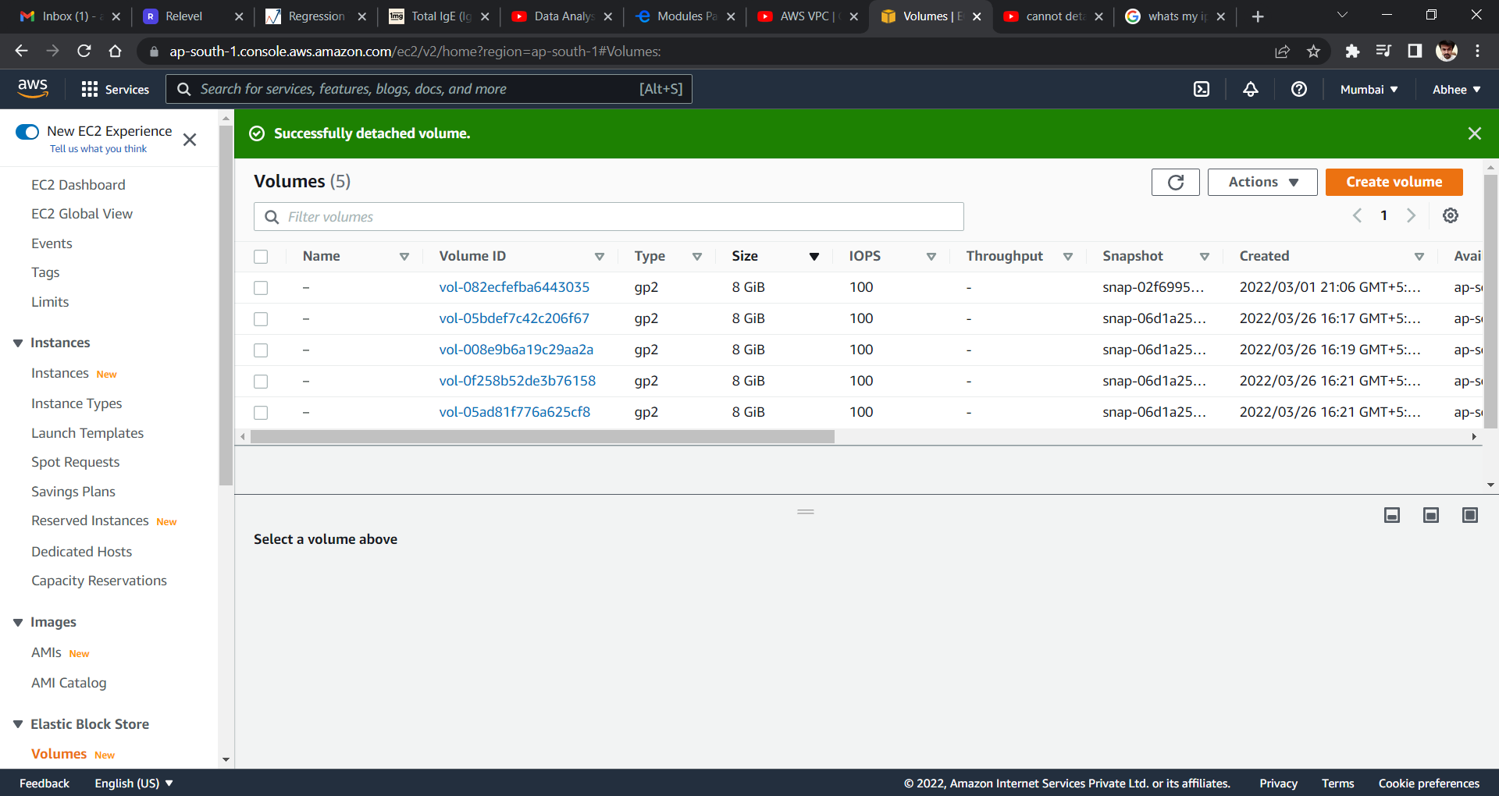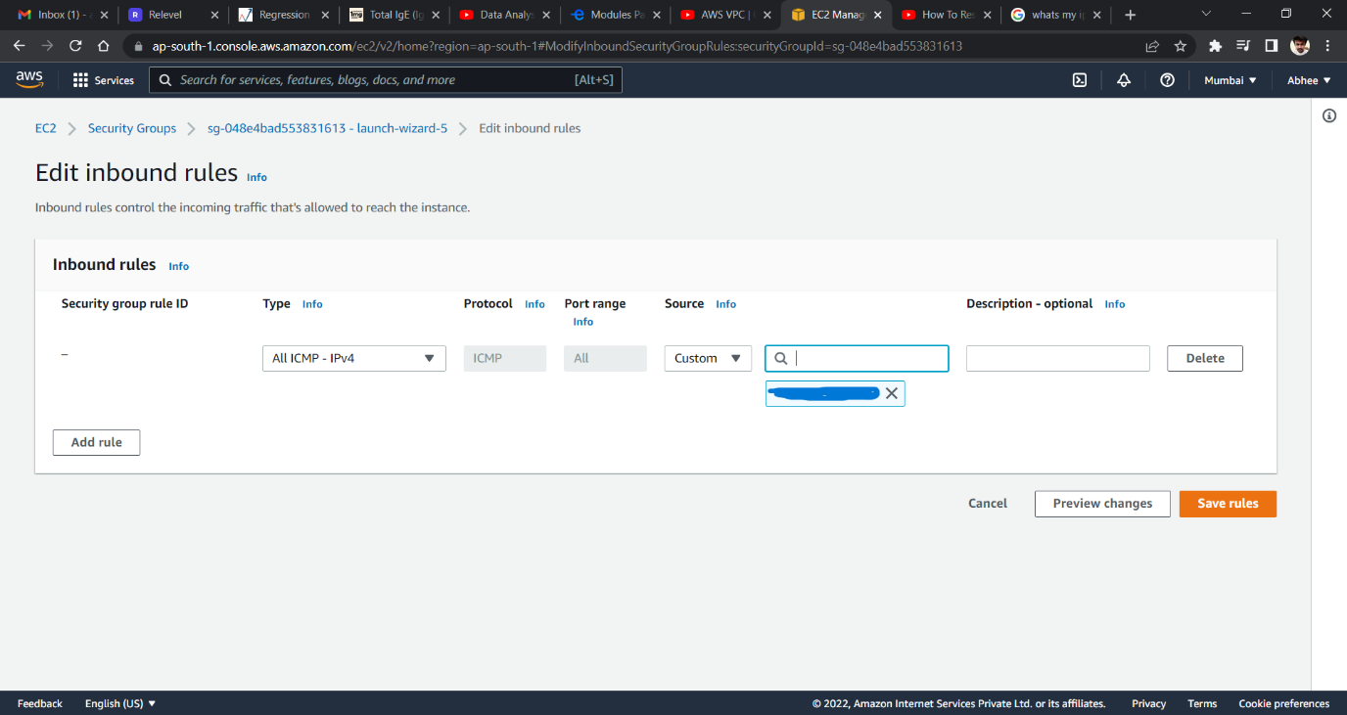

Hello Sir, I didn’t know how to submit this assignment and it went overdue. I also tried asking this issue from support but couldn’t get any solution. But I luckily took screenshot of 2 of the steps.

I also tried to check the response of VPC by using my IP address and it worked fine. [ in command prompt > ping ip address]

But got failed to remove the volume from Instance. So, I closed the instance and then detached the volume. I am not aware of Unmount and then Detaching method.