

Music Festival Cross platform Application

Author: Muhammad Abdullah

Supervised by: Shane wilson

A report submitted in partial fulfilment of the requirements for “Cross Platform Development”

BSc (Hons) in Computing in Applied Computing

Submitted to Atlantic Technological University

*Arna chur isteach chuig Ollscoil Teicneolaiochta an Atlantaigh*

# Table of Contents

Declaration 4

Acknowledgements 5

Abstract 6

Acronyms 7

Table of Contents 8

1. Introduction 1

2. Comparison 3

2.2. React Native 3

2.3. Flutter 4

2.4. .NET MAUI 5

3. Technology Evaluation of .NET MAUI 3

4. Architectural design 3

5. Visual of .NET MAUI 3

6. Conclusion 3

7. Reference 3

# Introduction

The development of native mobile applications required a highly specialized in programming. For Example, creating a mobile application for iPhone devices required knowledge of swift programming and for Android devices, you need knowledge of JAVA programming, and even more, still requires a development experience of some years in the industry. If you notice this, an eCommerce business owner needs a website for visible on desktop devices and mobile applications for iOS and Android devices [1]. Shoaibe Anwar highlight that “ Throughout the technology trends keep evolving and changing over time, the challenges of the development of platform-specific applications remain the same, as each platform has its own architecture and set of development tools for app creation”[2]. A cross-platform architecture solution is much more affordable, saving time and reducing the cost and effort and rapid delivery [1].

# Technology Evaluation

This research section is focuses on the cross-platform tools that we could use to develop Geil Music Festival application. Major cross-platform tools that are popular and known that are serving the software application industries very well are as follows:

### React Native and React:

React Native is a well-known open-source framework based on JavaScript released by Facebook in 2015. It allows developers to create natively-rendered mobile applications for Android, and iOS platforms by using the same codebase [3].

React and React Native components use React’s declarative UI paradigm and JavaScript to communicate with native APIs. This makes mobile app development quick and fast including multiple platforms. The native components of react native fully perform for both Android and iOS. This means that users of the hybrid iOS or Android app will have the same experience as they would have had with the native version [2].

React native based on a component-based approach means a component once created can be reused which helps to speed up the development process [5].

### Flutter

When we talk about cross-platform development tools, then one of the popular ones in meantime is the Flutter. Google develops Flutter to help developers to develop a single codebase application for multiple OS platforms like Android, iOS, window phones, and desktops. Google themselves says Flutters is a UI toolkit. Currently, web support is in the beta phase, while desktop (Linux, macOS, Windows) support is still in the alpha phase [4].

**Layered Architecture model:** According to flutter docs Flutter is based on a layered Architectural modal, which means it flutter is caped in layers with a series of independent libraries depending on the underlying layer these layers are the pieces on which flutter is developed [10]. Flutter is capped into three layers that we discuss:

Flutter uses a **Platform-Specific Embedder** which is the lower layer of flutter architecture. Embedder is written in the platform-specific language, they interact with the underlying native operating system. Embedder integrates the dart code into the native application as a module or as a complete application [10].

**Flutter Engine** is the backbone of flutter. It is written in C++. It takes care of the implement flutter API, file and network input and output request, text layouts etc. flutter framework use the flutter engine through dart:ui which cap the principal C++ code in Dart classes [10].

The **flutter Framework layer** is the top layer of flutter architecture, it is written in Dart programming language. Dart developed by Google, is written in C and C++, it’s an object-oriented programing language. Application development Within the flutter framework developer codes in Dart to create widgets, rendering, material and Cupertino [10].

Everything inside the flutter application that you can see is a **Widget** for example Text, Row, Column, Container, and Scanfold all our widgets. Widgets are the same concept of react js and react Native component. All the configuration and state changes from one state to another are implemented on the widget. Every single page of flutter application consist of trees of widgets that run inside of runApp() function [11].

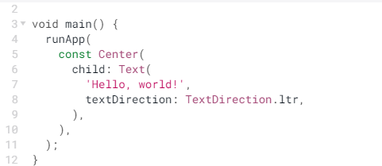

Fig.1 Flutter widget[11]

In the Fig1. there are two widgets center widgets and within it Text widgets [11].

### NET MAUI

### Microsoft release .NET MAUI, which is an “evolution of XamarinForms”. .NET MAUI lets developers combine Android, iOS, macOS, and Windows APIs into a single API. That means developers can code one app with C# and XAML that runs natively on many platforms. Microsoft announced .NET MAUI in .NET 7 RC1 in September 2022, and .NET 7 is also released[9].

.NET MAUI 6 or greater contains Base Class Library(BCL) which make your app run on different platforms, it depend on runtime execution environment ,one is known as Mono for Android ,iOS ,and macOS devices and .NETCore CLR for only Windows devices[6].

.NET MAUI API read your C# code and feed it to each of native platform API’s. For Android, .NET MAUI API compile C# code into intermediate language (IL) and then into Android native assembly. For iOS , it compile C# code to iOS ARM assembly code[6].

.NET MAUI API use Mac Catalyst for building macOS apps and Window WinUI 3 library for building native app. A simple MAUI app project contain a Platforms folder describe five specific platform. Within the Android folder contain AndroidManifist.xml, MainActivity , MainApplication these are android specific file , iOS and MacCatalyst both have AppDelegate, info.plist and Program file, and similarly Tizen and Windows have native platform specific file[6].

.NET MAUI using **XAML** ( eXtensible application markup language) for implement of user interface of .NET MAUI app like layouts, pages, flyouts using shell,tabbars . But XAML is not necessary for .NET MAUI apps but its recommended approach because of it high tooling supports and it’s also suited for MVVM (Model-View-ViewModel) pattern, where view is written in XAML and then we linked the viewModel and View using XAML-based data binding[7].

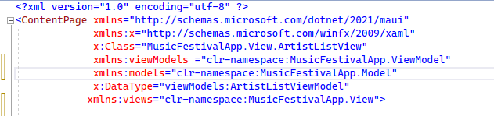

Fig 2

.Net maui user interface is developed on **controls** object of the maui control these object that map the xaml code to native controls of the each target platform. The .Net Maui main control group used to create Pages(such as contentPage, flyout, navigation and tabbed) , layouts( stacklayout, grid, flexlayout) and views ( such as collectionView, Frame,Image,scrollView) of the app[8].

### Cross platform comparison

when we comparison the three cross platform to we need to under in mind that our Geil Music festival application works for all the cross platform natively we need to discuss which tool has cover all the platform and able to access the native module.

If we discuss **native modules access** of the react native consumes different libraries to access the native feature of the platform for examples Bluetooth, geo location, access files, we need to install these libraries for accessing specific features from npm package manager [2]. Flutter usesPlatform-Specific Embedderwhich is written in native languages java, swift, C#. Embedders interacts with underlying native operating system and integrate the dart code in to native application as a module or as a complete application [10]. If you read Microsoft docs about .NET MAUI 6 or greater contains Base Class Library(BCL) which make your app run on different platforms, it depend on runtime execution environment ,one is known as Mono for Android, iOS and macOS devices and .NETCore CLR for only Windows devices [6].

When we talk about the **development language** then, first of all, react native use javascript, the most popular and favorite programming language by developers for front end development. React native allow the developers to write modules in n Objective-C, C++, Python, or Java languages [2]. Flutter is framework, which is written in dart programming language, which is introduced by google, it is object-oriented and adaptable programming language written by C an C++ [10]. Net Maui you can write code in C# and XAML. C# developed by Microsoft [6].

React native reduce the **development time** for the mobile application development, by adds more to the user interface and take less time to the to developing project but react native is only for mobile application development for developing application for web you need to use react js library which increases the for developing the application for the half one and half one [2]. On the other hand, Inside flutter app there is trees of widget(text, button etc), and API’s make the development in a streamline, and hot reload feature make the development easy without reloading the entire app [2].Net Maui allows to make frontend and the backend of the application on the single platform. Net Maui works on MVVM design pattern that saperates view, models and viewmodel. The view have the xaml code, they are the frontend of the Maui app and the viewmodel is in C#, viewmodel behaves as a intermediary layer between views and models, the views and viewmodel are bind together through data binding from properties between visual objects and the underlying data by using BindingContext [12].

When we talk about **user experience** then React Native have it own native UI controllers to provide a better user experience, these UI controller smoothly work for both android and iOS devices [2]. UI of Flutter widgets provide best user experience. Flutters widgets are built-in UI components that replace native components. Flutter layered architecture makes the widgets UI flexible and also ensure to render graphics quickly, supports widgets customization [2]. .Net Maui is fast, smooth , its because of it MVVM design model pattern , in which viewmodel build the connection between views and models to bind data easily [12]

### Selection

Shoaibe Anwar says the selection createria for choosing the cross-platform tools for the software development, is depends on platform coverage, user experience, and application development play an important role in selecting cross-platform tools for a specific application[2] like Geil Music Festival app. Especially, in Geil Music Festival appliation the UI/UX is critical for the experiment, and API capabilities of the tool with all native platform are also important for getting access to the native device. .Net MAUI stands out among these three cross-platform tools a best choice because it comes with mvvm pattern makes data binding easily and quickly, device API access, single project for the front and the backend development, provide builtin pages, views and layouts which make software development easily.

### Architectural design

Architectural design of Geil music festival is as follow

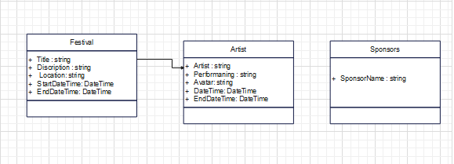

Fig.4

1. **Visual design**

This is the visual design section of the geil music festival app contain all the screenshots of the application fig 5 is the welcome page of the application shows the invitation for the festival.

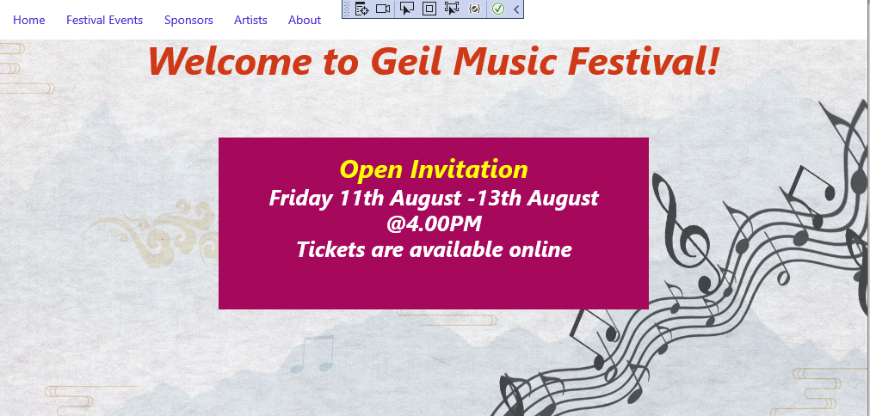

Fig.5

This fig 6 is the festival events page, which shows all the events going to happened by date.

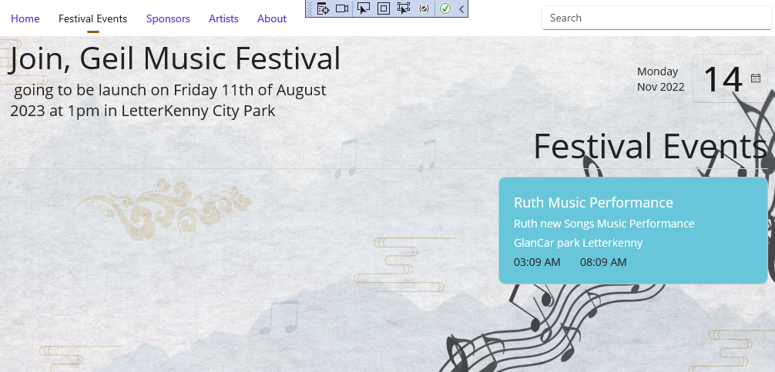

Fig.6

This Fig 7 represent the list of artist going to perform in the festival

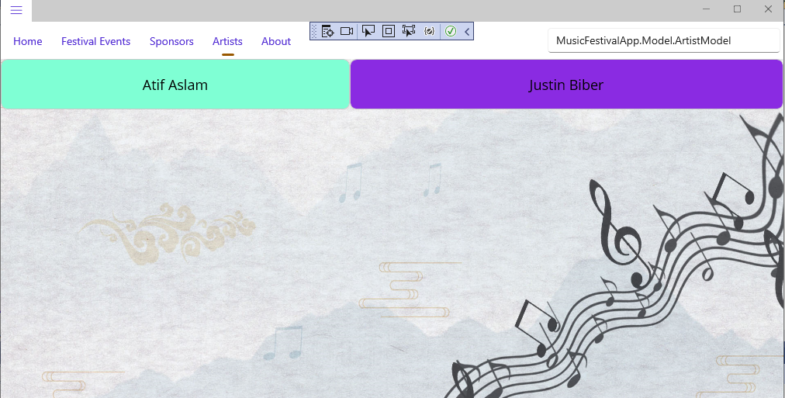

Fig 7

This Fig.8 represent the Artist detail page when a use search an artist and press enter, he move to this screen

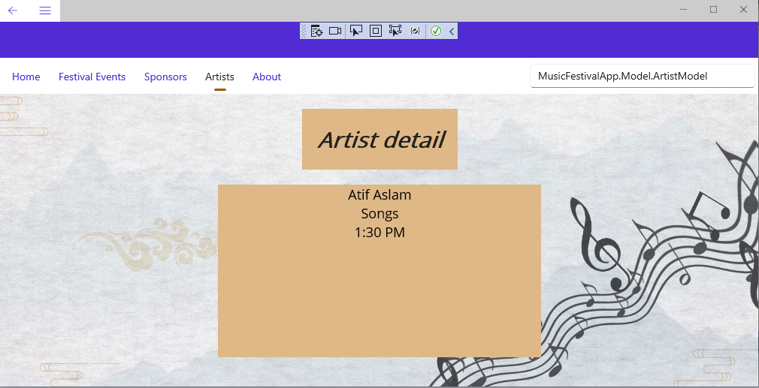

Fig.8

The fig 9 , below image is used as a background image of my website



(Fig 9 pngTree, source <https://pngtree.com/freebackground/music-and-landscape-poster-background_1123969.html> )

1. **Conclusion**

As we are looking to develop our Geil Music festival application using cross-platform tools then its need to in mind the selection criteria , and most important is how many platforms it can covers. This is also about saving time and reducing the cost and effort and rapid delivery of software. The cross-platform tool selection process will be easy if the characteristics of the application can be fallen into the parameters selected for this analysis.

This report, shows the unique and distinct features of each of the cross-platform we have discussed. This report is enough to choose one cross-platform tools for geil music festival application. As we already evaluated and selected tool, after evaluating on all three platforms unique feature, Net maui is best suited provides all the supports in developing Geil music festival application due to great documentation and available online resource

1. **Reference**

[1] Paulo R. M. de Andrade, Adriano B. Albuquerque, “CROSS PLATFORM APP  COMPARATIVE STUDY” available:<https://arxiv.org/ftp/arxiv/papers/1503/1503.03511.pdf>  , [accessed February 2015]

[2] Md Shoaibe Anwar, Dec 2021 “Comparison and evaluation of cross-platform framework and development of a digital health platform using selected framework”, available:<http://uu.diva-portal.org/smash/get/diva2:1626535/FULLTEXT01.pdf> , [accessed: December 2021]

[3] Elizabeth Boyarko, “Cross-Platform App Development: NativeScript vs React Native”, source: [**https://www.upsilonit.com/blog/cross-platform-app-development-nativescript-vs-react-native-what-to-choose**](https://www.upsilonit.com/blog/cross-platform-app-development-nativescript-vs-react-native-what-to-choose) [accessed: june 2022]

[4] ADIBBIN HAIDER, “Evaluation of cross-platform technology Flutter from the user’s perspective”,available:<https://kth.diva-portal.org/smash/get/diva2:1616654/FULLTEXT01.pdf>    , [accessed: October 3, 2021]

[5] Anastasia Moroz, Article :“Cross-Platform Mobile App Development: All You Need to Know” available:<https://www.upsilonit.com/blog/cross-platform-mobile-app-development-all-you-need-to-know> [accessed:April 2022]

[6] Microsoft, “What is .NET MAUI” source : <https://learn.microsoft.com/en-us/dotnet/maui/what-is-maui?view=net-maui-7.0> ,[accessed: 11/8/2022]

[7] Microsoft, “XAML” , source: <https://learn.microsoft.com/en-us/dotnet/maui/xaml/?view=net-maui-7.0> , [accessed: 24, june,2022]

[8] Microsoft, “Controls”, source: <https://learn.microsoft.com/en-us/dotnet/maui/user-interface/controls/?view=net-maui-7.0#pages> [Accessed: 11/08/2022]

[9]David Ramel, “.NET MAUI in .NET 7 Fills In Xamarin Gaps”, source: <https://visualstudiomagazine.com/articles/2022/09/22/net-maui-rc1.aspx>, accessed:09/22/2022

[10] flutter documentation, “architecture overview”, <https://docs.flutter.dev/resources/architectural-overview>

[11] flutter documentation ,”introduction to widgets”,“ <https://docs.flutter.dev/development/ui/widgets-intro> ”

[12] Microsoft ,”Simple MVVM”, <https://learn.microsoft.com/en-us/dotnet/maui/xaml/fundamentals/mvvm?view=net-maui-7.0#simple-mvvm>