// // // // // // // /// // //////////

// //

// Node-js Learn Stream //

// ================= //

// //

/// // // // // // // // // // // /////

source youtube video:https://youtu.be/ev5pgydOhT8

Each type of stream is an EventsEmitter instance and throw single or multiple events at different intance of time.

these events are fired:

data-> when data available to read.

end-> when data not available to read.

error-> when there is any error in recieving and writing data.

finish-> when all the data is finished or flushed to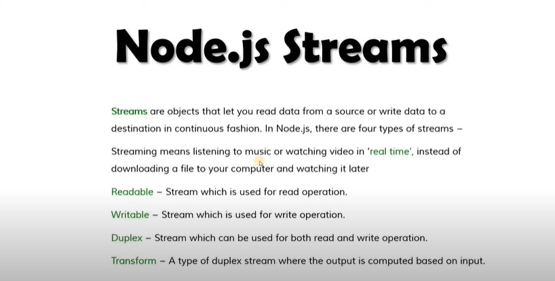 underlying thread or system