

Railway Maintenance System — System Design Document

System Design & Development Proposal

Railway Cargo & Equipment Maintenance Management System

Cleveland State University — IST 621 Advanced Systems Analysis & Design

Abheeshek Baskar • Lakshya Bharani • Group 10

Serial  No. | Contents | Page No
1 | Needs Assessment | 3
2 | Problem Statement | 3
3 | Root Cause Analysis | 3
4 | Change Strategy | 5
5 | Change Strategy Subsections | 7
6 | Change Strategy — Transition Plan | 8
7 | Stakeholder Power/ Interest Grid | 10
8 | Stakeholder Analysis | 11
9 | Interview Guide for Key Stakeholders | 12
10 | Document Analysis | 13
11 | Essential Features | 15
12 | User stories, Backlogs, Sprints | 17
13 | Backlogs and sprints break down | 18
14 | Prototype | 22

- Needs Assessment

I. Needs Assessment

In conducting a comprehensive needs assessment for the railway cargo and equipment maintenance sector, it is imperative to evaluate current processes and practices, analyze stakeholder needs and expectations, monitor market and industry trends, assess regulatory and compliance requirements, review technological landscape, and conduct financial analysis. This multifaceted approach allows stakeholders to identify inefficiencies, understand stakeholder priorities, anticipate industry challenges and opportunities, ensure regulatory compliance, explore technological advancements, and weigh financial implications, ultimately facilitating the development of informed strategies to drive positive change and achieve desired outcomes in railway cargo and equipment maintenance operations.

- Problem statement:

The current state of railway cargo and equipment maintenance operations presents significant challenges for both individual consumers and government entities reliant on railway transportation. Inefficiencies in cargo handling, characterized by a lack of streamlined processes and outdated technology, result in delays, errors, and increased operational costs. Limited accessibility to maintenance services for critical railway equipment leads to fragmented scheduling, increased downtime, safety concerns, and potential regulatory compliance issues. Moreover, suboptimal service quality, marked by inconsistent delivery and inadequate communication channels, contributes to widespread dissatisfaction among stakeholders. These challenges have far-reaching implications, disrupting supply chains, increasing costs, and posing safety risks. Addressing these issues requires comprehensive reforms to modernize infrastructure, improve maintenance practices, and enhance service quality standards. Failure to do so risks undermining the efficiency, safety, and reliability of railway transportation systems, with significant consequences for the economy and stakeholders alike.

- Root Cause Analysis:

The root cause analysis of the challenges faced in railway cargo and equipment maintenance operations reveals several underlying factors contributing to the inefficiencies, limited accessibility, and suboptimal service quality.

1.Outdated Infrastructure and Technology:

The reliance on outdated infrastructure and technology is a fundamental issue affecting cargo handling and maintenance operations. Manual tracking methods and legacy systems contribute to inefficiencies by hindering data accuracy, accessibility, and real-time monitoring. Lack of modern technology solutions such as integrated cargo tracking systems and predictive maintenance tools exacerbates delays, errors, and maintenance scheduling issues.

2. Fragmented Maintenance Processes

Fragmented maintenance processes, characterized by disjointed scheduling and coordination efforts, stem from inadequate communication and collaboration among stakeholders. Government agencies, railway operators, and maintenance crews often operate in silos, leading to miscommunication, redundant tasks, and inefficiencies in resource allocation. This fragmentation results in suboptimal utilization of maintenance resources, increased downtime, and compromised safety standards.

3. Insufficient Investment in Infrastructure and Training:

Insufficient investment in railway infrastructure and workforce training exacerbates the challenges faced in maintenance operations. Aging infrastructure, including tracks, signals, and rolling stock, requires significant maintenance and upgrades to ensure reliability and safety. However, limited funding and resources constrain the ability to address maintenance backlog and implement modernization initiatives. Additionally, inadequate training and skill development programs for maintenance crews lead to subpar performance, increased error rates, and safety incidents.

4. Regulatory Constraints and Compliance Challenges:

Regulatory constraints and compliance challenges impose additional burdens on railway cargo and equipment maintenance operations. Stringent regulatory requirements, including safety standards, environmental regulations, and industry certifications, necessitate meticulous adherence and documentation. However, navigating complex regulatory frameworks and ensuring compliance adds administrative overhead, delays maintenance activities, and increases operational costs. Moreover, evolving regulatory landscapes and inconsistent enforcement practices further compound compliance challenges for railway operators and maintenance providers.

5. Lack of Stakeholder Alignment and Accountability:

The lack of stakeholder alignment and accountability contributes to the persistence of challenges in railway maintenance operations. Ambiguous roles and responsibilities among government agencies, railway operators, and maintenance providers lead to finger-pointing, blame-shifting, and a lack of ownership over problems and solutions. Without clear accountability mechanisms and collaborative frameworks, addressing root causes and implementing effective solutions becomes challenging, perpetuating the cycle of inefficiencies and suboptimal service quality.

Addressing these root causes requires a multi-faceted approach encompassing investments in modern technology, streamlined processes, workforce development, regulatory reform, and stakeholder engagement. By addressing these underlying factors, railway cargo and equipment maintenance operations can be transformed to achieve greater efficiency, accessibility, and service quality, benefiting both individual consumers and government entities.

Five Whys Technique to identify the root cause of a specific maintenance issue in cargo equipment:

- Why is there a delay in maintenance of cargo locomotives?

Ans: Because the maintenance schedule is not being followed.

- Why is the maintenance schedule not being followed?

Ans: Because there is a lack of clear communication about maintenance priorities.

- Why is there a lack of clear communication about maintenance priorities?

Ans: Because there is no centralized system for prioritizing maintenance tasks and assigning responsibilities.

- Why is there no centralized system for prioritizing maintenance tasks and assigning responsibilities?

Ans: Because there is no standardized procedure in place, and responsibility is unclear among maintenance crews and supervisors.

- Why is there no standardized procedure for prioritizing maintenance tasks and assigning responsibilities?

Ans: Because there hasn't been sufficient training provided to maintenance crews and supervisors on maintenance planning and coordination protocols.

- Change Strategy

The change strategy to transition from the current state to the desired future state of the railway cargo and equipment maintenance system involves a comprehensive approach, considering various factors such as organizational readiness, costs, timelines, alignment with business objectives, value realization, and opportunity costs.

1.Organizational Readiness Assessment:

Conducting a thorough assessment of organizational readiness is crucial to gauge the readiness of stakeholders, including government agencies, railway operators, maintenance crews, and technology providers. This involves evaluating factors such as leadership commitment, workforce capabilities, change management capabilities, and organizational culture. Identifying gaps and barriers to change early in the process enables proactive mitigation strategies to be implemented.

2. Cost-Benefit Analysis:

Performing a cost-benefit analysis is essential to assess the financial implications of the proposed changes. This involves quantifying the costs associated with system development, implementation, training, and ongoing maintenance, as well as estimating the potential benefits, including cost savings, efficiency gains, and revenue generation opportunities. By comparing costs and benefits, decision-makers can make informed investment decisions and prioritize initiatives that offer the greatest return on investment.

3. Timelines and Milestones:

Developing clear timelines and milestones is essential to ensure timely progress and accountability throughout the change process. This involves creating a detailed project plan with defined milestones, deliverables, and timelines for each phase of the project, from requirements gathering and system development to testing, implementation, and post-launch support. By establishing clear timelines and milestones, project teams can track progress, identify potential delays, and take corrective action as needed to keep the project on track.

4. Alignment with Business Objectives:

Ensuring alignment with business objectives is critical to the success of the change initiative. This involves aligning the proposed changes with the strategic goals and priorities of the organization, including improving operational efficiency, enhancing customer satisfaction, reducing costs, and achieving regulatory compliance. By demonstrating how the proposed changes support broader business objectives, stakeholders are more likely to buy into the change and actively support its implementation.

5. Value Realization Plan:

Developing a value realization plan is essential to ensure that the expected benefits of the change initiative are realized. This involves identifying key performance indicators (KPIs) and metrics to measure the success of the initiative, such as improved cargo handling times, reduced maintenance downtime, increased customer satisfaction, and cost savings. By tracking progress against these KPIs, stakeholders can assess the impact of the changes and make data-driven decisions to optimize performance and maximize value.

6. Opportunity Costs Consideration:

Considering opportunity costs is essential to evaluate the trade-offs associated with the proposed changes. This involves assessing the potential costs of not implementing the changes, including lost revenue opportunities, increased operational risks, and reputational damage. By weighing the opportunity costs against the benefits of the proposed changes, decision-makers can make informed decisions about resource allocation and prioritize initiatives that offer the greatest potential for value creation.

By incorporating these elements into the change strategy, stakeholders can effectively navigate the transition from the current state to the desired future state of the railway cargo and equipment maintenance system, maximizing the likelihood of success and realizing the full potential of the proposed changes.

- Change Strategy Subsections:

Current State Description:

Assessing the existing system's capabilities involves a comprehensive evaluation of various aspects to understand the current state of railway cargo and equipment maintenance operations.

Organizational Goals:

Evaluate the current organizational goals and objectives related to railway cargo and equipment maintenance. This includes understanding the strategic direction, priorities, and performance metrics set by government agencies, railway operators, and maintenance providers.

Competitiveness:

Analyze the competitive landscape within the railway transportation industry to assess the current system's competitiveness. This involves benchmarking against industry standards, best practices, and competitor offerings to identify strengths, weaknesses, opportunities, and threats.

Resources:

Assess the resources available to support railway cargo and equipment maintenance operations. This includes evaluating human resources, technology infrastructure, financial resources, and external partnerships to determine the adequacy and alignment with organizational goals.

External Influences:

Identify external factors and influences impacting railway cargo and equipment maintenance operations. This involves considering regulatory requirements, industry trends, technological advancements, market dynamics, and geopolitical factors influencing the railway transportation sector.

Future State Description:

Outlining the desired features and functionality of the improved system provides a clear vision of the future state to be achieved through the change initiative.

Enhanced Efficiency:

Design the future system to improve operational efficiency in cargo handling and maintenance processes. This may include implementing automation, digitization, and optimization techniques to streamline workflows, minimize delays, and optimize resource utilization.

Improved Accessibility:

Ensure the future system provides enhanced accessibility to maintenance services for railway equipment. This involves optimizing maintenance scheduling, improving communication channels, and leveraging technology solutions for remote monitoring and real-time decision-making.

Enhanced Service Quality:

Focus on enhancing service quality to meet customer expectations and industry standards. This includes improving service delivery processes, enhancing transparency, and implementing quality assurance measures to ensure consistent and reliable service outcomes.

Innovative Features:

Incorporate innovative features and functionalities into the future system to drive competitive advantage and differentiation. This may involve integrating advanced technologies such as IoT, AI, and data analytics to enable predictive maintenance, optimize operations, and enhance decision-making capabilities.

- Change Strategy — Transition Plan

Selecting an appropriate strategy for transitioning from the current state to the desired future state of the railway cargo and equipment maintenance system involves careful consideration of various factors, including organizational readiness, costs, timelines, alignment with business objectives, value realization, and opportunity costs. By weighing these factors, the following strategy is proposed.

Assess Organizational Readiness:

Evaluate the organization's readiness for change by assessing factors such as leadership support, employee skills, and culture. Conduct surveys, interviews, and workshops to gauge the level of readiness and identify potential barriers to change.

Cost-Benefit Analysis:

Perform a comprehensive cost-benefit analysis to assess the financial implications of the proposed changes. Estimate the costs associated with system development, implementation, training, and ongoing maintenance, and compare them to the expected benefits in terms of improved efficiency, reduced costs, and increased revenue.

Develop Timelines and Milestones:

Create detailed timelines and milestones to guide the implementation process. Establish clear deadlines for key deliverables and milestones, and regularly monitor progress against these targets to ensure that the project stays on track.

Align with Business Objectives:

Ensure that the proposed changes align with the organization's overall business objectives and strategic priorities. Identify how the project will contribute to achieving these objectives and communicate the alignment to stakeholders to garner support and buy-in.

Maximize Value Realization:

Develop a plan to maximize the realization of value from the proposed changes. Identify key performance indicators (KPIs) and metrics to measure the success of the project, and implement mechanisms to track and monitor progress against these metrics.

Consider Opportunity Costs:

Consider the opportunity costs associated with the proposed changes, including the costs of not implementing the changes and the potential benefits that could be foregone as a result. Compare these opportunity costs to the expected benefits of the project to ensure that the benefits outweigh the costs.
Based on this analysis, the selected strategy will prioritize organizational readiness, ensure alignment with business objectives, and maximize value realization while minimizing costs and opportunity costs.

- Stakeholder List

- Government Agencies (e.g., Department of Transportation)
- Railway Operators (e.g., National Railway Company)
- Maintenance Crews and Technicians
- Technology Providers and Vendors
- Regulatory Bodies (e.g., Federal Railroad Administration)
- Freight Companies and Cargo Handlers
- Labor Unions (e.g., Railway Workers Union)
- Financial Stakeholders (e.g., Investors, Shareholders)
- Customers and End Users
- Community and Environmental Groups

Stakeholder Power/Interest Grid:
The Stakeholder Power/Interest Grid categorizes stakeholders based on their level of power and interest in the system development project, helping to prioritize engagement efforts and manage relationships effectively.

High Power/High Interest:

- Government Agencies
- Regulatory Bodies
- Railway Operators
- Financial Stakeholders

High Power/Low Interest:

- Technology Providers
- Freight Companies

Low Power/High Interest:

- Maintenance Crews and Technicians
- Labor Unions
- Community and Environmental Groups

Low Power/Low Interest:

- Customers and End Users

- Stakeholder Power/Interest Assessment

High Power/High Interest:

Government Agencies: Government agencies such as the Department of Transportation wield significant power and have a high interest in the outcome of the project as they are responsible for regulatory oversight and policy formulation related to railway transportation. Their involvement is crucial for obtaining regulatory approvals, funding, and support for the project.

Regulatory Bodies: Regulatory bodies like the Federal Railroad Administration hold substantial power and interest in ensuring compliance with safety standards, regulations, and industry practices. Their engagement is critical for obtaining regulatory approvals, ensuring adherence to standards, and mitigating compliance risks.

Railway Operators: Railway operators, including national railway companies, possess considerable power and interest as they are directly responsible for operating and maintaining railway infrastructure. Their involvement is essential for implementing changes, providing operational insights, and ensuring alignment with operational needs.

Financial Stakeholders: Financial stakeholders such as investors and shareholders hold significant power and interest in the project's outcome as they provide funding and expect a return on their investment. Their engagement is vital for securing financial support, managing budgetary constraints, and ensuring financial sustainability.

High Power/Low Interest:

Technology Providers: Technology providers and vendors may have high power due to their expertise and resources but may have low interest in the project's outcome if it does not directly impact their business interests. Their involvement may be limited to providing technical solutions and support as contracted.

Freight Companies: Freight companies and cargo handlers may have high power in influencing operational decisions but may have low interest in the project's outcome if it does not significantly affect their operations. Their involvement may be focused on ensuring minimal disruption to freight operations and compliance with service level agreements.

Low Power/High Interest:

Maintenance Crews and Technicians: Maintenance crews and technicians may have limited power but high interest in the project's outcome as they are directly involved in executing maintenance activities and rely on the effectiveness of the system for their daily tasks. Their involvement is crucial for providing insights into operational challenges, identifying user requirements, and ensuring system usability.
Labor Unions: Labor unions representing railway workers may have limited power individually but collectively exert influence on labor relations and workforce management. They have a high interest in the project's outcome, particularly concerning workforce impacts, job security, and working conditions. Their involvement is essential for addressing labor-related concerns, ensuring workforce buy-in, and mitigating resistance to change.
Community and Environmental Groups: Community and environmental groups may have limited power but high interest in the project's outcome due to potential impacts on local communities, natural habitats, and environmental sustainability. Their involvement is critical for addressing environmental concerns, engaging with affected communities, and ensuring compliance with environmental regulations.

Low Power/Low Interest:

Customers and End Users: Customers and end users of railway cargo and equipment maintenance services may have limited power and low interest in the project's technical details or implementation process. Their primary concern is receiving reliable, cost-effective, and timely services. However, their feedback and input are valuable for understanding user requirements, preferences, and expectations, thereby shaping the design and functionality of the system.

- Interview Guide for Key Stakeholders:

Introduction:

Thank you for participating in this interview. Your input is crucial for the success of our railway cargo and equipment maintenance system development project. The purpose of this interview is to gather your insights, requirements, and expectations regarding the current challenges and desired improvements in railway maintenance operations. We will be using a combination of structured and unstructured approaches to ensure a comprehensive understanding of your perspectives. Please feel free to share any additional thoughts or concerns throughout the interview.

Structured Questions:

1.For Government Agencies/Regulatory Bodies:

- What are the key regulatory requirements and standards that govern railway cargo and equipment maintenance operations?
- How do you currently oversee and regulate maintenance activities to ensure compliance with safety standards and regulations?
- What are the main challenges or pain points you encounter in regulating and monitoring railway maintenance operations?
- What specific features or functionalities would you like to see in a new system to enhance regulatory oversight and enforcement?

2. For Railway Operators:

- What are the primary objectives and goals of your railway cargo and equipment maintenance operations?
- What are the main challenges or inefficiencies you encounter in managing maintenance activities and ensuring operational reliability?
- How do you currently schedule and prioritize maintenance tasks, and what factors influence your decision-making process?
- What improvements or enhancements do you envision for the maintenance system to better meet your operational needs and objectives?

3. For Maintenance Crews and Technicians:

- Can you describe your daily tasks and responsibilities related to railway cargo and equipment maintenance?
- What tools, resources, or systems do you currently use to perform maintenance activities, and what are their strengths and limitations?
- What are the most common challenges or obstacles you face in executing maintenance tasks effectively and efficiently?
- How do you think a new maintenance system could help address these challenges and improve your work processes?

Unstructured Questions:

4. For all Stakeholders:
- Can you share any specific incidents or experiences that highlight the need for improvements in railway maintenance operations?
- What are your expectations for the outcome of this system development project, and how do you envision it impacting your role or operations?
- Are there any additional concerns, suggestions, or feedback you would like to share regarding railway maintenance operations or the development of a new system?

Closing:

Thank you once again for your valuable input. Your insights will be instrumental in shaping the design and functionality of the new railway cargo and equipment maintenance system. If you have any further thoughts or questions, please don't hesitate to reach out to us.

- Document Analysis

Analyzing existing documents related to the railway cargo and equipment maintenance system provides valuable insights into current functionalities, user workflows, and operational processes. Key documents to review include user manuals, system specifications, maintenance logs, incident reports, and business process documents. By thoroughly examining these documents, we can identify gaps, inefficiencies, and areas for improvement in the existing system.

Possible Solutions:

In response to the identified challenges in railway cargo and equipment maintenance operations, several possible solutions can be considered to improve system efficiency, accessibility, and service quality. Each solution aims to address specific aspects of the problem and enhance overall performance.

Implementation of a Centralized Maintenance Management System:

Introduction: Introduce a centralized maintenance management system to streamline maintenance workflows, optimize resource allocation, and enhance coordination between maintenance crews and operators.

Benefits:
Improved tracking and management of maintenance tasks, schedules, and resources.
Enhanced visibility into equipment status, performance metrics, and maintenance history.
Streamlined communication and collaboration among stakeholders, leading to faster response times and reduced downtime.

Costs:
Initial implementation costs for software procurement, customization, and integration.
Training costs for users and administrators to familiarize them with the new system.
Ongoing maintenance and support expenses for software updates, troubleshooting, and system enhancements.

Integration of Predictive Maintenance Technologies:
Introduction: Integrate predictive maintenance technologies, such as IoT sensors and data analytics, to enable proactive maintenance interventions, reduce equipment downtime, and prevent costly failures.

Benefits:
Early detection of equipment abnormalities and potential failure risks, allowing for timely maintenance interventions.
Optimization of maintenance schedules and resource allocation based on real-time equipment condition data.
Reduction in unplanned downtime, maintenance costs, and operational disruptions.

Costs:
Investment in IoT sensors, data analytics platforms, and predictive maintenance software.
Integration costs for connecting sensors to existing equipment and systems.
Data management and analysis expenses for processing and interpreting sensor data.

Enhancement of User Interface and Accessibility Features:
Introduction: Enhance the user interface and accessibility features of the maintenance system to improve user experience, facilitate usability, and increase user adoption rates.

Benefits:
Intuitive user interface design, tailored to the specific needs and preferences of maintenance crews and operators.
Accessibility features, such as mobile compatibility and multi-language support, to accommodate diverse user demographics and working environments.
Training materials and user guides to assist users in navigating the system effectively and maximizing its utility.

Costs:
Investment in user interface redesign, usability testing, and accessibility enhancements.
Development costs for creating training materials, user guides, and support resources.
Time and resources allocated for user training and onboarding activities.

Value

Expected Benefits:

Improved Efficiency: Streamlined maintenance workflows and proactive interventions result in reduced downtime and increased operational efficiency.
Enhanced User Experience: Intuitive user interface design and accessibility features improve user satisfaction and productivity.
Compliance with Regulations: Integration of predictive maintenance technologies ensures compliance with safety and regulatory standards.

Expected Costs:

Implementation Costs: Initial investment in software procurement, customization, and integration.
Maintenance Requirements: Ongoing expenses for software updates, data management, and system maintenance.
Resource Allocations: Allocation of time, personnel, and financial resources for training, support, and ongoing system management.

- All main features of your project based on Essential Features of Project Mobile App

User Authentication and Authorization:

Secure login functionality for different user roles such as maintenance crews, operators, administrators, and regulators.
Role-based access control to ensure appropriate permissions and data privacy.

Dashboard and Real-time Monitoring:

Interactive dashboard providing real-time insights into maintenance activities, equipment status, and performance metrics.
Visualizations such as charts, graphs, and maps to facilitate data interpretation and decision-making.

Maintenance Task Management:

Task creation, assignment, and tracking functionalities for scheduling and managing maintenance activities.
Prioritization features to identify critical tasks, allocate resources efficiently, and minimize downtime.

Equipment Management:

Comprehensive database of railway equipment, including locomotives, freight cars, tracks, signals, and infrastructure.
Asset tracking capabilities with detailed information on equipment specifications, maintenance history, and compliance status.

Predictive Maintenance:

Integration of predictive maintenance algorithms and IoT sensors to monitor equipment health and predict potential failures.
Automated alerts and notifications for proactive maintenance interventions, reducing unplanned downtime and repair costs.

Work Order Management:

Creation, tracking, and management of work orders for maintenance tasks, inspections, and repairs.
Workflow automation features to streamline approval processes, notifications, and task assignments.

Inventory and Spare Parts Management:

Inventory management system to track spare parts, consumables, and supplies for maintenance activities.
Automated reordering functionality based on predefined thresholds and usage patterns to ensure optimal inventory levels.

Documentation and Reporting:

Centralized repository for storing and accessing maintenance documentation, manuals, and regulatory records.
Customizable reporting tools to generate maintenance reports, performance metrics, and compliance documentation for internal use and regulatory purposes.

Communication and Collaboration:

Built-in messaging and collaboration tools to facilitate communication among maintenance crews, operators, and stakeholders.
Discussion forums, chat channels, and notification systems for sharing updates, alerts, and announcements in real-time.

Mobile Accessibility:

Mobile app compatibility for accessing the system from smartphones and tablets, enabling on-the-go maintenance operations and field inspections.
Responsive design and offline capabilities to ensure usability in remote locations with limited connectivity.

Integration with External Systems:

Seamless integration with existing railway management systems, ERP platforms, and third-party applications for data exchange and interoperability.
API endpoints and data connectors for integrating with IoT devices, sensor networks, and predictive analytics platforms.

Training and Support Resources:

Online training modules, tutorials, and user guides to onboard new users and train them on system functionalities.
Help desk support, FAQ sections, and troubleshooting guides to assist users with technical issues and system inquiries.

- User Stories:

As a maintenance crew member, I want to be able to log in securely to the mobile app so that I can access relevant maintenance tasks and information.
As a maintenance supervisor, I want to view a dashboard displaying real-time insights into maintenance activities and equipment status, so that I can monitor progress and allocate resources effectively.
As an equipment operator, I want to receive automated alerts and notifications for upcoming maintenance tasks and equipment failures, so that I can take proactive action to prevent downtime.
As a maintenance manager, I want to create and assign maintenance tasks to specific crews, prioritize tasks based on urgency, and track their progress in real-time.
As a regulatory compliance officer, I want to access documentation and reports related to maintenance activities and equipment compliance status, so that I can ensure adherence to safety standards and regulations.
As a maintenance technician, I want to be able to access detailed information about equipment specifications, maintenance history, and repair procedures, so that I can perform tasks efficiently and accurately.
As a procurement manager, I want to manage inventory levels, track spare parts and supplies, and receive automatic alerts for reordering when inventory levels are low.
As a system administrator, I want to customize user roles and permissions, configure system settings, and manage integrations with external systems.

- Backlogs:

Sprint 1: Authentication and Dashboard

User authentication functionality
Dashboard layout design
Real-time data visualization components

Sprint 2: Maintenance Task Management

Task creation and assignment feature
Task prioritization functionality
Task tracking and progress monitoring

Sprint 3: Equipment Management

Equipment database setup
Asset tracking and management features
Integration with predictive maintenance tools

Sprint 4: Work Order Management

Work order creation and tracking functionality
Workflow automation features
Approval processes and notifications setup

Sprint 5: Inventory Management

Inventory database setup
Spare parts tracking and reordering functionality
Integration with procurement systems

Sprint 6: Documentation and Reporting

Document repository setup
Reporting tool development
Customizable report generation features

Sprint 7: Communication and Collaboration

Messaging and notification system implementation
Discussion forum setup
Chat channels and real-time communication features

Sprint 8: Mobile Accessibility and Integration

Mobile app development and testing
Offline capabilities implementation
Integration with external systems and APIs

Sprint 9: Training and Support

Online training module development
Help desk support setup
FAQ sections and troubleshooting guides creation

Sprint 10: Final Testing and Deployment

Comprehensive testing of all features
Bug fixing and optimization
Deployment of the railway cargo and equipment maintenance system

Sprint 11: Post-Deployment Support

Ongoing maintenance and support activities
User feedback collection and analysis
Continuous improvement and iteration based on user needs and feedback

Sprint 12: Future Enhancements

Exploration of potential future enhancements and features
Planning for future development cycles and iterations
Research and development activities to stay abreast of industry trends and technological advancements.

BREAK DOWN

Sprint 1: Authentication and Dashboard

System Requirements:

Secure authentication mechanism using industry-standard protocols such as OAuth or JWT.
Backend server infrastructure for user authentication and session management.
Database for storing user credentials and access permissions.
Real-time data processing capabilities for dashboard updates.

User Requirements:

User-friendly login interface with options for username/password or biometric authentication.
Ability to reset passwords and recover accounts in case of forgotten credentials.
Clear and intuitive dashboard layout with customizable widgets and data visualizations.

Interface Requirements:

Responsive design for compatibility across various devices and screen sizes.
Intuitive navigation menu for accessing different sections of the dashboard.
Interactive charts, graphs, and tables for displaying real-time maintenance data.

Sprint 2: Maintenance Task Management

System Requirements:

Task management system for creating, assigning, and tracking maintenance tasks.
Database schema for storing task details, assignments, priorities, and status updates.
Workflow engine for automating task assignments and notifications.
User Requirements:

Easy-to-use task creation form with fields for task description, priority level, due date, and assigned personnel.
Dashboard widget displaying a list of pending tasks with filters for sorting and searching.
Notifications for new task assignments, task updates, and approaching deadlines.

Interface Requirements:

Task management interface with options for sorting, filtering, and updating task statuses.
Drag-and-drop functionality for assigning tasks to specific maintenance crews or individuals.
Visual indicators such as color-coded labels or icons to denote task priority and status.

Sprint 3: Equipment Management

System Requirements:

Equipment database for storing detailed information about railway assets.
Integration with sensor networks and IoT devices for real-time equipment monitoring.
Predictive maintenance algorithms for identifying potential equipment failures.

User Requirements:

Equipment catalog with searchable fields for asset type, model, serial number, and location.
Equipment detail pages displaying specifications, maintenance history, and status.
Alerts and notifications for equipment malfunctions, abnormalities, or upcoming maintenance needs.

Interface Requirements:

Intuitive search functionality with filters for locating specific equipment items.
Interactive equipment maps or diagrams for visualizing asset locations and dependencies.
Graphical representations of equipment health metrics such as temperature, pressure, and vibration levels.

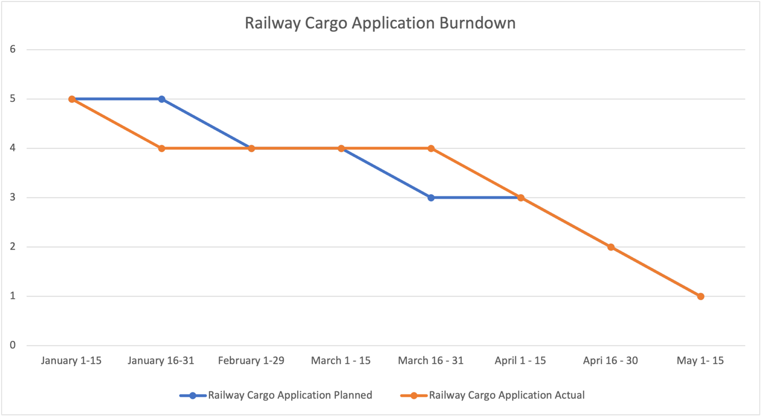

Commencing with stakeholder meetings (6), the project transitioned through crucial phases, including analysis (5), designing (4), development (3), testing (2), and finally, production and maintenance (1). Throughout the project's timeline, the planned and actual phases generally maintained close synchronicity, ensuring steady progress towards project completion. While minor discrepancies were observed, particularly during the shift from the designing to the development phase in March, the project remained largely on course. Consequently, this structured approach facilitated the successful implementation of the Railway Cargo Application within the designated time frame.

- PROTOTYPE:

- Note: Original prototype wireframe images were designed in Figma. The full working implementation of the Sign Up, Login, Dashboard, and all modules can be found in the accompanying codebase (see GitHub repository). The sections below list the screens that were prototyped.
Sign Up page.

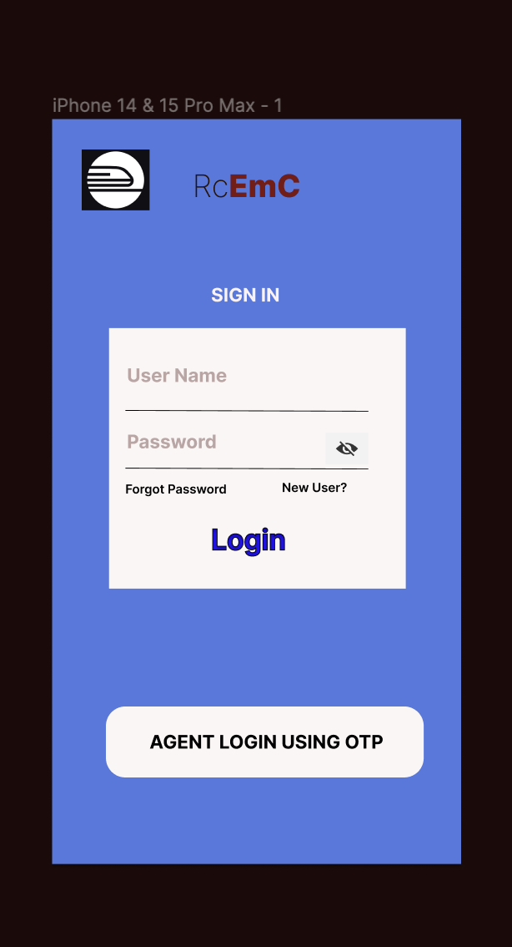

- Ticket Booking page:

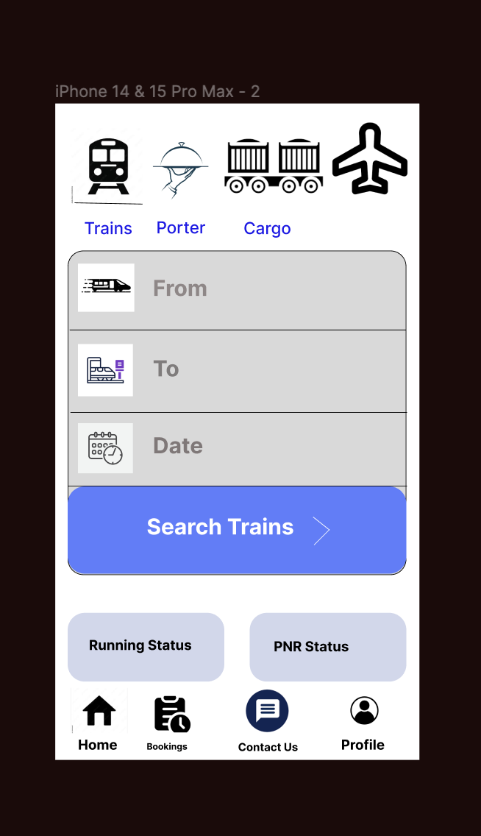

- Agent login page:

