Program – 1

Object - Write a program to display a file page wise assuming a page has 10 lines and each line has 80 characters.

Code :

#include <stdio.h>
#define MAX_LINE_LEN 80 // Define a constant for maximum line length
#define MAX_LINES_PER_PAGE 10 // Define a constant for maximum number of lines per page

int main(int argc, char *argv[])
{
if (argc != 2)
{ // Check if the user has provided a filename argument
fprintf(stderr, "Usage: %s <filename>\n", argv[0]);
return 1;
}
FILE *fp = fopen(argv[1], "r"); // Open the file for reading
if (fp == NULL)
{ // Check if the file was opened successfully
fprintf(stderr, "Error: could not open file %s\n", argv[1]);
return 1;
}
char line[MAX_LINE_LEN]; // Define a buffer for reading each line of the file
int line_count = 0; // Keep track of the number of lines printed so far
while (fgets(line, MAX_LINE_LEN, fp) != NULL)
{ // Read each line of the file
printf("%s\n", line); // Print the line to the console
line_count++; // Increment the line count
if (line_count >= MAX_LINES_PER_PAGE)
{ // Check if we've printed enough lines for the current page
printf("\nPress ENTER to continue...\n");
getchar(); // Wait for the user to press ENTER
line_count = 0; // Reset the line count for the next page
}
}
fclose(fp); // Close the file
return 0; // Exit the program
}

Output :
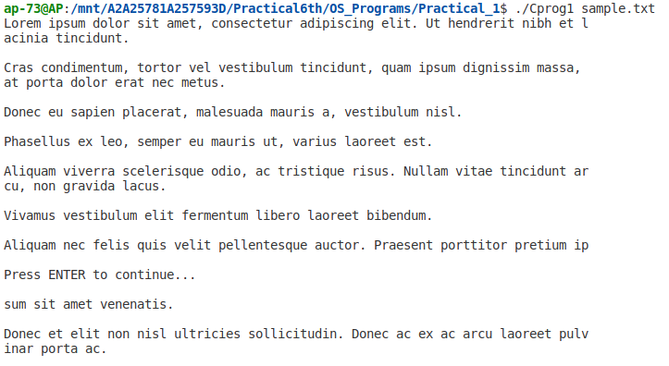

Program – 2

Object - Write a Program which converts all the small case letters in a file into appropriate
capital letters.

Code :

#include <stdio.h>
int main(int argc, char *argv[])
{
// Check if the program is run with the correct number of arguments
if (argc != 2)
{
// Print an error message to standard error output (stderr)
fprintf(stderr, "Usage: %s <filename>\n", argv[0]);
// Return an error code (-1) to indicate that the program did not run successfully
return -1;
}
// Open the file given as the argument in read/write mode
FILE *fp = fopen(argv[1], "r+");
// Check if the file was successfully opened
if (fp == NULL)
{
// Print an error message, including a description of the error that occurred
perror("Error opening file");
// Return an error code (-1) to indicate that the program did not run successfully
return -1;
}
int c;
// Read each character in the file until the end of the file is reached (EOF)
while ((c = fgetc(fp)) != EOF)
{
// Check if the character is a lowercase letter
if (c >= 'a' && c <= 'z')
{
// Move the file pointer back one position to overwrite the lowercase letter
fseek(fp, -1, SEEK_CUR);
// Write the uppercase version of the letter to the file
fputc(c - 'a' + 'A', fp);
}
}
fclose(fp);

return 0;
}

Output :
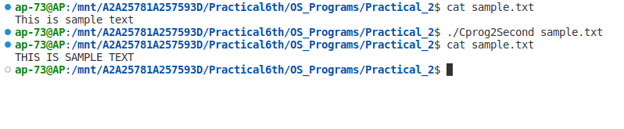

Program – 3
Object - Write a program to print the details of the system (use uname sys call).

Code :

#include <stdio.h>
#include <stdlib.h>
#include <sys/utsname.h>
// included header file `stdlib.h` for exit failure and sucess macros value, `sys/utsname.h` to get system information
int main()
{
struct utsname sys_data;
if (uname(&sys_data) != 0) // checks if there is any error in calling uname i.e. getting system info as uname return a dtructured info of the system
{
fprintf(stderr, "Error calling uname\n");
return EXIT_FAILURE; // EXIT_FAILURE is a macro defined in stdlib.h
}
printf("Operating System : %s\n", sys_data.sysname);
printf("Nodename : %s\n", sys_data.nodename);
printf("Release : %s\n", sys_data.release);
printf("Version : %s\n", sys_data.version);
printf("Machine : %s\n", sys_data.machine);
return EXIT_SUCCESS; // EXIT_SUCESS is a macro defined in stdlib.h
}

Output :
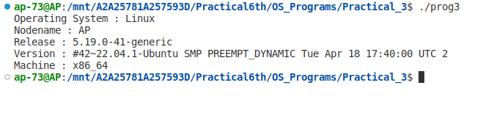
Program – 4

Object -Write a program which will print the list of environment variable and also print the
value of the PATH system variable.

Code :

#include <stdio.h> //Include standard input/output library
#include <stdlib.h> //Include standard library

extern char **environ; // Declare an external variable environ of type char**

int main()
{ // Declare the main function

char *path; // Declare a pointer variable named path of type char*
int i; // Declare an integer variable named i

printf("The environment list is as follows: \n"); // Print a message on the screen

for (i = 0; environ[i] != NULL; i++) // For loop to traverse all the environment variables
printf("Environ[%d] : %s\n", i, environ[i]); // Print the environment variables

path = getenv("PATH"); // Retrieve value of the PATH environment variable and store it

if ((path == NULL)) // Check if path is null or not
printf("Environment variable not set\n"); // Print a message on the screen if path is null
else // If path is not null
// Print the value of the PATH environment variable on the screen
printf("The value of Path variable : %s", path);

return 0; // Return 0 as the program executed successfully
}

Output :
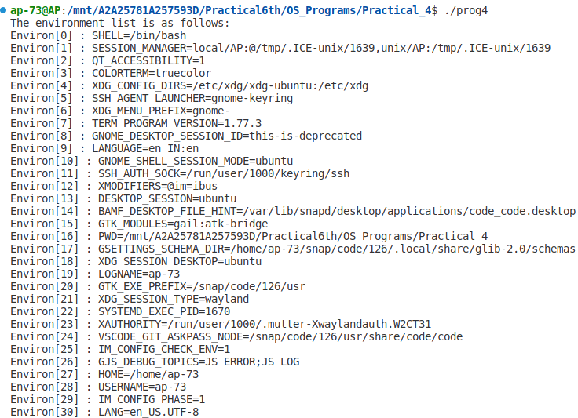
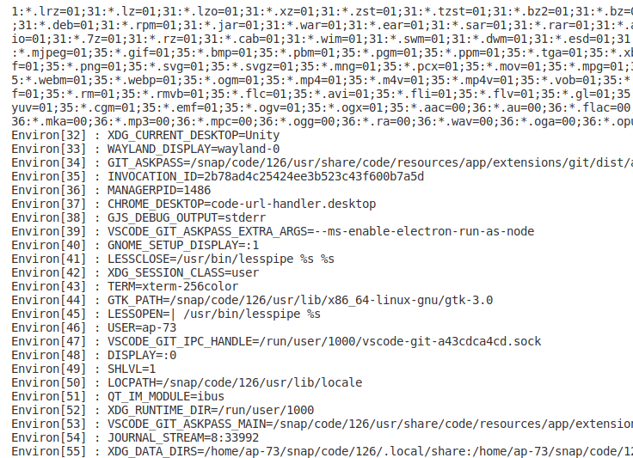

Program – 5

Object -Write a program to print current (soft) limit and maximum (Hard) limits of all
resources.

Code :

#include <stdio.h> // Standard Input/Output library
#include <stdlib.h> // Standard library
#include <errno.h> // Error handling library
#include <sys/resource.h> // System resource limits library

#define NUM_RESOURCES RLIM_NLIMITS // Define a constant to represent the number of system resources available

int main() {
struct rlimit rl; // Declare a structure to hold the resource limits
int i;
char* resource_names[NUM_RESOURCES] = { // Declare an array of strings to hold the names of the system resources
"RLIMIT_CPU",
"RLIMIT_FSIZE",
"RLIMIT_DATA",
"RLIMIT_STACK",
"RLIMIT_CORE",
"RLIMIT_RSS",
"RLIMIT_NPROC",
"RLIMIT_NOFILE",
"RLIMIT_MEMLOCK",
"RLIMIT_AS",
"RLIMIT_LOCKS"
};

// Print the header row for the output table
printf("\n%-15s\t%-15s\t%-15s\n", "Resource Name", "Soft Limit", "Hard Limit");

// Loop through each system resource and retrieve its limits
for (i = 0; i < NUM_RESOURCES; i++) {
if (getrlimit(i, &rl) != 0) { // Get the limits for the current system resource
perror("getrlimit"); // Print an error message if the limits cannot be retrieved
exit(EXIT_FAILURE); // Exit the program with an error code
}
// Print the resource name and its corresponding soft and hard limits
printf("%-15s\t%-15lld\t%-15lld\n", resource_names[i], (long long) rl.rlim_cur, (long long) rl.rlim_max);
}

return 0; // Return 0 to indicate success
}

Output :
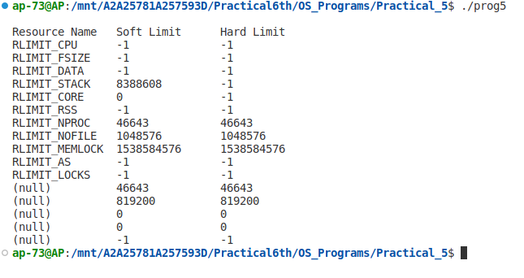

Program – 6

Object -Write a program with an exit handler that outputs CPU usage.

Code :

#include <stdio.h>
#include <stdlib.h>
#include <time.h>
#include<unistd.h>

int main(void) {
time_t start, end; // declare two variables of type "time_t" to hold the start and end times
start = time(NULL); // get the current time and store it in the "start" variable
printf("Start time: %ld\n", start); // print the start time
sleep(5); // sleep for 5 seconds
end = time(NULL); // get the current time again and store it in the "end" variable
printf("End time: %ld\n", end); // print the end time
printf("Time slept: %ld seconds\n", end - start); // calculate and print the time slept
return 0; // return success code
}

Output :
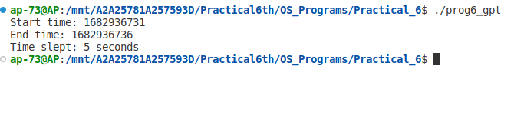

Program – 7

Object -Write a program that prints it’s & it’s parent’s process ID.

Code :

#include<stdio.h> // Including the standard input/output library header file
#include <unistd.h> // Including the POSIX library header file

int main (void) // Beginning of the main function
{
// Printing the process ID of the current process
printf("I am process %ld\n", (long)getpid());
// Printing the parent process ID of the current process
printf("My parent is %ld\n", (long)getppid());
return 0; // Returning 0 to indicate successful termination of the program
}

Output :
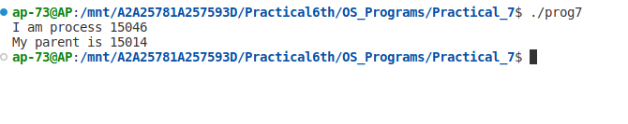

Program – 8

Object -Write a program that prints out various user & group ID’s.

Code :

#include <stdio.h>
#include <unistd.h>

int main(void)
{
// Print the real user ID of the current process
printf("My real user ID is %5ld\n", (long)getuid());

// Print the effective user ID of the current process
printf("My effective user ID is %5ld\n", (long)geteuid());

// Print the real group ID of the current process
printf("My real group ID is %5ld\n", (long)getgid());

// Print the effective group ID of the current process
printf("My effective group ID is %5ld\n", (long)getegid());

return 0;
}

Output :
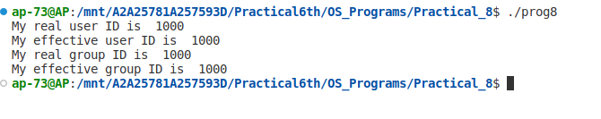

Program – 9

Object --Write a program which uses fork to create a child process& then parent & child print their respective process ID’s

Code :

#include <stdio.h>
#include <stdlib.h>
#include <unistd.h>

int main() {
pid_t pid; // declare a variable to store the process ID returned by fork()

pid = fork(); // create a child process and store the process ID in the pid variable

if (pid < 0) { // check if fork() failed
fprintf(stderr, "Fork failed\n");
exit(1);
}
if (pid == 0) { // code for child process
printf("\nI am the child process, my pid is %d\n", getpid());
exit(0); //terminate the child process
}
else { // code for parent process
printf("I am the parent process, my pid is %d", getpid());
}

return 0;
}

Output :
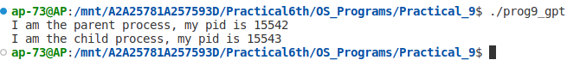

Program – 10

Object -Write a program that creates a chain of n processes, where n is a command line
argument.

Code :

#include <stdio.h>
#include <stdlib.h>
#include <unistd.h>

int main(int argc, char *argv[]) {
int n, i;
pid_t pid;
// check if the number of command line arguments is correct
if (argc != 2) {
printf("Usage: %s n\n", argv[0]);
exit(1);
}
// convert the command line argument to an integer
n = atoi(argv[1]);
// create the chain of n processes
for (i = 0; i < n; i++) {
pid = fork();
if (pid < 0) {
printf("Error: fork failed\n");
exit(1);
}
if (pid == 0) {
printf("Child process %d created, with parent process %d\n", getpid(), getppid());
while (getppid() != 1);
printf("Child process %d has completed, with parent process %d\n", getpid(), getppid());
exit(0);
}
}
// // parent process
// printf("Parent process exiting\n");
exit(0);
}

Output :

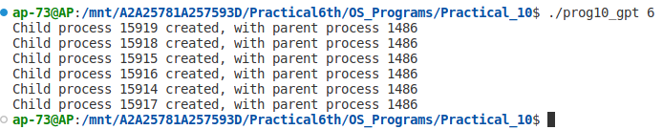

Program – 11
Object -Write a program that creates a fan of n processes where n is passed as a command line argument.

Code :

#include <stdio.h> //include standard input/output library
#include <stdlib.h> //include standard library for functions such as atoi()
#include <unistd.h> //include library for functions such as fork()

int main(int argc, char *argv[]) { //start of main function, takes command line arguments as inputs
//declare and initialize process ID variable for child process
pid_t childpid = 0;
//declare variables for loop iteration and number of processes
int i, n;
//check if there is only one command line argument
if (argc != 2) {
fprintf(stderr, "Usage: %s processes\n", argv[0]); //print error message to stderr
return 1; //exit program with error status
}
//convert command line argument to integer and assign to variable n
n = atoi(argv[1]);
for (i = 1; i <= n; i++) { //iterate through loop until i is equal to n
//if fork() returns a value less than or equal to 0, break out of loop
if ((childpid = fork()) <= 0) {
break;
}
//print process information to stderr
fprintf(stderr, "i:%d process ID:%ld parent ID:%ld child ID:%ld\n",
i, (long)getpid(), (long)getppid(), (long)childpid);
}
return 0; //exit program with success status
}

Output :
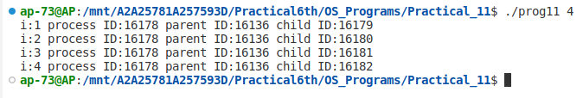

Program – 12

Object -Write a program to show that same opened file can be shared by both parent and child processes.

Code :

#include <stdio.h>
#include <string.h>
#include <stdlib.h>
#include <unistd.h>
#include <fcntl.h>

int main() {
int fd; // file descriptor for the opened file
pid_t pid; // process ID variable

// open file in write mode, create it if it doesn't exist, with permissions 0644
fd = open("file.txt", O_WRONLY | O_CREAT | O_TRUNC, 0644);
if (fd < 0) { // check if file was successfully opened
perror("Error opening file"); // display error message if open() failed
exit(1); // exit the program with status code 1
}

// fork a child process
pid = fork(); // create a copy of the current process
if (pid < 0) { // check if fork() failed
perror("Error forking process"); // display error message if fork() failed
exit(1); // exit the program with status code 1
}
else if (pid == 0) { // child process
// write to the opened file using the file descriptor fd
char *str = "This is the child process.\n";
write(fd, str, strlen(str)); // write string to file
printf("Child process wrote to file.\n");
}
else { // parent process
// write to the opened file using the file descriptor fd
char *str = "This is the parent process.\n";
write(fd, str, strlen(str)); // write string to file
printf("Parent process wrote to file.\n");
}

// close file descriptor
close(fd); // close the file

return 0; // exit the program with status code 0 (success)
}

Output :
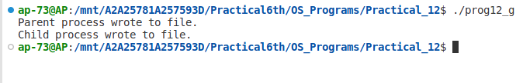
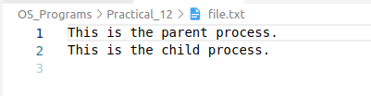

Program – 13

Object -Write a program that creates a child process to run ls – l.

Code :

#include <stdio.h>
#include <stdlib.h>
#include <unistd.h>
#include <sys/wait.h>

int main(void)
{
pid_t childpid;
// Call fork() to create a new child process
childpid = fork();
// Check if fork() failed and print an error message if it did
if (childpid == -1)
{
perror("Failed to fork");
return 1;
}
// If fork() returns 0, the current process is the child process
if (childpid == 0)
{
// Execute the "ls -l" command in the child process using execl()
execl("/bin/ls", "ls", "-l", NULL); // man 2 exec
// If execl() returns, there was an error, so print an error message and return failure
perror("Child failed to exec ls");
return 1;
}
// If fork() returns a positive value, the current process is the parent process
// Wait for the child process to complete using wait() and check for errors
if (childpid != wait(NULL))
{
perror("Parent failed to wait due to signal or error");
return 1;
}
return 0;
}

Output :
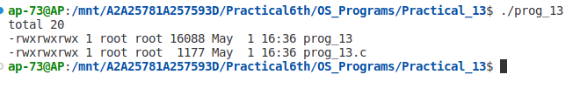

Program – 14

Object -Write a program to create a zombie child and find its status using system (ps) command.

Code :

#include<stdio.h>
#include<stdlib.h>
#include<unistd.h>
#include<signal.h>
int main(){
int fd;
// Creating a child process using fork()
if((fd=fork())<0){
printf("error in creating child");
exit(1);
}
// Child process code: send a signal to itself to terminate
if(fd==0)
kill(getpid(),SIGKILL);
// Parent process code: wait for 2 seconds
else
sleep(2);
// Print process information using the "ps" command
system("ps -f");
return 0;
}

Output :
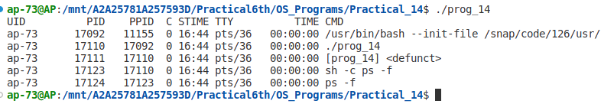

Program – 15

Object -Write a program to copy a file.

Code :

// Function to copy a file fromfd to tofd
#include <errno.h>
#include <unistd.h>
#define BLKSIZE 1024

int copyfile(int fromfd, int tofd) {
char *bp;
char buf[BLKSIZE];
int bytesread;
int byteswritten = 0;
int totalbytes = 0;

for (;;) { // Infinite loop until end of file or error occurs
// Read up to BLKSIZE bytes from fromfd
while (((bytesread = read(fromfd, buf, BLKSIZE)) == -1) &&
(errno == EINTR)) ; // Handle interruption by signal

if (bytesread <= 0) // Real error or end-of-file on fromfd
break;

bp = buf;
while (bytesread > 0) {
// Write up to bytesread bytes to tofd
while (((byteswritten = write(tofd, bp, bytesread)) == -1) &&
(errno == EINTR)) ; // Handle interruption by signal

if (byteswritten < 0) // Real error on tofd
break;

totalbytes += byteswritten;
bytesread -= byteswritten;
bp += byteswritten;
}

if (byteswritten == -1) // Real error on tofd
break;
}

return totalbytes;
}

// Main program to copy a file
#include <fcntl.h>
#include <stdio.h>
#include <unistd.h>
#include <sys/stat.h>
#define READ_FLAGS O_RDONLY
#define WRITE_FLAGS (O_WRONLY | O_CREAT | O_EXCL)
#define WRITE_PERMS (S_IRUSR | S_IWUSR)

int main(int argc, char *argv[]) {
int bytes;
int fromfd, tofd;

// Check for correct number of arguments
if (argc != 3) {
fprintf(stderr, "Usage: %s from_file to_file\n", argv[0]);
return 1;
}

// Open input file for reading
if ((fromfd = open(argv[1], READ_FLAGS)) == -1) {
perror("Failed to open input file");
return 1;
}

// Create output file for writing
if ((tofd = open(argv[2], WRITE_FLAGS, WRITE_PERMS)) == -1) {
perror("Failed to create output file");
return 1;
}

// Copy the contents of the input file to the output file
bytes = copyfile(fromfd, tofd);

// Print the number of bytes copied and the source and destination file names
printf("%d bytes copied from %s to %s\n", bytes, argv[1], argv[2]);

// Close the input and output files
return 0;
}

Output :
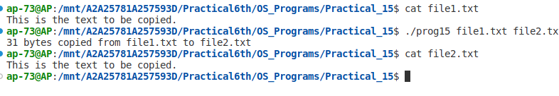

Program – 16

Object -Write a program for which output is automatically directed to a named file rather than on to the console.

Code :

#include<stdio.h>
#include<stdlib.h>
#include<sys/types.h>
#include<fcntl.h>
#include<sys/stat.h>
#include <unistd.h>
int main()
{
int fd;
// Open the file "test1" for writing or create it if it doesn't exist
if((fd = open("test1", O_WRONLY|O_CREAT)) < 0){
printf("Error in opening file..\n");
exit(1);
}
// Close standard output (file descriptor 1) to redirect the output
close(1);
// Duplicate file descriptor fd to 1 (stdout)
dup(fd);
// The next line will be written to the file "test1" instead of the console
printf("New Fun");
// Close the file descriptor fd and standard output
close(fd);
return (0);
}

Output :
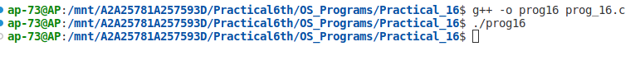


Program – 17

Object -Write a program that redirects standards output to the file my.file (or Write a program that do the following operation cat XYZ > myfile). using dup2 rather than dup.

Code :

#include <fcntl.h>
#include <stdio.h>
#include <sys/stat.h>
#include <unistd.h>

#define CREATE_FLAGS (O_WRONLY | O_CREAT | O_APPEND) // Define flags for file creation
#define CREATE_MODE (S_IRUSR | S_IWUSR | S_IRGRP | S_IROTH) // Define access permissions for the file

int main(void){
int fd; // file descriptor

// Open or create file "my.file" with the flags and mode specified
fd = open("my.file", CREATE_FLAGS, CREATE_MODE);
if (fd == -1){
perror("Failed to open my.file"); // Print error message if failed to open the file
return 1; // Exit program with error code
}
// Duplicate the file descriptor to the standard output file descriptor
if (dup2(fd, STDOUT_FILENO) == -1){ //dup2
perror("Failed to redirect standard output"); // Print error message if failed to redirect standard output
return 1; // Exit program with error code
}
// Close the file descriptor that was duplicated
if (close(fd) == -1){
perror("Failed to close the file"); // Print error message if failed to close the file
return 1; // Exit program with error code
}
// Write "OK" to the standard output file descriptor
if (write(STDOUT_FILENO, "OK", 2) == -1){
perror("Failed in writing to file"); // Print error message if failed to write to file
return 1; // Exit program with error code
}
return 0; // Exit program with success code
}

Output :
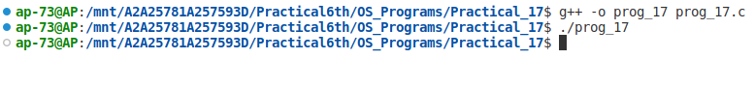
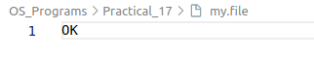

Program – 18

Object -Write a program to create an empty directory using system calls

Code :

#include<stdio.h>
#include<stdlib.h>
#include<sys/stat.h>

// Main function takes two arguments, argc (argument count) and argv (argument vector)
main(int argc, char *argv[])
{
// Check if the argument count is not equal to 2
if(argc!=2)
{
printf("Usages: ./a.out directory"); // Print error message for incorrect usage
exit(1); // Exit the program with error code
}

// Create a directory with the specified name and access permissions
if(mkdir(argv[1],744)!=0)
printf("Error in Making Directory"); // Print error message if the directory creation fails
}

Output :
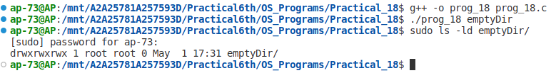

Program – 19

Object - Write a program to remove a directory using system call.

Code :

#include<stdio.h>
#include<stdlib.h>
#include<sys/types.h>
#include<fcntl.h>
#include<sys/stat.h>

// Main function takes two arguments, argc (argument count) and argv (argument vector)
int main(int argc, char *argv[])
{
// Check if the argument count is not equal to 2
if(argc!=2)
{
fprintf(stderr,"Too Less Arguments"); // Print error message for incorrect usage
exit(1); // Exit the program with error code
}

// Remove the directory with the specified name
if(remove(argv[1])!=0)
fprintf(stderr,"Error in Removing Directory"); // Print error message if the directory removal fails
exit(1); // Exit the program with error code
}

Output :
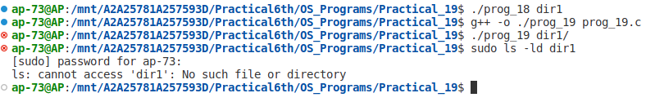

Program – 20

Object - Write a program to output current working directory.

Code :

#include <limits.h>
#include <stdio.h>
#include <unistd.h>

// Define PATH_MAX to be 255 if it is not already defined
#ifndef PATH_MAX
#define PATH_MAX 255
#endif

int main(void)
{
char mycwd[PATH_MAX];
// Get the current working directory and store it in mycwd array
if (getcwd(mycwd, PATH_MAX) == NULL)
{
perror("Failed to get current working directory"); // Print error message if getcwd fails
return 1; // Exit the program with error code
}
// Print the current working directory
printf("Current working directory: %s\n", mycwd);
return 0; // Exit the program
}

Output :
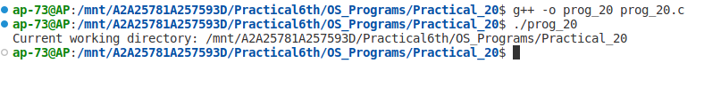

Program – 21

Object - Write a program to list files in a directory.

Code :

#include <dirent.h>
#include <errno.h>
#include <stdio.h>

int main(int argc, char *argv[]) {
struct dirent *direntp; // Pointer to directory entry
DIR *dirp; // Pointer to directory stream
if (argc != 2) {
fprintf(stderr, "Usage: %s directory_name\n", argv[0]);
return 1;
}
// Attempt to open the specified directory
if ((dirp = opendir(argv[1])) == NULL) {
perror ("Failed to open directory"); // Print error message if failed
return 1;
}
// Read and print each directory entry
while ((direntp = readdir(dirp)) != NULL) {
printf("%s\n", direntp->d_name);
}
// Close the directory stream and check for errors
while ((closedir(dirp) == -1) && (errno == EINTR)) ;
return 0;
}

Output :
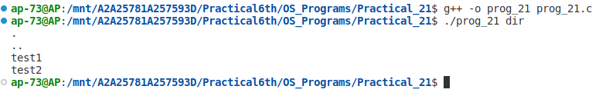

Program – 22

Object - Write a program that returns true if a given file is a directory & false otherwise.

Code :

#include <stdio.h>
#include <time.h>
#include <sys/stat.h>

int main(int argc, char *argv[]) {
struct stat statbuf; // Struct to hold file/directory information
// Attempt to get status information for the specified file/directory
if (stat(argv[1], &statbuf) == -1) {
perror ("Failed to get status of file/directory"); // Print error message if failed
return 1;
}
else {
// If successful, determine if the specified path is a directory or a file using S_ISDIR macro
if (S_ISDIR(statbuf.st_mode)) {
printf("%s : is a directory\n",argv[1]);
}
else {
printf("%s : is a file\n",argv[1]);
}
}
return 0;
}

Output :
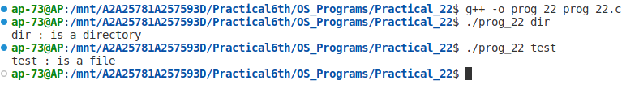

Program – 23

Object - Write a program that can display the type of a given file like regular, directory etc.

Code :

#include<stdio.h>
#include<stdlib.h>
#include<sys/types.h>
#include<fcntl.h>
#include<sys/stat.h>

main(int argc, char *argv[]) {
struct stat statbuff; // Struct to hold file/directory information
int check; // Return value of stat() function

if(argc != 2) {
printf("Can accept only two arguments"); // Print error message if incorrect number of arguments is passed
exit(1);
}
// Get status information for the specified file/directory using stat() function
check = stat(argv[1], &statbuff);

// Check if stat() was successful
if(check == 0) {
// Determine the type of the specified file/directory using S_IS* macros
if(S_ISREG(statbuff.st_mode)) {
printf("Regular File");
}
else if(S_ISDIR(statbuff.st_mode)) {
printf("Directory");
}
else if(S_ISCHR(statbuff.st_mode)) {
printf("Character Device");
}
else {
printf("Other File");
}
}
}

Output :
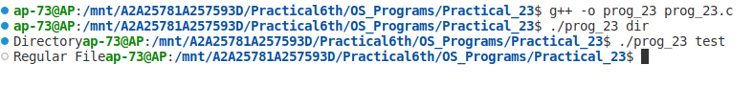

Program – 24

Object - Write a program to display the permission of a given file.

Code :

#include<stdio.h>
#include<stdlib.h>
#include<sys/types.h>
#include<fcntl.h>
#include<sys/stat.h>

int main(int argc, char *argv[]) {

struct stat statbuff; // Struct to hold file/directory information
int check; // Return value of stat() function

if(argc != 2) {
printf("Can Accept only two arguments"); // Print error message if incorrect number of arguments is passed
exit(1);
}

// Get status information for the specified file/directory using stat() function
check = stat(argv[1], &statbuff);

// Check if stat() was successful
if(check == 0) {
// Check permission for Owner
if((statbuff.st_mode & S_IRUSR) == S_IRUSR) {
printf("Owner has Read Permission\n");
}
if((statbuff.st_mode & S_IWUSR) == S_IWUSR) {
printf("Owner has Write Permission\n");
}
if((statbuff.st_mode & S_IXUSR) == S_IXUSR) {
printf("Owner has Execute Permission\n");
}

// Check permission for Group
if((statbuff.st_mode & S_IRGRP) == S_IRGRP) {
printf("Group has Read Permission\n");
}
if((statbuff.st_mode & S_IWGRP) == S_IWGRP) {
printf("Group has Write Permission\n");
}
if((statbuff.st_mode & S_IXGRP) == S_IXGRP) {
printf("Group has Execute Permission\n");
}

// Check permission for Others
if((statbuff.st_mode & S_IROTH) == S_IROTH) {
printf("Others has Read Permission\n");
}
if((statbuff.st_mode & S_IWOTH) == S_IWOTH) {
printf("Others has Write Permission\n");
}
if((statbuff.st_mode & S_IXOTH) == S_IXOTH) {
printf("Others has Executed Permission\n");
}
}
}

Output :
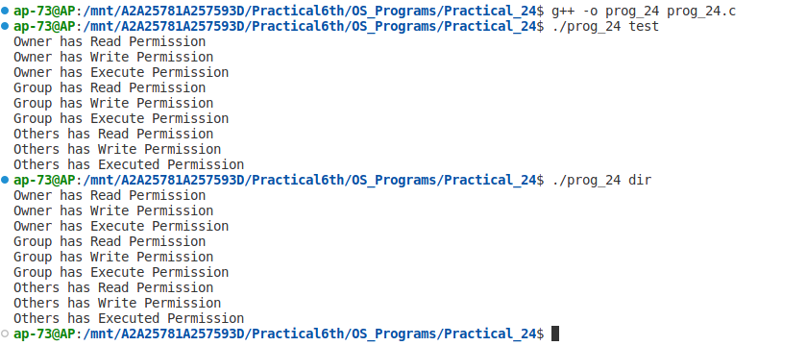

Program – 25

Object - Write a program to execute the equivalent of ls –l | sort –n +4.

Code :

#include <errno.h>
#include <stdio.h>
#include <unistd.h>
#include <sys/types.h>

int main(void){
pid_t childpid; //Variable to hold child process ID
int fd[2]; //Array to hold read and write file descriptors

//Create pipe and fork child process
if ((pipe(fd) == -1) || ((childpid = fork()) == -1))
{
perror("Failed to setup pipeline"); //Print error message if pipe or fork fails
return 1;
}

//Child process for ls command
if (childpid == 0)
{
//Redirect the standard output of child to the write end of the pipe
if (dup2(fd[1], STDOUT_FILENO) == -1)
perror("Failed to redirect stdout of ls");
//Close read and write file descriptors not required by child
else if ((close(fd[0]) == -1) || (close(fd[1]) == -1))
perror("Failed to close extra pipe descriptors on ls");
else
{
//Execute ls command with options "-l" to list files in long format
execl("/bin/ls", "ls", "-l", NULL);
perror("Failed to exec ls"); //Print error message if execution of ls fails
}
return 1;
}

//Parent process for sort command
if (dup2(fd[0], STDIN_FILENO) == -1)
perror("Failed to redirect stdin of sort"); //Redirect the standard input of parent to the read end of the pipe
//Close read and write file descriptors not required by parent
else if ((close(fd[0]) == -1) || (close(fd[1]) == -1))
perror("Failed to close extra pipe file descriptors on sort");
else
{
//Execute sort command with options "-n" to sort numerically and "+4" to skip first four fields of input
execl("/bin/sort", "sort", "-n", "+4", NULL);
perror("Failed to exec sort"); //Print error message if execution of sort fails
}
return 1;
}

Output :
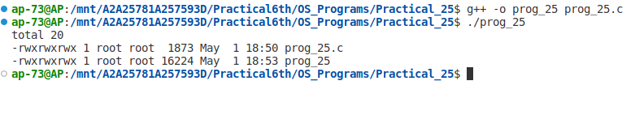

Program – 26

Object - Write a program to handle SIGUSR1 and SIGUSR2 signal.

Code :

#include<stdio.h>
#include<stdlib.h>
#include<sys/types.h>
#include<fcntl.h>
#include<sys/stat.h>
#include<signal.h>
#include<unistd.h>

void fun(int); // declaration of signal handler function

int main()
{
char a[200];

// register signal handler for SIGUSR1
if((signal(SIGUSR1,fun))==SIG_ERR)
{
printf("Handler not registered\n");
exit(1);
}

// register signal handler for SIGUSR2
if((signal(SIGUSR2,fun))==SIG_ERR)
{
printf("Handler not registered\n");
exit(1);
}

// enter an infinite loop and wait for signals
while(1)
pause(); // pause the program until a signal is received
}

// implementation of signal handler function
void fun(int i)
{
if(i==SIGUSR1)
{
printf("SIGUSR1 INTRRUPT");
fflush(NULL); // flush output buffer to print message immediately
}
else if(i==SIGUSR2)
{
printf("SIGUSR2 INTRRUPT");
fflush(NULL);
}
//raise(SIGKILL); // send SIGKILL signal to terminate program
}

Output :
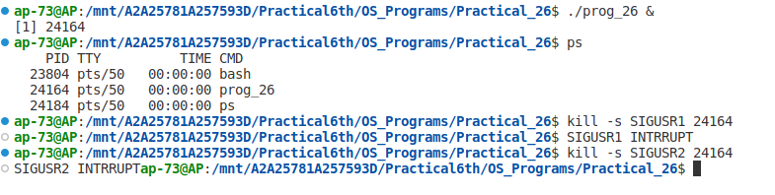

Program – 27

Object - Write a program which suspends itself till it receives a SIGALARM signal.

Code :

#include<stdio.h>
#include<stdlib.h>
#include<signal.h>
#include<unistd.h>

void sig_alrm(int); // declaration of signal handler function

int main(int argc, char *argv[])
{
// register signal handler for SIGALRM
if((signal(SIGALRM, sig_alrm))==SIG_ERR)
printf("Not Registered");
// set a timer for 5 seconds using alarm()
alarm(5);
// pause the program until a signal is received
pause();
return 0;
}
// implementation of signal handler function
void sig_alrm(int sig)
{
// check if the signal received is SIGALRM
if(sig==SIGALRM)
printf("Wake Up\n");
}

Output :
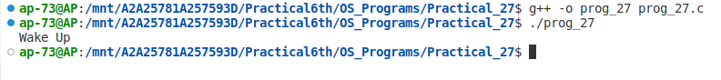

Program – 28

Object - Write a program which prints the second’s part of current time whenever the
SIGALRM signal is received by the program.

Code :

#include<stdio.h>
#include<stdlib.h>
#include<sys/types.h>
#include<fcntl.h>
#include<sys/stat.h>
#include<signal.h>
#include<time.h>
#include<unistd.h>

void sig_hand(int); // declaration of signal handler function
int main(){
int i=1;
pid_t pid;
// register the signal handler
if(signal(SIGALRM,sig_hand)==SIG_ERR)
printf("Not Registered");
while(i<=5){ // loop to send signals after 2 seconds delay
i++;
pid=getpid();
sleep(2); // wait for 2 seconds
kill(pid,SIGALRM); // send the signal
}
return 0;
}
void sig_hand(int sig)
{
struct tm *t; // structure to hold the broken-down time
time_t tt; // variable to hold the time in seconds
if(sig==SIGALRM) // check if the received signal is SIGALRM{
tt=time(NULL); // get the current time in seconds since epoch
t=localtime(&tt); // convert the time to broken-down time
printf("%d\n",t->tm_sec); // print the seconds field of the time
}
}

Output :
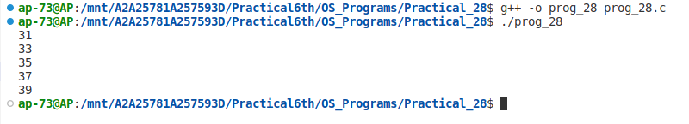

Program – 29

Object - Write a Program to print the entries of passwd file for a given user name or user ID.

Code :

#include<pwd.h>
#include<stdio.h>
#include<stdlib.h>
#include<sys/types.h>
#include<fcntl.h>
#include<sys/stat.h>
#include<signal.h>
#include<time.h>
#include<error.h>
#include<ctype.h>

int main(){
char u_name[10]; // variable to hold the username entered by user
char ch; // variable to hold the user's choice of input
uid_t u_id; // variable to hold the user ID entered by user
struct passwd *p; // pointer to the passwd structure

printf("Enter Your Choice\n");
printf("Whether you want to enter UNAME or UID?(N or I)"); // prompt user for choice of input
scanf("%c",&ch); // read the user's choice

if((ch == 'N')|| (ch == 'n')) // if user chooses to enter username
{
printf("Enter UNAME");
scanf("%s",u_name); // read the username entered by user
p=getpwnam(u_name); // get the passwd structure for the given username
printf("\n%s\n %s\n %d\n %d\n %s\n %s\n %s\n", p->pw_name, p->pw_passwd, p->pw_uid,p->pw_gid,p->pw_gecos, p->pw_dir, p->pw_shell); // print the information retrieved from passwd structure
}
else if((ch == 'I' || 'i')) // if user chooses to enter user ID
{
printf("Enter UID");
scanf("%d",&u_id); // read the user ID entered by user
p= getpwuid (u_id); // get the passwd structure for the given user ID
printf("\n%s\n %s\n %d\n %d\n %s\n %s\n %s\n", p->pw_name, p->pw_passwd, p->pw_uid,p->pw_gid,p->pw_gecos, p->pw_dir, p->pw_shell); // print the information retrieved from passwd structure
}
else
printf("Wrong Choice"); // if user enters a wrong choice
}

Output :
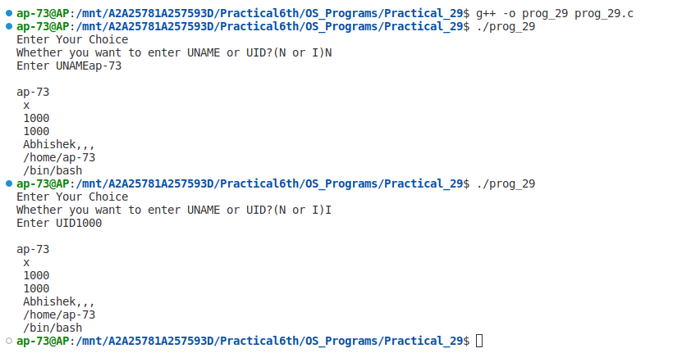

Program – 30

Object - Write a program to print the details of the system.

Code :

#include<grp.h> // header file that provides access to group-related functions
#include<stdio.h>
#include<stdlib.h>
#include <sys/types.h>

int main() // the main function
{
char g_name[10];
gid_t gid;
char ch;
struct group *g; // a pointer to a group structure

printf("Enter Your Choice: \nEnter Group Name(N) \nEnter Group ID (I)\n");
printf("Enter Choice");
scanf("%c",&ch); // prompts the user to enter their choice

switch(ch) // evaluates the user's choice
{
case 'N':
case 'n':
printf("Enter GNAME:");
scanf("%s",g_name); // reads the group name entered by the user
g=getgrnam(g_name); // retrieves the group information using the group name
printf("\n %s %s %d\n", g->gr_name, g->gr_passwd, g->gr_gid); // prints the group information
break;

case 'I':
case 'i':
printf("Enter GID:");
scanf("%d",&gid); // reads the group ID entered by the user
g=getgrgid(gid); // retrieves the group information using the group ID
printf("\n %s %s %d\n", g->gr_name, g->gr_passwd, g->gr_gid); // prints the group information
break;

default:
printf("Wrong Choice");
}
}

Output :
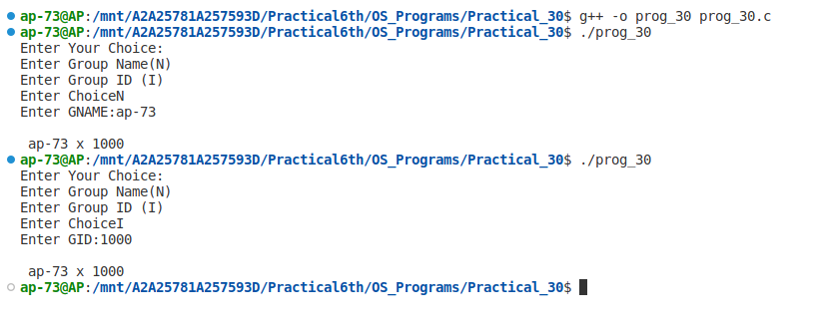

Program – 31, 32

Object – Write two programs :
1. Reads what is written to a named pipe & writes it to standard output.
2. Write an informative message to a named pipe.

Code 1 :

// server
#include <errno.h>
#include <fcntl.h>
#include <stdio.h>
#include <stdlib.h>
#include <unistd.h>
#include <sys/stat.h>

#define BLKSIZE 1024
#define FIFOARG 1
#define FIFO_PERMS (S_IRWXU | S_IWGRP| S_IWOTH)

// function prototype
int copyfile(int fromfd, int tofd);

int main(int argc, char *argv[]) {
int requestfd;
if (argc != 2) { /* name of server fifo is passed on the command line */
fprintf(stderr, "Usage: %s fifoname > logfile\n", argv[0]);
return 1;
}

/* create a named pipe to handle incoming requests */
if ((mkfifo(argv[FIFOARG], FIFO_PERMS) == -1) && (errno != EEXIST)) {
perror("Server failed to create a FIFO");
return 1;
}

/* open a read/write communication endpoint to the pipe */
if ((requestfd = open(argv[FIFOARG], O_RDWR)) == -1) {
perror("Server failed to open its FIFO");
return 1;
}

// copy the data received from the named pipe to STDOUT
copyfile(requestfd, STDOUT_FILENO);

return 1;
}

// function to copy data from one file descriptor to another
int copyfile(int fromfd, int tofd) {
char *bp;
char buf[BLKSIZE];
int bytesread;
int byteswritten = 0;
int totalbytes = 0;
for (;;) { // infinite loop
while (((bytesread = read(fromfd, buf, BLKSIZE)) == -1) && (errno == EINTR))
; // handle interruption by signal

if (bytesread <= 0) // real error or end-of-file on fromfd
break;

bp = buf;
while (bytesread > 0) {
while (((byteswritten = write(tofd, bp, bytesread)) == -1) && (errno == EINTR))
; // handle interruption by signal
if (byteswritten < 0) // real error on tofd
break;

totalbytes += byteswritten;
bytesread -= byteswritten;
bp += byteswritten;
}

if (byteswritten == -1) // real error on tofd
break;
}
return totalbytes;
}

Code 2 :

// Client
#include <errno.h>
#include <fcntl.h>
#include <limits.h>
#include <stdio.h>
#include <stdlib.h>
#include <string.h>
#include <time.h>
#include <unistd.h>
#include <sys/stat.h>
#include <limits.h>

#define FIFOARG 1 // Argument index for the name of the server FIFO.

int main(int argc, char *argv[])
{
time_t curtime;
int len;
char requestbuf[_PC_PIPE_BUF];
int requestfd;
if (argc != 2)
{ // Check if the argument count is correct.
fprintf(stderr, "Usage: %s fifoname\n", argv[0]);
return 1;
}
// Open the FIFO for writing.
if ((requestfd = open(argv[FIFOARG], O_WRONLY)) == -1)
{
perror("Client failed to open log fifo for writing");
return 1;
}

// Get the current time and format the message to be sent to the server.
curtime = time(NULL);
snprintf(requestbuf, _PC_PIPE_BUF, "%d: %s", (int)getpid(), ctime(&curtime));
len = strlen(requestbuf);

// Write the message to the server and check for errors.
if (write(requestfd, requestbuf, len) != len)
{
perror("Client failed to write");
return 1;
}
// Close the FIFO.
close(requestfd);
return 0;
}

Output :
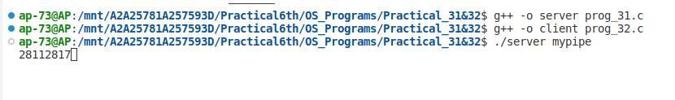
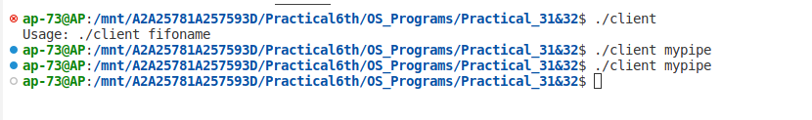

Index

Sr. no. | Program | Date | Remarks
1. | Write a program to display a file page wise assuming a page has 10 lines  and each line has 80 characters
2. | Write a Program which converts all the small case letters in a file into appropriate capital letters.
3. | Write a program to print the details of the system (use uname sys call)
4. | Write a program which will print the list of environment variable and also print the value of the PATH system variable
5. | Write a program to print current (soft) limit and maximum (Hard) limits of all resources
6. | Write a program with an exit handler that outputs CPU usage.
7. | Write a program that prints it’s & it’s parent’s process ID.
8. | Write a program that prints out various user & group ID’s.
9 | Write a program which uses fork to create a child process& then parent & child print their respective process ID’s.
10. | Write a program that creates a chain of n processes, where n is a command line argument.
11. | Write a program that creates a fan of n processes where n is passed as a command line argument.
12. | Write a program to show that same opened file can be shared by both parent and child processes
13. | Write a program that creates a child process to run ls – l

14. | Write a program to create a zombie child and find its status using system  (ps) command
15. | Write a program to copy a file.
16. | Write a program for which output is automatically directed to a named file rather than on to the console.
17. | Write a program that redirects standards output to the file my.file (or Write a program that do the following operation cat XYZ > myfile). using  dup2 rather than dup.
18. | Write a program to create an empty directory using system calls.
19. | Write a program to remove a directory using system call.
20. | Write a program to output current working directory.
21. | Write a program to list files in a directory.
22. | Write a program that returns true if a given file is a directory & false otherwise.
23. | Write a program that can display the type of a given file like regular, directory etc.
24. | Write a program to display the permission of a given file.
25. | Write a program to execute the equivalent of ls –l | sort –n +4.
26. | Write a program to handle SIGUSR1 and SIGUSR2 signal.
27. | Write a program which suspends itself till it receives a SIGALARM signal.
28. | Write a program which prints the second’s part of current time whenever the SIGALRM signal is received by the program.

29. | Write a Program to print the entries of passwd file for a given user name or user ID.
30. | Write a program to print the details of the system.
31. | Write a program which Reads what is written to a named pipe & writes it to standard output
32. | Write an informative message to a named pipe.

