Program – 1

Object – Write a program to print ‘Hello’.

Code :

#print(‘Hello’)
str = ‘Hello’
print(str)

Output:-

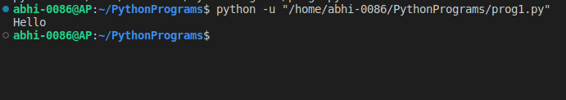

Program – 2

Object – Write a prgram to calculate area and circumference of a circle.

Code :

pi = 3.14
radius = float(input("Enter radius of circle : "))
area = pi * radius * radius
circumference = 2 * pi * radius
print("Area of cirlce = ", area)
print("Circumference of circle = ", circumference)

Output :

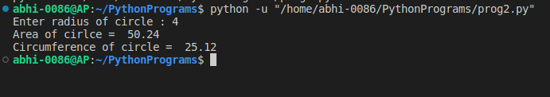

Program – 3

Object – Write a program to find the addition of two numbers.

Code :

num1, num2 = map(int, input("Enter the numbers : ").split())
print("The sum of ", str(num1), " and ", str(num2), " is :- ", num1+num2)

Output :

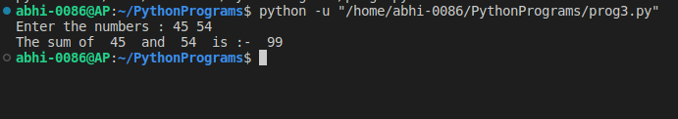

Program – 4

Object – Write a program to find Simple interest.

Code :

principal = float(input("Enter principal amount : "))
ROI = float (input("Enter rate of interest : "))
time = float(input("Enter time : "))
print("Simple interest : ",principal*ROI*time/100)

Output :

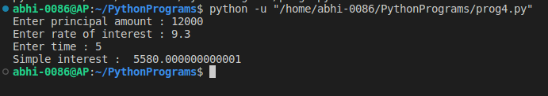

Program – 5

Object – Write a program to find sqaure root of a number.

Code :

num = int(input("Enter number : "))
print("Square root of",num,"is :-",num**0.5)

# import math as M
# print("Square root of",num,"is :-",M.sqrt(num))

Output :

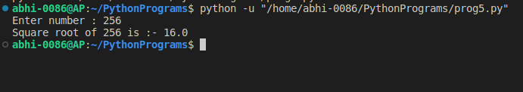

Program – 6

Object – Write a program to swap two numbers.

Code :

a, b = map(int, input("Enter two different numbers : ").split())
print("Before swapping a :",a,"and b :",b)
a,b = b,a
print("Before swapping a :",a,"and b :",b)

Output :

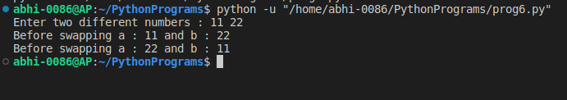

Program – 7

Object – Write a program to check a number is even or odd.

Code :

num = int(input("Enter a number:"));
if(num%2 == 0):
print(num,"is even.")
else:
print(num,"is odd.")

Output:

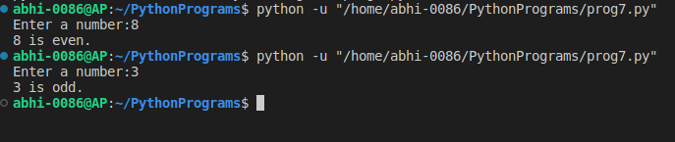

Program – 8

Object – Write to program to find greatest of three numbers.

Code :

num1, num2, num3 = map(int, input("Enter three numbers:").split())
if(num1>num2 and num1>num3):
print("Greatest number is",num1)
elif(num2>num1 and num2>num3):
print("Greatest number is",num2)
elif(num3>num1 and num3>num2):
print("Greatest number is",num3)
else:
print("All three numbers are equal!")

Output:

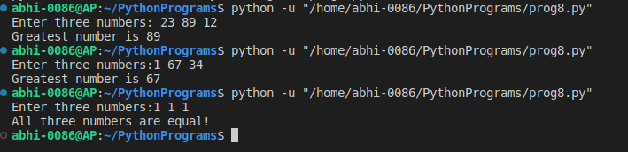

Program – 9

Object – Write a program to print multipluaction table of a number.

Code :

num = int(input("Enter a number : "))
print("Table of ", num)
for i in range(0, 11):
print(num,'x',i,'=',num*i)

Output:

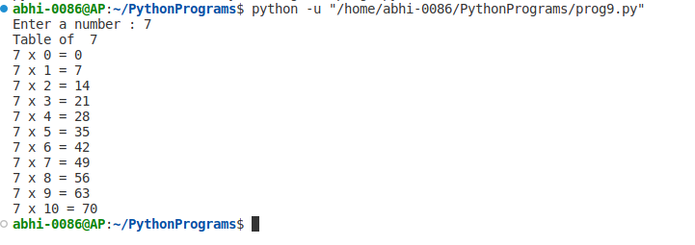

Program – 10

Object – Write a program to print sum of natural numbers.

Code :

num = int(input("Enter a number :"))
numSum = num*(num+1)/2
print("Sum =",numSum)
if(num<0):
print("Enter a positive number!")
else:
sum = 0
while(num>0):
sum += num
num -= 1
print("Sum is ",sum)

Output :

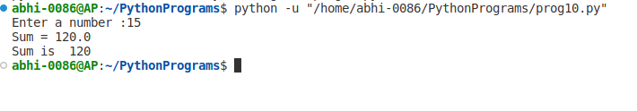

Program – 11

Object – Write a program to print prime numbers between 900 to 1000.

Code :

low_limit = 900
high_limit = 1000
print("Prime numbers between",low_limit,"&",high_limit,":")
for i in range(low_limit, high_limit+1):
for j in range(2,i):
if(i%j == 0):
break
else:
print(i)

Output :

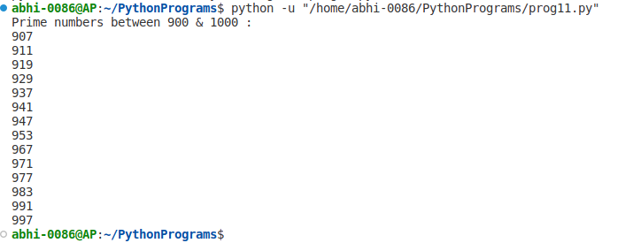

Program – 12

Object – Write a program to print a reverse string.

Code :

# string = input("Enter a string :")
# for word in reversed(string):
# print(word, end='')
# print()

str = input("Enter a string :")
reversed_str = ""
for i in range(len(str)-1, -1, -1):
reversed_str += str[i]
print("Original string :",str)
print("Reversed string :",reversed_str)

# def reverse(s):
# str = ""
# for i in s:
# str = i + str
# return str
# str = input("Enter a string :")
# print("Original string :",str)
# print("Reversed string :",reverse(str))

Output :
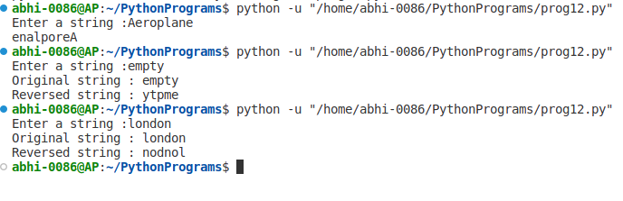

Program – 13

Object – Write a program to print right angle ‘#’ pattern.

Code :

num_row = int(input("Enter number of rows :"))
for i in range(0, num_row):
for j in range(0, i+1):
print("# ", end='')
print()

Output :

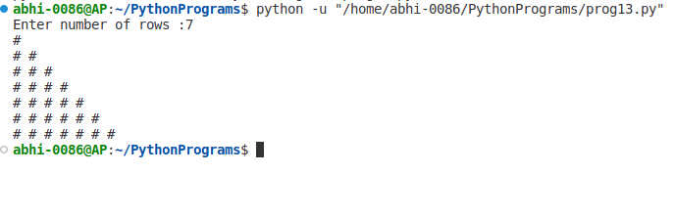

Program – 14

Object – Write a program to display Fibonacci sequence upto nth term.

Code :

n1, n2 = 0, 1
num_terms = int(input("Enter number of terms required :"))
count = 1
if num_terms <= 0:
print("Please enter a positive number!")
elif num_terms == 1:
print("Fibonacci series upto",num_terms,"terms :")
print(n1)
else:
print("Fibonacci series upto",num_terms,"terms :")
while count <= num_terms:
if count == num_terms:
print(n1)
else:
print(n1,end=', ')
temp = n1 + n2
n1 = n2
n2 = temp
count += 1

Output :

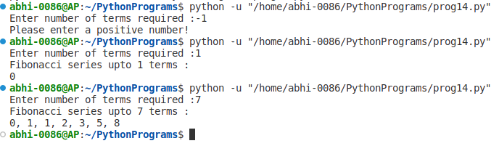

Program – 15

Object – Write a program to convert decimal into other number system.

Code :

decimal_num = int(input("Enter a decimal number: "))
# Converting decimal to binary
binary_num = bin(decimal_num)
# Converting decimal to octal
octal_num = oct(decimal_num)
# Converting decimal to hexadecimal
hexadecimal_num = hex(decimal_num)

print("The decimal number", decimal_num, "in binary is:", binary_num)
print("The decimal number", decimal_num, "in octal is:", octal_num)
print("The decimal number", decimal_num, "in hexadecimal is:", hexadecimal_num)

Output :
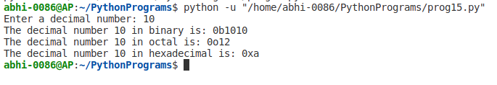

Program – 16

Object – Write a program to display calendar of given month and year.

Code :

import calendar
year = int(input("Enter year : "))
month = int(input("Enter the month : "))
print(calendar.month(year, month))

Output :

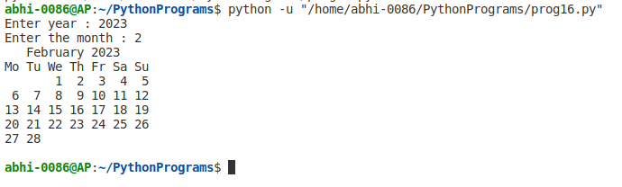

Program – 17

Object – Write a program to add two matrices using nested loop.

Code :

matrix1 = [[1,2,3],[4,5,6],[7,8,9]]
matrix2 = [[1,0,0],[0,1,0],[0,0,1]]

result = [[0,0,0],[0,0,0],[0,0,0]]

for i in range (len(matrix1)):
for j in range (len(matrix1[0])):
result[i][j] = matrix1[i][j] + matrix2[i][j]

for k in result:
print(k)

Output :
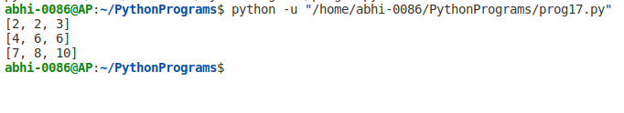

Program – 18

Object – Write a program to check armstring number in a certain interval.

Code :

#function to check if number is armstrong or not
def isArmstrong(num):
order = len(str(num))
sum = 0
temp = num
while(temp > 0):
digit = temp % 10
sum += digit ** order
temp //= 10
if(num == sum):
return True
else:
return False

a = int(input("Enter the lower limit of the interval: "))
b = int(input("Enter the upper limit of the interval: "))
print("Armstrong number between",a,"and",b,"are : ")
for i in range(a, b+1):
if(isArmstrong(i)):
print(i)

Output :
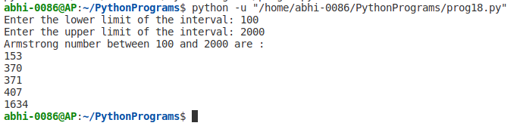

Program – 19

Object – Write a program to find if number is positive or negative using if-else ladder.

Code :

num = float(input("Enter number to check : "))
if num > 0:
print(num,"is positive number")
elif num == 0:
print("You have entered zero")
else:
print(num,"is negative number")

Output :
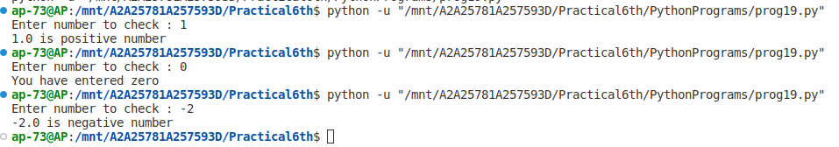

Program – 20

Object – Wriet a program to check if number is positive or negative using nested if-else.

Code :

num = float(input("Enter number to check : "))
if num >= 0:
if num == 0:
print("You have entered zero")
else:
print(num,"is a positive number")
else:
print(num,"is negative number")

Output :
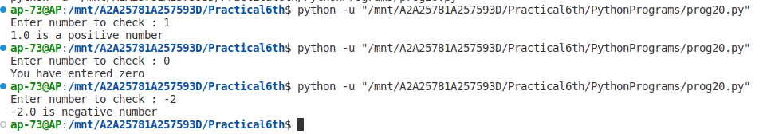

Program – 21

Object – Write a program to find factors of a number.

Code :

def factors(n):
for i in range(1,n+1):
if n%i == 0:
if i != n:
print(i, end=", ")
else:
print(i)

num = int(input("Enter a number : "))
print("The factors of",num,"are : ")
factors(num)

Output :
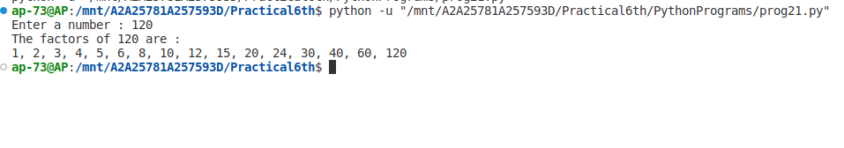

Program – 22

Object – Write a program to make a simple calculator.

Code :

#function to add two number
def add(x, y):
return x+y

#function to subtract two number
def subtract(x, y):
return x-y

#function to subtract two number
def multiply(x, y):
return x*y

#function to subtract two number
def divide(x, y):
return x/y

print("Select the operation to be performed : ")
print("1. Addition\n2. Subtraction\n3. Multiplication\n4. Division")

while True:
#take user input, which operation to
choice = input("Enter your choice :")

if choice in ('1','2','3','4'):
num1 = int(input("Enter first number : "))
num2 = int(input("Enter second number : "))
else:
print("Invalid Input!")

if choice == '1':
print(num1,"+",num2,"=",add(num1,num2))

if choice == '2':
print(num1,"-",num2,"=",subtract(num1,num2))

if choice == '3':
print(num1,"*",num2,"=",multiply(num1,num2))

if choice == '4':
print(num1,"/",num2,"=",divide(num1,num2))

#check if user want to perfrom any further calculation
next_cal = input("Want to perform any further calculation (y/n) : ")
if next_cal == 'n':
break

Output :

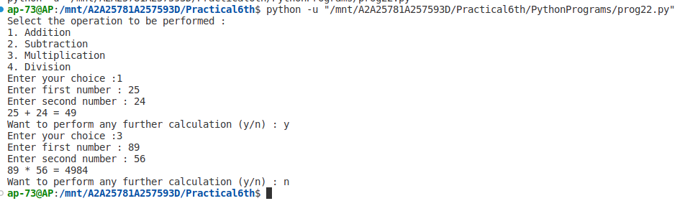

Program – 23

Object – Write a program to find LCM of two input numbers.

Code :

def compute_lcm(x,y):
#find the greatest number of two
if x > y:
max = x
else:
max = y

while 1:
if (max%x == 0) and (max%y == 0):
lcm = max
break
else:
max += 1

return lcm

num1, num2 = map(int, input("Enter two number : ").split())
print("LCM of",num1,"and",num2,"is",compute_lcm(num1,num2))

Output :
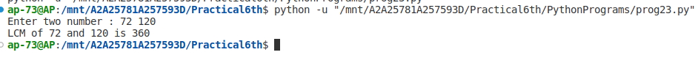

Program – 24

Object – Write a program to display power f 2 using anonymous function.

Code :

num_terms = int(input("Enter number of terms : "))

#use anonymous function
result = list(map(lambda x:2**x,range(num_terms)))

print("Total number of terms are : ")
for i in range(num_terms):
print("2 raised to power ",i,"is",result[i] )

Output :

