Provisioning an Amazon EBS Volume

Objective:
To successfully create and configure an Amazon Elastic Block Store (EBS) volume using the AWS Management Console while adhering to AWS Free Tier limits. This volume will act as external storage for an EC2 instance, suitable for storing datasets and projects.

Step 1: Navigating to the EBS Volumes Dashboard
From the AWS Management Console, navigate to the EC2 Dashboard. In the left navigation pane, scroll down to the 'Elastic Block Store' section and click on 'Volumes'. Click the orange 'Create volume' button to begin the setup.
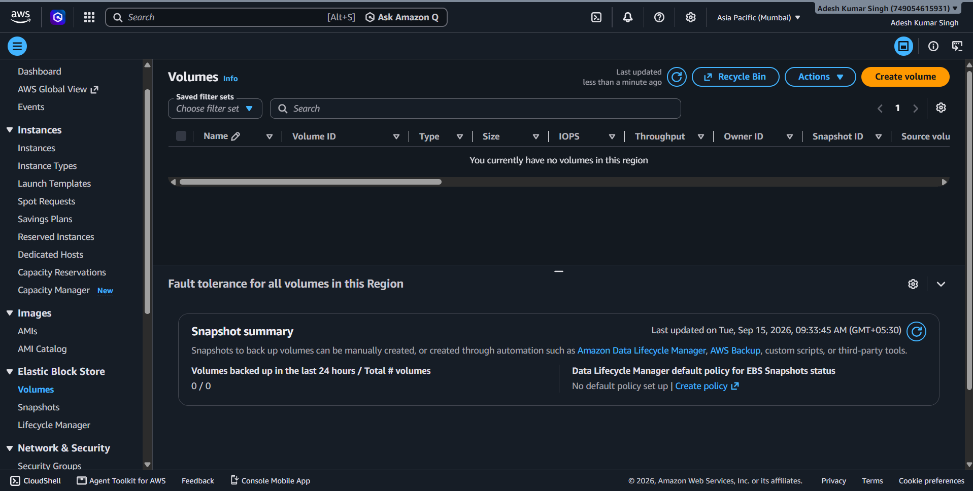

Step 2: Configuring Basic Volume Settings
In the Volume settings, select 'General Purpose SSD (gp3)' as the Volume type. This is the latest generation SSD and falls under the Free Tier. Set the Size to 5 GiB, ensuring the total account storage remains under the 30 GB monthly Free Tier limit. Leave IOPS at 3000 and Throughput at 125 MiB/s (default). Crucially, set the Availability Zone to 'aps1-az1 (ap-south-1a)' so it matches the geographic location of the target EC2 instance.
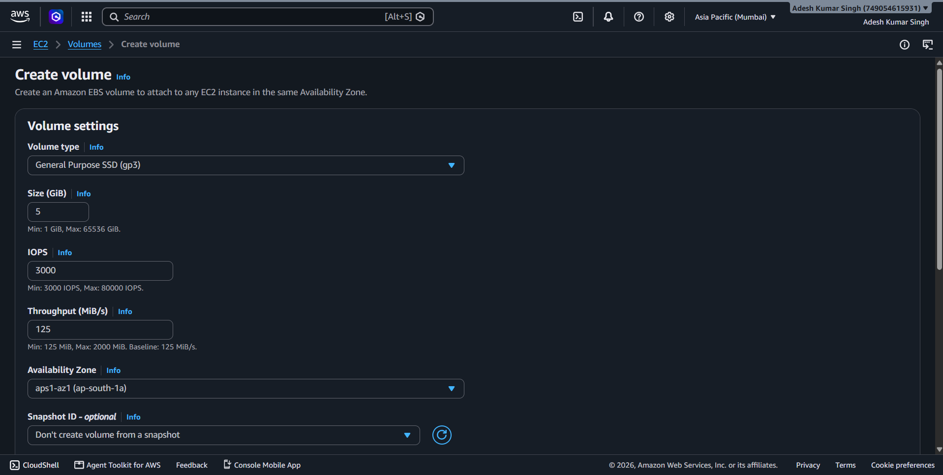

Step 3: Setting Tags and Finalizing Creation
For this basic setup, leave the Snapshot ID blank and Encryption unchecked. Under the 'Tags' section, click 'Add new tag'. Enter 'name' as the Key and 'Adesh-dataset-volume' as the Value. This helps easily identify the volume in the future. Finally, click the orange 'Create volume' button at the bottom right.
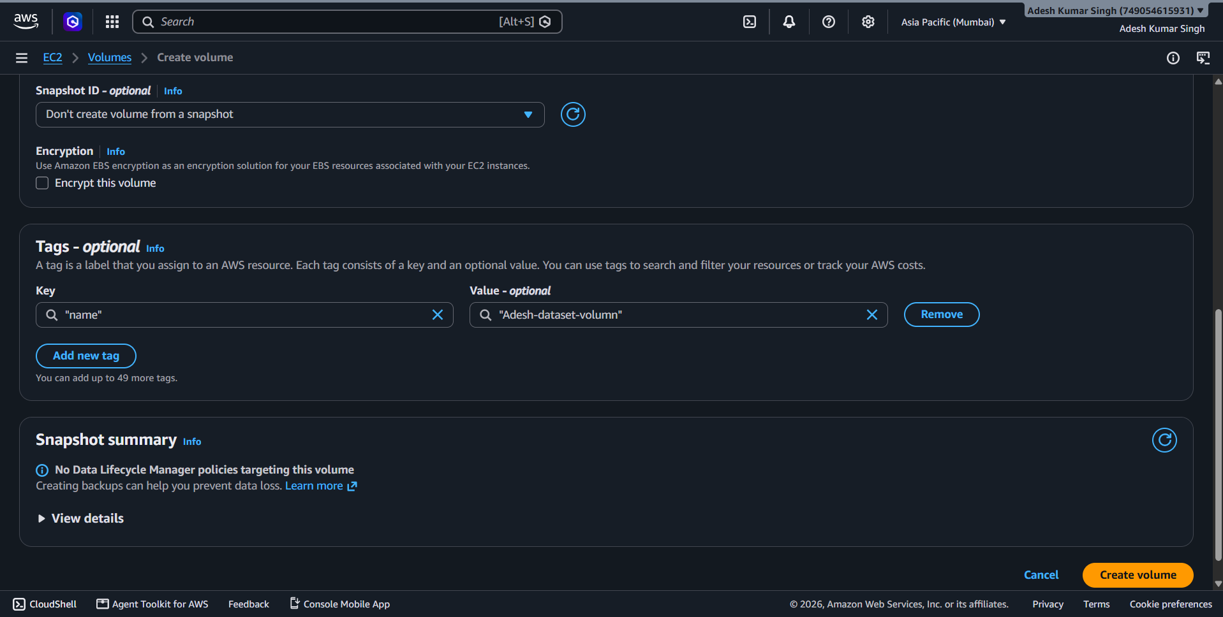

Step 4: Verifying the Created Volume
After creation, the console redirects to the Volumes dashboard. A green success banner will appear at the top confirming the volume (e.g., vol-0ff976a44e51fe0f5) was created. Verify that the 'Volume state' is marked as 'Available', which indicates that the storage is ready to be attached to an EC2 instance.
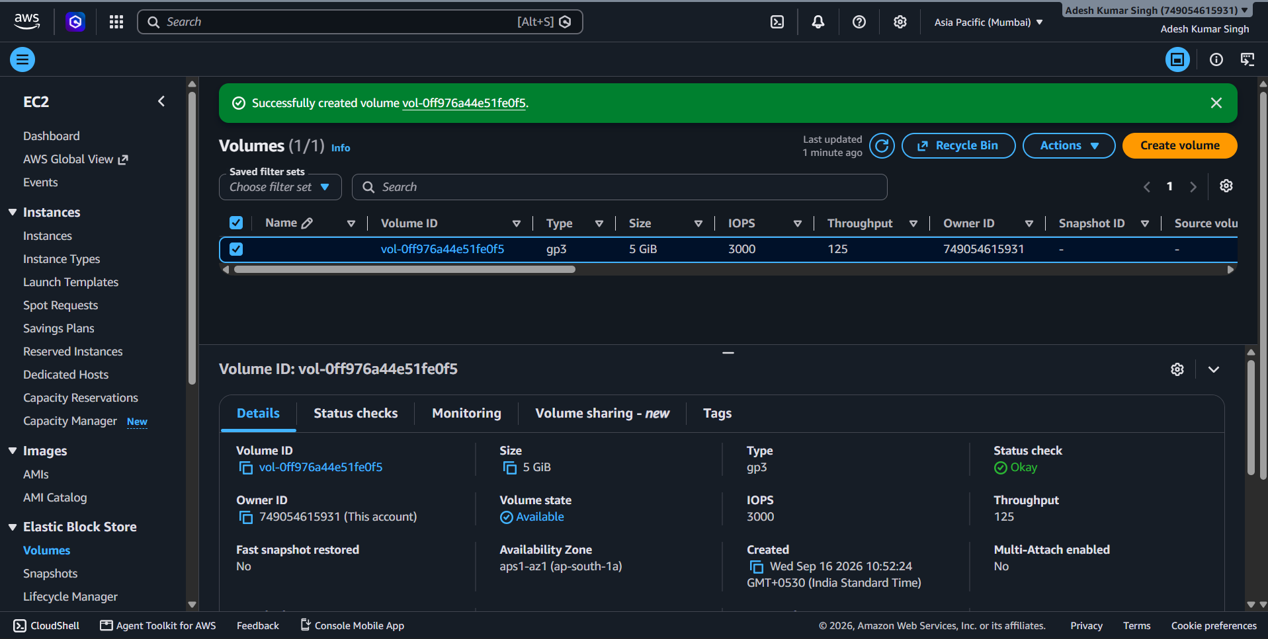

Conclusion:
By following these steps, a 5 GiB General Purpose SSD (gp3) EBS volume has been successfully provisioned. The volume is now in an "Available" state and ready to be attached to an EC2 instance in the ap-south-1a Availability Zone.

