Launching a Virtual Server on AWS EC2

Introduction to Amazon EC2
Amazon EC2 (Elastic Compute Cloud) is an AWS cloud service that
provides on-demand virtual servers, known as EC2 Instances. It allows
users to run applications without buying physical hardware.

Step 1: Sign in to AWS Console
- Action :- Logged into the AWS Management Console and selected the region
- Explanation :- Logging in and choosing the nearest region reduces network
latency and ensures faster access to the server.

Step 2: Open the EC2 Dashboard
- Action :- Searched for "EC2" in the search bar and opened the EC2 service page.
- Screenshot :-
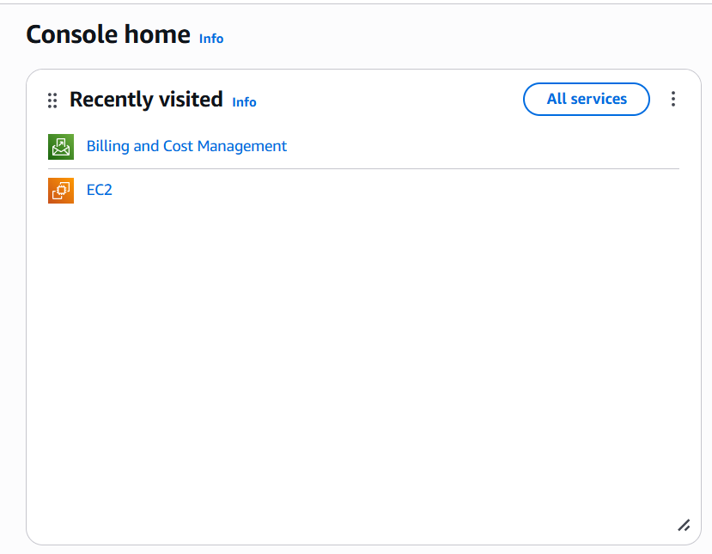
- Explanation :- The EC2 dashboard allows us to create, view, and manage virtual
servers and their storage.

Step 3: Start Instance Launch
- Action :- Clicked on the orange "Launch instance" button.
- Screenshot :-
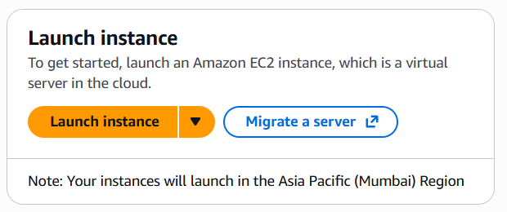
- Explanation :- This step opens the guided setup where we configure the server hardware, operating system, and network settings.

Step 4: Name the Server and Choose OS
- Action :- Named the instance and selected Operating System (Free Tier Eligible).
- Screenshot 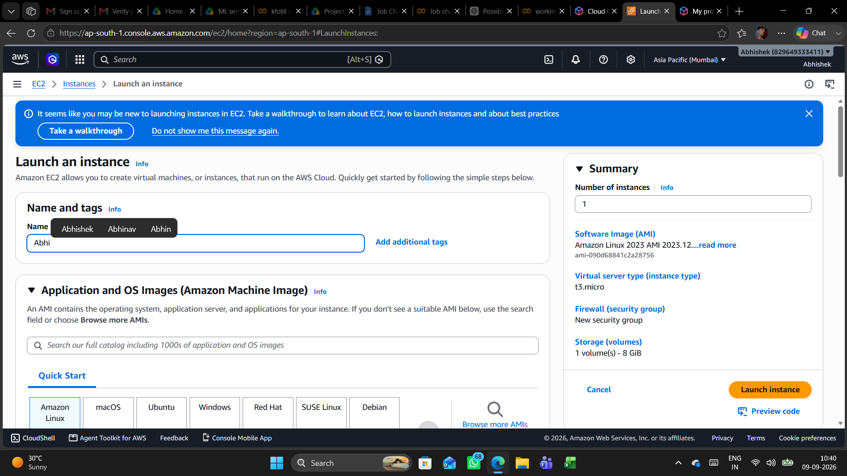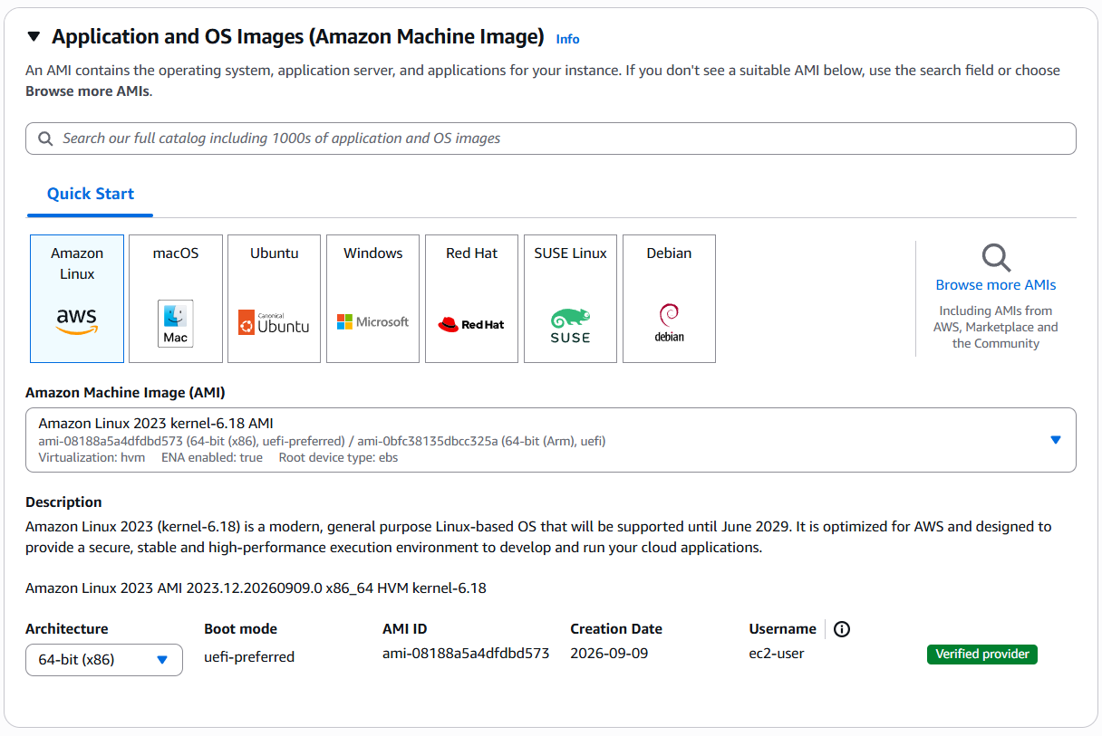
- Explanation :- The Amazon Machine Image (AMI) provides the operating system template needed to boot and run the server.

Step 5: Select Instance Type
- Action :- Selected the Instance Type like t3.micro from the dropdown list.
- Screenshot :- 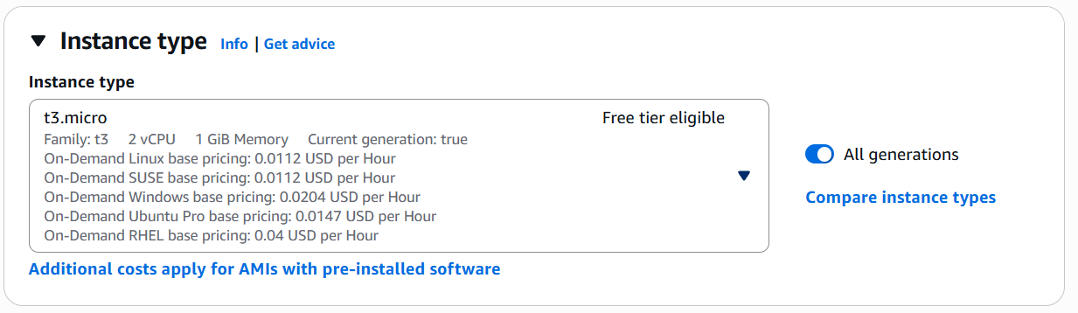
- Explanation :- The t2.micro type allocates 2vCPU and 1 GB RAM, which is free to use under the AWS Free Tier.

Step 6: Create and Download Key Pair
- Action :- Created a new key pair (my-key.pair) and download it.
- Screenshot :- 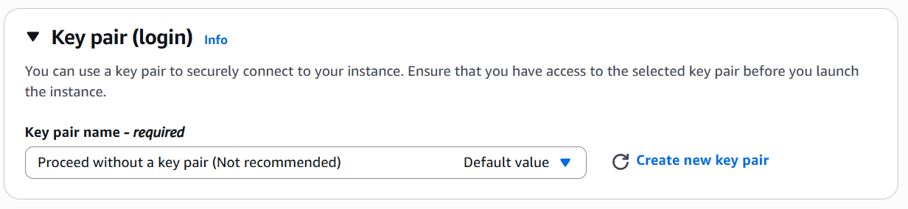
- Explanation :- In this step, we generate and download a private key file (.pem), which provides secure cryptographic authentication so we can log into the server remotely via SSH without using a password.

Step 7: Configure Network Security
- Action :- Kept default VPC and enabled SSH (Port 22) and HTTP (Port 80) traffic.
- Screenshot :- 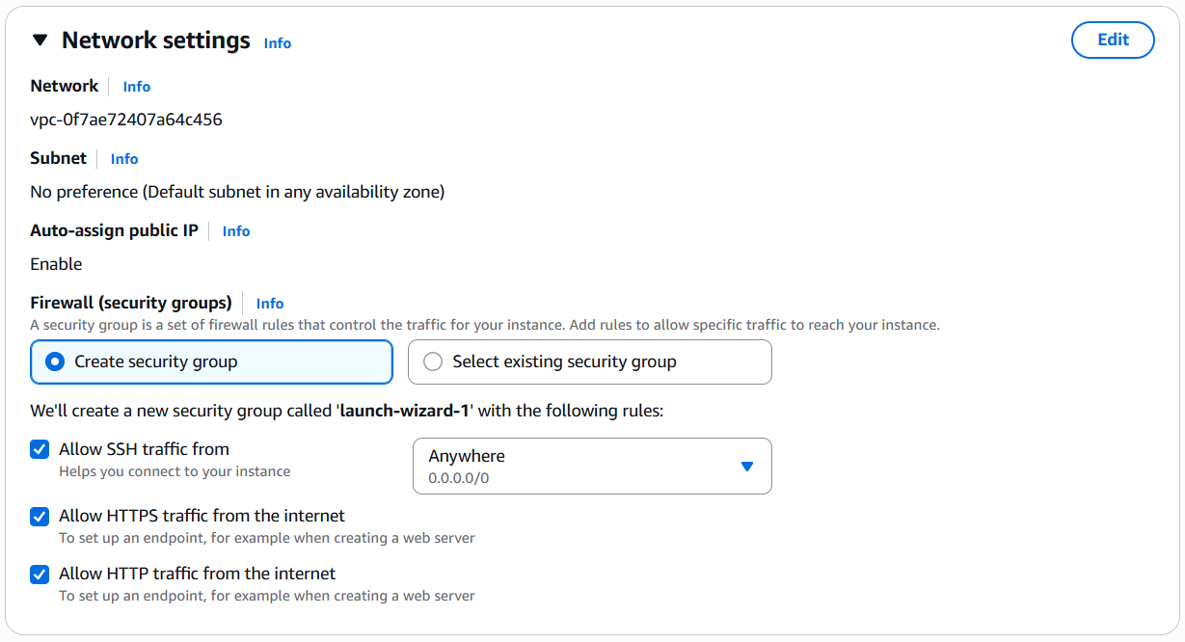
- Explanation :- In this step, we configure inbound Security Group rules to act as a virtual firewall, opening Port 22 for secure remote terminal access and Port 80 to accept public internet web traffic.

Step 8: Configure Storage
- Action :- Kept the default 8 GiB gp3 SSD root storage.
  - Screenshot :- 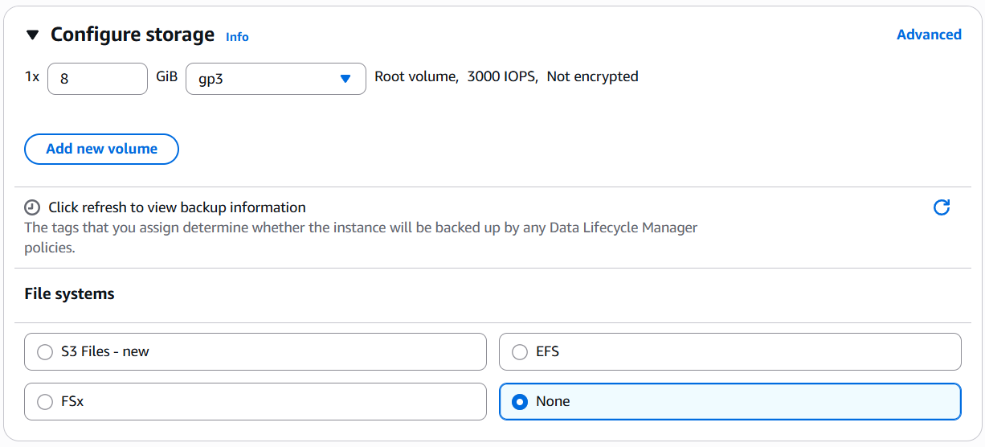
- Explanation :- In this step, we assign the default 8 GiB SSD root volume, which provides persistent block-level disk storage (EBS) to keep the operating system and saved files permanently intact.
Step 9: Launch the Server
- Action :- Checked the summary and clicked Launch instance.
- Screenshot :-
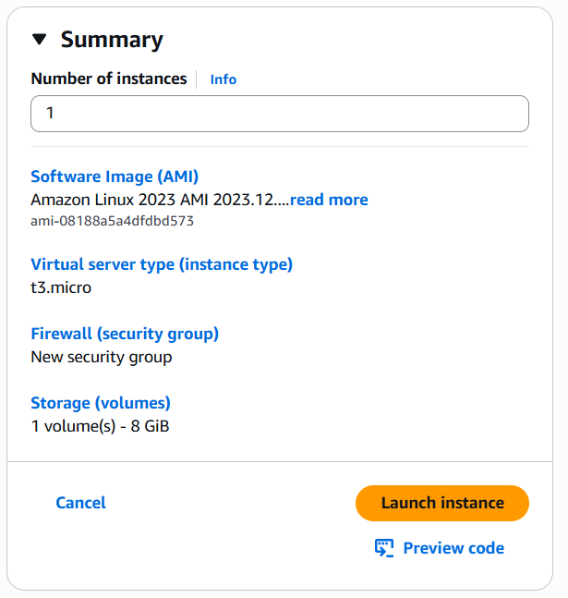
- Explanation :- In this step, we review our setup and click the launch button, which submits our request to AWS to automatically allocate physical hardware, attach storage, and boot the virtual server.

Step 10: Verify Running State and Public IP
- Action :- Checked that status shows Running and copied the Public IPv4 address.
- Screenshot :- 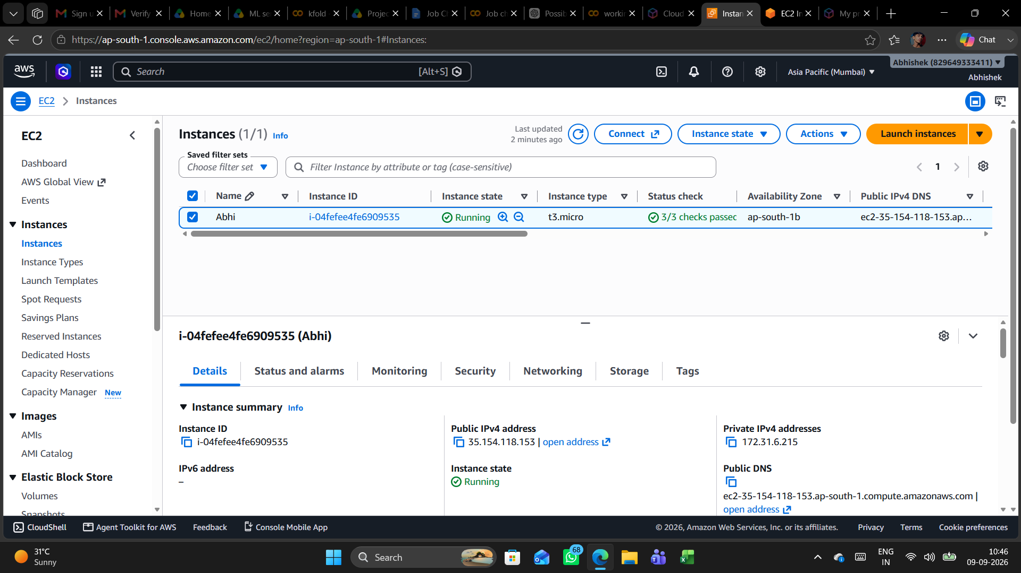
- Explanation :- In this step, we verify that the instance status has changed to "Running" and record the Public IP, confirming that the cloud server is live, healthy, and ready for network connections.

Conclusion :- In this lab, an Amazon EC2 virtual server was successfully configured and launched on AWS. We selected a Linux OS (AMI), allocated hardware resources (t3.micro), chose to proceed without a key pair for quick access, and configured firewall rules for network traffic. The server is live in the Running state and ready for remote access via its Public IP address.

