High-Level Design: SoCampus Facility Management — Desk Booking Enhancement
Status: Proposed | Date: 19 Aug 2026 | Author: Engineering (prepared with Claude) | Deciders: Rishabh Azad, Rahul Mohindra (CTO)
Inputs used: codebase audit (backend/frontend/services), client requirements brief (6 areas), phased milestone plan M1–M27, 5-vendor benchmark report (20-Aug-2026), competitor UI research.

0. How to read this document (and how to design any system)
An HLD answers five questions, in order. Every section of this document maps to one of them — reuse this as a template for any system:
- WHY — What problem, for whom, under what constraints? (Section 1: Requirements & Constraints)
- WHAT EXISTS — What is the as-is system? Never design on a blank page if there’s a running system. (Section 2)
- WHAT CHANGES — Target architecture: components, responsibilities, boundaries. (Section 3)
- HOW IT WORKS — Data model, key flows, APIs, cross-cutting concerns (the “mechanics”). (Sections 4–7)
- WHAT COULD GO WRONG — Trade-offs (ADRs), scaling limits, risks, rollout. (Sections 8–10)
Teaching note — the single most useful habit: for every box you draw, write one sentence: “This component owns X and nothing else.” If you can’t, the boundary is wrong. You’ll see this pattern applied to every component in Section 3.

1. Requirements & Constraints

1.1 Functional requirements (from the client brief)
# | Requirement | Essence
R1 | Auto-release of unutilized bookings | Check-in within configurable grace (15/30 min) or the desk is freed; notify before/after; audit everything
R2 | Biometric attendance integration | Validate presence vs. reservation; classify utilized / no-show / walk-in; compliance reports
R3 | Analytics & reporting | Real-time occupancy; cuts by location/building/floor/dept/BU; trends, no-show, peak; Excel/PDF; scheduled email
R4 | Enhanced UX | Interactive floor maps, live availability, search/filter, mobile-responsive, QR check-in/out, team seating visibility
R5 | Admin controls | Configurable rules & grace periods, desk blocking/maintenance, reservation limits, central admin dashboard
R6 | Notifications | Confirmations, reminders, check-in nudges, release notices, admin occupancy alerts

1.2 Non-functional requirements (NFRs)
- Multi-tenancy is non-negotiable — every new table carries tenant_id; every query goes through the existing tenantScope helpers. A multi-site client (Sodexo-scale, 1,100+ sites) must be able to set different grace periods per site.
- Correctness over speed for release logic — releasing a desk someone is sitting at is worse than releasing it 60 seconds late. The sweeper must be idempotent and race-safe.
- Reuse before build — mailer, cron patterns, approval chains, layout editor, and (Ph2) Mobilise’s own Count IoT attendance product are all existing assets.
- Scale target: hundreds of facilities, thousands of desks, tens of thousands of bookings/month per tenant. This is comfortably within a single MySQL + Node monolith — the design deliberately does NOT introduce microservices, queues, or Kubernetes (see ADR-1).
Teaching note: NFRs are where systems are actually won or lost. Ask three questions of every requirement: how many? (scale), how fast? (latency), how wrong can it be? (consistency). R1’s answer to the third question — “never release an occupied desk” — dictates half of this design.

1.3 Explicit constraints
- Existing stack is fixed: Node/Express + raw mysql2 (no ORM), hand-written SQL migrations, React 18 + Vite SPA, nodemailer, FastAPI/OpenCV side-service. No stack changes.
- Two developers, ~15 weeks (per sprint plan). Phase 2 depends on the Count-vs-vendor decision (M22).
- No committed budget for third-party licenses; everything below uses open-source components.

2. As-Is Architecture (what exists today)
One modular monolith with side services:
React SPA ──► Express API (modules: auth, bookings, facilities, approvals,
dashboards, notifications, admin, public portal, cron)
│
├─► MySQL (44 migrations; tenants → orgs → sites → buildings
│ → floors → facilities; bookings + approvals)
├─► nodemailer → SMTP (12+ templates, action-token links)
├─► floor-scan-svc (FastAPI + OpenCV chair detection)
└─► in-process jobs (checkoutSweeper, pre-end-notify cron)
Strengths to build on: race-safe booking transactions (SELECT … FOR SHARE), approval-chain engine, per-facility rule columns (advance windows, per-user quotas), the SVG layout editor with chair-level IDs, the email action-token pattern (one-click approve/cancel from email), an existing job-runner pattern, strict tenant scoping.
Gaps this design closes: no check-in of any kind, no grace config, nothing ever releases a booking, no audit log, no attendance data, today-only analytics, no QR, no desk blocking.
Teaching note: the as-is review is where you hunt for reusable mechanics, not just gaps. Here, three existing mechanics get recycled almost unchanged: the checkoutSweeper loop becomes the auto-release sweeper; the pre-end-notify cron becomes the reminder engine; the action-token email becomes the “keep my booking” one-tap link. Recognizing these cut ~30% off the estimate.

3. Target Architecture
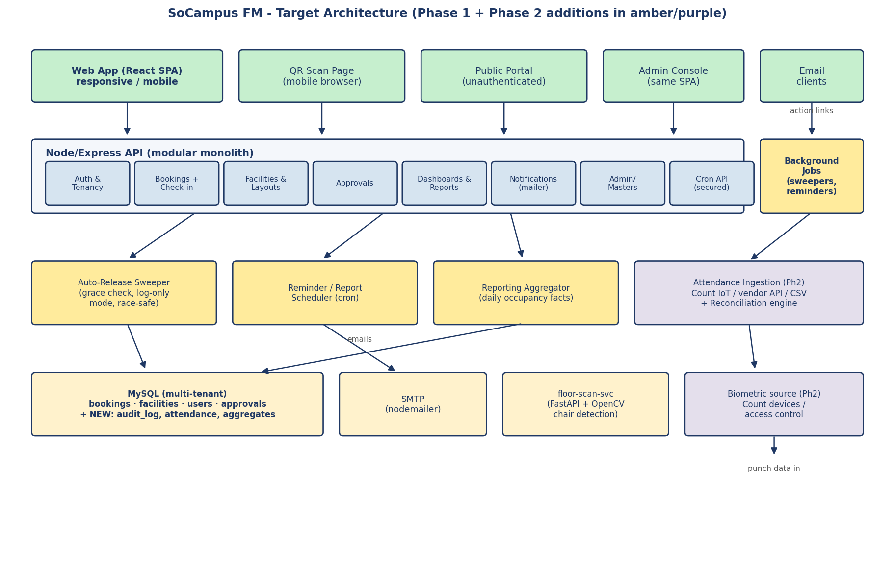
Target architecture
The monolith stays; we add four internal services (amber) and one Phase-2 subsystem (purple). One sentence of ownership per component:
Component | Owns (and nothing else)
Check-in module (inside bookings) | The checked_in_at / checked_out_at transition and its validation window
Auto-Release Sweeper | Finding overdue un-checked-in bookings and flipping them to released, atomically
Reminder/Report Scheduler | Time-triggered emails: pre-start reminders, check-in nudges, scheduled report delivery
Reporting Aggregator | Nightly rollup of raw bookings into occupancy_daily facts with building/floor/dept/BU dimensions
Audit Logger | Append-only booking_audit_log writes; never updated - append-only by design
Attendance Ingestion (Ph2) | Pulling punches from Count/vendor into attendance_records; nothing about interpretation
Reconciliation Engine (Ph2) | Joining attendance × bookings into utilized / no-show / walk-in classifications
Why these boundaries? Each is triggered differently (API call vs. clock vs. data arrival), fails independently (a broken biometric sync must not affect booking), and evolves at a different pace. That’s the test for a boundary: different trigger, different failure domain, different rate of change.

4. Data Design

4.1 New/changed schema (Phase 1)
-- facilities: grace config (per-facility; tenant default in tenant_settings)
ALTER TABLE facilities ADD COLUMN grace_period_minutes INT NULL; -- NULL = auto-release off
ALTER TABLE facilities ADD COLUMN checkin_open_before_min INT NULL; -- default 15
-- bookings: check-in lifecycle
ALTER TABLE bookings
ADD COLUMN checked_in_at DATETIME NULL,
ADD COLUMN checked_out_at DATETIME NULL,
MODIFY status ENUM('pending','approved','rejected','cancelled','completed','released');
-- desk blocking (layout-level, references stable chair IDs from M1)
CREATE TABLE desk_blocks (
id BIGINT UNSIGNED PRIMARY KEY AUTO_INCREMENT,
tenant_id BIGINT UNSIGNED NOT NULL,
facility_id BIGINT UNSIGNED NOT NULL,
desk_id VARCHAR(64) NOT NULL, -- stable chair ID
reason VARCHAR(255), starts_at DATETIME NOT NULL, ends_at DATETIME NULL,
created_by BIGINT UNSIGNED NOT NULL,
KEY idx_blocks_lookup (facility_id, desk_id, starts_at, ends_at)
);
-- append-only audit
CREATE TABLE booking_audit_log (
id BIGINT UNSIGNED PRIMARY KEY AUTO_INCREMENT,
tenant_id BIGINT UNSIGNED NOT NULL,
booking_id BIGINT UNSIGNED NOT NULL,
event ENUM('created','approved','checked_in','checked_out','released',
'cancelled','rescheduled','reminder_sent','release_warning_sent'),
actor_type ENUM('user','admin','system') NOT NULL,
actor_id BIGINT UNSIGNED NULL,
detail JSON NULL, -- old/new values, grace used, etc.
created_at DATETIME NOT NULL DEFAULT CURRENT_TIMESTAMP,
KEY idx_audit_booking (booking_id), KEY idx_audit_tenant_time (tenant_id, created_at)
);
-- analytics fact table (nightly aggregation)
CREATE TABLE occupancy_daily (
day DATE NOT NULL, tenant_id BIGINT UNSIGNED NOT NULL,
site_id BIGINT UNSIGNED, building_id BIGINT UNSIGNED, floor_id BIGINT UNSIGNED,
facility_id BIGINT UNSIGNED, department_id BIGINT UNSIGNED NULL,
booked_minutes INT, open_minutes INT, bookings_count INT,
released_count INT, checked_in_count INT,
PRIMARY KEY (day, tenant_id, facility_id, department_id)
);
Phase 2 adds attendance_records (raw punches, source-tagged) and attendance_reconciliation (day × user classification).
Teaching note — three data-design rules used above: (1) Audit tables are append-only: no UPDATE path exists, so they’re trustworthy in a dispute. (2) Aggregate what you read often, keep raw what you read rarely: dashboards hit occupancy_daily (small), exports can still hit bookings (big). (3) NULL means “feature off”, matching the existing convention from the advance-rules migration (032) — consistency with local convention beats textbook purity.

4.2 Config resolution order (grace period)
facility.grace_period_minutes → else tenant_settings.default_grace_minutes → else feature off. Per-site override satisfies the multi-site NFR without a new hierarchy table.

5. Key Flows

5.1 Booking lifecycle with auto-release
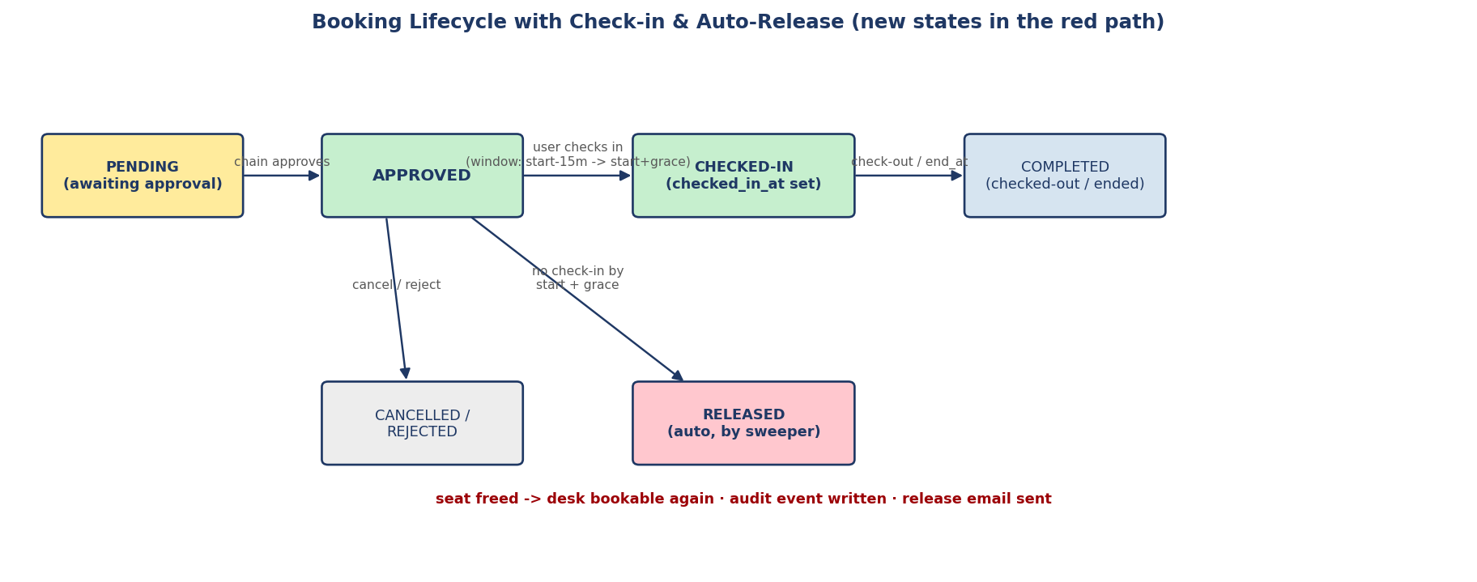
Booking lifecycle
Sweeper algorithm (runs every 60s, in-process like checkoutSweeper):
1. SELECT candidate bookings WHERE status='approved'
AND checked_in_at IS NULL
AND start_at + grace < NOW() (grace resolved per facility/tenant)
AND facility has grace enabled
LIMIT 50 FOR UPDATE SKIP LOCKED ← two app instances never double-process
2. For each, inside one transaction:
re-check conditions (idempotency guard)
IF mode = 'log-only': write audit event 'would_release', continue ← Skedda-style rollout
UPDATE bookings SET status='released'
write booking_audit_log ('released', actor=system, detail={grace, mode})
3. After commit: fire release email (fire-and-forget, like existing mailer)
The release-warning email goes out at start_at + grace − warning_offset from the same scheduler that sends check-in reminders — one clock, many message types.

5.2 QR check-in (M15)
QR payload = https://<host>/checkin?d=<stable_desk_id>&f=<facility_id> — no booking ID in the QR (labels are printed once, bookings change daily). The scan page authenticates, finds your active booking for that desk today, and calls the same POST /bookings/:id/check-in as the button. One API, three front doors (button, QR, admin override) — never fork business logic per channel.

5.3 Attendance reconciliation (Ph2, nightly)
attendance_records (punches, from Count/vendor)
⋈ join on user + site + date
bookings (that day, incl. released)
↓ classify
utilized (booked + punched) | no-show (booked, no punch)
| walk-in (punched, no booking) → attendance_reconciliation → reports
Runs as a nightly batch, not real-time: attendance data arrives in batches anyway, and no product decision needs sub-day latency here. Match the processing cadence to the decision cadence.

6. API Additions (Phase 1)
Endpoint | Purpose | Rules enforced
POST /api/bookings/:id/check-in | Stamp checked_in_at | Window: start−15min … start+grace; booker or admin; status must be approved
POST /api/bookings/:id/check-out | Stamp checked_out_at, free seat early | After check-in only
GET /api/floors/:id/live-map | Floor-level availability (M4) | Aggregates all facility layouts on the floor + current booking/block state
POST /api/desk-blocks / DELETE … | Desk blocking (M2) | Admin only; warns on conflicting future bookings
GET /api/reports/occupancy?from&to&group_by=building\|floor\|dept | Historical analytics (M6) | Reads occupancy_daily
POST /api/report-subscriptions | Scheduled email reports (M9) | Admin; cron renders & mails
All follow existing module conventions: authRequired, requireRole, scopeWhere(tenant), controller-per-module.

7. Cross-Cutting Concerns
- Multi-tenancy: every new table has tenant_id; every sweeper query is tenant-agnostic but every mutation writes tenant-scoped audit rows. No cross-tenant leakage possible via the aggregates because tenant_id is in the primary key.
- Idempotency: sweeper re-checks state inside the row lock; check-in returns 200 (not error) if already checked in — clients can retry safely.
- Clock discipline: all comparisons in SQL NOW() (DB clock), never app-server clocks — two app servers with skewed clocks must not disagree about grace expiry.
- Feature flags: grace_period_minutes IS NULL = off per facility; sweeper mode=log_only|enforce per tenant — both DB-driven, no deploy needed to toggle.
- Observability: sweeper writes a heartbeat row per run (processed/released/errors); admin monitoring dashboard (M20) reads it. An alert if the heartbeat goes stale — the job that silently stops is worse than the job that fails loudly.
- Privacy: team-seating visibility (M16) is permission-gated and opt-out-able per user; attendance data (Ph2) is restricted to admin/compliance roles.

8. Decisions (mini-ADRs)

ADR-1: Extend the monolith vs. new microservices
 | A: Extend monolith (chosen) | B: Separate services + queue
Complexity | Low — same deploy, same conventions | High — new infra (queue, service discovery)
Team fit | 2 devs already know the codebase | Ops burden 2 devs can’t carry
Scale headroom | Fine to ~10× current load | Needed only at ~100×
Failure isolation | Weaker (mitigated: jobs are crash-isolated try/catch loops) | Stronger
Decision: A. The scale target (Section 1.2) doesn’t justify distribution. Rule of thumb: introduce a queue when a task must survive an app restart AND take longer than a request timeout — neither applies here (sweeper state lives in the DB, not in memory).

ADR-2: Pre-aggregated facts table vs. on-the-fly analytics queries
Chosen: nightly occupancy_daily facts + live “today” queries. On-the-fly GROUP BY over a growing bookings table gets linearly slower and blocks adding BU/dept joins (HReVO). Facts table keeps dashboards O(days × facilities), decouples the HRMS join to ingestion time, and gives scheduled reports a stable source. Cost: up to 24h staleness for historical views — acceptable; “today” stays live via the existing dashboard query.

ADR-3: Count-first vs. third-party biometric vendor (Ph2)
Chosen: evaluate Mobilise’s Count IoT attendance product first (M22). If Count’s device layer exposes punch data, R2 becomes an internal integration: no vendor contract, no per-site device negotiation, and badge check-in (M26) piggybacks free. Fall back to vendor API/CSV-SFTP only if Count can’t cover the client’s hardware. This decision gates ~17 dev-days of Phase 2 — resolve it during Phase 1 (discovery runs in parallel, week 9).

9. Scalability, Reliability, Failure Modes
Concern | Analysis | Mitigation
Sweeper misses runs (crash/restart) | Bookings stay approved past grace | Next run picks them up (condition is state-based, not event-based). Worst case: late release, never wrong release
Two instances sweep at once | Double release / double email | FOR UPDATE SKIP LOCKED + state re-check in transaction
Release email flood after outage | Hundreds of releases at once | Cap releases/run (LIMIT 50) — backlog drains over minutes, mailer is fire-and-forget
Floor map polling load | N users × poll every 15s | Response is per-floor, cacheable 10s server-side; upgrade path to SSE if >500 concurrent
Aggregation job grows | Nightly window | Aggregate only yesterday (incremental), backfill script for history
Wrong-date bookings blamed on system (a real WorkInSync complaint) | User trust damage | Confirmation screens/emails echo date + desk loudly; audit log settles disputes

10. Rollout Plan
- Weeks 1–10: Phase 1 build (see sprint plan) — sweeper ships in log-only mode first.
- Week 11: pilot floor — sweeper enforcing on one floor, rest log-only; compare would_release audit events vs. reality to tune grace defaults (15 vs 30 min) with data, not opinion.
- Weeks 12–15: Phase 2 (Count-first attendance), UAT, tenant-by-tenant enablement.
- Re-run the vendor benchmark after Phase 1 — projected fit score moves ~3.2 → ~7.5–8 (per the comparison report).

Appendix A: The reusable HLD checklist (the “teach me” summary)
- Write functional requirements as a numbered table; write NFRs as how many / how fast / how wrong can it be.
- Audit the as-is system for reusable mechanics, not just gaps.
- Draw the target architecture; caption every box with a one-sentence ownership statement; test boundaries with trigger / failure domain / rate of change.
- Design data before APIs: append-only for evidence, aggregates for hot reads, NULL-off for feature flags, local conventions over textbook purity.
- Draw the one state machine that matters (here: booking lifecycle). Most systems have exactly one.
- Route every channel (UI, QR, admin, email link) through one API per action.
- Write 2–4 mini-ADRs for the decisions someone will question in six months.
- For every background job ask: what if it runs twice? what if it doesn’t run? what if it runs late? (idempotency / state-based recovery / monotonic clocks).
- Plan rollout as observe → pilot → enforce (log-only mode is cheap insurance).
- Define the metric that proves success (here: benchmark fit score + released-desk reuse rate).

