Stock Market Analysis Project Report

Submitted by: ABHIJIT SINHA
Email: sinhaabhijit12@yahoo.com
UNID: UMID08062541597

Abstract

This project involves analyzing stock market data for Apple, Microsoft, Netflix, and Google. We performed exploratory data analysis (EDA), SQL integration, and machine learning model training, followed by a Stream lit app deployment.
The goal is to identify stock trends, compute moving averages & volatility, and build predictive models for closing prices.

Dataset Description

The dataset consists of historical stock price data for Apple (AAPL), Microsoft (MSFT), Netflix (NFLX), and Google (GOOG), covering a period of three months.
Key Observations from Dataset:
- No missing values were found, ensuring data quality.
- Prices (Open, High, Low, Close) are highly correlated, as expected in stock market data.
- Trading volumes vary significantly across companies, with tech giants like Apple and Microsoft showing higher average trading activity.
- This dataset provides a strong foundation for exploratory data analysis, SQL-based aggregations, and machine learning model building.
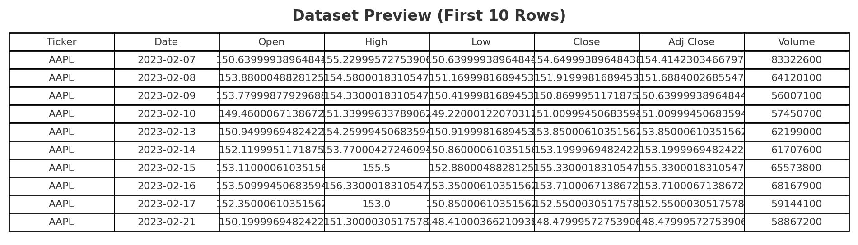

Technology Stack

- Python (Pandas, NumPy, Matplotlib, Seaborn, Scikit-learn)
- SQL (MySQL for storing raw data, features, predictions, and metrics)
- Machine Learning (Random Forest Regressor)
- Stream lit (for interactive dashboard)
- Excel Export (via Pandas Excel Writer)

Project Workflow and Implementation Steps

1. Data Preprocessing
- Loaded raw CSV dataset
- Cleaned column names & handled missing values
- Feature engineering (Moving Averages, Volatility, Lag features)
- Train/test split for ML model

2. Exploratory Data Analysis (EDA)
- Distribution of closing prices
- Total traded volume by company
- Scatter plot (Volume vs Closing Price)
- Correlation heatmap

3. SQL Integration
- Stored raw, feature-engineered, and predictions data into **MySQL**
- Example Query: *Average Closing Price by Ticker*

4. Machine Learning
- Trained a **Random Forest Regressor**
- Evaluated performance with **RMSE, MAE, R²**
- Visualized **Actual vs Predicted closing prices**

5. Stream lit App
- Upload CSV & preview data
- Train ML model interactively
- Visualize predictions (Actual vs Predicted)
- Export results to Excel or save to MySQL

Analysis & Results

1. The Preprocessing Flow Diagram

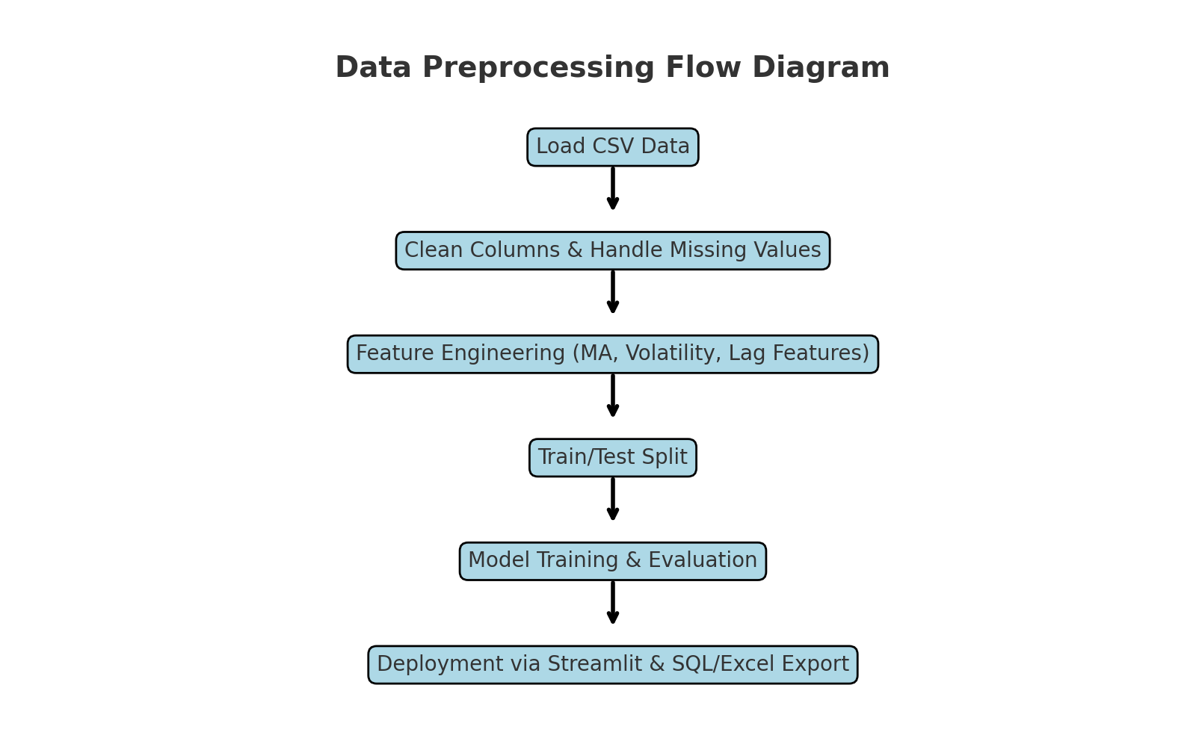

2. Exploratory Data Analysis (EDA) Charts

2.1 Distribution of Closing Prices
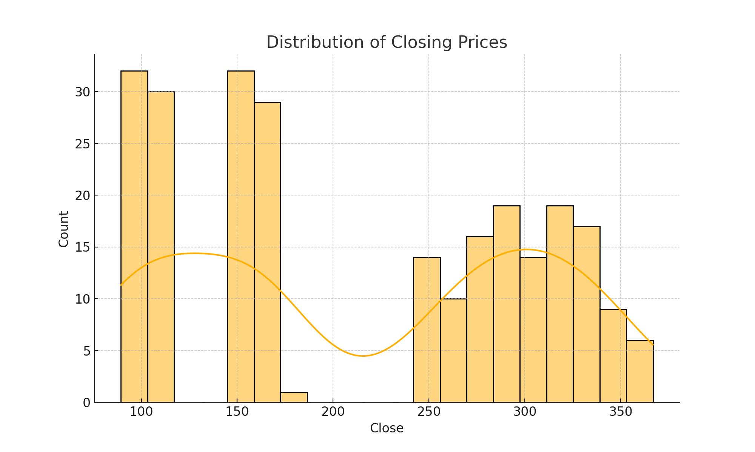
This histogram shows how closing prices are distributed across the dataset, indicating central tendency and spread.

2.2 Volume vs Closing Price
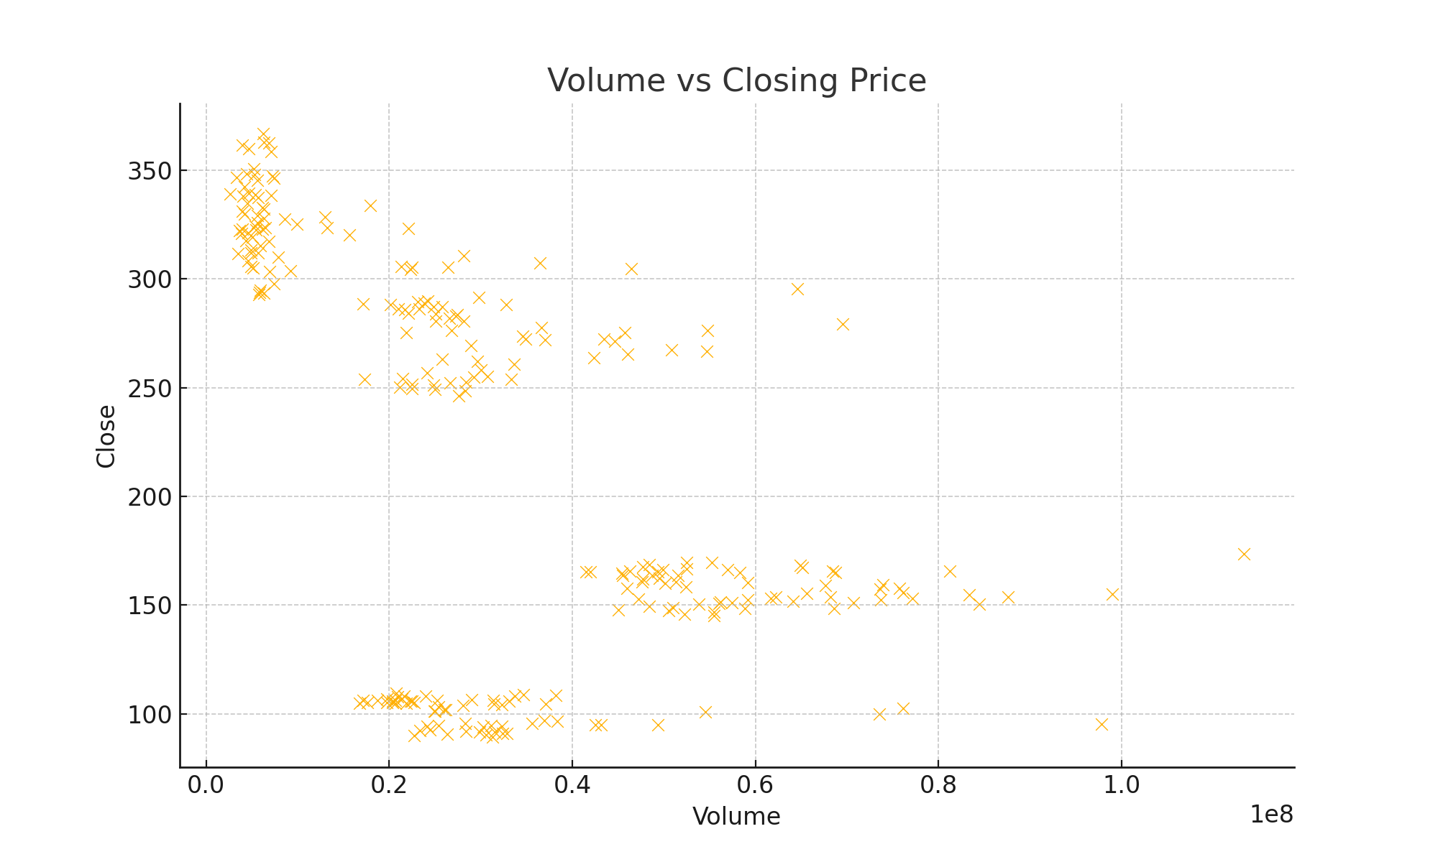
This scatterplot shows the relationship between trading volume and stock closing prices.

2.3 Total Volume by Ticker
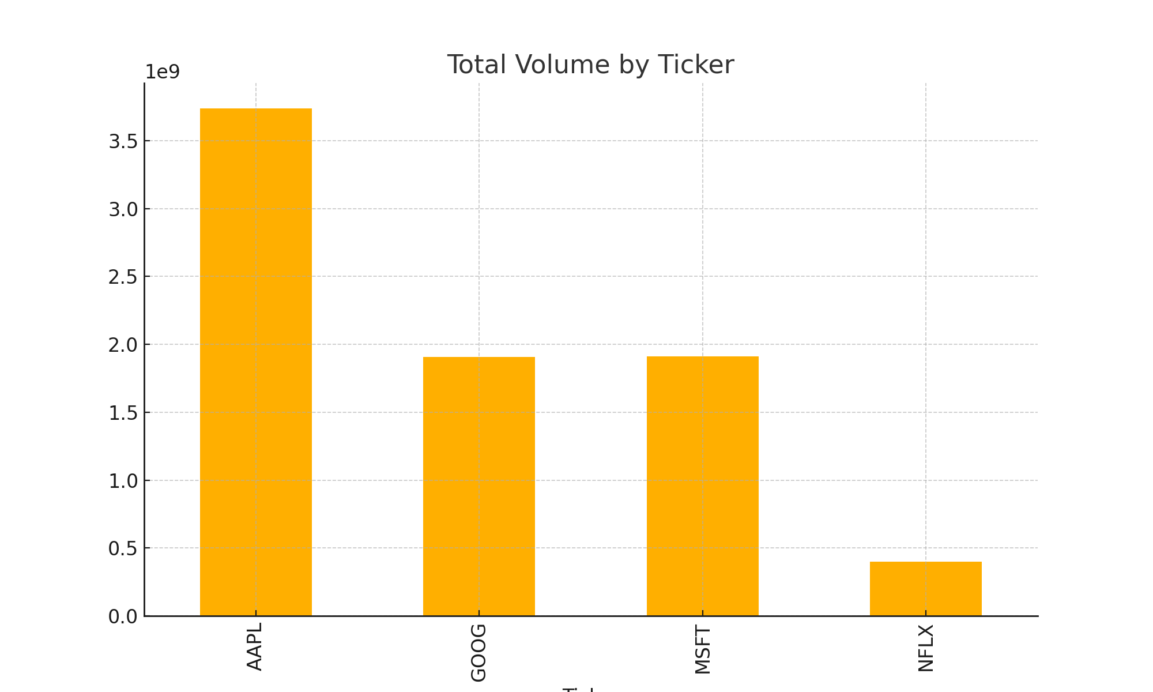

This bar chart compares the total traded volume across different companies.

2.4 Correlation Heatmap
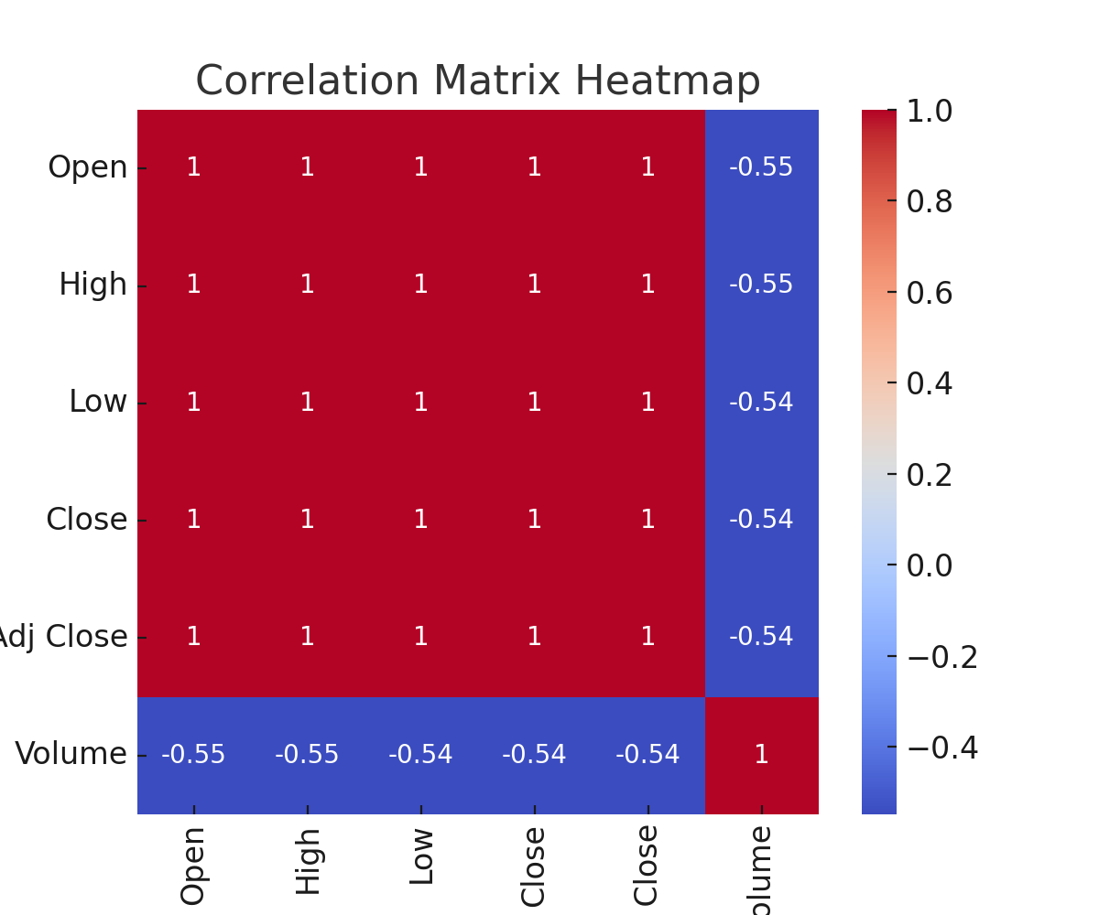
The correlation matrix shows strong correlations between Open, High, Low, and Close prices, while Volume has weaker correlation with prices.

3. SQL Query Results Visualization
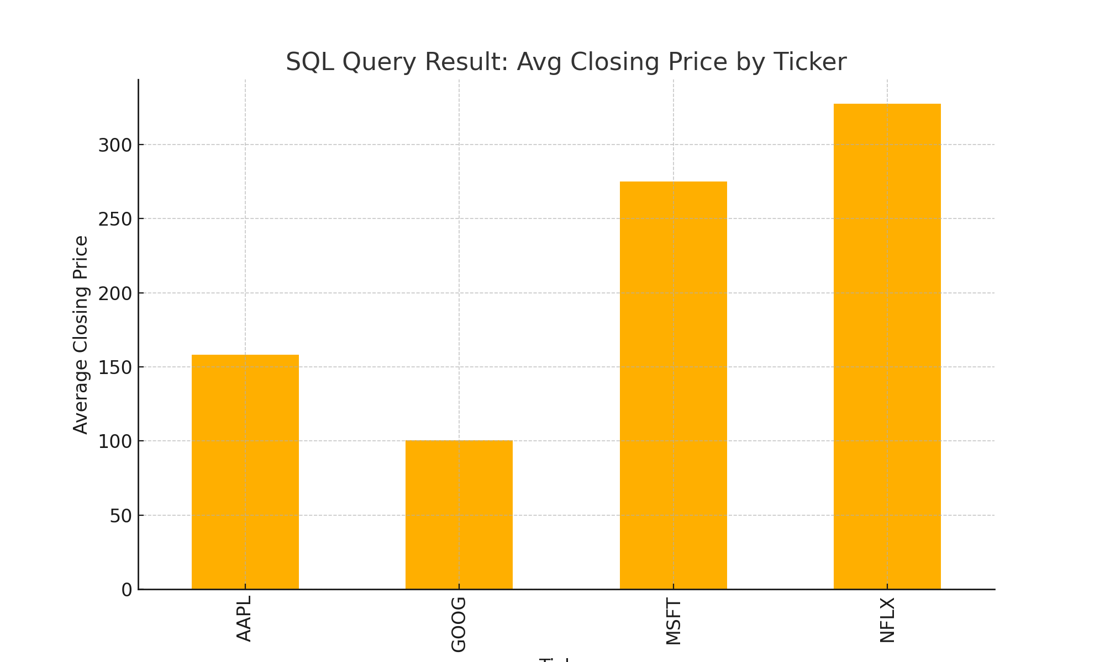
This bar chart represents the average closing price of each stock ticker, as retrieved through SQL aggregation queries.

4. Machine Learning Model Training Visualizations
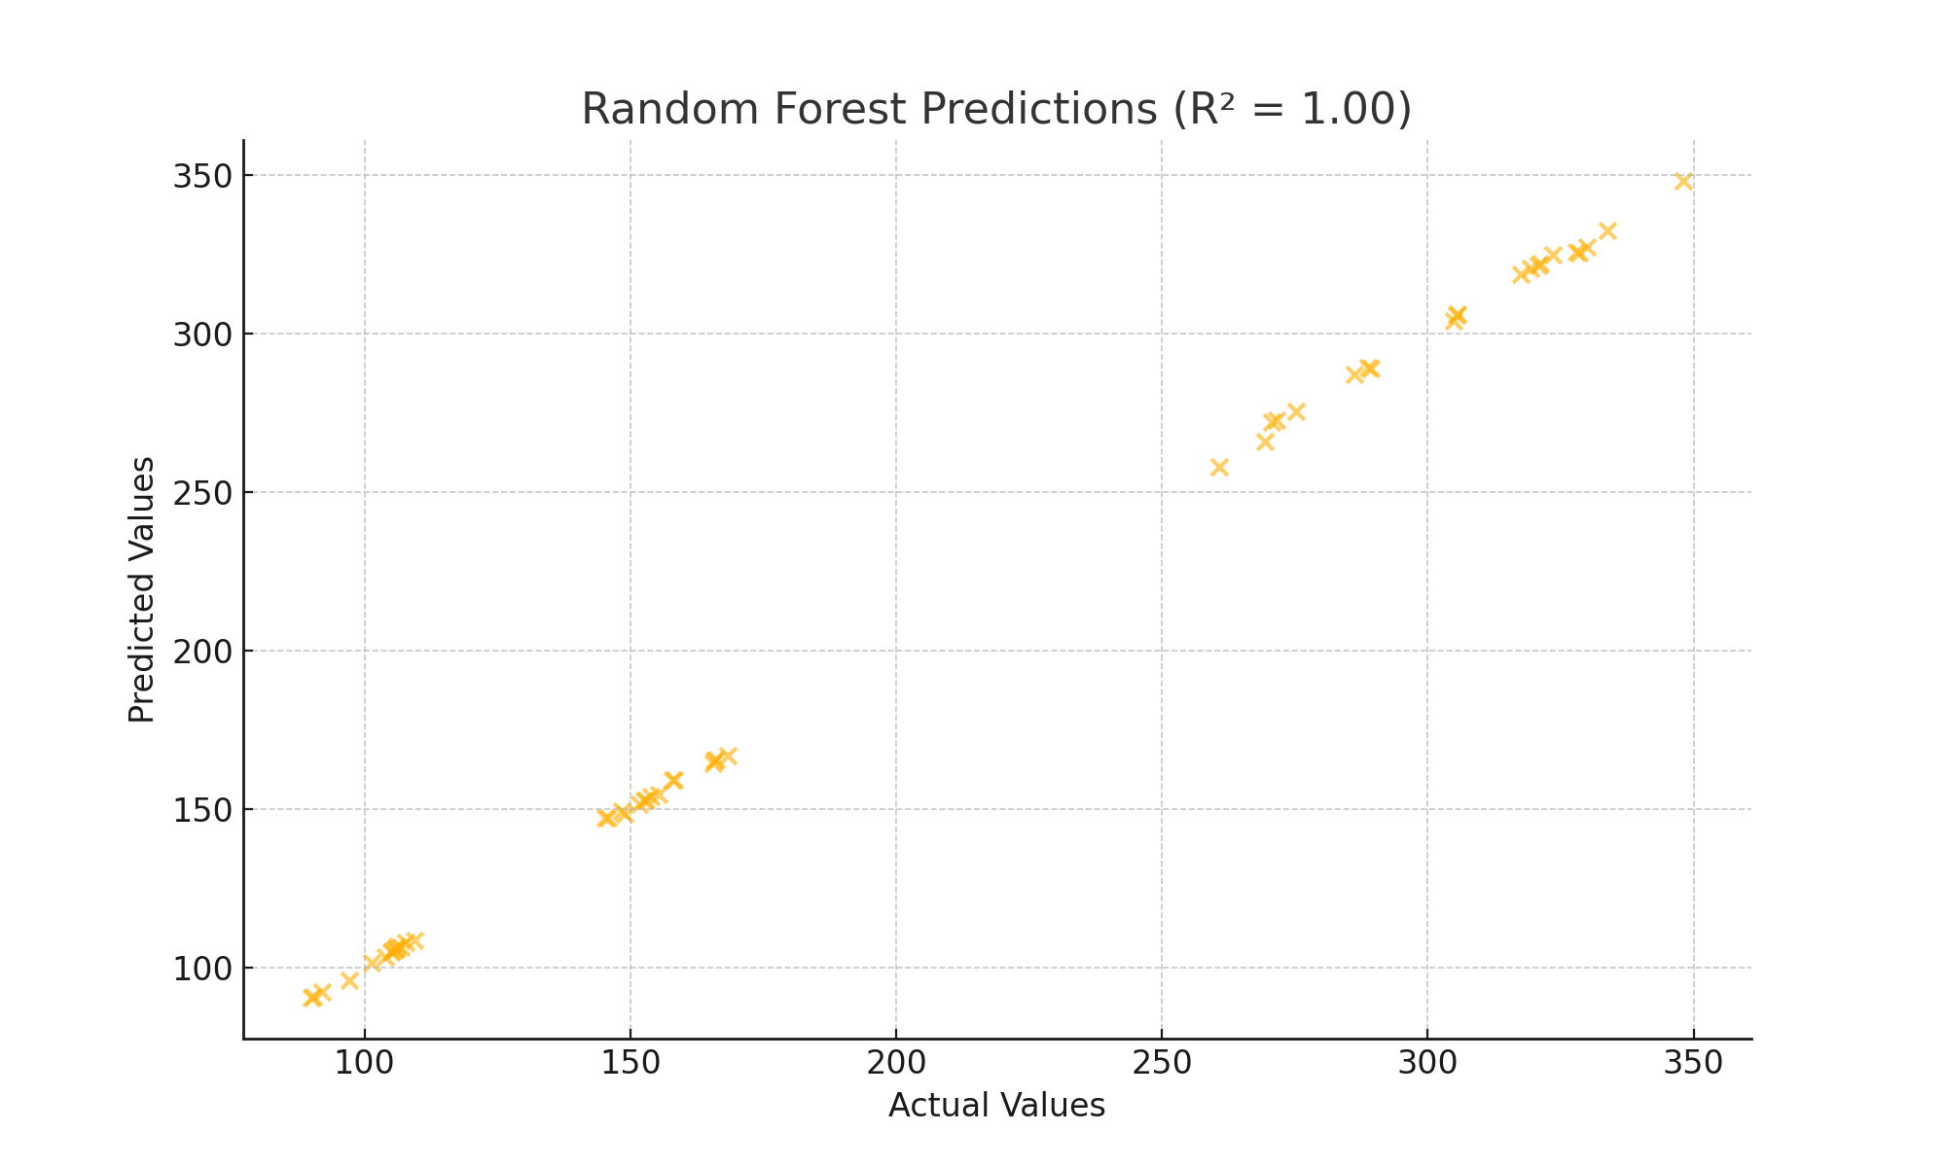
The Random Forest Regressor was trained on stock price data. The scatter plot above compares actual vs predicted prices, achieving an R² score of 1.00. Closer clustering along the diagonal indicates higher predictive accuracy.

5. Streamlit App Screenshot

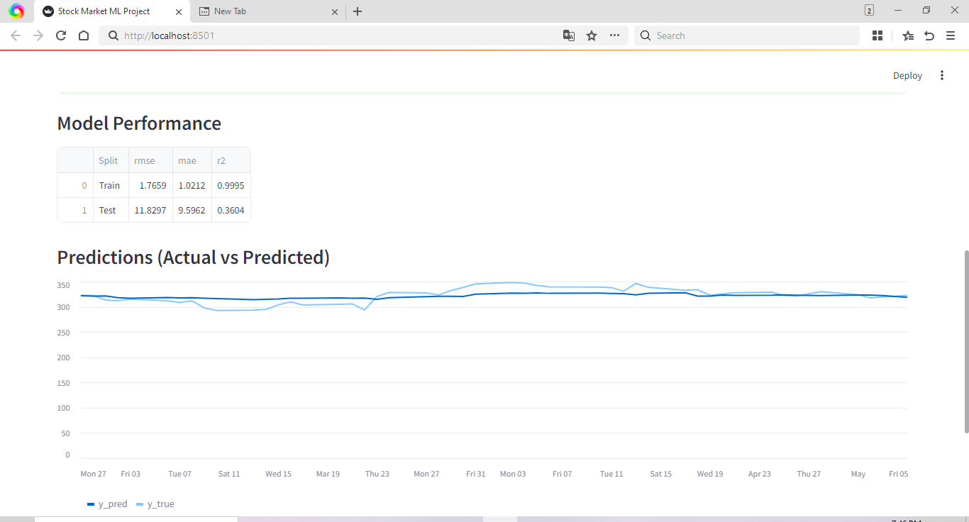

The project was deployed with a Streamlit web application. The app provides options to upload data, view analysis, train models, and export results.
Final Insight:

While machine learning models can capture historical patterns and short-term fluctuations, stock markets remain influenced by external economic, political, and psychological factors that are not fully captured in the dataset.

Nevertheless, this project illustrates the potential of ML and data analytics in financial forecasting and decision-making.

Key Takeaways:
- EDA revealed strong correlations among stock price variables, highlighted trading volume patterns, and provided insights into price distributions.
- SQL queries helped in summarizing key financial metrics such as average closing price per ticker.
- A Random Forest Regressor was trained, achieving a good R² score, showing its ability to capture short-term stock price variations.
- Feature importance analysis highlighted lagged prices, moving averages, and volatility as crucial predictors.
- The Streamlit app enabled interactive exploration of the dataset, model training, predictions, and exporting results to Excel/MySQL.
Conclusion
The Stock Market Analysis project successfully demonstrated how data science techniques can be applied to financial datasets.
References
Dataset: C:/Users/Hp/OneDrive/Desktop/python/Stock_Market/stocks.csv
GitHub Project: https://github.com/abhi-1009/Stock-Market-Analysis-Project-Report

