🐦 Bird Species Observation Analysis
Forest vs. Grassland Biodiversity & Conservation Insights
Project Report
Author: Abhijit Sinha | 2026
Detail | Value
Project Type | Exploratory Data Analysis & Interactive Dashboard
Domain | Wildlife Conservation / Ecological Monitoring
Tools Used | Python, Pandas, MySQL (SQLAlchemy + PyMySQL), Matplotlib, Seaborn, Streamlit, Plotly
Dataset Size | 17,077 raw rows -> 15,372 cleaned rows, 127 species, 2 habitats
Live Application | https://bird-species-observation-analysis-ynz2t8vlng3njrqnscfjqd.streamlit.app/
GitHub Repository | github.com/abhi-1009/bird-species-observation-analysis

1. Problem Statement & Business Objective

Problem Statement
The project analyzes the distribution and diversity of bird species across two distinct ecosystems — forests and grasslands — to understand how environmental factors such as vegetation type, climate, and terrain influence bird populations and behavior. By identifying habitat preference patterns and diversity differences between the two ecosystems, the findings support habitat conservation, biodiversity management, and assessment of environmental change impacts on avian communities.

Business Objective
Turn raw multi-site bird observation records into a cleaned, queryable dataset and an interactive dashboard that stakeholders can use to identify biodiversity hotspots, conservation priorities, and environmental drivers of bird activity — without needing to touch the underlying data themselves.
- Wildlife Conservation: inform decisions on protecting critical bird habitats
- Land Management: optimize land use and habitat restoration strategies
- Eco-Tourism: identify bird-rich areas to develop bird-watching tourism
- Sustainable Agriculture: support practices that minimize impact on bird populations
- Policy Support: data-driven insights for conservation policy on vulnerable species
- Biodiversity Monitoring: track ecosystem stability through avian population health

Approach
- Load and combine multi-sheet Forest and Grassland workbooks (Stage 1)
- Clean, standardize, and document schema differences between habitats (Stage 2)
- Explore patterns across 7 analysis categories (Stage 3)
- Load cleaned data into MySQL and re-express the analysis in SQL (Stage 4)
- Ship the analysis as an interactive, filterable Streamlit dashboard (Stage 5)

This is an exploratory / descriptive analytics project, not a predictive modeling one — the goal is to surface patterns and support decisions, not to forecast an outcome.

2. Dataset

Column (examples) | Description
Common_Name / Scientific_Name | Species identity
Date, Start_Time, End_Time | When the observation occurred
Admin_Unit_Code, Plot_Name | Where the observation occurred
Temperature, Humidity, Sky, Wind | Environmental conditions
Distance, Flyover_Observed | Observation distance and behavior
Sex, ID_Method, Interval_Length | Observation methodology
PIF_Watchlist_Status, Regional_Stewardship_Status, AOU_Code | Conservation status indicators

- Raw records: 17,077 rows across two workbooks (Forest, Grassland), 11 park/admin units each
- Cleaned records: 15,372 (1,705 exact duplicates removed)
- Unique species: 127 total — 108 in Forest, 107 in Grassland
- Coverage: 2018 only, Spring and Summer seasons only (no multi-year or full-annual-cycle data)
- Observers: 3 (Elizabeth Oswald, Kimberly Serno, Brian Swimelar)

3. Preprocessing Steps & Data Cleaning

- Loaded all 11 sheets from each workbook and tagged every row with its Habitat (Forest/Grassland) and source sheet
- Combined both habitats into one dataframe — Forest-only columns (Site_Name, NPSTaxonCode) and Grassland-only columns (Previously_Obs) were preserved rather than dropped, with the resulting missing values documented as a schema difference, not a data-quality error
- Converted Date to datetime and derived Month, Season, and Start_Hour for temporal analysis
- Kept Distance and Interval_Length as categorical text (they are bucketed ranges like "<= 50 Meters", not numeric values) — an early version of the pipeline mistakenly coerced these to numeric, which was caught and corrected before final analysis
- Removed 1,705 exact duplicate rows
- Standardized missing/blank text fields (Sex, ID_Method, Sky, Wind, Disturbance, Distance) to an explicit "Unknown" category instead of leaving nulls

4. Exploratory Data Analysis
Analysis is organized into the 7 categories specified in the project brief, each covered in both the Python EDA script and the equivalent SQL queries (bird_queries.sql).

4.1 Temporal Analysis

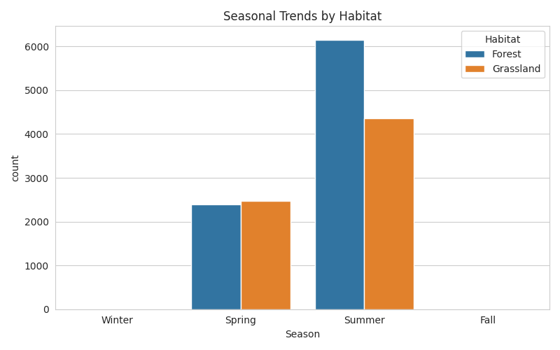

Observations are concentrated in Summer (10,508) over Spring (4,864) across both habitats. Since the data only covers one year, this reflects a within-season pattern rather than a year-over-year trend.

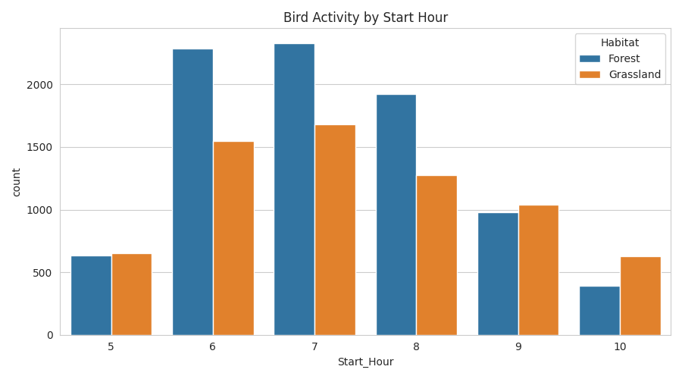

4.2 Spatial Analysis
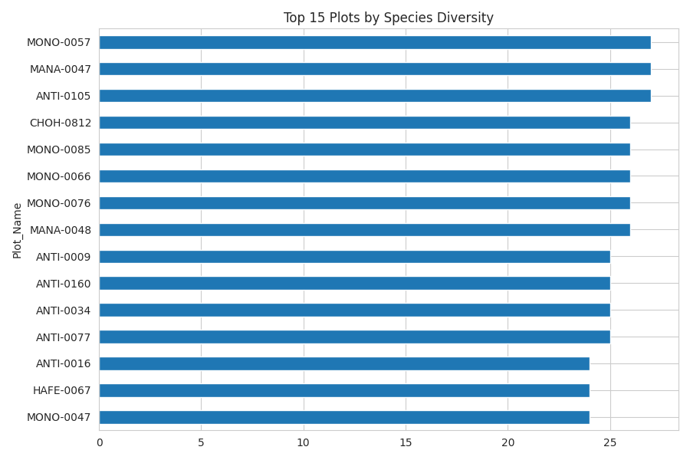
Species diversity is close to identical between habitats overall (108 Forest vs. 107 Grassland), but diversity is unevenly distributed across individual plots — a handful of plots (e.g. ANTI-0105, MONO-0057, MANA-0047) account for the highest species counts and are the clearest candidates for conservation priority.

4.3 Species Analysis
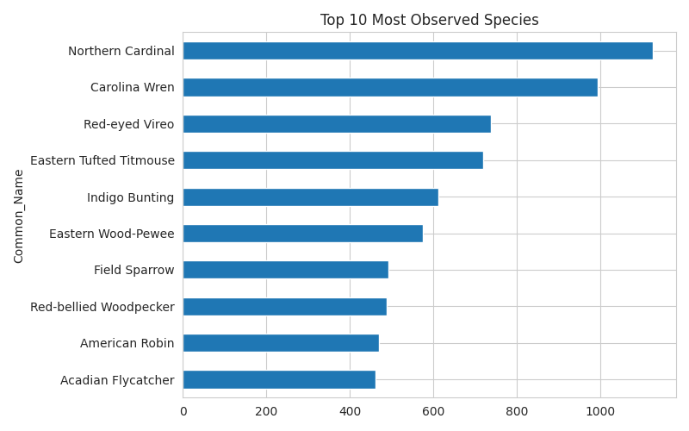
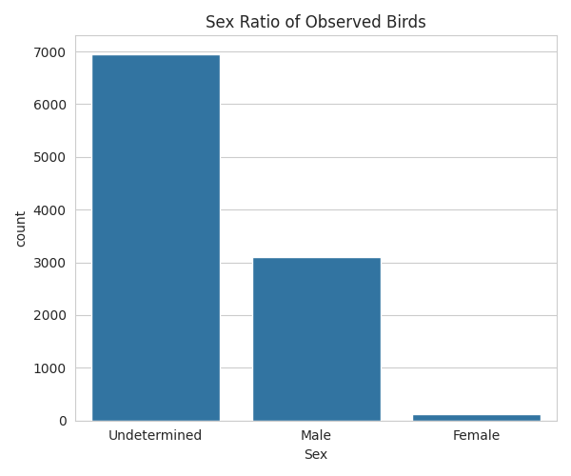

Northern Cardinal (1,125) and Carolina Wren (993) are the most-observed species. Sex could not be determined for the large majority of observations (Undetermined: 6,954, Unknown: 5,183) versus Male (3,109) and Female (only 126) — this imbalance is a data quality limitation, not a real population skew, and any sex-based conclusion should be treated cautiously.

4.4 Environmental Conditions
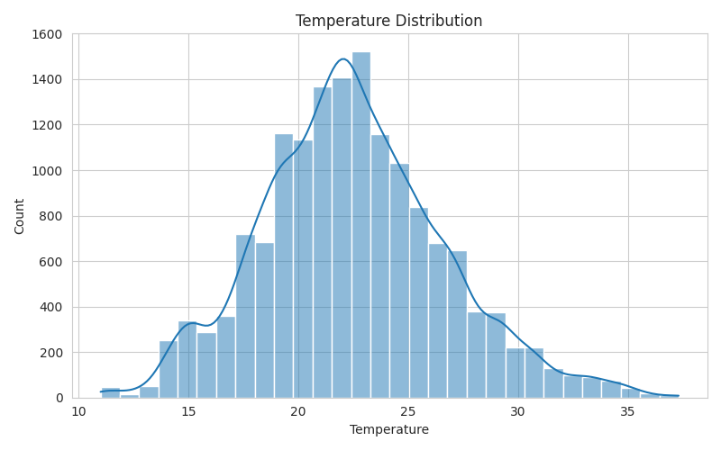
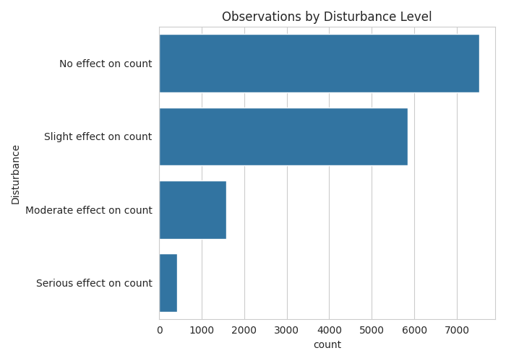
Mean temperature during observations was 22.5°C (range 11–37.3°C), mean humidity 74.2%. Most observations (7,525) recorded no disturbance effect, though a meaningful share (2,007 combined) noted moderate-to-serious disturbance impact on counts.

4.5 Distance and Behavior
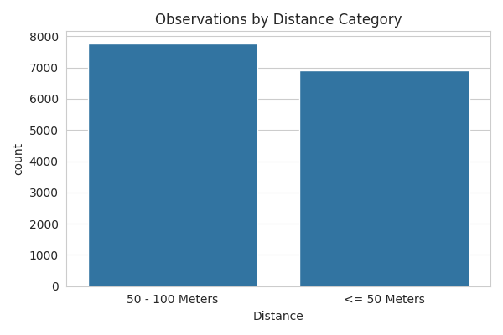
Most birds were observed at 50–100 meters (7,774) or within 50 meters (6,909). Flyovers were relatively rare (689 of 15,372, about 4.5%), with Common Grackle, American Goldfinch, and Barn Swallow the most frequent flyover species.

4.6 Observer Trends
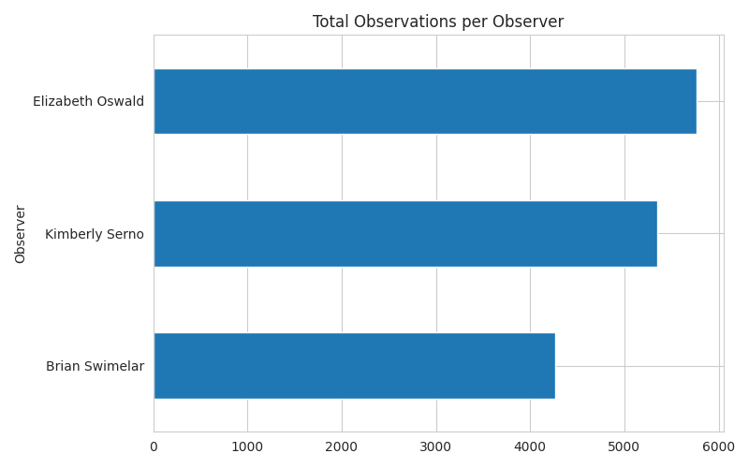
Only 3 observers contributed all data (Elizabeth Oswald: 5,763, Kimberly Serno: 5,346, Brian Swimelar: 4,263) — a known observer-bias risk, since individual observer habits could influence species/count patterns as much as true bird behavior. Species diversity also declined with repeat visits (Visit 1: 118 species, Visit 2: 99, Visit 3: 74), consistent with diminishing returns from revisiting the same plots.

4.7 Conservation Insights
378 observations (2.5%) were of species on the PIF Watchlist, and 3,890 (25.3%) involved species with Regional Stewardship status — a meaningful minority worth prioritizing in monitoring efforts despite being numerically smaller than common species.

5. SQL Analysis
The cleaned dataset (15,372 rows) was loaded into a MySQL table (bird_observations) via SQLAlchemy/PyMySQL. The same 7 analysis categories above were re-expressed as SQL queries (grouped counts, averages by category, top-N rankings) in bird_queries.sql, allowing every EDA finding to be independently verified directly against the database.

6. Streamlit Dashboard — 3 Pages
# | Page | What it shows
1 | Home | Problem statement, business use cases, key summary metrics
2 | Dashboard | Sidebar filters (habitat, park, season, species) + 7 tabs: Temporal, Spatial, Species, Environmental, Distance & Behavior, Observer, Conservation — interactive Plotly charts with explanatory captions under each
3 | Insights & Recommendations | Other insights, business insights, limitations, and actionable recommendations

7. Deployment
- Platform: Streamlit Community Cloud, connected directly to the project's public GitHub repository
- Configuration: Repository abhi-1009/bird-species-observation-analysis, branch main, main file birds_analysis_streamlit.py
- Change required for deployment: the local dashboard originally queried a local MySQL instance, which the cloud environment cannot reach. The deployed app was switched to read the pre-cleaned bird_data_cleaned.csv directly, while the local pipeline (birds_analysis.py) continues to demonstrate the full MySQL load and query workflow for grading purposes
- Sensitive credentials (config.py, containing the local MySQL password) are excluded from the repository via .gitignore and were never required by the deployed version

8. Insights & Recommendations

Key Insights
- Certain parks and plots consistently show higher species diversity than others — direct candidates for conservation priority or eco-tourism development
- Environmental conditions shape observability: temperature and disturbance level visibly relate to observation distance and counts
- A small but conservation-critical subset of species (2.5% Watchlist, 25.3% Regional Stewardship) deserves targeted monitoring despite being numerically rare
- Repeated visits to the same plots show diminishing species-diversity returns, useful for planning survey frequency

Recommendations
- Prioritize monitoring and habitat-protection resources toward the top-diversity plots and Watchlist species identified in the dashboard
- Expand data collection to multiple years and all four seasons to support genuine year-over-year trend analysis (current data covers one year, two seasons only)
- Add GPS coordinates in future data collection to enable true geographic hotspot mapping, rather than relying on plot/admin-unit codes as a proxy
- Increase the observer pool and standardize protocols further to reduce the observer-bias risk visible in the current 3-observer dataset

Limitations
The dataset covers a single year (2018) and two seasons, so temporal findings describe within-season patterns, not multi-year trends. Forest and Grassland source files have slightly different schemas, so a few fields are not directly comparable across habitats. No GPS coordinates are available, so spatial analysis relies on plot/admin-unit codes rather than a true map. Sex could not be determined for most observations, limiting confidence in any sex-based conclusion. Only 3 observers contributed data, which is a known bias risk for observer-trend findings.

9. Acknowledgement
Thanks to the project brief for the structured, stage-by-stage format that shaped this project's scope, and to the open-source Python data ecosystem (Pandas, SQLAlchemy, Matplotlib, Seaborn, Streamlit, and Plotly) that made the analysis and dashboard possible.

10. Thank You
Thank you for taking the time to review this project. Feedback and suggestions for improvement are always welcome.
— Abhijit Sinha

