GAME ANALYTICS PROJECT REPORT
Tennis Rankings Explorer
Unlocking Tennis Data with the Sportradar API
From raw nested JSON to a cloud MySQL database and a live, interactive dashboard
Author: Abhijit Sinha
Date: 01 November 2026
Live app: https://tennis-rankings-explorer-stjtrxsnyclfiewespoedo.streamlit.app/
Source code: https://github.com/abhi-1009/tennis-rankings-explorer
Python · SQL · MySQL (Aiven) · pandas · SQLAlchemy · Streamlit · Plotly

1. Executive summary
Sports data arrives as deeply nested JSON that is hard to search, compare or reuse. This project builds the whole pipeline around it: it extracts competitions, venues and doubles rankings from the Sportradar Tennis API, flattens them with pandas, stores them in a normalised MySQL database on Aiven, analyses them with 20 SQL queries, and presents them in a 9-page Streamlit dashboard deployed on Streamlit Community Cloud.
Business question
How are tennis competitions, venues and doubles rankings organised, and where is activity concentrated?

Key numbers
Measure | Value
Competitions loaded | 6,722
Venues loaded | 4,161
Complexes loaded | 787
Ranked players | 1,049
Ranking rows stored | 3,000
Ranking weeks stored | 2026 week 42, 2026 week 43, 2026 week 44
SQL queries written | 20
Dashboard pages | 9

What was delivered
- A Python pipeline with retries and rate-limit handling, validation of raw data, and a one-command weekly refresh
- A normalised six-table MySQL schema with keys, indexes and an ER diagram
- A data-quality audit, an EXPLAIN and timing report, and 99 automated tests
- A live dashboard with filters, world maps, leaderboards, a read-only SQL Playground and computed insights
- Public GitHub repository with README, SQL file and screenshots
Live app: https://tennis-rankings-explorer-stjtrxsnyclfiewespoedo.streamlit.app/
Repository: https://github.com/abhi-1009/tennis-rankings-explorer

2. Business problem and objectives
The Sportradar Event Explorer aims to manage, visualise and analyse sports competition data: parse the API responses, store them in a relational database, and give intuitive insight into tournaments, competition hierarchies and event details.

Stakeholders
Tennis analysts, event organisers and sports bodies who plan events, venues and resources, plus sports enthusiasts.

Business use cases
Use case | Question it answers | Where in the app
Event exploration | How are competitions organised? Which events sit under which parent tournament? | Competitions page, hierarchy viewer
Trend analysis | How do events split by type, gender, level and category? | Competitions and Overview pages
Performance insights | Which countries and players lead the doubles rankings? | Players, Countries, Leaderboards
Decision support | Where are venues and complexes concentrated? | Venues page, Insights page

3. Workflow and architecture
Sportradar  Tennis API | → | extract.py  raw JSON | → | transform.py  load.py | → | Aiven MySQL  + Streamlit

Step | Script | What it does
1 Extract | api/extract.py, api/sportradar_client.py | Calls the three endpoints with the key in a header, retries on 429 and server errors, saves raw JSON.
2 Transform | api/transform.py | Flattens nested JSON into tables and fills missing values with documented placeholders.
3 Create schema | db/init_db.py, db/schema_aiven.sql | Creates the database and six tables with keys and indexes.
4 Load | api/load.py | Idempotent upserts (INSERT ... ON DUPLICATE KEY UPDATE), so reloading never duplicates rows.
5 Verify | db/data_quality.py, db/explain_report.py, tests/ | Audits quality, proves index use, runs 99 tests.
6 Refresh | api/refresh.py | One command: download, validate, load, verify, log.
7 Present | app/streamlit_app.py, app/dashboard/ | 9-page dashboard reading live from MySQL.

4. Data sourcing and provenance
All data comes from the Sportradar Tennis API (v3) using a free 30-day trial key. The key is sent in the x-api-key header and kept only in the private .env file or in Streamlit Secrets. Trial keys are rate-limited, so the client waits between calls and retries on HTTP 429 and server errors. Raw responses are saved to data/raw/ before any processing, so the pipeline can be re-run without calling the API again.
Dataset | Endpoint | Loaded into | Rows
Competitions | /competitions.json | Categories, Competitions | 6,722
Complexes and venues | /complexes.json | Complexes, Venues | 4,161 venues
Doubles competitor rankings | /double_competitors_rankings.json | Competitors, Competitor_Rankings | 3,000

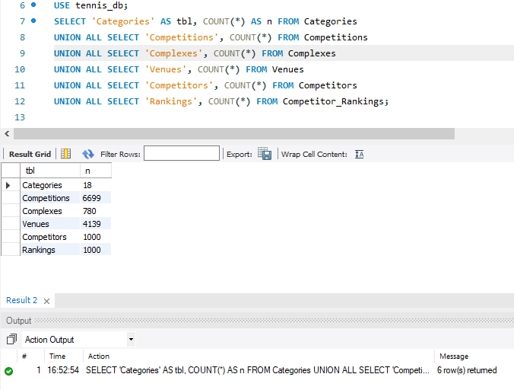
Row counts of all six tables on the Aiven database

5. Data preparation and quality
Transformation rules and the reason for each:
Rule | Reason
Flatten nested JSON into one table per entity | Relational tables are searchable and joinable; nested JSON is not.
Deduplicate categories and competitors by id | Each fact is stored once, which is the basis of the normalised design.
Fill missing NOT NULL values with Unknown / N/A / UNK | Keeps the row (and its other useful fields) instead of silently dropping it. Placeholders are counted below.
Cut country codes to 3 characters | Fits the CHAR(3) column and cannot fail the load.
Leave optional fields (level, parent, category) NULL | Inventing a value would distort the charts; NULL is honest.
Keep outliers | Very high points belong to elite players, who are the most important rows.

Data leakage: not applicable. This is a descriptive analytics project with no prediction target, so there is no train and test split to leak. Rank and points are linked by definition and are not treated as independent.

Data-quality audit (generated by python -m db.data_quality)
Summary: 10 checks passed, 0 warnings, 5 informational findings.
Missing values and placeholders. 3 of 15 checked columns contain placeholders; the other 12 are complete.
Column | Rows (%) | Treatment | Why this is justified
Competitions.level | 5989 (89.1%) | Left NULL | Level is optional; most events have none, so a default would distort the level chart.
Competitions.parent_id | 628 (9.34%) | Left NULL | Top-level competitions have no parent by design (query 1.7 depends on this).
Competitors.country_code | 51 (4.86%) | Stored as 'UNK' | Needed as CHAR(3) NOT NULL; the map page ignores unknown codes.

Integrity, duplicate and tie checks | Result | Status
Orphan category links (Competitions → Categories) | 0 | PASS
Orphan complex links (Venues → Complexes) | 0 | PASS
Orphan competitor links (Rankings → Competitors) | 0 | PASS
Duplicate ranking snapshots | 0 | PASS
Parent ids that point to a missing competition | 6093 | INFO
Complexes without any venue | 164 | INFO
Players sharing a name (different ids) | 0 | INFO
Venues sharing name, city and country | 257 | INFO
Tied rank groups (doubles partners share a rank) | 38 | INFO

Domain checks: all 6 passed (rank at least 1, no negative points, valid week numbers, 3-letter country codes).
Ranking list | Column | Median | Max | Upper fence | Above fence
ATP | points | 280.0 | 10180.0 | 1536.2 | 50
ATP | competitions_played | 22.0 | 41.0 | 54.0 | 0
WTA | points | 297.0 | 11260.0 | 1411.1 | 63
WTA | competitions_played | 17.0 | 43.0 | 42.5 | 1

Outliers are kept: very high points belong to the best players, who are the most important rows. ATP and WTA points use different scales, so they are summarised per list.
Week-over-week validation. Compared week (2026, 44) with week (2026, 43) for 979 players present in both (21 new). The stored movement equals the real rank change for 100.0% of them, which means: positive movement = moved up.

6. Database design
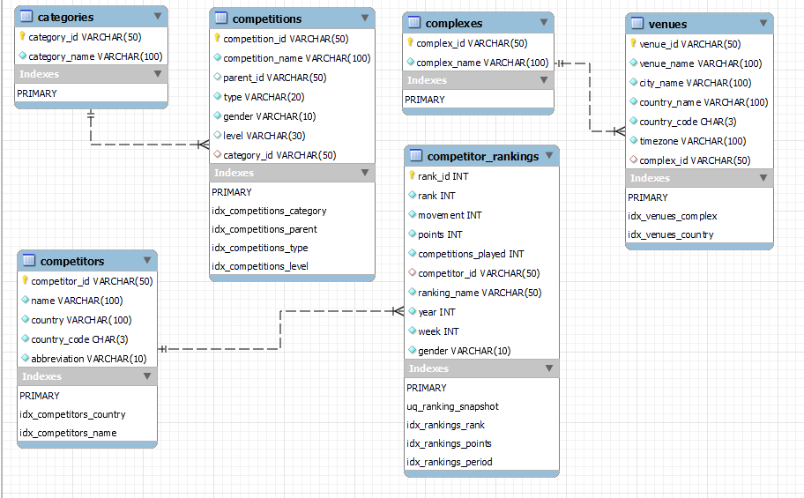
Entity-relationship diagram (MySQL Workbench)
- Six tables; every fact is stored once (categories, complexes and competitors are separate from their children).
- Primary keys everywhere, foreign keys on Competitions to Categories, Venues to Complexes and Rankings to Competitors.
- Competitions.parent_id is a logical self-reference. It is not an enforced foreign key because the API can reference a parent it does not return.
- Extra columns beyond the brief: level, and ranking_name, year, week, gender so rankings can be filtered by week and kept as history.
- A unique key on competitor, ranking list, year and week stops duplicate snapshots; indexes cover every filter and join column.

Data dictionary
Table | Columns (type, key or constraint)
Categories | category_id (VARCHAR(50), PK); category_name (VARCHAR(100), NOT NULL)
Competitions | competition_id (VARCHAR(50), PK); competition_name (VARCHAR(100), NOT NULL); parent_id (VARCHAR(50), NULL, logical self-reference); type (VARCHAR(20), NOT NULL, indexed); gender (VARCHAR(10), NOT NULL); level (VARCHAR(30), NULL, indexed); category_id (VARCHAR(50), FK to Categories, indexed)
Complexes | complex_id (VARCHAR(50), PK); complex_name (VARCHAR(100), NOT NULL)
Venues | venue_id (VARCHAR(50), PK); venue_name (VARCHAR(100), NOT NULL); city_name / country_name (VARCHAR(100), NOT NULL); country_code (CHAR(3), NOT NULL); timezone (VARCHAR(100), NOT NULL); complex_id (VARCHAR(50), FK to Complexes, indexed)
Competitors | competitor_id (VARCHAR(50), PK); name (VARCHAR(100), NOT NULL, indexed); country / country_code (VARCHAR(100) / CHAR(3), NOT NULL); abbreviation (VARCHAR(10), NOT NULL)
Competitor_Rankings | rank_id (INT, PK, auto increment); rank / points / movement (INT, NOT NULL); competitions_played (INT, NOT NULL); competitor_id (VARCHAR(50), FK to Competitors); ranking_name, year, week, gender (VARCHAR / INT, NOT NULL; unique with competitor_id)

7. SQL analysis (20 queries)
The queries answer the three parts of the brief (competitions, venues, rankings). Each block shows the SQL, the number of rows it returns on the live database and the result screenshot. All 20 are also run by the test suite.
1.1 List all competitions along with their category name  SELECT c.competition_id, c.competition_name, c.type, c.gender, cat.category_name  FROM Competitions c  LEFT JOIN Categories cat ON cat.category_id = c.category_id  ORDER BY cat.category_name, c.competition_name  Rows returned: 6,722 | 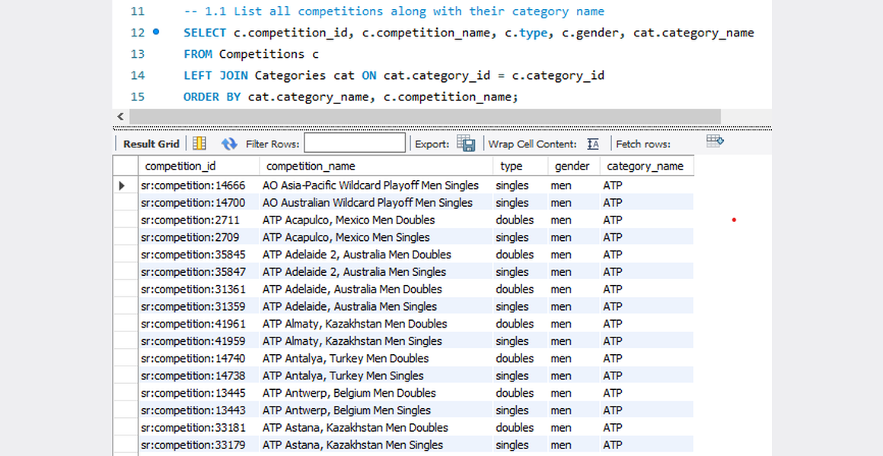

1.2 Count the number of competitions in each category  SELECT cat.category_name, COUNT(*) AS competition_count  FROM Competitions c  JOIN Categories cat ON cat.category_id = c.category_id  GROUP BY cat.category_id, cat.category_name  ORDER BY competition_count DESC  Rows returned: 18 | 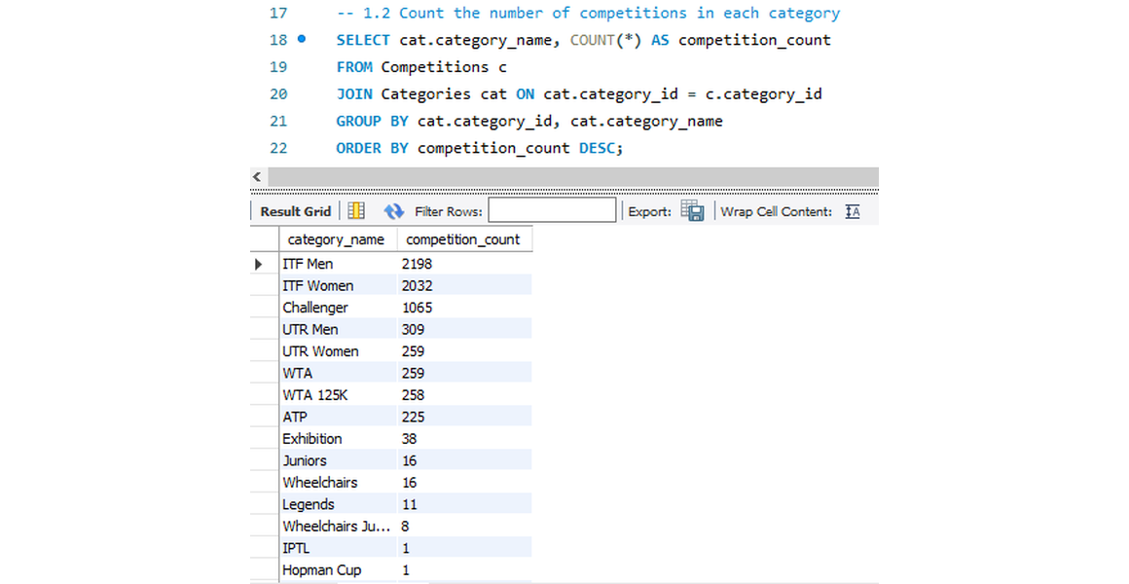

1.3 Find all competitions of type 'doubles'  SELECT competition_id, competition_name, gender, category_id  FROM Competitions  WHERE type = 'doubles'  Rows returned: 3,055 | 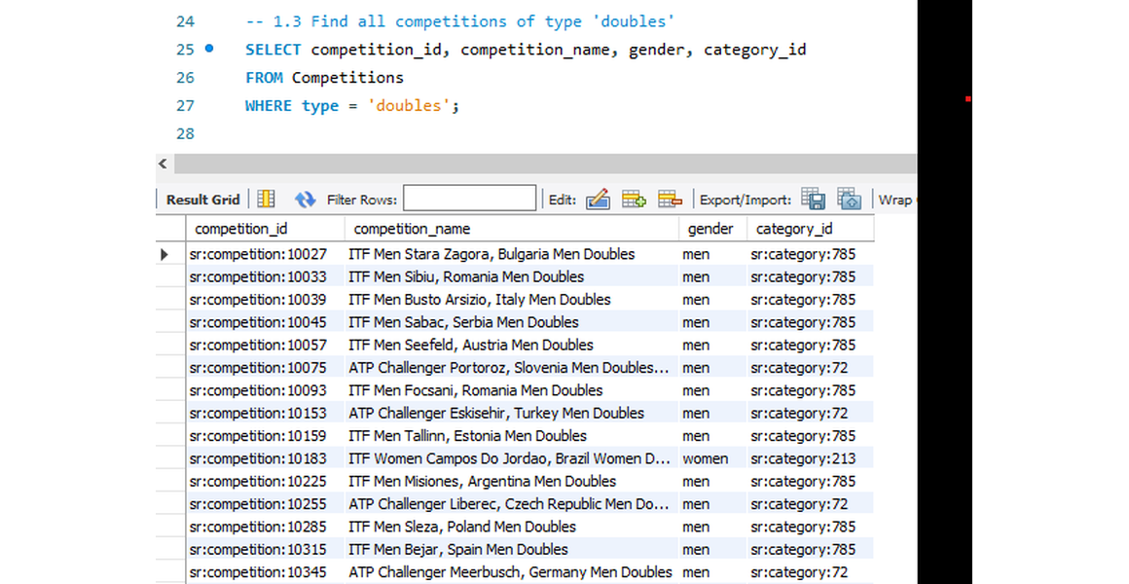

1.4 Get competitions that belong to a specific category (e.g. ITF Men)  SELECT c.competition_id, c.competition_name, c.type, c.gender  FROM Competitions c  JOIN Categories cat ON cat.category_id = c.category_id  WHERE cat.category_name = 'ITF Men'  Rows returned: 2,198 | 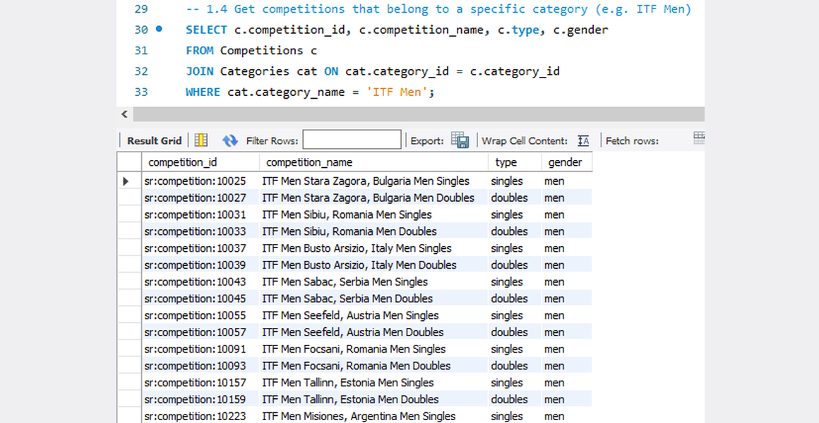

1.5 Identify parent competitions and their sub-competitions  SELECT p.competition_id AS parent_id,  p.competition_name AS parent_name,  s.competition_id AS sub_competition_id,  s.competition_name AS sub_competition_name  FROM Competitions s  JOIN Competitions p ON p.competition_id = s.parent_id  ORDER BY p.competition_name, s.competition_name  Rows returned: 1 | 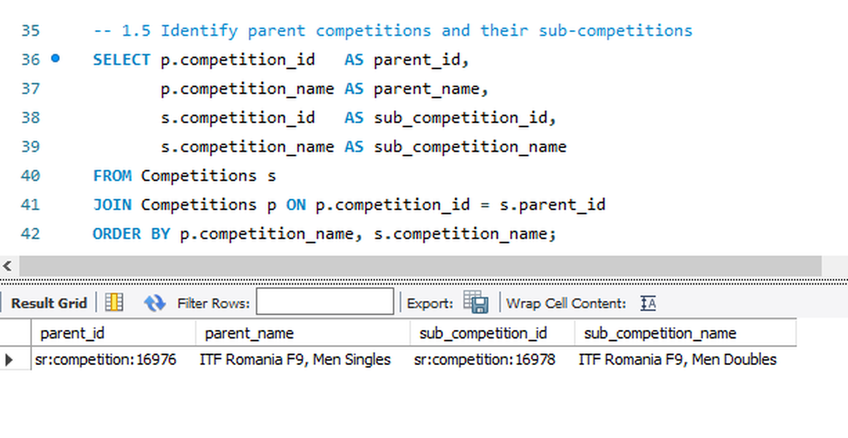

1.6 Analyze the distribution of competition types by category  SELECT cat.category_name, c.type, COUNT(*) AS competition_count  FROM Competitions c  JOIN Categories cat ON cat.category_id = c.category_id  GROUP BY cat.category_name, c.type  ORDER BY cat.category_name, competition_count DESC  Rows returned: 32 | 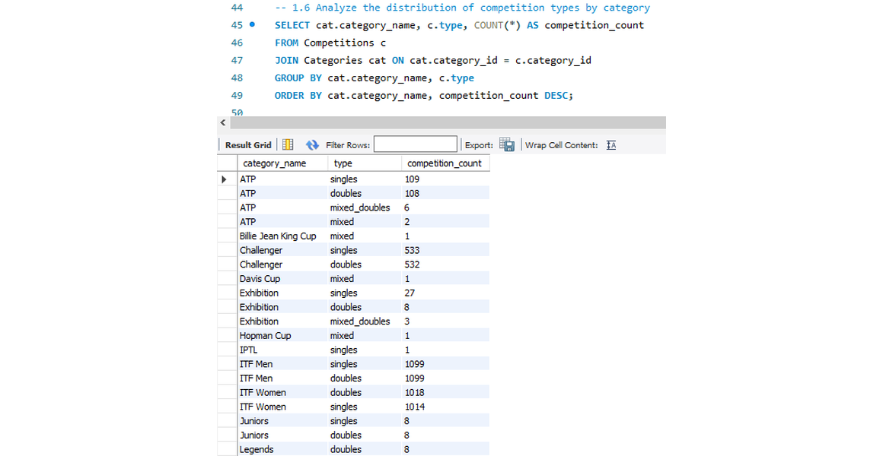

1.7 List all competitions with no parent (top-level competitions)  SELECT competition_id, competition_name, type, gender  FROM Competitions  WHERE parent_id IS NULL  Rows returned: 628 | 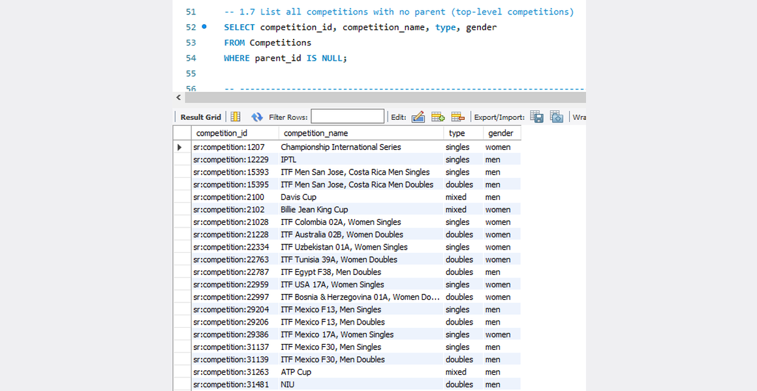

2.1 List all venues along with their associated complex name  SELECT v.venue_id, v.venue_name, v.city_name, v.country_name, cx.complex_name  FROM Venues v  LEFT JOIN Complexes cx ON cx.complex_id = v.complex_id  ORDER BY cx.complex_name, v.venue_name  Rows returned: 4,161 | 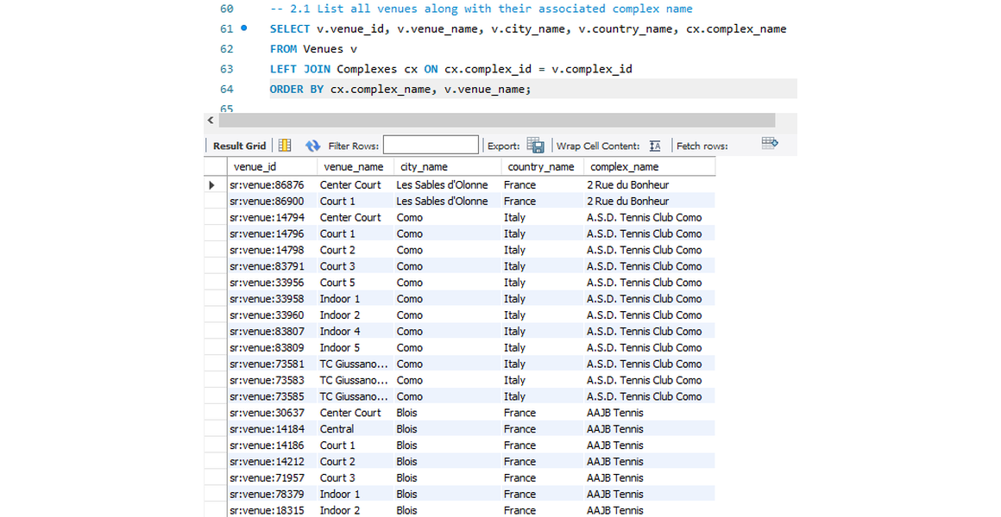

2.2 Count the number of venues in each complex  SELECT cx.complex_name, COUNT(v.venue_id) AS venue_count  FROM Complexes cx  LEFT JOIN Venues v ON v.complex_id = cx.complex_id  GROUP BY cx.complex_id, cx.complex_name  ORDER BY venue_count DESC  Rows returned: 787 | 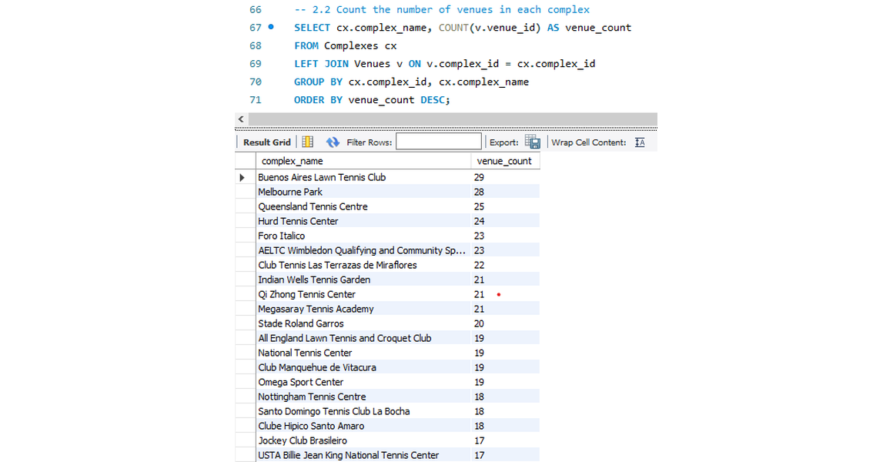

2.3 Get details of venues in a specific country (e.g. Chile)  SELECT venue_id, venue_name, city_name, country_name, country_code, timezone  FROM Venues  WHERE country_name = 'Chile'  Rows returned: 65 | 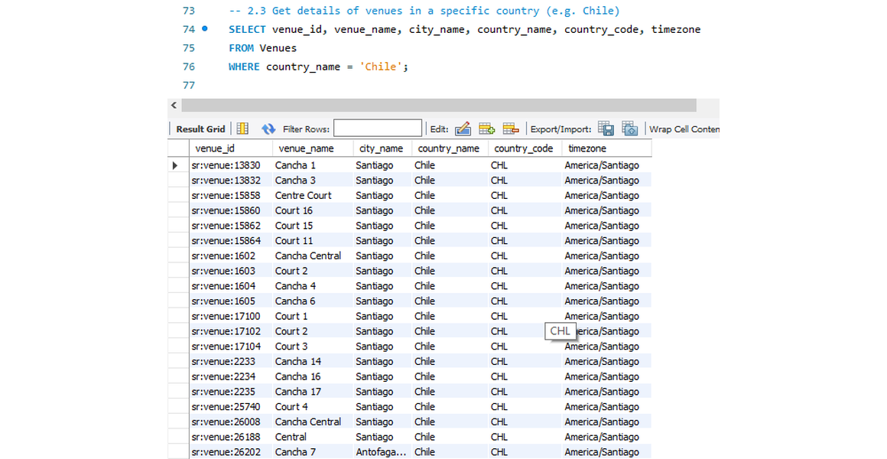

2.4 Identify all venues and their timezones  SELECT venue_name, city_name, country_name, timezone  FROM Venues  ORDER BY timezone, venue_name  Rows returned: 4,161 | 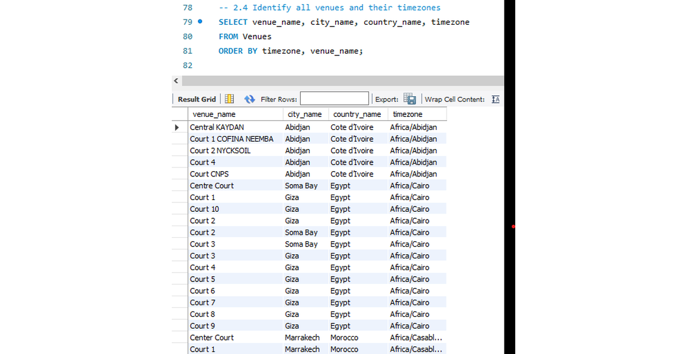

2.5 Find complexes that have more than one venue  SELECT cx.complex_name, COUNT(v.venue_id) AS venue_count  FROM Complexes cx  JOIN Venues v ON v.complex_id = cx.complex_id  GROUP BY cx.complex_id, cx.complex_name  HAVING COUNT(v.venue_id) > 1  ORDER BY venue_count DESC  Rows returned: 596 | 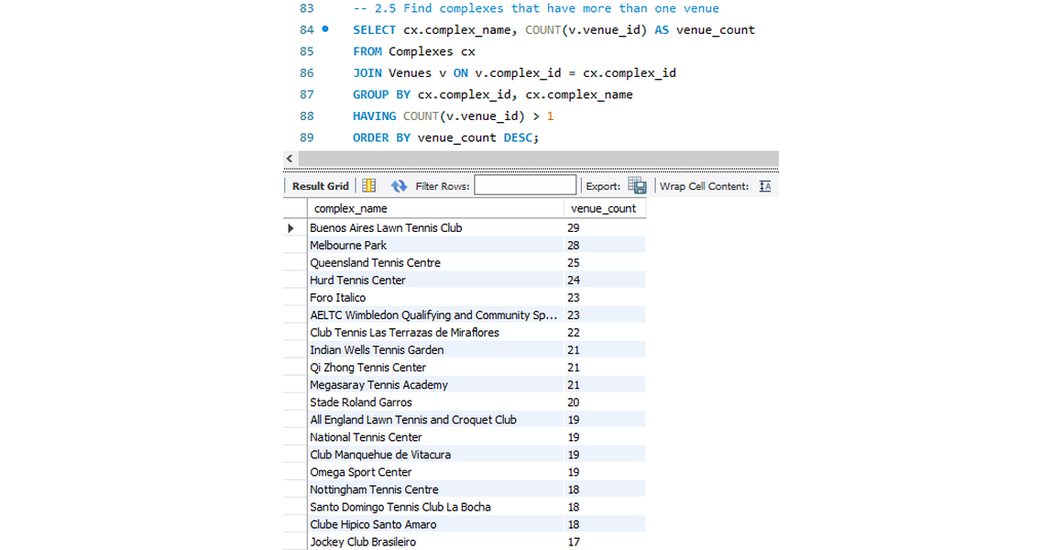

2.6 List venues grouped by country  SELECT country_name,  COUNT(*) AS venue_count,  GROUP_CONCAT(venue_name ORDER BY venue_name SEPARATOR ', ') AS venues  FROM Venues  GROUP BY country_name  ORDER BY venue_count DESC  Rows returned: 77 | 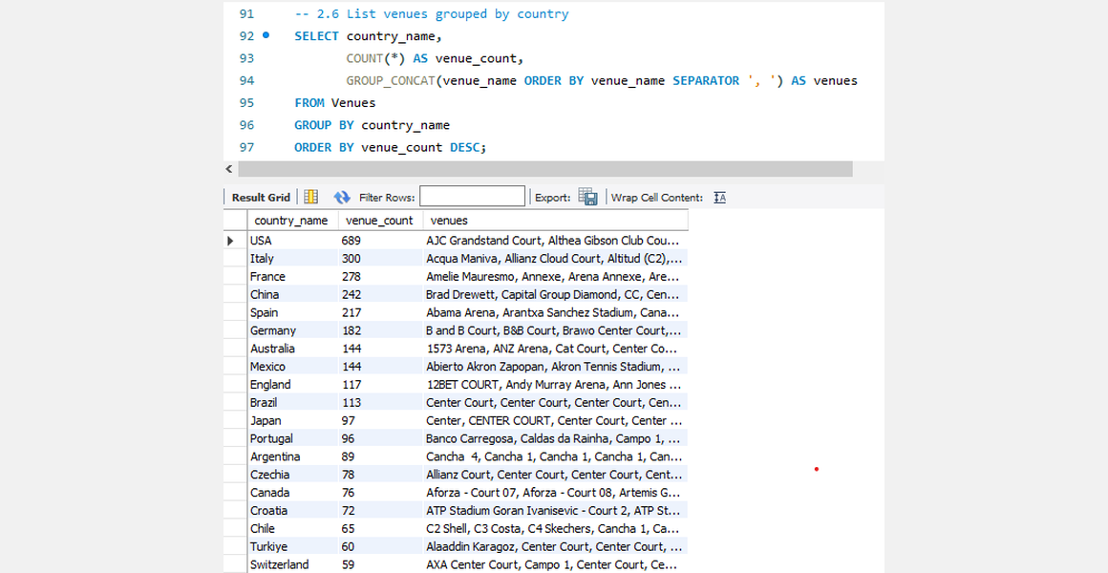

2.7 Find all venues for a specific complex (e.g. Nacional)  SELECT v.venue_id, v.venue_name, v.city_name, v.country_name  FROM Venues v  JOIN Complexes cx ON cx.complex_id = v.complex_id  WHERE cx.complex_name = 'Nacional'  Rows returned: 1 | 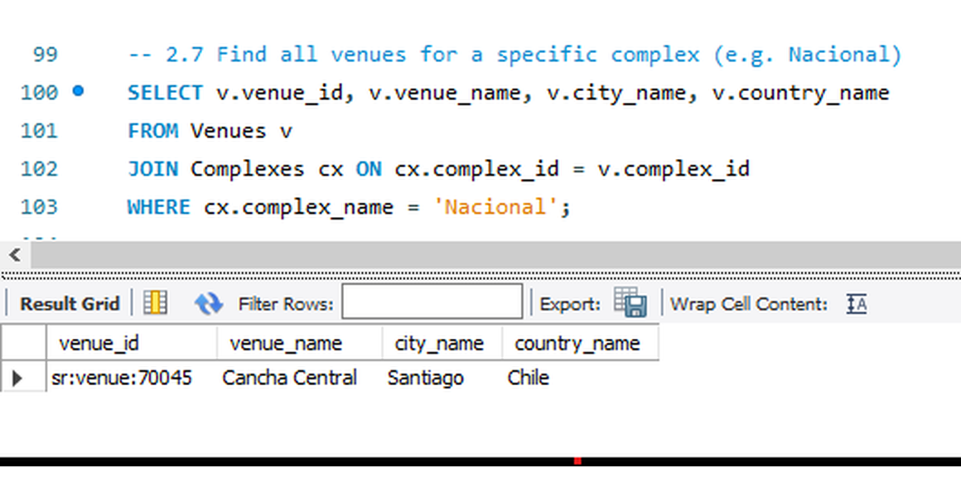

3.1 Get all competitors with their rank and points (latest week)  SELECT c.name, c.country, r.ranking_name, r.`rank`, r.points  FROM Competitor_Rankings r  JOIN Competitors c ON c.competitor_id = r.competitor_id  WHERE (r.year, r.week) = (SELECT year, week FROM Competitor_Rankings  ORDER BY year DESC, week DESC LIMIT 1)  ORDER BY r.ranking_name, r.`rank`  Rows returned: 1,000 | 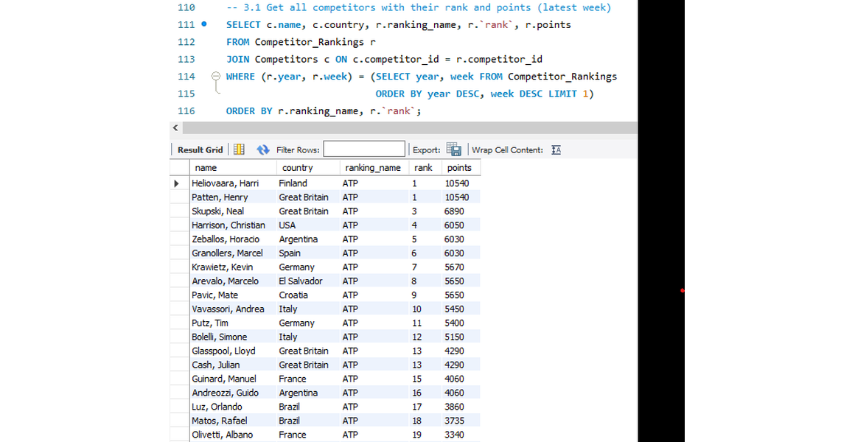

3.2 Find competitors ranked in the top 5 (latest week)  SELECT c.name, c.country, r.ranking_name, r.`rank`, r.points  FROM Competitor_Rankings r  JOIN Competitors c ON c.competitor_id = r.competitor_id  WHERE r.`rank` <= 5  AND (r.year, r.week) = (SELECT year, week FROM Competitor_Rankings  ORDER BY year DESC, week DESC LIMIT 1)  ORDER BY r.ranking_name, r.`rank`  Rows returned: 10 | 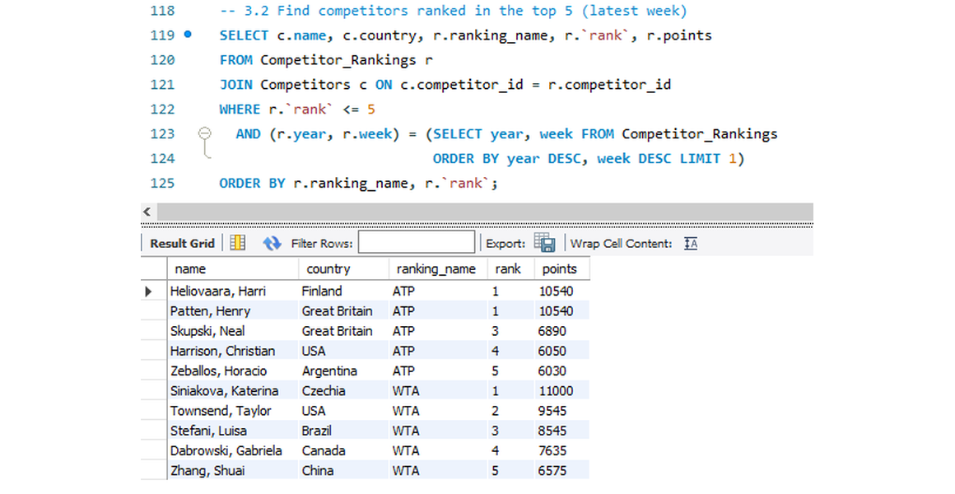

3.3 List competitors with no rank movement (stable rank)  SELECT c.name, c.country, r.ranking_name, r.`rank`, r.movement  FROM Competitor_Rankings r  JOIN Competitors c ON c.competitor_id = r.competitor_id  WHERE r.movement = 0  AND (r.year, r.week) = (SELECT year, week FROM Competitor_Rankings  ORDER BY year DESC, week DESC LIMIT 1)  ORDER BY r.`rank`  Rows returned: 111 | 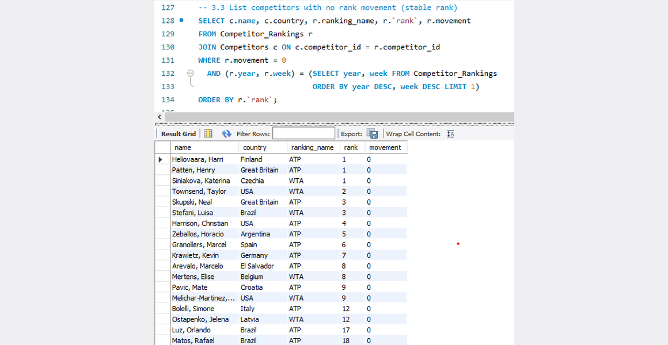

3.4 Get the total points of competitors from a specific country (e.g. Croatia)  SELECT c.country, SUM(r.points) AS total_points  FROM Competitor_Rankings r  JOIN Competitors c ON c.competitor_id = r.competitor_id  WHERE c.country = 'Croatia'  AND (r.year, r.week) = (SELECT year, week FROM Competitor_Rankings  ORDER BY year DESC, week DESC LIMIT 1)  GROUP BY c.country  Rows returned: 1 | 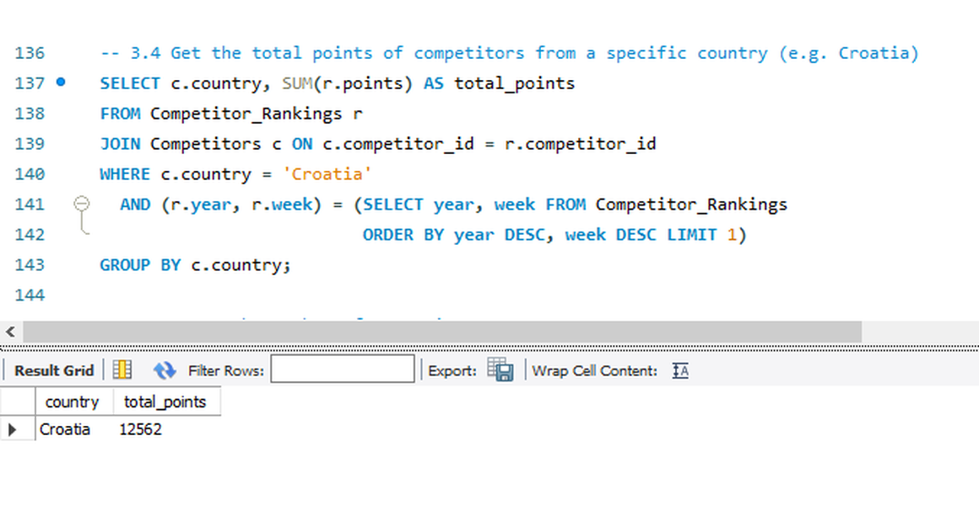

3.5 Count the number of competitors per country  SELECT country, COUNT(*) AS competitor_count  FROM Competitors  GROUP BY country  ORDER BY competitor_count DESC  Rows returned: 74 | 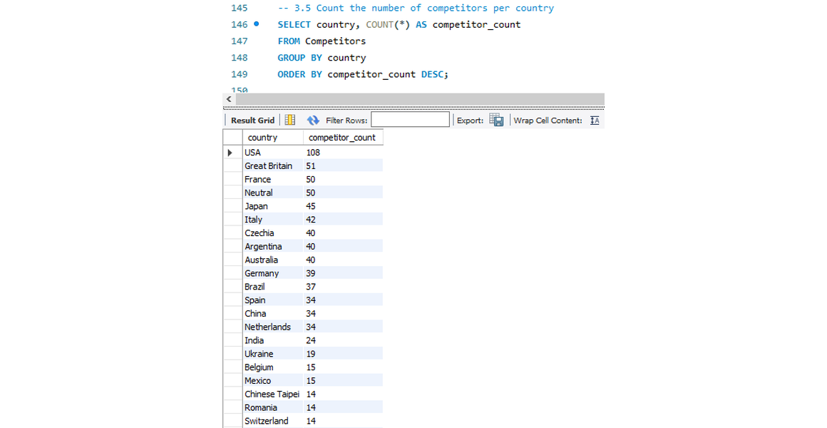

3.6 Find competitors with the highest points in the current week  SELECT c.name, c.country, r.ranking_name, r.points  FROM Competitor_Rankings r  JOIN Competitors c ON c.competitor_id = r.competitor_id  WHERE (r.year, r.week) = (SELECT year, week FROM Competitor_Rankings  ORDER BY year DESC, week DESC LIMIT 1)  AND r.points = (SELECT MAX(points) FROM Competitor_Rankings  WHERE (year, week) = (SELECT year, week FROM Competitor_Rankings  ORDER BY year DESC, week DESC LIMIT 1))  Rows returned: 1 | 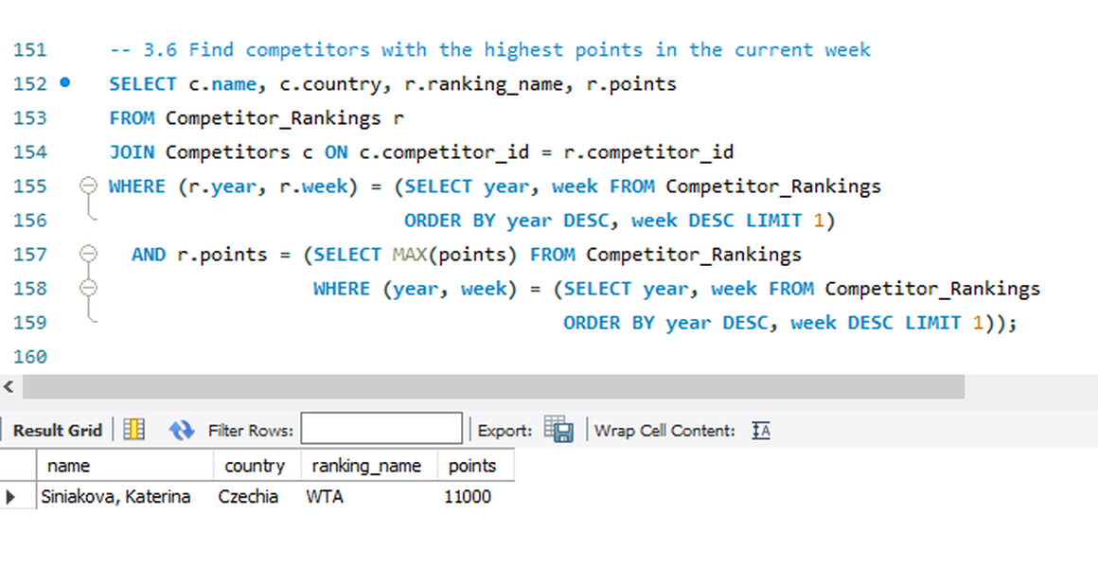

8. Query efficiency
Every column used for filtering or joining has an index. To prove the indexes work, each main query is explained twice by MySQL: normally, and with the index switched off (IGNORE INDEX). The access type, the index used, the estimated rows and the median run time are compared.
Case | Query | Variant | Access type | Index used | Est. rows | Median ms
A | Venues in a country | with index | ref | idx_venues_country | 65 | 14.89
A | Venues in a country | index ignored | ALL | none | 4200 | 17.64
B | Players of one country | with index | ref | idx_competitors_country | 10 | 10.8
B | Players of one country | index ignored | ALL | none | 1000 | 11.73
C | Top 5 ranks | with index | range | idx_rankings_rank | 10 | 10.43
C | Top 5 ranks | index ignored | ALL | none | 1000 | 11.13
D | Doubles competitions | with index | ref | idx_competitions_type | 3051 | 76.77
D | Doubles competitions | index ignored | ALL | none | 6867 | 100.86
E | Sub-competitions of the busiest parent | with index | ref | idx_competitions_parent | 5 | 14.1
E | Sub-competitions of the busiest parent | index ignored | ALL | none | 6867 | 31.23
F | Venues by city (no index on city_name) | as written | ALL | none | 4200 | 11.93
G | Players by competitions played (no index) | as written | ALL | none | 1000 | 14.44
H | Query 1.1: competitions with category name (JOIN on the foreign key) | as written | c: ALL; cat: eq_ref | c: none; cat: PRIMARY | 6867 | 313.32
I | Query 2.5: complexes with more than one venue (JOIN + GROUP BY) | as written | v: index; cx: eq_ref | v: idx_venues_complex; cx: PRIMARY | 4200 | 68.27

- Case A (Venues in a country): with the index the plan reads about 65 rows (ref) instead of 4,200 (ALL), roughly 64.6x fewer. Median time 14.89 ms vs 17.64 ms.
- Case B (Players of one country): with the index the plan reads about 10 rows (ref) instead of 1,000 (ALL), roughly 100.0x fewer. Median time 10.8 ms vs 11.73 ms.
- Case C (Top 5 ranks): with the index the plan reads about 10 rows (range) instead of 1,000 (ALL), roughly 100.0x fewer. Median time 10.43 ms vs 11.13 ms.
- Case D (Doubles competitions): with the index the plan reads about 3,051 rows (ref) instead of 6,867 (ALL), roughly 2.3x fewer. Median time 76.77 ms vs 100.86 ms.
- Case E (Sub-competitions of the busiest parent): with the index the plan reads about 5 rows (ref) instead of 6,867 (ALL), roughly 1373.4x fewer. Median time 14.1 ms vs 31.23 ms.
Reading the plan: type ALL is a full table scan; ref, range, const and eq_ref are index lookups. On small tables the optimizer may scan even when an index exists, and the index pays off as the data grows. Cases F and G have no index and show the full-scan baseline; cases H and I are JOINs that reach the second table through an index.

9. The application and deployment
Page | What it offers
Introduction | Problem statement, stakeholders, key result, assumptions and biases, pipeline, dataset counts
Overview | KPI cards, top countries, competitions per category, points distribution, rank movement, top-5 spotlight
Players | Search by name, filters for country, rank range and points, CSV export, profile card
Countries | Podium, ranking charts, bubble chart, world map, points treemap
Leaderboards | Top-ranked and highest-points lists with medals and bars
Competitions | Filters by type, gender, level and category, pagination, parent and sub-competition viewer
Venues | Filters, world map of venues, complexes with several venues
SQL Playground | Read-only SQL editor with the 20 project queries as examples, result table, chart builder, CSV download
Insights | Live insights, recommendations, limitations, acknowledgements

Every chart carries a one-line takeaway calculated from the data. The SQL Playground accepts one read-only statement per run, blocks data-changing keywords and MySQL executable comments, runs in a read-only session with a 15-second limit and a row cap.
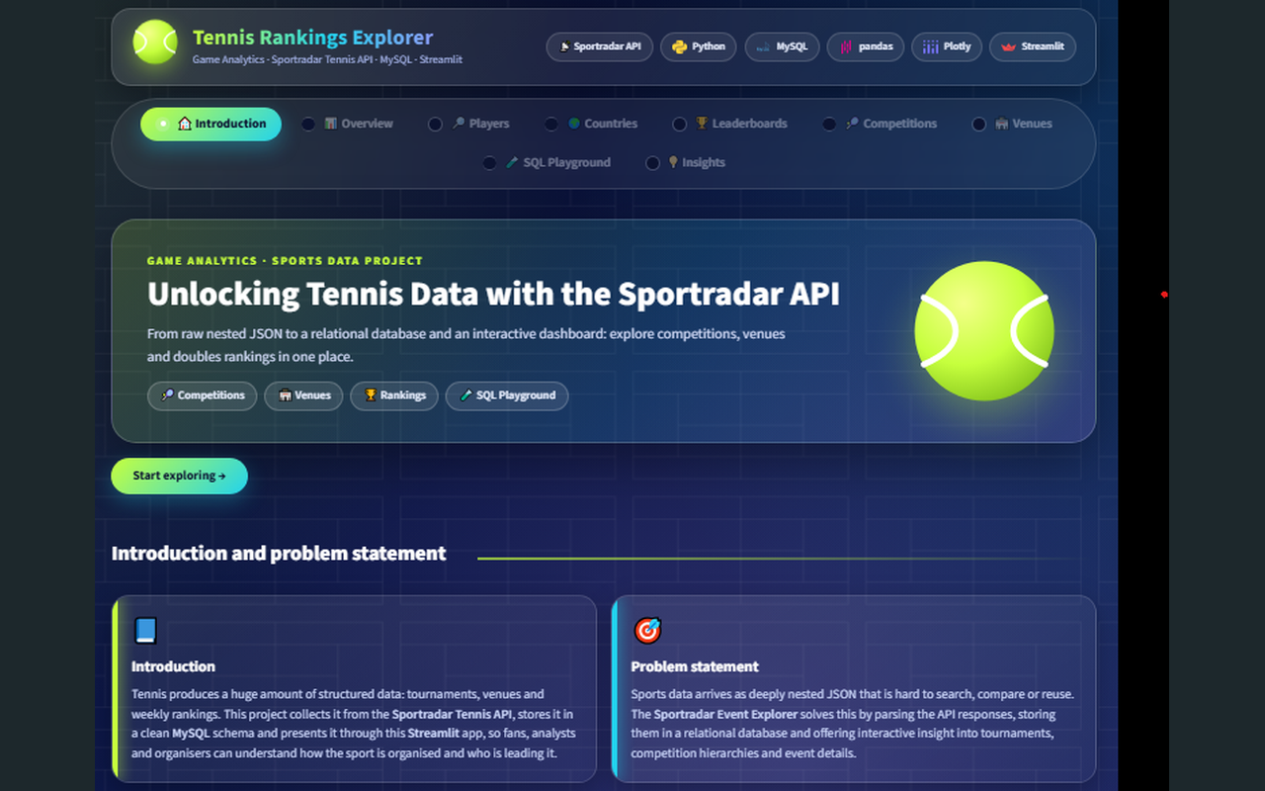  Live app: Introduction 1 | 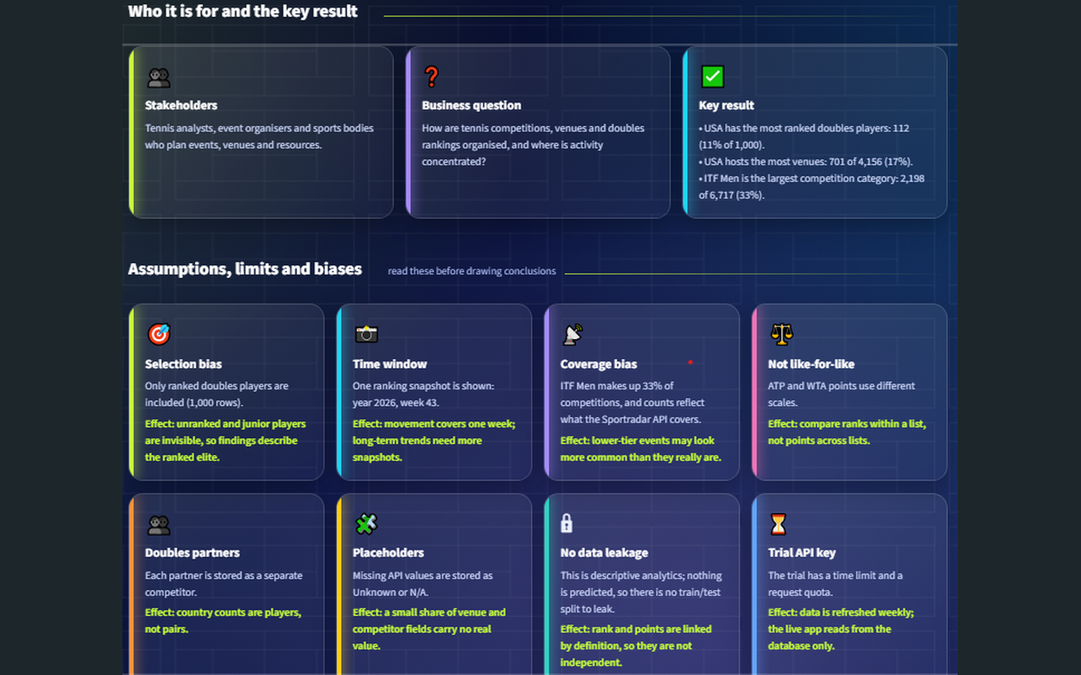  Live app: Introduction 2 | 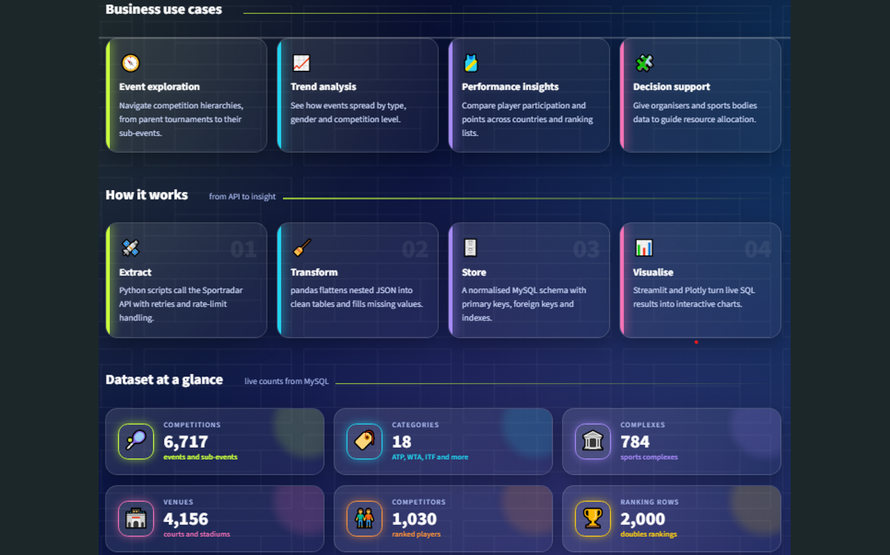  Live app: Introduction 3
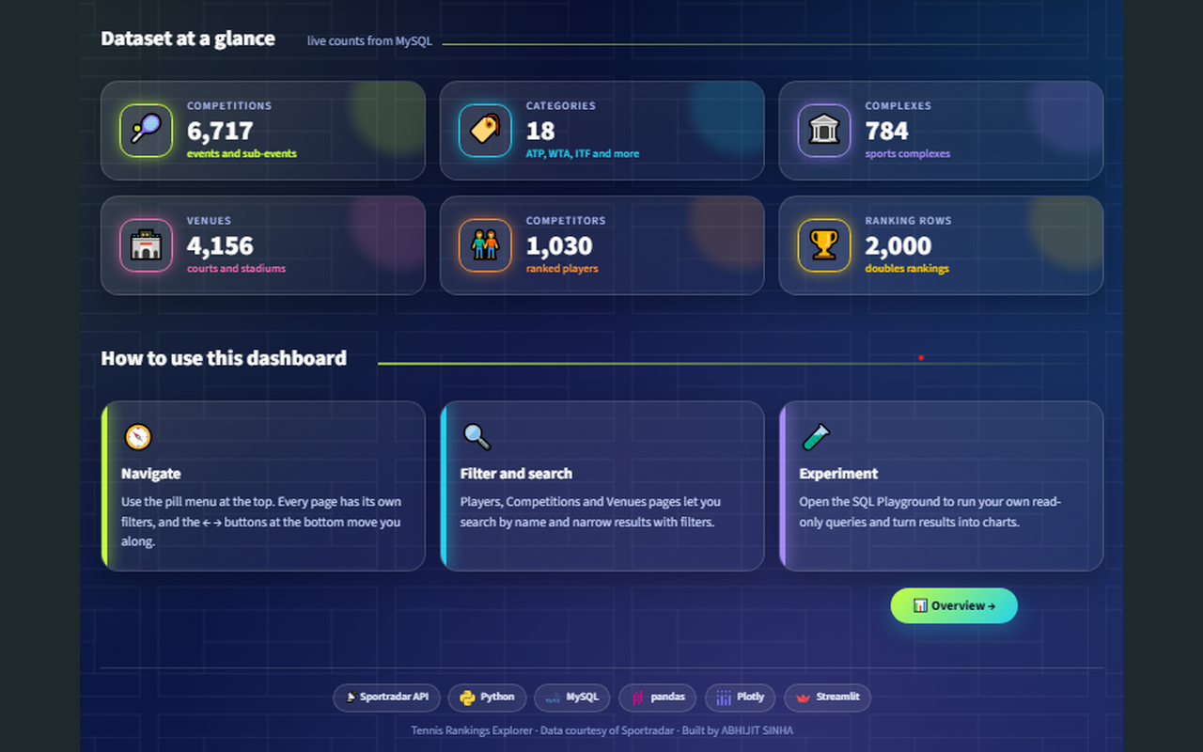  Live app: Introduction 4 | 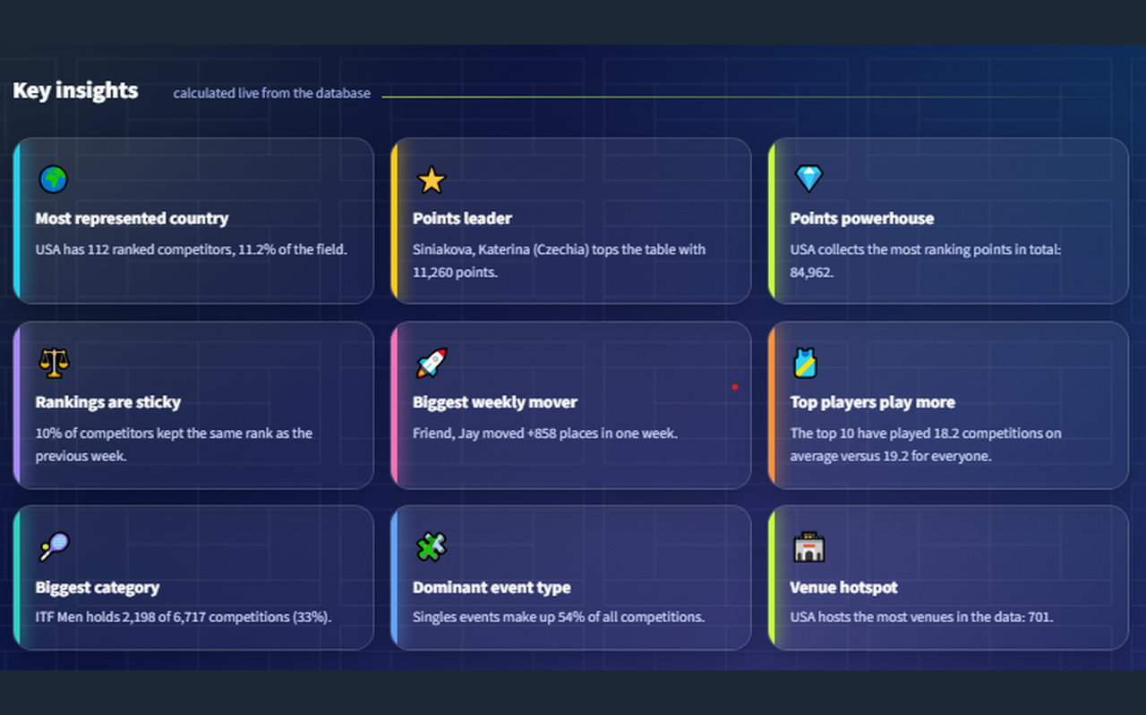  Live app: Key Insights | 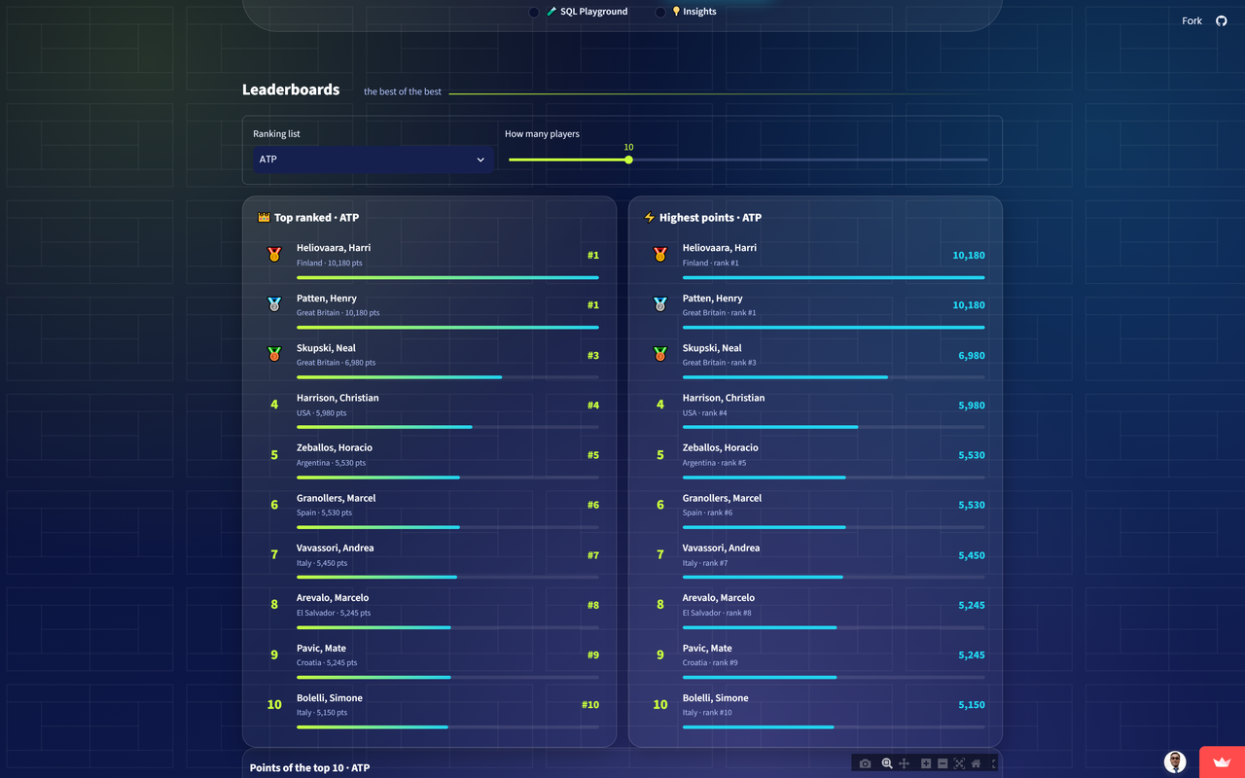  Live app: Leaderboards
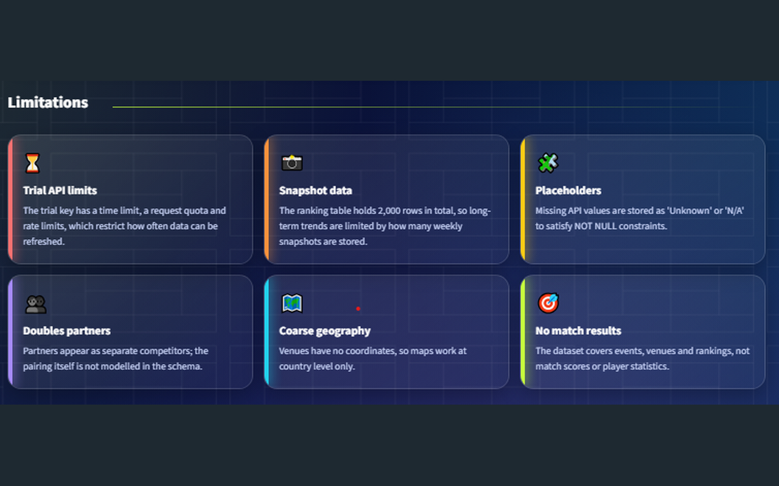  Live app: Limitations | 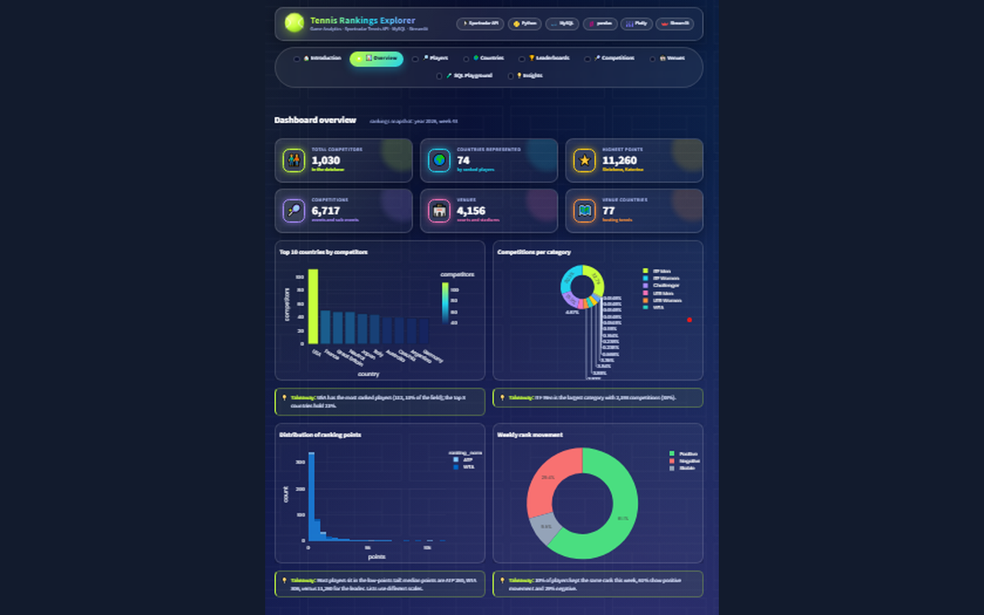  Live app: Overview | 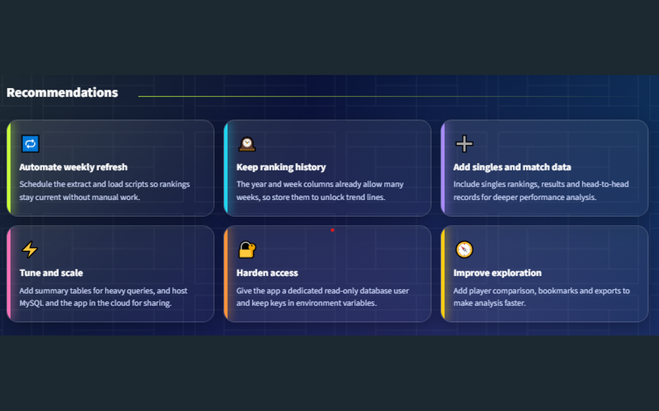  Live app: Recommendations
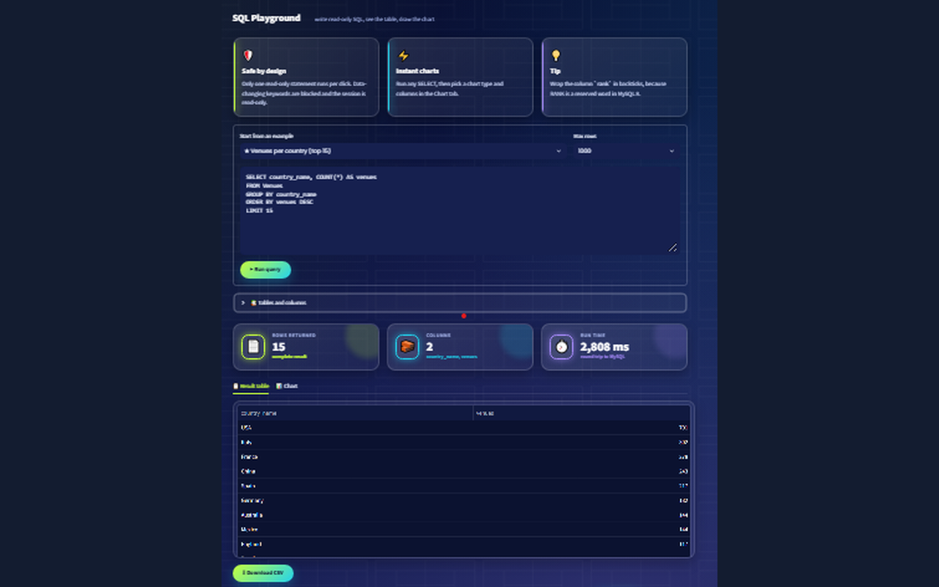  Live app: SQL Playground Venues 1 | 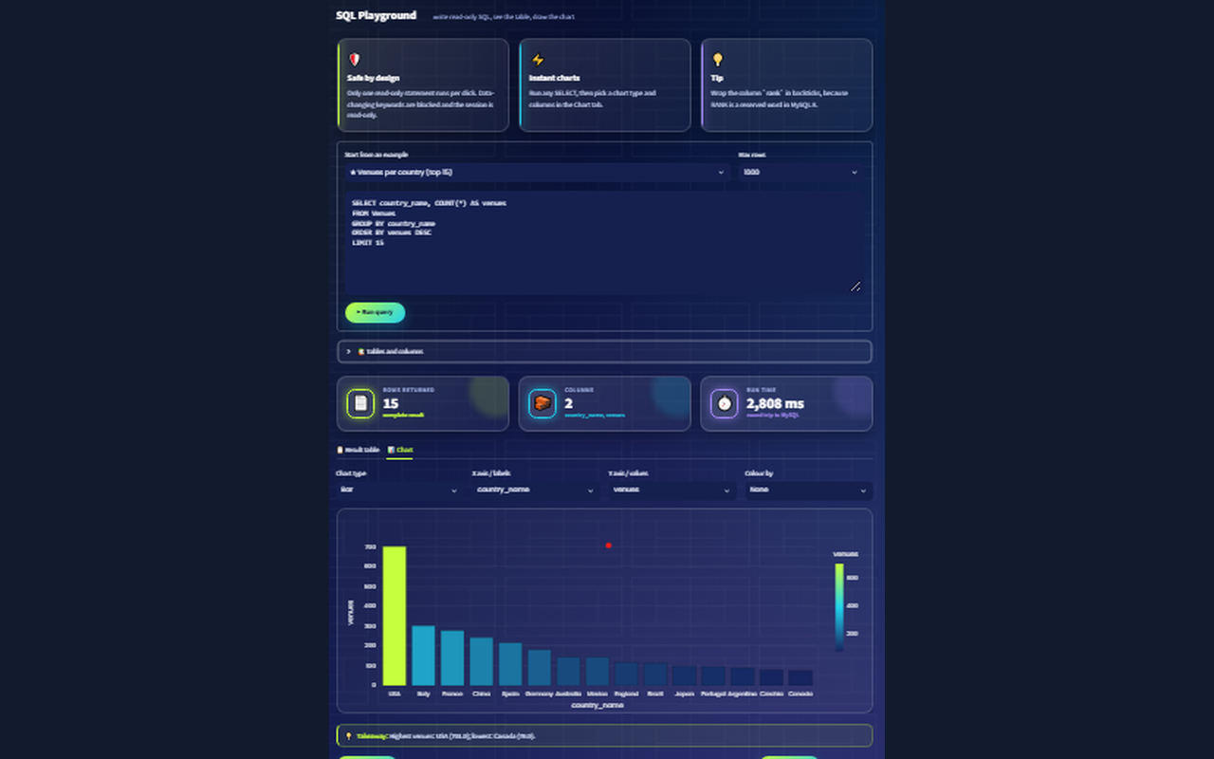  Live app: SQL Playground Venues 2

Deployment: MySQL on Aiven (SSL), code on GitHub, app on Streamlit Community Cloud with the database login stored in Streamlit Secrets. Live app: https://tennis-rankings-explorer-stjtrxsnyclfiewespoedo.streamlit.app/

10. Testing, monitoring and refresh
The automated test suite (pytest) result: 99 passed in 24.79s.
Test file | What it checks | Passed | Failed | Skipped
test_client.py | API client: key in header, retries on 429 and 5xx, clear errors, retry limit | 5 | 0 | 0
test_components.py | UI helpers: HTML escaping, percentages, movement arrows, leaderboards | 5 | 0 | 0
test_config.py | Settings: special-character passwords, SSL certificate path, endpoints | 4 | 0 | 0
test_data_quality.py | Data-quality audit and week-over-week movement validation | 9 | 0 | 0
test_database_live.py | Live database: row counts, integrity, indexes, and all 20 queries run | 26 | 0 | 0
test_explain_report.py | EXPLAIN report helpers | 4 | 0 | 0
test_queries_loader.py | The 20-query file is complete and read-only | 2 | 0 | 0
test_refresh.py | Weekly refresh: bad payloads rejected, week detection, log | 7 | 0 | 0
test_sqlguard.py | SQL Playground safety: read-only queries pass, unsafe ones are blocked | 29 | 0 | 0
test_transform.py | JSON parsers: flattening, defaults, deduplication | 8 | 0 | 0

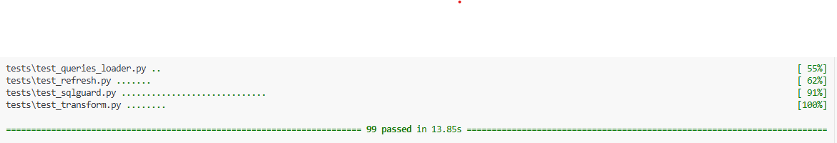
pytest result: pytest result 3

Monitoring and weekly refresh
- Rankings are refreshed weekly with python -m api.refresh.
- A run stops before touching the database if a download fails or a payload is empty.
- After loading it checks foreign keys, impossible values, shrinking tables (more than 20% fewer rows than the previous run) and the ranking week.
- From the second week on, the stored movement is compared with the real change in rank.
- Every run adds a line to docs/reports/refresh_log.csv; the exit code is 0 healthy, 1 failed, 2 loaded with warnings.
Week-over-week validation: comparing week 44 with week 43 for 979 players, the stored movement equals the real rank change for 100.0% of them (positive movement = moved up).

Refresh log
Run (UTC) | Status | Week | Week status | Competitions | Ranking rows | Notes
2026-10-24 14:38 | OK | 2026/43 | new week | 6717 | 2000
2026-10-30 07:51 | OK | 2026/44 | new week | 6722 | 3000

11. Assumptions, limitations and biases
Assumption or bias | What it means | Effect on conclusions
Selection bias | Only ranked doubles players are included. | Unranked and junior players are invisible; findings describe the ranked elite.
Time window | Only the weeks stored in the database are available. | Trends are limited to the number of weekly snapshots; movement covers one week.
Coverage bias | Counts reflect what the Sportradar API covers. | Lower-tier events may look more common than they really are.
Not like-for-like | ATP and WTA points use different scales. | Compare ranks within a list, not points across lists.
Doubles partners | Each partner is a separate competitor. | Country counts are players, not pairs.
Placeholders | Missing API values are stored as Unknown / N/A. | A small share of venue and player fields carry no real value (see section 5).
No data leakage | Descriptive analytics, nothing is predicted. | No train/test split is needed.
Trial API key | Time-limited, request quota and rate limits. | Data refreshed weekly; the live app reads only from the database.

Robustness
Distribution shift. New seasons add competitions and points change weekly. Every refresh stores a new year-and-week snapshot, and the refresh script compares row counts and rank movement with the previous run, so a change in the data shows up in the log instead of silently corrupting the analysis.
Monitoring and retraining. There is no model to retrain. The monitoring plan is the weekly refresh with its checks (section 10); the owner is the project author, and the log is the evidence.
Scalability. At ten times the data the risks are full table scans and loading too many rows into the browser. Indexes on every filter and join column, SQL aggregation, pagination and five-minute caching already reduce this; summary tables would be the next step.

12. Insights and recommendations

Key insights
- ITF Men is the largest competition category with 2,198 events (33%); the next is ITF Women (30%).
- Singles is the most common event type (54% of competitions).
- Venues exist in 77 countries; USA hosts 702 (17%) and the top 5 countries host 42%.
- Ranked players come from 73 countries; USA has 111 (11%) and the top 5 countries hold 30%.
- 11% of players kept the same rank in the latest week; most positions changed, so rankings move noticeably from week to week.

Recommendations
Finding | Why it matters | Action | How to measure
USA hosts 17% of venues; the top 5 countries host 42%. | Capacity is concentrated, so some regions have little access to tournament-grade courts. | Federations and organisers should look at under-served countries first when planning new events or venues. | Venues per country each season
ITF Men accounts for 33% of competitions. | One category drives most of the scheduling workload. | Size officials, scheduling tools and support for this category's volume. | Events per category per month
The top 5 countries hold 30% of ranked players. | Player supply is concentrated in a few countries. | Development and scouting programmes could target countries outside the top 5. | Share of the top 5 countries at each refresh
11% of players kept their rank in the latest week. | Positions change every week, so one week is a snapshot rather than a trend. | Compare several weeks (for example 4) before drawing conclusions about a player. | Average absolute movement over 4 weeks
The weekly refresh runs with validation and a log. | Fresh, checked data keeps the analysis trustworthy. | Schedule python -m api.refresh weekly and review the log. | Refresh success rate, row-count change

13. Challenges and solutions
Challenge | Solution
Sportradar expects the key in a header | Sent as x-api-key instead of in the URL; a unit test checks the key never appears in the URL.
Passwords with special characters broke the connection URL | Built the URL with SQLAlchemy URL.create, which escapes them; covered by a test.
Missing API values versus NOT NULL columns | Filled with Unknown / N/A / UNK in the transform step; every placeholder is counted and explained in the data-quality report.
rank is a reserved word in MySQL 8 | Wrapped in backticks in every query.
Aiven's free plan allows one MySQL service | Reused the existing service with a separate tennis_db database.
Cloud database needs SSL | Added DB_SSL_CA support and committed the public CA certificate.
Same code on a laptop and on Streamlit Cloud | config.py reads .env first, then Streamlit Secrets.
Reloading data must not duplicate rows | Upserts plus a unique key on competitor, ranking list, year and week.
A secret reached a template file | GitHub push protection blocked the push before anything was published; the template now holds placeholders only.
The first app file grew too long | Split into a small entry point and a dashboard package with one module per page.

14. Conclusion and next steps
The project delivers the full path from the Sportradar API to a live dashboard: validated extraction, a normalised database, 20 documented queries, quality and efficiency evidence, automated tests, a monitored weekly refresh and a public deployment.
- Store more weekly snapshots to unlock trend lines and a week selector in the app.
- Add singles rankings, match results and player statistics for deeper performance analysis.
- Model doubles pairings explicitly and add venue coordinates for city-level maps.
- Use a dedicated read-only database user for the deployed app and schedule the weekly refresh automatically.

15. Acknowledgements
Thanks to Sportradar for the Tennis API and data, Aiven for the managed MySQL database, Streamlit for hosting, the mentors and project sessions that guided the build, and the open-source communities behind Python, pandas, SQLAlchemy, MySQL, Streamlit and Plotly.

Appendix A: project structure
Game_Analytics_Tennis/
api/ config.py, sportradar_client.py, extract.py, transform.py, load.py, refresh.py
app/ streamlit_app.py and dashboard/ (settings, database, sqlguard, charts, components, theme,
insights_calc, queries_loader and views/ with one module per page)
db/ schema.sql, schema_aiven.sql, init_db.py, data_quality.py, explain_report.py
sql/ queries.sql (the 20 queries)
tests/ 99 pytest tests
docs/ screenshots/, reports/, build_report.py
certs/ ca.pem (public Aiven CA certificate)
.streamlit/ config.toml (theme), secrets.toml.example
.env.example, requirements.txt, requirements-dev.txt, pytest.ini, README.md

Appendix B: how to reproduce
python -m venv venv && venv\Scripts\activate
pip install -r requirements-dev.txt
copy .env.example .env (then fill in your values)
python -m api.extract # download JSON
python -m db.init_db # create database and tables
python -m api.load # load the data
python -m db.data_quality # quality report
python -m db.explain_report # EXPLAIN report
pytest -v > docs/reports/pytest_result.txt 2>&1
python -m api.refresh # weekly refresh
streamlit run app/streamlit_app.py
python docs/build_report.py # rebuild this report

