A
Special Project Report
on

“Project Title”

by
Student Name (Roll Number)
(Names and roll numbers of team members)

Under the guidance of
Spuervisor Name
designation


Faculty of Science & Technology,
The ICFAI Foundation for Higher Education, Hyderabad
November, 2026

Faculty of Science & Technology
The ICFAI Foundation for Higher Education Hyderabad

CERTIFICATE

This is to certify that the project entitled “PHISHING WEBSITE DETECTION USING SUPERVISED DEEP LEARNING” by Panjala Bhanu Teja (19STUCHH010087) has been submitted in the partial fulfilment of the requirements for the award of degree of Bachelor of technology in computer Science and Engineering from Faculty of Science & Technology (FST), IFHE Hyderabad. The results embodied in this project have not been submitted to any other University or Institution for the award of any degree or diploma.

Project Supervisor Head of the Department
Name: Name:
designation designation

DECLARATION

I hereby declare that the Project entitled “PHISHING WEBSITE DETCTION USING SUPERVISED DEEP LEARNING” is the work done during the period from January 2024 to April 2024 and is submitted in partial fulfillment of the requirements for the award of degree of Bachelor of technology in computer Science and Engineering from Faculty of Science & Technology (FST), IFHE Hyderabad. The results embodied in this project have not been submitted to any other university or Institution for the award of any degree or diploma.

This is to certify that the above statement made by the candidates is correct to the best of my knowledge.

DATE:
PLACE:

SIGNATURE OF THE CANDIDATE

ACKNOWLEDGEMENT

Student name
Roll Number

ABSTRACT

CONTENTS
Page numbers
- Introduction
  - Background and overview of the problem domain.
  - Problem statement — clearly identify the problem being addressed.
  - Motivation — explain why the problem is important.
  - Objectives — specify measurable and achievable goals.
  - Scope — define what the project covers and excludes.
  - Contributions — describe what the team has developed or improved.
  - Organization of the report — briefly describe each chapter.
- Literature Survey

2.1 Existing methods, related research, comparison of approaches, research gap

3. System Requirements
- Functional requirements: what the system must do.
- Non-functional requirements: performance, security, usability, reliability, and scalability.
- Hardware and software requirements.
- Feasibility analysis, where appropriate.

4. Proposed Methodology and Design
Explain how the project solves the identified problem.
Include:
- Reasons for selecting the proposed approach over alternatives.
- Proposed system (architecture, workflow , mathematical models, algorithm, etc ...)
- Dataset description and preprocessing, if applicable.
- Module descriptions and interfaces.
- UML diagrams, database schema, or circuit diagrams as relevant.

5. Implementation
Describe the actual development process.
- Programming languages, frameworks, libraries, and tools.
- System modules and their functions.
- Pseudo code or code snippets, with explanations.
- Dataset acquisition, preparation, and partitioning, if applicable.
- Integration of modules and implementation challenges.
- Git or other version-control practices, where used.
Do not include the entire source code
- 6. Results and Discussion
- Present evidence that the project works and assess how well it meets its objectives.
- Include:
- Experimental setup and test environment.
- Test cases and expected versus actual outcomes.
- Screenshots of important application features.
- Tables, graphs, and performance measurements.
- Comparison with existing methods or baseline systems, where appropriate.
- Discussion of results, limitations, errors, and observations.
7. Conclusion and Future Scope
Summarize the work completed, major findings, objectives achieved, and project limitations and future scope.
References

Please following the document guidelines for preparing the report
Element | Recommended format
Paper size | A4
Font | Times New Roman
Body text | 12 pt
Chapter headings | 16 pt, bold
Section headings | 14 pt, bold
Subsection headings | 12 pt, bold
Line spacing | 1.5
Alignment | Justified body text
Margins | Left 1.5 inches; other margins 1 inch
Paragraph spacing | Consistent throughout
Page numbering | Roman numerals for preliminary pages; Arabic numerals for main chapters
Figure captions | Below figures
Table captions | Above tables
References | One consistent citation style, such as IEEE

Sample Figure and Table Names

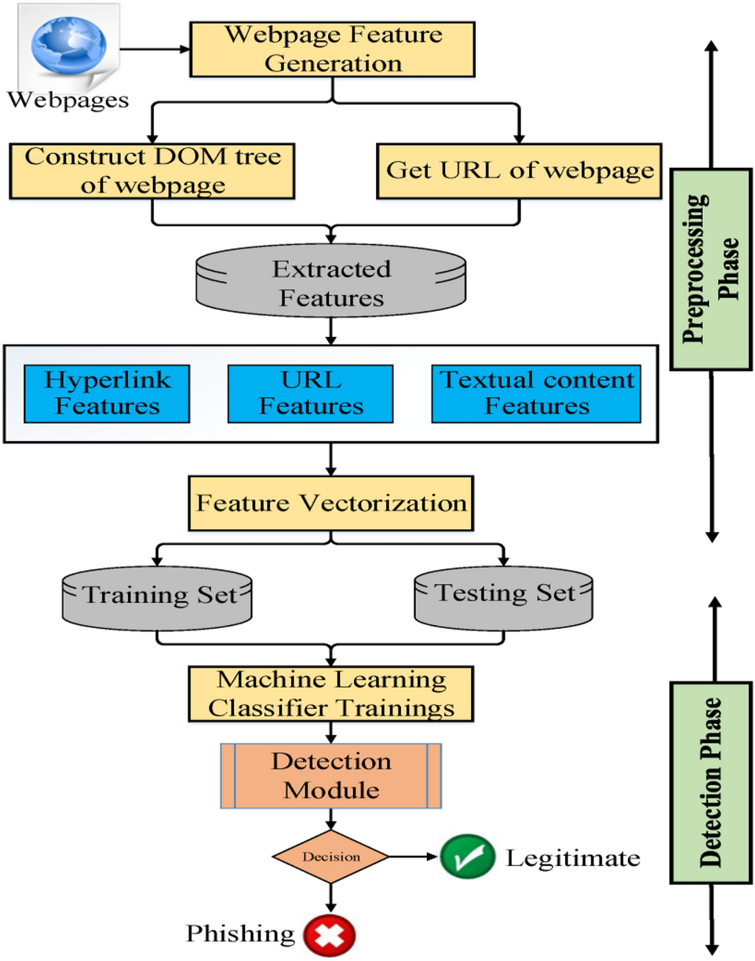
Figure 1: Data Flow diagram for the proposed model

Table 1: accuracy table
S. No

References

[1] J. Rashid, T. Mahmood, M. W. Nisar and T. Nazir, "Phishing Detection Using Machine Learning Technique," 2020 First International Conference of Smart Systems and Emerging Technologies (SMARTTECH), 2020, pp. 43-46.
[2] M. H. Alkawaz, S. J. Steven and A. I. Hajamydeen, "Detecting Phishing Website Using Machine Learning," 2020 16th IEEE International Colloquium on Signal Processing & Its Applications (CSPA), 2020, pp. 111-114.
[3] V. Patil, P. Thakkar, C. Shah, T. Bhat and S. P. Godse, "Detection and Prevention of Phishing Websites Using Machine Learning Approach," 2018 Fourth International Conference on Computing Communication Control and Automation (ICCUBEA), 2018, pp. 1-5.

