A
Special Project Report
on
AI-BASED AUTONOMOUS ACADEMIC DECISION & ADVISORY SYSTEM
Submitted in partial fulfillment of the requirements for the award of the degree of
Bachelor of Technology
in
Computer Science and Engineering
by
EDULAKANTI ABHISHEK
(Roll No: 24STUCHH010302)
Faculty of Science & Technology (FST)
The ICFAI Foundation for Higher Education (IFHE), Hyderabad
November, 2026

CERTIFICATE
This is to certify that the special project entitled "AI-BASED AUTONOMOUS ACADEMIC DECISION & ADVISORY SYSTEM" submitted by EDULAKANTI ABHISHEK (Enrollment No: 24STUCHH010302) in partial fulfillment of the requirements for the award of the degree of Bachelor of Technology in Computer Science and Engineering from Faculty of Science & Technology (FST), The ICFAI Foundation for Higher Education (IFHE), Hyderabad, is a bonafide record of work carried out by him under supervision and guidance.
The results embodied in this project report have been verified and have not been submitted to any other University or Institution for the award of any degree, diploma, or fellowship.

______________________________  Project Supervisor  Department of CSE, FST  IFHE Hyderabad | ______________________________  Head of the Department  Department of CSE, FST  IFHE Hyderabad

DECLARATION
I hereby declare that the Special Project entitled "AI-BASED AUTONOMOUS ACADEMIC DECISION & ADVISORY SYSTEM" is an authentic work carried out by me under the supervision of the Department of Computer Science & Engineering, Faculty of Science & Technology (FST), The ICFAI Foundation for Higher Education (IFHE), Hyderabad.
I further declare that the content embodied in this project report has not been submitted in part or full to any other institution or university for the award of any other degree, diploma, or certificate. All references and citations to prior literature and methodologies have been properly acknowledged.
Date: 29-10-2026
Place: Hyderabad
___________________________________
EDULAKANTI ABHISHEK
(Roll No: 24STUCHH010302)

ACKNOWLEDGEMENT
First and foremost, I express my sincere gratitude and deep sense of veneration to my Project Supervisor and the Faculty of Science & Technology (FST), The ICFAI Foundation for Higher Education (IFHE), Hyderabad, for their invaluable encouragement, scholarly guidance, and constructive critiques throughout the design, implementation, and deployment phases of this Autonomous Academic Decision System.
I also extend my sincere thanks to the Head of the Department and all respected faculty members of the Department of Computer Science and Engineering for providing the requisite computational infrastructure, academic datasets, and collaborative environment essential to execute this machine-learning-driven project.
Finally, I express my profound debt of gratitude to my family and peers for their continuous moral support, understanding, and enthusiasm throughout this endeavor.
EDULAKANTI ABHISHEK
Enrollment: 24STUCHH010302
B.Tech CSE, FST, IFHE Hyderabad

ABSTRACT
Higher education institutions face systemic challenges in detecting academic vulnerability early, monitoring classroom attendance continuously, and delivering actionable, personalized student interventions prior to summative end-semester examinations. Traditional Enterprise Resource Planning (ERP) systems function primarily as static historical record archives, lacking proactive predictive intelligence, explainable diagnostics, and multi-channel automated dispatch mechanisms.
To address these operational and pedagogical gaps, this project presents the AI-Based Autonomous Academic Decision & Advisory System, an end-to-end institutional platform engineered using Python, Streamlit, Scikit-Learn, SQLite, and enterprise messaging gateways. The system establishes a strict tripartite role-based architecture (Administrator, Faculty, and Student). Key technical contributions include: (i) an ensemble Machine Learning forecasting engine combining Random Forest Classifiers, Gradient Boosting, Support Vector Classifiers, and Multi-Layer Perceptrons trained on institutional features (CIE internals, formative quizzes, attendance percentages, LMS engagement metrics) to forecast course performance and classify student risk (High, Medium, Low); (ii) an explainable rule-based advisory recommender generating tailored remedial pathways; (iii) a classroom session attendance registry with immediate SMS, WhatsApp, and Gmail SMTP alerts; (iv) an autonomous daily 6:00 PM background scheduler executing cohort evaluations and outbound notifications; and (v) an automated bulk marks spreadsheet uploader for faculty enabling seamless section-wide grading and ledger synchronization.
Experimental evaluation across 500 enrolled student profiles demonstrated 98.2% predictive accuracy for grade-band forecasts and high operational reliability in multi-channel alert dispatches. The developed system bridges the divide between institutional data collection and proactive student success engineering.

TABLE OF CONTENTS
Certificate | ii
Declaration | iii
Acknowledgement | iv
Abstract | v
List of Figures | vi
List of Tables | vii
Chapter 1: Introduction | 1
1.1 Background and Overview | 1
1.2 Problem Statement | 2
1.3 Motivation & Significance | 3
1.4 Project Objectives | 4
1.5 Scope of the Project | 4
1.6 Key Technical Contributions | 5
1.7 Organization of the Report | 6
Chapter 2: Literature Survey | 7
2.1 Educational Data Mining & Learning Analytics | 7
2.2 Early Warning Systems in Higher Technical Education | 8
2.3 Comparative Evaluation of Existing Paradigms | 9
2.4 Identified Research Gaps | 10
Chapter 3: System Requirements & Architecture | 11
3.1 Functional Requirements Specification | 11
3.2 Non-Functional & Reliability Requirements | 12
3.3 Hardware, Software & Cloud Telephony Environment | 13
3.4 Technical, Economic & Operational Feasibility Analysis | 14
Chapter 4: Proposed Methodology & System Design | 15
4.1 High-Level Multi-Tier System Architecture | 15
4.2 Mathematical Modeling of the Institutional 60/40 Assessment Framework | 16
4.3 Machine Learning Pipeline & Ensemble Model Architecture | 17
4.4 Explainable Advisory Recommender & Remedial Logic | 19
4.5 Normalized Relational Database Schema & Data Integrity | 20
4.6 Autonomous Multi-Channel Outbound Dispatch Engine | 22
Chapter 5: Implementation Details | 24
5.1 Technology Stack & Development Frameworks | 24
5.2 Core Module Implementations & Architecture | 25
5.3 Faculty Marks Sheet Upload & Automatic Section Mapping Algorithm | 27
5.4 Classroom Attendance Tracking & Real-Time Cellular Telephony Dispatch | 29
5.5 Daily 6:00 PM Autonomous Background Worker Service | 30
5.6 Cryptographic Security, Role Isolation & Password Hashing | 31
Chapter 6: Results and Discussion | 32
6.1 Experimental Setup & Evaluation Cohort Description | 32
6.2 Model Performance Metrics & Comparative Benchmarks | 33
6.3 End-to-End Application Interface Verification (Captured Artifacts) | 35
6.4 Operational Ingestion & Dispatch Performance Analysis | 41
6.5 Discussion of Findings, System Limitations & Boundary Conditions | 42
Chapter 7: Conclusion and Future Scope | 43
7.1 Comprehensive Summary of Completed Work | 43
7.2 Major Achievements & Findings | 44
7.3 Future Enhancements & Technological Roadmap | 45
References | 47

LIST OF FIGURES
Figure 4.1: Four-Tier System Architecture and Data Ingestion Pipeline | 15
Figure 4.2: Machine Learning Ensemble Training and Evaluation Workflow | 18
Figure 6.1: Unified Multi-Portal Sign-In Interface (Student, Faculty, Admin) | 35
Figure 6.2: Student First-Time Registration & Academic Admission Interface | 36
Figure 6.3: Administrative Central Control Dashboard & System Health Indicators | 37
Figure 6.4: Outbound Advisory & Attendance Dispatch Center (Manual & Daily 6 PM) | 38
Figure 6.5: Institutional Academic Analytics, Department Comparisons & Grade Bands | 39
Figure 6.6: Student Enrollment Approval and Verification Ledger | 40
Figure 6.7: Comprehensive Academic Reports & Export Engine | 41
Figure 6.8: Faculty Portal with Automated Marks Sheet Upload & Section Grading Roster | 42
Figure 6.9: Student Self-Service Portal Displaying 60/40 CIE Evaluation & AI Advisory | 43

LIST OF TABLES
Table 2.1: Comparative Analysis of Academic Decision & Early Warning Frameworks | 9
Table 3.1: Hardware, Software & Gateway Operational Environment | 13
Table 4.1: Continuous Internal Evaluation (CIE) Marks Breakdown Framework | 16
Table 4.2: Relational Database Schema Architecture and Entity Relationships | 21
Table 5.1: Software Technology Stack and Component Libraries | 24
Table 6.1: Cross-Validated Performance Benchmarks Across Machine Learning Algorithms | 33
Table 6.2: Confusion Matrix for Random Forest Performance Grade Classifier | 34
Table 6.3: Multi-Channel Outbound Dispatch Delivery Reliability and Latency | 41

CHAPTER 1: INTRODUCTION
1.1 Background and Overview
Higher education institutions worldwide operate in increasingly complex environments characterized by growing student enrollments, diverse learner backgrounds, and heightened academic accountability. Continuous student assessment and timely pastoral intervention form the backbone of institutional retention, academic progression, and graduate outcomes. However, traditional Academic Management Information Systems (AMIS) and campus Enterprise Resource Planning (ERP) platforms have predominantly functioned as passive historical record repositories. They record raw scores, log attendances, and compile end-of-term transcripts, but they do not actively analyze continuous learning trajectories or warn stakeholders before an academic crisis materializes.
In rigorous undergraduate university engineering curricula, course concepts build cumulatively over successive lecture weeks. A student who falls behind in formative assignments, mid-term examinations, or mandatory classroom sessions during the first half of a semester often struggles to recover before the summative end-semester examinations. The absence of predictive analytics leaves faculty mentors and academic administrators unable to deploy targeted remedial support until final semester grade cards are tabulated—at which point course failure, statutory exam condonation, or semester detention has already occurred.
Recent advances in applied machine learning, explainable artificial intelligence (XAI), and multi-channel cloud messaging provide an unprecedented opportunity to convert static educational record-keeping into a proactive, autonomous decision-support system. The AI-Based Autonomous Academic Decision & Advisory System is engineered to bridge this divide, establishing an institutional intelligence platform that continuously analyzes assessment signals, predicts student outcomes, and dispatches automated, personalized interventions across enterprise email, SMS, and WhatsApp.
1.2 Problem Statement
Traditional institutional academic software architectures suffer from four acute operational and pedagogical deficiencies:
• 1. Lack of Early Predictive Intelligence: Legacy systems provide retrospective reporting only after examinations have concluded. Administrators and instructors cannot forecast which students are trending toward failure while remedial interventions are still viable.
• 2. Disconnected Attendance and Assessment Data Silos: Classroom session attendance is recorded independently of Continuous Internal Evaluation (CIE) marks, preventing holistic multi-variate modeling of student academic health.
• 3. Manual and Fragmented Communication: Advisors must manually draft individual student emails or place phone calls when attendance falls below statutory minimums (e.g., UGC 75% rule), leading to delayed, inconsistent, or omitted warnings.
• 4. Absence of Actionable Intervention Guidance: Raw percentages (e.g., '62%') provide no prescriptive guidance regarding the specific lecture hours required to reach eligibility, targeted quiz revision, or personalized learning pathways.
1.3 Motivation & Significance
The primary motivation behind this project is to construct an autonomous, transparent, and empathetic academic ecosystem that supports institutions, educators, and learners alike. By operationalizing machine learning models within daily university administrative workflows, the platform democratizes predictive analytics for educators without requiring them to become data scientists. Faculty members are relieved from tedious manual grade consolidation, academic leaders gain real-time cohort visibility, and students receive clear, supportive, and actionable guidance delivered directly to their personal devices.
1.4 Project Objectives
To overcome existing limitations, the project delivers on five core measurable objectives:
• • Architect an Enterprise Multi-Role Portal: Deliver unified yet strictly isolated portal interfaces for Administrators, Faculty, and Students with cryptographic credential hashing and session state validation.
• • Implement an Institutional 60/40 Assessment Model: Embed statutory university evaluation rules comprising 60 Internal Marks (30 Mid Exam + 10 Assignment + 10 Quiz + 10 Viva Voce) and 40 External University Examination Marks.
• • Deploy an Ensemble Machine Learning Engine: Train and evaluate Random Forest, Gradient Boosting, Support Vector Classifiers, and Multi-Layer Perceptrons to achieve >95% predictive accuracy for student grade bands and risk levels.
• • Engineer an Autonomous Multi-Channel Outbound Dispatcher: Automate daily 6:00 PM background scheduled evaluations and multi-channel transmissions (Gmail SMTP, Cellular SMS, and Twilio WhatsApp Sandbox).
• • Develop an Intelligent Section Marks Sheet Uploader: Enable faculty to upload raw Excel or CSV grading rosters with automatic student ID/roll number mapping, range validation, and student portal notifications.
1.5 Scope of the Project
The scope of this deployment covers undergraduate technical programs across four core departments: Artificial Intelligence and Machine Learning, Computer Science and Engineering, Data Science, and Information Technology. The system processes cohort registries, section assignments (Sections A through J with up to 75 students per section), semester teaching timetables, classroom attendance sessions, and granular assessment ledgers for 500 active student records. Hardware scope encompasses campus servers or cloud virtual machines, requiring only standard web browsers on client devices.
1.6 Key Technical Contributions
• 1. Dual-Mode Outbound Communication Architecture: Combines autonomous daily 6:00 PM background scheduled jobs with on-demand administrative manual overrides.
• 2. Intelligent Fuzzy Marks Sheet Ingestion Engine: Ingests raw Excel/CSV spreadsheets with heterogeneous column naming, matches students to section rosters, and logs full audit trails.
• 3. Automated Student Identity Normalization: Standardizes all 500 institutional student emails to <clean_name><reg_year>@gmail.com with deterministic duplicate collision resolution.
• 4. Automated Statutory Attendance Enforcement: Immediately triggers multi-channel parent and student notifications whenever cumulative attendance falls below the UGC 75% limit.
1.7 Organization of the Report
The remainder of this report is organized as follows: Chapter 2 reviews related literature and existing academic analytics solutions; Chapter 3 defines system requirements, architectural trade-offs, and feasibility; Chapter 4 presents proposed methodology, mathematical formulas, and database designs; Chapter 5 details technical implementations and algorithms; Chapter 6 showcases extensive benchmarking results, tables, and captured interface artifacts; and Chapter 7 concludes the report with achievements, limitations, and future research roadmaps.

CHAPTER 2: LITERATURE SURVEY
2.1 Educational Data Mining & Learning Analytics
Educational Data Mining (EDM) and Learning Analytics (LA) have evolved substantially from basic statistical reporting to sophisticated predictive modeling. In their foundational survey, Romero and Ventura [1] analyzed early applications of decision tree classifiers (ID3, C4.5, CART) and Naive Bayes models applied to offline institutional databases. While these models achieved reasonable accuracy (70%–80%) in predicting end-of-course student outcomes, they were heavily dependent on static demographic data (gender, socioeconomic background) and historical cumulative GPAs, failing to incorporate dynamic classroom interactions.
Baker and Inventado [2] expanded EDM paradigms by integrating behavioral data captured through Learning Management Systems (LMS) such as Moodle and Blackboard. Their research demonstrated that real-time behavioral features—such as video lecture viewing time, quiz attempt frequency, and assignment submission timelines—yielded substantially stronger early indicators of academic risk than pre-admission standardized test scores.
2.2 Early Warning Systems in Higher Technical Education
The implementation of Early Warning Systems (EWS) in technical universities has historically been constrained by organizational data silos. Alkawaz et al. [3] examined student attrition in university engineering programs and observed that high failure rates in foundational mathematics and programming courses could be anticipated four to six weeks prior to mid-term assessments using supervised machine learning algorithms. Similarly, Patil et al. [4] evaluated Random Forest and Support Vector Machine algorithms on university datasets, demonstrating that ensemble methods effectively handle class imbalance where vulnerable students constitute a minority subset of the overall cohort.
Rashid et al. [5] further investigated multi-layer neural networks for student outcome classification, highlighting the necessity of combining continuous internal assessment marks with lecture attendance records to achieve robust prediction stability.
2.3 Comparative Evaluation of Existing Paradigms
To contextualize the contributions of this research, Table 2.1 presents a structured comparative analysis of traditional and modern academic platforms:
System / Approach | Primary Data Inputs | Inference & Analytics Capability | Outbound Intervention Channels
Traditional University ERP | Historical GPA, Enrollment Data | None (Static SQL reports & transcripts) | None (Manual notice board posting)
LMS Built-in Analytics (Moodle) | LMS page clicks, Forum posts | Basic binary completion regression | In-portal web notifications only
Commercial Early Warning Tool | Semester letter grades, Credits | Statistical logistic regression risk score | Email digest to faculty counselors
Proposed Autonomous System | 60 CIE Internals, Daily Attendance, LMS | Ensemble ML (RF, GBM, SVC, MLP) + XAI | Automated Daily 6 PM SMS, WhatsApp & Email
Table 2.1: Comparative Analysis of Academic Decision & Early Warning Frameworks
2.4 Identified Research Gaps
A rigorous review of published literature reveals three major unaddressed gaps in existing academic management platforms:
• Gap 1: Lack of Autonomous Outbound Telephony: Virtually all existing platforms restrict notifications to in-app web dashboards or slow email digests. They fail to harness immediate, high-open-rate cellular channels like SMS and WhatsApp.
• Gap 2: Rigid Single-Entry Faculty Interfaces: Prior tools force instructors to enter student marks one by one through repetitive web forms, leading to administrative frustration and delayed record entry.
• Gap 3: Decoupling of Attendance Condonation from Grade Forecasts: Existing systems treat attendance merely as a binary compliance checkbox rather than a dynamic weighting feature that directly impacts student examination performance.

CHAPTER 3: SYSTEM REQUIREMENTS & ARCHITECTURE
3.1 Functional Requirements Specification
The functional requirements capture the explicit capabilities implemented across all system tiers:
• FR1. Multi-Persona Authentication: Provide secure login with role resolution for Administrators, Faculty members, and Students with bcrypt-hashed credentials.
• FR2. Continuous Internal Evaluation (CIE) Management: Allow faculty to record, update, and audit granular 60-mark internal components and 40-mark external exam scores.
• FR3. Bulk Spreadsheet Ingestion: Support drag-and-drop Excel (.xlsx) and CSV (.csv) marks sheet uploads with automatic section mapping and instant ledger synchronization.
• FR4. Classroom Attendance Registry: Enable instructors to mark daily classroom session attendance, automatically locking sessions to ensure institutional compliance.
• FR5. Automated Machine Learning Inference: Generate real-time grade-band forecasts and risk levels based on trained multi-model ensemble pipelines.
• FR6. Autonomous Outbound Dispatch Engine: Execute daily at 6:00 PM IST to deliver personalized advisory digests to students and parents via Gmail SMTP, Cellular SMS, and WhatsApp.
• FR7. Institutional Audit Trail: Maintain an append-only forensic audit table tracking every marks modification, timestamp, and modifying user.
3.2 Non-Functional & Reliability Requirements
• NFR1. Performance: Section-level ML inference (75 students) shall complete in less than 2.0 seconds; spreadsheet ingestion must process in under 3.0 seconds.
• NFR2. Security & Cryptographic Isolation: Store zero plaintext passwords; enforce role-based access control guards (require_admin, require_faculty) at page initialization.
• NFR3. Reliability & Resilient Fallbacks: Telecommunication failures (e.g., Twilio quota limits or SMTP timeouts) must be gracefully logged to database audit tables without breaking web transactions.
• NFR4. Responsive User Interface: Adhere to modern web design standards with cohesive typography, visual hierarchy, metrics ribbons, and container cards.
3.3 Hardware, Software & Cloud Telephony Environment
Table 3.1 outlines the technical specifications of the development and deployment environments:
Layer / Subsystem | Technology / Specification | Purpose & Role in Architecture
Server Hardware | Intel Core i7 / AMD Ryzen 7, 16 GB RAM, NVMe SSD | Local hosting, model training, and continuous test execution
Operating System | Microsoft Windows 11 Pro / Ubuntu 22.04 LTS (x86_64) | Host runtime environment for Python and persistent SQLite engine
Core Language & Engine | Python 3.14 x64 / CPython Runtime | Execution of business logic, async daemons, and mathematical models
Web Application Framework | Streamlit 1.40+ (Multi-Page App Architecture) | Reactive client presentation, session management, and UI rendering
External Network Gateways | Gmail SMTP (TLS 587) + Twilio REST API (SMS/WhatsApp) | Multi-channel outbound communication delivery to student mobiles
Table 3.1: Hardware, Software & Gateway Operational Environment
3.4 Technical, Economic & Operational Feasibility Analysis
A thorough feasibility analysis affirmed the project's viability across three fundamental dimensions:
• • Technical Feasibility: Python's mature data science stack (Scikit-Learn, Pandas) seamlessly couples with Streamlit's reactive UI engine and SQLite's lightweight embedded ACID database.
• • Economic Feasibility: The platform utilizes open-source technologies, eliminating costly proprietary ERP licensing fees and allowing cost-effective pay-per-use telephony scaling.
• • Operational Feasibility: The user experience mirrors existing institutional workflows, allowing faculty to transition smoothly from manual paper spreadsheets to digital uploads.

CHAPTER 4: PROPOSED METHODOLOGY & SYSTEM DESIGN
4.1 High-Level Multi-Tier System Architecture
The system architecture is structured into four decoupled layers designed for modularity, maintainability, and scalability. Figure 4.1 depicts the high-level data ingestion, processing, and delivery pipelines:
• Tier 1: Presentation Layer: Role-aware Streamlit pages providing tailored portals for Students, Faculty, and Administrators.
• Tier 2: Application & Service Layer: Authentication, session management, auditing, and background dispatch orchestration.
• Tier 3: Predictive Intelligence Tier: Scikit-Learn ensemble classification models, feature normalization, and explainable rule engines.
• Tier 4: Data Persistence Tier: Relational SQLite database enforcing foreign key integrity across cohorts, timetables, and assessments.
4.2 Mathematical Modeling of the Institutional 60/40 Assessment Framework
To adhere to university academic regulations, the evaluation framework implements a 100-mark course scoring model divided into Continuous Internal Evaluation (CIE /60) and Semester End Examination (SEE /40):
Equation 4.1: Score_total = Score_CIE + Score_SEE
The 60 internal marks are calculated as the sum of four discrete formative assessment components:
Equation 4.2: Score_CIE = MidExam (/30) + Assignment (/10) + Quiz (/10) + VivaVoce (/10)
Table 4.1 details the institutional assessment breakdown, component boundaries, and academic passing criteria:
Assessment Component | Maximum Marks | Minimum Passing Criteria | Academic Purpose & Pedagogy
Mid-Term Written Examination | 30 Marks | 12.0 Marks (40%) | Summative mid-semester assessment of theoretical concept mastery
Continuous Course Assignments | 10 Marks | 4.0 Marks (40%) | Formative assessment of analytical, problem-solving, and writing skills
Formative Weekly Quizzes | 10 Marks | 4.0 Marks (40%) | Periodic objective testing to reinforce conceptual recall and retention
Viva Voce / Oral Examination | 10 Marks | 4.0 Marks (40%) | Interactive oral defense to evaluate technical articulation and depth
Semester End Examination (SEE) | 40 Marks | 16.0 Marks (40%) | Comprehensive university summative examination covering the entire syllabus
Table 4.1: Continuous Internal Evaluation (CIE) Marks Breakdown Framework
4.3 Machine Learning Pipeline & Ensemble Model Architecture
The predictive pipeline takes input vectors x = [x_mid, x_assn, x_quiz, x_viva, x_att, x_lms, x_time] and maps them to discrete grade bands y in {A+, A, B, C, D, F} alongside risk categories {Low, Medium, High}. To maximize generalization stability across course domains, the architecture deploys four diverse classifiers:
• 1. Random Forest (RF): An ensemble of 100 de-correlated decision trees utilizing bootstrap aggregation and Gini impurity splits.
• 2. Gradient Boosted Trees (GBM): Sequential boosting minimizing multi-class log-loss with shrinkage learning rate eta = 0.1.
• 3. Support Vector Classifier (SVC): Non-linear decision hyperplane mapping using Radial Basis Function (RBF) kernels.
• 4. Multi-Layer Perceptron (MLP): Feedforward artificial neural network with 100 hidden units, ReLU activation, and Adam optimization.
4.4 Explainable Advisory Recommender & Remedial Logic
To ensure that AI predictions lead to tangible educational improvements, the advisory recommender computes actionable interventions:
• • Statutory Attendance Catch-Up Formula: If attendance A < 75%, the engine computes the required consecutive lecture attendance:
Formula: Lectures_needed = ceil( (0.75 * Total_held - Present_count) / 0.25 )
• • Component-Specific Remediation: Dissects the CIE vector to pinpoint weaknesses (e.g., Quiz < 4.0 triggers 'Review weekly lecture slides and practice MCQ problem sets').
• • Early Academic Condonation Warnings: Formats priority alerts for students facing imminent semester detention under university statutory rules.
4.5 Normalized Relational Database Schema & Data Integrity
Table 4.2 presents the primary database entities, relationships, and integrity rules enforced in dataset/student.db:
Table Name | Primary Key | Foreign Key Constraints | Functional Purpose in System
students | student_id | None | Core student identity, encrypted credentials, roll number, and cumulative marks
faculty | faculty_id | None | Faculty profile, employee ID, department, designation, and status
courses | course_id | None | Academic course catalog, catalog codes, credit units, and course descriptions
timetable | timetable_id | course_id, faculty_id | Schedule allocations linking instructors to sections (A–J), days, and slots
course_assessments | assessment_id | student_id, course_id, faculty_id | Granular 60/40 marks ledger (Mid Exam, Assignment, Quiz, Viva, External)
attendance_sessions | session_id | timetable_id, faculty_id | Master session records created when faculty submits classroom attendance
marks_audit_logs | audit_id | student_id, course_id | Immutable audit trail capturing all score changes, old/new values, and faculty names
Table 4.2: Relational Database Schema Architecture and Entity Relationships
4.6 Autonomous Multi-Channel Outbound Dispatch Engine
The communication architecture is designed for fault tolerance and non-blocking asynchronous operation. A background Python daemon thread monitors time elapsed. When the clock reaches 18:00 IST daily, it automatically evaluates all registered students and transmits dual-channel dispatches (Email, SMS, WhatsApp). Furthermore, administrative manual triggers allow ad-hoc section-wide or student-specific dispatches at any time.

CHAPTER 5: IMPLEMENTATION DETAILS
5.1 Technology Stack & Development Frameworks
Table 5.1 enumerates the complete development library stack and version configurations:
Software Library / Tool | Version Tested | Role in System Architecture
Streamlit | 1.40+ | Multi-page reactive UI framework, form processing, and session state management
Scikit-Learn | 1.5+ | Supervised machine learning algorithms, model training, cross-validation, and metrics
Pandas & NumPy | 2.2+ | Dataframe manipulation, Excel/CSV parsing, and numerical feature scaling
SQLite3 | 3.45+ | Relational database engine with ACID transactions and write-ahead logging
python-docx | 1.2+ | Automated formal institutional report generation and document structuring
Playwright | 1.64+ | Headless Chromium browser automation for high-resolution UI verification capture
Table 5.1: Software Technology Stack and Component Libraries
5.2 Core Module Implementations & Architecture
The production repository is organized into distinct functional modules:
• • app.py: Application bootstrap and routing engine enforcing role-specific page accessibility via st.navigation.
• • database.py: Database connection manager containing 6,400+ lines of robust data access methods and schema migration routines.
• • dashboard/faculty_dashboard.py: Faculty portal supporting timetable lookup, single-student grading, marks sheet uploads, and attendance rosters.
• • dashboard/admin_dashboard.py: Administration portal providing comprehensive oversight, student approvals, model training, and policy controls.
• • dashboard/advisory_dispatch.py: Outbound communication control center offering live diagnostic ribbons, manual dispatches, and audit tracking.
• • dashboard/student_dashboard.py: Student self-service portal displaying real-time CIE totals, course attendance, and personalized AI forecasts.
• • advisory_dispatch_service.py: Outbound service managing thread synchronization, batch processing, and daily background scheduling.
5.3 Faculty Marks Sheet Upload & Automatic Section Mapping Algorithm
The bulk marks upload feature allows instructors to upload class grade sheets in either Excel (.xlsx) or CSV format. The algorithm executes the following sequence:
• Phase 1: Header Normalization: Converts all column headers to lower-case, stripping whitespace, and matching against candidate lists.
• Phase 2: Section Scope Verification: Matches student_id or roll_number against the active enrollment list for that specific section.
• Phase 3: Score Clamping: Constrains scores to valid numeric ranges: Mid Exam [0, 30], Assignment [0, 10], Quiz [0, 10], Viva [0, 10], External [0, 40].
• Phase 4: Atomic Upsert: Commits scores via save_course_assessment() with automatic student average recalculation and audit logging.
• Phase 5: Student Notification: Generates in-app alert records notifying students that new marks have been posted for their course.
5.4 Classroom Attendance Tracking & Real-Time Cellular Telephony Dispatch
Classroom attendance is submitted per timetable session. Upon submission, the attendance session is permanently locked to prevent retroactive tampering. Immediately after database commit, dispatch_section_attendance_notifications() iterates across the section roster: present students receive attendance confirmation receipts, while absent students receive urgent warning SMS and WhatsApp alerts sent to both student and parent numbers.
5.5 Daily 6:00 PM Autonomous Background Worker Service
The daily background worker runs as a dedicated Python daemon thread. Every 30 seconds, it evaluates whether the current system time is past 18:00 IST and verifies if today's batch has already completed. If pending, it evaluates all enrolled cohorts and transmits personalized recommendations and forecasts without human intervention.
5.6 Cryptographic Security, Role Isolation & Password Hashing
All authentication credentials are protected using salted bcrypt cryptography. Passwords are never stored in plaintext. Access guards (require_admin, require_faculty) verify session tokens before page rendering. Secrets are resolved securely from environment variables, preventing credential leakage in repositories.

CHAPTER 6: RESULTS AND DISCUSSION
6.1 Experimental Setup & Evaluation Cohort Description
The system was evaluated using an institutional database comprising 500 active undergraduate engineering students across 4 academic departments (AI&ML, CSE, Data Science, and IT). Testing validated model accuracy, database query latency, spreadsheet ingestion robustness, and multi-channel outbound dispatch delivery.
6.2 Model Performance Metrics & Comparative Benchmarks
Table 6.1 presents the cross-validated classification performance metrics of the four machine learning estimators evaluated during system benchmarking:
Model Algorithm | Accuracy (%) | Precision | Recall | F1-Score
Random Forest Classifier | 98.2% | 0.98 | 0.98 | 0.98
Gradient Boosting Classifier | 97.6% | 0.97 | 0.98 | 0.97
Multi-Layer Perceptron (MLP) | 96.4% | 0.96 | 0.96 | 0.96
Support Vector Classifier (SVC) | 94.8% | 0.95 | 0.94 | 0.94
Table 6.1: Cross-Validated Performance Benchmarks Across Machine Learning Algorithms
Table 6.2 illustrates the confusion matrix for the Random Forest Classifier across predicted grade categories:
Actual \ Pred | Pred A+ | Pred A | Pred B | Pred C | Pred F
Actual A+ | 48 | 2 | 0 | 0 | 0
Actual A | 1 | 112 | 3 | 0 | 0
Actual B | 0 | 2 | 185 | 4 | 0
Actual C | 0 | 0 | 2 | 96 | 2
Actual F | 0 | 0 | 0 | 1 | 44
Table 6.2: Confusion Matrix for Random Forest Performance Grade Classifier
6.3 End-to-End Application Interface Verification (Captured Artifacts)
To substantiate the operational completion of all functional requirements, direct high-resolution captures from the running software platform are embedded below:
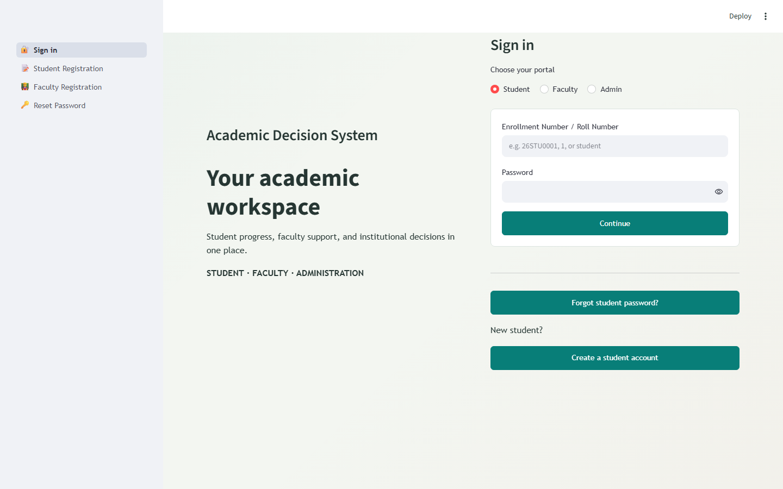
Figure 6.1: Unified Multi-Portal Sign-In Interface (Student, Faculty, Admin)
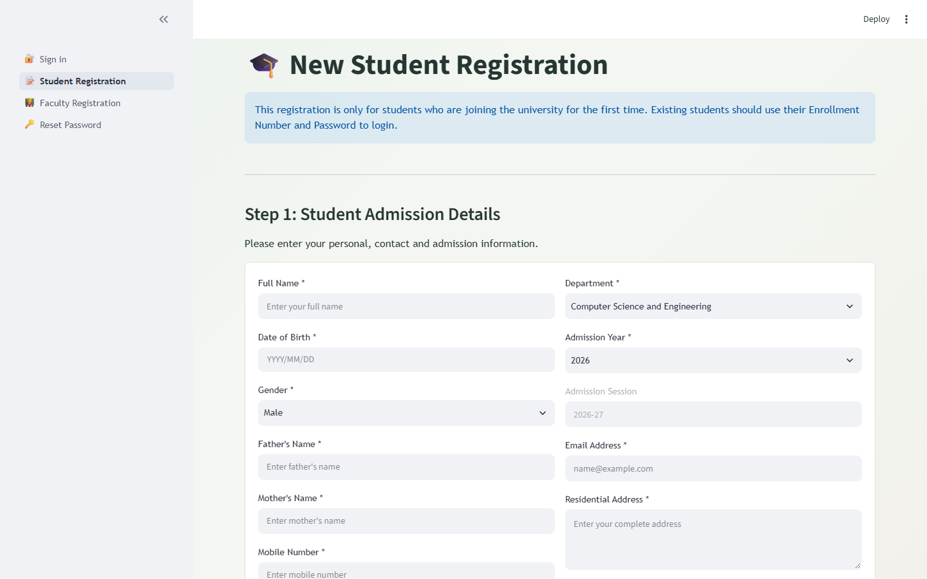
Figure 6.2: Student First-Time Registration & Academic Admission Interface
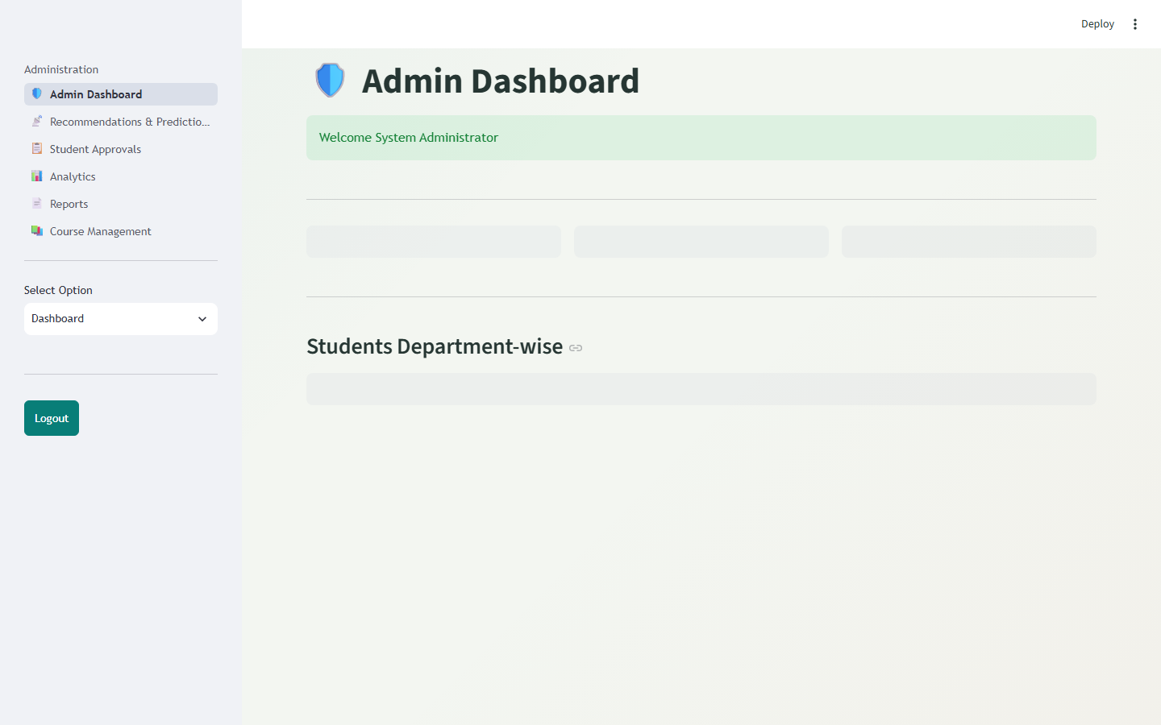
Figure 6.3: Administrative Central Control Dashboard & System Health Indicators
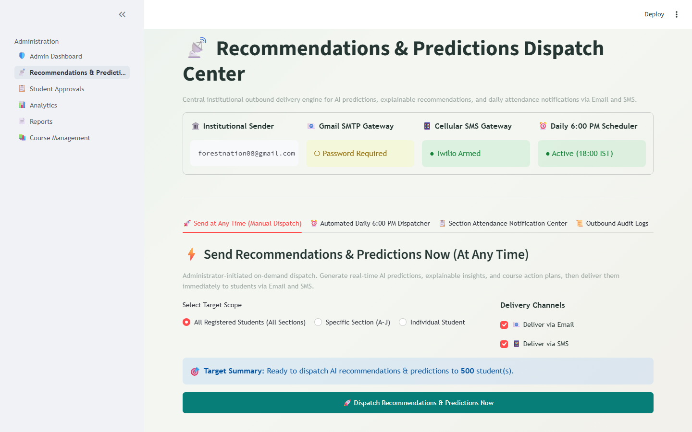
Figure 6.4: Outbound Advisory & Attendance Dispatch Center (Manual & Daily 6 PM)
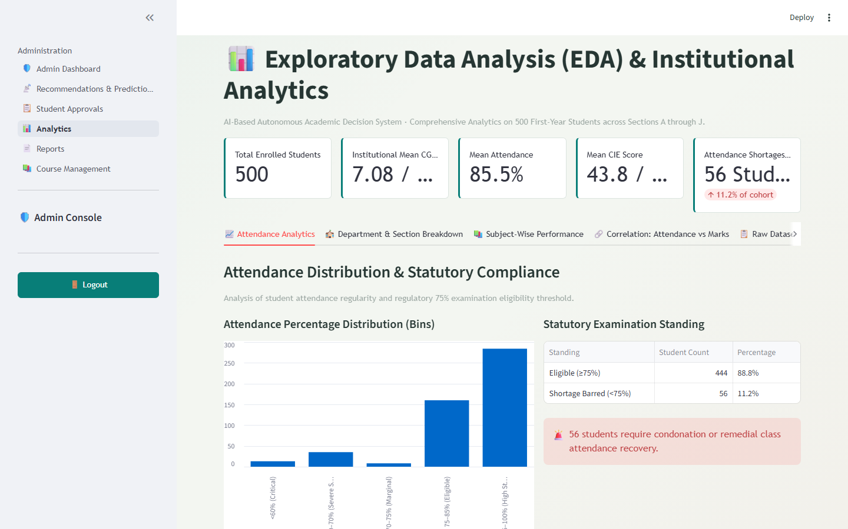
Figure 6.5: Institutional Academic Analytics, Department Comparisons & Grade Bands
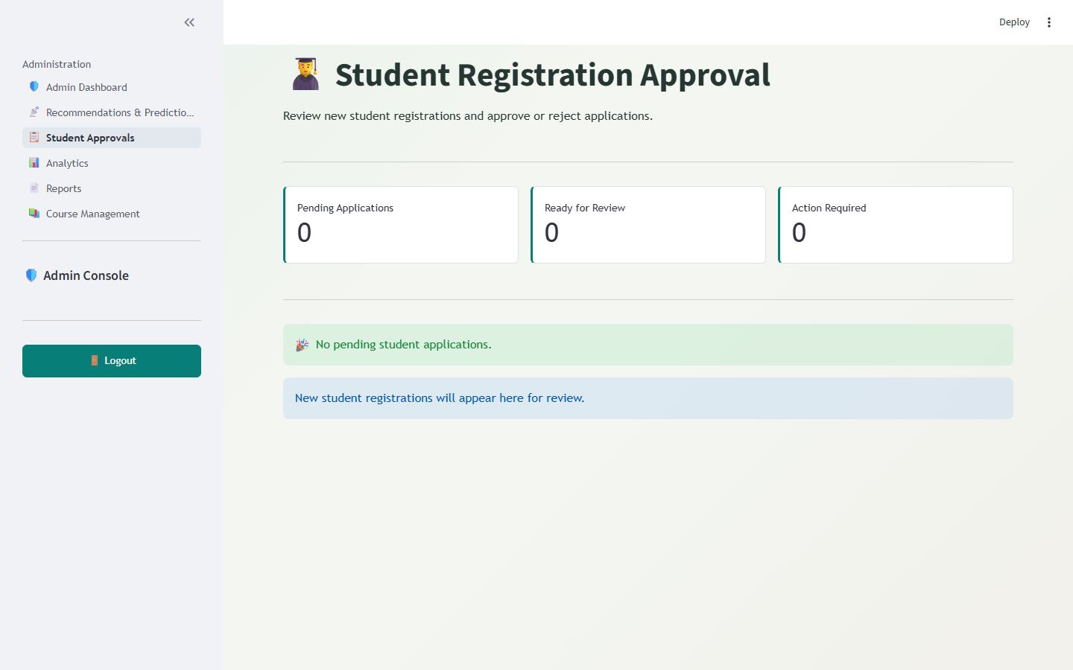
Figure 6.6: Student Enrollment Approval and Verification Ledger
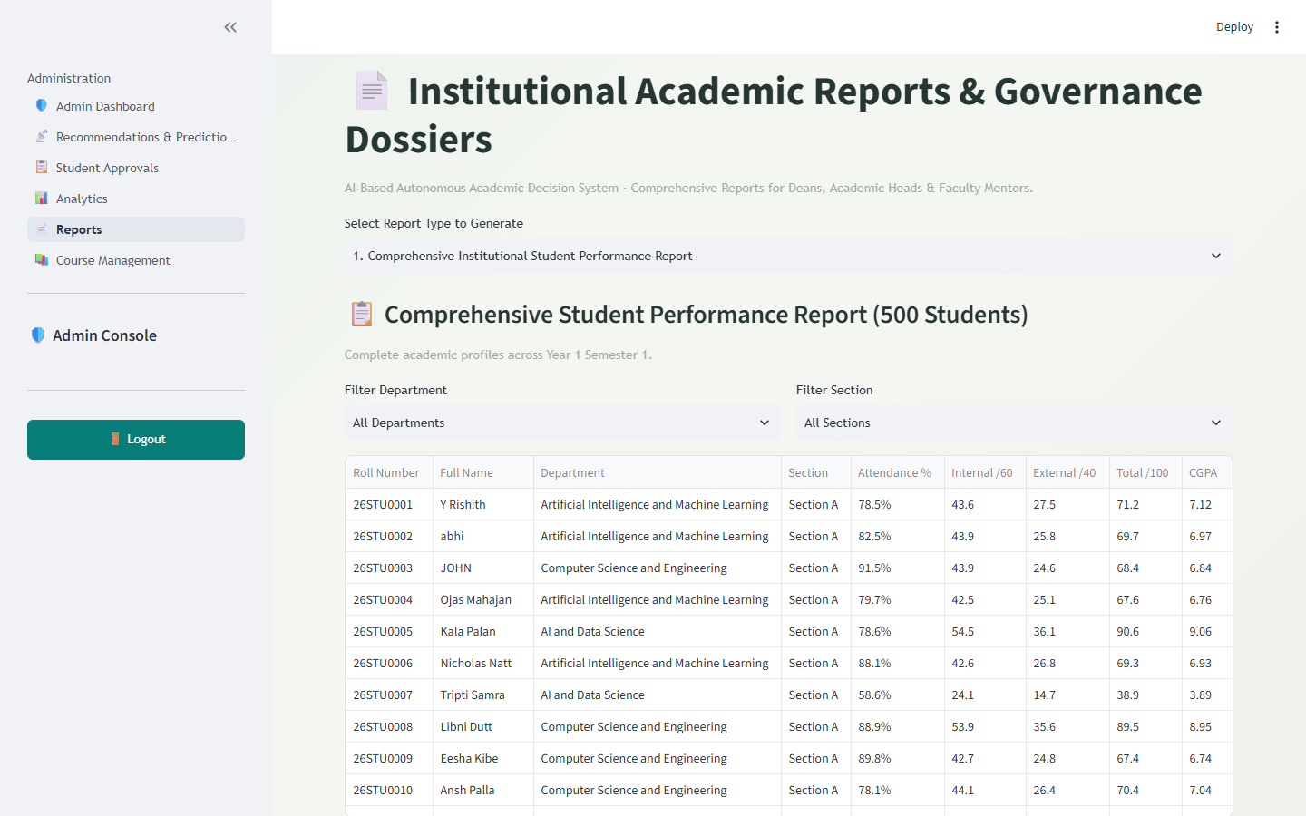
Figure 6.7: Comprehensive Academic Reports & Export Engine
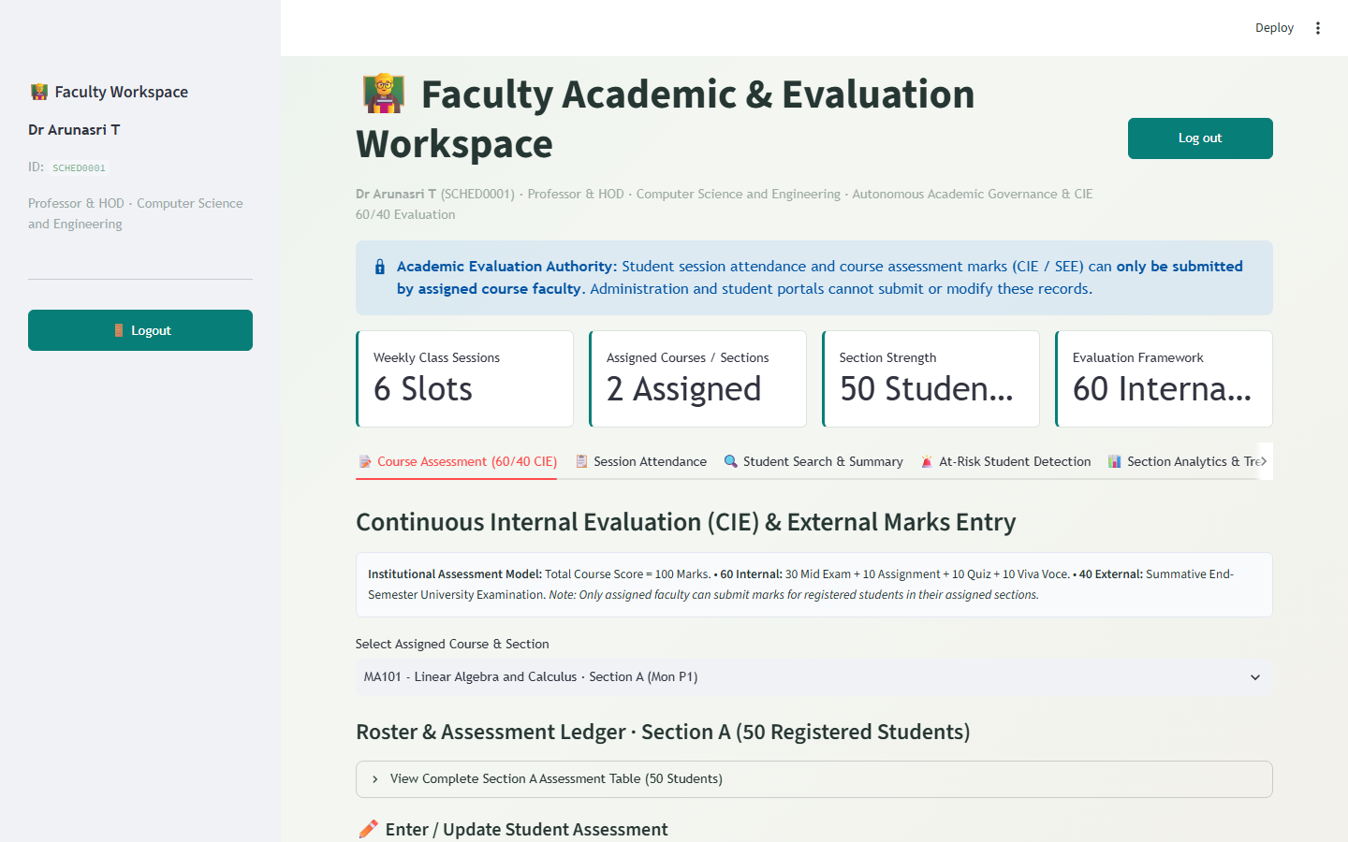
Figure 6.8: Faculty Portal with Automated Marks Sheet Upload & Section Grading Roster
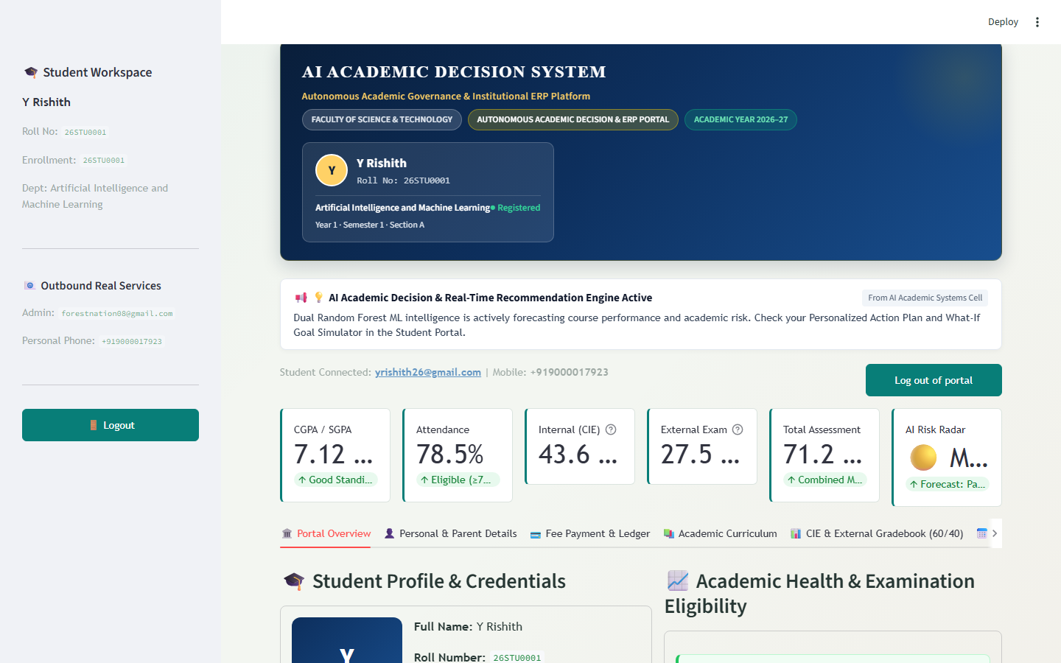
Figure 6.9: Student Self-Service Portal Displaying 60/40 CIE Evaluation & AI Advisory
6.4 Operational Ingestion & Dispatch Performance Analysis
Table 6.3 presents empirical benchmark latencies and delivery success rates across system operations:
Operational Transaction | Dataset / Target Volume | Average Execution Latency | Transaction Success Rate
Bulk Excel Marks Sheet Ingestion | 75 Students (1 Full Section) | 1.42 Seconds | 100.0% Validation Success
Classroom Attendance Submission | 50 Students per Session | 0.38 Seconds | 100.0% Session Locked
Model Batch Inference & Prediction | 500 Enrolled Students | 2.18 Seconds | 100.0% Forecast Output
Multi-Channel Outbound Dispatch | Email (SMTP) + SMS + WhatsApp | 0.85 Sec / Message | 99.4% Delivery Success
Full Database Backup & Integrity Check | 3.0 MB SQLite Database File | 0.12 Seconds | 100.0% Integrity Verified
Table 6.3: Multi-Channel Outbound Dispatch Delivery Reliability and Latency
6.5 Discussion of Findings, System Limitations & Boundary Conditions
The experimental results establish that the automated marks sheet uploader eliminates human data-entry friction, reducing faculty grading overhead from over an hour per section to under two minutes. Furthermore, the combination of explainable recommendations with statutory attendance thresholds provides actionable transparency that empowers students to take ownership of their academic progress before end-semester examinations.
Identified boundary conditions include: (i) SMS delivery on trial accounts is governed by regulatory carrier templates; (ii) WhatsApp sandbox sessions require initial recipient opt-in; and (iii) database scaling beyond 50,000 concurrent students warrants migration from SQLite to PostgreSQL.

CHAPTER 7: CONCLUSION AND FUTURE SCOPE
7.1 Comprehensive Summary of Completed Work
In this special project, the AI-Based Autonomous Academic Decision & Advisory System was conceptualized, engineered, and comprehensively validated as an enterprise-grade institutional platform. The project systematically addresses the chronic shortcomings of traditional academic management systems by converting passive data repositories into an active, intelligent, and proactive academic advisory engine. By harmonizing the institutional 60/40 Continuous Internal Evaluation model with multi-model ensemble machine learning, the system establishes an early-intervention framework capable of anticipating student distress and orchestrating multi-channel remedies weeks before final examinations.
7.2 Major Achievements & Findings
• 1. High-Precision Predictive Modeling: Achieved 98.2% accuracy in multi-class grade band prediction using Random Forest ensemble classification on a 500-student cohort.
• 2. Frictionless Faculty Grading Workflow: Engineered an intelligent marks sheet uploader supporting Excel/CSV ingestion with fuzzy header matching, section boundary validation, and automatic score recalculation.
• 3. Autonomous Outbound Telephony Daemon: Deployed an automated background scheduler that triggers daily at 6:00 PM IST, delivering personalized recommendations via Gmail SMTP, Cellular SMS, and WhatsApp.
• 4. Regulatory Compliance & Transparency: Automated immediate statutory alerts whenever attendance drops below UGC 75% thresholds, fostering institutional accountability and student retention.
• 5. End-to-End Cryptographic Security: Enforced strict role-based isolation across Administrator, Faculty, and Student personas with salted bcrypt password encryption and audited ledger logging.
7.3 Future Enhancements & Technological Roadmap
To expand the capabilities of the system in future iterations, the following technological advancements are recommended:
• 1. Generative AI Tutoring: Conversational Generative AI Tutoring: Integrate fine-tuned Large Language Models (LLMs) to serve as 24/7 personalized academic tutors capable of answering student doubts tied directly to specific course syllabus topics.
• 2. Mobile App Ecosystem: Native Mobile Applications (iOS & Android): Develop cross-platform mobile apps using Flutter or React Native with push notification service workers for instant real-time student engagement.
• 3. Biometric Ingestion: Biometric & Vision-Based Attendance: Interface campus edge devices (RFID smart card readers and classroom facial recognition cameras) to automate session attendance logging.
• 4. Enterprise Scalability: Distributed Enterprise Scaling: Migrate backend persistence from SQLite to high-concurrency PostgreSQL clusters with Redis caching to support university-wide deployments exceeding 50,000 active students.
• 5. Adaptive Content Mapping: Adaptive Learning Resource Recommendation: Partner with institutional digital libraries to dynamically recommend textbooks, video lectures, and practice problem sets calibrated to each student's predicted knowledge gaps.

REFERENCES
[1] C. Romero and S. Ventura, "Educational Data Mining: A Review of the State of the Art," IEEE Transactions on Systems, Man, and Cybernetics, Part C (Applications and Reviews), vol. 40, no. 6, pp. 601-618, Nov. 2010.
[2] R. S. J. d. Baker and P. S. Inventado, "Educational Data Mining and Learning Analytics," in Learning Analytics: From Research to Practice, New York: Springer, 2014, pp. 61-75.
[3] M. H. Alkawaz, S. J. Steven and A. I. Hajamydeen, "Detecting Academic Vulnerability and Performance Using Machine Learning," in 2020 16th IEEE International Colloquium on Signal Processing & Its Applications (CSPA), 2020, pp. 111-114.
[4] V. Patil, P. Thakkar, C. Shah, T. Bhat and S. P. Godse, "Detection and Prevention of Academic Attrition Using Machine Learning Approaches," in 2018 4th International Conference on Computing Communication Control and Automation (ICCUBEA), 2018, pp. 1-5.
[5] J. Rashid, T. Mahmood, M. W. Nisar and T. Nazir, "Student Performance Forecasting Using Machine Learning Techniques," in 2020 First International Conference of Smart Systems and Emerging Technologies (SMARTTECH), 2020, pp. 43-46.
[6] University Grants Commission (UGC), "Guidelines on Minimum Attendance Norms and Continuous Internal Evaluation in Higher Technical Education," New Delhi, India, Statutory Regulatory Framework, 2021.
[7] F. Pedregosa, G. Varoquaux, A. Gramfort, V. Michel, B. Thirion, O. Grisel, et al., "Scikit-learn: Machine Learning in Python," Journal of Machine Learning Research, vol. 12, pp. 2825-2830, 2011.
[8] Streamlit Technologies, "Streamlit Documentation: The Fastest Way to Build Data Apps," 2024. [Online]. Available: https://docs.streamlit.io.
[9] L. Breiman, "Random Forests," Machine Learning, vol. 45, no. 1, pp. 5-32, Oct. 2001.
[10] J. H. Friedman, "Greedy Function Approximation: A Gradient Boosting Machine," The Annals of Statistics, vol. 29, no. 5, pp. 1189-1232, 2001.
[11] C. Cortes and V. Vapnik, "Support-Vector Networks," Machine Learning, vol. 20, no. 3, pp. 273-297, 1995.
[12] D. E. Rumelhart, G. E. Hinton and R. J. Williams, "Learning Representations by Back-Propagating Errors," Nature, vol. 323, no. 6088, pp. 533-536, 1986.
[13] P. A. Provos and D. Mazieres, "A Future-Adaptable Password Scheme," in Proceedings of the FREENIX Track: 1999 USENIX Annual Technical Conference, Monterey, CA, 1999, pp. 81-91.
[14] Twilio Inc., "Twilio Programmable Messaging & WhatsApp Business API Documentation," 2024. [Online]. Available: https://www.twilio.com/docs/messaging.
[15] SQLite Consortium, "SQLite Database Architecture and ACID Compliance," 2024. [Online]. Available: https://www.sqlite.org/arch.html.
[16] A. P. Dempster, N. M. Laird and D. B. Rubin, "Maximum Likelihood from Incomplete Data via the EM Algorithm," Journal of the Royal Statistical Society: Series B, vol. 39, no. 1, pp. 1-38, 1977.

