**REPORT**

**Selected feature**

C:\Users\dell.DESKTOP-5VND8PJ\Desktop\Semester 6\ELL 409\Assignments\Assignment2\Final\Lab_Test\feature11.JPGTrain Accuracy on whole data set

C:\Users\dell.DESKTOP-5VND8PJ\Desktop\Semester 6\ELL 409\Assignments\Assignment2\Final\Lab_Test\train.JPG

Train Accuracy on selected Dataset

C:\Users\dell.DESKTOP-5VND8PJ\Desktop\Semester 6\ELL 409\Assignments\Assignment2\Final\Lab_Test\selected.JPG

Plot

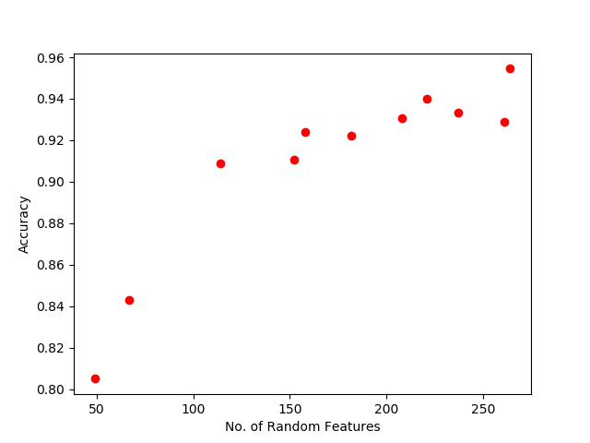The highest accuracy is of the selected feature

SVM

C:\Users\dell.DESKTOP-5VND8PJ\Desktop\Semester 6\ELL 409\Assignments\Assignment2\Final\Lab_Test\svm.JPG

The train accuracy turned out to be one for both selected and whole

