Problem statement:

AtliQo is one of the leading telecom providers in India and launched its 5G plans in May 2022 along with other telecom providers.

However, the management noticed a decline in their active users and revenue growth post 5G launch in May 2022. AtliQo’s business director requested their analytics team to provide a comparison report of KPIs between pre and post-periods of the 5G launch. The management is keen to compare the performance between these periods and get insights that would enable them to make informed decisions to recover their active user rate and other key metrics. They also wonder if they can optimize their internet plans to get more active users.

Data cleaning:

In the given data set the “date” column was in object datatype which was converted to date-time format.

Insights :

* The total revenue generated in crores is 3187.36
* The average revenue generated in crores is 26.56
* The average revenue per user is 200.74
* The total number of active users is 1617.23 Lakhs
* The average active users in lakhs per month is

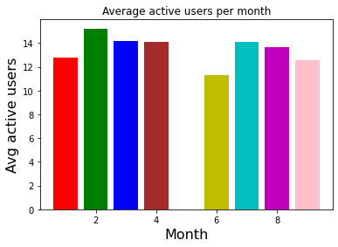

* The total number of unsubscribed users is 125.9 Lakhs
* The average market share captured by atliqo is 19.56%
* The market share captured by all the companies is

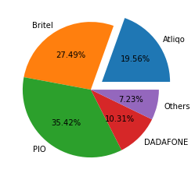

* The total revenue for all periods before the 5G implementation by atliqo is

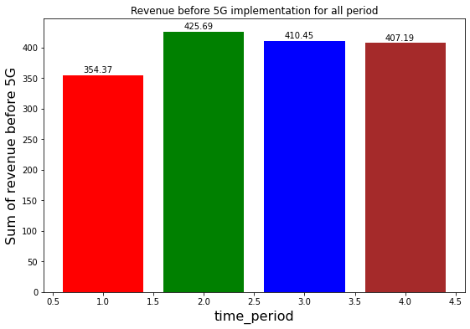

* The revenue reached the most during time period 2
* The total revenue for all periods after 5G implementation is

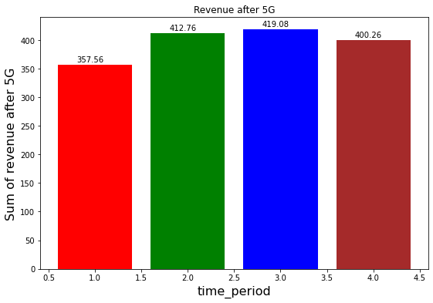

* The sum of arpu before 5G implementation for each time period is,

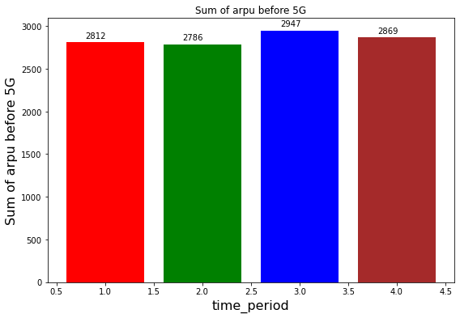

* The sum of arpu after 5G implementation for each time period is,

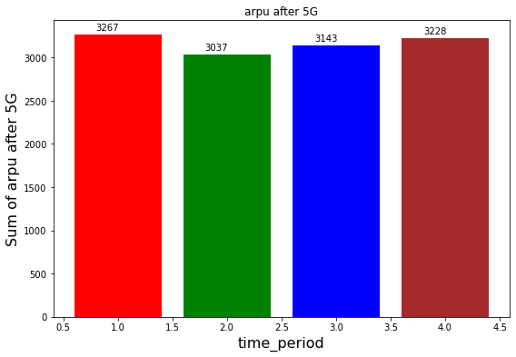

* Total active users in lakhs before 5G implementation is,

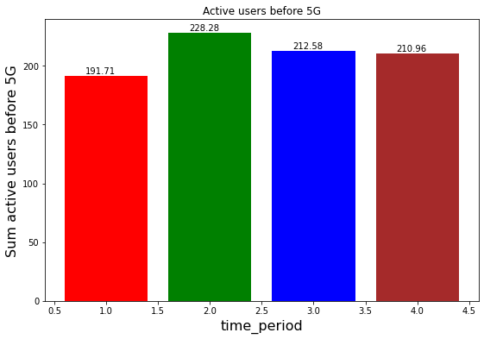

Total active users in lakhs after 5G implementation is,

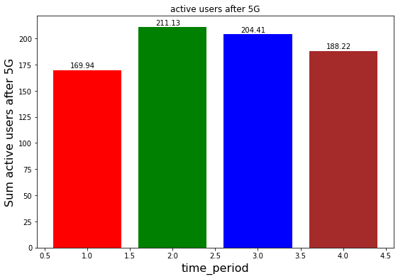

* Unsubscribed users in lakhs before 5G implementation is,

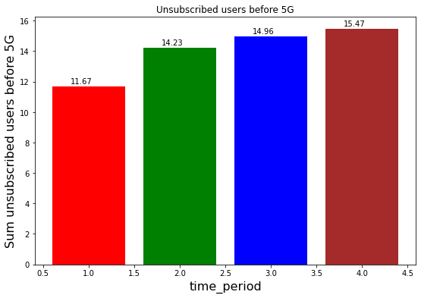

* Unsubscribed users in lakhs after 5G implementation is,

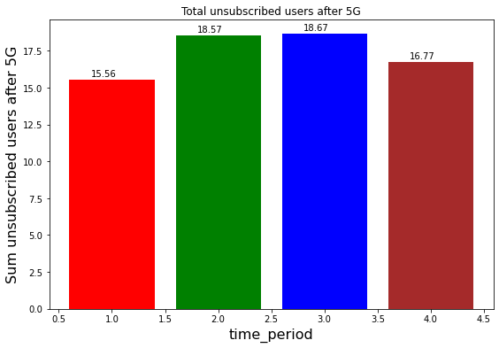

Recommendations and Summary:

* The total revenue generated for both before 5G and after 5G implementation is low during time period 1,hence that period must be given attention to increase revenue.
* Atliqo has captured the 3rd spot compared to other companies, now its next target will be to compete with the 2nd highest market-capturing company britel.
* Time period 2,3,4 is the period where atliqo has good amount of active users and revenue.
* After 5G implementation the price for the service has been increased by nearly 11%,this increase has made users to reduce their usage on the service.
* There is a drop in active users by 9% hence customers to be made aware of new service and plans.
* 23% of users have unsubscribed after 5G implementation hence the prices of the plans must be revised to attract more customers.