
Dashboard Design

Date | 2 November 2026
Team ID | [NEEDS INPUT: Team ID]
Project Name | Health360: Comprehensive Healthcare Risk & Disease Analysis
Maximum Marks | 5 Marks

Activity 1: Interactive and visually appealing dashboards
Creating an effective Streamlit dashboard involves presenting business data stored in Snowflake through clear, interactive, and easy-to-understand visualizations. Students should design the dashboard so that users can quickly understand important KPIs, trends, comparisons, and business insights.
- Clear and Intuitive Layout
- Use Appropriate Visualizations
- Colour and Theming
- Interactive Filters and Slicers
- Drill-Down Capabilities
- Responsive Design
- Custom Visuals and Icons
- Use of Infographics

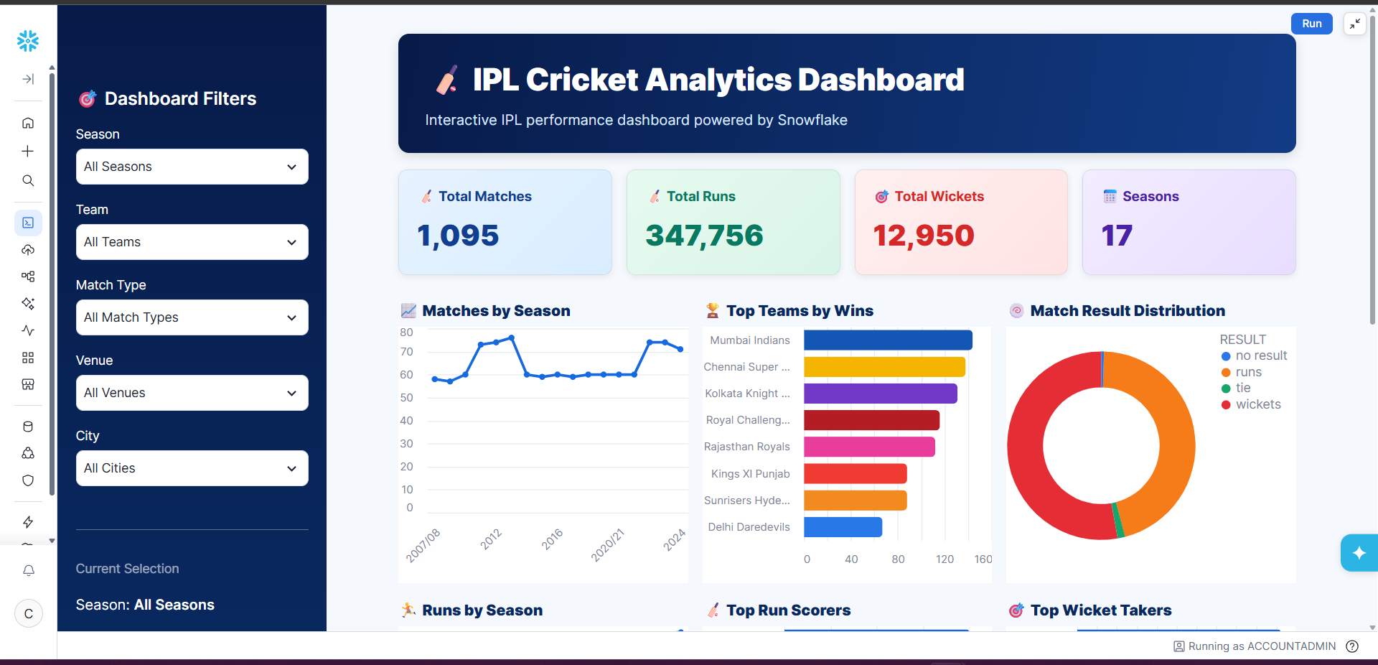
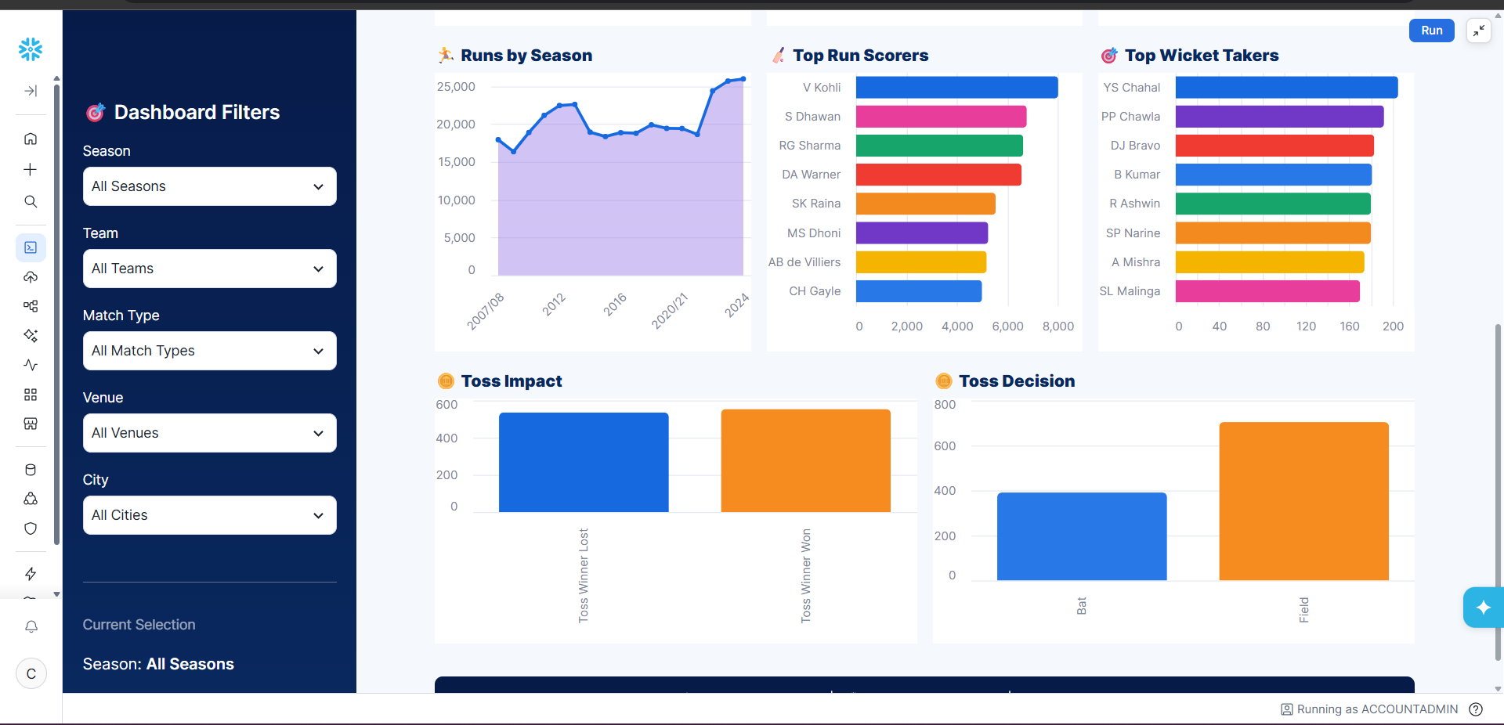
Note: Highlight the major outcomes in form of bullet points
Sample:
Here are five potential outcomes from the dashboard image provided:
- Mumbai Indians emerge as the strongest team by wins
Mumbai Indians are shown at the top of the Top Teams by Wins chart, indicating consistently strong performance across IPL seasons.
- Batting performance is dominated by a few key players
V. Kohli leads the Top Run Scorers chart, followed by players such as S. Dhawan, RG Sharma, and DA Warner. This highlights the importance of high-performing batsmen.
- Wicket-taking performance is concentrated among leading bowlers
YS Chahal ranks highest in the Top Wicket Takers chart, followed by PP Chawla and DJ Bravo, indicating that a relatively small group of bowlers has contributed significantly to wicket-taking.
- Fielding/toss decisions appear to have an impact on match outcomes
The Toss Impact and Toss Decision charts show differences between winning after winning the toss and choosing to bat vs. field. This can be used to investigate whether the toss provides a meaningful advantage.
- IPL match activity and scoring have grown over the seasons
The Matches by Season and Runs by Season charts show variation and an overall increase in IPL activity and run production across seasons, with particularly high run totals in later seasons.
Overall outcome: The dashboard suggests that IPL success is influenced by a combination of strong teams, elite batting and bowling performers, match/toss decisions, and changing scoring patterns across seasons.

Dashboard Design
Dashboard 1 contains nine visualizations. The supplied captures show a single-page arrangement with age distribution, disease-by-gender comparisons, lifestyle shares, exercise-level counts, heart disease by age group, and gender averages for cholesterol and glucose.
- The packaged workbook contains 9 worksheets, 1 dashboard (Dashboard 1), and a 9-point Tableau Story (Story 1).
- The age distribution and grouped gender charts indicate 5,000 patient records overall.
- Heart disease by gender: female category counts 762 and 1,744 (total 2,506); male category counts 737 and 1,757 (total 2,494). The screenshot does not expose the category legend, so the 0/1-to-colour mapping is not asserted here.
- Diabetes by gender: female category counts 887 and 1,619 (total 2,506); male category counts 859 and 1,635 (total 2,494). The screenshot does not expose the category legend, so the 0/1-to-colour mapping is not asserted here.
- Lifestyle distribution charts show smoking categories at 50.760% and 49.240%; alcohol categories at 50.140% and 49.860%. Category-to-colour mapping is not legible in the supplied screenshot.
- Exercise-level counts are category 0: 1,647; category 1: 1,677; category 2: 1,676 (total 5,000). Meaning of numeric codes was not supplied.
- Average cholesterol: Female 224.5108; Male 224.7225. Average glucose: Female 135.172; Male 133.820.
- Age-bin count labels visible on the dashboard are: 20:405, 25:309, 30:383, 35:301, 40:414, 45:326, 50:398, 55:352, 60:308, 65:213, 70:383, 75:317, 80:353. Heart-disease-by-age chart additionally shows visible segment labels 166, 251, 213, 80, and 383 in selected bins; full category mapping is not clear from the static image.
Design observations: the dashboard uses blue/teal categories, labels, and a multi-view layout. The supplied screenshots do not show filter controls; filter behavior, responsive behavior, accessibility, and drill-down were not verified. Consider adding explicit legends and definitions for binary/ordinal codes. The worksheet title “Cholestrol” appears misspelled in the workbook.
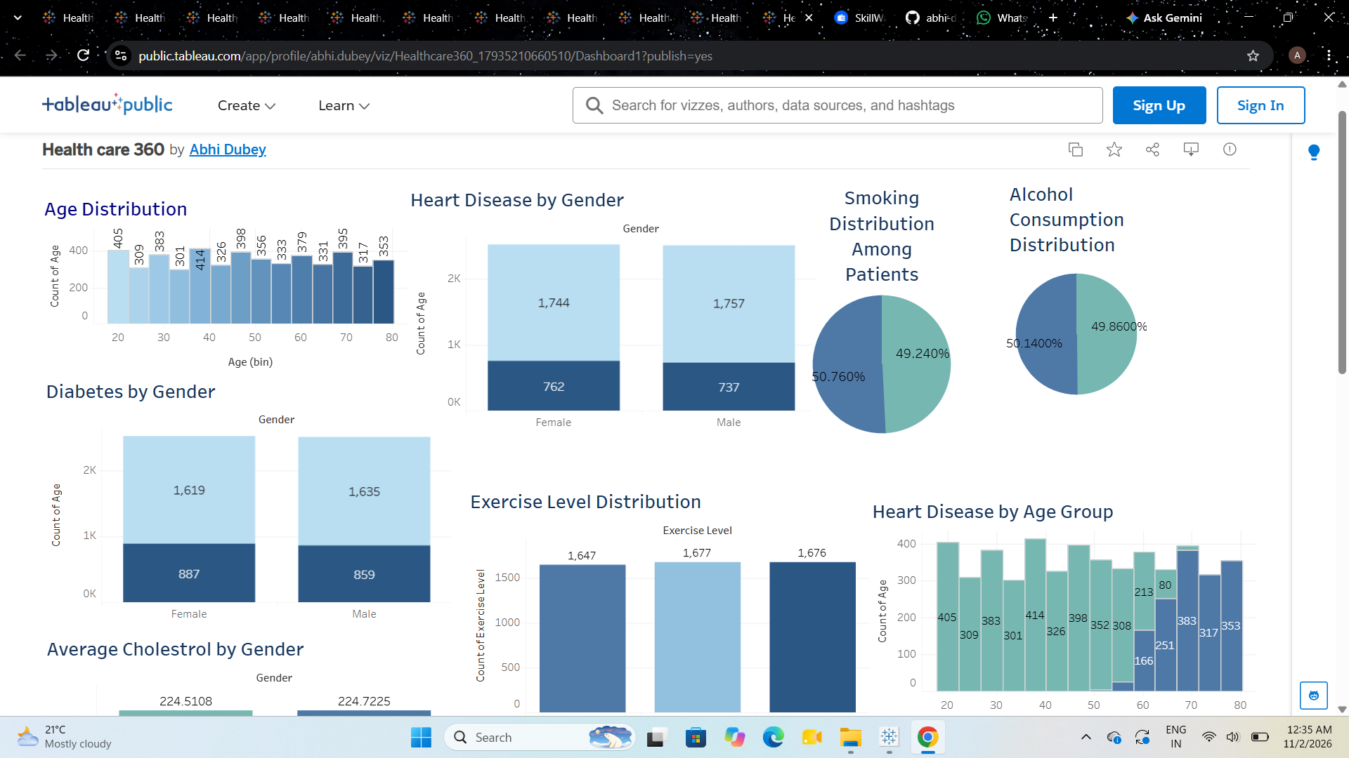
Dashboard evidence supplied by project owner.
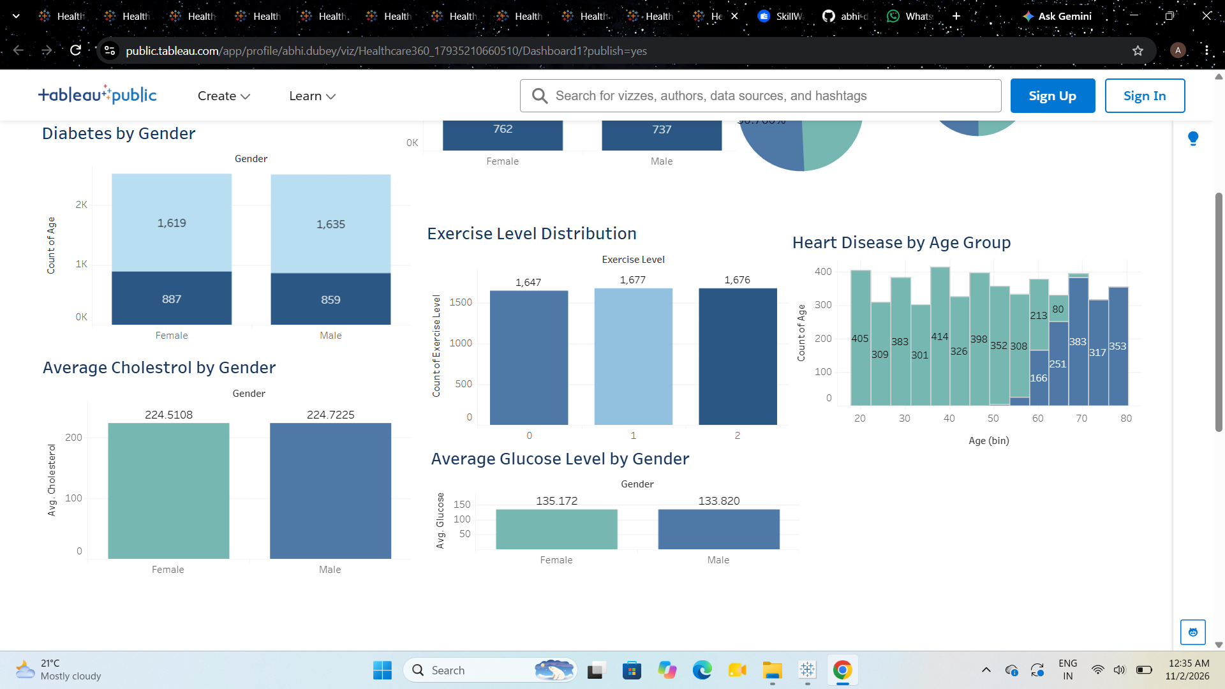
Dashboard evidence supplied by project owner.
Tableau Public view shown in supplied screenshot: https://public.tableau.com/app/profile/abhi.dubey/viz/Healthcare360_17935210660510/Dashboard1?publish=yes

