# DATABASE MANAGEMENT SYSTEMS (CO202)

LAB RECORD

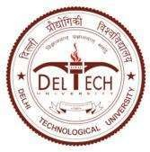

DELHI TECHNOLOGICAL UNIVERSITY

Formerly Delhi College of Engineering (Under Delhi Act 6 of 2009, Govt. of NCT of Delhi)

Submitted to: Mr. Nishant Singh Submitted by: Amandeep Singh (2K20/EE/31)