E-R Diagram

Register

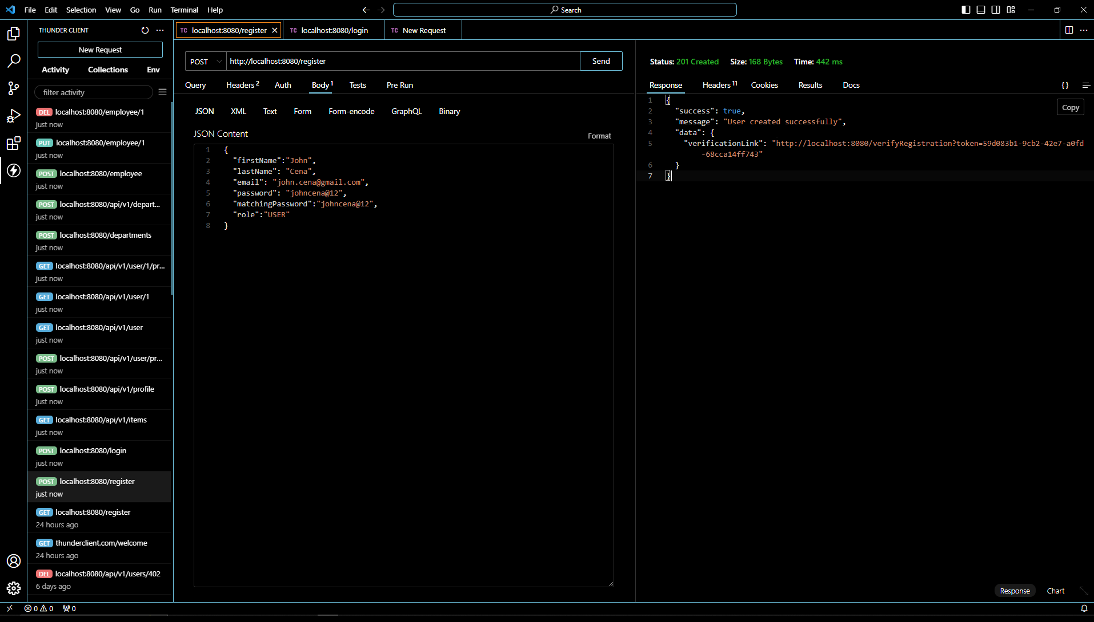

Login

Department Table(POST)

Department Table(GET)

Department Table(PUT)

Department Table(DELETE)

Employee Table(POST)

Employee Table(GET)

Employee Table(PUT)

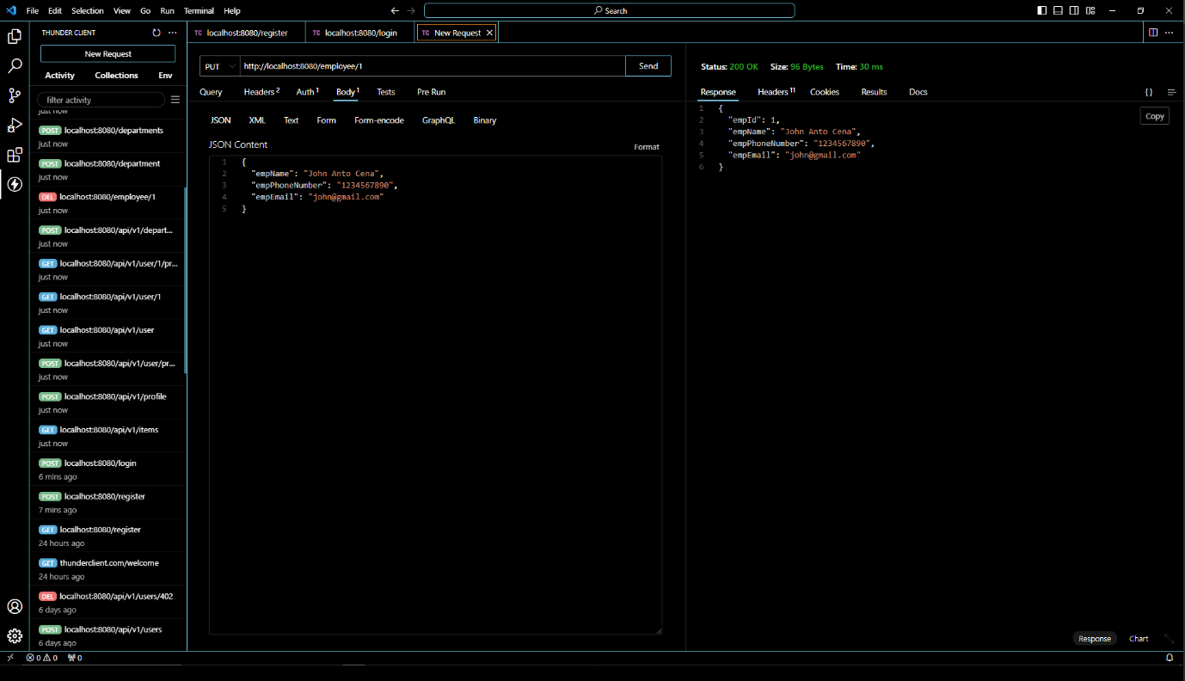

Employee Table(DELETE)

Workbench Showing POST End Point Employee Table

Workbench Showing PUT End Point Employee Table

