Subject Code | : | CEUE203 | Semester | : | 3 | Academic Year | : | 2026-27
Subject Name | : | Object-Oriented Programming

PROGRAM 1(class and object)
PROGRAM 1.1 | Vending machine (VendingMachine.java, main in this file)  (a) Define an enum Coin with constants ONE, TWO, FIVE, TEN.  (b) In main, set a snack price of 15 and a running total of 0; create a Scanner.  (c) Loop: read a coin name, use a switch expression to convert the Coin to its value  (ONE→1, TWO→2, FIVE→5, TEN→10), add it to the total, and print the total so  far.  (d) Stop the loop once the total reaches 15 or more.  (e) Print the change to return (total − 15).  Expected output: TEN then FIVE prints “Paid. Change: 0”; TEN then TEN prints  “Paid. Change: 5”
CODE | import java.util.Scanner;  enum coin  {  ONE,  TWO,  FIVE,  TEN  }  public class VendingMachine  {  public static void main(String arg[])  {  int sn=15,total=0;  Scanner sc =new Scanner(System.in);  while(sn>0) {  System.out.print("Insert Coin(ONE,TWO,FIVE,TEN) :");  String a =sc.next().toUpperCase();  coin d=coin.valueOf(a);  int r =switch(d)  {  case ONE-> 1;  case TWO -> 2;  case FIVE -> 5;  case TEN -> 10;  default -> 0;  };  total=total+r;  System.out.println("Insert so far : "+ total);  sn=sn-r;  }  sn=sn*(-1);  System.out.print("Paid charge : "+ sn);  sc.close();  }  }
OUTPUT | 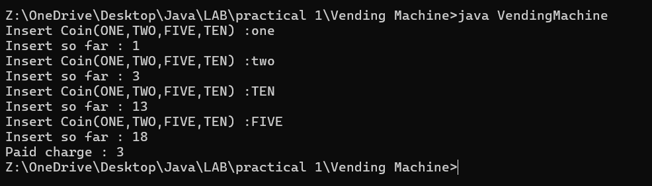
PACTICAL 1.2 | Toll booth (TollBooth.java, main in this file)  (a) Define a record Vehicle(String number, String type).  (b) In main, keep a running toll total and three counters (bike, car, truck).  (c) Loop until the user types “done” for the number: build a Vehicle, use a switch  expression on its type for the toll (bike→20, car→50, truck→150), add to the total,  and increment that type’s counter.  (d) After the loop, print the total toll and the type with the highest count.  Expected output: two cars + one bike → “Total toll: 120”, “Most frequent: car”
CODE | import java.util.Scanner;  record vehical(String no, String type) {  };  public class TollBooth {  public static void main(String []arg)  {  int max=0,c=0;  String m=null;  Scanner sc = new Scanner(System.in);  Scanner v = new Scanner(System.in);  while(true)  {  System.out.println("Enter no of vehicals or done:");  String s = v.next().toUpperCase();  if(s.equals("DONE"))  {  break;  }  System.out.println("Enter Type of vehical (car,truck,bike) :");  String a = sc.next().toUpperCase();  vehical ve = new vehical(s, a);  if (max < Integer.parseInt(ve.no())) {  m = ve.type();  max =Integer.parseInt(ve.no());  }  int r = switch (ve.type()) {  case "CAR" -> 50;  case "TRUCK" -> 150;  case "BIKE" -> 20;  default -> 0;  };  c = c + (r*Integer.parseInt(ve.no()));  v.toString();  System.out.println("Pays " + r);  }  System.out.println("Total toll : " + c);  System.out.println("Most frequent : " + m);  sc.close();  v.close();  }  }
OUTPUT | 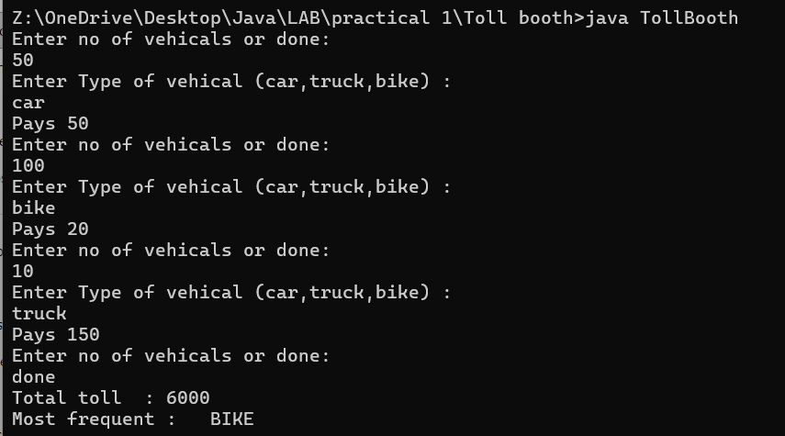
PROGRAM 1.3 | (For Advanced Learners – home) Rock-Paper-Scissors-Lizard-Spock (RPSLS.java)  (a) Define an enum Move with ROCK, PAPER, SCISSORS, LIZARD, SPOCK.  (b) Write winner(Move a, Move b) returning 1 if a beats b, -1 if b beats a, 0 for a tie —  use a switch expression listing what each move beats (Scissors cut Paper, Paper  covers Rock, Rock crushes Lizard, Lizard poisons Spock, Spock smashes Scissors,  and the five mirror cases).  (c) In main, play 5 rounds: pick a random computer Move, read the player’s Move, call  winner(), print the round result and keep score.  (d) After 5 rounds, print the overall winner.  Expected output: each round prints both moves and the round winner; ends with a  “You win 3–2” summary.
CODE | import java.util.Random;  import java.util.Scanner;  enum Move {  ROCK, PAPER, SCISSORS, LIZARD, SPOCK  }  public class RPSLS{  static int winner(Move a, Move b) {  if (a == b) {  return 0;  }  boolean ab = switch (a) {  case SCISSORS -> (b == Move.PAPER || b == Move.LIZARD);  case PAPER -> (b == Move.ROCK || b == Move.SPOCK);  case ROCK -> (b == Move.LIZARD || b == Move.SCISSORS);  case LIZARD -> (b == Move.SPOCK || b == Move.PAPER);  case SPOCK -> (b == Move.SCISSORS || b == Move.ROCK);  };  if(ab==true)  {  return 1;  }  else  {  return -1;  }  }  public static void main(String[] args) {  Scanner sc = new Scanner(System.in);  Random r = new Random();  Move[] moves = Move.values();  int ps = 0;  int cs = 0;  System.out.println(" Starting Rock, Paper, Scissors, Lizard, Spock (5 Rounds) ");  for (int i = 1; i <= 5; i++) {  System.out.println("------------");  System.out.println("Round : " + i );  System.out.println("------------");  Move cm = moves[r.nextInt(moves.length)];  Move pm = null;  while (pm == null) {  System.out.print("Enter your move (ROCK, PAPER, SCISSORS, LIZARD, SPOCK): ");  String input = sc.next().toUpperCase();  pm = Move.valueOf(input);  }  int result = winner (pm, cm);  System.out.println("Player: " + pm + " | Computer: " + cm);  if (result == 1) {  System.out.println("Result: You win this round!");  ps++;  } else if (result == -1) {  System.out.println("Result: Computer wins this round!");  cs++;  } else {  System.out.println("Result: It's a tie!");  }  }  System.out.println("\n=================================");  System.out.println("Final Score -> You: " + ps + "& Computer: " + cs);  if (ps > cs) {  System.out.println("You win : " + ps + "-" + cs );  } else if (cs > ps) {  System.out.println("Computer wins " + cs + "-" + ps );  } else {  System.out.println("It's an overall tie " + ps + "-" + cs);  }  System.out.println("\n=================================");  sc.close();  }  }
OUTPUT | 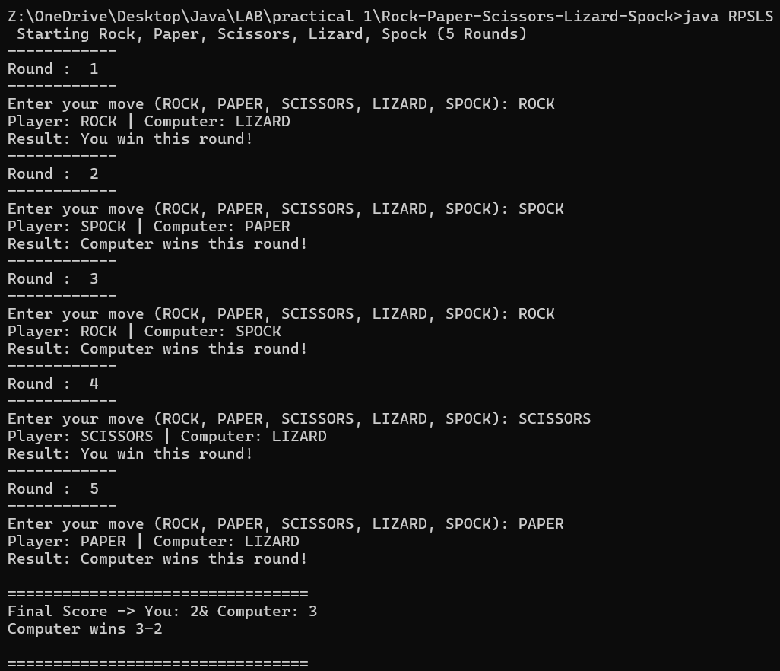
PROGRAM 2
PROGRAM 2.1 | 1. Smart thermostat (Thermostat.java, main in this file)  (a) Create class Thermostat with private String location, private int temperature, private  static final int MIN=16 and MAX=30, and private static int activeCount=0.  (b) Constructor(location, startTemp): store location; set temperature to startTemp if it is  within MIN..MAX else 22; increment activeCount.  (c) Constructor(location): chain with this(location, 22).  (d) raise(): if temperature < MAX add 1, else print “Already at maximum (30)”.  (e) lower(): if temperature > MIN subtract 1, else print “Already at minimum (16)”.  (f) Add getTemperature() (no setter) and static getActiveCount().  (g) In main: create two thermostats, call raise() 10 times then lower() 20 times in loops  (printing the temperature each time), then print getActiveCount().  Expected output: temperature rises to 30 then “Already at maximum”, falls to 16  then “Already at minimum”, count 2.
CODE | public class Thermostat {  private String location;  private int temperature;  private static final int MIN=16 , MAX=30;  private static int activeCount=0;  Thermostat(String location)  {  this(location,22);  }  Thermostat(String location, int startTemp)  {  this.location = location;  if (startTemp >= MIN && startTemp <= MAX) {  this.temperature = startTemp;  } else {  this.temperature = 22;  }  activeCount++;  }  public void raise() {  if (temperature < MAX) {  temperature++;  } else {  System.out.println("Already at maximum (" + MAX + ")");  }  }  public void lower() {  if (temperature > MIN) {  temperature--;  } else {  System.out.println("Already at minimum (" + MAX + ")");  }  }  public int getTemperature() {  return temperature;  }  public static int getActiveCount() {  return activeCount;  }  public static void main(String []args)  {  Thermostat t1 =new Thermostat("Bedroom");  Thermostat t2=new Thermostat("Livingroom",26);  System.out.println("====Raise Temprature 10 times====");  for(int i=1;i<=10;i++)  {  t2.raise();  System.out.println("Temprature : " + t2.getTemperature());  }  System.out.println("====Lower Temprature 20 times====");  for(int i=1;i<=20;i++)  {  t2.lower();  System.out.println("Temprature : " + t2. getTemperature());  }  System.out.println("====Active count ====");  System.out.println("Active count is : " + getActiveCount());  }  }
OUTPUT | 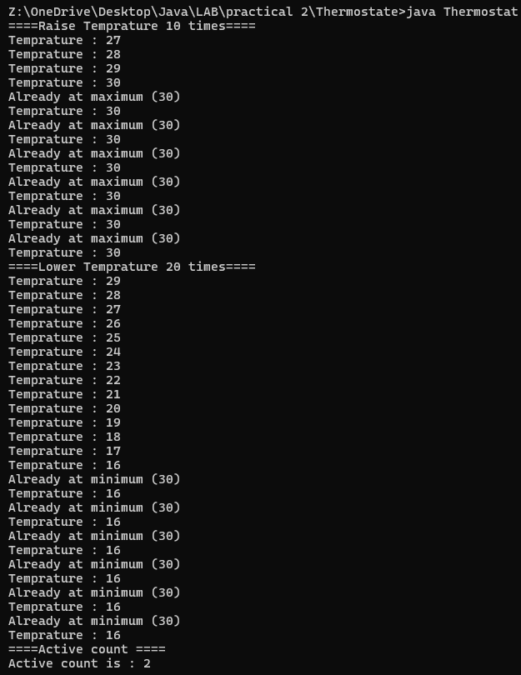
PROGRAM 2.2 | Cinema show (CinemaShow.java, main in this file)  (a) Create class CinemaShow with private String title, private int seatsAvailable, private  final int capacity, and private static int totalBooked=0.  (b) Constructor(title, capacity): set both and seatsAvailable = capacity.  Constructor(title): chain with this(title, 100).  (c) book(int n): if n ≤ seatsAvailable, reduce seatsAvailable by n, add n to totalBooked,  return true; else return false unchanged.  (d) cancel(int n): increase seatsAvailable by n but never above capacity.  (e) Add getSeatsAvailable() and static getTotalBooked().  (f) In main: run a sequence of book and cancel calls, printing the result and seats after  each, then print getTotalBooked().  Expected output: booking more than available prints false and leaves seats  unchanged; totalBooked equals the successful bookings.
import java.util.Scanner;

public class CinemaShow {
private String title;
private int seatsAvailable;
private int capacity;
private static int totalBooked=0;
CinemaShow(String title)
{

this(title,100);
}
CinemaShow(String title,int capacity)
{
this.title=title;
this.seatsAvailable = capacity;

}
public boolean book(int n)
{
if (n <=seatsAvailable)
{
seatsAvailable=seatsAvailable - n;
totalBooked=totalBooked+n;
return true;
}
else{
return false;
}
}
public boolean cancel(int n)
{
if(totalBooked>=n)
{
seatsAvailable=seatsAvailable +n;
totalBooked=totalBooked-n;
return true;
}
else
{
return false;
}

}
int getSeatsAvailable()
{
return seatsAvailable;
}
static int getTotalBooked()
{
return totalBooked;
}
public static void main(String []args)
{
int ch;
CinemaShow c=new CinemaShow("Abcd");
Scanner sc=new Scanner(System.in);
do{System.out.println("Enter 1 For Book ticket ");
System.out.println("Enter 2 For cancel ticket ");
System.out.println("Enter 3 For check total available ticket ");
System.out.println("Enter 4 Exit ");
System.out.print("Enter your choice : ");
ch=sc.nextInt();
switch(ch)
{
case 1:
System.out.print("Total no. of seats you booked : ");
int n=sc.nextInt();
boolean a=c.book(n);
if(a==true)
{
System.out.println("===Ticket is booked successfully====");
}
else
{
System.out.println("===booking more than available false====");
}
System.out.println("Total booked seats : "+getTotalBooked());
System.out.println("Total avilable seats : "+ c.getSeatsAvailable());
System.out.println("==========================================");
break;
case 2:
System.out.print("Total no. of seats you canceled : ");
int x=sc.nextInt();
boolean b=c.cancel(x);
if(b==true)
{
System.out.println("===Ticket is canceled successfully===");
}
else
{
System.out.println("===Cancled more than available false===");
}
System.out.println("Total booked seats : "+ getTotalBooked());
System.out.println("Total avilable seats : "+ c.getSeatsAvailable());
System.out.println("==========================================");
break;
case 3:
System.out.println("===Seat Avilability===");
System.out.println("Total booked seats : "+ getTotalBooked());
System.out.println("Total avilable seats : "+ c.getSeatsAvailable());
System.out.println("==========================================");
break;
case 4:
System.out.println("Thank you for visit ");
break;
}
}while(ch!=4);
sc.close();
}
}

OUTPUT | 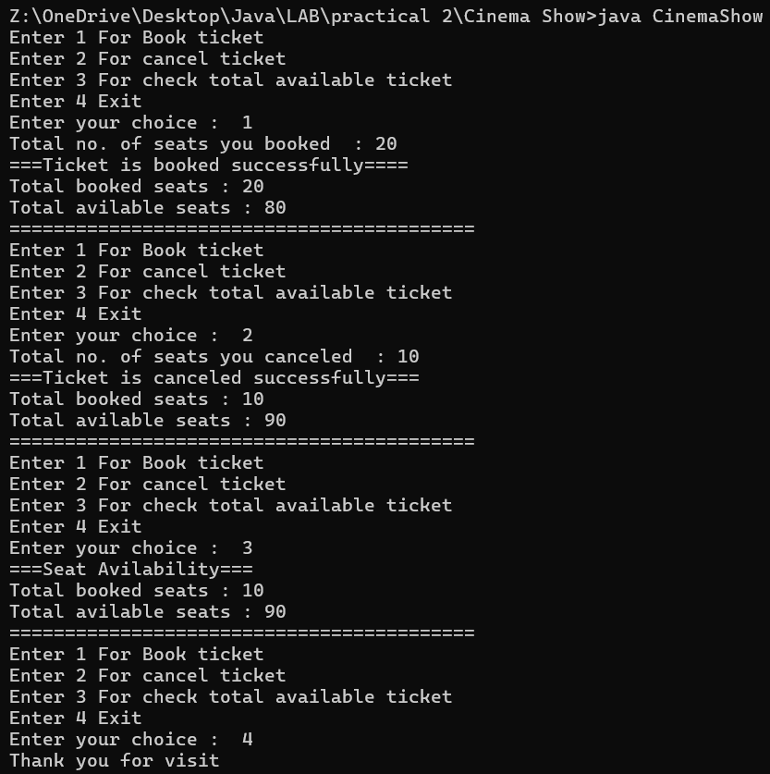
PROGRAM 2.3 | . (For Advanced Learners – home) Parking lot (ParkingLot.java)  (a) Create class ParkingLot with private int twoWheelers and fourWheelers, private final  int twoCap and fourCap, and private static long revenue=0.  (b) park(String type): for “two”, if twoWheelers < twoCap increment and add 20 to  revenue; for “four”, if fourWheelers < fourCap increment and add 40; otherwise print  “Full” and reject.  (c) leave(String type): decrement the matching count but never below 0.  (d) In main: simulate a sequence of park/leave events, printing each outcome, then print  final occupancy and revenue.  Expected output: parking into a full section is refused; revenue = 20×(two parked)  + 40×(four parked)
CODE | import java.util.Scanner;  public class ParkingLot{  private int twoWheelers=0 , fourWheelers=0;  private final int twoCap =5, fourCap=5;  private static long revenue=0;  void park(String type)  {  if(type.equals("TWO"))  {  if (twoWheelers < twoCap)  {  twoWheelers++;  revenue+=20;  }  else{  System.out.println("Two wheeler parking lot is full");  }  }  else if(type.equals("FOUR"))  {  if (fourWheelers < fourCap)  {  fourWheelers++;  revenue+=40;  }  else{  System.out.println("Four wheeler parking lot is full");  }  }  else  {  System.out.println("Enter valid type of vehical");  }  }  void leave(String type)  {  if(type.equals("TWO"))  {  if (twoWheelers !=0)  {  twoWheelers--;  }  else{  System.out.println("No two wheeler inside parking lot");  }  }  else if(type.equals("FOUR"))  {  if (fourWheelers != 0)  {  fourWheelers--;  }  else{  System.out.println("No four wheeler inside parking lot");  }  }  else  {  System.out.println("Enter valid type of vehical");  }  }  static long getRevenue()  {  return revenue;  }  int getTwo()  {  return twoWheelers;  }  int getFour()  {  return fourWheelers;  }  public static void main(String args[])  {  int ch;  ParkingLot p= new ParkingLot();  Scanner sc=new Scanner(System.in);  do{ System.out.println("Enter 1 for park");  System.out.println("Enter 2 for leave");  System.out.println("Enter 3 for final occupancy and revenue");  System.out.println("Enter 4 for exit");  System.out.println("Enter your choice: ");  ch=sc.nextInt();  switch(ch)  {  case 1:  System.out.print("Enter vehical type : (two or four) : ");  String t=sc.next().toUpperCase();  p.park(t);  break;  case 2:  System.out.print("Enter vehical type : (two or four) : ");  String t1=sc.next().toUpperCase();  p.leave(t1);  break;  case 3:  System.out.println("final occupancy and revenue ");  System.out.println("total two wheeler in parking lot : " + p.getTwo() );  System.out.println("total four wheeler in parking lot : "+ p.getFour());  System.out.println(" total revenue is : "+ getRevenue());  case 4:  System.out.println("Thank you for visit ");  break;  }  }while(ch!=4);  sc.close();  }  }
OUTPUT | 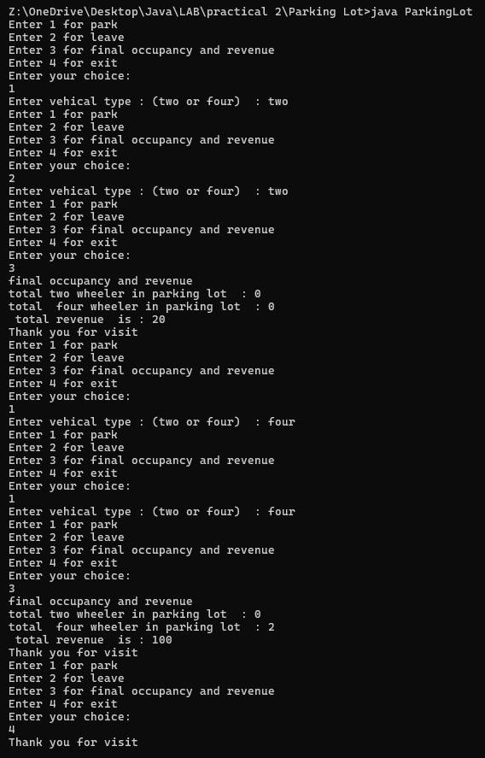
PROGRAM 3
PROGRAM 3.1 | . Distinct points (Point.java + Driver.java with main)  (a) Create class Point with private int x, y and a constructor.  (b) Override toString() to return “(x, y)”.  (c) Override equals(Object) to be true when both x and y match, and hashCode() to agree  (e.g. Objects.hash(x, y)).  (d) In Driver.main: build a Point[] with some repeated coordinates.  (e) Count distinct points: for each point, use equals() to check whether it already  appeared earlier; count those that did not.  (f) Print “Distinct: N”.
CODE | Driver.java  public class Driver {  public static void main(String[] args) {  Point[] points = {  new Point(5, 2),  new Point(3, 4),  new Point(1, 2),  new Point(5, 2),  new Point(3, 4)  };  int distinctCount = 0;  for (int i = 0; i < points.length; i++) {  boolean alreadyAppeared = false;  for (int j = 0; j < i; j++) {  if (points[i].equals(points[j])) {  alreadyAppeared = true;  break;  }  if (!alreadyAppeared) {  distinctCount++;  }  }  System.out.println("Distinct: " + distinctCount);  }  }  }  Point.java  import java.lang.Object;  import java.util.Objects;  public class Point {  private int x;  private int y;  public Point(int x, int y) {  this.x = x;  this.y = y;  }  @Override  public String toString() {  return "(" + x + ", " + y + ")";  }  @Override  public boolean equals(Object o) {  if (this == o) return true;  if (o == null || getClass() != o.getClass()) return false;  Point point = (Point) o;  return x == point.x && y == point.y;  }  @Override  public int hashCode() {  return Objects.hash(x, y);  }  }
OUTPUT | 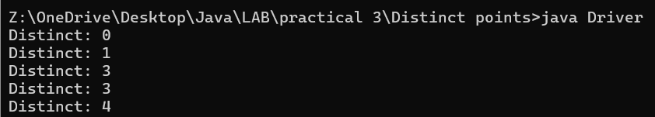
PROGRAM 3.2 | . Duplicate card check (Card.java + Driver.java)  (a) Create class Card with private String rank, suit and a constructor.  (b) Override toString() to return rank + “ of ” + suit (e.g. “Queen of Hearts”).  (c) Override equals()/hashCode() by rank + suit.  (d) In Driver.main: add cards to a Card[] one at a time; before adding each, use equals()  to check it against the earlier cards.  (e) Print “Duplicate found: <card>” the first time a repeat appears.  Expected output: a second “Ace of Spades” → “Duplicate found: Ace of Spades”
CODE | Driver.java  import java.util.Objects;  public class Driver {  public static void main(String[] args) {  Card[] cards = new Card[5];  int count = 0;  Card[] newCards = {  new Card("Ace", "Spades"),  new Card("Queen", "Hearts"),  new Card("Ace", "Spades"),  new Card("10", "Diamonds"),  new Card("Queen", "Hearts")  };  boolean firstDuplicateFound = false;  for (Card nextCard : newCards) {  boolean isDuplicate = false;  for (int i = 0; i < count; i++) {  if (nextCard.equals(cards[i])) {  if (!firstDuplicateFound) {  System.out.println("Duplicate found: " + nextCard);  firstDuplicateFound = true;  }  isDuplicate = true;  break;  }  }  if (!isDuplicate && count < cards.length) {  cards[count] = nextCard;  count++;  }  }  }  }  Card.java  import java.util.Objects;  class Card {  private String rank;  private String suit;  public Card(String rank, String suit) {  this.rank = rank;  this.suit = suit;  }  @Override  public String toString() {  return rank + " of " + suit;  }  @Override  public boolean equals(Object o) {  if (this == o) return true;  if (o == null || getClass() != o.getClass()) return false;  Card card = (Card) o;  return Objects.equals(rank, card.rank) && Objects.equals(suit, card.suit);  }  @Override  public int hashCode() {  return Objects.hash(rank, suit);  }  }
OUTPUT
PROGRAM 3.3 | (For Advanced Learners – home) Fractions (Fraction.java + Driver.java)  (a) Create class Fraction with private int num, den.  (b) In the constructor, reduce to lowest terms: compute g = gcd(num, den) and divide  both by g.  (c) Override toString() to return num + “/” + den.  (d) Override equals()/hashCode() using the reduced num and den.  (e) In Driver.main: create several equivalent fractions (1/2, 2/4, 3/6) and confirm they  are all equal and print the same.  Expected output: new Fraction(2,4) prints “1/2” and equals new Fraction(1,2)
CODE | Driver.java  public class Driver {  public static void main(String[] args) {  Fraction f1 = new Fraction(1, 2);  Fraction f2 = new Fraction(2, 4);  Fraction f3 = new Fraction(3, 6);  System.out.println("f1 (1/2): " + f1);  System.out.println("f2 (2/4): " + f2);  System.out.println("f3 (3/6): " + f3);  System.out.println("f2 equals f1: " + f2.equals(f1));  System.out.println("f3 equals f1: " + f3.equals(f1));  }  }  Function.java  import java.util.Objects;  public class Fraction {  private int num;  private int den;  public Fraction(int num, int den) {  if (den == 0) {  throw new IllegalArgumentException("Denominator cannot be zero.");  }  int g = gcd(num, den);  this.num = num / g;  this.den = den / g;  if (this.den < 0) {  this.num = -this.num;  this.den = -this.den;  }  }  private int gcd(int a, int b) {  a = Math.abs(a);  b = Math.abs(b);  while (b != 0) {  int temp = b;  b = a % b;  a = temp;  }  return a;  }  @Override  public String toString() {  return num + "/" + den;  }  @Override  public boolean equals(Object o) {  if (this == o) return true;  if (o == null || getClass() != o.getClass()) return false;  Fraction fraction = (Fraction) o;  return num == fraction.num && den == fraction.den;  }  @Override  public int hashCode() {  return Objects.hash(num, den);  }  }
OUTPUT | 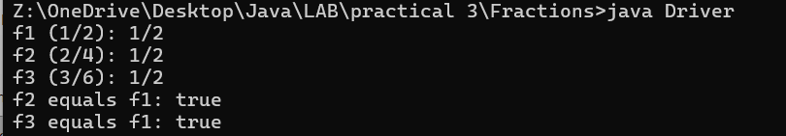
PROGRAM 4
PROGRAM 4.1 | Password strength (PasswordChecker.java + Driver.java)  (a) In PasswordChecker, check four rules — length ≥ 8, contains an uppercase letter,  contains a digit, contains a special character — using regex (e.g. “.*[A-Z].*”) or  String methods.  (b) Write strength(String pw) that counts how many rules pass and returns “Weak” (0–  1), “Medium” (2–3) or “Strong” (4).  (c) In Driver.main: test several passwords; for each, print which rules passed and the  final label.  Expected output: “abc” → Weak; “Abcd1234!” → Strong
CODE | PasswordChecker.java  import java.util.Scanner;  import java.util.regex.Pattern;  import java.util.regex.Matcher;  class PasswordChecker  {  public static void main(String[] args)  {  Scanner sc = new Scanner(System.in);  String[] p = new String[5];  int[] a = {0,0,0,0,0};  System.out.println("Enter 5 passwords: ");  p[0] = sc.nextLine();  p[1] = sc.nextLine();  p[2] = sc.nextLine();  p[3] = sc.nextLine();  p[4] = sc.nextLine();  Pattern upper = Pattern.compile("[A-Z]");  Pattern digit = Pattern.compile("[\\d]");  Pattern special = Pattern.compile("[^A-Za-z0-9]");  Pattern length = Pattern.compile("[{8,}]");  //checks if upper  for(int i =0;i<5;i++)  {  Matcher check = upper.matcher(p[i]);  boolean checker = check.find();  if(checker)  {  a[i]++;  }  }  //checks if digit  for(int i =0;i<5;i++)  {  Matcher check = digit.matcher(p[i]);  boolean checker = check.find();  if(checker)  {  a[i]++;  }  }  //checks if special  for(int i =0;i<5;i++)  {  Matcher check = special.matcher(p[i]);  boolean checker = check.find();  if(checker)  {  a[i]++;  }  }  //checks length  for(int i =0;i<5;i++)  {  Matcher check = length.matcher(p[i]);  boolean checker = check.find();  if(checker)  {  a[i]++;  }  }  for(int i =0;i<5;i++)  {  System.out.println("''"+p[i]+"'' -> ");  if(a[i]==0 || a[i]==1)  {  System.out.print("Weak");  }  if(a[i]==2 || a[i]==3)  {  System.out.print("Medium");  }  if(a[i]==4)  {  System.out.print("Strong");  }  }  sc.close();  }  }
 | Driver.java
import java.util.Scanner;
class Driver
{
public static void main(String args[])
{
String[] logs = new String[]
{
"10:05 alice hey there",
"15:15 lion hey",
"18:10 deer hey",
"hey"
};

Scanner sc = new Scanner(System.in);
System.out.println("Enter the keyword: ");
String keyword = sc.nextLine().toLowerCase();

Chatfilter c = new Chatfilter();
StringBuilder report = c.filter(logs,keyword);
System.out.println(report);
sc.close();
}
}

OUTPUT | 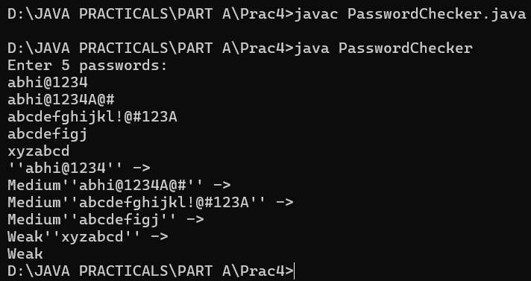
PROGRAM 4.2 | Chat-log filter (ChatFilter.java + Driver.java)  (a) In Driver.main, define a String[] of log lines like “10:05 alice Hello there” (include  one malformed line with fewer than 3 parts).  (b) Read a keyword from the user.  (c) For each line, split into time/user/message with split(“ ”, 3); skip lines that do not  have 3 parts.  (d) If the message contains the keyword (case-insensitive), increment a counter and  append “time user: message” to a StringBuilder.  (e) Print “Matches: N” and the built report.  Expected output: keyword “hello” over 3 lines (1 malformed) → “Matches: 1” and  the matching line.
CODE | ChatFilter.java  public class ChatFilter {  public static class FilterResult {  private final int matchCount;  private final String report;  public FilterResult(int matchCount, String report) {  this.matchCount = matchCount;  this.report = report;  }  public int getMatchCount() {  return matchCount;  }  public String getReport() {  return report;  }  }  public static FilterResult processLogs(String[] logs, String keyword) {  int matches = 0;  StringBuilder report = new StringBuilder();  for (String line : logs) {  String[] parts = line.split(" ", 3);  if (parts.length < 3) {  continue;  }  String time = parts[0];  String user = parts[1];  String message = parts[2];  if (message.toLowerCase().contains(keyword.toLowerCase())) {  matches++;  report.append(time)  .append(" ")  .append(user)  .append(": ")  .append(message)  .append("\n");  }  }  return new FilterResult(matches, report.toString());  }  }  Driver.java  import java.util.Scanner;  public class Driver {  public static void main(String[] args) {  String[] logs = {  "10:05 alice Hello there",  "10:06 Nice outfit",  "10:07 Hello Good morning"  };  Scanner scanner = new Scanner(System.in);  System.out.print("Enter keyword: ");  String keyword = scanner.nextLine().trim();  scanner.close();  ChatFilter.FilterResult result = ChatFilter.processLogs(logs, keyword);  System.out.println("Matches: " + result.getMatchCount());  System.out.print(result.getReport());  }  }
OUTPUT | 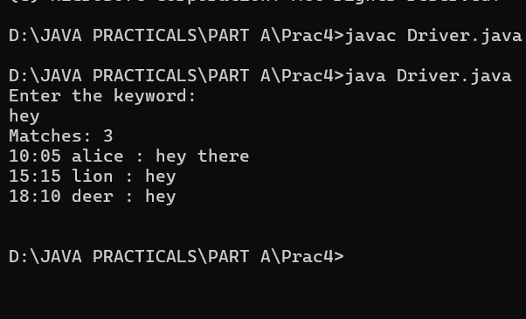
PROGRAM 4.3 | (For Advanced Learners – home) Template filler (TemplateFiller.java +  Driver.java)  (a) In Driver.main, define a template like “Dear {name}, order {id} ships {date}.” and  two parallel arrays: names {“name”, “id”} and values {“Riya”, “A07”} (note {date}  is not supplied).  (b) Compile a Pattern for \{(\w+)\} and get a Matcher on the template.  (c) Walk the matches with a StringBuilder: for each {placeholder}, look up its value in  the names array and replace with the value, or with “[?]” if not found.  (d) Print the filled template.  Expected output: the unsupplied {date} becomes [?]
CODE
OUTPUT
PROGRAM 5
PROGRAM 5.1 | Shape areas: an abstract Shape with abstract area(); subclasses Circle, Rectangle,  Triangle. Put a mix in a Shape[] and loop once to print each area and the running total,  tracking the largest — one loop handling every shape through polymorphism
CODE | import java.util.Scanner;  abstract class area  {  abstract void calculate_area();  }  class Circle extends area  {  int r;  Circle(int r )  {  this.r=r;  }  void calculate_area()  {  System.out.println("Area of given redius "+ r+ "m is " + (3.14*r*r)+" square meter");  }  }  class Rectangle extends area  {  int l,b;  Rectangle(int l,int b)  {  this.l=l;  this.b=b;  }  void calculate_area()  {  System.out.println("Area of given length "+ l + "m and width "+b +" m is :" + (l*b)+" square meter");  }  }  class Triangle extends area  {  int h,b;  Triangle(int h, int b)  {  this.h=h;  this.b=b;  }  void calculate_area()  {  System.out.println("Area of given hight "+ h + "m and base "+b +" m is :" + (0.5*h*b)+" square meter");  }  }  public class shape {  public static void main(String[] args)  {  Scanner sc=new Scanner(System.in);  System.out.print("Enter radius of circle : ");  int r=sc.nextInt();  System.out.print("Enter length of rectangle : ");  int l=sc.nextInt();  System.out.print("Enter length of rectangle : ");  int b=sc.nextInt();  System.out.print("Enter hight of triangle : ");  int h=sc.nextInt();  System.out.print("Enter base of triangle : ");  int w=sc.nextInt();  area a[]={  new Circle(r),  new Rectangle(l,b),  new Triangle(h, w),  };  for(area a1: a)  {  a1.calculate_area();  }  sc.close();  }  }
OUTPUT | 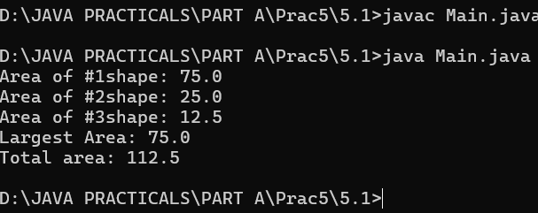
PROGRAM 5.2 | Payroll: an abstract Employee with abstract monthlySalary(); FullTime (fixed), PartTime  (hours × rate) and Intern (stipend), each calling super for the shared name/id. Loop a  mixed array to print each salary and the total; use instanceof to add a note only for  interns
CODE | abstract class Employee {  private String name;  private int id;  public Employee(String name, int id) {  this.name = name;  this.id = id;  }  public String getName() {  return name;  }  public int getId() {  return id;  }  public abstract double monthlySalary();  }  class FullTimeEmployee extends Employee {  private double fixedSalary;  public FullTimeEmployee(String name, int id, double fixedSalary) {  super(name, id);  this.fixedSalary = fixedSalary;  }  @Override  public double monthlySalary() {  return fixedSalary;  }  }  class PartTimeEmployee extends Employee {  private double hoursWorked;  private double hourlyRate;  public PartTimeEmployee(String name, int id, double hoursWorked, double hourlyRate) {  super(name, id);  this.hoursWorked = hoursWorked;  this.hourlyRate = hourlyRate;  }  @Override  public double monthlySalary() {  return hoursWorked * hourlyRate;  }  }  class Intern extends Employee {  private double stipend;  public Intern(String name, int id, double stipend) {  super(name, id);  this.stipend = stipend;  }  @Override  public double monthlySalary() {  return stipend;  }  }  public class Payroll {  public static void main(String[] args) {  Employee[] employees = new Employee[] {  new FullTimeEmployee("Abhi", 101, 5000.00),  new PartTimeEmployee("Mihir", 102, 80, 25.50),  new Intern("Nirbhay", 103, 1500.00),  new FullTimeEmployee("Dhairya", 104, 6200.00)  };  double totalPayroll = 0;  System.out.println("--- Payroll Summary ---");  for (Employee emp : employees) {  double salary = emp.monthlySalary();  totalPayroll += salary;  System.out.printf("ID: %d | Name: %-8s | Salary: %.2f Rs.", emp.getId(), emp.getName(), salary);  if (emp instanceof Intern) {  System.out.print(" [Note: Stipend-based temporary role]");  }  System.out.println();  }  System.out.println("-----------------------");  System.out.printf("Total Monthly Payroll (Rs.) : %.2f%n ", totalPayroll);  }  }
OUTPUT | 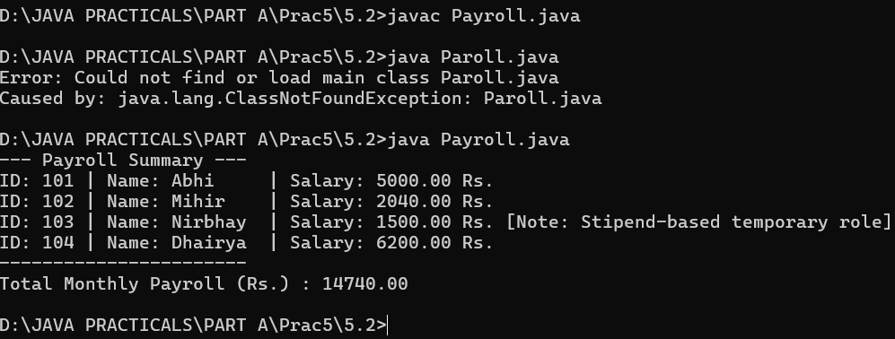
PROGRAM 5.3 | (For Advanced Learners – home) Model a few media types that each compute a late fee  differently and total the fees for a returned batch. Design the hierarchy and rules yourself
CODE | abstract class media  {  private String title;  private int day;  media(String title, int day) {  this.title = title;  this.day=day ;  }  public String getTitle() {  return title;  }  public int getDay() {  return day;  }  abstract double calculateLateFee();  }  class vedioGame extends media{  vedioGame(String n,int d)  {  super(n,d);  }  double calculateLateFee()  {  return 50*getDay();  }  }  class DVD extends media{  DVD(String n,int d)  {  super(n,d);  }  double calculateLateFee()  {  return 20*getDay();  }  }  class redioTap extends media{  redioTap(String n,int d)  {  super(n,d);  }  double calculateLateFee()  {  return 100*getDay();  }  }  public class fee {  public static void main(String args[])  {  media []m={  new vedioGame("Super maryo ", 10),  new DVD("songs ", 10),  new redioTap("pravachan", 25),  new DVD("Movie",50),  };  double total = 0;  for (media m1 : m) {  System.out.print("Name of media : "+m1.getTitle());  System.out.print("| days : "+m1.getDay());  System.out.print("| total fee pay : "+m1.calculateLateFee());  total+= m1.calculateLateFee();  System.out.println();  }  System.out.println("total fee : "+ total);  }  }
OUTPUT | 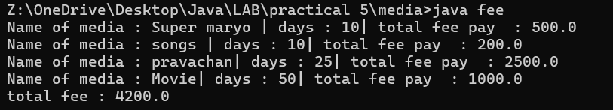
PROGRAM 6
PROGRAM 6.1 | Remote control: an interface Switchable with on()/off() and a default toggle(); Fan and  Light implement it. Loop over a Switchable[] toggling each. Then add a functional  interface that decides, given a device and an hour, whether it may switch on, and supply it  once as an anonymous class and once as a lambda.
CODE | interface Switchable {  void on();  void off();  default void toggle() {  System.out.println("Toggling device state...");  }  }  class Light implements Switchable {  @Override  public void on() {  System.out.println("Light is ON");  }  @Override  public void off() {  System.out.println("Light is OFF");  }  @Override  public void toggle() {  System.out.println("Toggling Light:");  on();  }  }  class Fan implements Switchable {  @Override  public void on() {  System.out.println("Fan is ON");  }  @Override  public void off() {  System.out.println("Fan is OFF");  }  @Override  public void toggle() {  System.out.println("Toggling Fan:");  on();  }  }  interface SwitchPolicy {  boolean canSwitchOn(Switchable device, int hour);  }  public class RemoteControlDemo {  public static void main(String[] args) {  Switchable[] devices = new Switchable[] {  new Light(),  new Fan()  };  System.out.println("--- Loop & Toggle Devices ---");  for (Switchable device : devices) {  device.toggle();  }  System.out.println("\n--- SwitchPolicy Evaluations ---");  int currentHour = 23;  Light hallwayLight = new Light();  Fan bedroomFan = new Fan();  SwitchPolicy nightQuietPolicy = new SwitchPolicy() {  @Override  public boolean canSwitchOn(Switchable device, int hour) {  return hour >= 6 && hour < 22;  }  };  System.out.println("Anonymous Class Policy (Night Quiet) at " + currentHour + ":00 ->");  boolean lightAllowed = nightQuietPolicy.canSwitchOn(hallwayLight, currentHour);  System.out.println("Can turn on hallway light? " + lightAllowed);  SwitchPolicy deviceSpecificPolicy = (device, hour) -> {  if (device instanceof Fan) {  return hour >= 6 && hour < 23;  }  return true;  };  System.out.println("\nLambda Expression Policy at " + currentHour + ":00 ->");  boolean fanAllowed = deviceSpecificPolicy.canSwitchOn(bedroomFan, currentHour);  System.out.println("Can turn on bedroom fan? " + fanAllowed);  }  }
OUTPUT | 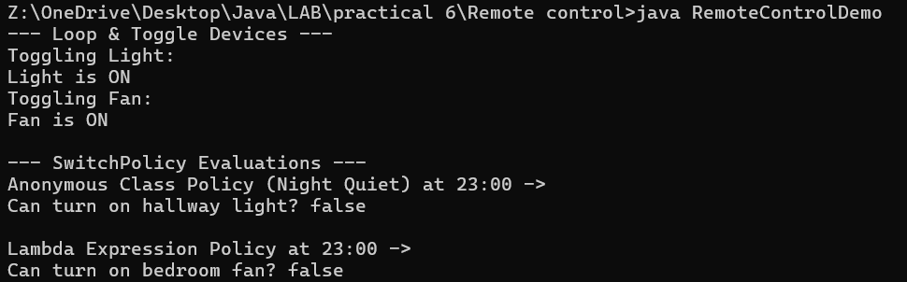
PROGRAM6.2 | Notification senders: a functional interface Notifier with send(String); make email and  SMS senders as lambdas, hold them in an array, and broadcast one message through all.  Add a marker interface Urgent and send twice for senders marked urgent
CODE | @FunctionalInterface  interface Notifier {  void send(String message);  }  interface Urgent {}  class UrgentNotifier implements Notifier, Urgent {  @Override  public void send(String message) {  System.out.println("[SMS] Sending: " + message);  }  }  class UrgentPushNotifier implements Notifier, Urgent {  @Override  public void send(String message) {  System.out.println("[PUSH] Sending: " + message);  }  }  public class NotificationDemo {  public static void main(String[] args) {  Notifier emailNotifier = message ->  System.out.println("[EMAIL] Sending: " + message);  Notifier urgentSmsNotifier = new UrgentNotifier();  Notifier urgentPushNotifier = new UrgentPushNotifier();  Notifier[] notifiers = new Notifier[] {  emailNotifier,  urgentSmsNotifier,  urgentPushNotifier  };  String broadcastMessage = "Server maintenance scheduled in 10 minutes!";  System.out.println("--- Broadcasting Message ---");  for (Notifier notifier : notifiers) {  notifier.send(broadcastMessage);  if (notifier instanceof Urgent) {  System.out.print(" -> [URGENT MARKER DETECTED] Priority re-sending: ");  notifier.send(broadcastMessage);  }  }  }  }
OUTPUT | 