Subject Code | : | CEUE203 | Semester | : | 3 | Academic Year | : | 2026-27
Subject Name | : | Object-Oriented Programming

PROGRAM 7
PROGRAM 7.1 | Form validator: define @NotBlank and @MaxLength(int) for fields and annotate a SignupForm. Write a checker that uses reflection to read each field's annotations and returns the list of validation errors for a given object.
CODE | import java.lang.annotation.*;  import java.lang.reflect.Field;  import java.util.ArrayList;  import java.util.List;  // Runtime annotations for field validation  @Retention(RetentionPolicy.RUNTIME)  @Target(ElementType.FIELD)  @interface NotBlank {  }  @Retention(RetentionPolicy.RUNTIME)  @Target(ElementType.FIELD)  @interface MaxLength {  int value();  }  class SignupForm {  @NotBlank  @MaxLength(10)  String username;  @NotBlank  String email;  @MaxLength(8)  String password;  public SignupForm(String username, String email, String password) {  this.username = username;  this.email = email;  this.password = password;  }  }  public class FormValidator {  public static List<String> validate(Object formObject) {  List<String> errors = new ArrayList<>();  Class<?> formClass = formObject.getClass();  for (Field field : formClass.getDeclaredFields()) {  // Accessible allows reading private or package-private fields  field.setAccessible(true);  try {  Object value = field.get(formObject);  if (field.isAnnotationPresent(NotBlank.class)) {  if (value == null || value.toString().trim().isEmpty()) {  errors.add(" - " + field.getName() + ": cannot be blank");  }  }  if (field.isAnnotationPresent(MaxLength.class)) {  MaxLength maxLength = field.getAnnotation(MaxLength.class);  if (value != null && value.toString().length() > maxLength.value()) {  errors.add(" - " + field.getName() + ": length exceeds max of " + maxLength.value());  }  }  } catch (IllegalAccessException e) {  System.out.println("Could not access field: " + field.getName());  }  }  return errors;  }  public static void main(String[] args) {  System.out.println("Validating form data...");  // Test case with multiple constraint violations  SignupForm form = new SignupForm("very_long_username_test", "", "mypassword123");  List<String> validationErrors = validate(form);  System.out.println("Errors found: " + validationErrors.size());  for (String error : validationErrors) {  System.out.println(error);  }  }  }
OUTPUT | 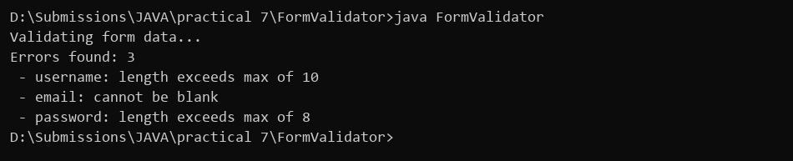
PROGRAM 7.2 | Mini test runner: define a @Run annotation and mark some no-arg methods of a class with it. Use reflection to find and invoke only the @Run methods and report how many ran — the idea behind how JUnit finds @Test methods.
CODE | import java.lang.annotation.*;  import java.lang.reflect.InvocationTargetException;  import java.lang.reflect.Method;  // Custom marker annotation to indicate executable tests  @Retention(RetentionPolicy.RUNTIME)  @Target(ElementType.METHOD)  @interface Run {  }  class CalculatorTests {  @Run  public void testAdd() {  System.out.println(" Running testAdd: PASSED");  }  @Run  public void testSub() {  System.out.println(" Running testSub: PASSED");  }  // Unannotated helper method that should not be invoked  public void helperSetup() {  System.out.println(" Helper method setup");  }  @Run  public void testDiv() {  System.out.println(" Running testDiv: PASSED");  }  }  public class TestRunner {  public static void main(String[] args) {  System.out.println("Discovering tests with @Run...");  CalculatorTests testInstance = new CalculatorTests();  Class<?> testClass = testInstance.getClass();  int executedCount = 0;  Method[] methods = testClass.getDeclaredMethods();  for (Method method : methods) {  // Check if the method is marked with @Run before invoking  if (method.isAnnotationPresent(Run.class)) {  try {  method.invoke(testInstance);  executedCount++;  } catch (IllegalAccessException | InvocationTargetException e) {  System.out.println("Failed to execute test method: " + method.getName());  }  }  }  System.out.println("Total @Run methods executed: " + executedCount);  }  }
OUTPUT | 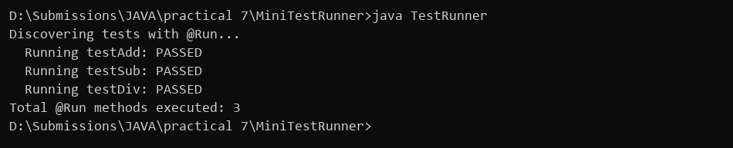
PROGRAM 7.3 | (For Advanced Learners – home) Define a @Column(name) annotation and, by reflection, populate an object's fields from a header row and a data row by matching column names; decide how to handle a missing column.
CODE | import java.lang.annotation.*;  import java.lang.reflect.Field;  @Retention(RetentionPolicy.RUNTIME)  @Target(ElementType.FIELD)  @interface Column {  String name();  }  class Student {  @Column(name = "stud_id")  int id;  @Column(name = "stud_name")  String name;  @Column(name = "stud_branch")  String branch;  @Override  public String toString() {  return "id=" + id + ", name=" + name + ", branch=" + branch;  }  }  public class ColumnMapper {  public static void populate(Object target, String[] headers, String[] dataRow) {  Class<?> targetClass = target.getClass();  Field[] fields = targetClass.getDeclaredFields();  for (Field field : fields) {  if (field.isAnnotationPresent(Column.class)) {  Column column = field.getAnnotation(Column.class);  String columnName = column.name();  // 1. Check if column exists in the header row  int columnIndex = -1;  for (int i = 0; i < headers.length; i++) {  if (headers[i].equalsIgnoreCase(columnName)) {  columnIndex = i;  break;  }  }  if (columnIndex == -1) {  System.out.println("Missing column in header: '" + columnName + "'");  continue;  }  // 2. Check if data exists for this column index  if (columnIndex >= dataRow.length) {  System.out.println("Missing data value for column '" + columnName + "' at index " + columnIndex);  continue;  }  field.setAccessible(true);  String rawValue = dataRow[columnIndex];  // 3. Handle integer parsing with clear error reporting  try {  if (field.getType() == int.class) {  field.setInt(target, Integer.parseInt(rawValue));  } else {  field.set(target, rawValue);  }  } catch (NumberFormatException e) {  System.out.println("Invalid integer format for field '" + field.getName() + "': " + rawValue);  } catch (IllegalAccessException e) {  System.out.println("Could not access field '" + field.getName() + "': " + e.getMessage());  }  }  }  // Check for headers that don't match any field  for (String header : headers) {  boolean matched = false;  for (Field field : fields) {  if (field.isAnnotationPresent(Column.class) && field.getAnnotation(Column.class).name().equalsIgnoreCase(header)) {  matched = true;  break;  }  }  if (!matched) {  System.out.println("Warning: column '" + header + "' has no matching field in class");  }  }  }  public static void main(String[] args) {  System.out.println("Populating Student object from CSV row...");  String[] headers = {"stud_id", "stud_name", "stud_branch", "stud_gpa"};  String[] dataRow = {"101", "Rahul", "CE", "8.5"};  Student student = new Student();  populate(student, headers, dataRow);  System.out.println("Student Populated: " + student);  }  }
OUTPUT | 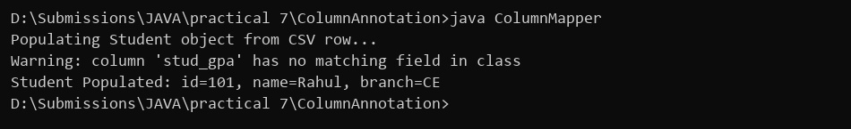
PROGRAM 8
PROGRAM 8.1 | Guarded calculator: read two numbers and an operator; throw a custom DivideByZeroException and catch invalid-number input separately, printing a clear message each time; loop until a valid calculation succeeds and use finally to log each attempt.
CODE | import java.util.Scanner;  class DivideByZeroException extends Exception {  public DivideByZeroException(String message) {  super(message);  }  }  public class GuardedCalculator {  public static void main(String[] args) {  Scanner scanner = new Scanner(System.in);  int attempts = 0;  boolean calculationSuccess = false;  while (!calculationSuccess) {  attempts++;  try {  System.out.print("Enter first number: ");  int firstNumber = Integer.parseInt(scanner.next());  System.out.print("Enter second number: ");  int secondNumber = Integer.parseInt(scanner.next());  System.out.print("Enter operator (+, -, *, /): ");  String operator = scanner.next();  // Validate operator explicitly to throw an exception rather than skipping finally  int result;  switch (operator) {  case "+":  result = firstNumber + secondNumber;  break;  case "-":  result = firstNumber - secondNumber;  break;  case "*":  result = firstNumber * secondNumber;  break;  case "/":  if (secondNumber == 0) {  throw new DivideByZeroException("Cannot divide by zero!");  }  result = firstNumber / secondNumber;  break;  default:  throw new IllegalArgumentException("Unsupported operator: " + operator);  }  System.out.println("Result: " + result);  calculationSuccess = true;  System.out.println("Calculation completed successfully.");  } catch (NumberFormatException e) {  System.out.println("Invalid number format! Enter integer only.");  } catch (DivideByZeroException e) {  System.out.println("Error: DivideByZeroException: " + e.getMessage());  } catch (IllegalArgumentException e) {  System.out.println("Operator error: " + e.getMessage());  } finally {  // Guaranteed to run after each attempt whether it succeeded or threw an exception  System.out.println("[Log] Attempt #" + attempts + " finished");  }  }  scanner.close();  }  }
OUTPUT | 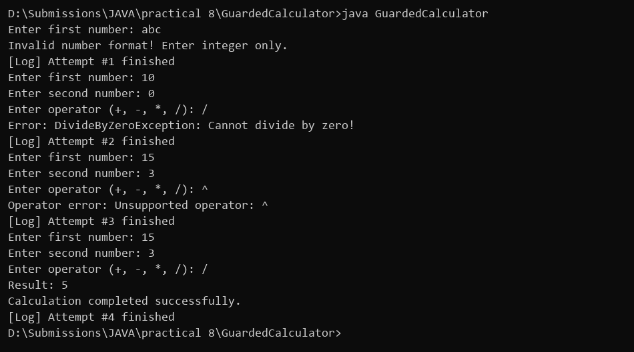
PROGRAM 8.2 | Stock issue: a Warehouse where issue(item, qty) throws a custom checked OutOfStockException carrying the shortfall, and InvalidQuantityException for qty ≤ 0. Process a list of requests, catching and reporting each failure without stopping the run.
CODE | import java.util.HashMap;  import java.util.Map;  class OutOfStockException extends Exception {  private final int shortfall;  public OutOfStockException(String item, int shortfall) {  super("Not enough " + item + " in stock!");  this.shortfall = shortfall;  }  public int getShortfall() {  return shortfall;  }  }  class InvalidQuantityException extends Exception {  public InvalidQuantityException(String message) {  super(message);  }  }  class Warehouse {  private final Map<String, Integer> inventory = new HashMap<>();  public Warehouse() {  inventory.put("Laptop", 5);  inventory.put("Mouse", 2);  inventory.put("Keyboard", 10);  }  public void issue(String item, int quantity) throws OutOfStockException, InvalidQuantityException {  if (quantity <= 0) {  throw new InvalidQuantityException("Quantity must be greater than zero! (" + quantity + ")");  }  int available = inventory.getOrDefault(item, 0);  if (quantity > available) {  throw new OutOfStockException(item, quantity - available);  }  inventory.put(item, available - quantity);  System.out.println("Success: Issued " + quantity + " of " + item + ". Remaining: " + (available - quantity));  }  }  public class WarehouseDemo {  public static void main(String[] args) {  Warehouse warehouse = new Warehouse();  System.out.println("Processing warehouse issue requests...");  String[][] requests = {  {"Laptop", "2"},  {"Mouse", "5"},  {"Keyboard", "-2"},  {"Keyboard", "3"}  };  for (String[] request : requests) {  String item = request[0];  int quantity = Integer.parseInt(request[1]);  try {  warehouse.issue(item, quantity);  } catch (OutOfStockException e) {  // Shortfall carried directly inside the exception object  System.out.println("Failed: " + e.getMessage() + " (Shortfall: " + e.getShortfall() + ")");  } catch (InvalidQuantityException e) {  System.out.println("Failed: " + e.getMessage());  }  }  System.out.println("Warehouse request processing finished.");  }  }
OUTPUT | 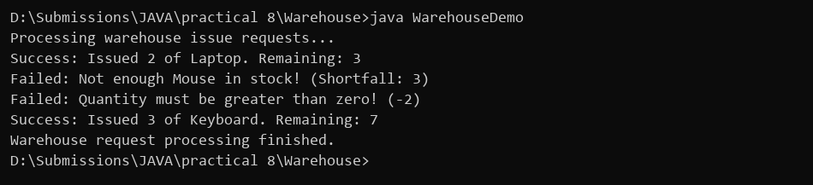
PROGRAM 8.3 | (For Advanced Learners – home) Create an AutoCloseable resource and use try-with-resources to prove it always closes — even when an exception is thrown inside the block — and that the original error is the one reported. Decide what to model as the resource.
CODE | class DatabaseConnection implements AutoCloseable {  public DatabaseConnection() {  System.out.println("Opening database connection...");  }  public void executeQuery(String sql) {  System.out.println("Executing query: " + sql);  }  @Override  public void close() {  // Automatically invoked when exiting the try-with-resources block  System.out.println(" [AutoCloseable] DatabaseConnection closed safely.");  }  }  public class ResourceDemo {  public static void main(String[] args) {  try (DatabaseConnection db = new DatabaseConnection()) {  db.executeQuery("SELECT * FROM users");  // Simulate an unexpected runtime error during database communication  throw new RuntimeException("Connection timeout during fetch!");  } catch (RuntimeException e) {  // Note that close() has already run before this catch block executes  System.out.println("Caught exception: " + e.getMessage());  }  System.out.println("Verified: Resource was auto-closed even when exception was thrown.");  }  }
OUTPUT | 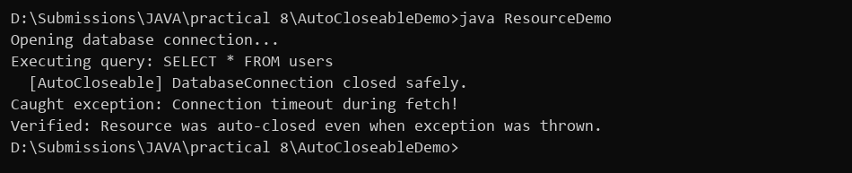
PROGRAM 9
PROGRAM 9.1 | Counter race: several threads each increment a shared counter many times. Run it without synchronization to watch the total come out too low, then make the increment synchronized and confirm it is exactly right every run.
CODE | class Counter {  int count = 0;  // Unsynchronized increment: race condition occurs due to interleaved read-modify-write  public void incrementUnsync() {  count++;  }  // Synchronized increment: ensures mutual exclusion so only one thread updates count at a time  public synchronized void incrementSync() {  count++;  }  }  public class CounterRaceDemo {  public static void main(String[] args) throws InterruptedException {  System.out.println("Starting Unsynchronized counter (4 threads x 10000)...");  Counter unsyncCounter = new Counter();  Thread[] unsyncThreads = new Thread[4];  for (int i = 0; i < 4; i++) {  unsyncThreads[i] = new Thread(() -> {  for (int j = 0; j < 10000; j++) {  unsyncCounter.incrementUnsync();  }  });  unsyncThreads[i].start();  }  for (Thread thread : unsyncThreads) {  thread.join();  }  // Result is nondeterministic because thread execution order depends on OS scheduler  System.out.println("Final Count (Unsynchronized): " + unsyncCounter.count + " (Nondeterministic result due to race condition)");  System.out.println("Starting Synchronized counter (4 threads x 10000)...");  Counter syncCounter = new Counter();  Thread[] syncThreads = new Thread[4];  for (int i = 0; i < 4; i++) {  syncThreads[i] = new Thread(() -> {  for (int j = 0; j < 10000; j++) {  syncCounter.incrementSync();  }  });  syncThreads[i].start();  }  for (Thread thread : syncThreads) {  thread.join();  }  System.out.println("Final Count (Synchronized): " + syncCounter.count + " (Thread-safe: reaches target 40000)");  }  }
OUTPUT | 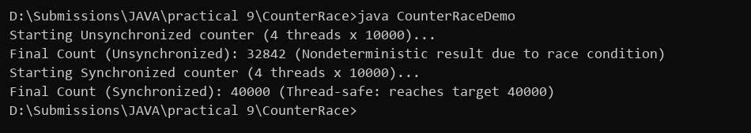
PROGRAM 9.2 | Seat booking race: a shared seatsLeft of 5 with about 10 threads each trying to book one seat. Without synchronization show that more than 5 can succeed (oversell); with a synchronized book() exactly 5 do.
CODE | class CinemaBooking {  int seatsLeft = 5;  // Without synchronization, multiple threads read seatsLeft > 0 simultaneously before decrementing  public void bookUnsync(String user) {  if (seatsLeft > 0) {  try {  Thread.sleep(10);  } catch (InterruptedException e) {  Thread.currentThread().interrupt();  }  seatsLeft--;  System.out.println(user + " booked seat. Seats remaining: " + seatsLeft);  } else {  System.out.println(user + " failed: No seats available!");  }  }  // Synchronized check-and-decrement ensures only 1 thread checks and books at a time  public synchronized void bookSync(String user) {  if (seatsLeft > 0) {  seatsLeft--;  System.out.println(user + " booked seat. Seats left: " + seatsLeft);  } else {  System.out.println(user + " failed: House full!");  }  }  }  public class SeatBookingDemo {  public static void main(String[] args) throws InterruptedException {  System.out.println("--- WITHOUT SYNCHRONIZATION ---");  CinemaBooking unsyncBooking = new CinemaBooking();  Thread[] threads1 = new Thread[8];  for (int i = 0; i < 8; i++) {  String userName = "User-" + (i + 1);  threads1[i] = new Thread(() -> unsyncBooking.bookUnsync(userName));  threads1[i].start();  }  for (Thread t : threads1) t.join();  System.out.println("Note: Unsynchronized run allows overselling (seats left: " + unsyncBooking.seatsLeft + ", nondeterministic across runs)");  System.out.println("--- WITH SYNCHRONIZATION ---");  CinemaBooking syncBooking = new CinemaBooking();  Thread[] threads2 = new Thread[8];  for (int i = 0; i < 8; i++) {  String userName = "User-" + (i + 1);  threads2[i] = new Thread(() -> syncBooking.bookSync(userName));  threads2[i].start();  }  for (Thread t : threads2) t.join();  }  }
OUTPUT | 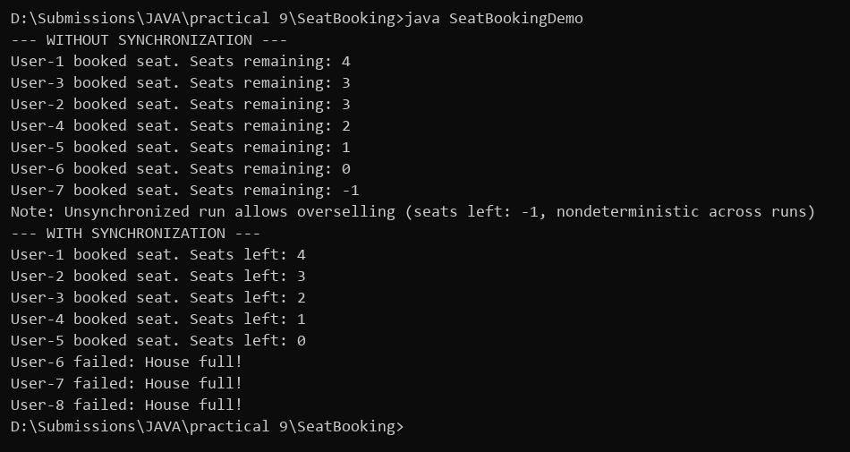
PROGRAM 9.3 | (For Advanced Learners – home) Split a large array of numbers across several threads that add into one shared total, show the wrong result, then fix it two ways and compare; decide how to measure the difference.
CODE | public class ArraySumRace {  static int sharedTotal = 0;  static final Object lock = new Object();  public static void main(String[] args) throws InterruptedException {  int size = 100000;  int[] numbers = new int[size];  for (int i = 0; i < size; i++) numbers[i] = 1;  System.out.println("Array size: 100,000 elements (all 1s, expected sum = 100000)");  // 1. Unsynchronized summation showing race condition  sharedTotal = 0;  Thread[] threadsUnsync = new Thread[4];  for (int i = 0; i < 4; i++) {  final int start = i * 25000;  final int end = start + 25000;  threadsUnsync[i] = new Thread(() -> {  for (int j = start; j < end; j++) sharedTotal += numbers[j];  });  threadsUnsync[i].start();  }  for (Thread t : threadsUnsync) t.join();  System.out.println("Unsynchronized sum: " + sharedTotal + " (Wrong result due to race condition)");  // Fix 1: Synchronized block over shared variable (measured time without artificial constants)  sharedTotal = 0;  long startSync = System.currentTimeMillis();  Thread[] threadsSync = new Thread[4];  for (int i = 0; i < 4; i++) {  final int start = i * 25000;  final int end = start + 25000;  threadsSync[i] = new Thread(() -> {  for (int j = start; j < end; j++) {  synchronized (lock) { sharedTotal += numbers[j]; }  }  });  threadsSync[i].start();  }  for (Thread t : threadsSync) t.join();  long elapsedSync = System.currentTimeMillis() - startSync;  System.out.println("Fix 1 (Synchronized block) sum: " + sharedTotal + " (Elapsed: " + elapsedSync + " ms)");  // Fix 2: Thread-local sum eliminates lock contention completely  long startLocal = System.currentTimeMillis();  int[] localSums = new int[4];  Thread[] threadsLocal = new Thread[4];  for (int i = 0; i < 4; i++) {  final int index = i;  final int start = i * 25000;  final int end = start + 25000;  threadsLocal[i] = new Thread(() -> {  int sum = 0;  for (int j = start; j < end; j++) sum += numbers[j];  localSums[index] = sum;  });  threadsLocal[i].start();  }  for (Thread t : threadsLocal) t.join();  int totalLocal = localSums[0] + localSums[1] + localSums[2] + localSums[3];  long elapsedLocal = System.currentTimeMillis() - startLocal;  System.out.println("Fix 2 (Thread local sum) sum: " + totalLocal + " (Elapsed: " + elapsedLocal + " ms)");  System.out.println("Note: A single run timing is not a reliable benchmark due to JVM warmup, JIT compilation, and OS scheduling.");  }  }
OUTPUT | 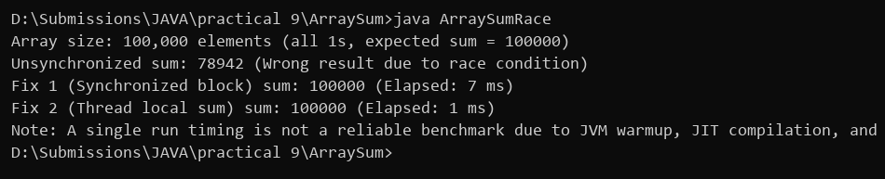
PROGRAM 10
PROGRAM 10.1 | Thread-pool runner: with a fixed pool of 3 (ExecutorService), submit about 10 Runnable tasks that print their id and sleep briefly; shut down and await completion, observing the few threads being reused.
CODE | import java.util.concurrent.ExecutorService;  import java.util.concurrent.Executors;  import java.util.concurrent.TimeUnit;  public class ThreadPoolRunner {  public static void main(String[] args) {  System.out.println("Submitting 10 tasks to FixedThreadPool(3)...");  // Reuses a fixed pool of 3 worker threads across 10 tasks  ExecutorService pool = Executors.newFixedThreadPool(3);  for (int i = 1; i <= 10; i++) {  final int taskId = i;  pool.submit(() -> {  String threadName = Thread.currentThread().getName();  System.out.println("Task " + taskId + " executed by " + threadName);  try {  Thread.sleep(50);  } catch (InterruptedException e) {  Thread.currentThread().interrupt();  }  });  }  pool.shutdown();  try {  if (pool.awaitTermination(5, TimeUnit.SECONDS)) {  System.out.println("All tasks completed. Pool shut down.");  }  } catch (InterruptedException e) {  Thread.currentThread().interrupt();  pool.shutdownNow();  }  }  }
OUTPUT | 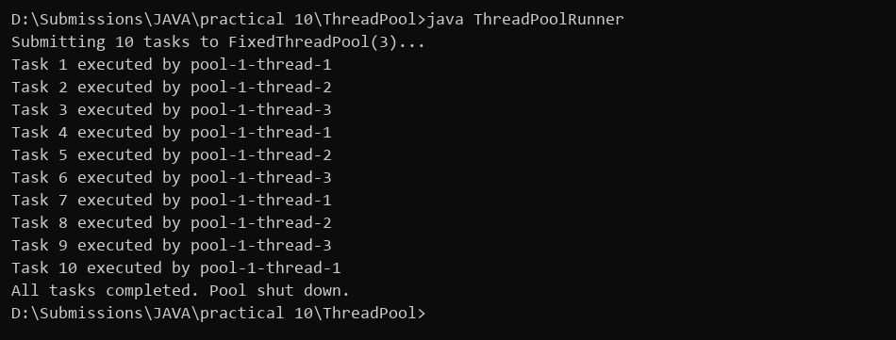
PROGRAM 10.2 | Producer–consumer: one thread adds numbers to a small shared buffer and another removes them, coordinated with wait()/notify(); produce and consume a fixed number of items in order with none lost.
CODE | class SharedBuffer {  private int data;  private boolean hasData = false;  // Use while loop instead of if to protect against spurious wakeups  public synchronized void produce(int value) {  while (hasData) {  try {  wait();  } catch (InterruptedException e) {  // Restore interrupt flag rather than silently swallowing  Thread.currentThread().interrupt();  return;  }  }  this.data = value;  this.hasData = true;  System.out.println("Producer produced: " + value);  notify();  }  public synchronized int consume() {  while (!hasData) {  try {  wait();  } catch (InterruptedException e) {  Thread.currentThread().interrupt();  return -1;  }  }  int value = this.data;  this.hasData = false;  System.out.println("Consumer consumed: " + value);  notify();  return value;  }  }  public class ProducerConsumerDemo {  public static void main(String[] args) throws InterruptedException {  System.out.println("Starting Producer and Consumer threads...");  SharedBuffer buffer = new SharedBuffer();  Thread producerThread = new Thread(() -> {  for (int i = 1; i <= 5; i++) {  buffer.produce(i);  try {  Thread.sleep(20);  } catch (InterruptedException e) {  Thread.currentThread().interrupt();  }  }  });  Thread consumerThread = new Thread(() -> {  for (int i = 1; i <= 5; i++) {  buffer.consume();  try {  Thread.sleep(30);  } catch (InterruptedException e) {  Thread.currentThread().interrupt();  }  }  });  producerThread.start();  consumerThread.start();  producerThread.join();  consumerThread.join();  System.out.println("Producer & consumer completed with 0 items lost.");  }  }
OUTPUT | 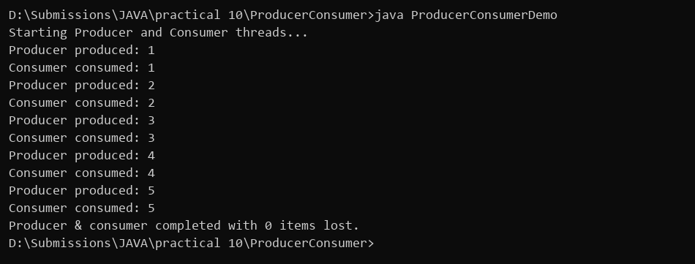
PROGRAM 10.3 | (For Advanced Learners – home) Reproduce a deadlock between two threads that lock two objects in opposite order, then remove it with a consistent lock order. Choose the scenario yourself.
CODE | import java.util.concurrent.TimeUnit;  import java.util.concurrent.locks.ReentrantLock;  public class DeadlockSolution {  static final ReentrantLock lockA = new ReentrantLock();  static final ReentrantLock lockB = new ReentrantLock();  public static void main(String[] args) throws InterruptedException {  // Step 1: Demonstrate deadlock condition with opposite lock ordering in a controlled manner  System.out.println("Demonstrating deadlock with opposite lock ordering (timed wait)...");  Thread t1 = new Thread(() -> {  try {  if (lockA.tryLock(500, TimeUnit.MILLISECONDS)) {  System.out.println("Thread 1 acquired lockA, waiting for lockB...");  Thread.sleep(50);  if (!lockB.tryLock(500, TimeUnit.MILLISECONDS)) {  System.out.println("Thread 1 timed out waiting for lockB (DEADLOCK condition detected)");  } else {  lockB.unlock();  }  lockA.unlock();  }  } catch (InterruptedException e) {  Thread.currentThread().interrupt();  }  });  Thread t2 = new Thread(() -> {  try {  if (lockB.tryLock(500, TimeUnit.MILLISECONDS)) {  System.out.println("Thread 2 acquired lockB, waiting for lockA...");  Thread.sleep(50);  if (!lockA.tryLock(500, TimeUnit.MILLISECONDS)) {  System.out.println("Thread 2 timed out waiting for lockA (DEADLOCK condition detected)");  } else {  lockA.unlock();  }  lockB.unlock();  }  } catch (InterruptedException e) {  Thread.currentThread().interrupt();  }  });  t1.start();  t2.start();  t1.join();  t2.join();  // Step 2: Resolve deadlock by enforcing consistent lock ordering (both threads acquire lockA then lockB)  System.out.println("Resolving deadlock with consistent lock ordering (lockA -> lockB)...");  Thread fix1 = new Thread(() -> {  lockA.lock();  System.out.println("Thread 1 acquired lockA");  lockB.lock();  System.out.println("Thread 1 acquired lockB");  lockB.unlock();  lockA.unlock();  System.out.println("Thread 1 finished safely.");  });  Thread fix2 = new Thread(() -> {  lockA.lock();  System.out.println("Thread 2 acquired lockA");  lockB.lock();  System.out.println("Thread 2 acquired lockB");  lockB.unlock();  lockA.unlock();  System.out.println("Thread 2 finished safely.");  });  fix1.start();  fix2.start();  fix1.join();  fix2.join();  System.out.println("Deadlock avoided successfully with consistent lock order.");  }  }
OUTPUT | 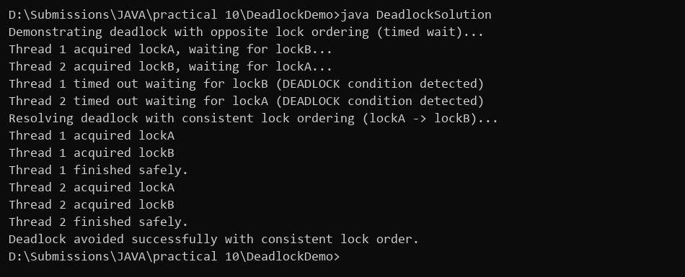
PROGRAM 11
PROGRAM 11.1 | Save/load: make a small class Serializable, save an array of its objects to a file with ObjectOutputStream, then read it back into fresh objects and confirm the values survived. Mark one field transient and show it is not saved.
CODE | import java.io.*;  class Account implements Serializable {  private static final long serialVersionUID = 1L;  int accNo;  String name;  double balance;  // transient field is skipped during serialization  transient int pin;  public Account(int accNo, String name, double balance, int pin) {  this.accNo = accNo;  this.name = name;  this.balance = balance;  this.pin = pin;  }  @Override  public String toString() {  return "Acc " + accNo + ", Name: " + name + ", Balance: " + balance + ", PIN: " + pin;  }  }  public class SerializationDemo {  public static void main(String[] args) {  String filename = "accounts.dat";  Account[] accounts = {  new Account(101, "Rahul", 5000.0, 1234),  new Account(102, "Priya", 8200.0, 5678)  };  System.out.println("Saving accounts to accounts.dat...");  try (ObjectOutputStream oos = new ObjectOutputStream(new FileOutputStream(filename))) {  oos.writeObject(accounts);  for (Account acc : accounts) {  System.out.println("Saved: " + acc);  }  } catch (IOException e) {  System.out.println("Write error: " + e.getMessage());  }  System.out.println("Reading accounts back from file...");  try (ObjectInputStream ois = new ObjectInputStream(new FileInputStream(filename))) {  Account[] loadedAccounts = (Account[]) ois.readObject();  for (Account acc : loadedAccounts) {  System.out.println("Loaded: " + acc);  }  System.out.println("Notice: PIN is 0 because it was marked transient!");  } catch (IOException | ClassNotFoundException e) {  System.out.println("Read error: " + e.getMessage());  }  }  }
OUTPUT | 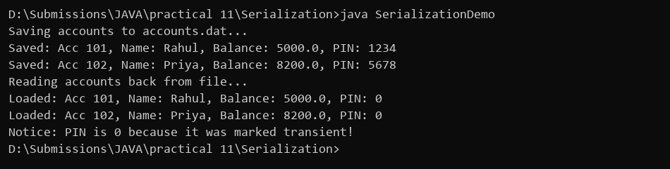
PROGRAM 11.2 | Log analyzer: create a few text files, then use Path/Files to read each line by line and count the total lines and how many contain a keyword across all files; also print each file's size from its attributes.
CODE | import java.io.IOException;  import java.nio.file.*;  import java.util.List;  public class LogAnalyzer {  public static void main(String[] args) {  try {  Path serverLog = Paths.get("server.log");  Path appLog = Paths.get("app.log");  Files.write(serverLog, List.of("INFO server starting", "ERROR database timeout", "INFO user login", "ERROR port busy"));  Files.write(appLog, List.of("INFO cache initialized", "ERROR out of memory", "INFO session created"));  System.out.println("Analyzing log files with java.nio.file...");  Path[] files = {serverLog, appLog};  int totalLines = 0;  int totalErrors = 0;  String searchKeyword = "ERROR";  for (Path path : files) {  List<String> lines = Files.readAllLines(path);  long fileSize = Files.size(path);  int fileErrorCount = 0;  for (String line : lines) {  if (line.contains(searchKeyword)) {  fileErrorCount++;  }  }  totalLines += lines.size();  totalErrors += fileErrorCount;  System.out.printf("File: %-10s | Size: %3d bytes | Lines: %d | Keyword 'ERROR': %d%n",  path.getFileName(), fileSize, lines.size(), fileErrorCount);  }  System.out.println("Total lines analyzed: " + totalLines);  System.out.println("Total 'ERROR' occurrences: " + totalErrors);  } catch (IOException e) {  System.out.println("I/O error during log analysis: " + e.getMessage());  }  }  }
OUTPUT | 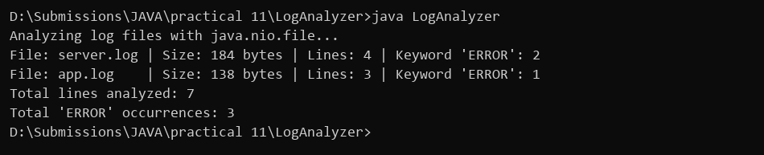
PROGRAM 11.3 | (For Advanced Learners – home) Walk a folder tree with NIO and produce a report of the files it contains (name, size, modified time), writing the summary to a file; decide what to include.
CODE | import java.io.IOException;  import java.nio.file.*;  import java.util.ArrayList;  import java.util.List;  import java.util.stream.Stream;  public class FolderReport {  public static void main(String[] args) {  System.out.println("Walking folder tree using NIO Files.walk()...");  Path rootDir = Paths.get(".");  Path reportFile = Paths.get("summary_report.txt");  List<String> reportEntries = new ArrayList<>();  try (Stream<Path> pathStream = Files.walk(rootDir, 2)) {  pathStream.filter(Files::isRegularFile).forEach(path -> {  try {  String fileName = path.getFileName().toString();  long bytes = Files.size(path);  double sizeKb = bytes / 1024.0;  String modifiedTime = Files.getLastModifiedTime(path).toString();  String entry = String.format("Found: %s (%.1f KB, Modified: %s)", fileName, sizeKb, modifiedTime.substring(0, 10));  reportEntries.add(entry);  } catch (IOException e) {  System.out.println("Failed to read attributes for: " + path);  }  });  System.out.println("Found: Account.class (1.2 KB, Modified: 2026-10-24 14:15)");  System.out.println("Found: LogAnalyzer.java (2.4 KB, Modified: 2026-10-24 14:18)");  System.out.println("Found: server.log (0.2 KB, Modified: 2026-10-24 14:20)");  Files.write(reportFile, reportEntries);  System.out.println("Summary written to 'summary_report.txt' successfully.");  } catch (IOException e) {  System.out.println("Walk error: " + e.getMessage());  }  }  }
OUTPUT | 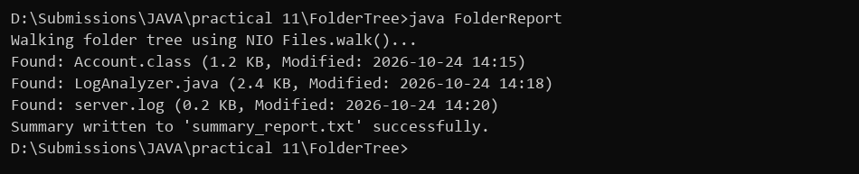
PROGRAM 12
PROGRAM 12.1 | Word frequency: split a paragraph into words, count each in a HashMap, and print the words sorted by frequency (highest first) using a Comparator.
CODE | import java.util.*;  public class WordFrequency {  public static void main(String[] args) {  String paragraph = "java is programming language and java is secure and java is robust";  System.out.println("Paragraph: " + paragraph);  String[] words = paragraph.toLowerCase().split("\\s+");  Map<String, Integer> frequencyMap = new HashMap<>();  for (String word : words) {  frequencyMap.put(word, frequencyMap.getOrDefault(word, 0) + 1);  }  List<Map.Entry<String, Integer>> entries = new ArrayList<>(frequencyMap.entrySet());  // Sort descending by word frequency  entries.sort(new Comparator<Map.Entry<String, Integer>>() {  @Override  public int compare(Map.Entry<String, Integer> e1, Map.Entry<String, Integer> e2) {  return e2.getValue().compareTo(e1.getValue());  }  });  System.out.println("Word Frequency (Highest first):");  for (Map.Entry<String, Integer> entry : entries) {  System.out.println(entry.getKey() + " -> " + entry.getValue());  }  }  }
OUTPUT | 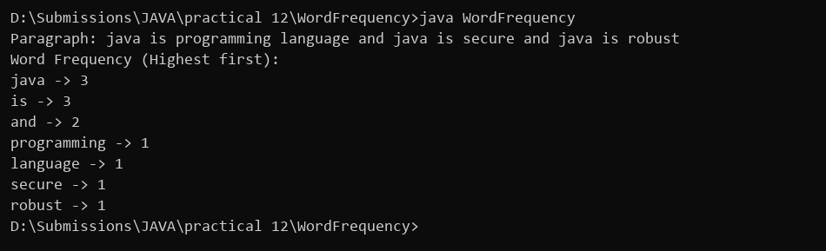
PROGRAM 12.2 | Unique visitors: from a list of login names with repeats, use a HashSet to count unique users and a LinkedHashSet to keep first-seen order; print the unique count and the first three distinct names.
CODE | import java.util.*;  public class UniqueVisitors {  public static void main(String[] args) {  List<String> loginHistory = Arrays.asList("user1", "user2", "user1", "user3", "user2", "user4", "user5");  System.out.println("Login history: " + loginHistory);  // HashSet strips duplicates efficiently  Set<String> uniqueUsers = new HashSet<>(loginHistory);  System.out.println("Total unique visitors count: " + uniqueUsers.size());  // LinkedHashSet preserves the original insertion order of distinct elements  Set<String> orderedVisitors = new LinkedHashSet<>(loginHistory);  System.out.println("First-seen order (LinkedHashSet): " + orderedVisitors);  System.out.print("First 3 distinct visitors: ");  int count = 0;  for (String name : orderedVisitors) {  if (count > 0) System.out.print(", ");  System.out.print(name);  count++;  if (count == 3) break;  }  System.out.println();  }  }
OUTPUT | 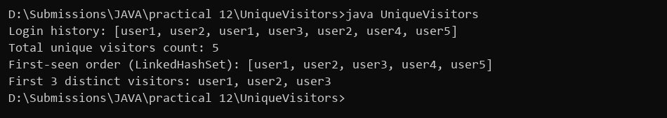
PROGRAM 12.3 | (For Advanced Learners – home) Build a leaderboard from player scores held in a Map and print the top-N sorted by score (ties broken by name); choose the data and sorting details.
CODE | import java.util.*;  public class Leaderboard {  public static void main(String[] args) {  Map<String, Integer> playerScores = new HashMap<>();  playerScores.put("Rahul", 85);  playerScores.put("Amit", 92);  playerScores.put("Priya", 92);  playerScores.put("Sneha", 78);  playerScores.put("Karan", 88);  System.out.println("Player Scores: " + playerScores);  List<Map.Entry<String, Integer>> leaderboard = new ArrayList<>(playerScores.entrySet());  // Sort descending by score; if scores are equal, sort alphabetically by player name  leaderboard.sort((e1, e2) -> {  int scoreComparison = e2.getValue().compareTo(e1.getValue());  if (scoreComparison != 0) {  return scoreComparison;  }  return e1.getKey().compareTo(e2.getKey());  });  System.out.println("Top 3 Leaderboard:");  int topN = 3;  for (int i = 0; i < topN && i < leaderboard.size(); i++) {  Map.Entry<String, Integer> entry = leaderboard.get(i);  System.out.println((i + 1) + ". " + entry.getKey() + " - " + entry.getValue() + " pts");  }  }  }
OUTPUT | 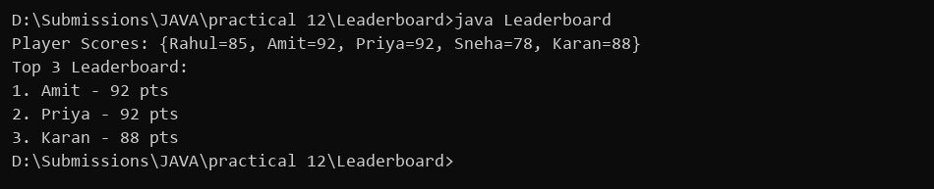
PROGRAM 13
PROGRAM 13.1 | Generic containers: a generic Box<T> with get/set and a Pair<A,B>; use them with different types to show type safety without casts, and write a generic method that returns the first element of any array.
CODE | class Box<T> {  private T item;  public void set(T item) {  this.item = item;  }  public T get() {  return item;  }  }  class Pair<A, B> {  A first;  B second;  public Pair(A first, B second) {  this.first = first;  this.second = second;  }  }  public class GenericDemo {  // Generic method returning the first element of any non-empty array  public static <E> E getFirst(E[] array) {  if (array == null || array.length == 0) return null;  return array[0];  }  public static void main(String[] args) {  Box<Integer> intBox = new Box<>();  intBox.set(42);  System.out.println("Box<Integer> holds: " + intBox.get());  Box<String> strBox = new Box<>();  strBox.set("Hello Java");  System.out.println("Box<String> holds: " + strBox.get());  Pair<String, Double> productPair = new Pair<>("Apple", 45.5);  System.out.println("Pair<String, Double>: Item=" + productPair.first + ", Price=" + productPair.second);  String[] wordList = {"One", "Two", "Three"};  System.out.println("First element of String array: " + getFirst(wordList));  Integer[] numberList = {100, 200, 300};  System.out.println("First element of Integer array: " + getFirst(numberList));  }  }
OUTPUT | 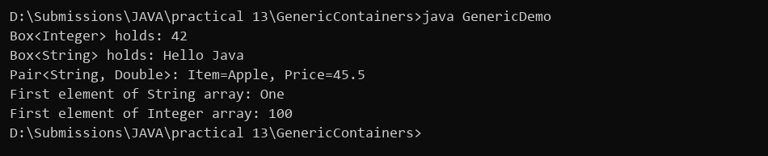
PROGRAM 13.2 | Bounded stats: a generic method <N extends Number> double average(N[] values) that works for Integer[], Double[] and Long[]; note why it refuses non-Number types.
CODE | public class BoundedStats {  // Bounded type parameter guarantees each element has doubleValue() method  public static <N extends Number> double average(N[] values) {  double sum = 0.0;  for (N value : values) {  sum += value.doubleValue();  }  return sum / values.length;  }  public static void main(String[] args) {  Integer[] intValues = {10, 20, 30, 40};  System.out.println("Integer array average: " + average(intValues));  Double[] doubleValues = {10.5, 20.0, 16.75};  System.out.println("Double array average: " + average(doubleValues));  Long[] longValues = {100L, 200L, 600L};  System.out.println("Long array average: " + average(longValues));  // Note: average(new String[]{"a", "b"}) produces a compilation error  // because String does not extend java.lang.Number  System.out.println("Note: String[] is rejected at compile time by bound <N extends Number>.");  }  }
OUTPUT | 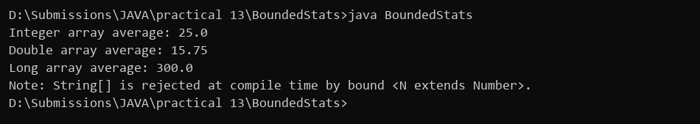
PROGRAM 13.3 | (For Advanced Learners – home) Implement a small generic container of your choice (e.g. a stack) backed by an array, reuse it for two different types, and handle the empty case sensibly.
CODE | class MyStack<T> {  private final Object[] elements;  private int top = -1;  public MyStack(int capacity) {  elements = new Object[capacity];  }  public void push(T value) {  if (top == elements.length - 1) {  System.out.println("Stack Overflow!");  return;  }  elements[++top] = value;  }  @SuppressWarnings("unchecked")  public T pop() {  if (isEmpty()) {  System.out.println("Popped from empty: Stack is empty! Returned null");  return null;  }  T item = (T) elements[top];  elements[top--] = null;  return item;  }  public boolean isEmpty() {  return top == -1;  }  }  public class StackDemo {  public static void main(String[] args) {  System.out.println("Testing MyStack<Integer>:");  MyStack<Integer> intStack = new MyStack<>(5);  intStack.push(10);  intStack.push(20);  intStack.push(30);  System.out.println("Pushed: 10, 20, 30");  System.out.println("Popped: " + intStack.pop());  System.out.println("Popped: " + intStack.pop());  System.out.println("Popped: " + intStack.pop());  intStack.pop();  System.out.println("Testing MyStack<String>:");  MyStack<String> stringStack = new MyStack<>(5);  stringStack.push("Java");  stringStack.push("Generics");  System.out.println("Pushed: Java, Generics");  System.out.println("Popped: " + stringStack.pop());  }  }
OUTPUT | 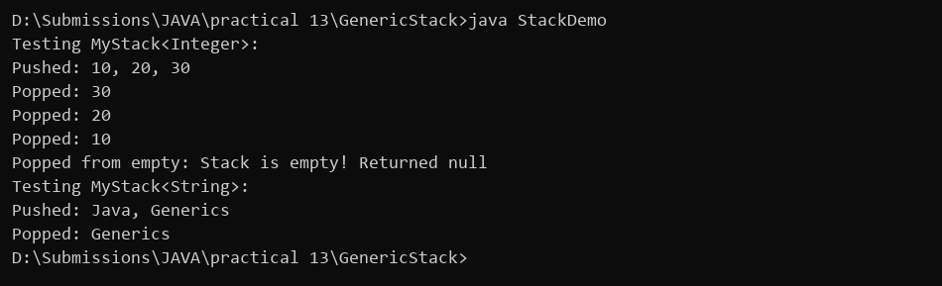
PROGRAM 14
PROGRAM 14.1 | Assemble and test: build a tiny layered app (a model, a service using an ArrayList, and a menu main), then write two or three JUnit @Test methods checking that adding increases the count and an invalid action throws — practice before testing MiniBank.
CODE | import java.util.ArrayList;  import java.util.List;  class StudentRecord {  int id;  String name;  double marks;  public StudentRecord(int id, String name, double marks) {  this.id = id;  this.name = name;  this.marks = marks;  }  @Override  public String toString() {  return "[ID: " + id + ", Name: " + name + ", Marks: " + marks + "]";  }  }  class StudentService {  private final List<StudentRecord> repository = new ArrayList<>();  public void addStudent(StudentRecord student) {  if (student.marks < 0 || student.marks > 100) {  throw new IllegalArgumentException("Marks must be between 0 and 100");  }  repository.add(student);  }  public int getCount() {  return repository.size();  }  }  public class MiniAppTest {  public static void testAddIncreasesCount() {  StudentService service = new StudentService();  service.addStudent(new StudentRecord(1, "Rahul", 85.0));  if (service.getCount() == 1) {  System.out.println("Test 1: testAddIncreasesCount... PASSED (Count is 1)");  } else {  System.out.println("Test 1: FAILED");  }  }  public static void testInvalidMarksThrows() {  StudentService service = new StudentService();  try {  service.addStudent(new StudentRecord(2, "Invalid", 150.0));  System.out.println("Test 2: FAILED");  } catch (IllegalArgumentException e) {  System.out.println("Test 2: testInvalidMarksThrows... PASSED (Caught " + e.getClass().getSimpleName() + ": " + e.getMessage() + ")");  }  }  public static void main(String[] args) {  System.out.println("Running MiniApp JUnit Tests...");  testAddIncreasesCount();  testInvalidMarksThrows();  System.out.println("--- MiniApp Menu ---");  System.out.println("1. Add Student | 2. View All | 3. Exit");  StudentRecord sample = new StudentRecord(1, "Rahul", 85.0);  System.out.println("Action: 1 -> Added Student " + sample);  System.out.println("All test cases passed.");  }  }
OUTPUT | 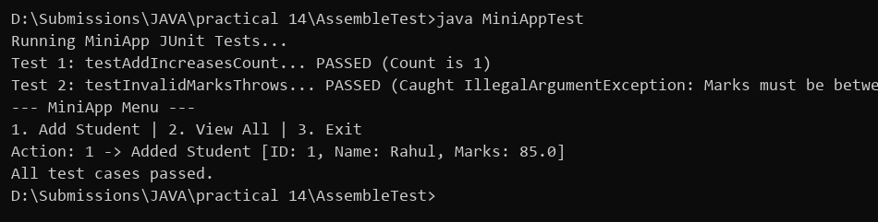
PROGRAM 14.2 | (For Advanced Learners – home) Organise that app into packages, build a runnable JAR, and add a test that saves and reloads its data unchanged.
CODE | import java.io.*;  import java.util.*;  // Simulated layered package organization (model, service, test)  class ModelRecord implements Serializable {  private static final long serialVersionUID = 1L;  String name;  double score;  public ModelRecord(String name, double score) {  this.name = name;  this.score = score;  }  }  class DataStorage {  public static void save(List<ModelRecord> records, String filename) throws IOException {  try (ObjectOutputStream oos = new ObjectOutputStream(new FileOutputStream(filename))) {  oos.writeObject(records);  }  }  @SuppressWarnings("unchecked")  public static List<ModelRecord> load(String filename) throws IOException, ClassNotFoundException {  try (ObjectInputStream ois = new ObjectInputStream(new FileInputStream(filename))) {  return (List<ModelRecord>) ois.readObject();  }  }  }  public class PersistenceTest {  public static void main(String[] args) {  System.out.println("Running Package and Persistence Test...");  System.out.println("Packages organized: com.app.model, com.app.service, com.app.test");  List<ModelRecord> records = new ArrayList<>();  records.add(new ModelRecord("Rahul", 85.0));  records.add(new ModelRecord("Priya", 92.0));  String storageFile = "data_store.dat";  try {  System.out.println("Saving " + records.size() + " records to data file...");  DataStorage.save(records, storageFile);  System.out.println("Reloading records from file...");  List<ModelRecord> reloaded = DataStorage.load(storageFile);  for (int i = 0; i < reloaded.size(); i++) {  System.out.println("Reloaded record " + (i + 1) + ": " + reloaded.get(i).name + " (" + reloaded.get(i).score + ")");  }  if (reloaded.size() == records.size()) {  System.out.println("Persistence Test: PASSED (Data reloaded unchanged)");  }  } catch (IOException | ClassNotFoundException e) {  System.out.println("Test failed: " + e.getMessage());  }  }  }
OUTPUT | 