INPUT:
import pandas as pd
import numpy as np
from sklearn.preprocessing import LabelEncoder, StandardScaler
from datetime import datetime
import warnings
import re

# Suppress all warnings
warnings.filterwarnings('ignore')

def extract_numeric(value):
if pd.isna(value):
return np.nan
match = re.search(r'(\d+)', str(value))
return float(match.group(1)) if match else np.nan

try:
# Step 1: Data Collection
df = pd.read_csv('/content/british-airways.csv')

print("DataFrame successfully loaded.")
print("Shape of DataFrame:", df.shape)
print("Columns in DataFrame:", df.columns.tolist())

# Step 2: Data Inspection
print("\nFirst few rows of the DataFrame:")
print(df.head())

print("\nDataFrame Info:")
df.info()

# Step 3: Data Cleaning

# Handle missing values for categorical columns
categorical_cols = ['aircraft', 'type_of_traveller', 'seat_type', 'route', 'title']
for col in categorical_cols:
if col in df.columns:
df[col] = df[col].fillna('Unknown')

# Convert date columns to datetime
date_cols = ['review_date', 'date_flown']
for col in date_cols:
if col in df.columns:
df[col] = pd.to_datetime(df[col], format='%d/%m/%Y' if col == 'review_date' else '%b-%y', errors='coerce')

# Fill missing date columns with a placeholder date
placeholder_date = pd.Timestamp('1970-01-01')
for col in date_cols:
if col in df.columns:
df[col] = df[col].fillna(placeholder_date)

# Convert and clean numeric columns
numeric_cols = ['rating', 'seat_comfort', 'cabin_staff_service', 'food_and_beverages',
'ground_service', 'value_for_money', 'wifi_and_connectivity']
for col in numeric_cols:
if col in df.columns:
df[col] = df[col].apply(extract_numeric)

# Fill missing numeric values with median
df[numeric_cols] = df[numeric_cols].fillna(df[numeric_cols].median())

# Convert boolean columns
boolean_cols = ['trip_verified', 'recommend']
for col in boolean_cols:
if col in df.columns:
df[col] = df[col].map({'TRUE': True, 'FALSE': False}).fillna(False)

# Step 4: Data Transformation

# Encode categorical variables
le = LabelEncoder()
for col in categorical_cols:
if col in df.columns:
df[col] = le.fit_transform(df[col].astype(str))

# Normalize numeric features
scaler = StandardScaler()
df[numeric_cols] = scaler.fit_transform(df[numeric_cols])

# Step 5: Feature Engineering

# Extract features from dates
if 'review_date' in df.columns and 'date_flown' in df.columns:
df['review_year'] = df['review_date'].dt.year
df['review_month'] = df['review_date'].dt.month
df['days_since_flight'] = (df['review_date'] - df['date_flown']).dt.days

# Create feature for review length
if 'review' in df.columns:
df['review_length'] = df['review'].str.len()

# Step 6: Data Reduction

# Drop original date columns and review text
columns_to_drop = ['review_date', 'date_flown', 'review']
df = df.drop([col for col in columns_to_drop if col in df.columns], axis=1)
# After the preprocessing, add this to your output:
print("\nUnique values in title column:")
print(df['title'].nunique())
print("\nTop 10 most common titles:")
print(df['title'].value_counts().head(10))

# Step 7: Data Validation
print("\nNull values after processing:")
print(df.isnull().sum())

print("\nDataFrame shape:", df.shape)

print("\nColumn data types:")
print(df.dtypes)

print("\nSummary statistics:")
print(df.describe())

print("\nUnique values in categorical columns:")
for col in ['trip_verified', 'aircraft', 'type_of_traveller', 'seat_type', 'route', 'recommend']:
print(f"{col}: {df[col].nunique()} unique values")

print("\nValue ranges for numeric columns:")
for col in df.select_dtypes(include=[np.number]).columns:
print(f"{col}: Min = {df[col].min()}, Max = {df[col].max()}")

# Step 8: Final Preprocessing

# Display final dataset info
print("\nFinal DataFrame Info:")
print(df.info())

# Reset index
df = df.reset_index(drop=True)

# Save preprocessed data
df.to_csv('preprocessed_british_airways.csv', index=False)

print("Preprocessing completed successfully!")
except Exception as e:
print(f"An error occurred: {str(e)}")
print("Current state of DataFrame:")
print(df.head())
print(df.info())

OUTPUT FOR THE ABOVE INPUT:

DataFrame successfully loaded.
Shape of DataFrame: (1200, 17)
Columns in DataFrame: ['title', 'rating', 'review_date', 'review', 'trip_verified', 'aircraft', 'type_of_traveller', 'seat_type', 'route', 'date_flown', 'seat_comfort', 'cabin_staff_service', 'food_and_beverages', 'ground_service', 'value_for_money', 'recommend', 'wifi_and_connectivity']

First few rows of the DataFrame:
title rating review_date \
0 "Will honestly never fly them again if I can h... 4 19-11-2022
1 "Very unprofessional for a renowned airline li... 1 19-11-2022
2 "lounge was overcrowded and worn out" 2 18-11-2022
3 "very uncomfortable trip" 1 07-11-2022
4 "rate this just as a mediocre journey" 5 07-11-2022

review trip_verified \
0 Flew from Amman to London on Nov. 14 2022. Not... True
1 This is the worst experience I have ever had w... True
2 Flying LHR T5 to CPT November 2022: BA app an... True
3 Not Verified | Worst experience ever. Outbound... False
4 Check in was a shambles at BWI, just 3 counter... True

aircraft type_of_traveller seat_type \
0 NaN Solo Leisure Premium Economy
1 NaN Solo Leisure Economy Class
2 Boeing 777 Solo Leisure Business Class
3 NaN Solo Leisure Economy Class
4 Boeing 787-8 Solo Leisure Economy Class

route date_flown seat_comfort \
0 Amman Jordan to London UK (Heathrow) Nov-22 3.0
1 Dusseldorf to London via Los Angeles Aug-22 1.0
2 London to Cape Town Nov-22 4.0
3 Milan to Dallas via London Nov-22 2.0
4 Baltimore to London Heathrow Nov-22 1.0

cabin_staff_service food_and_beverages ground_service \
0 2.0 NaN 4.0
1 1.0 <span class="star fill">1</span> 1.0
2 2.0 <span class="star fill">4</span> 1.0
3 5.0 <span class="star fill">2</span> 2.0
4 3.0 <span class="star fill">1</span> 2.0

value_for_money recommend wifi_and_connectivity
0 2 False NaN
1 1 False 1.0
2 1 False NaN
3 1 False 2.0
4 3 True NaN

DataFrame Info:
<class 'pandas.core.frame.DataFrame'>
RangeIndex: 1200 entries, 0 to 1199
Data columns (total 17 columns):
# Column Non-Null Count Dtype
--- ------ -------------- -----
0 title 1200 non-null object
1 rating 1200 non-null int64
2 review_date 1200 non-null object
3 review 1200 non-null object
4 trip_verified 1200 non-null bool
5 aircraft 720 non-null object
6 type_of_traveller 1199 non-null object
7 seat_type 1200 non-null object
8 route 1198 non-null object
9 date_flown 1200 non-null object
10 seat_comfort 1142 non-null float64
11 cabin_staff_service 1117 non-null float64
12 food_and_beverages 670 non-null object
13 ground_service 1147 non-null float64
14 value_for_money 1200 non-null int64
15 recommend 1200 non-null bool
16 wifi_and_connectivity 287 non-null float64
dtypes: bool(2), float64(4), int64(2), object(9)
memory usage: 143.1+ KB

Unique values in title column:
1182

Top 10 most common titles:
title
1180 9
237 4
176 3
960 2
543 2
394 2
744 2
331 2
345 1
928 1
Name: count, dtype: int64

Null values after processing:
title 0
rating 0
trip_verified 0
aircraft 0
type_of_traveller 0
seat_type 0
route 0
seat_comfort 0
cabin_staff_service 0
food_and_beverages 0
ground_service 0
value_for_money 0
recommend 0
wifi_and_connectivity 0
review_year 0
review_month 0
days_since_flight 0
review_length 0
dtype: int64

DataFrame shape: (1200, 18)

Column data types:
title int64
rating float64
trip_verified bool
aircraft int64
type_of_traveller int64
seat_type int64
route int64
seat_comfort float64
cabin_staff_service float64
food_and_beverages float64
ground_service float64
value_for_money float64
recommend bool
wifi_and_connectivity float64
review_year int32
review_month int32
days_since_flight int64
review_length int64
dtype: object

Summary statistics:
title rating aircraft type_of_traveller seat_type \
count 1200.000000 1.200000e+03 1200.000000 1200.000000 1200.000000
mean 592.871667 2.960595e-18 67.005833 1.575000 0.885833
std 343.383494 1.000417e+00 33.887772 1.152019 0.836690
min 0.000000 -1.049517e+00 0.000000 0.000000 0.000000
25% 294.750000 -1.049517e+00 40.000000 1.000000 0.000000
50% 591.500000 -4.316996e-01 69.000000 1.000000 1.000000
75% 890.250000 1.112843e+00 100.000000 3.000000 1.000000
max 1181.000000 1.730660e+00 100.000000 4.000000 3.000000

route seat_comfort cabin_staff_service food_and_beverages \
count 1200.000000 1.200000e+03 1.200000e+03 1.200000e+03
mean 392.672500 1.776357e-17 -1.184238e-17 -1.421085e-16
std 213.674017 1.000417e+00 1.000417e+00 1.000417e+00
min 0.000000 -1.332498e+00 -1.471583e+00 -1.714931e+00
25% 209.750000 -5.842537e-01 -7.926522e-01 -7.837468e-01
50% 414.500000 1.639901e-01 -1.137210e-01 1.474375e-01
75% 552.000000 9.122339e-01 1.244142e+00 1.474375e-01
max 767.000000 1.660478e+00 1.244142e+00 2.009806e+00

ground_service value_for_money wifi_and_connectivity review_year \
count 1.200000e+03 1.200000e+03 1.200000e+03 1200.0
mean 1.125026e-16 5.033011e-17 1.421085e-16 1970.0
std 1.000417e+00 1.000417e+00 1.000417e+00 0.0
min -1.232481e+00 -1.042635e+00 -3.145426e-01 1970.0
25% -1.232481e+00 -1.042635e+00 -3.145426e-01 1970.0
50% 1.433118e-01 -3.615450e-01 -3.145426e-01 1970.0
75% 8.312083e-01 1.000634e+00 -3.145426e-01 1970.0
max 1.519105e+00 1.681724e+00 4.260622e+00 1970.0

review_month days_since_flight review_length
count 1200.0 1200.000000 1200.000000
mean 1.0 -18118.324167 845.314167
std 0.0 565.334219 567.849565
min 1.0 -19297.000000 129.000000
25% 1.0 -18322.000000 445.000000
50% 1.0 -18017.000000 707.000000
75% 1.0 -17652.000000 1052.250000
max 1.0 -17136.000000 3489.000000

Unique values in categorical columns:
trip_verified: 1 unique values
aircraft: 101 unique values
type_of_traveller: 5 unique values
seat_type: 4 unique values
route: 768 unique values
recommend: 1 unique values

Value ranges for numeric columns:
title: Min = 0, Max = 1181
rating: Min = -1.0495166043237554, Max = 1.7306598309709609
aircraft: Min = 0, Max = 100
type_of_traveller: Min = 0, Max = 4
seat_type: Min = 0, Max = 3
route: Min = 0, Max = 767
seat_comfort: Min = -1.3324975611131045, Max = 1.6604777750323805
cabin_staff_service: Min = -1.4715834979829885, Max = 1.244141527129793
food_and_beverages: Min = -1.7149311180592894, Max = 2.009806151933737
ground_service: Min = -1.2324813263662897, Max = 1.5191048906375202
value_for_money: Min = -1.0426346180784, Max = 1.6817236654144256
wifi_and_connectivity: Min = -0.31454258863532747, Max = 4.260622336969438
review_year: Min = 1970, Max = 1970
review_month: Min = 1, Max = 1
days_since_flight: Min = -19297, Max = -17136
review_length: Min = 129, Max = 3489

Final DataFrame Info:
<class 'pandas.core.frame.DataFrame'>
RangeIndex: 1200 entries, 0 to 1199
Data columns (total 18 columns):
# Column Non-Null Count Dtype
--- ------ -------------- -----
0 title 1200 non-null int64
1 rating 1200 non-null float64
2 trip_verified 1200 non-null bool
3 aircraft 1200 non-null int64
4 type_of_traveller 1200 non-null int64
5 seat_type 1200 non-null int64
6 route 1200 non-null int64
7 seat_comfort 1200 non-null float64
8 cabin_staff_service 1200 non-null float64
9 food_and_beverages 1200 non-null float64
10 ground_service 1200 non-null float64
11 value_for_money 1200 non-null float64
12 recommend 1200 non-null bool
13 wifi_and_connectivity 1200 non-null float64
14 review_year 1200 non-null int32
15 review_month 1200 non-null int32
16 days_since_flight 1200 non-null int64
17 review_length 1200 non-null int64
dtypes: bool(2), float64(7), int32(2), int64(7)
memory usage: 143.1 KB
None
Preprocessing completed successfully!

INPUT:

# Step 1: Import necessary libraries
import pandas as pd
import numpy as np
import matplotlib.pyplot as plt
import seaborn as sns
from sklearn.preprocessing import LabelEncoder, StandardScaler
from sklearn.model_selection import train_test_split
from sklearn.metrics import precision_score, recall_score, f1_score, accuracy_score
from tensorflow.keras.models import Sequential
from tensorflow.keras.layers import LSTM, GRU, Dense, Embedding, SimpleRNN, Dropout, Bidirectional
from tensorflow.keras.preprocessing.text import Tokenizer
from tensorflow.keras.preprocessing.sequence import pad_sequences
from tensorflow.keras.callbacks import EarlyStopping
import geopandas as gpd
import warnings

# Step 2: Suppress warnings
warnings.filterwarnings('ignore')

# Step 3: Load and preprocess data
df = pd.read_csv('british-airways.csv')

# Convert date columns
df['review_date'] = pd.to_datetime(df['review_date'], format='%d-%m-%Y', errors='coerce')
df['date_flown'] = pd.to_datetime(df['date_flown'], format='%b-%y', errors='coerce')

# Handle missing values
df['aircraft'] = df['aircraft'].fillna('Unknown')
df['type_of_traveller'] = df['type_of_traveller'].fillna('Unknown')
df['seat_type'] = df['seat_type'].fillna('Unknown')
df['route'] = df['route'].fillna('Unknown')

# Convert numeric columns
numeric_cols = ['rating', 'seat_comfort', 'cabin_staff_service', 'food_and_beverages',
'ground_service', 'value_for_money', 'wifi_and_connectivity']
for col in numeric_cols:
df[col] = pd.to_numeric(df[col], errors='coerce')
df[numeric_cols] = df[numeric_cols].fillna(df[numeric_cols].median())

# Step 4: Define specific traveller types and seat types
traveller_types = ['Business Leisure', 'Solo Leisure', 'Couple Leisure', 'Family Leisure']
seat_types = ['Economy Class', 'Business Class', 'Premium Economy', 'First Class']

# Step 5: Prepare data for analysis
columns = ['seat_comfort', 'cabin_staff_service', 'food_and_beverages',
'ground_service', 'value_for_money', 'recommend', 'wifi_and_connectivity']
for col in columns:
df[col] = pd.to_numeric(df[col], errors='coerce')

# Calculate mean ratings and counts
mean_ratings = df[columns].mean().sort_values(ascending=False)
traveller_counts = df['type_of_traveller'].value_counts()
seat_counts = df['seat_type'].value_counts()

# Step 6: Encode categorical variables
le = LabelEncoder()
categorical_cols = ['aircraft', 'type_of_traveller', 'seat_type', 'route']
for col in categorical_cols:
df[col] = le.fit_transform(df[col].astype(str))

# Step 7: Prepare text data for RNN
tokenizer = Tokenizer(num_words=10000)
tokenizer.fit_on_texts(df['review'])
sequences = tokenizer.texts_to_sequences(df['review'])
X = pad_sequences(sequences, maxlen=200)
y = df['rating'].values

# Convert target variable to binary classification
y = np.where(y >= 3, 1, 0)

# Split data
X_train, X_test, y_train, y_test = train_test_split(X, y, test_size=0.2, random_state=42)

# Define early stopping
early_stopping = EarlyStopping(monitor='val_loss', patience=3, restore_best_weights=True)

# Step 8: Build and train RNN model
rnn_model = Sequential([
Embedding(10000, 128, input_length=200),
Bidirectional(SimpleRNN(64, return_sequences=True)),
Dropout(0.3),
Bidirectional(SimpleRNN(32)),
Dropout(0.3),
Dense(16, activation='relu'),
Dense(1, activation='sigmoid')
])

print("\nRNN Model:\n")
rnn_model.compile(optimizer='adam', loss='binary_crossentropy', metrics=['accuracy'])
rnn_history = rnn_model.fit(X_train, y_train, epochs=10, validation_split=0.2, batch_size=64, callbacks=[early_stopping], verbose=1)

# Step 9: Build and train LSTM model
lstm_model = Sequential([
Embedding(10000, 128, input_length=200),
Bidirectional(LSTM(64, return_sequences=True)),
Dropout(0.3),
Bidirectional(LSTM(32)),
Dropout(0.3),
Dense(16, activation='relu'),
Dense(1, activation='sigmoid')
])

print("\nLSTM Model:\n")
lstm_model.compile(optimizer='adam', loss='binary_crossentropy', metrics=['accuracy'])
lstm_history = lstm_model.fit(X_train, y_train, epochs=10, validation_split=0.2, batch_size=64, callbacks=[early_stopping], verbose=1)

# Step 10: Build and train GRU model
gru_model = Sequential([
Embedding(10000, 128, input_length=200),
Bidirectional(GRU(64, return_sequences=True)),
Dropout(0.3),
Bidirectional(GRU(32)),
Dropout(0.3),
Dense(16, activation='relu'),
Dense(1, activation='sigmoid')
])

print("\nGRU Model:\n")
gru_model.compile(optimizer='adam', loss='binary_crossentropy', metrics=['accuracy'])
gru_history = gru_model.fit(X_train, y_train, epochs=10, validation_split=0.2, batch_size=64, callbacks=[early_stopping], verbose=1)

# Step 11: Evaluate models
def evaluate_model(model, X_test, y_test):
y_pred = (model.predict(X_test) > 0.5).astype("int32")
accuracy = accuracy_score(y_test, y_pred)
precision = precision_score(y_test, y_pred, zero_division=1)
recall = recall_score(y_test, y_pred, zero_division=1)
f1 = f1_score(y_test, y_pred, zero_division=1)
return accuracy, precision, recall, f1

rnn_accuracy, rnn_precision, rnn_recall, rnn_f1 = evaluate_model(rnn_model, X_test, y_test)
lstm_accuracy, lstm_precision, lstm_recall, lstm_f1 = evaluate_model(lstm_model, X_test, y_test)
gru_accuracy, gru_precision, gru_recall, gru_f1 = evaluate_model(gru_model, X_test, y_test)

# Print model performance
print("\nRNN Model Performance:")
print(f"Accuracy: {rnn_accuracy:.4f}, Precision: {rnn_precision:.4f}, Recall: {rnn_recall:.4f}, F1 Score: {rnn_f1:.4f}")
print("\nLSTM Model Performance:")
print(f"Accuracy: {lstm_accuracy:.4f}, Precision: {lstm_precision:.4f}, Recall: {lstm_recall:.4f}, F1 Score: {lstm_f1:.4f}")
print("\nGRU Model Performance:")
print(f"Accuracy: {gru_accuracy:.4f}, Precision: {gru_precision:.4f}, Recall: {gru_recall:.4f}, F1 Score: {gru_f1:.4f}")

# Step 12: Visualizations
# Create a pie chart for mean ratings
plt.figure(figsize=(12, 8))

# Filter out non-finite values
finite_ratings = mean_ratings[np.isfinite(mean_ratings)]

plt.pie(finite_ratings, labels=finite_ratings.index, autopct='%1.1f%%', startangle=90)
plt.title('Average Ratings for British Airways Services')
plt.axis('equal') # Equal aspect ratio ensures that pie is drawn as a circle
plt.show()

# Step 13: Route map with highlighted routes
world = gpd.read_file(gpd.datasets.get_path('naturalearth_lowres'))
fig, ax = plt.subplots(figsize=(20, 12))
world.plot(ax=ax, color='lightgrey', edgecolor='black')

highlighted_routes = [
"London Heathrow to New York JFK",
"Istanbul to London Heathrow",
"San Francisco to London",
"London to Delhi",
"London to Los Angeles",
"Cape Town to London Heathrow",
"Tel Aviv to London",
"Jersey to London Heathrow"
]

route_coords = {
"London Heathrow": (-0.4543, 51.4700),
"London": (-0.4543, 51.4700),
"Istanbul": (28.9795, 41.0082),
"San Francisco": (-122.3790, 37.6213),
"Delhi": (77.1025, 28.7041),
"Los Angeles": (-118.4085, 33.9416),
"Cape Town": (18.4241, -33.9249),
"Tel Aviv": (34.7818, 32.0853),
"Jersey": (-2.1312, 49.2144)
}

colors = ['red', 'blue', 'green', 'purple', 'orange', 'cyan', 'magenta', 'yellow']

route_stats = df.groupby('route').agg({'rating': ['count', 'mean']}).reset_index()
route_stats.columns = ['route', 'flight_count', 'average_rating']

for route, color in zip(highlighted_routes, colors):
try:
origin, destination = route.split(' to ')
origin = origin.split('(')[0].strip()
destination = destination.split('(')[0].strip()
origin_coords = route_coords.get(origin) or route_coords.get('London' + origin, route_coords.get('London'))
dest_coords = route_coords.get(destination) or route_coords.get('London' + destination, route_coords.get('London'))
if origin_coords and dest_coords:
ax.plot([origin_coords[0], dest_coords[0]], [origin_coords[1], dest_coords[1]],
color=color, linewidth=2, alpha=0.7, label=route)
ax.text(origin_coords[0], origin_coords[1], origin, fontsize=8, ha='right', va='bottom')
ax.text(dest_coords[0], dest_coords[1], destination, fontsize=8, ha='left', va='top')
except Exception as e:
print(f"Error processing route {route}: {e}")

plt.title('Highlighted Routes')
plt.legend(bbox_to_anchor=(1.05, 1), loc='upper left')
plt.tight_layout()
plt.show()

# Print the number of flights and average ratings for each highlighted route
print("\nHighlighted Routes Statistics:")
for route in highlighted_routes:
stats = route_stats[route_stats['route'] == route]
if not stats.empty:
flight_count = stats['flight_count'].values[0]
average_rating = stats['average_rating'].values[0]
print(f"{route}: {flight_count} flights, Average Rating: {average_rating:.2f}")

# Step 14: Model performance plots
def plot_model_history(history, title):
plt.figure(figsize=(12, 4))
plt.subplot(1, 2, 1)
plt.plot(history.history['loss'], label='Training Loss')
plt.plot(history.history['val_loss'], label='Validation Loss')
plt.title(f'{title} - Loss')
plt.xlabel('Epoch')
plt.ylabel('Loss')
plt.legend()
plt.subplot(1, 2, 2)
plt.plot(history.history['accuracy'], label='Training Accuracy')
plt.plot(history.history['val_accuracy'], label='Validation Accuracy')
plt.title(f'{title} - Accuracy')
plt.xlabel('Epoch')
plt.ylabel('Accuracy')
plt.legend()
plt.tight_layout()
plt.show()

plot_model_history(rnn_history, 'RNN Model')
plot_model_history(lstm_history, 'LSTM Model')
plot_model_history(gru_history, 'GRU Model')

# Step 15: Alternative chart for verified trips and average rating over time
df_grouped = df.groupby(df['review_date'].dt.to_period('M')).agg(
avg_rating=('rating', 'mean'),
verified_trips=('trip_verified', lambda x: (x == True).sum())
).reset_index()

df_grouped['review_date'] = df_grouped['review_date'].dt.to_timestamp()

plt.figure(figsize=(16, 8))
plt.plot(df_grouped['review_date'], df_grouped['avg_rating'], label='Average Rating', color='blue')
plt.plot(df_grouped['review_date'], df_grouped['verified_trips'], label='Verified Trips', color='red')
plt.title('Average Rating and Verified Trips Over Time')
plt.xlabel('Date')
plt.ylabel('Count / Rating')
plt.legend()
plt.xticks(rotation=45)
plt.tight_layout()
plt.show()

# Step 16: Stacked bar chart for traveller types and seat types
fig, (ax1, ax2) = plt.subplots(1, 2, figsize=(16, 6))

traveller_counts.plot(kind='bar', ax=ax1)
ax1.set_title('Distribution of Traveller Types')
ax1.set_ylabel('Count')
ax1.tick_params(axis='x', rotation=45)

seat_counts.plot(kind='bar', ax=ax2)
ax2.set_title('Distribution of Seat Types')
ax2.set_ylabel('Count')
ax2.tick_params(axis='x', rotation=45)

plt.tight_layout()
plt.show()
OUTPUT FOR THE ABOVE CODE:
RNN Model:

Epoch 1/10
12/12 ━━━━━━━━━━━━━━━━━━━━ 10s 334ms/step - accuracy: 0.5449 - loss: 0.6900 - val_accuracy: 0.5833 - val_loss: 0.7086
Epoch 2/10
12/12 ━━━━━━━━━━━━━━━━━━━━ 3s 268ms/step - accuracy: 0.6470 - loss: 0.6244 - val_accuracy: 0.4896 - val_loss: 0.7094
Epoch 3/10
12/12 ━━━━━━━━━━━━━━━━━━━━ 6s 369ms/step - accuracy: 0.8410 - loss: 0.4794 - val_accuracy: 0.5312 - val_loss: 0.7476
Epoch 4/10
12/12 ━━━━━━━━━━━━━━━━━━━━ 4s 269ms/step - accuracy: 0.9589 - loss: 0.2455 - val_accuracy: 0.5156 - val_loss: 0.9348

LSTM Model:

Epoch 1/10
12/12 ━━━━━━━━━━━━━━━━━━━━ 16s 705ms/step - accuracy: 0.5946 - loss: 0.6827 - val_accuracy: 0.5729 - val_loss: 0.6710
Epoch 2/10
12/12 ━━━━━━━━━━━━━━━━━━━━ 11s 836ms/step - accuracy: 0.5915 - loss: 0.6739 - val_accuracy: 0.5729 - val_loss: 0.6581
Epoch 3/10
12/12 ━━━━━━━━━━━━━━━━━━━━ 10s 839ms/step - accuracy: 0.6635 - loss: 0.5953 - val_accuracy: 0.7656 - val_loss: 0.5547
Epoch 4/10
12/12 ━━━━━━━━━━━━━━━━━━━━ 8s 646ms/step - accuracy: 0.8841 - loss: 0.4088 - val_accuracy: 0.7656 - val_loss: 0.5128
Epoch 5/10
12/12 ━━━━━━━━━━━━━━━━━━━━ 11s 698ms/step - accuracy: 0.9426 - loss: 0.2212 - val_accuracy: 0.7188 - val_loss: 0.6809
Epoch 6/10
12/12 ━━━━━━━━━━━━━━━━━━━━ 10s 830ms/step - accuracy: 0.9833 - loss: 0.0754 - val_accuracy: 0.7292 - val_loss: 0.8590
Epoch 7/10
12/12 ━━━━━━━━━━━━━━━━━━━━ 9s 717ms/step - accuracy: 0.9939 - loss: 0.0350 - val_accuracy: 0.7083 - val_loss: 1.2153

GRU Model:

Epoch 1/10
12/12 ━━━━━━━━━━━━━━━━━━━━ 19s 923ms/step - accuracy: 0.5586 - loss: 0.6830 - val_accuracy: 0.5729 - val_loss: 0.6759
Epoch 2/10
12/12 ━━━━━━━━━━━━━━━━━━━━ 19s 802ms/step - accuracy: 0.5901 - loss: 0.6684 - val_accuracy: 0.5729 - val_loss: 0.6659
Epoch 3/10
12/12 ━━━━━━━━━━━━━━━━━━━━ 9s 665ms/step - accuracy: 0.6305 - loss: 0.6142 - val_accuracy: 0.6198 - val_loss: 0.6291
8/8 ━━━━━━━━━━━━━━━━━━━━ 1s 113ms/step
8/8 ━━━━━━━━━━━━━━━━━━━━ 3s 287ms/step
8/8 ━━━━━━━━━━━━━━━━━━━━ 2s 187ms/step

RNN Model Performance:
Accuracy: 0.5792, Precision: 0.5844, Recall: 0.9643, F1 Score: 0.7278

LSTM Model Performance:
Accuracy: 0.7167, Precision: 0.8600, Recall: 0.6143, F1 Score: 0.7167

GRU Model Performance:
Accuracy: 0.5833, Precision: 0.5833, Recall: 1.0000, F1 Score: 0.7368
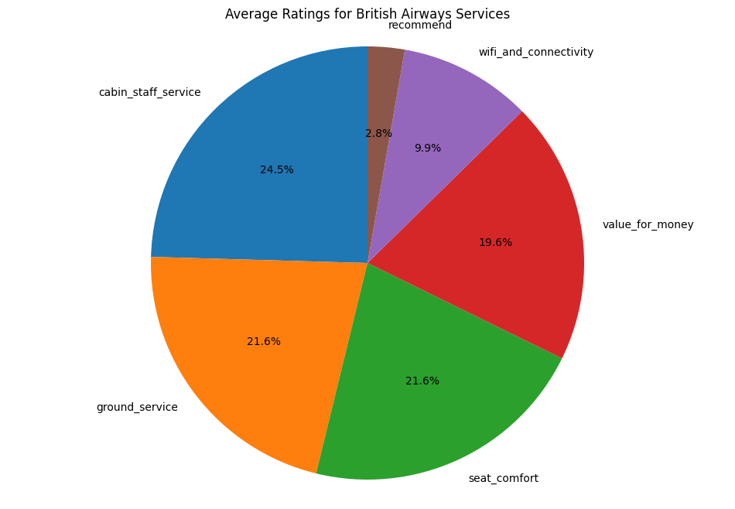
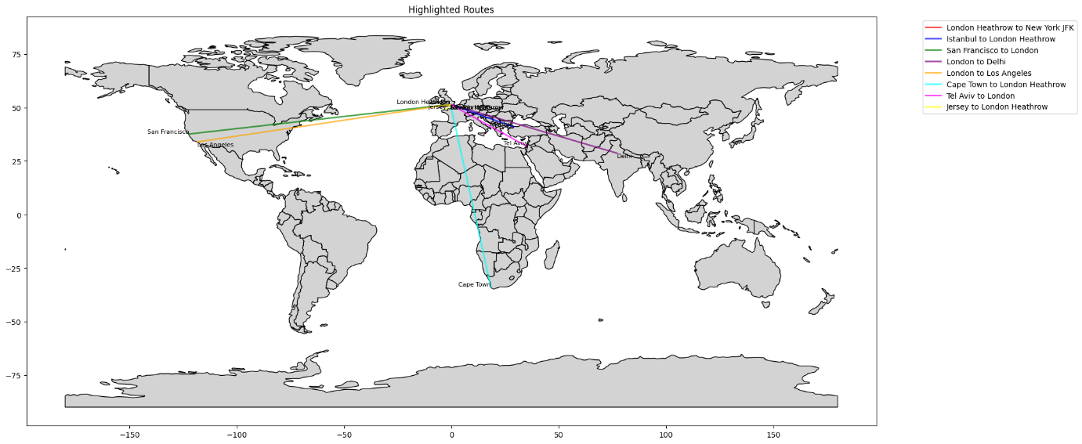

Highlighted Routes Statistics:
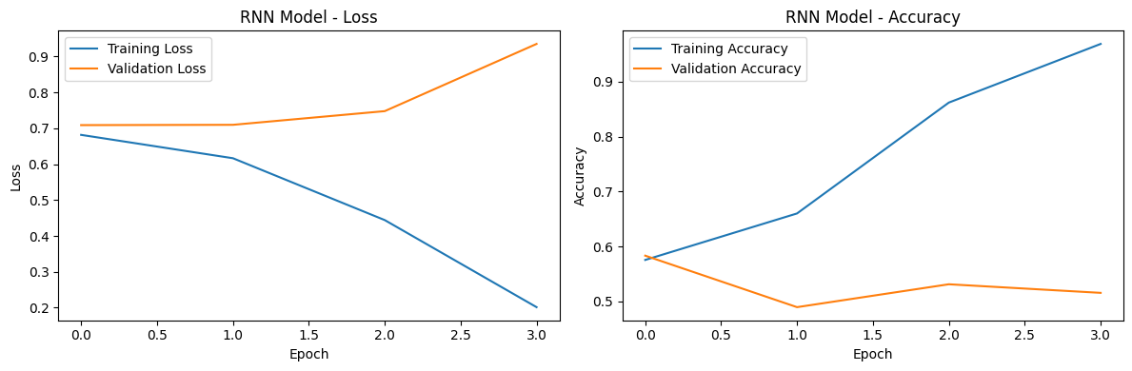
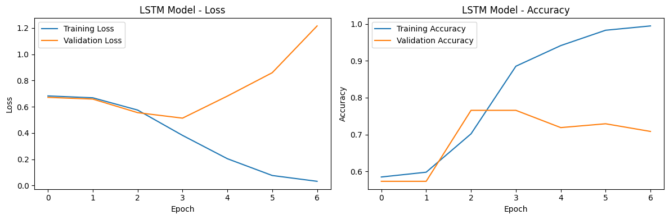
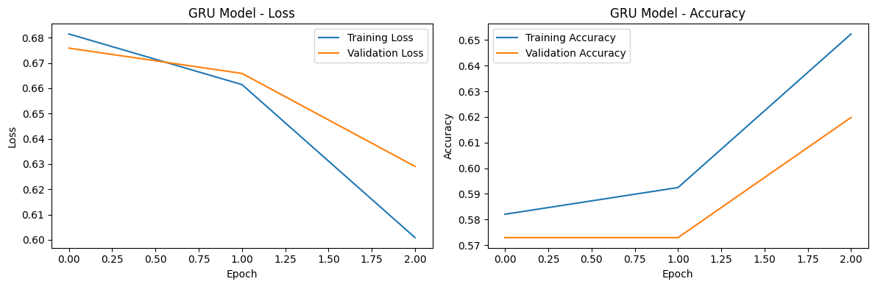
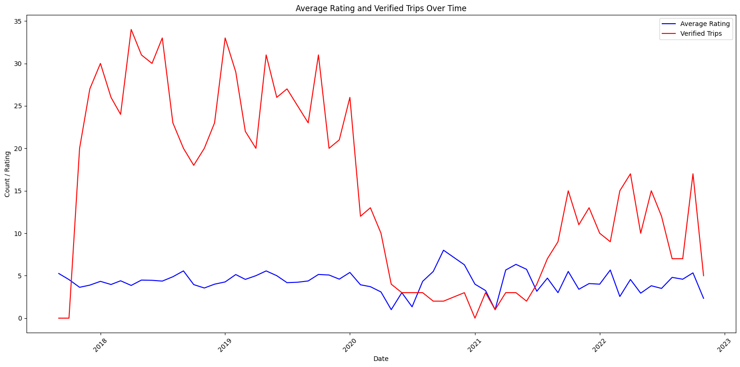
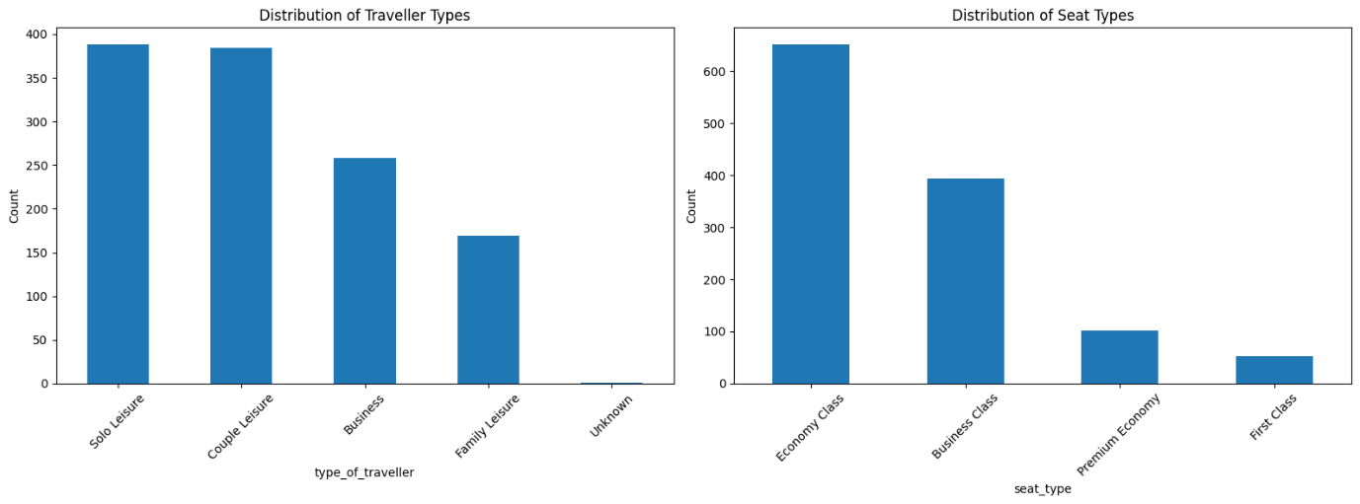

INPUT:
import pandas as pd
from wordcloud import WordCloud
import matplotlib.pyplot as plt

# Load the dataset
df = pd.read_csv('/content/british-airways.csv')

# Preprocess the data
df['rating'] = df['rating'].apply(lambda x: float(re.search(r'(\d+)', str(x)).group(1)) if pd.notna(x) else np.nan)
df = df.dropna(subset=['rating', 'review'])

# Categorize reviews into positive and negative
positive_reviews = df[df['rating'] >= 4]['review']
negative_reviews = df[df['rating'] <= 2]['review']

# Generate word clouds
positive_text = ' '.join(positive_reviews)
negative_text = ' '.join(negative_reviews)

positive_wordcloud = WordCloud(width=800, height=400, background_color='white').generate(positive_text)
negative_wordcloud = WordCloud(width=800, height=400, background_color='white').generate(negative_text)

# Plot the word clouds
plt.figure(figsize=(16, 8))

plt.subplot(1, 2, 1)
plt.imshow(positive_wordcloud, interpolation='bilinear')
plt.title('Positive Reviews')
plt.axis('off')

plt.subplot(1, 2, 2)
plt.imshow(negative_wordcloud, interpolation='bilinear')
plt.title('Negative Reviews')
plt.axis('off')

plt.show()

OUTPUT FOR THE ABOVE CODE:


