**EXPLAINABLE ARTIFICIAL INTELLIGENCE**

MINI PROJECT REPORT

Submitted By

# ABHINAV R(MCC21CS004)

# ABHIRAGH A R(MCC21CS005)

# ALFIN MUHAMMED N S(MCC21CS012)

# ASWATHY M L(MCC21CS021)

**to**

The APJ Abdul Kalam Technological University

In partial fulfilment of the requirements for the award of the Degree

of

Bachelor of Technology

In

*Computer Science and Engineering*

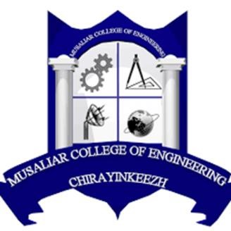

# DEPARTMENT OF COMPUTER SCIENCE AND ENGINEERING

MUSALIAR COLLEGE OF ENGINEERING

KADAKAM P.O CHIRAYINKEEZHU, TRIVANDRUM 695304

May 2024

**DECLARATION**

We undersigned hereby declare that the project report **“EXPLAINABLE ARTIFICIAL INTELLIGENCE”**, submitted for partial fulfilment of the requirements for the award of degree of Master of Technology of the APJ Abdul Kalam Technological University, Kerala is a bonafide work done by us under supervision of Mrs. Labeeba Vahid. This submission represents our ideas in our own words and where ideas or words of others have been included, we have adequately and accurately cited and referenced the original sources. we also declare that we have adhered to ethics of academic honesty and integrity and have not misrepresented or fabricated any data or idea or fact or source in my submission. We understand that any violation of the above will be a cause for disciplinary action by the institute and/or the University and can also evoke penal action from the sources which have thus not been properly cited or from whom proper permission has not been obtained. This report has not been previously formed the basis for the award of any degree, diploma or similar title of any other University.

**ABHINAV R(MCC21CS004)**

**ABHIRAGH A R (MCC21CS005)**

**ALFIN MUHAMMED N S (MCC21CS012)**

**ASWATHY M L (MCC21CS021)**

# DEPARTMENT OF COMPUTER SCIENCE AND ENGINEERING MUSALIAR COLLEGE OF ENGINEERING KADAKAM P.O CHIRAYINKEEZHU, TRIVANDRUM 695304



# CERTIFICATE

This is to certify that, the project report entitled ‘**EXPLAINABLE ARTIFICIAL INTELLIGENCE’,** is a Bonafide record of the CSD334 Project presented by **ABHINAV R(MCC21CS004), ABHIRAGH A R(MCC21CS005),ALFIN MUHAMMED N S(MCC21CS012), ASWATHY M L(MCC21CS021)** ofSixth Semester B. Tech. Computer Science & Engineering students, under our guidance and super vision, in partial fulfilment of the requirements for the award of the degree, B. Tech. Computer Science & Engineering of APJ Abdul Kalam Technological University.

**Mrs. Labeeba Vahid Mrs. Aswathy Gandhi Mrs. Remya R S**

**Project Guide Project Coordinator Head of the Department**

Assistant Professor Assistant Professor Department of CSE

Department of CSE Department of CSE