**EDGE COMPUTING TECHNOLOGY ENABLERS**

SEMINAR REPORT

Submitted By

# ABHIRAGH A R

# MCC21CS005

Under The Guidance of

Prof. Remya R S

**to**

The APJ Abdul Kalam Technological University

In partial fulfilment of the requirements for the award of the Degree

of

Bachelor of Technology

In

*Computer Science and Engineering*

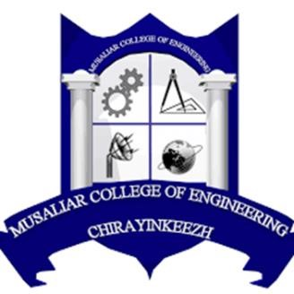

# DEPARTMENT OF COMPUTER SCIENCE AND ENGINEERING

MUSALIAR COLLEGE OF ENGINEERING

KADAKAM P.O CHIRAYINKEEZHU, TRIVANDRUM 695304

Oct 2024

# ACKNOWLEDGEMENT

On submission of this report, I am greatly indebted to all those who helped to complete the seminar on “Edge Computing Technology Enablers”.

First and foremost, let me thank Lord Almighty for all his blessings in every step of my way. I would like to express my sincere gratitude to Dr. K. K. Abdul Rasheed, Principal of Musaliar College of Engineering for providing constant support and encouragement throughout the course of my seminar. Let me also express my deep and sincere gratitude to Mrs. Remya.R.S, Head of the Department, Computer Science and Engineering for giving me technical advice and timely instructions, without which I could never have been able to complete the work on time. I would like to thank the Seminar Coordinator Mrs. Labeeba Vahid ,Assistant Professor, Department of Computer Science and Engineering for all the guidance and instructions through various phases of my study and motivation in completing the seminar. I would also like to express my indebtedness and sincere thanks to my Seminar Guide , Mrs. Remya R S , Head Of the Department, Department of Computer Science and Engineering , whose tutelage proffered generous guidance, useful suggestions along with continuous inspiration.

Let me next extend my sincere thanks to the entire faculty and staff of the Department of Computer Science and Engineering, for their ever-present encouragement and support. Last but not the least I would like to thank, my parents and friends for all their love and moral support during the preparation of this seminar.

**ABHIRAGH A R**

**MCC21CS005**

**DEPT OF CSE**

# DEPARTMENT OF COMPUTER SCIENCE AND ENGINEERING MUSALIAR COLLEGE OF ENGINEERING KADAKAM P.O CHIRAYINKEEZHU, TRIVANDRUM 695304



# CERTIFICATE

This is to certify that, the report entitled ‘**EDGE COMPUTING TECHNOLOGY ENABLERS’,** is a bonafide record of the seminar presented by **ABHIRAGH A R(MCC21CS005)** ofSeventh Semester B. Tech. Computer Science & Engineering students, under our guidance and super vision, in partial fulfilment of the requirements for the award of the degree, B. Tech. Computer Science & Engineering of APJ Abdul Kalam Technological University.

**Mrs. Remya R S Mrs. Labeeba Vahid Mrs. Remya R S**

**Seminar Guide Seminar Coordinator Head of the Department**

Head of the Department Assistant Professor Department of CSE

Department of CSE Department of CSE