## CHAPTER 1

## INTRODUCTION

The rapid evolution of technology in the modern world is driven by a variety of factors, including the explosive growth of connected devices, the rise of Internet of Things (IoT) systems, and the increasing demand for real-time data processing. As more industries and businesses integrate these technologies, traditional computing paradigms are struggling to keep up with the stringent Quality of Service (QoS) requirements. These include demands for ultra-low latency, high bandwidth, minimal jitter, and robust real-time data processing. Centralized cloud computing, once the dominant force in data storage and processing, is finding it increasingly difficult to meet these requirements due to its inherent limitations such as network congestion, high latency, and bandwidth constraints.

By 2025, it is estimated that 75% of all data generated by enterprises will be processed at the edge of the network rather than in traditional cloud data center. This shift from centralized to decentralized computing architectures represents a critical transformation in how data is processed, analyzed, and stored. Enterprises across a wide range of industries—from healthcare and smart cities to manufacturing and autonomous vehicles—are driving this transition, seeking solutions that minimize latency, optimize bandwidth, and ensure real-time decision-making capabilities. Edge Computing (EC) emerges as a powerful response to these demands, offering a novel paradigm that brings computation closer to the data source.

**1.1 CENTRALIZED CLOUD COMPUTING: A BOTTLENECK IN THE DIGITAL AGE**

Cloud computing has served as the backbone of modern computing infrastructure, enabling companies to store and process vast amounts of data in remote, centralized data centers. By offloading computation to the cloud, businesses have been able to scale their operations, improve efficiency, and reduce costs. However, as the number of connected devices and IoT systems has grown, this centralized model has shown significant limitations.

One of the primary challenges with centralized cloud computing is latency. Data generated by devices in remote locations needs to travel long distances to centralized cloud servers, resulting in delays that are unacceptable for applications that require near-instantaneous responses. For example, autonomous vehicles rely on real-time sensor data to make split-second decisions that can be the difference between a safe journey and a collision. Even a delay of a few milliseconds in processing this data can result in disastrous consequences. Similarly, healthcare applications, such as real-time monitoring of patient vitals, require immediate responses to ensure proper care and treatment.

Another key limitation is network congestion. The traditional cloud model funnels all data through central servers, which can lead to bottlenecks, particularly in regions with inadequate infrastructure. With the rise of IoT devices, which are constantly generating large volumes of data, the centralized model struggles to manage this load efficiently. This is exacerbated by the need for high bandwidth, as many modern applications involve transmitting massive datasets, such as high-definition video feeds, across the network. Managing such large volumes of data not only increase latency but also leads to higher operational costs for businesses.

Moreover, the centralized nature of cloud computing raises concerns regarding data privacy and security. Transmitting sensitive information over long distances to central servers introduces multiple points of vulnerability, making it easier for attackers to intercept or tamper with data. Industries that handle highly sensitive data, such as healthcare and finance, are particularly concerned about these risks.

**1.2 THE EMERGENCE OF EDGE COMPUTING**

To address these limitations, Edge Computing has emerged as a transformative paradigm. Edge Computing brings data storage and processing closer to the end-users, effectively minimizing the distance data must travel and thereby reducing latency. Instead of relying on remote cloud servers to perform computational tasks, EC leverages edge nodes—servers, gateways, or other computational devices located near the data source—to process and store data locally. This shift reduces the reliance on centralized cloud infrastructures, alleviating network congestion, lowering operational costs, and significantly improving response times.

In its essence, Edge Computing decentralizes computation by moving it away from core data centers and distributing it across the network’s edge. The "edge" refers to the boundary between the local network (where IoT devices, smartphones, sensors, etc., reside) and the broader internet. By processing data at or near the source of generation, EC enables faster decision-making and enhances the performance of applications that require real-time data analysis.

EC is not intended to completely replace cloud computing but rather to complement it. While the cloud remains a crucial component for long-term data storage and large-scale processing tasks, Edge Computing handles time-sensitive tasks that require immediate processing. This hybrid approach ensures that the strengths of both centralized and decentralized models are leveraged, resulting in a more efficient and resilient computing ecosystem.

**1.3 ADVANTAGES OF EDGE COMPUTING**

Edge Computing offers several distinct advantages over traditional cloud computing, making it particularly well-suited for modern applications that demand low latency, real-time processing, and high bandwidth.

1. Reduced Latency: The most significant advantage of EC is the reduction in latency. By processing data closer to the source, EC eliminates the need for data to travel long distances to centralized servers. This is crucial for applications like autonomous vehicles, industrial automation, augmented reality (AR), and real-time healthcare monitoring, where even a slight delay can have serious consequences.

2. Bandwidth Efficiency: EC reduces the amount of data that needs to be transmitted to and from centralized cloud servers, conserving bandwidth and lowering network traffic. This is especially beneficial for IoT devices, which constantly generate large volumes of data. Instead of sending all raw data to the cloud for processing, EC filters and processes the data locally, only transmitting essential information to the cloud when necessary.

3. Improved Security and Privacy: With EC, sensitive data can be processed and stored locally at the edge of the network, reducing the risks associated with transmitting data across long distances. This enhances data privacy and security, as fewer points of vulnerability are introduced when data is processed closer to the source. This is particularly important in industries such as healthcare, where patient data must be protected from unauthorized access.

4. Scalability for IoT Devices: As the number of connected devices continues to grow, EC provides a scalable solution for managing the vast amounts of data generated by these devices. Traditional cloud computing struggles to handle the sheer volume of data produced by IoT systems, but EC offers a decentralized approach that can efficiently manage data processing at scale.

5. Cost Efficiency: By offloading data processing to edge nodes, businesses can reduce the costs associated with transmitting large volumes of data to centralized cloud servers. Additionally, EC reduces the strain on core network infrastructure, which can result in lower operational costs for companies.

**1.4 EDGE COMPUTING IN MODERN APPLICATIONS**

Edge Computing has already begun to play a pivotal role in a variety of modern applications across different industries:

- Autonomous Vehicles

- Smart Cities

- Healthcare (e-Health)

- Industrial IoT.

## CHAPTER 2

## LITERATURE SURVEY

Edge Computing is a rapidly growing field that addresses the limitations of traditional cloud computing by bringing computation and data storage closer to the source of data generation. As the number of IoT devices and the demand for real-time processing continues to increase, researchers are exploring various aspects of Edge Computing, such as architectures, resource management, and specific use cases across different industries.

**2.1** **EDGE INTELLIGENCE: EMPOWERING INTELLIGENCE TO THE EDGE OF NETWORK**

Explores the concept of Edge Intelligence (EI), which integrates artificial intelligence (AI) capabilities directly into the edge of the network, allowing for real-time data processing and decision-making. The key advantage of Edge Intelligence is that it brings computation closer to the data source, reducing latency and improving the performance of time-sensitive applications, such as autonomous driving and smart cities. Highlighting how Edge Intelligence can enhance data processing efficiency and reduce the reliance on centralized cloud infrastructures.

**2.2** **RESOURCE SCHEDULING IN EDGE COMPUTING: A SURVEY**

This survey provides an extensive overview of resource scheduling in Edge Computing environments, where resource allocation is a critical factor in ensuring optimal performance and meeting the Quality of Service (QoS) requirements of various applications. The paper categorizes existing scheduling strategies and techniques, such as task offloading, dynamic resource allocation, and load balancing, and evaluates their effectiveness in different edge computing scenarios. One of the primary goals of resource scheduling is to minimize latency while maximizing resource utilization across geographically distributed edge nodes. The survey also addresses the challenge of managing resources in heterogeneous environments, where edge nodes vary in computational power and capacity.

**2.3** **EDGE-COMPUTING-ENABLED SMART CITIES: A COMPREHENSIVE SURVEY**

This paper provides a comprehensive overview of the role of Edge Computing in smart cities. It explores how edge technologies can be leveraged to enhance urban services through real-time data processing and analytics. Edge Computing enables smart cities to process massive amounts of data generated by IoT sensors locally, reducing the load on centralized cloud infrastructures and improving response times. Challenges such as scalability, data privacy, and the need for standardized platforms are highlighted, and the paper concludes with a discussion on future research directions to address these challenges.

**2.4** **AN OVERVIEW ON EDGE COMPUTING RESEARCH**

This paper offers a broad overview of the current state of research in the field of Edge Computing, covering its definitions, architectures, and key technologies. The authors trace the evolution of Edge Computing, from its origins in Content Delivery Networks (CDNs) and Cloudlets to its more advanced forms such as Multi-Access Edge Computing (MEC). The paper discusses the fundamental components of EC systems, including resource management, computation offloading, data security, and network optimization

**2.5** **EDGE-COMPUTING ARCHITECTURES FOR INTERNET OF THINGS APPLICATIONS**

This survey focuses on various Edge Computing architectures specifically designed for Internet of Things (IoT) applications. The paper explores different architectural models, such as Cloudlets, Fog Computing, and MEC, and evaluates their suitability for handling the unique requirements of IoT environments, including low-latency communication, energy efficiency, and scalability. The authors analyze trade-offs between performance, cost, and resource management across these architectures, highlighting the challenges of deploying edge solutions in IoT-heavy environments. The paper also reviews recent advancements in edge technologies, such as the use of AI for dynamic resource allocation and the role of 5G in improving communication speeds for IoT applications.

**2.6** **A COMPREHENSIVE SURVEY ON MOBILE EDGE COMPUTING: CHALLENGES, TOOLS, APPLICATIONS**

This paper provides an extensive survey of Mobile Edge Computing (MEC), focusing on the challenges, tools, and applications associated with deploying MEC in mobile environments. MEC brings computation and storage resources closer to mobile users by integrating edge servers within Radio Access Networks (RAN). The authors also examine the technical challenges of implementing MEC, including the management of limited resources at edge nodes, the complexity of orchestrating distributed edge resources, and ensuring seamless connectivity between mobile devices and edge servers.

|  |  |  |  |
| --- | --- | --- | --- |
| Serial No | Title | Author | Summary |
| 1. | Edge Intelligence: Empowering Intelligence to the Edge of Network | D. Xu, T. Li, Y. Li, X. Su, S. Tarkoma, T. Jiang, J. Crowcroft, P. Hui | This paper discusses the concept of Edge Intelligence, which integrates AI capabilities at the edge of the network and empowering edge devices with intelligence to enhance data processing efficiency, reduce latency, in real-time applications. |
| 2. | Resource Scheduling in Edge Computing: A Survey | Q. Luo, S. Hu, C. Li, G. Li, W. Shi | This provides a comprehensive overview of resource scheduling techniques in Edge Computing. It categorizes existing scheduling strategies and discusses their effectiveness in managing resources across diverse edge environments. |

|  |  |  |  |
| --- | --- | --- | --- |
| 3. | Edge-Computing-Enabled Smart Cities: A Comprehensive Survey | L. U. Khan, I. Yaqoob, N. H. Tran, S. M. A. Kazmi, T. N. Dang, C. S. Hong | This paper surveys the role of Edge Computing in the development of smart cities. It examines how edge technologies can enhance urban services by enabling real-time data processing and analytics. |
| 4. | An Overview on Edge Computing Research | K. Cao, Y. Liu, G. Meng, Q. Sun | This overview highlights the current state of research in Edge Computing, covering its definitions, architectures, and key technologies. The authors provide insights into the evolution of EC and its applications across different domains. |
| 5. | Edge-Computing Architectures for Internet of Things Applications: A Survey | S. Hamdan, M. Ayyash, S. Almajali | This survey focuses on various edge-computing architectures specifically designed for IoT applications and analyze different architectural models and their suitability for IoT environments. |
| 6. | A Comprehensive Survey on Mobile Edge Computing: Challenges, Tools, Applications | F. Vhora, J. Gandhi | This paper provides an extensive survey of Mobile Edge Computing (MEC), examining its challenges, tools, and applications. |

Fig 2.1 Literature Survey

**CHAPTER 3**

**EVOLUTION OF EDGE COMPUTING**

Edge Computing is not a completely novel concept but rather a culmination of previous technologies that evolved to meet the growing demand for low-latency data processing. Over the years, multiple paradigms have laid the foundation for the development of Edge Computing.

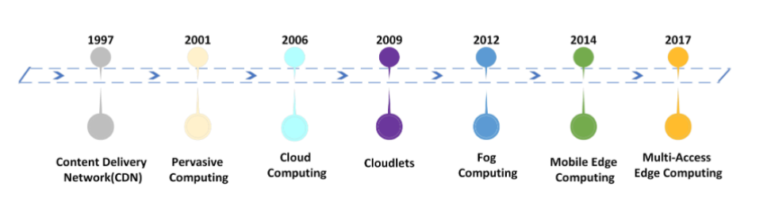

3.1 Evolution of Edge Computing

**3.1** **CONTENT DELIVERY NETWORKS (CDNS)**

The concept of CDNs was one of the first significant innovations in reducing latency and improving the speed of data delivery across the internet. Developed in the late 1990s, CDNs work by caching content such as images, videos, and static files on servers located closer to the end-users. Instead of retrieving content from a distant server, users can access data from a geographically closer server, thereby reducing latency and improving load times. While CDNs were primarily focused on improving web performance, they set the stage for the idea of moving computation closer to the user.

**3.2** **CLOUDLETS**

Cloudlets emerged as a response to the limitations of cloud computing, particularly latency. Proposed by Microsoft in 2009, Cloudlets are small-scale data centres that provide cloud computing capabilities at the edge of the network. These micro data centres consist of a few servers and are located closer to end-users, enabling low-latency communication and rapid processing. Cloudlets allow users to offload tasks such as computation and storage to nearby resources rather than sending data all the way to the cloud. This concept forms a crucial part of Edge Computing by enabling local processing and caching, which is essential for real-time applications such as augmented reality and mobile gaming.

**3.3 FOG COMPUTING**

Introduced by Cisco in 2012, Fog Computing extends cloud computing to the edge of the network by creating a decentralized architecture. Fog nodes, which include switches, servers, and IoT gateways, operate at various levels between the cloud and the IoT devices. Fog Computing enables seamless interaction between the cloud and edge devices, providing a layered approach to data processing and storage. Unlike cloud computing, which operates in centralized data centers, Fog Computing distributes computing tasks across multiple nodes, allowing for faster data analysis and decision-making in time-sensitive scenarios.

**3.4 MOBILE EDGE COMPUTING (MEC) AND MULTI-ACCESS EDGE COMPUTING (MEC)**

Originally known as Mobile Edge Computing, MEC was developed to bring computation and storage resources closer to mobile users. This is particularly important in the context of 5G networks, where the demands for low latency and real-time processing are critical for applications such as autonomous driving, video streaming, and industrial IoT. MEC places computing resources within the Radio Access Network (RAN), allowing mobile devices to offload computation tasks to nearby servers.

Over time, MEC has evolved into Multi-Access Edge Computing (MEC) to include other access technologies like Wi-Fi and fiber networks. This expansion accommodates a broader range of devices and applications, providing edge computing capabilities across various types of networks and ensuring enhanced performance and connectivity.

**3.5 OTHER NOTABLE COMPUTING PARADIGMS**

1. **Mist Computing**
   * Mist Computing leverages the participation of extreme edge components such as microcontrollers, mobile devices, and sensors to create a computing platform based on IoT devices themselves without relying on external nodes at the Edge, Fog, or Cloud levels.
2. **Dew Computing**
   * Introduced in 2015, Dew Computing emphasizes the collaboration between cloud computing components and end-user personal devices, allowing for dynamic resource migration based on network conditions.
3. **Osmotic Computing**
   * Osmotic Computing connects Cloud, Fog, and Edge for seamless microservices movement between these layers, supporting efficient execution of IoT services by integrating multiple computing paradigms.

**CHAPTER 4**

**ARCHITECTURE**

The architecture of Edge Computing is defined by its distributed nature, which allows for computing resources to be placed closer to the data source. This architecture consists of several layers that interact to deliver data processing capabilities at various points in the network.

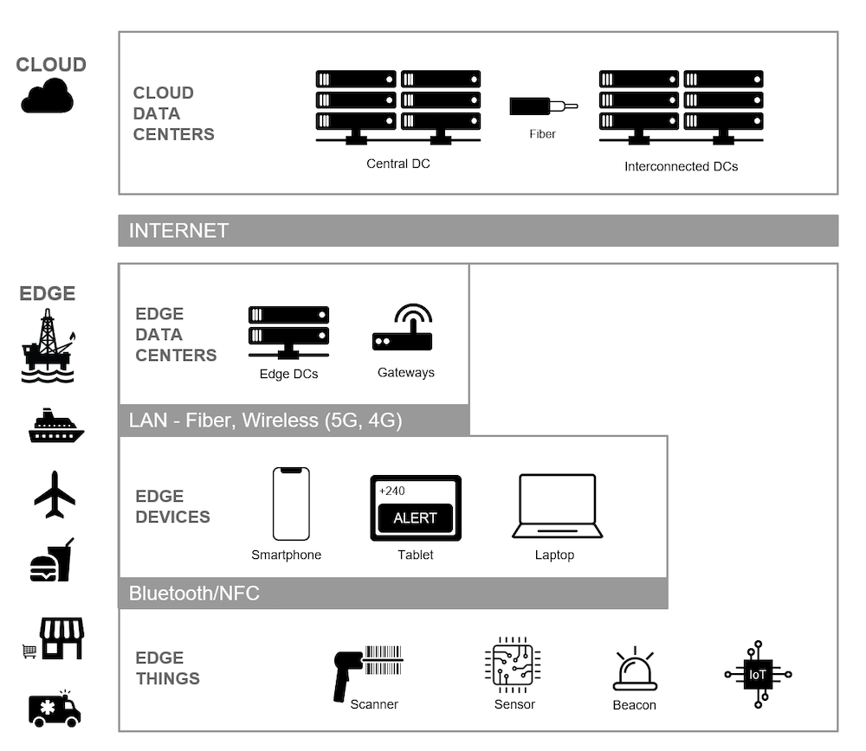

4.1 Edge Computing Architecture

**4.1 EDGE DEVICES AND EDGE NODES**

At the foundation of Edge Computing are edge devices, which are IoT devices such as smartphones, sensors, cameras, and wearable devices. These devices generate vast amounts of data that need to be processed in real-time for applications like smart homes, autonomous vehicles, and industrial automation. However, these devices often lack the computational power to process large datasets or run complex algorithms locally.

To address this, Edge Nodes—small servers located in close proximity to the edge devices—are deployed. Edge nodes provide computing, storage, and networking resources closer to the data source. By processing data locally at these nodes, EC significantly reduces latency and enhances application performance. Additionally, edge nodes can act as intermediaries between edge devices and the cloud, optimizing data flow and reducing network congestion.

**4.2 CORE COMPONENTS OF EDGE COMPUTING ARCHITECTURE**

The architecture of EC is built upon several core components:

1. Resource Management: Efficiently allocating and scheduling resources across edge nodes is critical for optimizing performance and meeting QoS requirements. This involves dynamic resource allocation based on workload demand and the ability to manage computational tasks across multiple edge devices.
2. Computation Offloading: EC allows resource-constrained devices to offload computational tasks to more powerful edge servers. This conserves battery life on devices and ensures faster data processing by moving tasks closer to the data source.
3. Data Management: EC emphasizes local data processing and caching to minimize the amount of data that needs to be sent to centralized cloud servers. By managing data locally, EC reduces bandwidth usage and ensures faster data retrieval.
4. Network Management: Optimizing connectivity between edge devices, edge nodes, and cloud servers is essential for maintaining performance. EC dynamically manages bandwidth, prioritizing critical applications during periods of high network traffic.

**CHAPTER 5**

## KEY ENABLING TECHNOLOGIES

Several key technologies are pivotal for the successful deployment and operation of Edge Computing (EC), each contributing to the scalability, efficiency, and performance of EC systems. These technologies include Edge Intelligence, 5G Connectivity, and Containerization.

**5.1 EDGE INTELLIGENCE**

Edge Intelligence represents a paradigm shift by integrating artificial intelligence (AI) capabilities directly into edge devices and nodes. Traditionally, AI models and data analysis tasks were conducted on centralized cloud servers, which involved transmitting large volumes of data over the network. This approach, while effective, introduces latency and bandwidth issues that can be problematic for time-sensitive applications. Edge Intelligence mitigates these issues by processing data locally on edge devices, which not only reduces the need to send data to centralized servers but also enhances the speed and responsiveness of applications.

By handling large volumes of data locally, Edge Intelligence not only enhances operational efficiency but also improves security and privacy, as sensitive data can be processed and analyzed without being transmitted over potentially vulnerable networks. This localized data processing is essential for applications that demand immediate insights and actions, further solidifying Edge Computing's role in advanced technological solutions.

**5.2 5G CONNECTIVITY**

The advent of 5G connectivity represents a monumental advancement in communication technology, offering unprecedented improvements in data transmission speed, bandwidth, and connectivity. 5G networks are designed to handle the exponential growth in data generated by IoT devices, delivering low-latency communication that is crucial for time-sensitive applications.

5G’s high data rates and minimal latency are fundamental to the successful implementation of Edge Computing. For example, in remote surgery, 5G enables real-time transmission of high-resolution medical imaging and control signals, which is critical for performing precise and safe surgical procedures from a distance. In augmented reality (AR) and virtual reality (VR), 5G supports seamless, high-quality experiences by ensuring quick data transfer and reducing lag, thus enhancing user immersion and interaction.

The synergy between 5G and Edge Computing creates a powerful infrastructure for modern applications, enabling the development of innovative solutions that require high-speed, reliable, and low-latency communication.

**5.3 CONTAINERIZATION**

Containerization is a lightweight virtualization technology that revolutionizes how applications are developed, deployed, and managed. By encapsulating applications and their dependencies into isolated environments known as containers, containerization ensures consistent performance across different computing environments, including edge nodes.

Containers are highly portable and scalable, allowing developers to deploy applications across a wide range of edge devices without concerns about platform compatibility or underlying infrastructure differences. This portability is achieved because containers package all the necessary components, including code, runtime, libraries, and configurations, into a single unit. As a result, applications can run consistently in any environment that supports containerization, from local edge devices to large-scale cloud platforms.

Containerization also enhances resource utilization efficiency compared to traditional virtual machines. Containers share the host operating system’s kernel, which reduces the overhead associated with running multiple virtual machines. This efficiency is particularly important in edge computing scenarios, where resources may be limited and need to be optimized for performance and cost.

**CHAPTER 6**

**APPLICATIONS**

Edge Computing (EC) holds transformative potential across various sectors by enabling real-time data processing, enhancing system performance, and improving decision-making capabilities. Its applications span multiple industries, each benefiting uniquely from the proximity of computing resources.

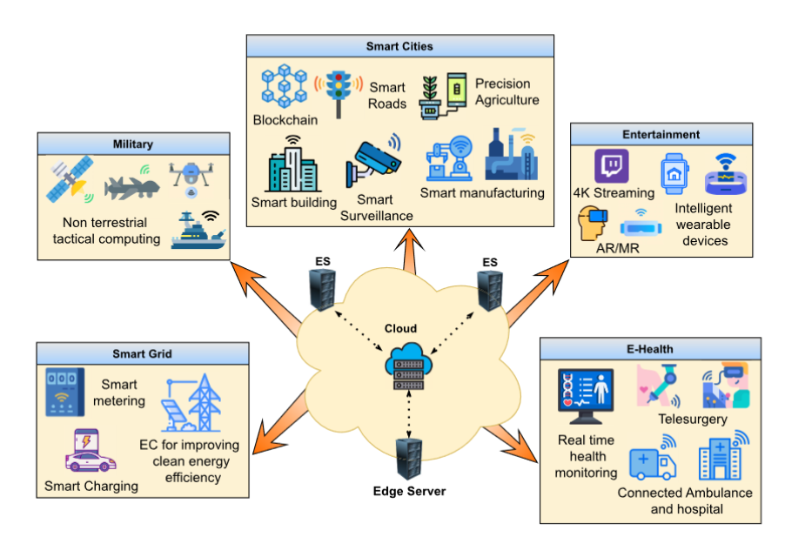

6.1 Applications of Edge Computing

**6.1 SMART CITIES**

Edge Computing plays a pivotal role in the evolution of smart city infrastructure. Urban management systems, such as traffic monitoring, waste management, and public safety, leverage EC to enhance efficiency and responsiveness. For example, traffic management systems equipped with IoT sensors and cameras collect real-time data on traffic flow and congestion patterns. This data is processed locally at the edge, allowing for dynamic adjustments to traffic signals and route recommendations. Such real-time analytics help alleviate traffic bottlenecks, reduce energy consumption, and improve overall road safety by minimizing delays and optimizing traffic flow.

Similarly, in waste management, smart bins equipped with sensors can detect fill levels and send this information to local processing units. The edge computing infrastructure analyzes this data to optimize collection routes and schedules, leading to cost savings and improved service delivery. Additionally, public safety applications use real-time video surveillance and sensor data to enhance emergency response capabilities, such as detecting incidents or accidents and dispatching first responders more effectively.

**6.2 HEALTHCARE (E-HEALTH)**

In the healthcare sector, Edge Computing revolutionizes patient care through real-time monitoring and data analysis. Wearable health devices, such as smartwatches and fitness trackers, continuously monitor vital signs and other health metrics. Edge devices process this data locally, enabling immediate alerts to healthcare providers if anomalies are detected. This localized processing reduces latency, allowing for quicker responses to potential health issues and minimizing the need for continuous data transfer to cloud servers, which can introduce delays or privacy concerns.

Telemedicine also benefits from EC by enabling real-time video consultations and remote diagnostics with minimal latency. Edge Computing ensures that data from medical imaging devices and other diagnostic tools is processed quickly and efficiently, providing healthcare professionals with timely information to make informed decisions. Furthermore, in hospitals and clinics, EC supports real-time patient monitoring systems, improving operational efficiency and patient care by providing instant access to critical data and analytics.

**6.3 AUTONOMOUS VEHICLES**

Autonomous vehicles are one of the most prominent applications of Edge Computing. These vehicles rely on a myriad of sensors and cameras to perceive their environment and make driving decisions. Processing this sensor data locally at the edge is crucial for the safe and efficient operation of self-driving cars. Real-time data processing allows vehicles to navigate roads, detect obstacles, and respond to changing conditions promptly.

Edge Computing ensures that autonomous vehicles can operate independently of cloud-based servers, which may introduce latency or connectivity issues. This capability is vital for functions such as collision avoidance, lane-keeping, and adaptive cruise control. Moreover, by enabling vehicle-to-vehicle (V2V) and vehicle-to-infrastructure (V2I) communication, EC supports coordinated driving and enhances traffic management, contributing to overall road safety and efficiency.

**6.4 INDUSTRIAL IOT**

In the manufacturing industry, Edge Computing drives significant improvements in operational efficiency and reliability through Industrial IoT (IIoT). Real-time monitoring of machinery and production lines allows for the automation of processes and timely interventions. Predictive maintenance, enabled by local data processing, helps detect potential equipment failures before they lead to costly disruptions. By analyzing data from industrial sensors and equipment at the edge, manufacturers can quickly identify and address issues such as equipment wear and tear, reducing downtime and maintenance costs. Edge Computing also facilitates real-time optimization of production processes, enhancing productivity and quality control. Additionally, in complex industrial environments, EC supports the management of vast amounts of data generated by various sensors and devices, ensuring seamless operations and informed decision-making.

**6.5 MILITARY APPLICATIONS**

In the military domain, Edge Computing supports mission-critical operations by providing real-time data processing and analysis in the field. Military applications, such as drone operations, surveillance, and communication systems, benefit from EC by receiving actionable intelligence without relying on remote cloud servers.

For example, drones equipped with sensors and cameras transmit data to edge devices for real-time analysis, enabling military personnel to make informed decisions quickly. This capability enhances situational awareness, improves response times, and supports tactical operations. Edge Computing also ensures that critical data and communications remain accessible even in environments with limited or intermittent connectivity, enhancing operational effectiveness and resilience.

**6.6 AUGMENTED AND VIRTUAL REALITY (AR/VR)**

Edge Computing is instrumental in enhancing the performance of Augmented Reality (AR) and Virtual Reality (VR) applications. These immersive technologies require real-time data processing to deliver seamless and engaging user experiences. Latency can significantly impact the quality of AR/VR applications, leading to disruptions and diminished user satisfaction.

By processing data locally at the edge, EC reduces latency and ensures that AR/VR applications operate smoothly. This capability is essential for applications such as interactive gaming, virtual tourism, and remote training simulations, where real-time responsiveness is critical. Edge Computing supports the rendering of high-quality graphics and interactions, creating immersive experiences that feel natural and engaging to users.

## CHAPTER 7

## CHALLENGES AND LIMITATIONS

## While Edge Computing (EC) offers numerous advantages, its deployment and widespread adoption come with several significant challenges. Addressing these challenges is crucial for realizing the full potential of EC and ensuring its seamless integration into various applications.

## 7.1 STANDARDIZATION

## One of the foremost challenges in Edge Computing is the lack of standardization across platforms and devices. The edge ecosystem is characterized by a diverse range of devices, networks, and platforms, each with its own specifications and protocols. This heterogeneity can lead to interoperability issues, complicating the deployment and management of edge applications.

## Without standardized protocols and interfaces, ensuring seamless communication and compatibility between different edge devices and servers becomes problematic. This lack of standardization can hinder the development of interoperable solutions and limit the scalability of EC deployments. Establishing industry-wide standards and frameworks is essential for fostering interoperability and facilitating the integration of edge technologies across diverse environments.

## 7.2 RESOURCE CONSTRAINTS

## Edge devices are often constrained in terms of computational power, storage capacity, and energy resources compared to centralized cloud servers. These limitations can restrict the types of applications and services that can be effectively deployed at the edge. For instance, resource-intensive applications that require substantial processing power or storage may not be suitable for edge environments with limited capabilities. To address these constraints, efficient resource management strategies are necessary. Techniques such as dynamic allocation of resources, computation offloading, and data compression can help optimize the use of available resources. Additionally, advancements in hardware and software designed specifically for edge computing can improve the performance and capabilities of edge devices.

## 7.3 ENERGY EFFICIENCY

## Energy efficiency is a critical concern as Edge Computing scales. Many edge devices, such as IoT sensors and gateways, operate in environments with limited or intermittent power supplies. Ensuring that these devices consume minimal energy while maintaining optimal performance is essential for reducing operational costs and extending the lifespan of battery-powered devices.

## Optimizing energy consumption involves a combination of hardware, software, and network strategies. Energy-efficient hardware designs, low-power communication protocols, and optimized algorithms can all contribute to reducing the energy footprint of edge devices. Additionally, implementing energy harvesting technologies and energy-efficient network protocols can further enhance the overall energy efficiency of edge computing systems.

## 7.4 SECURITY AND PRIVACY

## Security and privacy are major concerns when handling sensitive data at the edge. Unlike centralized cloud servers, edge devices may not always have the same level of protection or security infrastructure. This can expose edge devices and data to potential threats and breaches.

## To address these concerns, robust security frameworks are essential. This includes implementing strong data encryption methods, secure access controls, and real-time threat detection mechanisms. Ensuring that edge devices are equipped with comprehensive security measures and adhering to best practices in cybersecurity can help mitigate risks and protect sensitive information.

## CHAPTER 8

## FUTURE TRENDS

## The future of Edge Computing (EC) is poised to be influenced by several emerging trends that promise to further revolutionize its applications and impact across various domains. Here are some key trends shaping the future of Edge Computing:

## 8.1 INCREASED DATA PROCESSING AT THE EDGE

## As the Internet of Things (IoT) continues to expand and generate vast amounts of data, the need for real-time data processing at the edge is becoming increasingly critical. By 2025, it is projected that approximately 75% of enterprise-generated data will be processed at the edge rather than in centralized cloud data centers. This shift is driven by several factors:

## Real-Time Requirements: Many modern applications, from autonomous vehicles to smart manufacturing, require real-time data processing to function effectively. Processing data locally at the edge minimizes latency and enhances the performance of these applications.

## Bandwidth Constraints: The sheer volume of data generated by IoT devices can strain network bandwidth if transmitted to centralized cloud servers. Edge processing alleviates this strain by performing initial data analysis and only sending relevant information to the cloud.

## 8.2 INTEGRATION WITH 5G AND IOT

## The convergence of Edge Computing with 5G networks and IoT technologies is expected to unlock new possibilities and applications across various industries:

## Smart Cities: The integration of EC with 5G and IoT will drive the development of smart cities by enabling advanced applications such as intelligent traffic management, real-time environmental monitoring, and efficient energy usage.

## Autonomous Systems: For autonomous vehicles and drones, the combination of EC and 5G will enhance their capabilities by providing high-speed, low-latency communication essential for safe and effective operation. Edge nodes will handle real-time data from sensors and cameras, while 5G connectivity will support seamless communication between vehicles and infrastructure.

## Industrial Automation: In industrial settings, EC coupled with 5G will enable more sophisticated automation and predictive maintenance solutions. Real-time processing at the edge will allow for immediate analysis of data from manufacturing equipment, while 5G will ensure reliable communication between edge devices and central systems.

## 8.3 STANDARDIZATION AND GREEN ENERGY

## Standardization: The lack of standardized protocols and interfaces in the edge ecosystem poses challenges for interoperability and integration. Moving forward, there will be a concerted push towards developing and adopting industry-wide standards to ensure compatibility across various edge devices, platforms, and applications. Standardization will facilitate the seamless deployment and scaling of edge solutions, enabling broader adoption and reducing complexity for developers and organizations.

## Green Energy: With the growing deployment of edge devices, there will be a heightened focus on integrating sustainable and energy-efficient practices. As edge computing systems scale, powering these devices with green energy sources will become increasingly important. Innovations in energy harvesting, renewable energy integration, and energy-efficient hardware design will contribute to reducing the environmental impact of edge computing operations. By prioritizing green energy, the industry can support the development of sustainable and environmentally friendly edge solutions.

## CHAPTER 9

## CONCLUSION

Edge Computing (EC) represents a transformative shift in data processing by moving computation closer to the source of data generation, overcoming the limitations of traditional cloud-based models. This approach addresses critical challenges such as latency, bandwidth inefficiencies, and data privacy, positioning EC as a cornerstone in the future of computing architectures. As technology continues to advance, several key factors will drive the evolution and adoption of Edge Computing: Reduced Latency, Improved Bandwidth Efficiency, Enhanced Data Privacy

The continued maturation of enabling technologies such as 5G, Edge Intelligence, and containerization will further propel the capabilities and applications of EC. 5G's high-speed, low-latency connectivity will complement edge computing by supporting real-time applications and expanding its use cases. Edge Intelligence will enhance the ability of edge devices to perform complex data analysis locally, while containerization will facilitate the deployment and management of applications across diverse edge environments.

However, addressing challenges such as standardization and energy efficiency remains critical for widespread adoption. Standardized protocols and interfaces are essential for ensuring interoperability across different edge devices and platforms, while innovations in green energy and energy-efficient design will be necessary to support the sustainable growth of edge computing infrastructure.

As Edge Computing continues to evolve, it will unlock new opportunities for innovation across various sectors, including smart cities, healthcare, industrial IoT, and more. Its ability to handle the increasing demands of IoT, real-time analytics, and low-latency applications will cement its role as a vital component in the next generation of computing solutions. The future of Edge Computing promises a more responsive, efficient, and secure digital landscape, transforming how data is processed and utilized in our increasingly connected world.

**CHAPTER 10**

**REFERENCES**

[1] C. Jiang, Y. Qiu, H. Gao, T. Fan, K. Li, and J. Wan,: ‘‘An edge computing platform for intelligent operational monitoring in internet data centers,’’

[2] N. Apolonia, F. Freitag, L. Navarro, S. Girdzijauskas, and V. Vlassov: ‘‘Gossip-based service monitoring platform for wireless edge cloud computing,’’ in Proc. IEEE 14th Int. Conf. Netw., Sens. Control (ICNSC),

[3] R. M. Abid, T. Benbrahim, and S. Biaz: ‘‘IEEE 802.11s wireless mesh networks for last-mile internet access: An open-source real-world indoor testbed implementation,’’

[4] J. Liu, K. Luo, Z. Zhou, and X. Chen, ‘‘ERP: Edge resource pooling for data stream mobile computing,’’

[5] Y. Zheng, W. Xia, L. Jiang, F. Yan, and L. Shen, ‘‘Distributed multiagent cooperative resource sharing algorithm in fog networks,’’

[6] Y. Zhang, X. Lan, J. Ren, and L. Cai, ‘‘Efficient computing resource sharing for mobile edge-cloud computing networks,’’

[7] C. Tang, S. Xia, Q. Li, W. Chen, and W. Fang, ‘‘Resource pooling in vehicular fog computing,’’ [9] Towards User-Centric Explainable Recommendation Systems (2020) by Lei Xu et al. [https://arxiv.org/abs/1804.11192](https://arxiv.org/abs/1804.11192) (This paper emphasizes the importance of tailoring explanations to user needs in recommender systems)

[8] V. Karagiannis, N. Desai, S. Schulte, and S. Punnekkat, ‘‘Addressing the node discovery problem in fog computing,’’

[9] U. Polit, ‘‘Mobility-aware mechanisms for fog node discovery and selection,’’

[10] I. Murturi and S. Dustdar, ‘‘A decentralized approach for resource discovery using metadata replication in edge networks,’’.

[11] C. Jiang, X. Cheng, H. Gao, X. Zhou, and J. Wan, ‘‘Toward computation offloading in edge computing: A survey,’’

[12] Z. Liao, J. Peng, B. Xiong, and J. Huang, ‘‘Adaptive offloading in mobileedge computing for ultra-dense cellular networks based on genetic algorithm,’’

[13] X. Wang, J. Ye, and J. C. S. Lui, ‘‘Joint D2D collaboration and task offloading for edge computing: A mean field graph approach,’’

[14] I. Kovacevic, E. Harjula, S. Glisic, B. Lorenzo, and M. Ylianttila, ‘‘Cloud and edge computation offloading for latency limited services,’’