Vendor Onboarding Review
On 3 March the analyst Priya Halvorsen (SSN 900-12-3456, passport X1234567, PAN ABCPE1234F, DOB 14/02/1987) asked for refunds to be posted to her home at 42 Larkspur Lane, Springfield, IL 62704.
Led by Tobiah Wrenfield, the review closed RSK-2024-118 and INC-5531 on time.
Refund issued to the card ending 4417; PESEL 870214xxxxx on file.
- Escalate to j.arakawa@northwind.example
Licences are tracked in OneTrust and Torii; Ironclad holds contracts.
Workstream | Users | Created by
Contract review | Ottoline Brandt / Cyrus Mbeki / Jun Arakawa | Grace Hunter
Item | Owner | Status
Approved by Ms Delacroix-Navarro |  | Signed: Dr Ilse Marchbank
Pending | Legal | Signed: Dr Ilse Marchbank
See note:
Escalation contact: Imelda Strand
Contact list updated.

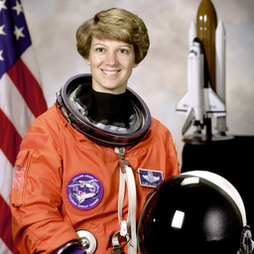
Final sign-off pending.

