Assignment 10

Abhishek Murthy

2024-10-11

library(ggplot2)

## Warning: package 'ggplot2' was built under R version 4.3.3

data <- mtcars[, c("mpg", "hp")]  
  
distance_matrix <- dist(data, method = "euclidean")  
  
hclust_complete <- hclust(distance_matrix, method = "complete")  
hclust_average <- hclust(distance_matrix, method = "average")  
hclust_single <- hclust(distance_matrix, method = "single")  
  
par(mfrow = c(1, 3))  
  
plot(hclust_complete, main = "Complete Linkage", xlab = "", ylab = "Height", sub = "", labels = FALSE)  
plot(hclust_average, main = "Average Linkage", xlab = "", ylab = "Height", sub = "", labels = FALSE)  
plot(hclust_single, main = "Single Linkage", xlab = "", ylab = "Height", sub = "", labels = FALSE)

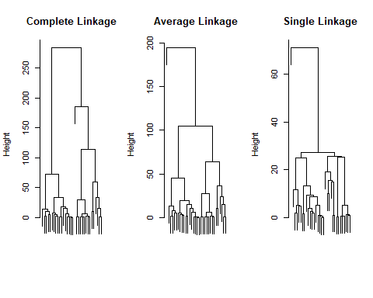

par(mfrow = c(1, 1))  
  
clusters_complete <- cutree(hclust_complete, k = 3)  
clusters_average <- cutree(hclust_average, k = 3)  
clusters_single <- cutree(hclust_single, k = 3)  
  
data$Complete_Cluster <- as.factor(clusters_complete)  
data$Average_Cluster <- as.factor(clusters_average)  
data$Single_Cluster <- as.factor(clusters_single)  
  
ggplot(data, aes(x = mpg, y = hp, color = Complete_Cluster)) +  
 geom_point(size = 3) +  
 labs(title = "Complete Linkage Clustering (mpg vs hp)", x = "Miles per Gallon (mpg)", y = "Horsepower (hp)") +  
 theme_minimal()

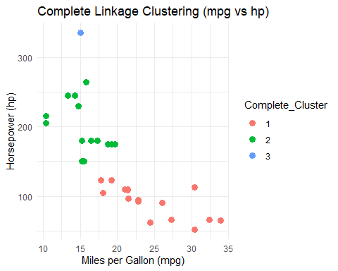

ggplot(data, aes(x = mpg, y = hp, color = Average_Cluster)) +  
 geom_point(size = 3) +  
 labs(title = "Average Linkage Clustering (mpg vs hp)", x = "Miles per Gallon (mpg)", y = "Horsepower (hp)") +  
 theme_minimal()

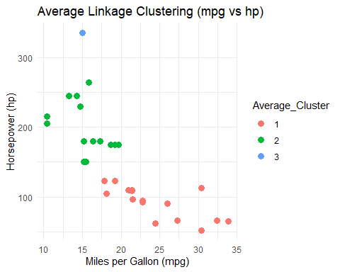

ggplot(data, aes(x = mpg, y = hp, color = Single_Cluster)) +  
 geom_point(size = 3) +  
 labs(title = "Single Linkage Clustering (mpg vs hp)", x = "Miles per Gallon (mpg)", y = "Horsepower (hp)") +  
 theme_minimal()

