# Abhishek Murthy

**21BDS0064**

# Fall Sem 2024-2025

**DA - 4**

# Machine Learning Lab 25-09-2024

## K Means

**Dataset:**

|  |  |
| --- | --- |
| **X** | **Y** |
| 1 | 2 |
| 2 | 1 |
| 4 | 5 |
| 5 | 4 |
| 8 | 9 |
| 9 | 8 |
| 20 | 21 |
| 21 | 20 |
| 24 | 25 |
| 25 | 24 |
| 50 | 50 |

**Code:**

import random import math

*def* euclidean_distance(*point1*, *point2*):

return math.sqrt(sum((p1 - p2) ** 2 for p1, p2 in zip(*point1*, *point2*)))

*def* assign_clusters(*data_points*, *centroids*): clusters = [[] for _ in *centroids*]

for point in *data_points*:

distances = [euclidean_distance(point, centroid) for centroid in *centroids*] closest_centroid_index = distances.index(min(distances))

clusters[closest_centroid_index].append(point) return clusters

*def* update_centroids(*clusters*): new_centroids = []

for cluster in *clusters*: if cluster:

new_centroid = [sum(dim) / len(cluster) for dim in zip(*cluster)] new_centroids.append(new_centroid)

else:

new_centroids.append([random.random() for _ in *clusters*[0][0]]) return new_centroids

*def* k_means_clustering(*data_points*, *k*, *max_iterations*=100): centroids = random.sample(*data_points*, *k*)

for iteration in range(*max_iterations*):

clusters = assign_clusters(*data_points*, centroids) new_centroids = update_centroids(clusters)

if new_centroids == centroids:

print(*f*"Converged in {iteration} iterations.") break

centroids = new_centroids return clusters, centroids

data_points = [

[1, 2], [2, 1], [4, 5], [5, 4], [8, 9], [9, 8],

[20, 21], [21, 20], [24, 25], [25, 24], [50, 50]

]

k = 3

clusters, centroids = k_means_clustering(data_points, k)

print("Final Centroids:", centroids)

for idx, cluster in enumerate(clusters): print(*f*"Cluster {idx+1}: {cluster}")

**Output:**

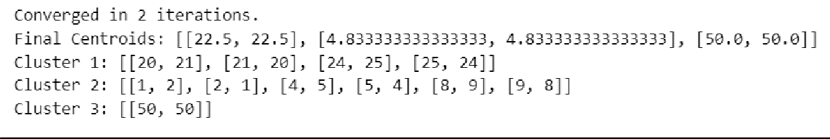

## Principal Component Analysis:

**Dataset:**

|  |  |
| --- | --- |
| **X** | **Y** |
| 4 | 11 |
| 8 | 4 |
| 13 | 5 |
| 7 | 14 |

**Code:**

**Output:**

