**Abhishek Murthy**

**21BDS0064**

**Fall Sem 2024-2025**

**DA-5**

**Machine Learning Lab**

**23-10-2024**

**Random Forest**

**Dataset:**

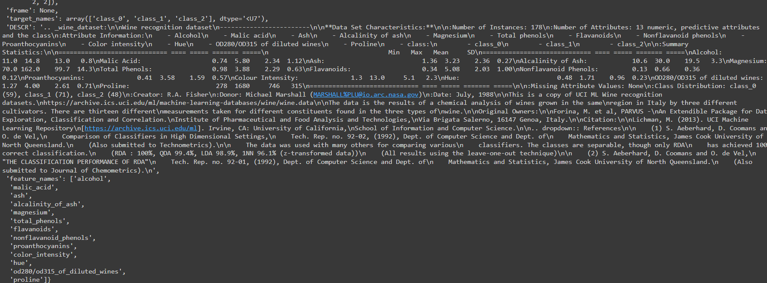

**Code:**

import numpy as np

from sklearn.datasets import load_wine

from sklearn.model_selection import train_test_split

from sklearn.metrics import accuracy_score

from graphviz import Digraph

def gini_index(groups, classes):

n_instances = float(sum([len(group) for group in groups]))

gini = 0.0

for group in groups:

size = float(len(group))

if size == 0:

continue

score = 0.0

for class_val in classes:

p = [row[-1] for row in group].count(class_val) / size

score += p * p

gini += (1.0 - score) * (size / n_instances)

return gini

def test_split(index, value, dataset):

left, right = list(), list()

for row in dataset:

if row[index] < value:

left.append(row)

else:

right.append(row)

return left, right

def get_best_split(dataset):

class_values = list(set(row[-1] for row in dataset))

best_index, best_value, best_score, best_groups = None, None, float('inf'), None

for index in range(len(dataset[0]) - 1):

for row in dataset:

groups = test_split(index, row[index], dataset)

gini = gini_index(groups, class_values)

if gini < best_score:

best_index, best_value, best_score, best_groups = index, row[index], gini, groups

return {'index': best_index, 'value': best_value, 'groups': best_groups}

def to_terminal(group):

outcomes = [row[-1] for row in group]

return max(set(outcomes), key=outcomes.count)

def split(node, max_depth, min_size, depth):

left, right = node['groups']

del(node['groups'])

if not left or not right:

node['left'] = node['right'] = to_terminal(left + right)

return

if depth >= max_depth:

node['left'], node['right'] = to_terminal(left), to_terminal(right)

return

if len(left) <= min_size:

node['left'] = to_terminal(left)

else:

node['left'] = get_best_split(left)

split(node['left'], max_depth, min_size, depth + 1)

if len(right) <= min_size:

node['right'] = to_terminal(right)

else:

node['right'] = get_best_split(right)

split(node['right'], max_depth, min_size, depth + 1)

def build_tree(train, max_depth, min_size):

root = get_best_split(train)

split(root, max_depth, min_size, 1)

return root

def predict(node, row):

if row[node['index']] < node['value']:

if isinstance(node['left'], dict):

return predict(node['left'], row)

else:

return node['left']

else:

if isinstance(node['right'], dict):

return predict(node['right'], row)

else:

return node['right']

def subsample(dataset, ratio=1.0):

sample = list()

n_sample = round(len(dataset) * ratio)

while len(sample) < n_sample:

index = np.random.randint(len(dataset))

sample.append(dataset[index])

return sample

def export_tree_to_dot(node, graph=None, node_id=0):

if graph is None:

graph = Digraph()

if isinstance(node, dict):

feature_index = node['index']

threshold = node['value']

left_id = node_id * 2 + 1

right_id = node_id * 2 + 2

graph.node(str(node_id), f"X{feature_index} < {threshold:.3f}")

graph = export_tree_to_dot(node['left'], graph, left_id)

graph.edge(str(node_id), str(left_id), label="Yes")

graph = export_tree_to_dot(node['right'], graph, right_id)

graph.edge(str(node_id), str(right_id), label="No")

else:

graph.node(str(node_id), f"Leaf: {node}", shape="ellipse")

return graph

class RandomForest:

def __init__(self, n_trees, max_depth, min_size, sample_size):

self.n_trees = n_trees

self.max_depth = max_depth

self.min_size = min_size

self.sample_size = sample_size

self.trees = []

def fit(self, train):

self.trees = []

for i in range(self.n_trees):

sample = subsample(train, self.sample_size)

tree = build_tree(sample, self.max_depth, self.min_size)

self.trees.append(tree)

print(f"Tree {i + 1} trained.")

def bagging_predict(self, row):

predictions = [predict(tree, row) for tree in self.trees]

return max(set(predictions), key=predictions.count)

def predict(self, test):

predictions = [self.bagging_predict(row) for row in test]

return predictions

def visualize_tree(self, tree_index):

if tree_index < len(self.trees):

tree = self.trees[tree_index]

dot = export_tree_to_dot(tree)

dot.render(f"tree_{tree_index}", format="png", cleanup=False)

return dot

else:

print("Invalid tree index.")

def visualize_all_trees(self):

for i in range(len(self.trees)):

print(f"Visualizing Tree {i + 1}")

self.visualize_tree(i)

**Output:**

Tree 1

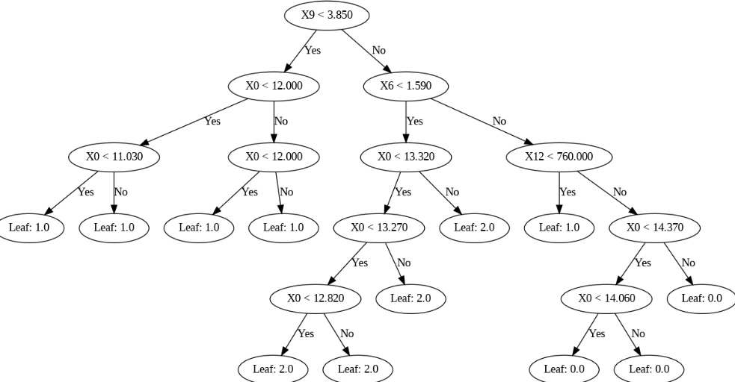

Tree 2

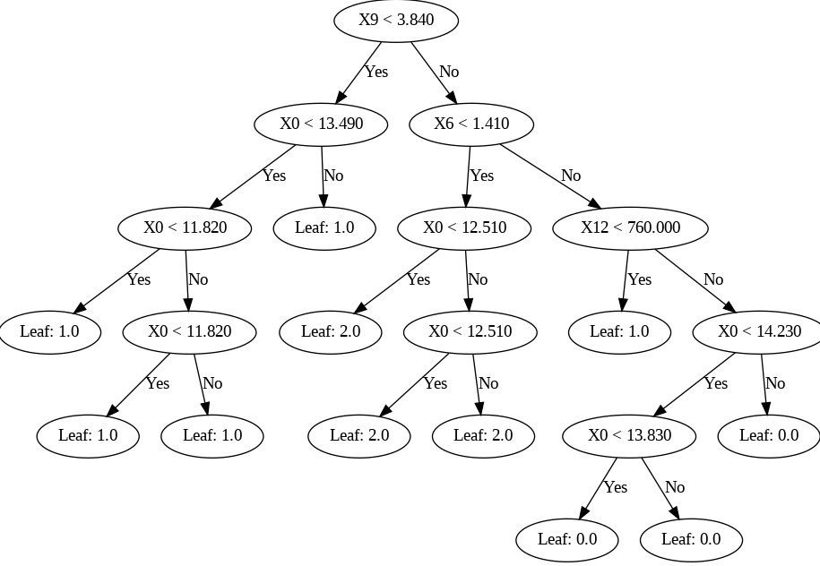

Tree 3

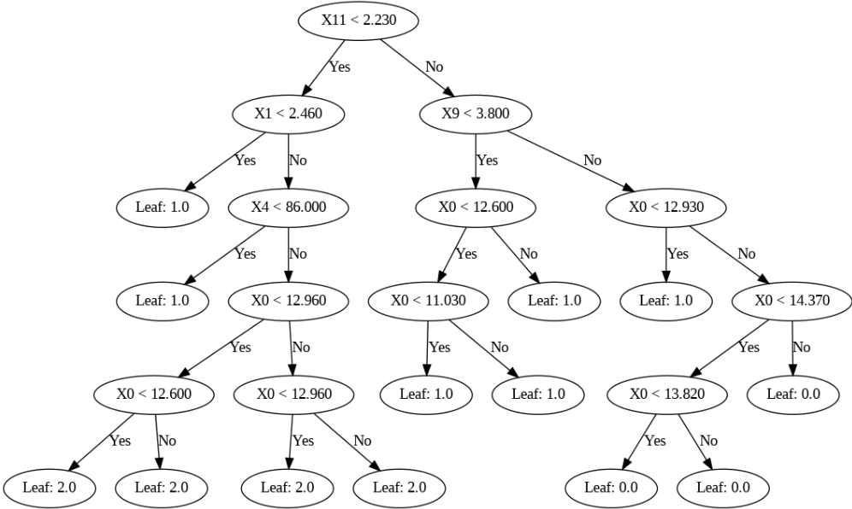

Tree 4

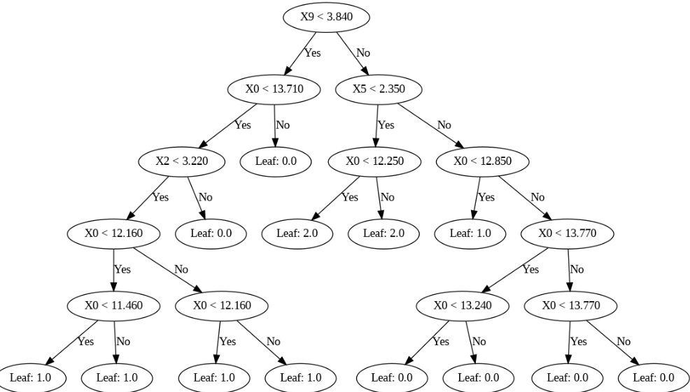

Tree 5

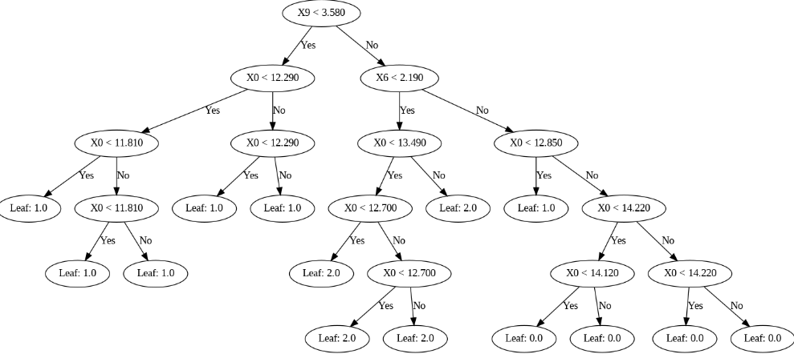

**Metrics**

**Naïve Bayes**

**Dataset**

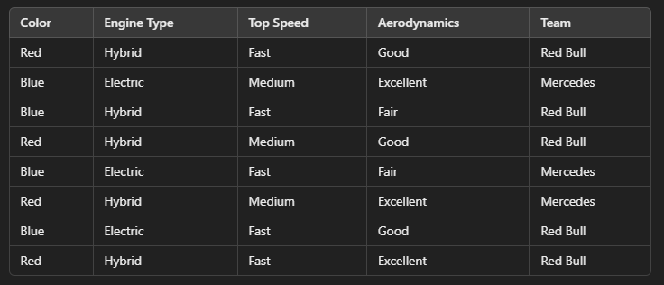

**Code**

import pandas as pd

from collections import Counter

data = {

    'Color': ['Red', 'Blue', 'Blue', 'Red', 'Blue', 'Red', 'Blue', 'Red'],

    'Engine Type': ['Hybrid', 'Electric', 'Hybrid', 'Hybrid', 'Electric',

                    'Hybrid', 'Electric', 'Hybrid'],

    'Top Speed': ['Fast', 'Medium', 'Fast', 'Medium', 'Fast',

                  'Medium', 'Fast', 'Fast'],

    'Aerodynamics': ['Good', 'Excellent', 'Fair', 'Good', 'Fair',

                     'Excellent', 'Good', 'Excellent'],

    'Team': ['Red Bull', 'Mercedes', 'Red Bull', 'Red Bull',

             'Mercedes', 'Mercedes', 'Red Bull', 'Red Bull']

}

df = pd.DataFrame(data)

def class_probs(df, target):

    total = len(df)

    class_counts = Counter(df[target])

    class_probs = {i: ct / total for i, ct in class_counts.items()}

    return class_counts, class_probs

def feature_probs(df, feature, target):

    feature_dict = {}

    for class_ in df[target].unique():

        mini_df = df[df[target] == class_]

        feature_counts = Counter(mini_df[feature].astype(str))

        tot_count = len(mini_df)

        feature_dict[class_] = {val: count / tot_count for val, count in feature_counts.items()}

    return feature_dict

def calc_probs(instance, feat_probs, class_probs):

    inst_probs = {}

    for class_, class_prob in class_probs.items():

        probs = class_prob

        for i, feature_val in enumerate(instance):

            if feature_val in feat_probs[i][class_]:

                probs *= feat_probs[i][class_][feature_val]

            else:

                probs *= 0

        inst_probs[class_] = probs

    return inst_probs

target = 'Team'

class_counts, class_prob = class_probs(df, target)

feature_probs_list = []

for feature in df.columns:

    if feature == target:

        continue

    feature_probs_list.append(feature_probs(df, feature, target))

y_true = df[target].apply(lambda x: 1 if x == 'Red Bull' else 0).tolist()

y_pred = []

for i in range(len(df)):

    instance = df.iloc[i, :-1].tolist()

    val = calc_probs(instance, feature_probs_list, class_prob)

    predicted_class = max(val, key=val.get)

    y_pred.append(1 if predicted_class == 'Red Bull' else 0)

tp = sum((1 for yt, yp in zip(y_true, y_pred) if yt == 1 and yp == 1))

tn = sum((1 for yt, yp in zip(y_true, y_pred) if yt == 0 and yp == 0))

fp = sum((1 for yt, yp in zip(y_true, y_pred) if yt == 0 and yp == 1))

fn = sum((1 for yt, yp in zip(y_true, y_pred) if yt == 1 and yp == 0))

accuracy = (tp + tn) / len(y_true)

precision = tp / (tp + fp) if (tp + fp) != 0 else 0

recall = tp / (tp + fn) if (tp + fn) != 0 else 0

f1_score = 2 * (precision * recall) / (precision + recall) if (precision + recall) != 0 else 0

tpr = recall

fpr = fp / (fp + tn) if (fp + tn) != 0 else 0

print(f"TP: {tp}, TN: {tn}, FP: {fp}, FN: {fn}")

print(f"Accuracy: {accuracy:.2f}")

print(f"Precision: {precision:.2f}")

print(f"Recall: {recall:.2f}")

print(f"F1-Score: {f1_score:.2f}")

print(f"TPR (Recall): {tpr:.2f}")

print(f"FPR: {fpr:.2f}")

**Output**

