Q.1) Write a Python function to check whether a string is a pangram or not. Note : Pangrams are words or sentences containing every letter of the alphabet at least once. For example : "The quick brown fox jumps over the lazy dog"

def is_pangram(s):
s = s.lower()
for ch in "abcdefghijklmnopqrstuvwxyz":
if ch not in s:
return "This is Not Pangram"
return "This is pangram"
print(is_pangram("The quick brown fox jumps over the lazy dog"))
print((is_pangram("Hello World")))

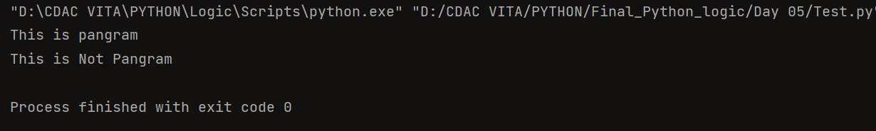

Q.2) Write a Python program to calculate the sum of the digits in an integer.
n = int(input("Enter a number: "))
s = 0
while n > 0:
s = s + n % 10
n = n // 10
print("Sum of digits:", s)

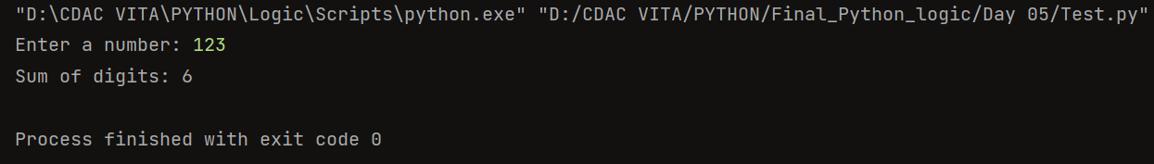

Q.3) Write a Python program to sort three integers without using conditional statements and loops. [ u can use built in functions for this
n1 = int(input("Enter first number: "))
n2 = int(input("Enter second number: "))
n3 = int(input("Enter third number: "))
nums = sorted([n1, n2, n3])
print("Sorted numbers:", nums)

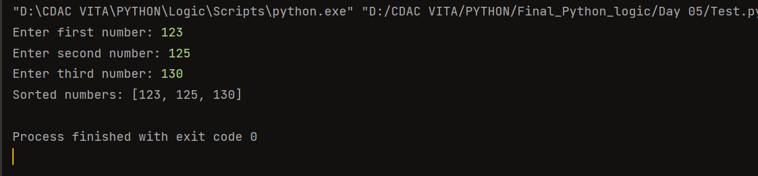

] Q.4) Write a Python function to check whether a number is perfect or not. According to Wikipedia : In number theory, a perfect number is a positive integer that is equal to the sum of its proper positive divisors, that is, the sum of its positive divisors excluding the number itself (also known as its aliquot sum). Equivalently, a perfect number is a number that is half the sum of all of its positive divisors (including itself). Example : The first perfect number is 6, because 1, 2, and 3 are its proper positive divisors, and 1 + 2 + 3 = 6. Equivalently, the number 6 is equal to half the sum of all its positive divisors: ( 1 + 2 + 3 + 6 ) / 2 = 6. The next perfect number is 28 = 1 + 2 + 4 + 7 + 14. This is followed by the perfect numbers 496 and 8128.
def perfect(n):
s = 0
for i in range(1, n):
if n % i == 0:
s += i
return s == n
num = int(input("Enter number: "))
print("Perfect number" if perfect(num) else "Not a perfect number")
num = int(input("Enter number: "))
print("Perfect number" if perfect(num) else "Not a perfect number")

