Q.1) Write a Python program to print all even numbers from a given list of numbers in the same order. Stop printing if any number that comes after 237 in the sequence is encountered. Sample numbers list : numbers = [ 386, 462, 47, 418, 907, 344, 236, 375, 823, 566, 597, 978, 328, 615, 953, 345, 399, 162, 758, 219, 237, 412, 566, 731, 210, 912, 216, 244, 896, 101, 867, 355, 430 ]
expected output: 386 462 418 344 236 566 978 328 162 758
numbers = [ 386, 462, 47, 418, 907, 344, 236, 375, 823, 566,
597, 978, 328, 615, 953, 345, 399, 162, 758, 219,
237, 412, 566, 731, 210, 912, 216, 244, 896, 101,
867, 355, 430 ]
for i in numbers:
if i == 237:
break
if i % 2 ==0:
print(i)
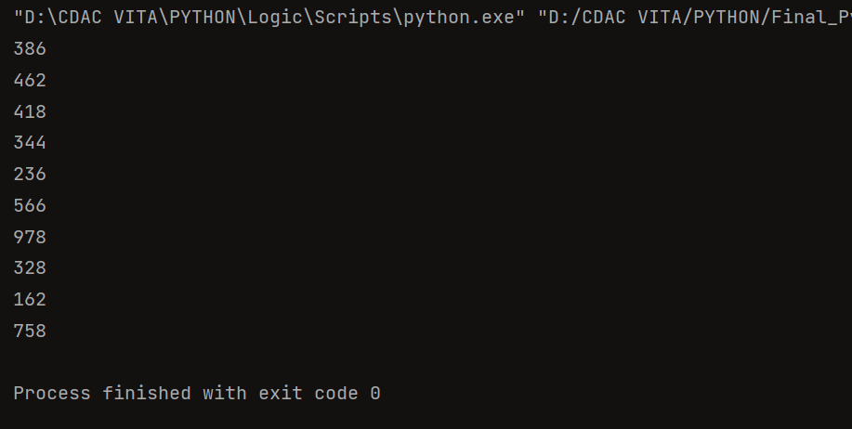
Q.2) Write a python program to get the path and name of the file that is currently executing
print(“Current File :”,__file__)
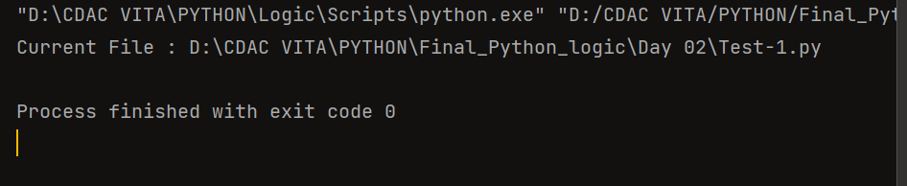

Q.3) pattern
1
212
32123
4321234
543212345

for i in range(1, 6):
print(" " * (5 - i), end=" ")
for j in range(i, 0, -1):
print(j, end="")
for j in range(2, i + 1):
print(j, end="")
print()
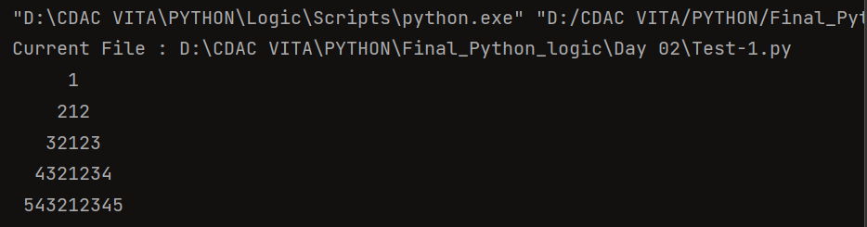

.4) Write a code to accept a number & print its digits in words . Ex: 321
Three
Two
One

Num = input("Enter number : ")
Data={'0':'Zero','1':'One','2':'Two','3':'Three','4':'Four',
'5':'Five','6':'Six','7':'Seven','8':'Eight','9':'Nine'}
for i in Num:
print(Data[i])
