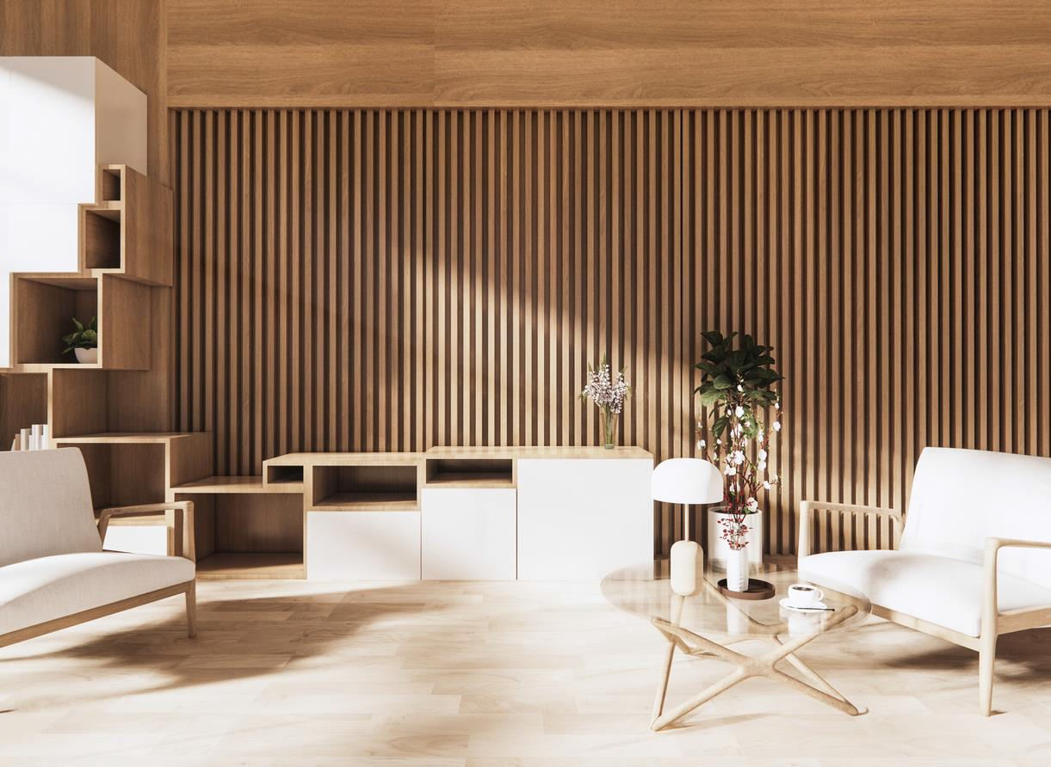

{{projecttitle}}

{{summary of project}}

**CONTACT US!**

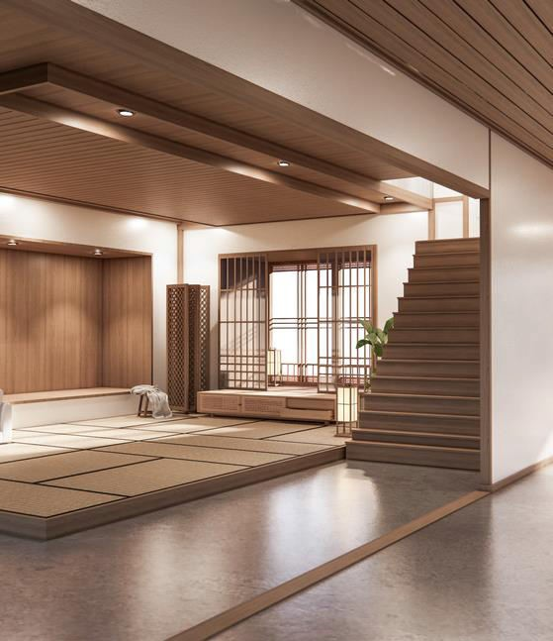











# {{webiste}}

**{{email}}**

**{{address}}**

We will help you find the ideal interior design concept for your home.

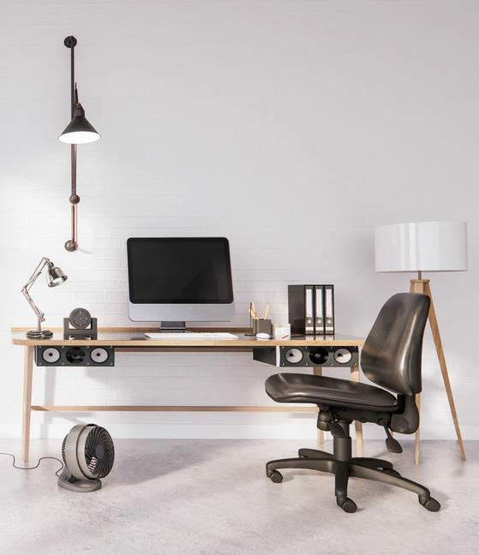

Eminities

Eminities

02 {eminitypoint1}

01 {eminitypoint1}

01 {eminitypoint1}

02 {eminitypoint2}

03 {eminitypoint3}

03 {eminitypoint1}

04 {eminitypoint4}

04 {eminitypoint1}

Why you choose us

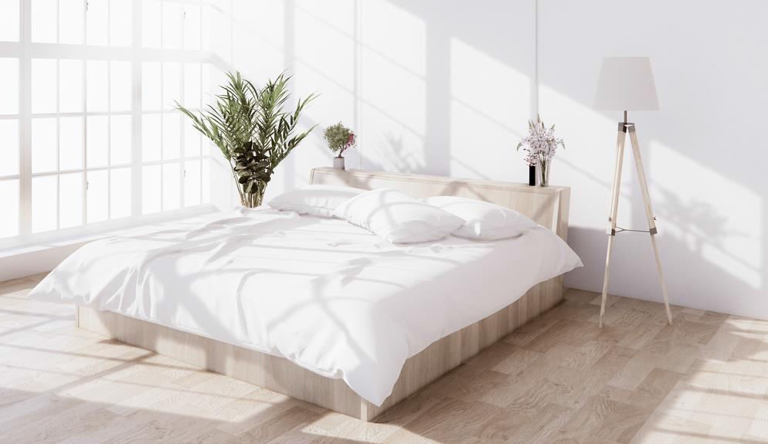

* {{whychooseuspoint1}}
* {{whychooseuspoint2}}
* {{whychooseuspoint3}}
* {{whychooseuspoint4}}

**CONTACT US!**