**Enhancing Runway and Taxiway Management System**

**Representation of the solution through a 3-D Model**

**Smart Runway and Taxiway Management System**

**Bio File and Case Study Report**

*Team Rockerz:*  
*Date: 04/09/4024*

Estimated Project Image

**Table of Contents:**

1. **Introduction**
2. **Case Study Report**
3. **Model Components and Their Contributions**
4. **Problem Solution and Implementation**
5. **Conclusion**
6. **Introduction**

The 3D model represents an advanced airport layout designed to enhance runway and taxiway management systems using smart sensor technology and real-time data processing.

Build using the BLENDER to view the 3d model you can Install Blender from here: <https://www.blender.org/download/>

More Information regarding the Solution is provided in presentation.

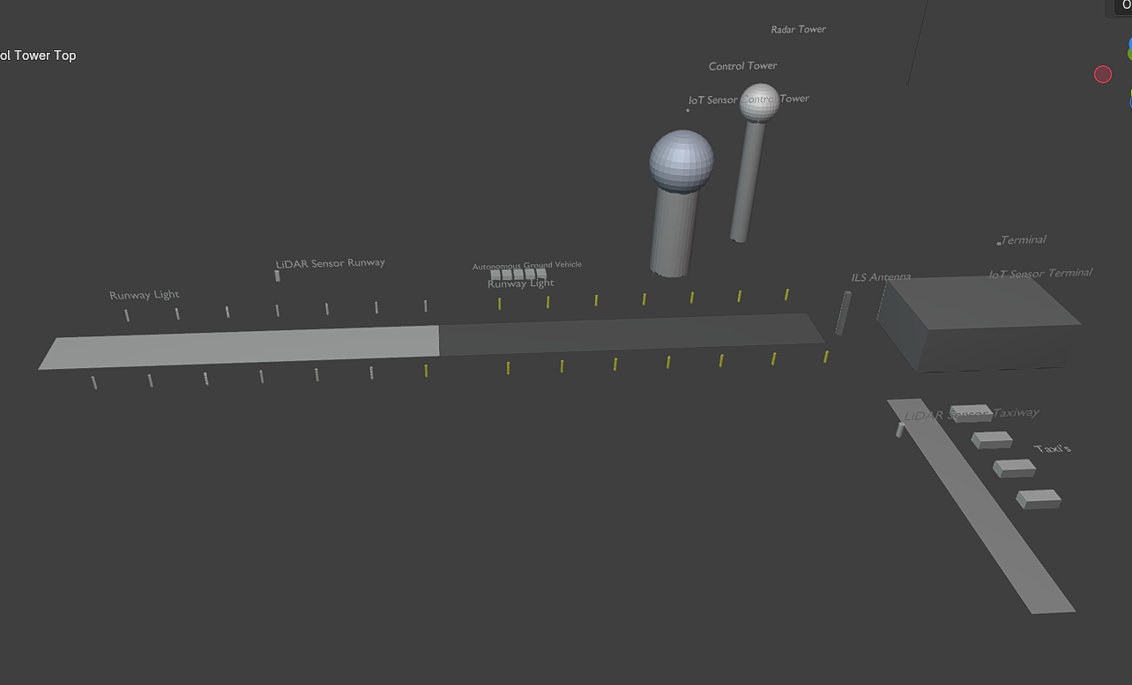

1. **Case Study Report: Enhancing Runway and Taxiway Management Systems**

**2.1 Objective:**

Develop a smart runway and taxiway management system to improve monitoring, management, and optimization of aircraft and ground vehicle movements. This system aims to provide accurate, timely information to air traffic controllers and ground personnel to enhance safety, reduce delays, and increase airport throughput.

*[Insert Icons or Illustrations Highlighting Key Objectives]*

1. **Model Components and Their Contributions**
   * **Runway and Taxiway Infrastructure**
   * **Runway:** 300x45 meter runway with asphalt material.
   * **Taxiway:** 200x25 meter taxiway with concrete material.
   * *Graphics*

**3.1 Sensor Technology**

* + **LiDAR Sensors:** For monitoring runway and taxiway conditions. These sensors continuously monitor the runway and taxiway conditions to ensure safety by detecting hazards like debris or surface damage.
  + **IoT Sensors:** Located at the control tower and terminal for real-time data. Placed at strategic locations such as the control tower and terminal, these sensors provide real-time data to help with decision-making and resource management.
  + ***Graphics:***

**3.2Autonomous Ground Vehicle (AGV)**

* + Represents a ground vehicle equipped with sensors for autonomous operations. Ground vehicles equipped with sensors for autonomous operations, ensuring they can navigate the airport efficiently and safely.
  + ***Graphics:***

**3.3 Control Tower**

* + **Base and Top:** Realistic materials for central command and observation. The control tower serves as the command center, relying on real-time data from various sensors to guide aircraft and ground vehicles.
  + *Graphics:*

**3.4 Terminal Building**

* + Passenger and operational facilities with metal material.
  + *Graphics:*

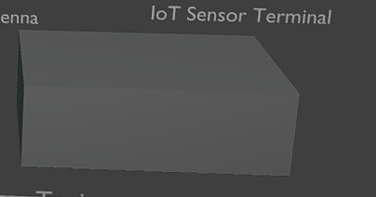

**3.5 Radar Tower and Dome**

* + Radar tower with a white radar dome for air traffic monitoring. A radar tower with a radar dome monitors air traffic, enhancing the overall situational awareness of air traffic controllers.
  + *Graphics:*

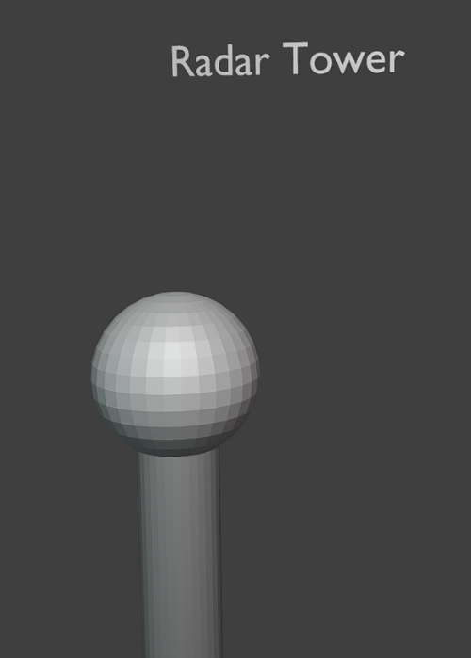

**3.6 Runway Lights**

* + Lights for night operations and low visibility conditions. These are essential for night operations and low-visibility conditions.
  + *Graphics:*

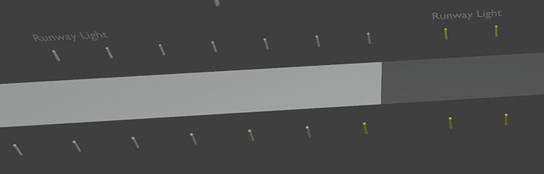

**3.7 ILS Antenna**

* + For guiding aircraft during landing. Provide guidance to aircraft during landing, improving safety.
  + *Graphics:*

**

**Text Labels**

* + Informative labels at key locations.

**4. Problem Solution and Implementation**

1. **Real-Time Monitoring:**
   * LiDAR sensors continuously monitor runway and taxiway conditions, ensuring safety and detecting hazards.
2. **Efficient Management:**
   * IoT sensors provide crucial real-time data for effective resource management and decision-making.
3. **Enhanced Safety:**
   * Runway lights, radar systems, and ILS antennas improve visibility and guidance, reducing the risk of accidents.
4. **Increased Throughput:**
   * Optimized management through sensor data reduces delays and enhances operational efficiency.
5. **Advanced Simulation:**
   * Realistic materials and components offer an accurate simulation environment for training and operational planning.
6. **Conclusion**

This 3D model offers a comprehensive solution for enhancing runway and taxiway management systems by integrating advanced sensor technology and realistic infrastructure. It aids in improving safety, efficiency, and overall airport throughput. Data Aggregation: Collect and combine sensor data from various sources. Which shall be implemented in Application for Control Room.

In developing the enhanced runway and taxiway management solution, significant effort was dedicated to researching, experimenting, and iterating through multiple approaches before arriving at the final, comprehensive solution. I thoroughly investigated various sensor technologies, AI algorithms, and data processing techniques to ensure the system was both cutting-edge and practical for real-world applications.

The process involved detailed exploration of LiDAR and radar technologies, evaluating their performance in diverse weather conditions, and testing IoT-enabled sensors to ensure they could provide accurate real-time data under high-traffic scenarios. Extensive simulations were run to refine the AI-driven predictive analytics and optimization models, ensuring that the system would accurately detect potential hazards, predict delays, and suggest optimal routes for aircraft and ground vehicles.

Countless hours were spent analysing airport traffic patterns and working through technical challenges, such as latency in data transmission and the integration of autonomous ground vehicles into the existing airport infrastructure. I engaged in extensive consultations with aviation experts and reviewed aviation safety standards to ensure that the system not only improved efficiency but also met the stringent regulatory requirements essential for airport operations.

The solution was not arrived at lightly. I rigorously tested different models, iteratively improving the system to ensure it would deliver significant long-term benefits such as enhanced safety, reduced delays, and cost savings. This entire journey required continuous learning, troubleshooting, and tireless commitment to achieve a robust, scalable solution that can truly revolutionize airport operations.

A Message from Rockerz

Dear Team Aerospanza,

I would like to extend my heartfelt thanks for giving me the opportunity to work on this project. It has been an incredibly rewarding experience, allowing me to challenge myself, dive deep into cutting-edge technologies, and contribute to an innovative solution that can significantly improve runway and taxiway management.

I truly appreciate the trust and support provided throughout this journey, and I am grateful for the chance to be a part of such a meaningful and impactful project. The knowledge and skills I have gained during this process are invaluable, and I look forward to applying them to future endeavors.

Thank you once again for this wonderful opportunity!

Sincerely,  
Team Rockerz

Abhirath([Abhirathkumar2211@gmail.com](mailto:Abhirathkumar2211@gmail.com))

Anshika