FINLOAN AI
Loan Eligibility, Credit Analytics and Smart Financial Intelligence Platform

Submitted by | Abhijeet Wani
Course / Program | AI Loan Eligibility Checker
Institution | Dr. D. Y. Patil College Of Engineering And Innovation, Talegaon Dabhade, Pune
Project type | Capstone Project
Repository | https://github.com/abhi007-deve/Capstone_project

Abstract
FinLoan AI is a web-based financial technology project intended to help users understand loan affordability, credit-related factors, repayment schedules, and practical financial-planning options. The application brings together a loan eligibility checker, credit score analysis and what-if simulation, an EMI calculator, financial tips, and saved appraisal reports. Its stated approach combines rule-based financial calculations with optional AI-provider integration, with an algorithmic fallback when external AI credentials are not configured. The tool is an educational decision-support aid; its estimates are not an official credit-bureau score, bank sanction, or substitute for advice from a regulated financial institution.

1. Introduction
Loan decisions depend on several factors, including income, existing monthly obligations, credit history, requested loan amount, interest rate, and repayment tenure. These factors can be difficult for a borrower to evaluate manually. FinLoan AI presents key calculations and scenario comparisons through a single web interface so that users can explore possible borrowing and repayment outcomes before approaching a lender.

1.1 Problem statement
Borrowers may have limited visibility into how existing commitments affect their capacity to repay a new loan, how interest changes the total repayment amount, and which financial habits may improve their profile. A simple, transparent planning interface can make these concepts easier to explore.

1.2 Objectives
- Estimate loan affordability using borrower-provided financial information and rule-based indicators.
- Show credit-health indicators and allow users to explore hypothetical changes in utilization or debt repayment.
- Calculate monthly instalments and illustrate principal-versus-interest repayment over time.
- Provide general financial-planning tips and possible debt-management actions.
- Allow users to save and review prior appraisal scenarios where the configured storage feature is available.

2. Project Overview and Scope
The public repository describes FinLoan AI as a full-stack browser application. The user interface is built with React and TypeScript, styled using Tailwind CSS, and served through a Node.js/Express server with Vite tooling. The project includes optional integration with Google Gemini and Anthropic Claude, plus optional Google Sheets synchronization. Actual provider availability depends on environment configuration.

2.1 Main modules
Module | Purpose
Dashboard and navigation | Provides a central entry point and navigation between the financial tools.
Loan Eligibility Checker | Uses inputs such as income, expenses, existing EMI, credit-card debt, age, employment details, dependents, requested amount, and tenure to estimate eligibility and borrowing capacity.
Credit Score Analyzer | Displays a 300–900-style score scale and lets users explore hypothetical utilization and debt-payoff scenarios. It should not be described as a real bureau pull unless such integration is separately verified.
EMI Calculator | Calculates an estimated monthly instalment using a reducing-balance repayment formula and presents an amortization breakdown.
AI Financial Tips | Offers general financial-planning suggestions such as liquidity reserves, debt consolidation considerations, and credit-improvement steps.
Saved Reports and History | Supports appraisal/report viewing and history comparison; persistence and Google Sheets sync depend on how the application is configured.

3. Technology Stack
Layer | Technology
Frontend | React, TypeScript, React DOM
Build and development | Vite, TypeScript, tsx
Backend | Node.js with Express
Styling and motion | Tailwind CSS and Motion
Icons | Lucide React
Optional AI integration | Google Gemini via @google/genai; Anthropic Claude where configured
Optional external reporting | Google Sheets API/service-account configuration, if enabled

4. System Architecture and Workflow
At a high level, the user enters financial information through the browser interface. The frontend performs interactive display and passes supported analysis or save requests to the Express backend. The backend exposes API routes for health checks, analysis, saving evaluations, and retrieving history. Depending on configuration, analysis may use the internal rule-based calculation path or an external AI provider. Optional Google Sheets synchronization can be enabled with the required service-account settings.
- User opens the application in a browser.
- User selects a module and enters the required financial values.
- The application calculates relevant ratios, repayment estimates, or scenario results.
- The analysis view presents the result and explanatory guidance.
- Where enabled, the user can save the appraisal and review earlier scenarios.
Architecture flow (conceptual):
User → React/TypeScript UI → Express API → Rule-based engine / optional AI provider → Results
Optional reporting path: Express API → Google Sheets (only when credentials and sheet configuration are provided).

5. Financial Logic

5.1 Fixed Obligation to Income Ratio (FOIR)
FOIR represents the proportion of monthly income committed to fixed debt obligations. A typical calculation is:
FOIR (%) = (Monthly fixed obligations ÷ Monthly income) × 100
The exact obligations included and thresholds used should be checked against the implementation and clearly stated in any final report. Lenders may apply different policies.

5.2 Debt-to-Income (DTI) ratio
DTI (%) = (Monthly debt payments ÷ Gross monthly income) × 100
DTI is a general affordability indicator. The definition of debt payments and income can vary by institution and product.

5.3 Equated Monthly Instalment (EMI)
For a fixed-rate reducing-balance loan, the standard EMI formula is:
EMI = P × r × (1 + r)ⁿ ÷ [(1 + r)ⁿ − 1]
Where P is the principal, r is the monthly interest rate expressed as a decimal, and n is the number of monthly instalments. For a quoted annual rate, the monthly rate is generally annual rate divided by 12, with percentage converted to decimal.

5.4 Eligibility estimate
The eligibility module combines multiple profile inputs and affordability checks to produce a guidance score or risk category. This should be presented as a project estimate only; actual lender underwriting can include additional checks, bureau data, policy rules, verification, and regulatory requirements.

6. API Overview
Endpoint | Purpose
GET /api/health | Reports backend health and configured AI / Sheets integration status.
POST /api/analyze | Accepts applicant and loan parameters and returns an appraisal analysis.
POST /api/save | Saves an appraisal to the configured in-memory store and optionally synchronizes it to Google Sheets.
GET /api/history | Retrieves previous evaluations available in the current configured history store.
For the final submission, include actual request/response examples only after testing the running application. Do not include live API keys, private keys, passwords, or other credentials in the report.

7. Setup and Execution
Prerequisites listed by the repository include Node.js (18 or later recommended) and npm.
- Clone the public repository: git clone https://github.com/abhi007-deve/Capstone_project.git
- Open the project folder: cd Capstone_project
- Install dependencies: npm install
- Create a local environment file based on the repository's example environment file and add only the keys you actually intend to use.
- Start the development server: npm run dev
- Open the local address printed by the server in a browser (the README describes port 3000).
- For a production build, run npm run build. Run npm run lint to perform the configured TypeScript check.
Configuration note: AI provider keys and Google Sheets service-account values are optional in the README. Keep secrets in a local environment file and never commit the populated file to a public repository.

8. Testing and Validation
This section is a test plan, not a claim that all tests have already passed. Run each test on the current application, record the actual result, and attach screenshots or logs as evidence.
Test | Procedure | Result
Launch | Run npm run dev and confirm that the interface loads without a fatal error. | To be tested
Loan analysis | Enter valid sample inputs and confirm an appraisal result is displayed. | To be tested
Input validation | Try missing, zero, negative, and unusually large values where relevant. | To be tested
EMI calculation | Compare the displayed EMI for a known principal, rate, and tenure with an independent calculation. | To be tested
Credit what-if | Change utilization or debt values and confirm the scenario output updates as intended. | To be tested
Save/history | Save a report and confirm it appears in history; repeat after refresh to verify persistence behavior. | To be tested
AI fallback | Test without external AI credentials and record whether the fallback path works. | To be tested
Build/type check | Run npm run build and npm run lint; capture the actual output. | To be tested

9. Screenshots and Demonstration Evidence

Screenshot 1 — Dashboard
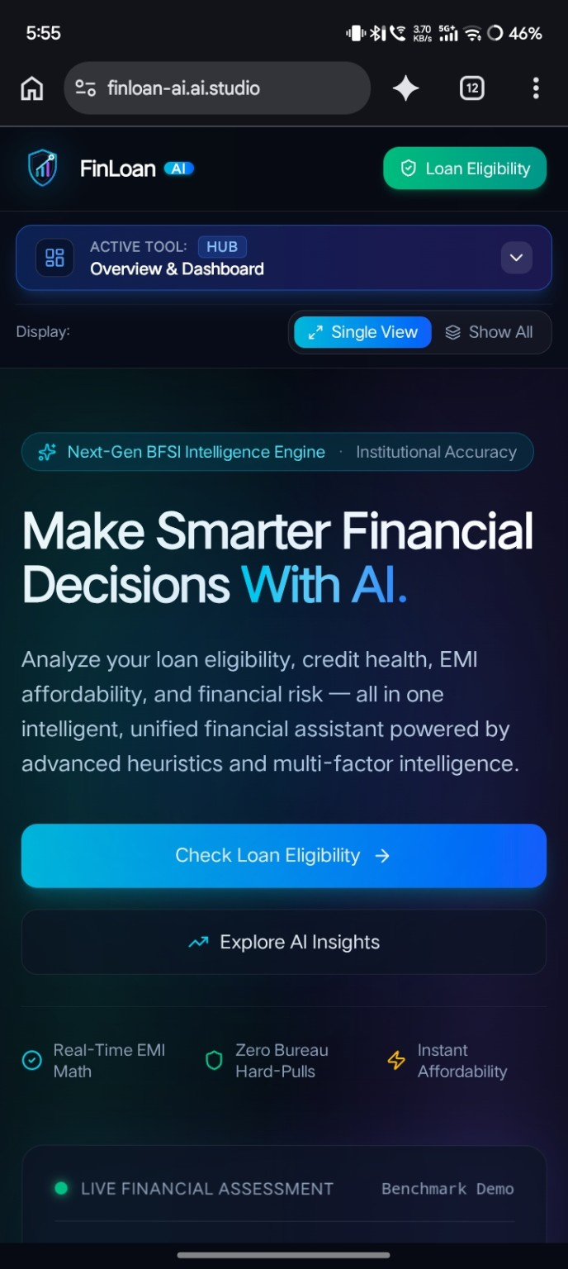
Figure 1. FinLoan AI dashboard and main navigation.

Screenshot 2 — Tools/Features
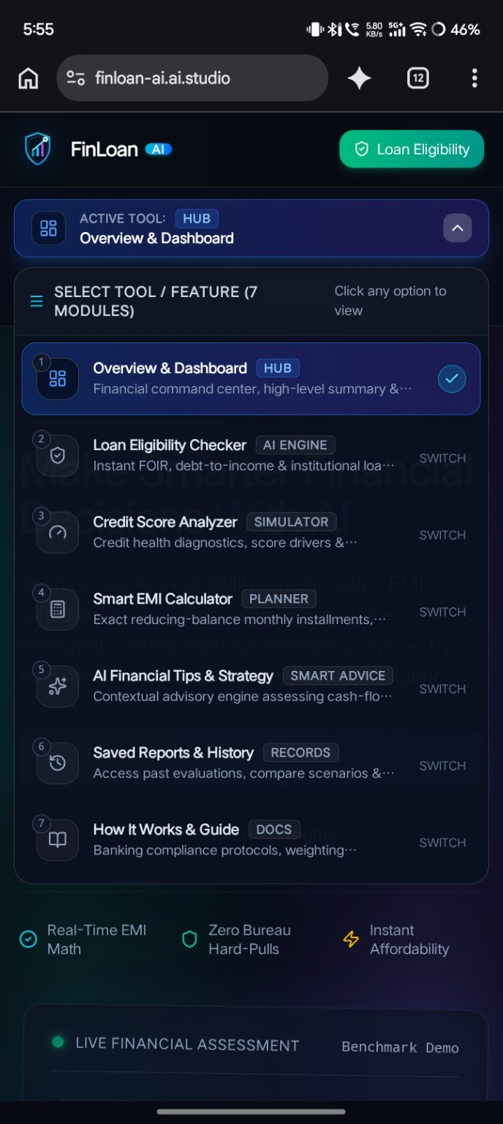
Figure 2. Tools/Features

Screenshot 3 — Credit Score Analyzer
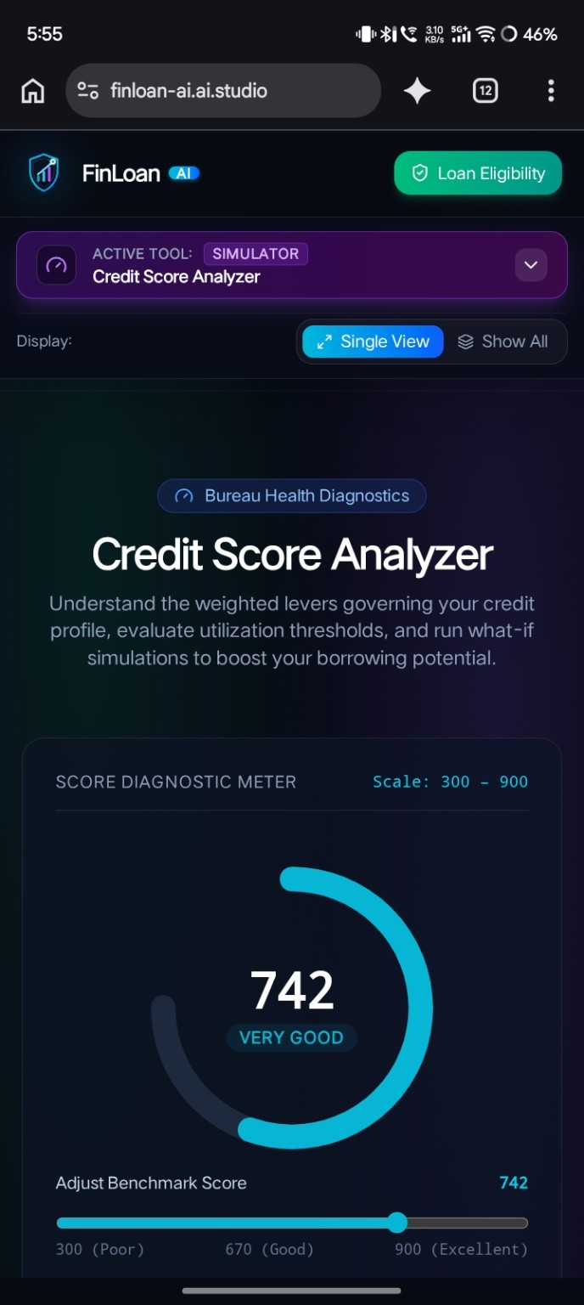
Figure 3. Credit Score Analyzer and benchmark score display.

Screenshot 4 — EMI Calculator
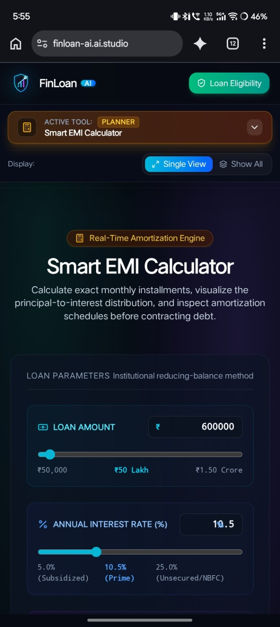
Figure 4. Smart EMI Calculator and loan parameters.

Screenshot 5 — AI Loan Eligibility Checker
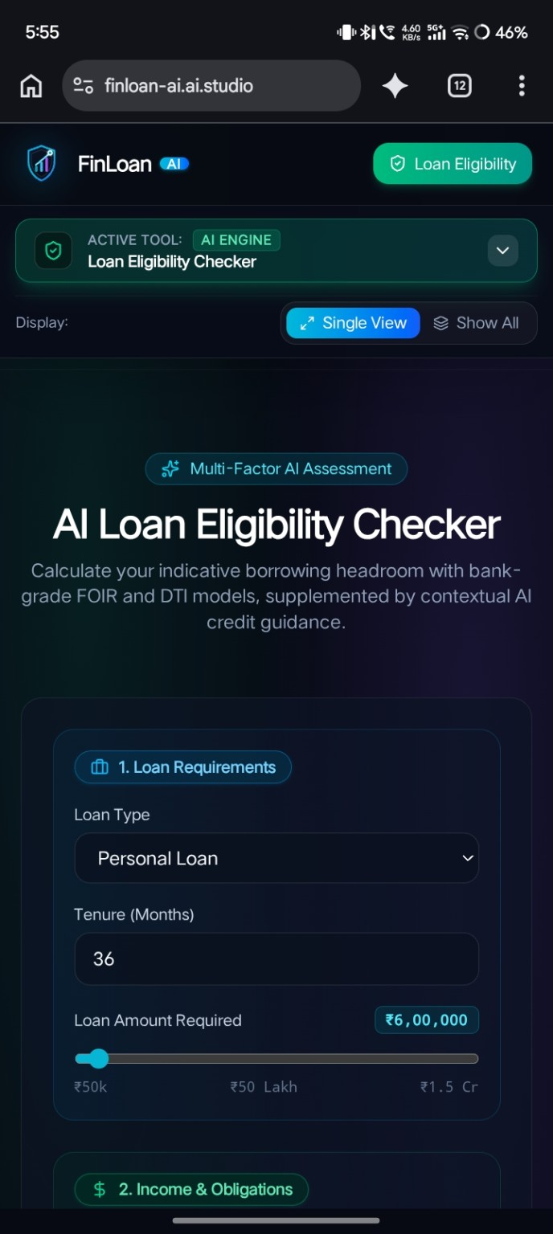
Figure 5. AI Loan Eligibility Checker

Screenshot 6 — AI Finance Tips and Strategy
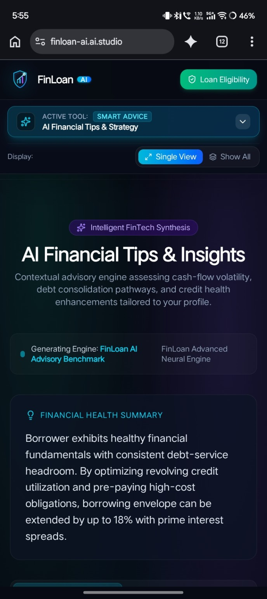
Figure 6. Saved Reports & History showing an example analysis.

10. Limitations and Responsible Use
- Outputs are estimates for learning and planning and do not represent an official loan approval or credit-bureau report.
- Results depend on the accuracy of the user-entered values and the rules implemented in the application.
- External AI and Google Sheets features require correct configuration and may be unavailable without credentials or network access.
- The repository README describes history as memory-based; verify persistence behavior before claiming permanent database storage.
- Financial decisions should be verified with the relevant lender or qualified financial professional.

11. Future Scope
- Add automated unit and integration tests for financial calculations and API endpoints.
- Improve input validation, error handling, and accessibility.
- Add transparent explanations of every eligibility factor and configurable lender-specific thresholds.
- Introduce secure, authenticated, database-backed user accounts and durable report storage if required.
- Add consent-aware export options and stronger privacy controls for any saved financial information.
- Validate calculations against independently checked test cases and document the expected results.

12. Conclusion
FinLoan AI brings together loan affordability estimation, credit scenario exploration, EMI planning, financial guidance, and report-history features in a single web application. Its main value is to help users understand financial concepts and compare hypothetical scenarios. Before formal submission, the project should be run and tested, screenshots should be added, and all statements about implemented functionality should be confirmed against the current code and runtime behavior.

References
1. FinLoan AI public source repository: https://github.com/abhi007-deve/Capstone_project
2. Project README and package configuration in the repository (accessed 24 October 2026).
3. Standard reducing-balance EMI formula, as included for explanatory purposes; confirm the application's exact implementation.

