**Abstract**

OWASP vulnerabilities Scanner is used to scan the web page of the websites. The tool requires regular updating from both users and creators. The whole objective of the project is to find the vulnerabilities in the web page.

Most of the Vulnerabilities are found on users’ side through client-side submission of unexpected inputs. It is clear that Vulnerabilities are present since the widespread of WWW (world wide web) but what seem unclear is that why anything is not done to prevent and cure it. Here we will find out current methods and practices to prevent these Vulnerabilities.

1. **INTRODUCTION:**

The Open Web Application Security Project (OWASP) is a non-profit organisation dedicated to improving software security. The OWASP Foundation is the source for developers and technologists to protect the internet, with community-led open-source software initiatives, many local structures around the world, a vast number of participants, and leading educational and training conferences.

• Resources and Tools

• Collaboration and Networking

• Training & Education

The Scanner for OWASP vulnerabilities is used to detect the bug and vulnerabilities that the websites display about the kinds of vulnerabilities in them. As we all know, over the last decade, organisations have been affected by an ever-increasing number of status data breaches. A large number of them are so-called "injection attacks," in which malicious code is injected into an online application. Indeed, according to OWASP, a web application security organisation, “How data input is managed by Web applications is arguably the most important aspect of security.”

Two reasons for increasing the cyber brawl's stakes. Tactically and operationally, new kinds of exploitable vulnerabilities are created by the growing reliance of new technological strength on networks and knowledge systems. Secondly, with the evolution of societies of the new era, including the military, they must become increasingly involved in a series of interconnected and increasingly vulnerable 'critical infrastructures' that can function effectively. In addition to significantly enhancing the daily efficiency of almost one part of our society, these infrastructures also require introducing new forms of vulnerabilities.

* 1. **Problem Definition**

It is very important to keep an eye on the critical safety risks and vulnerabilities when designing or managing a website.

Open-source software is a great way to make your application more effective, but risky as software vulnerabilities. It is important to track new vulnerabilities when using Open-Source (and probably also if you are), so that you can upgrade to the latest patched up version of the software.

The list given by the Open Web Application Security Project (OWASP), which was last updated in 2017, is one thing that you can do to keep the knowledge of open-source vulnerabilities. The OWASP Top 10 provides you with the most common and dangerous web applications security risks.

* 1. **Project Overview/Specifications**

The list given by the Open Web Application Security Project (OWASP), which was last updated in 2017, is one thing that you can do to keep the knowledge of open-source vulnerabilities. The OWASP Top 10 provides you with the most common and dangerous web applications security risks.

* 1. **Objectives**

The Open Web Application Security Project (OWASP) vulnerability, with the goal of helping website owners and security experts protect web applications from cyber-attacks.

* 1. **Scope**

The Scope of the application is limited to desktop application right now.

* 1. **Limitations**

1. The application will be desktop only.
2. Active internet connection is required for testing.
   1. **Software Specification**

**Operating System**: Windows 10 Home Insider Preview Single Language 64-bit (10.0, Build 20206) (20206.rs_prerelease.200828-1431)

**Language**: English (Regional Setting: English)

**Processor**: Intel(R) Core(TM) i5-7300HQ CPU @ 2.50GHz (4 CPUs), ~2.5GHz

**Memory**: 16384MB RAM

**Available OS Memory**: 16250MB RAM

**Page File**: 9985MB used, 8696MB available

**Windows Dir**: C:\WINDOWS

**DirectX Version**: DirectX 12

**DX Setup Parameters**: Not found

**User DPI Setting**: 96 DPI (100 percent)

**System DPI Setting**: 120 DPI (125 percent)

**DWM DPI Scaling**: Disabled

**DirectX Database Version**: 1.1.5

**IDE**: Visual Studio Code v1.48.2

**Database Server**: MySQL-server-2012

**Programming Language**: Python v3.6,

**Design Software**: Adobe XD v29.1

1. **Literature Review:**

Requests Security and software is only one of the main development planning steps. The extent of reliability is, after all, what will determine your success, as an example for the number of active users in the application. And without mentioning OWASP, there is no reason to debate security.

In order to combat safety violations, systems to protect against unauthorised infringements and wind leaks of users and corporations, IT professionals work together. This makes monitoring and participation in OWASP essential.

Rubidha Devi.D [1] the author of this paper says that web sites have become the most important part in our lives during this era of security. The greatest threats to safety The attack is supported top by SQL Injection OWASP [1] OWASP [1]. Report on top 10 vulnerability vulnerabilities. We insert a number of non-public data that is stored within the database through these websites. We can access it via the network from anywhere. The attackers have thus opened the door to collect these data from vulnerable websites. To find vulnerable websites, attackers can find numerous efficient tools such as botnet that generate a list of vulnerable websites. The attack is detected on the website.

Md. Maruf Hassan stated that a variety of web application vulnerabilities are being researched. There have been about fünf security vulnerabilities in web applications (SQLi, Inclusion Attack, XSS, Brute Forcing Attack and Increased Cryptographic Storage) covered in the paper. The author discovered that 60% of the Internet resources are not safe due to the presence of the device level faults, according to a survey conducted on Internet usages. The author of an article suggested a further survey of the different SQLi and XSS vulnerabilities styles in the web app.

Md A. Obaida1 suggested that the developer could use plug-ins to enhance the IDE functionality. As an interactive tool, SSD benefits from the JDT (Java Development Tooling) extension points and APIs of Eclipse. In the generic resource platform model, JDT adds Java specific behaviour, adds specific Java perspectives, editors and workbench actions. We will access Java Editor in eclipse using JDT API and extension points and manipulate Java resources programmatically. SSD is included in the Eclipse plugin variety. It is the ability to start and stop the plug-in, unlike most other interactive plug-ins. This feature becomes useful

**System Analysis**

The analysis of systems is a very important stage of the development of any system. The system is analysed and analysed in detail. The system analyst plays the role of a questioner and deeply influences the functioning of the current system. In analysis, the system and its relationships within and without the system are examined in detail. The system is considered as a complete system and the system inputs are also recognised. The analyst understands what is to be done as soon as the analysis is completed. The project aims at developing an organization's Web-based approach. This document gives details on all requirements for software

Attacks of injection input may serve various purposes. In general, malicious users are most popular with learning from a back-end information or imbating malicious code on an online server which can successively disseminate malware for unsuspecting shoppers. These shoppers could then notice that they have exfiltrated their credentials or personal information.

* 1. **Existing System:**

For this there are no systems available. All the work is therefore done individually and partially for every vulnerability that costs money, takes time and is not effective and efficient and disturbs the valuable customers.

WHY THIS SYSTEM?

In order to overcome the problems, we plan to develop a system for both the customers and the company that scans all vulnerabilities in one go and identifies the lack of an efficient approach.

* 1. **Proposed System:**

This method tends to replace the current manual system with a scanning process, which is time consuming, less interactive, and costly. The most important features of this approach are the creation of reports and the discovery of different types of vulnerabilities, as well as the storage of scanning data, process initiation, and the generation of a report of all scanned websites.

Proposed System Advantages:

• Easy-to-use register system

• Fastest Wed Spider/Crawler

• Session ease of control

• Registration free of charge

• Large test spectrum

• Fastest Scanner

• Search for a particular Websites if Once it is used

OWASP SCAN is a user interface platform that helps you solve a real-world dilemma. Having the ability to combat cybercrime. Recommendations is also a significant feature because it acts as a deterrent to hackers and assists in identifying and closing open gaps in a computer system or network.

* 1. **Feasibility Study:**

During this section, the feasibility of the project is analysed and the business proposal is accompanied by a very general project setup and several price estimates. The practicality study of the scheduled system shall be administered throughout the system analysis. This can be to ensure that the system that is being planned is not a business burden.

A feasibility test might be a system proposal test according to its functionality, its impact on the organisation, its ability to meet its user needs and its efficient use of resources. It is not a matter to resolve, but to accumulate a path of its extent to a feasibility study. During the study, the definition of subject is crystallised and aspects of the issue are identified and the costs and benefits are therefore estimated in more detail at this stage. The results will be evaluated. The feasibility study's findings could lead to a formal system proposal. This may simply be a method of describing or describing the nature and scope of potential solutions. The plan outlines what is already understood as well as what needs to be accomplished. Within the feasibility study, there are three main considerations:

❖ Schedule feasibility

❖ Technical feasibility

❖ Operational feasibility

❖ Economic feasibility

2.3.1 Technical feasibility

This study is used to check the technical practicality, that is, the system's technical needs. Every developed system should not have high demand for the technical resources that are available. This can create high demands on technical resources that are accessible. This could lead to high consumer demands. The system designed should have a modest demand, since only the square measurement needed to implement this system is low or zero changes.

2.3.2 Operational feasibility

The project will be usable since the user will have basic computer and internet knowledge. Furthermore, the project is only used if the machines do not have internet access.

2.3.3 Schedule feasibility

The feasibility analysis schedule is the CPM technology for mistreatment. CPM was used to defining important tasks and to calculating the relationship between tasks. The arrangement was intended to outline important and non-critical tasks in order to prevent timeframe problems and method bottlenecks.

2.3.4 Economic feasibility

Economic analysis is that the most common method of comparing the price against the advantage or income of the developed system is expected. A system which will often be used if installed still must be an honest investment for the organisation is developed technically. The cost of the event in the development of the system is assessed in accordance with the final word benefit derived from the new systems within the economic viability. Financial advantages shall be equal to or above prices.

|  |  |
| --- | --- |
| **3.** | **SYSTEM ANALYSIS & DESIGN:**  All the technical conditions required for the software design and deployment will be provided in this Document section. The goal is to provide readers with the rough design of the software and to understand few of its features.  The main purpose of this document is to provide a general insight into the analysis, requirements and operating characteristics of the system or the current state of affairs. The Complete Net Vulnerabilities Scanner project is twice designed to develop a web-based scanner for an entire company.  Scope: In the Event Life Cycle (SDLC), this document plays an essential role in describing the total system need. It is intended to be used by developers and is essential for the entire testing process.  **FUNCTIONAL REQUIREMENTS**  **OUTPUT DESIGN**  PC system unit outputs mainly needed to communicate users' process results. You are also used to providing a continuous copy of the results for further consultation. In general, the numerous output varieties are:  external products, which are destined outside the company Internal outputs whose target is the main interface of the user with the pc in the organisation they are area. Operating outputs which are used in the pc department. Interface outputs, which directly involve the user  **OUTPUT DEFINITION**  In the following points the results are to be described:  • Type of exit  • Content output  • Output format;  • Output positioning  • output frequency  • The output volume  • Output sequence  It is not always desirable to print or display data as it is stored on a computer. It should be determined which output is best suited.  **Output Media:**  The next step is to determine that medium is the most acceptable to the output. The main considerations for deciding on the output media are:  1 Suitability for the application currently in use.  2 Requirements for hard copying.  3 The time interval required.  4 situations of users  5 There are 5 packages and equipment.  If the project can be described more than enough, outputs are returned mainly in the internal output class. The most desired outputs are as follows:  The results must be created as a hot copy and additionally as queries on the screen. If these outputs are visible, the output format will be taken from the outputs that are currently manual in the area unit. The quality printer output media are used  **INPUT DESIGN**  It belongs to the overall design of the system. The main objective is the following during the design of the input:  A cost-effective input method is created to ensure the highest possible level of accuracy.  Make sure the user understands and accepts the information.  **INPUT STAGES:**  The following are the main input stages:  The following:  • Transcription of data  • Data recording  • Conversion of data.  • Checking of data  • Control of data  • Data transmission  • Validation of data  • Fixed data.  INPUT TYPES:  The different types of inputs need to be determined. The inputs may be divided into the following:  • External inputs that are the system's main inputs.  • Internal inputs that are system user communications.  • Operational, which are system communication in the computer department?  • Inputs that have been entered in the dialogue, interactive.  INPUT MEDIA:  The input media must be chosen at this stage.  • Input type  • format flexibility: to conclude the media input consideration;  • The velocity.  • Precision  • Methods of checking  • Rates of refusal  • Facility to correct  • Requirements for storage and management  • Security  • Security  • Use easily  • Wear ableness.  With the input varieties and media above the description in sight, the majority of the inputs can be equal to the internal and interactive measurement of the shape. The keyboard can be seen as the most suited data input device, because the input file is the user's own key.  **ERROR AVOIDANCE**  At this stage it is necessary to ensure that the computer file remains correct in the stage at which the information is recorded to the stage at which the system accepts the information. This can only be achieved by careful administration when handling the information  **ERROR DETECTION**  Those types of errors can be discovered through validations to check input data, despite every effort to prevent error occurrence, still a small proportion of errors is likely to occur.  **DATA VALIDATION**  Procedures square to identify knowledge errors at a lower level of detail. In almost every space where there is a chance for the user to commit errors, the system includes knowledge validation. The system will not solve invalid knowledge |
|  | * 1. **Requirement Specification**\* (page-2)   The three crowns of a project depend primarily on the hardware and computer code used to compile it. The hardware used in the machine should support the computer code, which is mounted for the project to be aggregated. This project covers the hardware and computer code, which is readily and easily accessible to every user machine.  Operating environment:  **Operating System**: Windows 10 Home Insider Preview Single Language 64-bit (10.0, Build 20206) (20206.rs_prerelease.200828-1431)  **Language**: English (Regional Setting: English)  **Processor**: Intel(R) Core(TM) i5-7300HQ CPU @ 2.50GHz (4 CPUs), ~2.5GHz  **Memory**: 16384MB RAM  **Available OS Memory**: 16250MB RAM  **Page File**: 9985MB used, 8696MB available  **Windows Dir**: C:\WINDOWS  **DirectX Version**: DirectX 12  **DX Setup Parameters**: Not found  **User DPI Setting**: 96 DPI (100 percent)  **System DPI Setting**: 120 DPI (125 percent)  **DWM DPI Scaling**: Disabled  **DirectX Database Version**: 1.1.5  **IDE**: Visual Studio Code v1.48.2  **Database Server**: MySQL-server-2012  **Programming Language**: Python v3.6,  **Design Software**: Adobe XD v29.1 |
|  |  |
|  |  |

**ABOUT PROJECT DEVELOPMENT**

Python and its various modules are used to develop this project. For the QT front end, it is the latest and most visually attractive python tool.

3.3.1 Back End tools used

Python:

Python is a language of interpretation, high quality and general use. With his remarkable application of important whitespace, Python's design philosophy emphasises code readability. Its language structures and object-oriented approach are aimed at allowing programmers to produce clear and logical code for large and small projects.

Python is collected with dynamic typing and waste. It supports several paradigms for programming such as structured, object-oriented and functional programming. Because of its comprehensive standard library, Python is often described as "batteries included."

Python is a language of multiple paradigms. Object-oriented and structured programming are fully supported, and several of their features support functional programming and aspect-oriented (including metaprogramming and metapointing) programming. Many other paradigms, including contract design and logic programming, are supported through extensions.

For memory management, Python uses dynamic typeing and a combination of reference and cycle detection waste. This includes also late binding dynamic nominal resolution, which binds the method and the variable names when running the programme.

Python was designed to be highly expandable rather than having all its functionality built into its core. It has been especially popular as a way to add programmable interfaces to existing applications. Van Rossum was struck by his frustration at the approach of ABC with a small core language with a big standard library and a smooth interpreter.

This language has been chosen for its modularity and its easy reading and a vast community of help and support

• Beautiful Soup Module

• URL module to join

• cProfile module for the performance measurement

• Facing design QT

• OS: separate OS.

OPERATING SYSTEM

This project is a separate platform for running in many OSes, including Windows XP, Window 7 and Window 8, Ubuntu 10 and above (IE 9 or above).

**SYSTEM DESIGN**

Modules of project

The design of software sits on the software system technique kernel and is applied irrespective of event paradigm and application space. Style is that any built product or system begins during the development phase. The designer's objective is to provide a model or illustration of an entity that is to be developed later. Initially, once the demand for the system is fixed and the style of the system is analysed, the first of three technical activities is to design, code and take a look at software system design and verification.

* Sql py module
* Xss module
* Broken authentication module

ENTITY RELATIONSHIP DIAGRAMS

An ER model is an abstract way to describe a database.

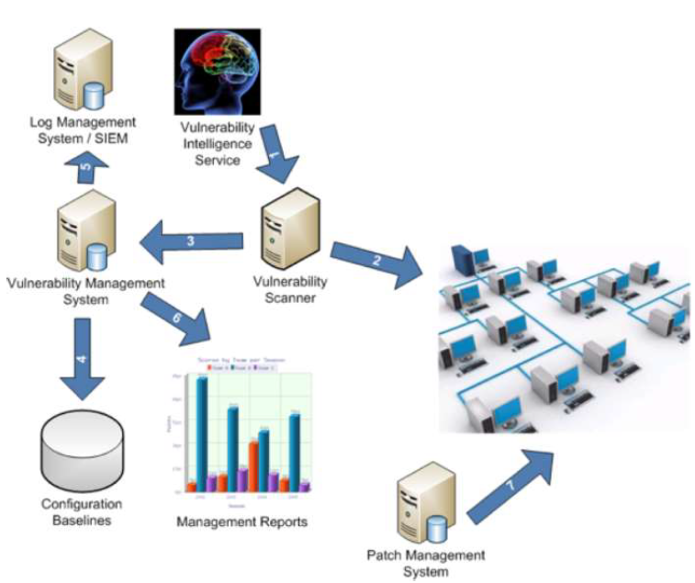

**USECASE DIAGRAM:**

It is important to consider use case diagram in the planning of an economical and efficient healthcare partner system. The case diagram for use is one of the 5 YML diagrams or modelling the system dynamics. Case diagram for modelling a system, system or category comportement is central. Use case diagrams are very important for the visualisation, specification and creation of approachable systems, systems and subsystems and categories, and they can be used in context.

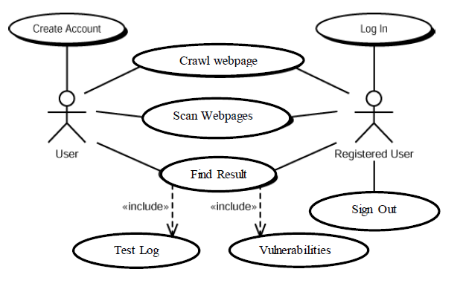

PHYSICAL SYSTEM DESIGN

The work system is created by defining design requirements that tell the programmers precisely what the applicant system has to do.

ARCHITECTURAL DESIGN

Architectural style can be an overview of its type and structure and the ways in which its components match. The style of study can be a package element, one thing as easy as the programming module, but it could be extended to include information and middleware that changes the shopper and server network configuration. There are several modules in this project. The Admin module supports the management of the entire website. The manager may decide that the complaint should be read by the department.

INTERFACE DESIGN

An effective communication media between a human and computer is created by the interface design. The communication between the administrator and the commissioning station is part of this project. As a database is necessary for this project, clients' machines have to be connected to the server host. Through the user friendly web pages, users interact with the software.

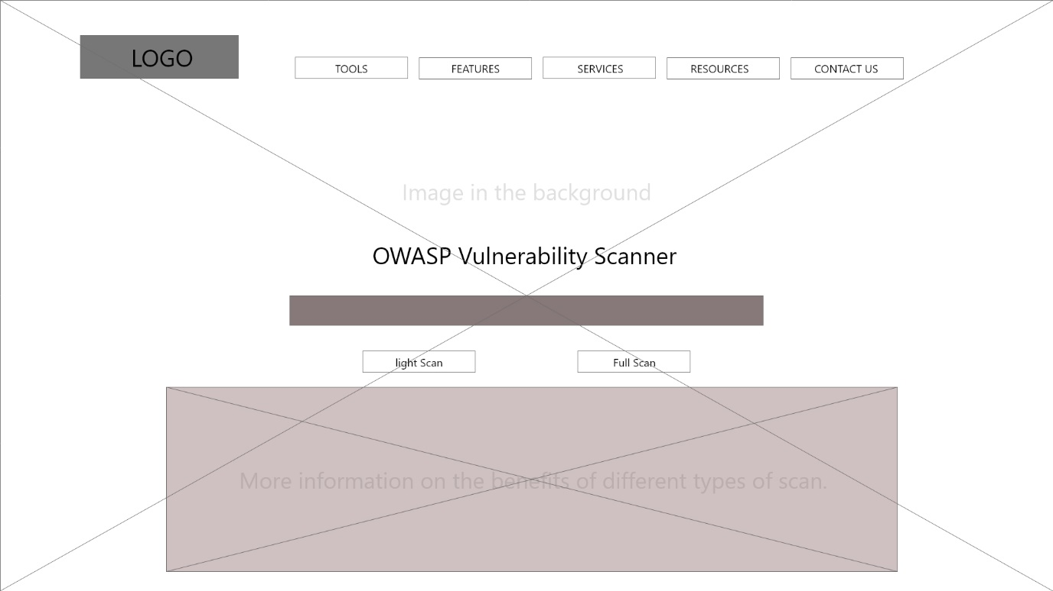

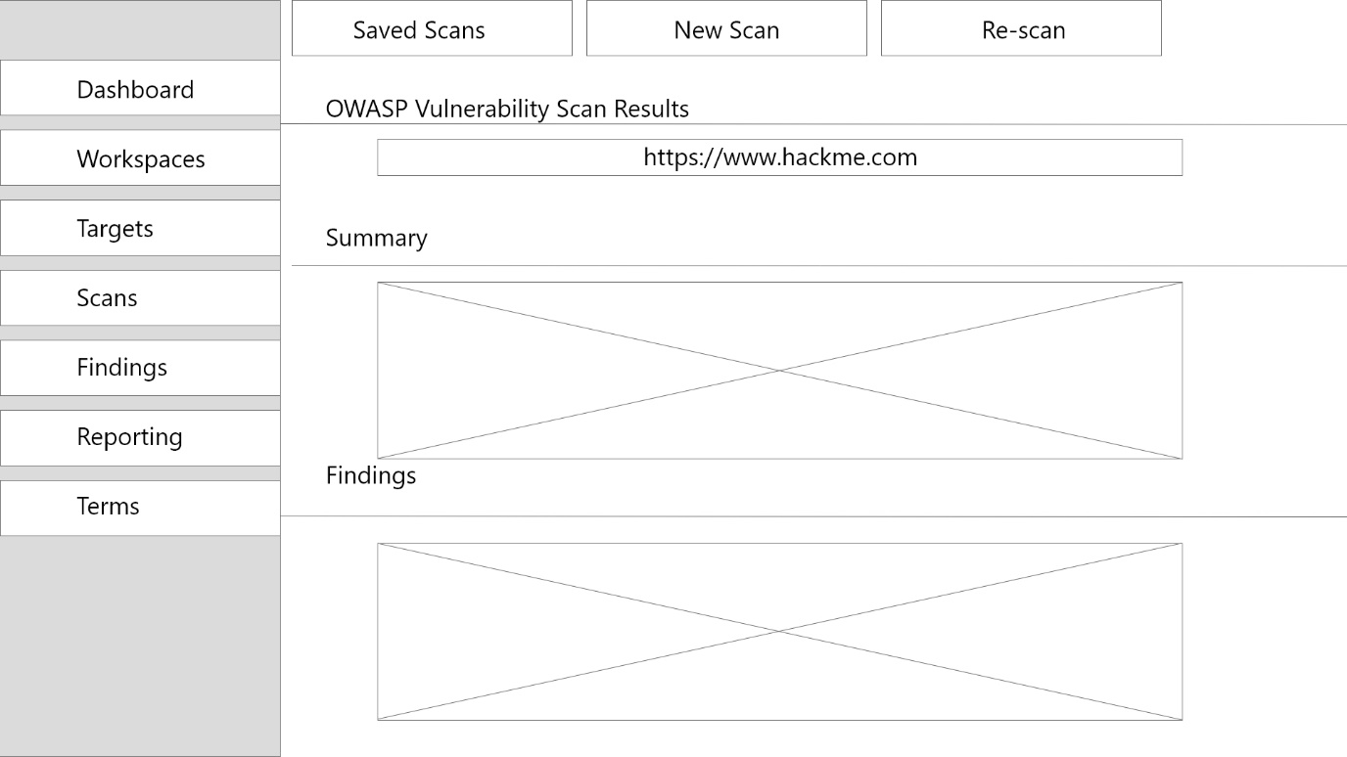Scan Report Page:

**FUTURE ENHANCEMENT**

In one step, nothing can be achieved. It's just that during this world nothing is permanent. In addition, this project has further improvements in the evergreen and booming trade in IT. Change is unavoidable. The "OWASP Scanner of Vulnerabilities" project was developed and tested successfully. The system and thus the design square are compatible and can therefore lead to abundant problems by adding the latest modules. Since this module has its characteristic characteristics, it can extend it to make a whole technique.

**Scope**

It gives the security analyst all the security issues and resolves them by the hackers.

It gives users access and modifies the information intended for them to all the privileges they need.

The present system will not be completely replaced, but the Scanning method and the information used will be largely automated.

**Success Criteria**

t automates the manual method of scanning. We are inclined to believe that the organisation will finally recognise the value and necessity of this technique when it chooses to use that technique and will perceive the questions in question under the manual procedure.

**CONCLUSION**

There is a great deal of security in the project. The simplicity and simplicity of this project unite the advantages. The user-friendly code for pc is created in the first place so that anybody can execute the pc code provided by the login word.

All details with no risk are managed in this project. All goals have been met with pleasure.