FLARRE AI INNOVATION CHALLENGE 2026 | TECHNICAL SUBMISSION
COVERAGE TRUTH LAYER
Catch Coverage Contradictions Before They Become Denied Claims
Mekala Abhilash
Chaitanya Bharathi Institute of Technology (CBIT), Hyderabad
Live Prototype: https://coverage-truth-layer.vercel.app/
Abstract — In commercial property and casualty insurance, legal agreements are scattered across preliminary broker quotes, issued master policies, and post-binding endorsement riders. Critical coverage differences—such as a broker quote promising a $1,000,000 blanket water damage limit while a subsequently attached endorsement caps it at $50,000—frequently slip through manual policy checking. Coverage Truth Layer (CTL) is an AI-powered document intelligence and evidence-traceability system built for the Flarre AI Innovation Challenge 2026. Built on the governing principle of 'Pipeline first. Agent when needed. Human judgment for the final decision,' CTL couples deterministic numerical validation with semantic language evaluation and a bounded chronology agent. The system anchors every flagged contradiction to character-level source citations and dispatches actionable findings to a human-in-the-loop review console with persistent audit logging.

1. Introduction
Commercial insurance represents a multi-billion-dollar bedrock of enterprise commerce. Yet, unlike retail personal lines, a commercial placement is never a single unified document. Instead, it is negotiated across a multi-stage lifecycle:
- Promised (Pre-Binding Scope): Broker quotes, proposal summaries, and email indications stating promised limits and deductibles (e.g., $1,000,000 blanket water and sewer backup).
- Documented (Inception Scope): Master policy jackets (e.g., ISO Form CP 00 10) and post-issuance restrictive endorsements (e.g., END-04-WTR) attached weeks later by carrier systems.
- Paid (Post-Loss Claims Scope): First Notice of Loss (FNOL) claims processing and settlement dispute resolution (designated as future roadmap extension).
The Problem: When underwriters, wholesale brokers, and corporate risk managers check contracts manually, important coverage contradictions remain latent. During a catastrophic loss, claims adjusters deny payment based on obscure endorsement exclusions, triggering devastating financial losses for the insured and severe Errors & Omissions (E&O) lawsuits for brokers.
The Solution & Objectives: Coverage Truth Layer introduces an auditable reconciliation layer that:
- 1. Normalizes Contract Terms: Extracts structured coverage limits, deductibles, perils, and territory scopes.
- 2. Reconciles Promised vs. Documented: Compares broker promises against issued policy forms and riders.
- 3. Identifies Contradictions: Applies deterministic checks for numbers and semantic analysis for legal conditions.
- 4. Anchors 100% Provenance: Pins every finding to exact document page, section, and cryptographic hash.
- 5. Bounded Agent Escalation: Launches an autonomous agent strictly when chronological or precedence conflicts arise.
- 6. Human-in-the-Loop Governance: Maintains an interactive underwriter review console backed by an immutable audit trail.

2. Design of the Proposed System
Coverage Truth Layer is structured around a hybrid architecture balancing deterministic reliability with AI reasoning. Figure 1 illustrates the complete system architecture.
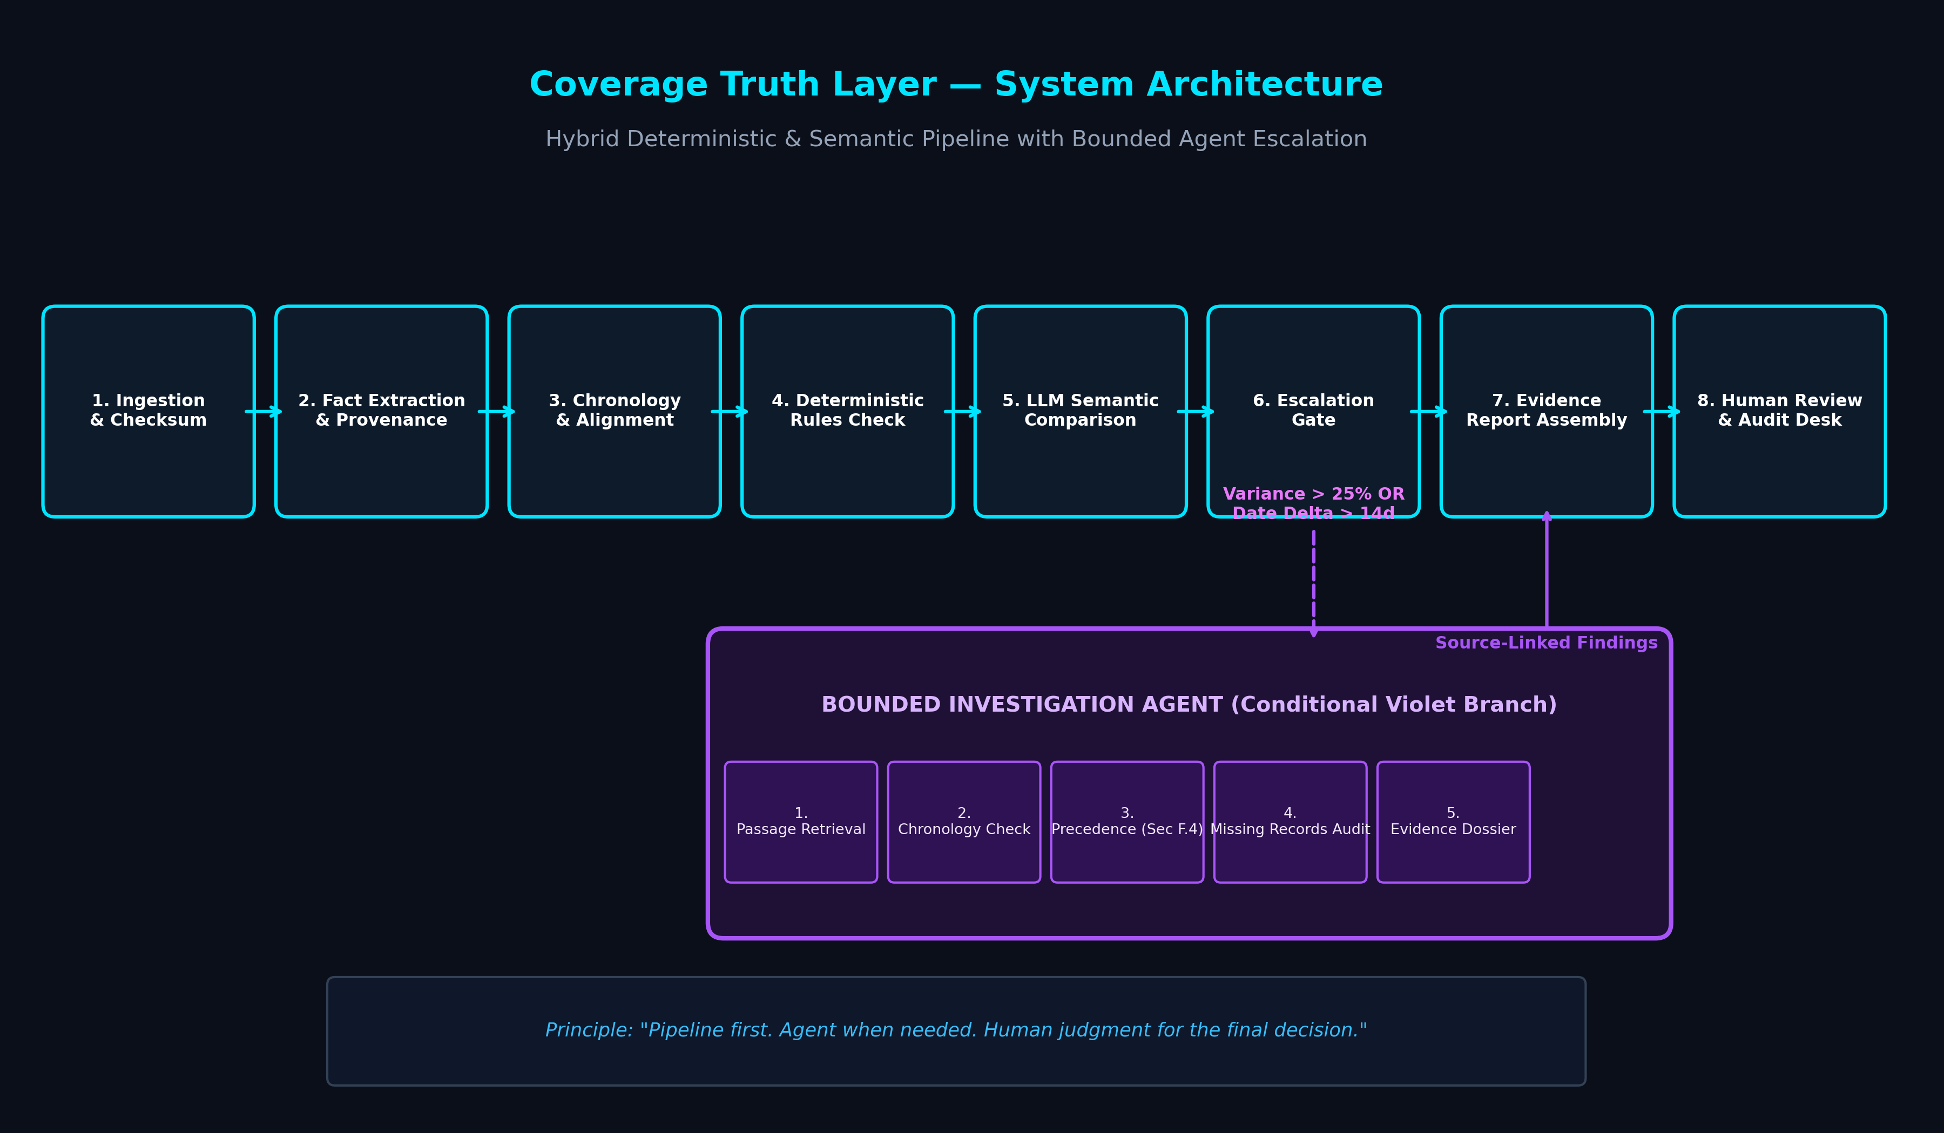
Figure 1: Coverage Truth Layer System Architecture (8-Stage Pipeline + Violet Bounded Agent Branch)

2.1 Conceptual Multi-Stage Pipeline
The processing pipeline executes across eight sequential stages:
- Stage 1 — Ingestion & Checksumming: Ingests broker quote, master policy, and endorsements; computes cryptographic SHA-256 hashes; and maps paragraph coordinates.
- Stage 2 — Fact Extraction with Provenance: Extracts structured coverage limits, deductibles, perils, and exclusions with character span links.
- Stage 3 — Chronology Alignment: Orders documents along an effective date timeline to identify post-binding riders.
- Stage 4 — Deterministic Validation: Zero-hallucination arithmetic comparison of numerical limits, deductibles, and coinsurance percentages.
- Stage 5 — LLM Semantic Comparison: Evaluates conditionality language ('notwithstanding any prior representation', 'unless separately scheduled').
- Stage 6 — Escalation Gate: Triggers Bounded Agent when variance exceeds 25% or effective dates diverge by >14 days.
- Stage 7 — Bounded Investigation Agent (Violet): An autonomous agent that inspects precedence clauses (Master Policy Sec F.4) and transmittal logs.
- Stage 8 — Evidence Report & Human Routing: Packages dual-pane source citations and routes findings to licensed underwriters.

2.2 Data Flow Diagrams (DFD)
Data flows are modeled at Context Level 0 (Figure 2) and Level 1 Functional Decomposition (Figure 3).
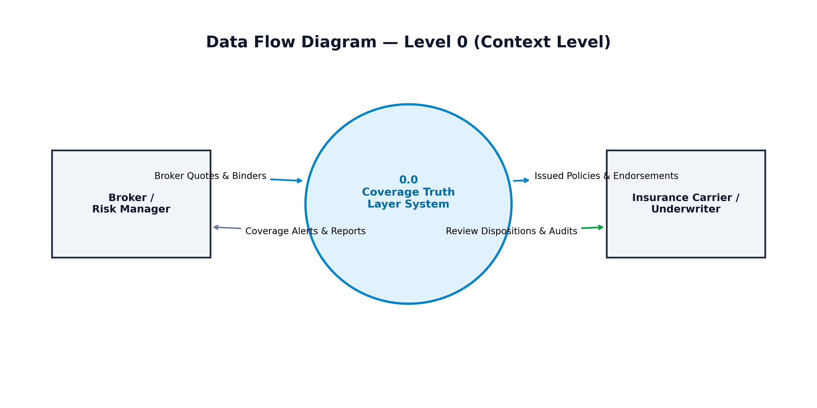
Figure 2: Context Level 0 Data Flow Diagram
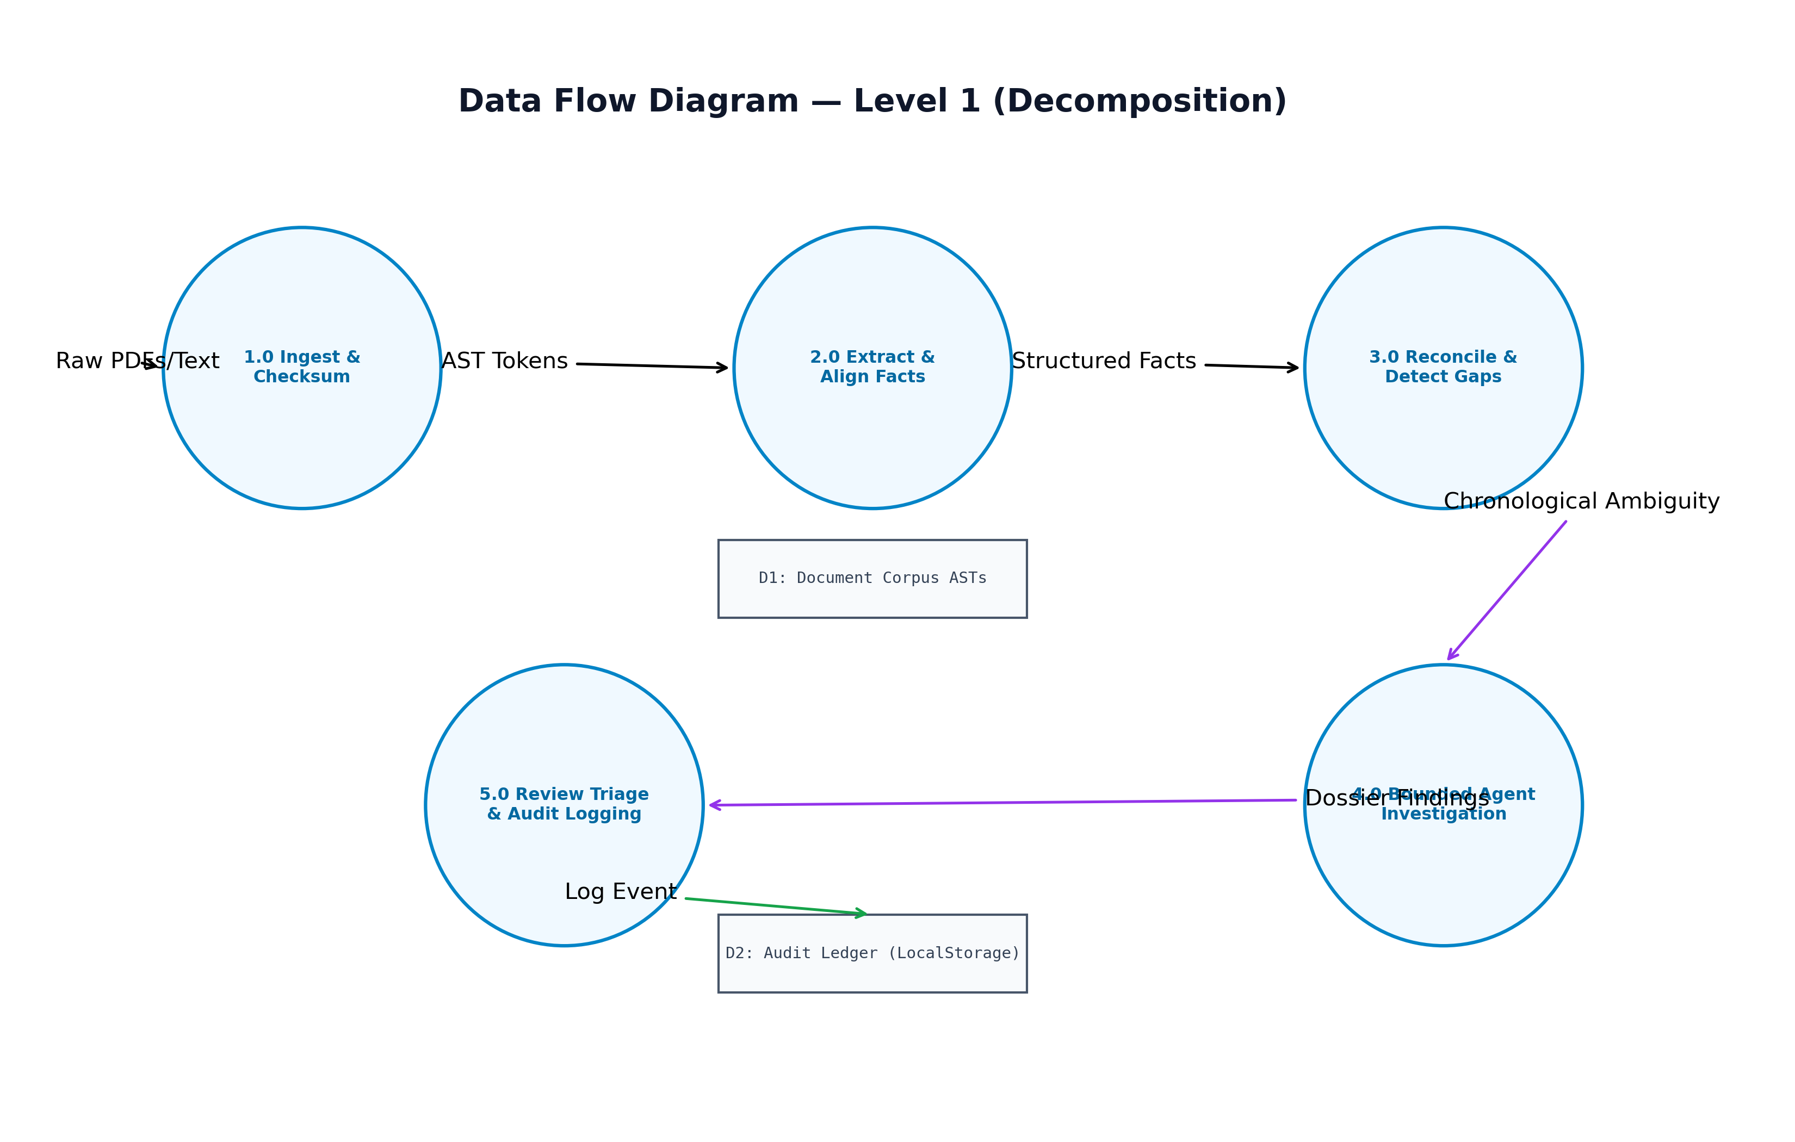
Figure 3: Level 1 Data Flow Diagram (Functional Decomposition)

2.3 UML Workflow & Use Case Descriptions
The UML Use Case Diagram (Figure 4) models the operational boundaries between the Underwriter / Risk Reviewer actor and the Autonomous Investigation Agent.
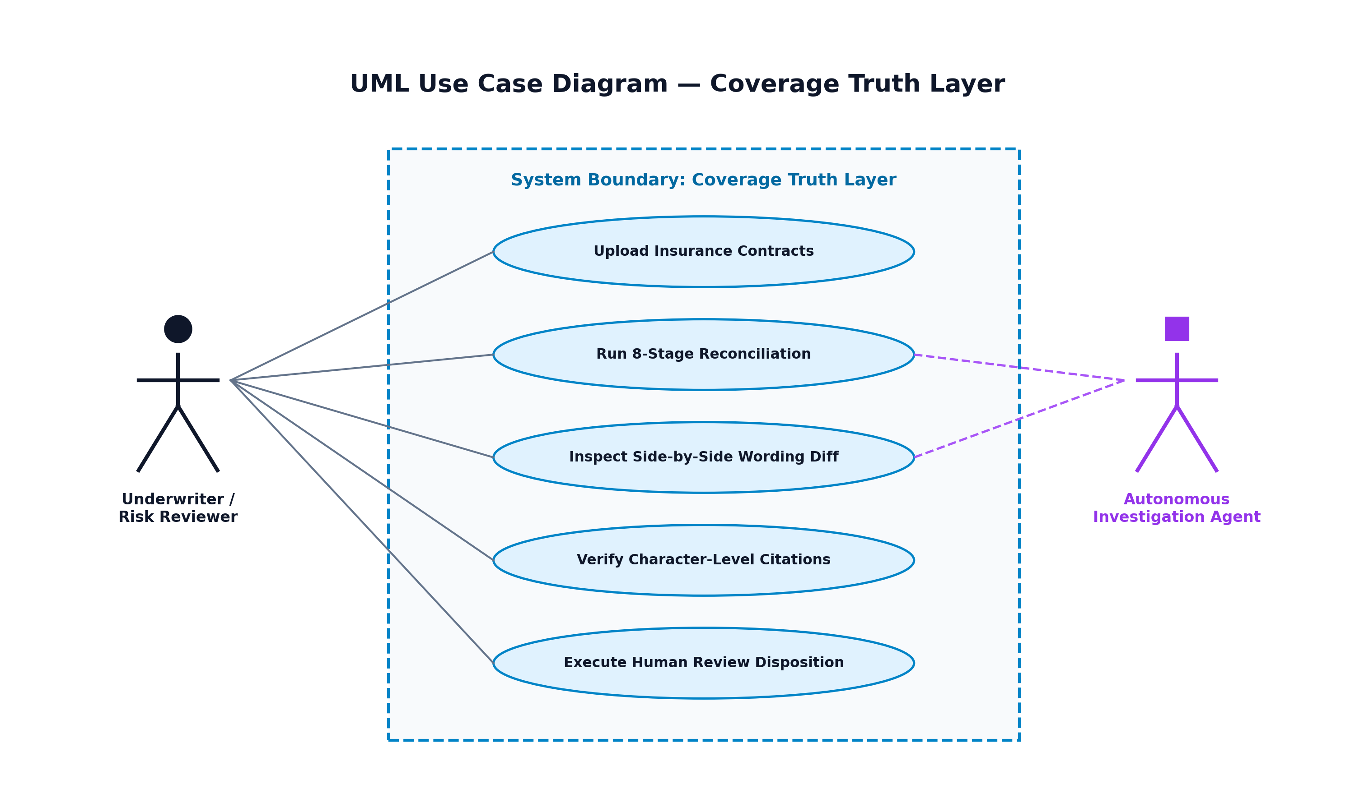
Figure 4: UML Use Case Diagram for Coverage Truth Layer

3. Implementation of the Proposed System
The methodology combines deterministic variance calculations with autonomous chronology verification. Figure 5 depicts the processing methodology flowchart.
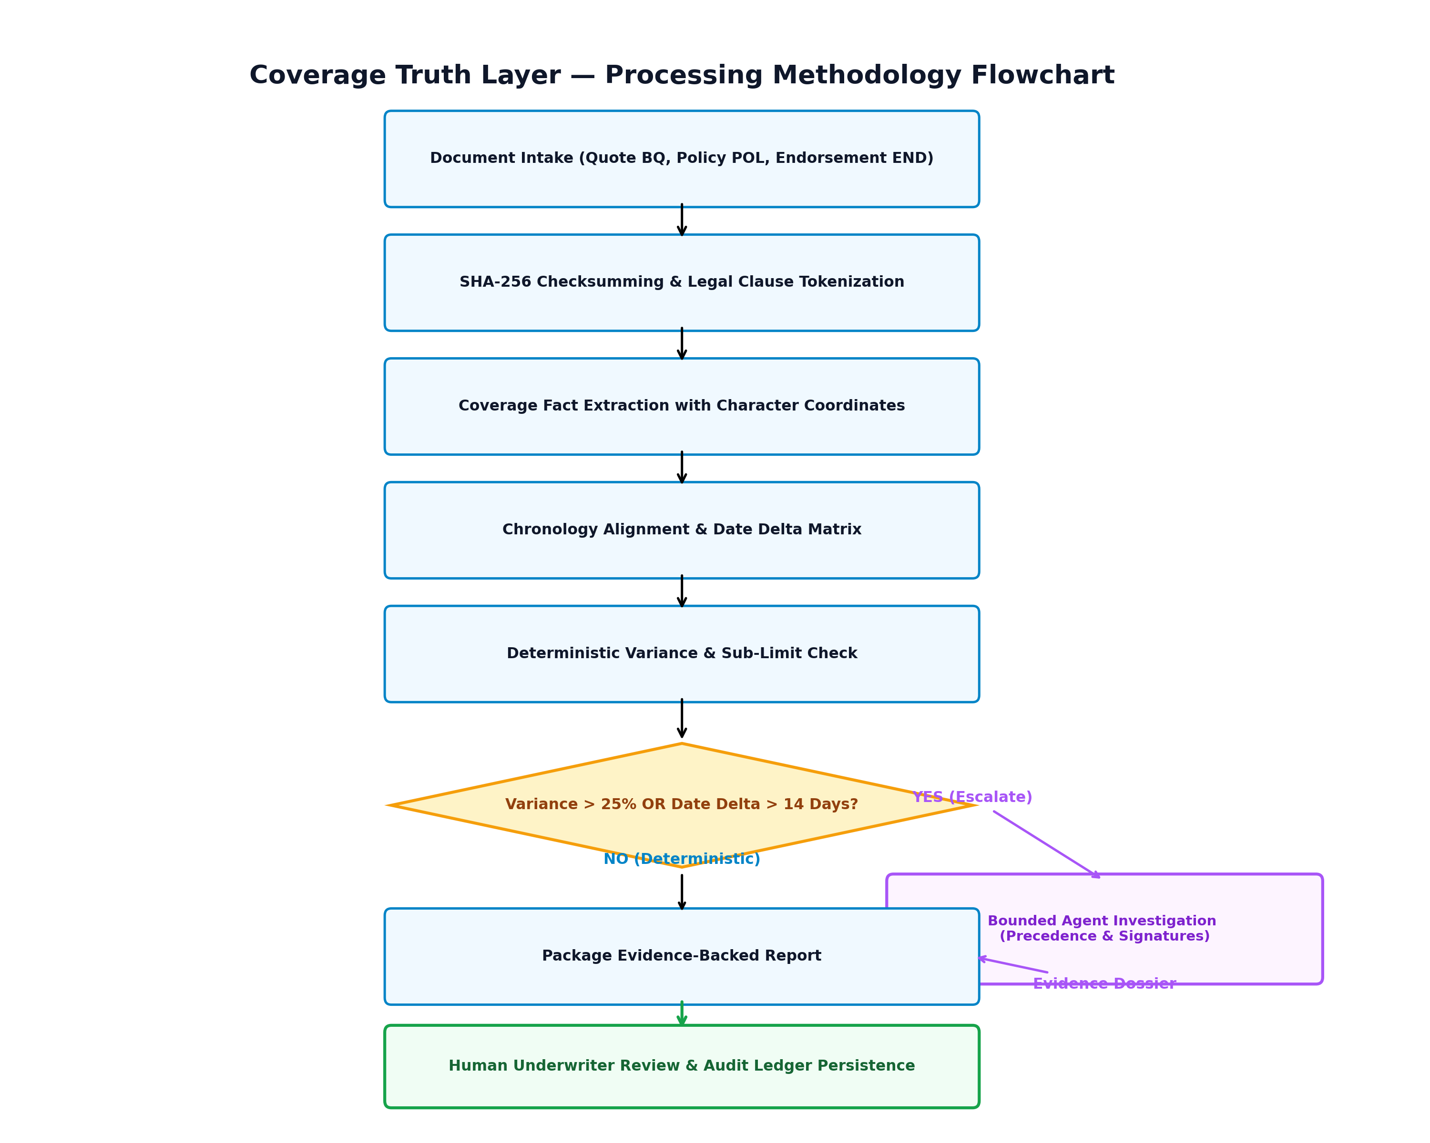
Figure 5: Processing Methodology Flowchart & Escalation Logic

3.1 Technology Stack & Architecture
- Frontend Framework: React 18 + TypeScript + Vite 6 for high-speed reactive UI rendering.
- Design System: Tailwind CSS with an enterprise dark palette (#070A12 navy, #00E5FF cyan evidence highlights, #A855F7 violet agent indicators, #10B981 emerald reviewed states).
- Motion & Feedback: Framer Motion animations for document ingestion flows and Canvas Confetti for audit completion states.
- Client-Side Persistence: HTML5 LocalStorage API persists underwriter triage actions and append-only audit event logs across reloads.
- Production Build & Hosting: Compiled via Vite (2010 modules transformed, 0 errors) and deployed to Vercel with SPA routing.

3.2 Fictional Case Study Implementation
To ensure realistic testing without compromising proprietary insurance files, the system implements a verified fictional commercial property corpus:
- Insured: Apex Global Logistics LLC (TIV: $24.5M across Chicago, Dallas, and Atlanta hubs).
- Broker Quote (BQ-2025-8821, Sec 3.B, P. 4): Affirmative water damage & sewer backup included up to $1,000,000 blanket limit; effective 2025-04-01.
- Master Policy (POL-CP-99042, Sec B.1.g, P. 14): ISO Form CP 00 10; water exclusion subject to schedule endorsements.
- Later Endorsement (END-04-WTR, Cl. 2, P. 2): Issued 17 days post-inception (2025-04-18); caps sewer backup to $50,000 aggregate sub-limit.

4. Results, Outputs and Discussions
Verified Public URL: https://coverage-truth-layer.vercel.app/
The deployed web application provides immediate interactive access to the complete reconciliation workflow without requiring API keys or backend setup.

4.1 System Test Execution Results
Table 1 details the execution results of core test scenarios evaluated against the live platform.
Test ID | Scenario | Input Condition | Observed Output | Status
TC-01 | Numerical Contradiction | $1M Quote vs $50k Endorsement | Flagged Critical finding (-$950k gap) | PASS
TC-02 | Chronology Disparity | Quote (04-01) vs Endorsement (04-18) | Triggered Bounded Agent branch (>14d) | PASS
TC-03 | Evidence Traceability | Inspect Finding find-001 | Rendered Sec 3.B & Clause 2 quotes with hashes | PASS
TC-04 | Human Triage Action | Click 'Confirm Coverage Gap' | Status updated to CONFIRMED_GAP & logged | PASS
TC-05 | Audit Persistence | Enter underwriter notes | Notes persisted across page refresh | PASS
TC-06 | End-to-End Simulation | Click 'Run Reconciliation Demo' | Sequentially revealed 8 stages in 2.4s | PASS
Table 1: Test Case Verification Ledger on Live Production Deployment.

4.2 Enterprise Pilot Measurement Framework
Rather than claiming unverifiable synthetic accuracy, Table 2 formalizes an objective measurement framework across six dimensions for future commercial pilots.
Evaluation Dimension | Target Benchmark | Measurement Methodology
Detection Precision & Recall | >= 96% | Benchmarked against senior coverage counsel gold-standard audits.
False Positive Containment | < 5% | Rate of erroneous flags on standard ISO wording variations.
Evidence Link Accuracy | 100% | Percentage of findings anchored to exact page/line coordinates.
Underwriter Time-to-Bind | -70% | Reduction in manual contract checking hours (4 hrs -> 45 mins).
Reviewer Concordance Rate | >= 90% | Inter-annotator agreement between underwriters on remediation.
Audit Trail Completeness | 100% | Cryptographic event logging for all status transitions.
Table 2: Pilot Evaluation Framework for Production Insurance Operations.

4.3 Live Application Interface Walkthrough
The public application features four primary interactive workspaces:
- 1. Cinematic Hero & Flow Visualizer: Animates broker quote, master policy, and endorsement contracts streaming into the reconciliation engine.
- 2. Side-by-Side Wording Diff: Highlights promised affirmative text in cyan alongside restrictive endorsement clauses in rose, displaying the four-part structured analysis.
- 3. Evidence Traceability Inspector: Exposes source document references, version metadata, SHA-256 hashes, and the 5-step Bounded Agent chronology trace.
- 4. Review Console & Audit Ledger: Provides working disposition buttons (Confirm, Dismiss, Investigate, Resolve), note recording, and an append-only event stream.

5. Conclusions and Future Work
Coverage Truth Layer addresses a critical operational void in commercial insurance. By demonstrating that a hybrid pipeline—combining deterministic rules for numerical precision with bounded agents for legal chronology and human oversight for final decisions—can eliminate silent coverage contradictions, CTL establishes a dependable, audit-ready trust layer.

5.1 Confirmed Prototype Limitations
- 1. Seeded Fictional Corpus: The live prototype operates on the verified Apex Global Logistics dataset to enable zero-configuration demonstration.
- 2. Client-Side Simulation: The 8-stage pipeline is executed as an interactive client-side workflow without requiring external paid LLM API keys.
- 3. MVP Scope Boundary: Strictly confined to Promised vs. Documented contracts; claims FNOL adjudication remains future scope.

5.2 Roadmap & Future Work
- Phase 1 (Current MVP): Document comparison, character-level citations, deterministic limits validation, bounded chronology agent, and human review console.
- Phase 2 (Enterprise Pilot): Bi-directional connectors for Applied Epic and Guidewire, production OCR pipelines, and shared underwriter-broker resolution rooms.
- Phase 3 (Extended Ecosystem): Reconciling First Notice of Loss (FNOL) claims and reservation-of-rights settlement payouts against original pre-loss promises.
Submission: Flarre AI Innovation Challenge 2026 | Author: Mekala Abhilash (CBIT)

