**Software Requirements Specification**

**for**

**Food Delivery Service Management Software (FDSM)**

**Prepared by:**

* **Gangaram Arvind Sudewad**
* **Ragala Abhishek**
* **Sailada Vishnu Vardhan**

**Team: Brogrammers**

**Group No.:22**

**04th March 2022**

# Table of Contents

Table of Contents 2

Revision History 2

1. Introduction 3

1.1 Purpose 3

1.2 Document Conventions 3

1.3 Intended Audience and Reading Suggestions 3

1.4 Product Scope 3

1.5 References 4

2. Overall Description 4

2.1 Product Perspective 4

2.2 Product Functions 4

2.3 User Classes and Characteristics 4

2.4 Operating Environment 5

2.5 Design and Implementation Constraints 5

2.6 User Documentation 5

2.7 Assumptions and Dependencies 5

3. External Interface Requirements 5

3.1 User Interfaces 5

3.2 Hardware Interfaces 6

3.3 Software Interfaces 6

3.4 Communications Interfaces 7

4. System Features 7

4.1 Managing History 7

4.2 OTP System 8

4.3 Plot Support for Sales Statistics 8

4.4 Printing Bill 9

4.5 Adding Delivery agent 9

5. Other Non-functional Requirements 10

5.1 Performance Requirements 10

5.2 Safety Requirements 10

5.3 Security Requirements 10

5.4 Software Quality Attributes 10

5.5 Business Rules 10

6. Other Requirements 11

Appendix A: Glossary 11

Appendix B: Analysis Models 11

Appendix C: To Be Determined List 12

# Revision History

|  |  |  |  |
| --- | --- | --- | --- |
| **Name** | **Date** | **Reason For Changes** | **Version** |
|  |  |  |  |
|  |  |  |  |

# 1. Introduction

## 1.1 Purpose

*The main objective of the Food Delivery Service Management Software (FDSM) provides a platform for a food delivery service and to manage its business in an efficient manner which will give opportunities to multiple restaurants to make their business more efficient. It will also keep the record of past orders of customer, restaurants. The Software Requirements Specification (SRS) document specifies the requirements for the Food Delivery Service Management Software (FDSM). It contains both the functional and the non-functional requirements.*

## 1.2 Document Conventions

* *The document is written in Times New Roman Font*
* *Main headings (size 18) and subheadings (size 14) are written in bold*
* *Remainder of the document is written out in Italics. (size 11)*
* *Since all the requirements in this application are disjoint and independent, they have their own priority and are not inherited from each other.*

## 1.3 Intended Audience and Reading Suggestions

*This document is intended for developers, technicians who will help the food restaurants to make their business online (so that they are aware of the dependencies of the application and how it works) and for the manager of the restaurants (so that he / she knows what all features this application is having) which will help him to increase their profits in today’s competitive world.*

*This SRS contains the structure of the application as well as the required hardware and software dependencies of the application, which must be present for the application to function smoothly. For reading this SRS, the reader must have a basic knowledge of Object Oriented Programming, Web Development Frameworks and Database Management. The reader must also have some knowledge about UML diagrams.*

## 1.4 Product Scope

* *FDSM should help the customers to check the menu and order food items online. And to keep the records of customers previous orders and keep status of his pending orders as well as while ordering check for his promotional offers if any. And at last ask him for his feedback for the service provided.*
* *FDSM should create a platform for the restaurants to provide their menu, keep record of the orders placed to it in past. Check pending orders and also accept, reject and provide estimated time for delivery depending upon the availability.*
* *FDSM should check the availability of the delivery agents in that area restaurants. The manager upon query should be able manage the lists of all customers, restaurants and delivery agents. In order to provide good recommendation to the customers manager should be able to maintain the ratings of the restaurants. FDSM should also supports an option by which the manager can provide promotional offer for the customers.*
* *FDSM should, at the end of a sales transaction print the bill containing the serial number of the sales transaction, the name of the food item, quantity, unit price, and food item price. The bill should indicate the total amount payable. Which should be paid in online mode only.*

## 1.5 References

*Although the basic outline of the SRS was provided, another website was referred to while the making of this document*

# 2. Overall Description

## 2.1 Product Perspective

*This application/webpage is useful for the restaurants for automating its daily tasks and freeing up its employees from the mundane and repetitive task, all the while eliminating the chances of human error. This also decreases the customer wait time, thus enriching the customer interaction and experience. FDSM makes it easier to keep track of transactions and keep records of the previous transactions, that can help multiple restaurants to increase their profit the food item and help in devising new strategies for better sales. And will reduce the competition within the restaurants and will help for development of all.*

## 2.2 Product Functions

*The functions of this software include different features for automating the ordering and billing process that occurs daily in a while online food ordering for restaurants.*

* *Checking availability of delivery agent: It will check the delivery agent’s current location and the location where food is to be delivered that will help in reduction of time consumption and will assign the nearest delivery agent for that task.*
* *Multiple Logins: It supports multiple logins, customers login, restaurants login, delivery agent login as well as managers login, since there may be multiple restaurants. Manager can fully access to all customers, restaurants, delivery agent details and will maintain ratings and will provide promotional offer like manager will the main junction to gather all restaurants and run the business.*
* *Assigning of restaurants for order: It checks the restaurants menu check for its pending order and availability of delivery agent and depending on that order will be placed and will be marked as out for delivery otherwise and only delivery will show item delivered.*
* *Printing the bill: At the end of the transaction, it prints a bill containing the serial number of the transaction, the names of items sold, quantity of the items sold, unit price and item price.*

## 2.3 User Classes and Characteristics

*There are four types of users intended for using the Food Delivery Service Management Software (FDSM).*

* *Customer: A customer is able to check the menu and then order food. And can check his previous orders and also check the status of his pending orders and while ordering customer is able to apply promotional offer for discount if any. At last a customer can provide a feedback for the restaurants for the service provided.*
* *Restaurants: Should be able to create their menu. And can have a list of their past orders. Check all of its pending orders, accept or reject orders depending upon the availability and if accepted should provide estimated time for delivery. And should assign one delivery agent nearby to the location of customer.*
* *Delivery Agent: Should be able to mark their location and check for the orders from nearby area and then pick up the order from the assigned restaurants and deliver it to the customer while updating all status of the task and also he should be able to provide estimated time for picking up order from restaurants and also the time it might take to deliver food to customer. So that from here restaurants can give an estimated time for the delivery. At last delivery agent should be able to rate the customer depending upon customers behaviour.*
* *Manager: The Manager oversees the FDSM and manages details of all other users. Manager maintains the rating for all types of users, also provide food as well as restaurants recommendation, and gives promotional offer to increase the sales. Manager is one of the most important users of FDSM.*

## 2.4 Operating Environment

*Operating environment for the Food Delivery Service Management Software is as listed below.*

* *Operating system: Windows, Linux and MacOS.*
* *Platform: The website will be hosted on Heroku / or on a local server.*
* *Database: SQLite*
* *Client / Server system*
* *The hardware requirements are a bar-code reader and weighing machine*

## 2.5 Design and Implementation Constraints

*The current constraints on the project are related to provision of the database resources. The more robust and fast the database, the better the performance of the software. Once the customer orders any food item he/she is not allowed to cancel that order, even their will be complete 100% cancellation charges. On the practical side, we are ignoring the traffic, whether conditions and many more such chances for the estimated time for delivery.*

## 2.6 User Documentation

*Brief description and hands - on tutorial would be sufficient for understanding the workings of the Food Delivery Service Management Software. Along with this, a user's manual would be handy for quick references to the various features that the software has.*

## 2.7 Assumptions and Dependencies

* *The users are supposed to know the basics of using computers, like typing on a keyboard, clicking using a mouse or should be able to use an android mobile.*
* *Order can be only made if the customer pays the full bill then only delivery agent will be assigned.*
* *Once after the order, the transaction and delivery agent is assigned the sold food items cannot be returned.*
* *Transactions that were done before the implementation of this software cannot be brought up in the statistics that are shown to the manager.*
* *Since the whole software is implemented in the English Language, the users of this software are expected to be comfortable with the English Language*

# 3. External Interface Requirements

## 3.1 User Interfaces

*Manager Interface: The FDSM screen will have a manager Interface through which one can*

* *Manage the list of Customers, Restaurants and Delivery Agents.*
* *Maintain ratings for Customer, Restaurants and Delivery Agents.*
* *To provide restaurants and food recommendation for the customers.*
* *This Interface also allows to provide promotional offers for customers.*

*Customer Interface: The FDSM screen will have a Customer Interface through which one can*

* *Can see the menu of restaurants and order any subset of items.*
* *Through this customer can check his past orders and also keep the status pending orders.*
* *Can give their feedback for the restaurants and the delivery agent.*
* *Can also store some promotional offers which can be used later.*

*Restaurants Interface: The FDSM screen will have a Customer Interface through which one can*

* *Can create their menu for customers*
* *Have a check on all their past orders placed in the restaurants.*
* *Can check all their pending orders, accepts or reject them and will also provide estimated time for delivery.*
* *Can make the arrangements in such a way that the nearby delivery agents to the customers address will be assigned for the delivery*
* *This Interface also allows to change the status as out for delivery after acceptance of order.*

*Delivery Agent Interface: The FDSM screen will have a Customer Interface through which one can*

* *Can mark their locations and then see for any delivery request from nearby restaurants.*
* *Through this interface they can accept the delivery request, pick up the order and deliver the order and also update all this status while delivering the order.*
* *Can provide an estimated time for the picking up order from restaurants as well as delivery time from restaurant to the customer.*
* *This Interface also allows delivery agents to rate the customer.*

## 3.2 Hardware Interfaces

*The Hardware Requirements are as follows:*

* *A Computer Data Base and Wide Network.*
* *Also, there will be need of smartphones or computer at customers end in order to place an order of food.*
* *This is to join the various restaurants computers present at different restaurants which will be in turn connected to the same database by a wide area network so that they work on the same server in order to avoid the confusion and their Information is saved in the same Database.*

## 3.3 Software Interfaces

*Menu Query: The Manager through his interface will be able to look into food items of which he/she wants to know about including its current stock, buying cost, profit margin, and will be able to modify these food items in the menu.*

*Sales Query: The Manager can query about the statistics related to previous sales made, quantity sold, price realised, and net profit for a single day, or for a specific period of time.*

*Adding or removing from the menu: The FDSM will also support the addition or removal of food items from menu on the basis of its sales. The FDSM database can also be edited by the Manager Interface. This will update the restaurant’s current menu.*

*New Transaction: On ordering a specific product its details are stored in a temporary class object. On pressing the Generate the Bill button, after which there will be option for payment on final payment, the final bill including all the taxes is generated. After the Bill is printed with a confirmation OTP will be sent to delivery agent and to the customer.*

## 3.4 Communications Interfaces

* *After a transaction is executed, a copy of the bill is stored in the Sales Database which will be used for future Query.*
* *After a transaction an OTP will be generated and will be shared to both delivery agent and the customer. So, that there will be secure delivery.*
* *The software is implemented using the HTTP protocol.*
* *The software will follow secure logins using password encryption to protect its user's information*

# 4. System Features

## 4.1 Managing History

### 4.1.1 Description and Priority

*The FDSM maintains the record of all the food items that are sold. This feature is high priority because without these details, management or restaurant cannot operate well.*

4.1.2 Stimulus/Response Sequences

• *The manager can increase or decrease the price of the food items, give recommendations to customers.*

• *Restaurants can also access the record of all previous orders and can remove less sold items from the menu.*

4.1.3 Functional Requirements

*Django: If no database is present, then the inventory cannot be handled. Thus, it is necessary to have a database at hand. Django implements the database internally by using SQLite.*

*The programming language required to run the application is python.*

REQ-1: *django_req*

REQ-*2*: *py_req*

## 4.2 OTP System

#### 4.2.1 Description and Priority

*The FDSM prints an OTP on the bill of every order and also sends it to the customer. Which ensures safe delivery, so it is of high priority.*

4.2.2 Stimulus/Response Sequences

*The management generates OTP for every order such that order goes to the right customer.*

#### 4.2.3 Functional Requirements

*Python: The programming language required to run the application*

REQ-1*: py_req*

## 4.3 Plot Support for Sales Statistics

#### 4.3.1 Description and Priority

*The FDSM provides the ability to plot out the sales statistics of food items of each restaurant. The sales statistics indicate the quantity of food item sold, the price realised, the profit made and average rating. Since it manages sales of food items , it is of medium priority.*

#### 4.3.2 Stimulus/Response Sequences

*These plots gives better understanding for the restaurant on each food item, so that restaurant tries to produce the quantity of food items based on the statistics. It also helps management to adjust the prices of the food items.*

#### 4.3.3 Functional Requirements

*Django: If no database is present, then the inventory cannot be handled. Thus, it is necessary to have a database at hand. Django implements the database internally by using SQLite.*

*Matplotlib: Matplotlib is required to build graphs*

*Python: The programming language required to run the application*

*REQ-1: django_req*

REQ-*2*: *py_req*

REQ-*3*: *plt_req*

## 4.4 Printing Bill

#### 4.4.1 Description and Priority

*The FDSM provides the feature to print the bill of a transaction. It contains the name of the restaurant, name of the customer, address of the customer, serial number of the sales transaction, code number, details of food items ordered which also include quantity of each item ordered. The bill also indicates the total amount payable.*

#### 4.4.2 Stimulus/Response Sequences

*Upon a successful transaction, the bill is displayed for the customer.*

4.4.3 Functional Requirements

*Python: The programming language required to run the application*

REQ-1: py_req

## 4.5 Adding Delivery agent

4.4.1 Description and Priority

*The FDSM provides an option to register for the new delivery agents. Because it helps delivery agents to join in FDSM easily. So, it is of high priority.*

#### 4.4.2 Stimulus/Response Sequenced

*The manager can see all the requests from the delivery agents and accept or decline.*

4.4.3 Functional Requirements

*Python: The programming language required to run the application*

REQ-1: py_req

# 5. Other Non-functional Requirements

## 5.1 Performance Requirements

•*For better performance high speed Internet connection is preferred.*

•*Any browser with a recent version would work fine.*

## 5.2 Safety Requirements

• *All the users must remember their login credentials and customers should tell their OTP to the delivery agent to receive the order.*

## 5.3 Security Requirements

•*The passwords are encrypted so that no one else can know the password.*

•*Since there are separate logins for different type of users, so that their work is restricted to the respective users.*

## 5.4 Software Quality Attributes

•*MAINTAINABILITY: The Manager will be able to see the statistics and accordingly make any changes and also the restaurants can add or remove the food items.*

•*RELIABILITY: The FDSM can be used by multiple users on multiple devices at the same time.*

•*AVAILABILITY: The system would be available for 24 hours a day.*

•*PORTABILTY: The software can be used on any platform on any device.*

• *ROBUSTNESS: The system would be tested before deployment and thus the occurrence of bugs would be a rare phenomenon. In any case, the bugs won't break down the system.*

***Requirements Specification for <Project>***

## 5.5 Business Rules

•*Based on the statistics the manager can give some discount or offers to particular products and add taxes to the food items accordingly.*

# 6. Other Requirements

### 6.1 Database

*Since* *the database stores a lot of data in it, like the transaction details and the menu of each restaurant, it is suggested that the platform on which this software is to be deployed must have sufficient reserve memory in it.*

### 6.2 Reuse Objectives

*Since, we plot the statistics for each restaurant and should be visible to both manager and the corresponding   restaurant. So, we use the same function here. Similarly, the ratings of a restaurant should also visible to customer*

# Appendix A: Glossary

* *py_req: Python Required*
* *django_req: Django Required*
* *plt_req: Matplotlib Required*

*More terms to be added as and when required or requested by the client.*

# Appendix B: Analysis Models

Case Diagram

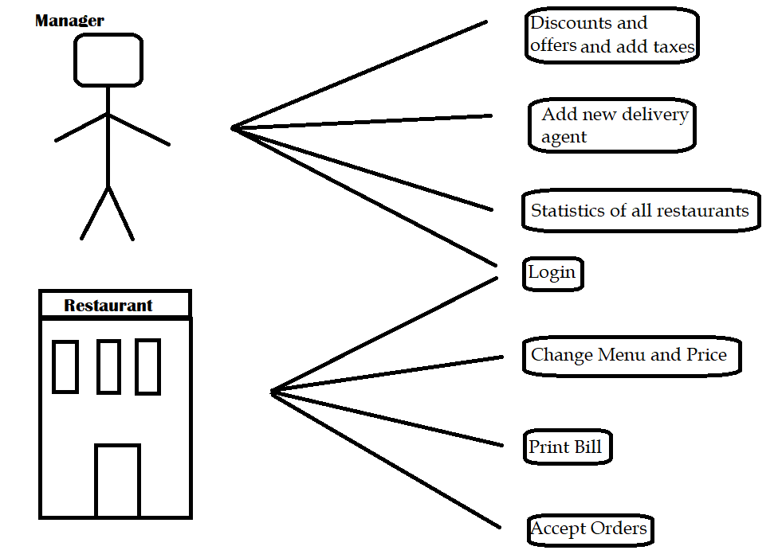

Class Diagram

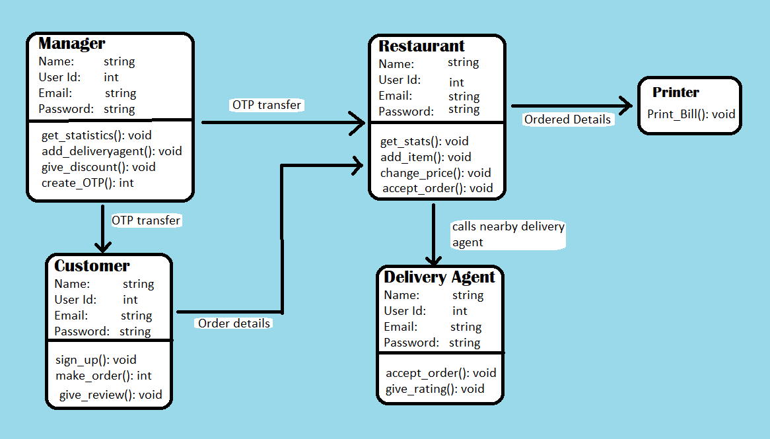

# Appendix C: To Be Determined List