**MID Report**

**MINI PROJECT**

**On**

**(2020-2021)**

**LIVE VIDEO CALLING APP**



Department of Computer Engineering & Applications

**Institute of Engineering & Technology**

**Submitted to: Submitted by:(Group)**

Mr. Neeraj Khanna Sarthak Mishra

(Assistant Professor) Satyam Srivastav

Abhishek Agarwal

Subhi Gautam

Raghvendra Singh

**GLA University**

**Mathura- 281406, INDIA**

**2020**

|  |
| --- |
| **TABLE OF CONTENTS** |
| **Certificate 4**  **Synopsis 5**  **Acknowledgement 7**  **Abstract… 8** |
| **1. Introduction….…………………………………………………………….** |
| 1.1 Overview 9 |
| 1.2 Motivation 9 |
| 1.3 Problem Statement 10 |
| 1.4 Objective… 10 |
| **2. Software Requirement Analysis…………………………………………..** |
| 2.1 System Analysis 11 |
| 2.2 Role of System Analyst 11 |
| 2.2.1 Main roles of System Analyst 12 |
| 2.3 Users 12 |
| * 1. Methodology 12   2. Dependencies /External Systems 13   3. DFD 15   4. Use-case Diagram 17 |
| 1. **Implementation details 18=** 2. **Contribution Summary 18** 3. **Tables 19** |

|  |
| --- |
| 1. **Project Work 25** 2. **Future Scope… 40** |
| **Reference 40** |

Acknowledgment

It gives us a great sense of pleasure to present the mid report of the B.Tech Mini Project (Live Video Calling App) undertaken during B.Tech IIIrd Year. This project in itself is going to be an acknowledgement to the inspiration, drive and technical assistance will be contributed to it by many individuals. We owe special debt of gratitude to Mr. Neeraj Khanna, Assistant Professor Department of CEA, for providing us with an encouraging platform to develop this project, which thus helped us in shaping our abilities towards a constructive goal and for his constant support and guidance to our work. His sincerity, thoroughness and perseverance is been a constant source of inspiration for us. We believe that he will shower us with all his extensively experienced ideas and insightful comments at different stages of the project & also taught us about the latest industry-oriented technologies. We also do not like to miss the opportunity to acknowledge the contribution of all faculty members of the department for their kind guidance and co-operation.

Sarthak Mishra(181500622)

Satyam Srivastav(181500630)

Abhishek Agarwal(181500013)

Subhi Gautam(181500705)

Raghvendra Singh(181500533)

1. Introduction

1.1 General Introduction to the topic

Live Video calling App

(Android Development)

We are developing an app which is having the main functionality as video calls and will give a better platform for being in contact with known ones. Android development helped in developing this app using the language Java. Certain features of our app are :-

->Provides high quality video calls.

->Performs stable connection.

->It helps to stay connected with the ones whose contact number is known.

This will contain functionalities such as Safe Phone Authentication OTP Registration, adding/removing friends getting their notifications and status Updates.

People will be able to maintain good relations with their loved ones.

Many people get worried about their privacy. So here we have developed this app keeping above point in mind. People will enjoy and enhance their interest while using this app and by remaining in contact with their friends.

1.2 Area of Computer Science

While development of video calling started in the late 19th century, the technology only became available to the public starting in the 1930s. These early demonstrations were installed at "booths" in post offices and shown at various world expositions. It took until 1970 for AT&T to launch the first true video conferencing system, wherein anyone could subscribe to the service and have the technology in their home or office. Videotelephony also included "image phones" which would exchange still images between units every few seconds over conventional [plain old telephone service](https://en.wikipedia.org/wiki/Plain_old_telephone_service) (POTS) lines, essentially the same as [slow-scan TV](https://en.wikipedia.org/wiki/Slow-scan_television). The development of advanced [video codecs](https://en.wikipedia.org/wiki/Codec), more powerful [CPUs](https://en.wikipedia.org/wiki/CPU), and high-bandwidth [Internet telecommunication services](https://en.wikipedia.org/wiki/Internet_Protocol) in the late 1990s allowed videophones to provide high quality low-cost colour service between users almost any place in the world where the Internet is available.

1.3 Requirements

## Hardware:

• External Hard Drives or DVDs for Backup

• Internet

• Minimum 2GB RAM

• i3 Processor

• 1024x765 Display

## Software:

• Android Studio

• Operating System(Window, Linux)

• Programming Language

• JAVA¬ Front End

• Java Xml¬ Front End

• Java firebase¬ Back End

2. Objective

Today’s world the most used social platforms are facebook, instagram and Whatsapp. They have very high security and privacy which makes them the best for people to be connected on that. We also got motivated from there and thought of developing this app. This will surely get enhanced in future and many other options will be added. This will benfit people to stay connected with other peoples

## Future Prospects

As we move towards the mid-21st century, it’s going to be obvious that everyone will become busy with their schedules and daily life. So, it will be a good medium through which people will be connected. As the whole world is moving in a digital era this app can play a good role for getting connected with peoples. It can be made to connect peoples in worse circumstances such as pandemic like covid-19.

3. Implementation Details

user

Check the OTP enter by the user

OTP is generated

User enter the mobile no.

Successfully signup

If

True

False

Error

**Process of Signup**

**THE KEY FEATURES OF APP**

While creating a video calling app, you have to consider a number of standard functionalities that are a must-have. Conceptualizing a complex app and trying to add too many features at once can affect the user experience. Therefore, make a list of features that serve as the basic components of your mobile app. Some of these are the following.

**User Registration**

To begin with, the first screen that your user should see is the registration screen. Users are too impatient to fill out large sign-up forms, therefore make it as short and uncluttered as possible. You can add only the most necessary fields like name, email address, contact number, etc. For further convenience, integrate your app with all the major social media networks (Gmail, Facebook, Twitter) so users can sign up easily.

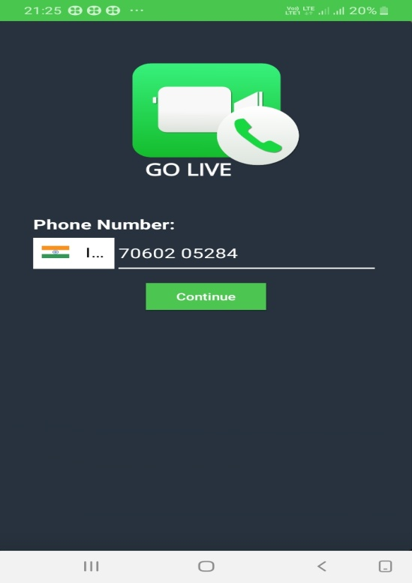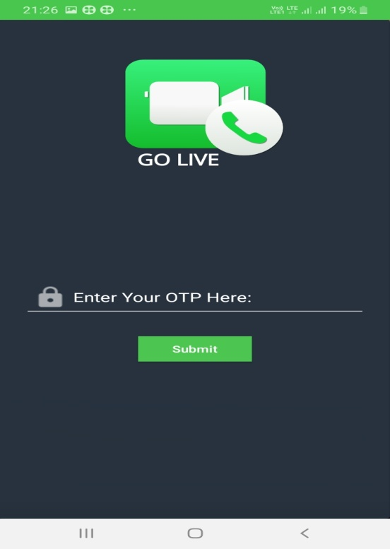

**Profile Management**

This is the basic feature that implies displaying the general user information on the profile. The scope of options may vary from identifying the user’s location to giving the short bio. In addition, there is an option of image display, phone number visibility and mandatory privacy settings. Another important profile management function is integration of the in-app purchase tools enabling customers to pay with credit cards via the approved payment system.

**Search and add contacts**

The option of search for contacts and adding them in the app requires two functions: the search engine for easy navigation and fast identifying the proper contact by username or real name, and integration of contacts from user's phonebook.

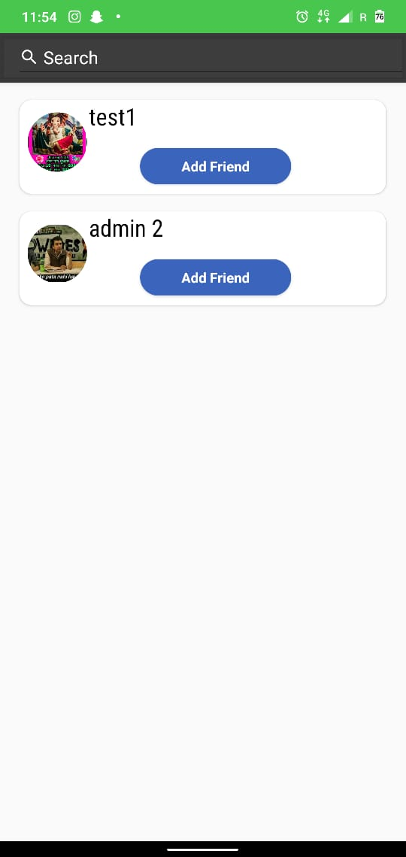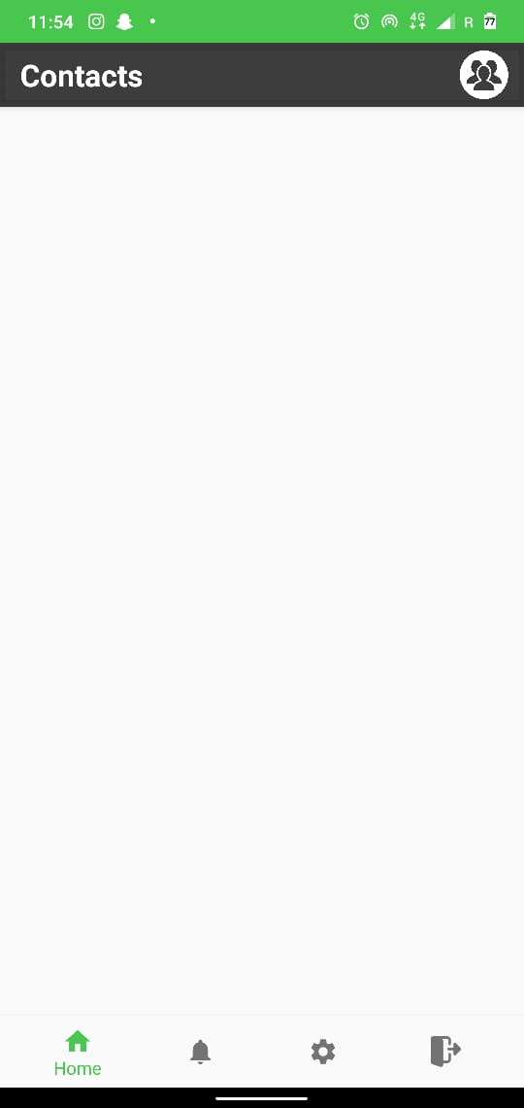

4. Progress till Date & the Remaining work

Overall progress report

In percentage of the project is about 60-65 %.

The remaining work

Is on the video calling and some little bugs to be fixed .

## Time taken to complete

About 2-3 weeks

5. Some Screenshots

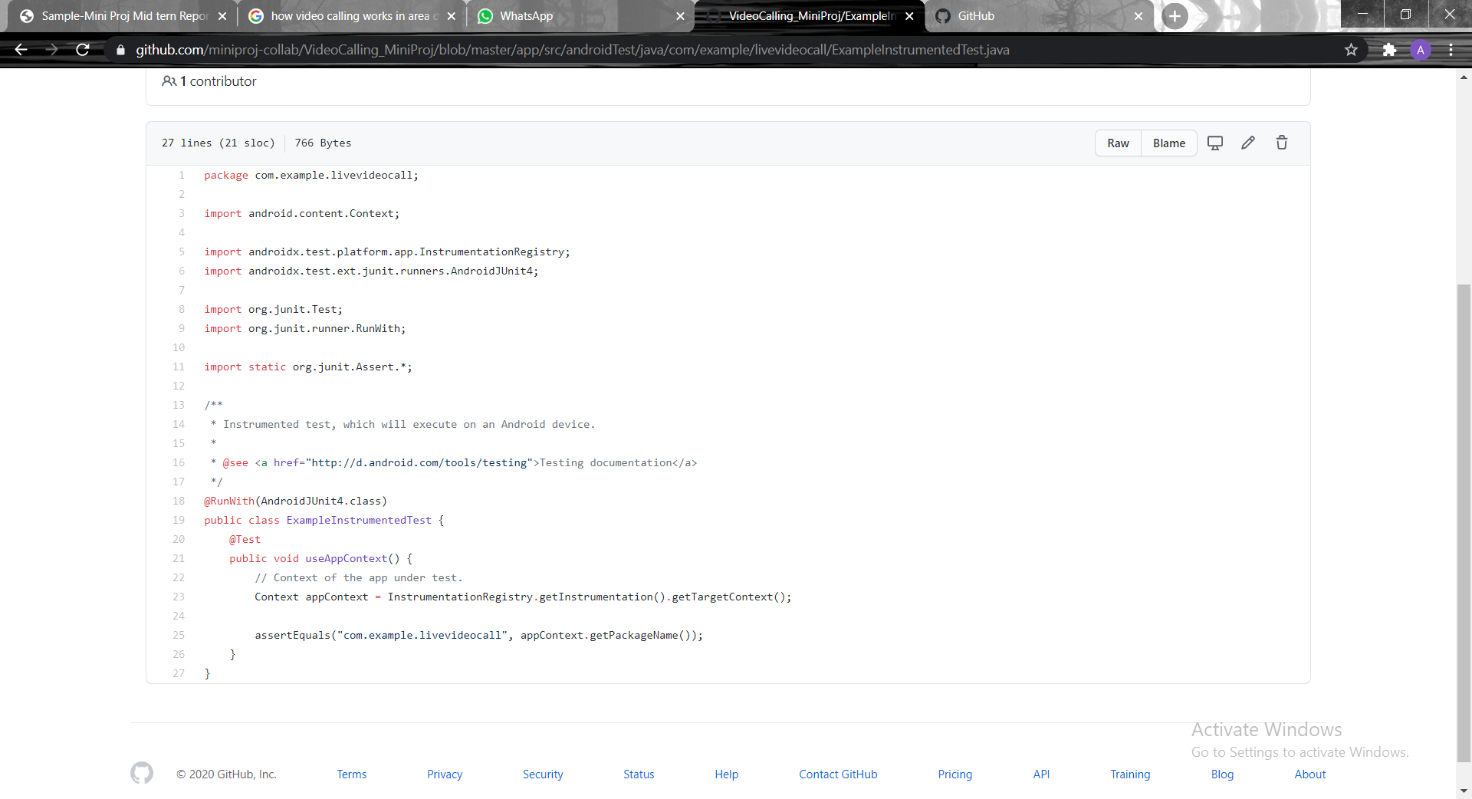

Search

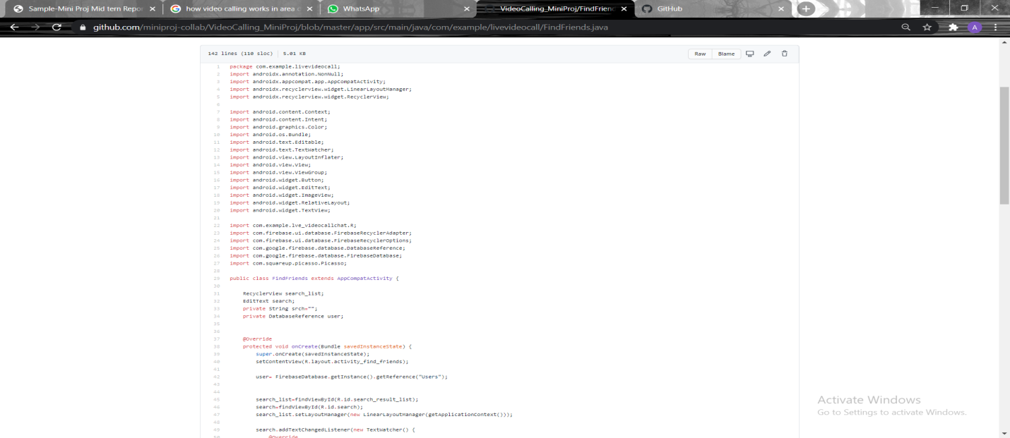

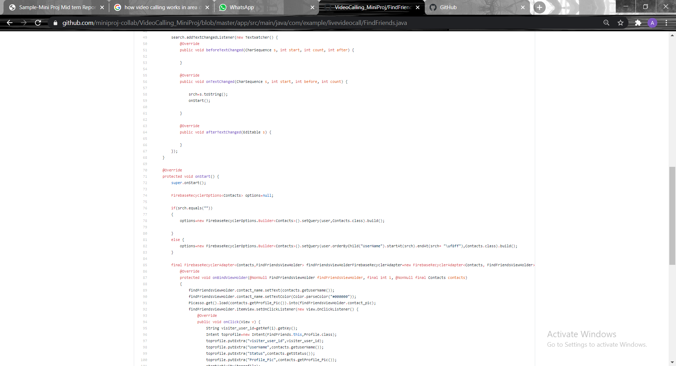

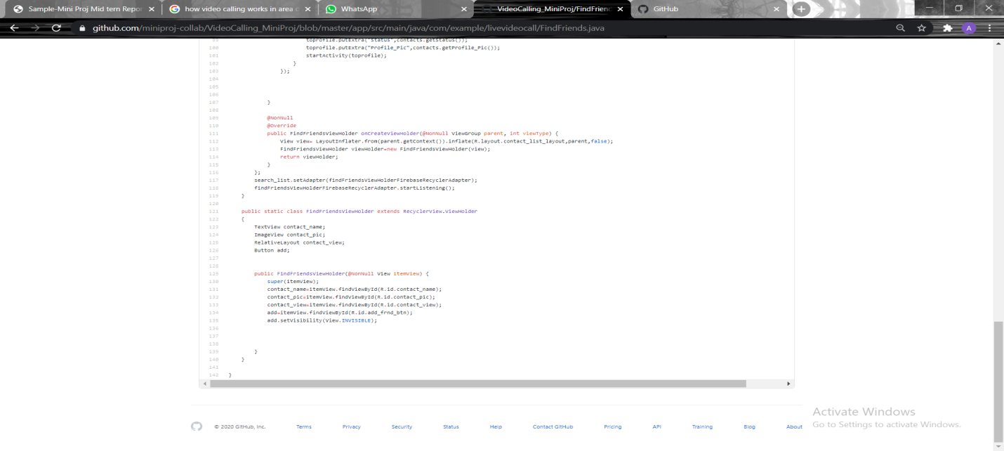

Profile

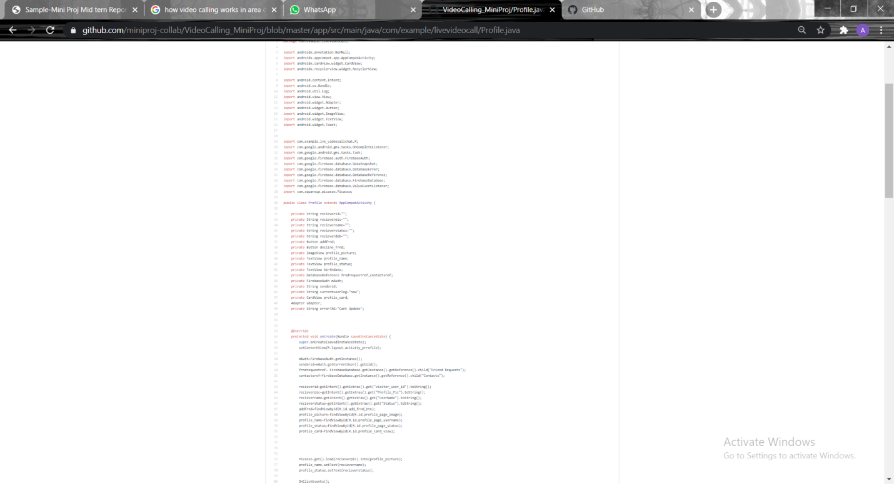

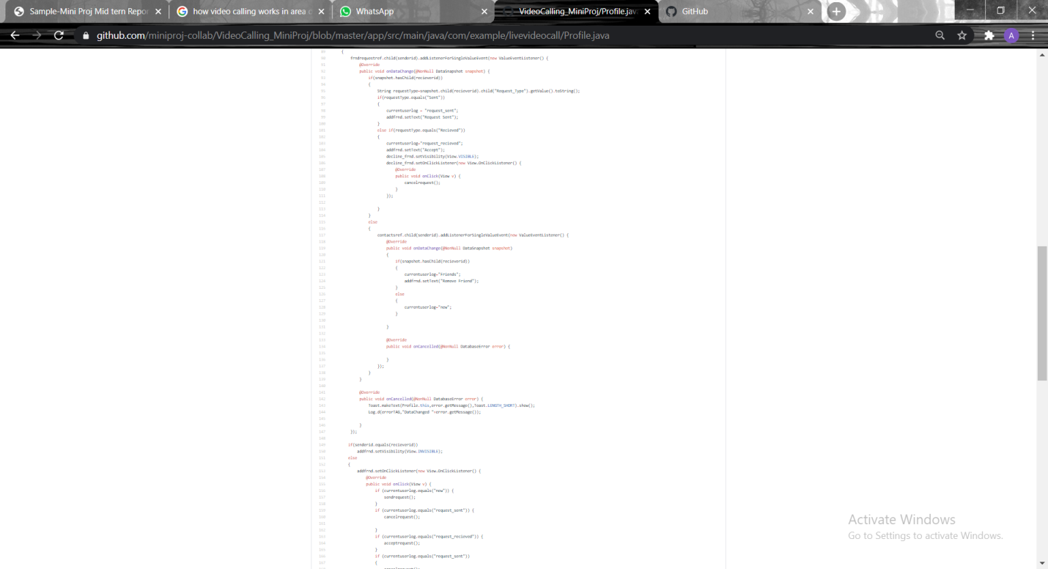

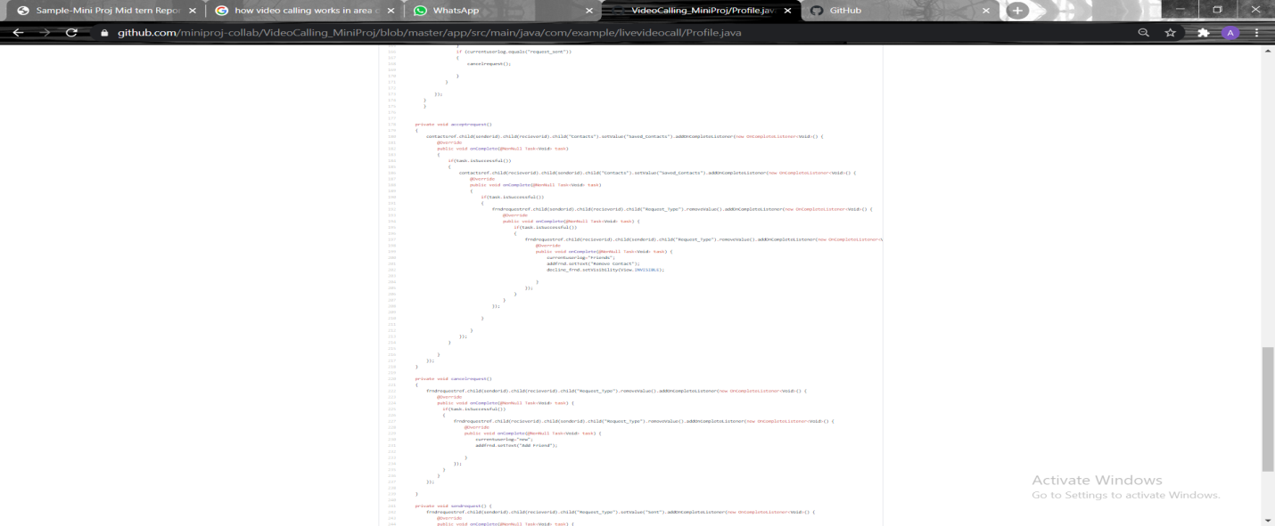

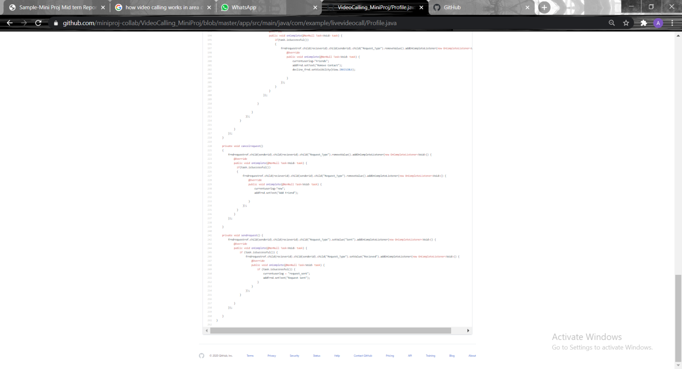

Registration

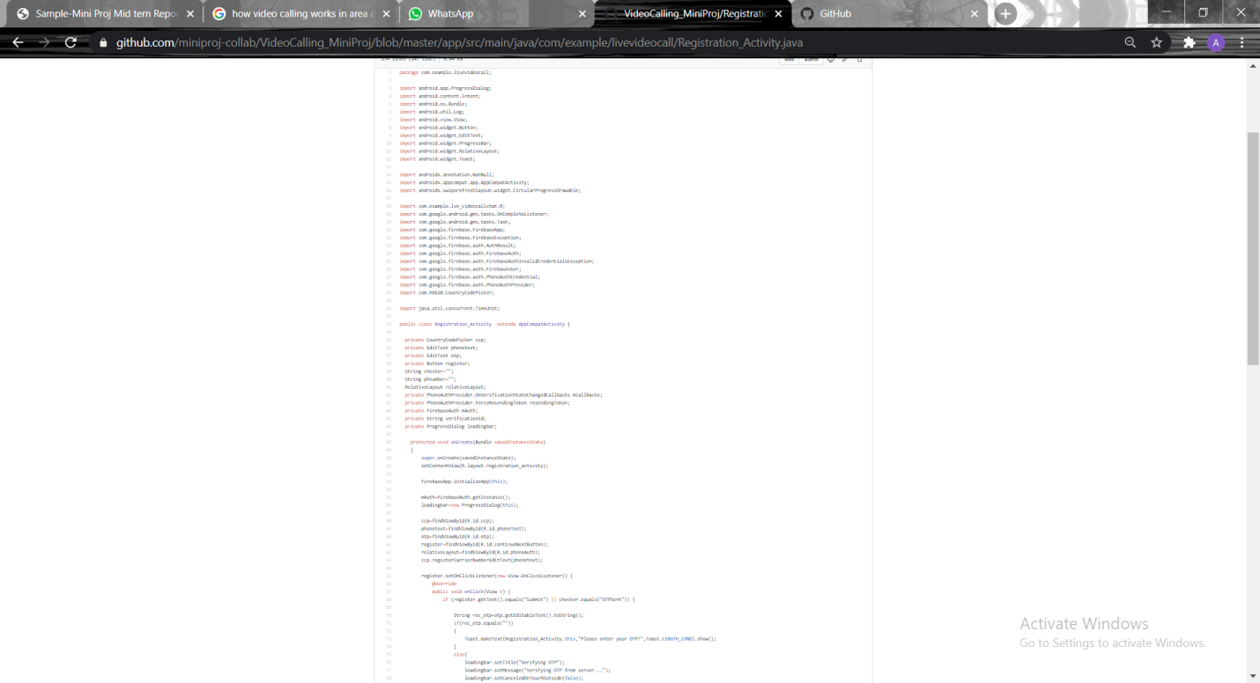

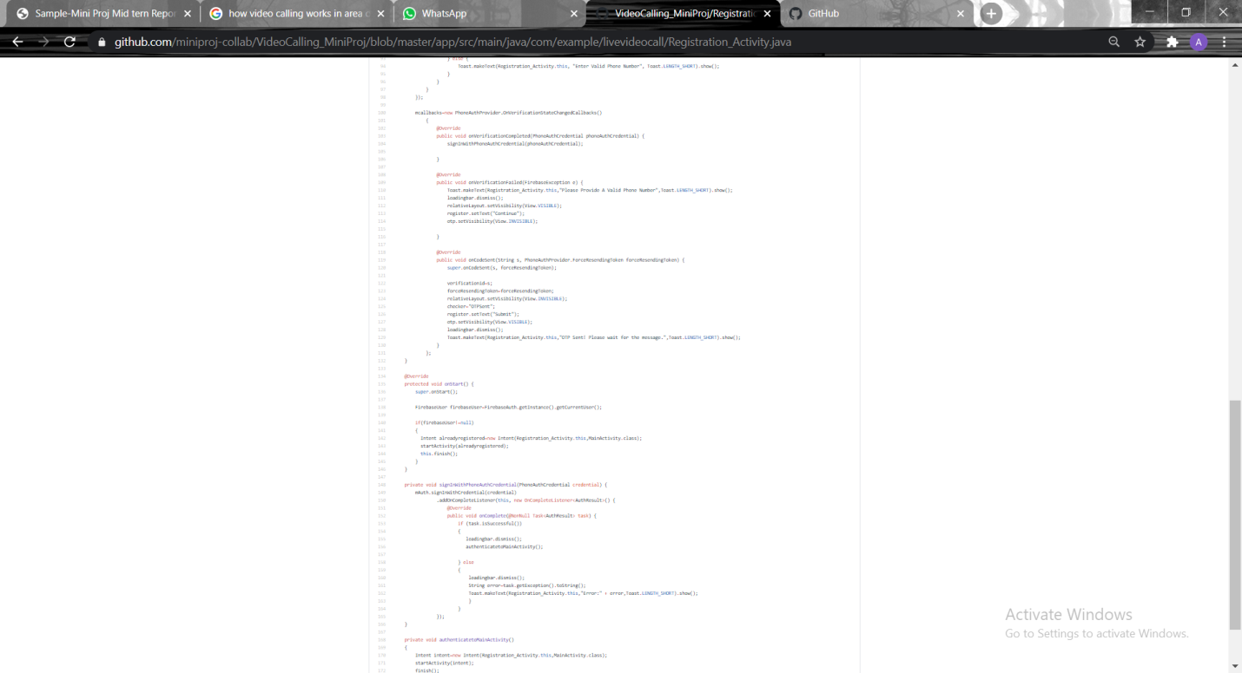

6. References

**Book References**

**• Android Development**

**• Core Java Book**

**•** [**www.stackoverflow.com**](http://www.stackoverflow.com)

**•** [**WWW.Developer.android.com**](http://WWW.Developer.android.com)

**• Firebase documentation**

**• Faculty Guidelines**

**• Mr. Neeraj Khanna Sir**