DAYANANDA SAGAR COLLEGE OF ENGINEERING
SHAVIGE MALLESHWARA HILLS, K.S.LAYOUT, BANGALORE-560078

Department of Computer Science and Engineering



2017-2018

VIth Semester

Computer Graphics and Visualization Lab Manual
Sub Code: CSL68

COMPILED BY
Dr. Kusuma. M
Prof. Anitha M

COMPUTER GRAPHICS AND VISUALIZATION LABORATORY

Course Code: CSL68 | Credits: 02
L: P: T: S: 1: 2: 0: 0 | CIE Marks: 50
Exam Hours: 03 | SEE Marks: 50
Course objectives:
1. To provide an introduction to the theory and practice of computer graphics.
2. Apply graphics programming techniques to design, and create computer graphics scenes.
3. Analyze the two-dimensional transformations, line drawing, Clipping, and filling algorithms.
4. Create effective OpenGL programs to solve graphics programming issues, including objects modeling, 3D transformation, color modeling, lighting, and textures.

Course Outcomes: At the end of the course, student will be able to:

CO1 | Implement the core concepts of computer graphics and visualization
CO2 | Implement 2D graphics and algorithms including line drawing, polygon filling, clipping, and transformations.
CO3 | Create and compose the geometric transformations on graphics objects and their application in composite form.
CO4 | Integrate the concepts and techniques used in 3D computer graphics, including viewing, transformations, hierarchical modeling, color, lighting and texture mapping.
CO5 | Explore projections and visible surface detection techniques for display of 3D scene on 2D screen.
CO6 | Develop a graphics application using C++ and OpenGL through planning and completing a mini project included in lab curriculum.

PART - A

Design, develop, and implement the following programs in C / C++ and OpenGL

Program No. | List of Programs | COs
1. | Program to display a set of values {fij} as a rectangular mesh. | CO1
2. | Program to recursively subdivide a tetrahedron to form 3D Sierpinski gasket. The number of recursive steps is to be specified by the user. | CO4
3. | Program to create a cylinder and a parallel piped by extruding a circle and quadrilateral respectively. Allow the user to specify the circle and quadrilateral. | CO2
4. | Program to fill any given polygon using scan-line area filling algorithm. (Use appropriate data structures.) | CO2,CO4
5. | Program to implement Liang-Barsky line clipping algorithm. | CO2
6. | Program to implement the Cohen-Sutherland line-clipping algorithm. Make provision to specify the input line, window for clipping and view port for displaying the clipped image. | CO2,CO4
7. | Program to draw a color cube and spin it using OpenGL transformation matrices. | CO3,CO4,CO5
8. | Program to create a house like figure and rotate it about a given fixed point using OpenGL functions. | CO3
9. | Program to draw a color cube and allow the user to move the camera suitably to experiment with perspective viewing. Use OpenGL functions. | CO3,CO4,CO5
10. | Program using OpenGL functions, to draw a simple shaded scene consisting of a tea pot on a table. Define suitably the position and properties of the light source along with the properties of the surfaces of the solid object used in the scene. | CO4,CO5

PART - B
Develop a suitable Graphics package to implement the skills learnt in the theory and the exercises indicated in Part A. Use the OpenGL API.

Note:
- Any question from Part A may be asked in the examination.
- A report of about 10 – 12 pages on the package developed in Part B, duly certified by the department must be submitted during examination.

Instructions:
In the examination, one exercise from Part A is to be asked for a total of 30 marks. The package developed under Part B has to be evaluated for a total of 20 marks.

Assessment Pattern:
CIE –Continuous Internal Evaluation Laboratory (50 Marks)

Bloom’s Category | CIE
Bloom’s Category | Continuous Evaluation | Internal Test | Total
Marks (Out of 50) | 25 | 25 | 50
Remember
Understand | 5 | 5 | 10
Apply | 15 | 15 | 30
Analyze | 5 | 5 | 10
Evaluate
Create

SEE –Semester End Examination Laboratory (50 Marks)

Bloom’s Category | Program write up, Execution & Viva | Mini Project Evaluation | Total
Marks (Out of 50) | 30 | 20 | 50
Remember | 5 |  | 5
Understand | 5 | 3 | 8
Apply | 10 | 10 | 20
Analyze | 5 | 1 | 6
Evaluate | 5 | 1 | 6
Create |  | 5 | 5

Instructions to Execute OpenGL Programs on Windows

Installing the OpenGL run-time libraries

The latest OpenGL run-time libraries from Microsoft are included in Windows 98, NT and Win 2K. The files are opengl32.dll and glu32.dll.

Installing developer's header files and libraries for Microsoft's OpenGL

- Install MS Visual Studio. Visual Studio will install the needed header files and libraries.

Installing developer's header files and libraries for SGI's OpenGL

- Copy opengl.lib and glu.lib from SGI’s directory (usually OGLSDK\lib) to Program Files\ MS Visual Studio\VC98\lib\.

- Copy gl.h and glu.h from SGI’s directory (usually OGLSDK\include) to Program Files\ MS Visual Studio\VC98\include\.

Installing glut

4. Download glut. Get glut-3.7.2-dlls.zip (104 Kbytes) or the latest glut version from http://www.xmission.com/~nate/glut.html

- Unzip glut**dlls.zip.

- There are two sets of files, one for Microsoft's OpenGL (files with 32 in filenames) and one for SGI's OpenGL (no 32). Copy glut*.dll to Win 98: windows\system NT or Win 2K: winnt\system32

- Copy glut*.lib to Program Files\ MS Visual Studio\VC98\lib\.

- Copy glut.h to Program Files\ MS Visual Studio\VC98\include\gl.

Building an OpenGL/GLUT program

- Open Visual C++ and create a new project (File->New-> projects)

- Select Win32 Console Application and name your project gasket or whatever you want. Click ok.

- Select an empty project and click finish.

- Insert project files. Project->Add to Project-> files. Find gasket.c OR click on source files folder in the workspace of your project and go to insert menu and select new classes, give the name for your program and click ok.

- Linking libraries. Project->Settings. Select link tab. In the Object\libraries field, type either of these: For Microsoft's OpenGL: opengl32.lib glu32.lib glut32.lib

- Compile your program.

PROGRAMS

1. Program to display a set of values {f_{ij}} as a rectangular mesh.

Objective:
In this program the students will learn to create rectangular mesh using OpenGL functions.

#include <GL/glut.h>
#define maxx 20
#define maxy 25
#define dx 15
#define dy 10

GLfloat x[maxx]={0.0},y[maxy]={0.0};
GLfloat x0=50.0, y0=50.0;
GLint i,j;

void myinit()
{
glClearColor(1.0,1.0,1.0,1.0);
glColor3f(1.0,0.0,0.0);
glPointSize(5.0);
glMatrixMode(GL_PROJECTION);
glLoadIdentity();
gluOrtho2D(0.0,500.0,0.0,500.0);
}

void display(void)
{
glClear(GL_COLOR_BUFFER_BIT);
for(i=0;i<maxx; i++) x[i]=x0+i*dx;
for(j=0;j<maxy; j++) y[j]=y0+j*dy;

for(i=0;i<maxx-1;i++)
for(j=0;j<maxy-1;j++)
{
glBegin(GL_LINE_LOOP);
glVertex2f(x[i],y[j]);
glVertex2f(x[i],y[j+1]);
glVertex2f(x[i+1],y[j+1]);
glVertex2f(x[i+1],y[j]);
glEnd();
}
glFlush();
}

void main(int argc, char **argv)
{
glutInit(&argc,argv);
glutInitDisplayMode(GLUT_SINGLE|GLUT_RGB);
glutInitWindowSize(500,500);
glutCreateWindow("mesh");
glutDisplayFunc(display);
myinit();
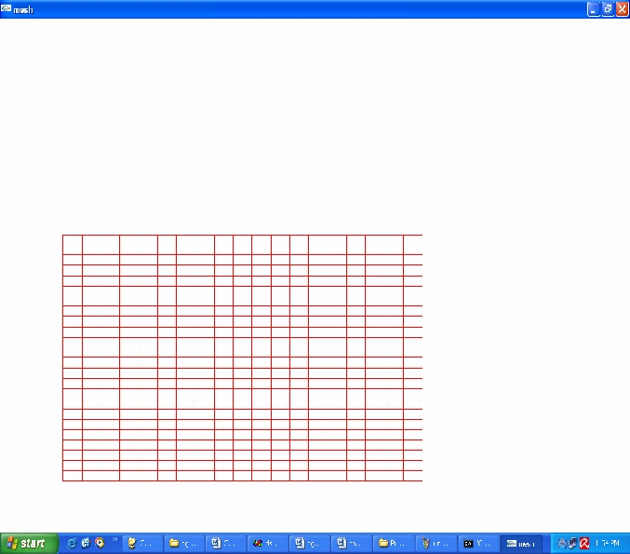
glutMainLoop();
}

Output

Viva Questions
1. Explain all the OpenGL functions used in this program?
2. Name four applications of Computer Graphics
3. What is synthetic camera model?
4. What is Bitmap?
5. Define a Pixel.

2. Program to recursively subdivide a tetrahedron to form 3D Sierpinski gasket. The number of recursive steps is to be specified by the user.

Objective:
In this program, students will learn to create a window and to draw 3D Sierpinski gasket using openGL functions.

Program

#include <GL/glut.h>
#include<stdio.h>
typedef float point[3];
point v[]={ {0.0,0.0,1.0}, {0.0,1.0,-0.33}, {-0.8, -0.5, -0.33}, {0.8,-0.5,-0.33}};
int n;
void triangle(point a, point b, point c)
{
glBegin(GL_POLYGON);
glVertex3fv(a);
glVertex3fv(b);
glVertex3fv(c);
glEnd();
}
void divide_tri(point a,point b,point c,int m)
{
point v1,v2,v3;
int j;
if (m>0)
{
for(j=0;j<3;j++) v1[j]=(a[j]+b[j])/2;
for(j=0;j<3;j++) v2[j]=(a[j]+c[j])/2;
for(j=0;j<3;j++) v3[j]=(b[j]+c[j])/2;
divide_tri(a,v1,v2,m-1);
divide_tri(c,v2,v3,m-1);
divide_tri(b,v3,v1,m-1);
}
else
triangle(a,b,c);
}
void tetrahedron(int m)
{
glColor3f(1.0,0.0,0.0);
divide_tri(v[0],v[1],v[2],m);
glColor3f(0.0,1.0,0.0);
divide_tri(v[3],v[2],v[1],m);
glColor3f(0.0,0.0,1.0);
divide_tri(v[0],v[3],v[1],m);
glColor3f(0.0,0.0,0.0);
divide_tri(v[0],v[2],v[3],m);
}

void display(void)
{
glClear(GL_COLOR_BUFFER_BIT|GL_DEPTH_BUFFER_BIT);
tetrahedron(n);
glFlush();
}
void myReshape(int w,int h)
{
glViewport(0,0,w,h);
glMatrixMode(GL_PROJECTION);
glLoadIdentity();
if(w<=h)
glOrtho(-2.0,2.0,-2.0*(GLfloat)h/(GLfloat)w,2.0*(GLfloat)h/(GLfloat)w,-10.0,10.0);
else
glOrtho(-2.0*(GLfloat)w/(GLfloat)h,2.0*(GLfloat)w/(GLfloat)h,-2.0,2.0,-10.0,10.0);
glMatrixMode(GL_MODELVIEW);
glutPostRedisplay();
}

void main(int argc,char **argv)
{
printf(“Enter the number of recursive steps you want\n”);
scanf(“%d”, &n);
glutInit(&argc,argv);
glutInitDisplayMode(GLUT_SINGLE|GLUT_RGB|GLUT_DEPTH);
glutInitWindowSize(500,500);
glutCreateWindow("3d gasket");
glutReshapeFunc(myReshape);
glutDisplayFunc(display);
//glEnable(GL_DEPTH_TEST);
glClearColor(1.0,1.0,1.0,1.0);
glutMainLoop();
}

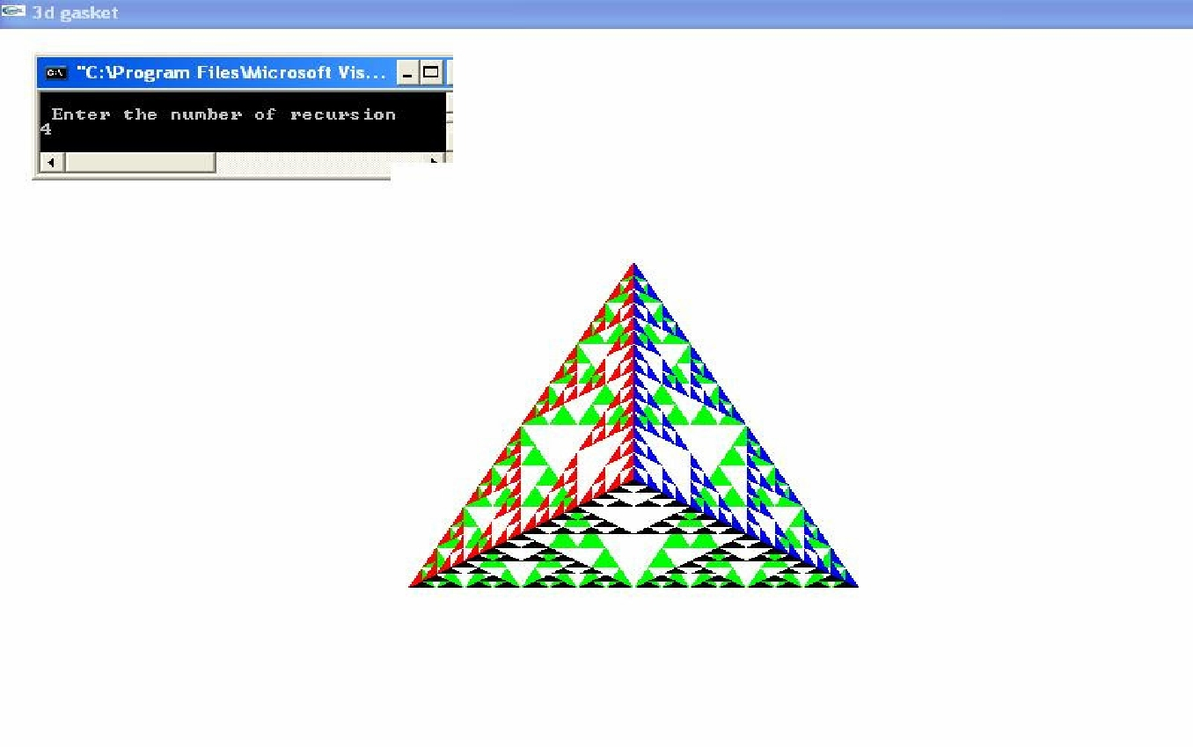
Output:

Viva Questions
1. What is the principle of Sierpinski gasket?
2. What is Resolution.
3. Difference between additive and subtractive color models?
4. What is the Graphics Architecture used in OpenGL?
5. What is Rasterisation?

3. Program to create a cylinder and a parallelepiped by extruding a circle and a quadrilateral respectively. Allow the user to specify the circle and the quadrilateral.
Objective: In this program the students will learn to create a cylinder and a parallelepiped using OpenGL functions.

#include <stdlib.h>
#include <math.h>
#include <GL/glut.h>

void draw_pixel(GLint cx,GLint cy)
{
glColor3f(1.0,0.0,0.0);
glBegin(GL_POINTS);
glVertex2f(cx,cy);
glEnd();
}

void plot_pixel(GLint h,GLint k,GLint x,GLint y)
{
draw_pixel(x+h,y+k);
draw_pixel(-x+h,y+k);
draw_pixel(x+h,-y+k);
draw_pixel(-x+h,-y+k);
draw_pixel(y+h,x+k);
draw_pixel(-y+h,x+k);
draw_pixel(y+h,-x+k);
draw_pixel(-y+h,-x+k);
}

void circle_draw(GLint h,GLint k,GLint r)
{
GLint d=1-r, x=0, y=r;
while (y>x)
{
plot_pixel(h,k,x,y);
if(d<0) d+=2*x+3;
else
{
d+=2*(x-y)+5;
--y;
} ++x;
}
plot_pixel(h,k,x,y);
}

void cylinder_draw()
{
GLint xc=100,yc=100,r=50;
GLint i,n=50;
for(i=0;i<n;i+=3)
circle_draw(xc,yc+i,r);
}

void parallelopiped(int x1,int x2,int y1,int y2,int y3,int y4)
{
glColor3f(0.0,0.0,1.0);
glPointSize(2.0);
glBegin(GL_LINE_LOOP);
glVertex2f(x1,y1);
glVertex2f(x2,y3);
glVertex2f(x2,y4);
glVertex2f(x1,y2);
glEnd();
}

void parallelopiped_draw()
{
int x1=200,x2=300,y1=100,y2=175,y3=100,y4=175;
GLint i,n=40;
for(i=0;i<n;i+=2)
parallelopiped(x1+i,x2+i,y1+i,y2+i,y3+i,y4+i);
}

void init(void)
{
glClearColor(1.0,1.0,1.0,1.0);
glMatrixMode(GL_PROJECTION);
gluOrtho2D(0.0,400.0,0.0,300.0);
}

void display(void)
{
glClear(GL_COLOR_BUFFER_BIT);
glColor3f(1.0,0.0,0.0);
glPointSize(2.0);
cylinder_draw();
parallelopiped_draw();
glFlush();
}

void main(int argc,char *argv[])
{
glutInit(&argc,argv);
glutInitDisplayMode(GLUT_SINGLE|GLUT_RGB);
glutInitWindowSize(500,500);
glutInitWindowPosition(0,0);
glutCreateWindow("cylinder and parallelopiped");
glutDisplayFunc(display);
init();
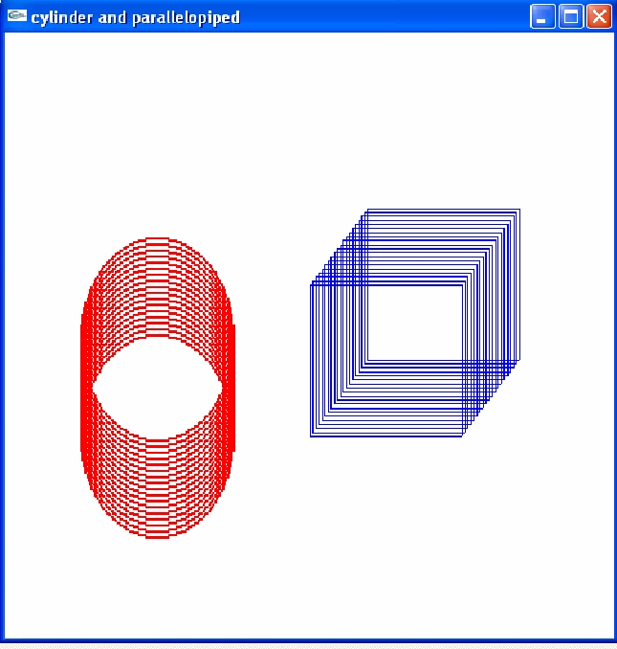
glutMainLoop();
}

Output

Viva Questions:
  - Explain about gluLookAt(…), glFrustum(…), gluPerspective?
  - Explain the different types of projections?
  - Explain Z-buffer algorithm?
  - What is antialiasing?
  - What is COP, DOP?

4. Program to fill any given polygon using scan-line area filling algorithm. (Use appropriate data structures)

Objective:
In this program the students will learn to apply scan-line area filling algorithm to fill a polygon using OpenGL functions.

Program
// Scan-Line algorithm for filling a polygon
#include<stdio.h>
#include<GL/glut.h>

static float x1=250.0,y1=150.0,x2=150.0,y2=250.0,x3=250.0,y3=350.0,x4=350.0,y4=250.0;

void edgeDetect(float x1,float y1,float x2,float y2,int *le, int *re)
{
float mx, x, temp;
int i;
if((y2-y1)<0)
{
temp=y1;y1=y2;y2=temp;
temp=x1;x1=x2;x2=temp;
}
if((y2-y1)!=0)
mx=(x2-x1)/(y2-y1);
else
mx=x2-x1;
x=x1;
for(i=y1;i<=y2;i++)
{
if(x<(float)le[i]) le[i]=(int)x;
if(x>(float)re[i]) re[i]=(int)x;
x+=mx;
}
}

void drawPixel(int x,int y)
{
glColor3f(1.0,1.0,0.0);
glBegin(GL_POINTS);
glVertex2i(x,y);
glEnd();
}

void scanFill(float x1,float y1,float x2,float y2,float x3,float y3,float x4,float y4)
{
int le[500],re[500];
int i,y;
for(i=0;i<500;i++)
{
le[i]=500;
re[i]=0;
}
edgeDetect(x1,y1,x2,y2,le,re);
edgeDetect(x2,y2,x3,y3,le,re);
edgeDetect(x3,y3,x4,y4,le,re);
edgeDetect(x4,y4,x1,y1,le,re);
for(y=0;y<500;y++)
{
if(le[y]<=re[y])
for(i=(int)le[y];i<(int)re[y];i++)
drawPixel(i,y);
}
}

void display(void)
{
glClear(GL_COLOR_BUFFER_BIT);
glColor3f(1.0,1.0,0.0);
glBegin(GL_LINE_LOOP);
glVertex2f(x1,y1);
glVertex2f(x2,y2);
glVertex2f(x3,y3);
glVertex2f(x4,y4);
glEnd();
scanFill(x1,y1,x2,y2,x3,y3,x4,y4);
glFlush();
}

void myInit(void)
{
glClearColor(1.0,1.0,1.0,1.0);
gluOrtho2D(0.0,500.0,0.0,500.0);
}

void main(void)
{
glutInitDisplayMode(GLUT_SINGLE | GLUT_RGB);
glutInitWindowSize(500,500);
glutCreateWindow("Scan Line fill");
glutDisplayFunc(display);
myInit();
glutMainLoop();
}

Output

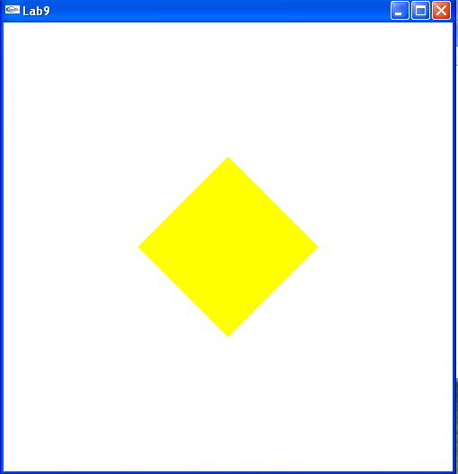
Viva Questions
1. Explain scanline filling algorithm?
2. What is AspectRatio, Viewport?
3. How do you use timer?
4. What are the different frames in OpenGL?
5. What is fragment processing?

5. Program to implement Liang-Barsky line clipping algorithm.

Objective: In this program the students will learn to implement Liang-Barsky Line Clipping Algorithm with Window to viewport Mapping with OPENGL API

Program
#include <stdio.h>
#include <GL/glut.h>
double xmin=50,ymin=50, xmax=100,ymax=100; // Window boundaries
double xvmin=200,yvmin=200,xvmax=300,yvmax=300; // Viewport boundaries
int cliptest(double p, double q, double *t1, double *t2)
{
double t=q/p;
if(p < 0.0) // potentially enry point, update te
{
if( t > *t1) *t1=t;
if( t > *t2) return(false); // line portion is outside
}
else if(p > 0.0) // Potentially leaving point, update tl
{
if( t < *t2) *t2=t;
if( t < *t1) return(false); // line portion is outside
}
else if(p == 0.0)
{
if( q < 0.0) return(false); // line parallel to edge but outside
}
return(true);
}
void LiangBarskyLineClipAndDraw (double x0, double y0,double x1, double y1)
{
double dx=x1-x0, dy=y1-y0, te=0.0, tl=1.0;
if(cliptest(-dx,x0-xmin,&te,&tl)) // inside test wrt left edge
if(cliptest(dx,xmax-x0,&te,&tl)) // inside test wrt right edge
if(cliptest(-dy,y0-ymin,&te,&tl)) // inside test wrt bottom edge
if(cliptest(dy,ymax-y0,&te,&tl)) // inside test wrt top edge
{
if( tl < 1.0 )
{
x1 = x0 + tl*dx;
y1 = y0 + tl*dy;
}
if( te > 0.0 )
{
x0 = x0 + te*dx;
y0 = y0 + te*dy;
}
// Window to viewport mappings
double sx=(xvmax-xvmin)/(xmax-xmin); // Scale parameters
double sy=(yvmax-yvmin)/(ymax-ymin);
double vx0=xvmin+(x0-xmin)*sx;
double vy0=yvmin+(y0-ymin)*sy;
double vx1=xvmin+(x1-xmin)*sx;
double vy1=yvmin+(y1-ymin)*sy;
//draw a red colored viewport
glColor3f(1.0, 0.0, 0.0);
glBegin(GL_LINE_LOOP);
glVertex2f(xvmin, yvmin);
glVertex2f(xvmax, yvmin);
glVertex2f(xvmax, yvmax);
glVertex2f(xvmin, yvmax);
glEnd();
glColor3f(0.0,0.0,1.0); // draw blue colored clipped line
glBegin(GL_LINES);
glVertex2d (vx0, vy0);
glVertex2d (vx1, vy1);
glEnd();
}
}// end of line clipping
void display()
{
double x0=60,y0=20,x1=80,y1=120;
glClear(GL_COLOR_BUFFER_BIT);
//draw the line with red color
glColor3f(1.0,0.0,0.0);
glBegin(GL_LINES);
glVertex2d (x0, y0);
glVertex2d (x1, y1);
glEnd();
//draw a blue colored window
glColor3f(0.0, 0.0, 1.0);
glBegin(GL_LINE_LOOP);
glVertex2f(xmin, ymin);
glVertex2f(xmax, ymin);
glVertex2f(xmax, ymax);
glVertex2f(xmin, ymax);
glEnd();
LiangBarskyLineClipAndDraw(x0,y0,x1,y1);
glFlush();
}
void myinit()
{
glClearColor(1.0,1.0,1.0,1.0);
glColor3f(1.0,0.0,0.0);
glPointSize(1.0);
glMatrixMode(GL_PROJECTION);
glLoadIdentity();
gluOrtho2D(0.0,499.0,0.0,499.0);
}
void main(int argc, char** argv)
{
glutInit(&argc,argv);
glutInitDisplayMode(GLUT_SINGLE|GLUT_RGB);
glutInitWindowSize(500,500);
glutInitWindowPosition(0,0);
glutCreateWindow("Liang Barsky Line Clipping Algorithm");
glutDisplayFunc(display);
myinit();
glutMainLoop();
}

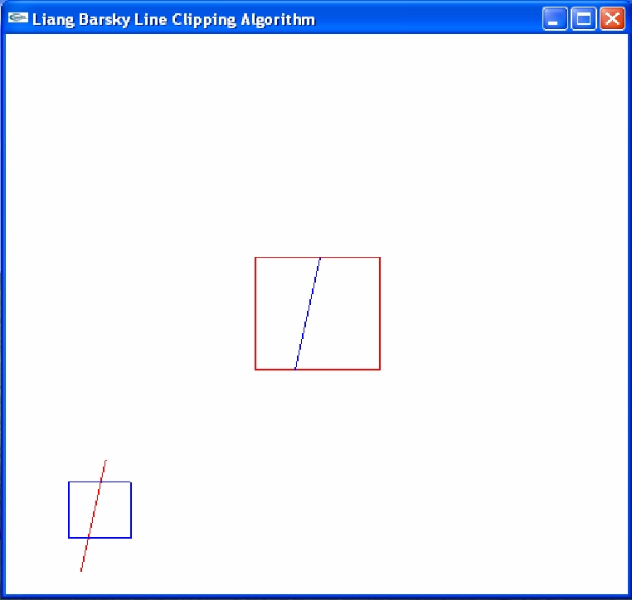
Output

Viva Questions
1. What do you mean by clipping?
2. How is Liang-Barsky clipping different from CohenSutherland Clipping Algorithm?
3. How do you set the color attributes in Opengl?
4. What is the command for clearscreen in OpenGL?
5. What is Event callback function?

6. Cohen-Sutherland Line Clipping Algorithm with Window to viewport mapping using OpenGL API.

Objective: In this program the students will learn to implement Cohen-Sutherland Line Clipping Algorithm with Window to viewport Mapping with OpenGL API.

Program
#include <stdio.h>
#include <GL/glut.h>
#define outcode int

double xmin=50,ymin=50, xmax=100,ymax=100; // Window boundaries
double xvmin=200,yvmin=200,xvmax=300,yvmax=300; // Viewport boundaries

//bit codes for the right, left, top, & bottom
const int LEFT = 1;
const int RIGHT = 2;
const int BOTTOM = 4;
const int TOP = 8;

//used to compute bit codes of a point
outcode ComputeOutCode (double x, double y);

/* Cohen-Sutherland clipping algorithm clips a line from P0 = (x0, y0) to P1 = (x1, y1) against a rectangle with diagonal from (xmin, ymin) to (xmax, ymax). */

void CohenSutherlandLineClipAndDraw (double x0, double y0,double x1, double y1)
{
//Outcodes for P0, P1, and whatever point lies outside the clip rectangle
outcode outcode0, outcode1, outcodeOut;
bool accept = false, done = false;
//compute outcodes
outcode0 = ComputeOutCode (x0, y0);
outcode1 = ComputeOutCode (x1, y1);
do{
if (!(outcode0 | outcode1)) //logical or is 0 Trivially accept & exit
{
accept = true;
done = true;
}
else if (outcode0 & outcode1) //logical and is not 0. Trivially reject and exit
done = true;
else
{
/*failed both tests, so calculate the line segment to clip from an outside point to an intersection with clip edge */
double x, y;
//At least one endpoint is outside the clip rectangle; pick it.
outcodeOut = outcode0? outcode0: outcode1;
//Now find the intersection point;
//use formulas y = y0 + slope * (x - x0), x = x0 + (1/slope)* (y - y0)
if (outcodeOut & TOP) //point is above the clip rectangle
{
x = x0 + (x1 - x0) * (ymax - y0)/(y1 - y0);
y = ymax;
}
else if (outcodeOut & BOTTOM) //point is below the clip rectangle
{
x = x0 + (x1 - x0) * (ymin - y0)/(y1 - y0);
y = ymin;
}
else if (outcodeOut & RIGHT) //point is to the right of clip rectangle
{
y = y0 + (y1 - y0) * (xmax - x0)/(x1 - x0);
x = xmax;
}
else //point is to the left of clip rectangle
{
y = y0 + (y1 - y0) * (xmin - x0)/(x1 - x0);
x = xmin;
}

//Now we move outside point to intersection point to clip and get ready for next pass.
if (outcodeOut == outcode0)
{
x0 = x;
y0 = y;
outcode0 = ComputeOutCode (x0, y0);
}
else
{
x1 = x;
y1 = y;
outcode1 = ComputeOutCode (x1, y1);
}
} //else
} while (!done);

if (accept) // Window to viewport mappings
{
double sx=(xvmax-xvmin)/(xmax-xmin); // Scale parameters
double sy=(yvmax-yvmin)/(ymax-ymin);
double vx0=xvmin+(x0-xmin)*sx;
double vy0=yvmin+(y0-ymin)*sy;
double vx1=xvmin+(x1-xmin)*sx;
double vy1=yvmin+(y1-ymin)*sy;
//draw a red colored viewport
glColor3f(1.0, 0.0, 0.0);
glBegin(GL_LINE_LOOP);
glVertex2f(xvmin, yvmin);
glVertex2f(xvmax, yvmin);
glVertex2f(xvmax, yvmax);
glVertex2f(xvmin, yvmax);
glEnd();
glColor3f(0.0,0.0,1.0); // draw blue colored clipped line
glBegin(GL_LINES);
glVertex2d (vx0, vy0);
glVertex2d (vx1, vy1);
glEnd();
}
}

/* Compute the bit code for a point (x, y) using the clip rectangle bounded diagonally by (xmin, ymin), and (xmax, ymax) */
outcode ComputeOutCode (double x, double y)
{
outcode code = 0;
if (y > ymax) //above the clip window
code |= TOP;
else if (y < ymin) //below the clip window
code |= BOTTOM;
if (x > xmax) //to the right of clip window
code |= RIGHT;
else if (x < xmin) //to the left of clip window
code |= LEFT;
return code;
}

void display()
{
double x0=120,y0=10,x1=40,y1=130;
glClear(GL_COLOR_BUFFER_BIT);
glColor3f(1.0,0.0,0.0); //draw the line with red color
glBegin(GL_LINES);
glVertex2d (x0, y0);
glVertex2d (x1, y1);
glVertex2d (60,20);
glVertex2d (80,120);
glEnd();

glColor3f(0.0, 0.0, 1.0); //draw a blue colored window
glBegin(GL_LINE_LOOP);
glVertex2f(xmin, ymin);
glVertex2f(xmax, ymin);
glVertex2f(xmax, ymax);
glVertex2f(xmin, ymax);
glEnd();

CohenSutherlandLineClipAndDraw(x0,y0,x1,y1);
CohenSutherlandLineClipAndDraw(60,20,80,120);
glFlush();
}

void myinit()
{
glClearColor(1.0,1.0,1.0,1.0);
glColor3f(1.0,0.0,0.0);
glPointSize(1.0);
glMatrixMode(GL_PROJECTION);
glLoadIdentity();
gluOrtho2D(0.0,499.0,0.0,499.0);
}

void main(int argc, char** argv)
{
//int x1, x2, y1, y2;
//printf("Enter End points:");
//scanf("%d%d%d%d", &x1,&x2,&y1,&y2);
glutInit(&argc,argv);
glutInitDisplayMode(GLUT_SINGLE|GLUT_RGB);
glutInitWindowSize(500,500);
glutInitWindowPosition(0,0);
glutCreateWindow("Cohen Suderland Line Clipping Algorithm");
glutDisplayFunc(display);
myinit();
glutMainLoop();
}

Output
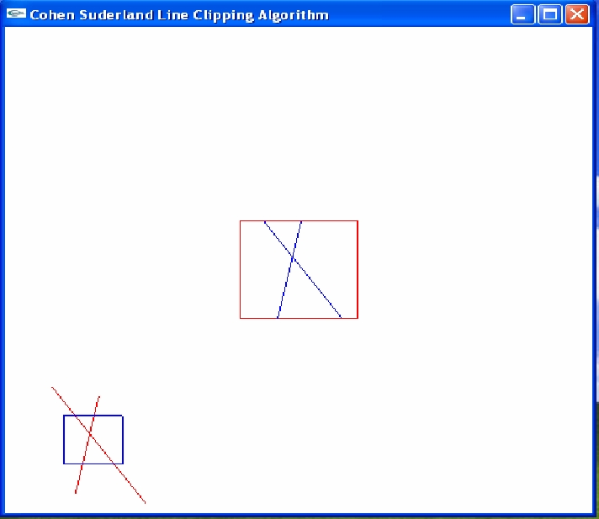

Viva Questions:
1. What is the principle of Cohen-Sutherland Algorithm?
2. State the advantages and disadvantages of Cohen-Sutherland Algorithm?
3. What is an outcode?
4. What is Synthetic Camera Model?
5. What are the Camera Specifications?

7. Program to draw a color cube and spin it using openGL transformation matrices.
Objective: In this program the students will learn to draw a color cube and spin it using OpenGL functions.

Program

#include <GL/glut.h>
#include <stdio.h>
#include <stdlib.h>
GLfloat vertices[ ]={ -1.0,-1.0,-1.0,
1.0,-1.0,-1.0,
1.0, 1.0,-1.0,
- 1.0, 1.0,-1.0,
- 1.0,-1.0, 1.0,
1.0,-1.0, 1.0,
1.0, 1.0, 1.0,
-1.0, 1.0, 1.0 };
GLfloat normals[ ]={ -1.0,-1.0,-1.0,
1.0,-1.0,-1.0,
1.0, 1.0,-1.0,
-1.0, 1.0,-1.0,
-1.0,-1.0, 1.0,
1.0,-1.0, 1.0,
1.0, 1.0, 1.0,
-1.0, 1.0, 1.0 };
GLfloat colors[ ]={ 0.0,0.0,0.0,
1.0, 0.0, 0.0,
1.0, 1.0, 0.0,
0.0, 1.0, 0.0,
0.0, 0.0, 1.0,
1.0, 0.0, 1.0,
1.0, 1.0, 1.0,
0.0, 1.0, 1.0};
GLubyte cubeIndices[]={0,3,2,1,
2,3,7,6,
0,4,7,3,
1,2,6,5,
4,5,6,7,
0,1,5,4 };
static GLfloat theta[]={0.0,0.0,0.0};
static GLint axis=2;
void display(void)
{
glClear(GL_COLOR_BUFFER_BIT|GL_DEPTH_BUFFER_BIT);
glLoadIdentity();
glRotatef(theta[0],1.0,0.0,0.0);
glRotatef(theta[1],0.0,1.0,0.0);
glRotatef(theta[2],0.0,0.0,1.0);
glDrawElements(GL_QUADS,24,GL_UNSIGNED_BYTE,cubeIndices);
glFlush();
glutSwapBuffers();
}
void mouse(int btn,int state,int x,int y)
{
if(btn==GLUT_LEFT_BUTTON && state==GLUT_DOWN)axis=0;
if(btn==GLUT_RIGHT_BUTTON && state==GLUT_DOWN) axis=1;
if(btn==GLUT_MIDDLE_BUTTON && state==GLUT_DOWN) axis=2;
}
void spincube()
{
theta[axis]+=2.0;
if(theta[axis]>360.0) theta[axis]-=360.0;
glutPostRedisplay();
}
void myReshape(int w,int h)
{
glViewport(0,0,w,h);
glMatrixMode(GL_PROJECTION);
glLoadIdentity();
if(w<=h)
glOrtho(-2.0,2.0,-2.0*(GLfloat)h/(GLfloat)w,2.0*(GLfloat)h/(GLfloat)w,10.0,10.0);
else
glOrtho(-2.0*(GLfloat)w/(GLfloat)h,2.0*(GLfloat)w/(GLfloat)h,-2.0,2.0,-10.0,10.0);
glMatrixMode(GL_MODELVIEW);
}
void main(int argc,char **argv)
{
glutInit(&argc,argv);
glutInitDisplayMode(GLUT_DOUBLE|GLUT_RGB|GLUT_DEPTH);
glutInitWindowSize(500,500);
glutCreateWindow("color cube");
glutReshapeFunc(myReshape);
glutDisplayFunc(display);
glutMouseFunc(mouse);
glutIdleFunc(spincube);
glEnable(GL_DEPTH_TEST);
glEnableClientState(GL_COLOR_ARRAY);
glEnableClientState(GL_VERTEX_ARRAY);
glEnableClientState(GL_NORMAL_ARRAY);
glVertexPointer(3,GL_FLOAT,0,vertices);
glColorPointer(3,GL_FLOAT,0,colors);
glNormalPointer(GL_FLOAT,0,normals);
glColor3f(1.0,1.0,1.0);
glutMainLoop();
}

Output

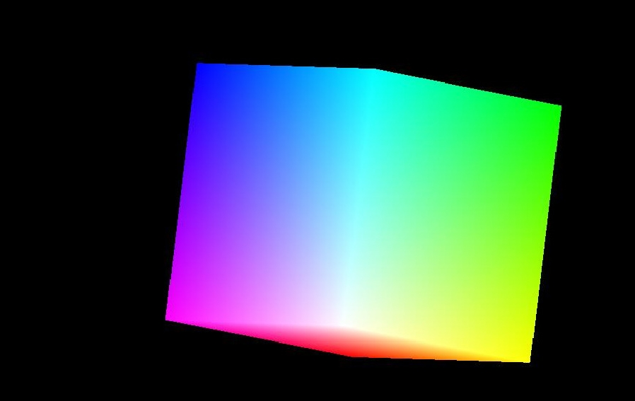

Viva Questions
1. What are vertex arrays?
2. How are the faces of the color cube modeled?
3. How do you consider the inward and outward pointing of the faces?
4. Explain the OpenGL function used to rotate the color cube?
5. What is the difference between 2D and 3D orthographic projection statements?

8. Program to create a house like figure and rotate about a given fixed point using openGL functions.

Objective: In this program the students will learn to draw a house and use transformation
functions of OpenGL to rotate it about a fixed point.

#include <stdlib.h>
#include <stdio.h>
#include <math.h>
#include <GL/glut.h>

GLfloat house[3][9]={ {100.0,100.0,175.0,250.0,250.0,150.0,150.0,200.0,200.0},
{100.0,300.0,400.0,300.0,100.0,100.0,150.0,150.0,100.0},
{1.0, 1.0, 1.0, 1.0, 1.0, 1.0, 1.0, 1.0, 1.0 } };
GLfloat rot_mat[3][3]={{0},{0},{0}};
GLfloat result[3][9]={{0},{0},{0}};
GLfloat h=100.0;
GLfloat k=100.0,theta;

void multiply()
{
int i,j,l;
for(i=0;i<3;i++)
for(j=0;j<9;j++)
{
result[i][j]=0;
for(l=0;l<3;l++)
result[i][j]=result[i][j]+rot_mat[i][l]*house[l][j];
}
}

void rotate()
{
GLfloat m,n;
m=-h*(cos(theta)-1)+k*(sin(theta));
n=-k*(cos(theta)-1)-h*(sin(theta));
rot_mat[0][0]=cos(theta);
rot_mat[0][1]=-sin(theta);
rot_mat[0][2]=m;
rot_mat[1][0]=sin(theta);
rot_mat[1][1]=cos(theta);
rot_mat[1][2]=n;
rot_mat[2][0]=0;
rot_mat[2][1]=0;
rot_mat[2][2]=1;
multiply();
}

void draw_house()
{
glColor3f(0.0,0.0,1.0);
glBegin(GL_LINE_LOOP);
glVertex2f(house[0][0],house[1][0]);
glVertex2f(house[0][1],house[1][1]);
glVertex2f(house[0][3],house[1][3]);
glVertex2f(house[0][4],house[1][4]);
glEnd();
glColor3f(1.0,0.0,0.0);
glBegin(GL_LINE_LOOP);
glVertex2f(house[0][5],house[1][5]);
glVertex2f(house[0][6],house[1][6]);
glVertex2f(house[0][7],house[1][7]);
glVertex2f(house[0][8],house[1][8]);
glEnd();
glColor3f(0.0,0.0,1.0);
glBegin(GL_LINE_LOOP);
glVertex2f(house[0][1],house[1][1]);
glVertex2f(house[0][2],house[1][2]);
glVertex2f(house[0][3],house[1][3]);
glEnd();
}
void drawrotatedhouse()
{
glColor3f(0.0,0.0,1.0);
glBegin(GL_LINE_LOOP);
glVertex2f(result[0][0],result[1][0]);
glVertex2f(result[0][1],result[1][1]);
glVertex2f(result[0][3],result[1][3]);
glVertex2f(result[0][4],result[1][4]);
glEnd();
glColor3f(1.0,0.0,0.0);
glBegin(GL_LINE_LOOP);
glVertex2f(result[0][5],result[1][5]);
glVertex2f(result[0][6],result[1][6]);
glVertex2f(result[0][7],result[1][7]);
glVertex2f(result[0][8],result[1][8]);
glEnd();
glColor3f(0.0,0.0,1.0);
glBegin(GL_LINE_LOOP);
glVertex2f(result[0][1],result[1][1]);
glVertex2f(result[0][2],result[1][2]);
glVertex2f(result[0][3],result[1][3]);
glEnd();
}

void display()
{
glClear(GL_COLOR_BUFFER_BIT);
draw_house();
rotate();
drawrotatedhouse();
glFlush();
}

void myinit()
{
glClearColor(1.0,1.0,1.0,1.0);
glColor3f(1.0,0.0,0.0);
glPointSize(1.0);
glMatrixMode(GL_PROJECTION);
glLoadIdentity();
gluOrtho2D(0.0,500.0,0.0,500.0);
}

void main(int argc,char *argv[])
{
printf("enter the rotation angle\n");
scanf("%f",&theta);
glutInit(&argc,argv);
glutInitDisplayMode(GLUT_SINGLE|GLUT_RGB);
glutInitWindowSize(500,500);
glutInitWindowPosition(0,0);
glutCreateWindow("house rotation");
glutDisplayFunc(display);
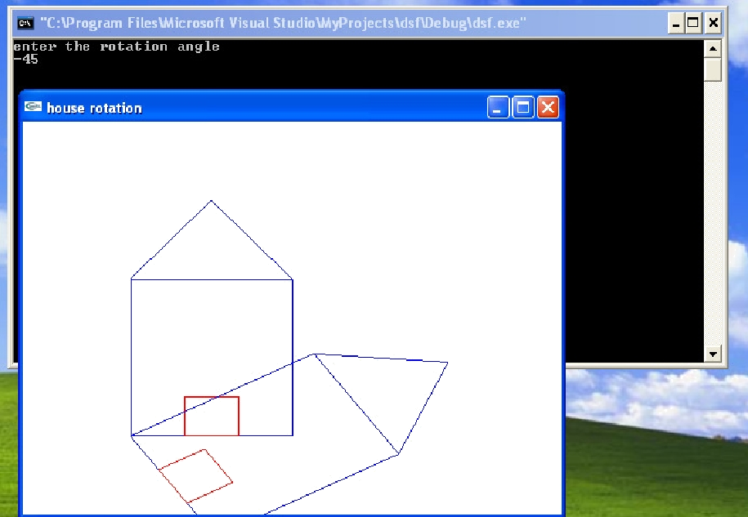
myinit();
glutMainLoop();
}

Output

Viva Questions
1. What is transformation?
2. Explain the OpenGL functions used for translation, rotation and scaling?
3. What is the order of transformation?
4. State the difference between modelview and projection?
5. What is Homogeneous-coordinate representation?

9. Program to draw a color cube and allow the user to move the camera to experiment with perspective viewing .Use OpenGL functions.

Objective:
In this program the students will learn to create color cube and performing events on the color cube with mouse and keyboard using OpenGL functions.

#include <GL/glut.h>
#include <stdio.h>
#include <stdlib.h>

GLfloat vertices[ ]={ -1.0,-1.0,-1.0,
1.0,-1.0,-1.0,
1.0, 1.0,-1.0,
- 1.0, 1.0,-1.0,
- 1.0,-1.0, 1.0,
1.0,-1.0, 1.0,
1.0, 1.0, 1.0,
-1.0, 1.0, 1.0 };

GLfloat normals[ ] ={ -1.0,-1.0,-1.0,
1.0,-1.0,-1.0,
1.0, 1.0,-1.0,
-1.0, 1.0,-1.0,
-1.0,-1.0, 1.0,
1.0,-1.0, 1.0,
1.0, 1.0, 1.0,
-1.0, 1.0, 1.0 };

GLfloat colors[ ]={ 0.0,0.0,0.0,
1.0, 0.0, 0.0,
1.0, 1.0, 0.0,
0.0, 1.0, 0.0,
0.0, 0.0, 1.0,
1.0, 0.0, 1.0,
1.0, 1.0, 1.0,
0.0, 1.0, 1.0 };

GLubyte cubeIndices[]={ 0,3,2,1,
2,3,7,6,
0,4,7,3,
1,2,6,5,
4,5,6,7,
0, 1, 5, 4 };

static GLfloat theta[]={0.0,0.0,0.0};
static GLint axis=2;
static GLdouble viewer[]={0.0,0.0,5.0};

void display(void)
{
glClear(GL_COLOR_BUFFER_BIT|GL_DEPTH_BUFFER_BIT);
glLoadIdentity();
gluLookAt(viewer[0],viewer[1],viewer[2],0.0,0.0,0.0,0.0,1.0,0.0);
glRotatef(theta[0],1.0,0.0,0.0);
glRotatef(theta[1],0.0,1.0,0.0);
glRotatef(theta[2],0.0,0.0,1.0);
glDrawElements(GL_QUADS,24,GL_UNSIGNED_BYTE,cubeIndices);
glFlush();
glutSwapBuffers();
}

void mouse(int btn, int state, int x, int y)
{
if(btn==GLUT_LEFT_BUTTON && state==GLUT_DOWN)axis=0;
if(btn==GLUT_RIGHT_BUTTON && state==GLUT_DOWN) axis=1;
if(btn==GLUT_MIDDLE_BUTTON && state==GLUT_DOWN) axis=2;
theta[axis]+=2.0;
if(theta[axis]>360.0) theta[axis]-=360.0;
glutPostRedisplay();
}

void keys(unsigned char key, int x, int y)
{
if(key=='x') viewer[0]-=1.0;
if(key=='X') viewer[0]+=1.0;
if(key=='y') viewer[1]-=1.0;
if(key=='Y') viewer[1]+=1.0;
if(key=='z') viewer[2]-=1.0;
if(key=='Z') viewer[2]+=1.0;
glutPostRedisplay();
}

void myReshape(int w, int h)
{
glViewport(0,0,w,h);
glMatrixMode(GL_PROJECTION);
glLoadIdentity();
if(w<=h)
glFrustum(-2.0,2.0,-2.0*(GLfloat)h/(GLfloat)w,2.0*(GLfloat)h/(GLfloat)w,2.0,20.0);
else
glFrustum(-2.0,2.0,-2.0*(GLfloat)w/(GLfloat)h,2.0*(GLfloat)w/(GLfloat)h,2.0,20.0);
glMatrixMode(GL_MODELVIEW);
}

void main(int argc, char **argv)
{
glutInit(&argc,argv);
glutInitDisplayMode(GLUT_DOUBLE|GLUT_RGB|GLUT_DEPTH);
glutInitWindowSize(500,500);
glutCreateWindow("color cuce");
glutReshapeFunc(myReshape);
glutDisplayFunc(display);
glutKeyboardFunc(keys);
glutMouseFunc(mouse);
glEnable(GL_DEPTH_TEST);
glEnableClientState(GL_COLOR_ARRAY);
glEnableClientState(GL_VERTEX_ARRAY);
glEnableClientState(GL_NORMAL_ARRAY);
glVertexPointer(3,GL_FLOAT,0,vertices);
glColorPointer(3,GL_FLOAT,0,colors);
glNormalPointer(GL_FLOAT,0,normals);
glColor3f(1.0,1.0,1.0);
glutMainLoop();
}

Output
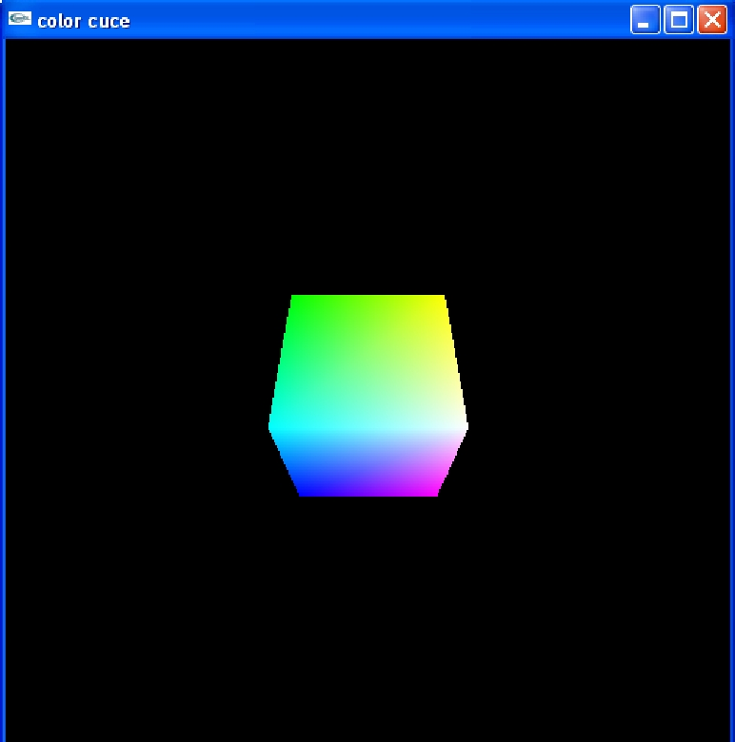

Viva Questions
1. Explain the keyboard and mouse events used in this program?
2. What is Hidden surface Removal? How do you achieve this in OpenGL?
3. What are the functions for creating Menus in OpenGL?
4. Explain about fonts in GLUT?
5. Explain about glutPostRedisplay()?

10. Program using openGL functions to draw a simple shaded scene consisting of a teapot on a table. Define suitably the positions and properties of the light source along with the properties of the surfaces of the solid object used in the scene.

Objective: In this program the students will learn to draw teapot with table and surfaces using OpenGL functions.

#include <GL/glut.h>
#include <stdio.h>
#include <stdlib.h>

void wall(double thickness)
{
glPushMatrix();
glTranslated(0.5,0.5*thickness,0.5);
glScaled(1.0,thickness,1.0);
glutSolidCube(1.0);
glPopMatrix();
}

void tableleg(double thick,double len)
{
glPushMatrix();
glTranslated(0,len/2,0);
glScaled(thick,len,thick);
glutSolidCube(1.0);
glPopMatrix();
}

void table(double topw,double topt,double legt,double legl)
{
glPushMatrix();
glTranslated(0,legl,0);
glScaled(topw,topt,topw);
glutSolidCube(1.0);
glPopMatrix();
double dist=0.95*topw/2.0-legt/2.0;
glPushMatrix();
glTranslated(dist,0,dist);
tableleg(legt,legl);
glTranslated(0,0,-2*dist);
tableleg(legt,legl);
glTranslated(-2*dist,0,2*dist);
tableleg(legt,legl);
glTranslated(0,0,-2*dist);
tableleg(legt,legl);
glPopMatrix();
}

void displaysolid(void)
{
GLfloat mat_ambient[]={0.7f,0.7f,0.7f,1.0f};
GLfloat mat_diffuse[]={0.5f,0.5f,0.5f,1.0f};
GLfloat mat_specular[]={1.0f,1.0f,1.0f,1.0f};
GLfloat mat_shininess[]={50.0f};
glMaterialfv(GL_FRONT,GL_AMBIENT,mat_ambient);
glMaterialfv(GL_FRONT,GL_DIFFUSE,mat_diffuse);
glMaterialfv(GL_FRONT,GL_SPECULAR,mat_specular);
glMaterialfv(GL_FRONT,GL_SHININESS,mat_shininess);
GLfloat lightint[]={0.7f,0.7f,0.7f,1.0f};
GLfloat lightpos[]={2.0f,6.0f,3.0f,0.0f};
glLightfv(GL_LIGHT0,GL_POSITION,lightpos);
glLightfv(GL_LIGHT0,GL_DIFFUSE,lightint);
glMatrixMode(GL_PROJECTION);
glLoadIdentity();
double winht=1.0;
glOrtho(-winht*64/48.0,winht*64/48.0,-winht,winht,0.1,100.0);
glMatrixMode(GL_MODELVIEW);
glLoadIdentity();
gluLookAt(2.3,1.3,2.0,0.0,0.25,0.0,0.0,1.0,0.0);
glClear(GL_COLOR_BUFFER_BIT|GL_DEPTH_BUFFER_BIT);
glPushMatrix();
glRotated(90.0,0.0,0.0,1.0);
wall(0.02);
glPopMatrix();
wall(0.02);
glPushMatrix();
glRotated(-90.0,1.0,0.0,0.0);
wall(0.02);
glPopMatrix();
glPushMatrix();
glTranslated(0.4,0,0.4);
table(0.6,0.02,0.02,0.3);
glPopMatrix();
glPushMatrix();
glTranslated(0.6,0.38,0.5);
glRotated(30,0,1,0);
glutSolidTeapot(0.08);
glPopMatrix();
glFlush();
}

void main(int argc,char**argv)
{
glutInit(&argc,argv);
glutInitDisplayMode(GLUT_SINGLE|GLUT_RGB|GLUT_DEPTH);
glutInitWindowSize(500,500);
glutInitWindowPosition(0,0);
glutCreateWindow("teapot");
glutDisplayFunc(displaysolid);
glEnable(GL_LIGHTING);
glEnable(GL_LIGHT0);
glShadeModel(GL_SMOOTH);
glEnable(GL_DEPTH_TEST);
glEnable(GL_NORMALIZE);
glClearColor(0.1,0.1,0.1,0.0);
glViewport(0,0,640,480);
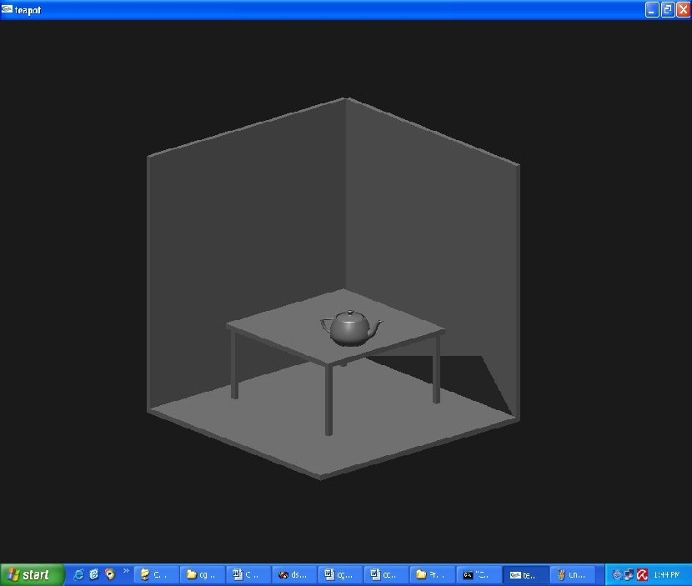
glutMainLoop();
}

Output

Viva Questions

- Explain Specular, Diffuse and Translucent surfaces.
- What is ambient light?
- What is umbra, penumbra?
- Explain Phong lighting model.
- Explain glLightfv(…), glMaterialfv(…).

